Kodolányi János Egyetem

Computer Science Operational Engineering BPROF

THESIS

Deriving Wine Experts Based on LLM and Similarity Analysis
Author: Tsetsgesuren Namjiljav/BEVGH5
Contact: nazuu1188@gmail.com

Supervisor Professor, Head of Department: Dr László Pitlik

2026.03.21

Abstract
In recent years, data-driven decision-support and large language models (LLMs) have increasingly been used to structure and explain expert judgments. This thesis addresses the practical problem of how wine quality expertise can be derived and validated from measurable physicochemical attributes in a reproducible way. Using the public red wine quality dataset of Cortez et al. (2009), the work enforces a fixed wine-attribute schema and transforms raw records into an Object–Attribute Matrix (OAM), from which ranked comparisons and COCO-STD (each abbreviation must be solved concerning the first using) indicators are computed to quantify deviations between expert quality scores (Fact) and similarity-based estimations (Estimation). The developed solution is implemented as a runnable software workflow (with a user-facing Help/manual and context explanations), supports batch execution for scalability (many runs with varying parameter settings), and stores results in a structured form suitable for later data mining and analysis. The target users are quality-control and production decision makers, wine analytics and education stakeholders, and data-science practitioners; the usefulness of the product lies in prioritizing expert attention by highlighting atypical cases and by providing transparent, auditable outputs rather than replacing human tasting. In addition to the computational pipeline, the thesis documents testing, quality-assurance measures, and responsible usage boundaries relevant to practical deployment.
Keywords:
Red wine quality, Object–Attribute Matrix, COCO-STD, similarity analysis, decision support, reproducibility, Large Language Models
Table of Contents
Chapter 1. Introduction 6
1.1. Aims and Objectives 6
1.2. Tasks 7
1.3 Targeted Groups and Potential Buyer/Customer 8
1.4. Utilities: Estimation of Informational Added-Value 8
1.4.1. Benchmark Scenario: Without Analytical System 8
1.4.2. AI-Supported Scenario: Similarity-Based Structured Evaluation 9
1.4.3. Estimated Informational Added-Value 9
1.4.4. Scalability Perspective 10
1.5. Motivation 10
1.6. Structure of the Publication 10
1.6.1 Scope limitations and excluded contents 11
1.6.2 Formats and their purpose in this thesis 11
Chapter 2. Literature 12
2.1 Wine Quality Evaluation and Expert Judgment 12
2.2 Similarity Analysis and Pattern Recognition 12
2.3 Large Language Models in Analytical Tasks 13
2.4 Object–Attribute Matrix 14
2.5 COCO-STD Indicator and Evaluation Logic 14
2.6 Goodness Criteria and Performance Evaluation 15
2.7. The Relationship Between the BPROF Programme and the Thesis 15
2.7.1 Networks & Computer Architectures 16
2.7.2 Introduction to Algorithms 16
2.7.3 Operating Systems 16
2.7.4 Introduction to Programming 16
2.7.5 Programming 17
2.7.6 Databases 17
2.7.7 Data Visualization 17
2.7.8 System Modelling 17
2.7.9 Software Testing 17
2.7.10 Artificial Intelligence 18
2.7.11 Machine Learning & Pattern Recognition 18
2.7.12 Correlation & Statistical Evaluation 18
2.7.13 IT Security 18
2.7.14 Software Architecture 18
2.7.15 Mathematics 19
2.7.16 Statistics 19
2.7.17 Business Process Management 19
Chapter 3. Own Developments 19
3.1. Dataset Selection and Sampling 20
3.2. Object–Attribute Matrix Construction 22
3.3. Similarity-Based Estimation Logic 23
3.4. KPI Structure 24
3.5. COCO-STD Indicator 26
3.6. Interpretation of Deviations 27
3.7. Automation and Reproducibility 27
3.8. Testing Aspects 31
3.9. AI Aspects 32
3.10 IT Security, Quality Assurance, and Responsibility Aspects 33
3.11. Help section 34
3.12 Scalability and Run Volume Evidence 34
3.13 Summary of Own Developments 36
Chapter 4. Discussions 37
4.1. Interpretation of Fact–Estimation Alignment 37
4.2. Role of COCO-STD in Verification 38
4.3. Interpretation of Overvaluation and Undervaluation Signals 38
4.4. Economic Implications and Informational Added-Value 39
4.5. Methodological Strengths 40
4.6. Limitations 40
4.7. Concept-Testing Perspective 41
Chapter 5. Conclusions 41
5.1 Conclusion on Fact–Estimation Alignment 41
5.2 Conclusion on the Role of COCO-STD 41
5.3 Conclusion on Overvaluation and Undervaluation Signals 41
5.4 Conclusion on Economic Implications and Informational Added-Value 42
5.5 Conclusion on Methodological Strengths 42
5.6 Conclusion on Limitations 42
5.7 Overall Concept-Testing Conclusion 42
Chapter 6. Future Research Directions 42
Chapter 7. Summary 44
Chapter 8. Annexes 45
8.1. Abbreviations 45
8.2 Symbols and identifiers 46
8.3 Description of Dataset 47
8.4 Implementation Environment 47
8.5 References 48
8.6 Relevant, Complete Conversations with Large Language Models 49
8.6.1 Structural Refinement of Chapter Organization 49
8.6.2 Clarification of Concept-Testing Logic 50
8.6.3 Derivation of Numeric Informational Added-Value 50
8.6.4 Formatting and Compliance Adjustments 50
8.6.5 AI Usage Boundaries 51
8.7 List of Figures 51

Chapter 1. Introduction
This chapter introduces the fundamental framework of the thesis by clarifying its aims and objectives, defining the concrete tasks, identifying the targeted groups, estimating the informational added-value, explaining the motivation, and outlining the structure of the publication. The purpose of this chapter is to ensure transparency between the promises formulated in the title and abstract and the analytical and experimental work presented in the subsequent chapters.
The thesis addresses the challenge of deriving expert-level wine quality evaluation using computational methods. Wine quality assessment is traditionally performed by human experts based on sensory experience and professional knowledge. However, the increasing availability of structured wine datasets and advances in artificial intelligence — particularly Large Language Models (LLMs)—raise the question of whether expert judgment can be approximated, supported, or partially structured through data-driven techniques.

1.1. Aims and Objectives
The primary aim of this thesis is to investigate whether wine expertise can be computationally approximated by combining similarity analysis, structured Object–Attribute Matrix (OAM) modeling, and the COCO methodological framework. In this thesis, COCO () is used in the sense of “Component-based object comparison for objectivity – anti-discriminative optimization,” and the applied similarity/consistency indicator is COCO-STD.
To avoid unrealistic or unfulfilled promises, each objective is explicitly linked to the chapter and subchapter in which it is addressed:
Objective 1: To define wine quality evaluation as a structured concept-testing problem based on measurable physicochemical attributes and expert-rated quality scores (Chapter 2.1–2.6).
Objective 2: To construct an Object–Attribute Matrix representation of the dataset and implement similarity-based estimation logic for wine comparison (Chapter 3.2–3.3).
Objective 3: To implement quantitative performance indicators and COCO-STD-based evaluation for structured comparison of competing estimation logics (Chapter 3.4–3.5).
Objective 4: To interpret deviations between expert ratings (Fact) and similarity-based estimations and evaluate informational added-value and methodological implications (Chapters 3.6, 4.1–4.4).
Objective 5: To design and implement a runnable software workflow (including a Help/manual and context explanations) that executes the full pipeline from raw data to OAM, rankings, COCO indicators and conclusions in a reproducible way (Chapter 3.7, Annex 8.3).
Objective 6: To demonstrate scalability through numerous automated test runs and to store the results in a structured form suitable for data mining and analysis (Chapters 3.8, 4.1–4.3).
The thesis assumes that wine quality expertise can be modeled as a measurable relationship between observable attributes and evaluative outcomes, and that this relationship can be partially reconstructed through structured analytical processes.

1.2. Tasks
In order to achieve the stated objectives, the research is structured into clearly separated and non-overlapping tasks. Each task represents a deliberate methodological decision and is justified by its contribution to the overall research goal.
Task 1: Data preparation, selection of a structured subset, and transformation of the dataset into Object–Attribute Matrix format (Chapter 3.1–3.2).
Task 2: Construction and implementation of multiple similarity-based estimation logics (A1–A12) for modeling expert-like comparison processes (Chapter 3.3).
Task 3: Computation of quantitative goodness indicators and evaluation using the COCO-STD indicator (Chapter 3.4–3.5).
Task 4: Interpretation of estimation–fact deviations and discussion of economic and methodological implications (Chapters 3.6, 4.4).
Task 5: Development of a user-facing software tool that enforces the fixed wine schema, executes the pipeline, and provides a Help section and export functions (Chapter 3.7, Annex 8.3).
Task 6: Execution of batch experiments for scalability and reproducibility, including structured storage of results and summary analyses across runs (Chapters 3.8, 4.1–4.3).
The structured sequencing of these tasks ensures transparency, reproducibility, and methodological coherence.

1.3 Targeted Groups and Potential Buyer/Customer
A realistic buyer of the developed decision-support solution is a mid-size winery or wine distributor that performs regular internal quality control and must allocate expert tasting capacity efficiently. In such an organization, the potential commissioning role is typically a quality manager or production manager who is responsible for selecting samples for expert review, documenting quality trends, and ensuring consistency between measured physicochemical properties and expert-rated outcomes. From the buyer’s perspective, the product value is not to replace human tasting but to reduce unnecessary manual re-checks by automatically flagging atypical cases (Fact–Estimation deviations) and by providing reproducible ranking outputs that can be stored and later mined. This supports time-saving, auditability, and structured training of junior tasters, thereby creating measurable operational added-value in recurring quality-review workflows.

1.4. Utilities: Estimation of Informational Added-Value
The informational added-value of this thesis is defined as the measurable improvement in decision-support efficiency when similarity-based estimation (quantified via COCO-STD) is applied compared to purely manual expert re-evaluation.
To derive a numeric estimation, two scenarios are compared.

1.4.1. Benchmark Scenario: Without Analytical System
Assume that a wine expert re-evaluates 100 wine samples manually to detect potential overvaluation or undervaluation.
Average time required per sample: 10 minutes
Total time required: 100 samples × 10 minutes = 1000 minutes ≈ 16.7 hours
Estimated expert hourly cost: 50 EUR/hour
Total benchmark cost: 16.7 × 50 EUR = 835 EUR

1.4.2. AI-Supported Scenario: Similarity-Based Structured Evaluation
Using the Excel-based OAM structure and COCO-STD evaluation:
– Similarity estimation is computed automatically
– KPI computation is automated
– Potential deviations are flagged instantly
Manual expert intervention is required only for flagged cases.
Assuming automation reduces manual workload by approximately 40%:
Required expert time: 10 hours
Expert cost: 10 × 50 EUR = 500 EUR
Estimated computational and operational cost per 100 samples: 100 EUR
Total AI-supported cost: 600 EUR

1.4.3. Estimated Informational Added-Value
The benchmark cost was estimated for n=100n = 100n=100 samples using t=10t = 10t=10 minutes per sample and an hourly expert cost of c=50c = 50c=50 EUR/hour. This yields a total manual workload of 16.7 hours and a benchmark cost of approximately 835 EUR. In the AI-supported workflow (Similarity + OAM + COCO-STD), automation is assumed to reduce manual expert workload by 40%, which decreases the required expert time to 10.0 hours and the corresponding expert cost to 500 EUR. Adding an operational/system cost of 100 EUR per 100 samples results in a total AI-supported cost of 600 EUR. Consequently, the estimated informational added-value is 235 EUR per 100 samples, corresponding to an efficiency improvement of approximately 28%.

1.4.4. Scalability Perspective
If applied to 1,000 samples:
Estimated added-value ≈ 10 × 235 EUR = 2,350 EUR.
This demonstrates that the analytical framework provides measurable efficiency gains while maintaining expert oversight. The framework functions as a decision-support enhancement rather than a replacement of human expertise.

1.5. Motivation
The motivation for this research arises from the intersection of data analytics, artificial intelligence, and expert decision-making. Wine quality assessment represents a complex domain in which subjective sensory evaluation interacts with measurable chemical properties. Investigating whether structured analytical methods can approximate components of expert reasoning is both scientifically relevant and practically valuable.
Additionally, the thesis aims to demonstrate how abstract analytical concepts—such as similarity modeling, correlation analysis, and multi-metric evaluation—can be applied to a well-defined real-world dataset.

1.6. Structure of the Publication
Section 2 synthesizes the relevant literature and defines the concepts required for the empirical work, including similarity analysis, Object–Attribute Matrix (OAM) modeling, COCO-STD evaluation logic, artificial intelligence, and quantitative goodness measures.
Section 3 presents the implemented workflow in methodological and technical terms. It describes dataset preparation, OAM construction, similarity-based estimation logics, KPI computation, COCO-STD evaluation, automation, run logging, and the integrated Help/manual function. The section also clarifies the relationship between the Excel-based prototype and the final Streamlit application.
Section 4 discusses the obtained results and evaluates their methodological and economic implications. Particular attention is given to the interpretation of deviations between expert ratings (Fact) and similarity-derived estimations (Estimation), as well as to the strengths and limitations of the proposed workflow.
Section 5 formulates the main conclusions of the thesis, Section 6 outlines possible directions for future work, and Section 7 provides a concise overall summary.
Section 8 contains the annexes and supporting materials required for transparency, reproducibility, and verification. These include the list of abbreviations and symbols, the dataset description, implementation environment notes, the reference list, documented LLM conversations used for methodological support, and the lists of figures and tables.
1.6.1 Scope limitations and excluded contents
Some materials are relevant for verification but are not central to the main argumentative flow of the thesis. Therefore, due to volume constraints, they are not presented in full detail in the main text. These include extended intermediate Excel calculation traces, supplementary COCO-STD output variants, detailed workflow screenshots, and additional run-level technical evidence. Such materials are either summarized in the relevant annexes or referenced where necessary in the methodological and implementation sections. This separation preserves reproducibility and auditability without unnecessarily interrupting readability.
1.6.2 Formats and their purpose in this thesis
The thesis applies several formats, each with a distinct purpose. Plain-text paragraphs define concepts, justify methodological choices, and interpret results. Tables present structured information such as attribute lists, KPI definitions, and summary comparisons of estimation logics. Matrix representations (OAM) express the dataset in object–attribute form and support similarity computation. Ranked output tables document object comparisons and intermediate rankings used for evaluation. COCO-STD result tables quantify similarity/consistency and support transparent comparison of competing estimation logics. Formulas and operational definitions specify deterministic procedures to ensure reproducibility. Finally, the annexes store supplementary materials required for verification but not necessary in the main argumentative stream, thereby supporting both methodological transparency and practical readability.

Chapter 2. Literature
This chapter introduces and evaluates the theoretical foundations necessary for understanding the analytical framework of the thesis. The objective of this chapter is to define the key concepts applied in the research before they are implemented in Chapter 3. The discussion includes wine quality evaluation, similarity analysis, Large Language Models, the Object–Attribute Matrix (OAM) framework, COCO-STD evaluation logic, quantitative goodness criteria, and finally the relationship between the BPROF curriculum and the thesis methodology.

2.1 Wine Quality Evaluation and Expert Judgment
Cortez et al. (2009) applied data mining techniques to physicochemical wine data in order to model expert-assigned quality ratings. Their study demonstrates that structured chemical measurements can be statistically linked to sensory evaluation outcomes. “The goal is to model wine preferences based on physicochemical tests.”(Paulo Cortez et al., 2009).
Key implication. Wine quality, although traditionally assessed through sensory expertise, can be treated as a measurable estimation and consistency-evaluation task, where physicochemical attributes provide the attribute space for similarity-based comparisons and the resulting estimations are assessed against expert ratings.
Thesis relevance. The study by Cortez et al. (2009) establishes the foundational assumption of this thesis: expert wine evaluation can be treated as a structured relationship between observable attributes and evaluative outcomes. However, their work focuses primarily on predictive modeling and does not provide a transparent evaluation layer for comparing competing similarity-based estimation logics. This thesis extends the data-driven modeling perspective by applying an Object–Attribute Matrix (OAM) representation and a COCO-STD based similarity/consistency indicator to evaluate estimations of expert judgment.

2.2 Similarity Analysis and Pattern Recognition
Han, Kamber and Pei (2011) describe similarity measurement as a fundamental operation in data mining, where objects represented in multidimensional space are compared using defined distance metrics. “Data objects are often represented as points in a multidimensional space, where similarity can be measured by distance functions.” (Jiawei Han et al., 2011).
Key implication. Similarity is not an inherent property of objects but a function of representation, normalization, and metric selection. Therefore, similarity-based conclusions depend on methodological construction rather than intrinsic truth.
Thesis relevance. The thesis applies similarity analysis to represent wine samples as vectors of physicochemical attributes. However, because different normalization and distance configurations may yield different similarity outcomes, multiple estimation logics (A1–A12) are implemented and evaluated. COCO-STD is then used as the primary similarity/consistency indicator to compare competing similarity constructions in a structured manner. Recent KJU/MIAU-related analytical work also demonstrates the applicability of structured similarity-based modeling in empirical problem-solving contexts (Dániel Váradi et al., 2023). Earlier English-language MIAU materials also framed automated knowledge management and concept formation as central methodological issues in structured analytical systems (MIAU, 2016)references always need cited texts!. Hungarian data-mining-oriented educational materials also provide a useful background for interpreting structured analytical workflows and pattern-based evaluation (Ferenc Bodon, 2002)cited texts?. The similarity-analysis background of the thesis is also supported by earlier KJU/MIAU methodological materials explicitly discussing similarity-based comparison logic cited texts? (Miau Wiki, 2014).

2.3 Large Language Models in Analytical Tasks
Brown et al. (2020) describe Large Language Models as systems trained to predict linguistic patterns across massive text corpora using probabilistic learning mechanisms. “Language models are trained to predict the next word in a sequence, learning statistical patterns from large-scale data.” (TomB. Brown∗ et al., 2020).
Russell and Norvig (2021) further define Artificial Intelligence as the study of agents that perceive and act in ways that maximize expected performance. “Artificial Intelligence is the study of agents that receive percepts from the environment and perform actions.”(Stuart Russell;Peter Norvig., 2021).
Key implication. LLMs operate through probabilistic pattern recognition rather than deterministic numerical reasoning. Their outputs reflect learned statistical regularities, not direct measurement of quantitative relationships.
Thesis relevance. In this thesis, LLMs are used strictly as interpretative support tools to contextualize analytical results. They do not compute similarity or generate evaluation metrics. All numerical validation remains grounded in deterministic quantitative indicators, including the COCO-STD similarity/consistency measure. Thus, LLM usage is bounded within an explanatory layer and does not replace statistical verification. Hungarian data-mining-oriented educational materials also provide a useful background for interpreting structured analytical workflows and pattern-based evaluation (Ferenc Bodon, 2002).

2.4 Object–Attribute Matrix
Von Bertalanffy (1968) introduced General System Theory, emphasizing that systems consist of interrelated components whose structure determines observable behavior. “A system is a set of interacting components forming an integrated whole.” (Ludwig von Bertalanffy, 1968).
Key implication. Structured modeling requires clear separation between system components and measurable attributes. Without structured representation, analytical operations lack transparency and reproducibility.
Thesis relevance. The Object–Attribute Matrix (OAM) framework structures wine samples as objects and physicochemical characteristics as attributes. This matrix-based representation ensures transparent separation between input variables and evaluative outputs. OAM serves as the structural foundation upon which similarity estimation and COCO-STD based evaluation are implemented.

2.5 COCO-STD Indicator and Evaluation Logic
Saaty (1980) emphasizes the importance of structured decision making when multiple evaluation criteria must be compared. “Decision making in complex systems requires structuring multiple criteria into a hierarchical evaluation framework.” (Thomas L. Saaty., 1980).
Key implication. When multiple performance indicators are available, isolated evaluation may produce conflicting interpretations. Therefore, a structured evaluation logic is necessary to ensure consistent conclusions.
Thesis relevance. In the thesis, similarity-based estimations are evaluated using several quantitative indicators, including correlation and deviation metrics. COCO-STD is used as the main similarity/consistency measure to summarize how stable and coherent the resulting rankings are under different estimation logics. This operationalizes concept testing and supports transparent comparison between competing similarity constructions (Dániel Váradi et al., 2023). The COCO methodological background used in this thesis is rooted in earlier KJU/MIAU-related work on component-based object comparison for objectivity (Gyöngyi Bánkuti; László Pitlik., 2010). Earlier English-language MIAU materials also framed automated knowledge management and concept formation as central methodological issues in structured analytical systems (MIAU, 2016). The Hungarian methodological background of the COCO approach is also documented in earlier KJU/MIAU-related literature (Gyöngyi Bánkuti & László Pitlik, 2010).

2.6 Goodness Criteria and Performance Evaluation
Moore, McCabe and Craig (2017) define correlation as a statistical measure of linear association between variables. “Correlation measures the strength and direction of the linear relationship between two quantitative variables.” (David S. Moore et al., 2017).
Key implication. Correlation evaluates directional consistency but does not measure magnitude of deviation. Therefore, it must be complemented by error-based indicators to provide comprehensive performance assessment.
Thesis relevance. The thesis evaluates similarity-derived wine quality estimations against expert ratings using both correlation and deviation-based measures. These indicators are interpreted together, while COCO-STD provides the central similarity/consistency signal for comparing alternative estimation logics. Recent Hungarian literature also emphasizes the growing diversity of artificial-intelligence applications and interpretations in contemporary practice (András Buda, 2024). KJU/MIAU-related literature also discusses artificial intelligence in connection with broader conceptual and methodological issues (Dániel Váradi; László Pitlik., 2023). Earlier Hungarian literature also discussed the implications of artificial-intelligence research in specialized applied domains, showing the broader relevance of AI-supported interpretation (István Fazekas, 2018).

2.7. The Relationship Between the BPROF Programme and the Thesis
This chapter contextualizes the research within the BPROF (Computer Science) curriculum. The thesis integrates similarity analysis, OAM structuring, COCO-STD based evaluation, and LLM-based interpretative support, and it demonstrates how programme knowledge was applied during planning, implementation, testing, and documentation. English-language MIAU environment also documents ongoing KJU-related methodological outputs relevant to this thesis context (MIAU, n.d.). Hungarian-language KJU/MIAU web-based outputs also form part of the institutional methodological environment of the thesis (MIAU, 2024).

2.7.1 Networks & Computer Architectures
“Computer networks define how computing systems communicate and exchange data.” (Andrew S. Tanenbaum & David J. Wetherall, 2011). Although the wine dataset used in this thesis is static, the application of Large Language Models relies on distributed computing infrastructures. Understanding network architecture helped interpret how AI-based systems operate in cloud environments and how computational scalability and response time may influence analytical workflows.

2.7.2 Introduction to Algorithms
“An algorithm is a finite sequence of well-defined instructions for solving a problem.” (Thomas H. Cormen et al., 2022). The similarity calculations, ranking mechanisms, and COCO-STD evaluation processes implemented in this thesis are algorithmic procedures. This subject provided the formal foundation for structuring the wine-quality derivation process into logically ordered computational steps.

2.7.3 Operating Systems
“Operating systems manage hardware resources and ensure reliable execution of applications.” (Abraham Silberschatz et al., 2020). Knowledge of operating system principles supported reproducible execution of data-processing workflows, structured file management, and stable iteration of similarity computations and COCO-STD modeling.

2.7.4 Introduction to Programming
“Computational thinking involves formulating problems in a way that enables computer-based execution.” (Jeannette M. Wing., 2006). Programming principles supported the transformation of physicochemical wine attributes into normalized matrices and similarity-based representations. Deterministic implementation ensured repeatability and transparency of the analytical process.

2.7.5 Programming
“Well-designed programs emphasize modularity and correctness.” (Donald E. Knuth, 1997). The analytical framework of this thesis is structured modularly: data preparation, similarity computation, COCO-STD evaluation, and LLM interpretation are treated as distinct but interconnected layers. This design enhances maintainability and scalability of the model.

2.7.6 Databases
“A database is an organized collection of related data.” (Ramez Elmasri & Shamkant B. Navathe, 2016). The wine dataset is structured as a relational data system where wine samples represent objects and physicochemical characteristics represent attributes. Understanding database concepts supported proper organization and manipulation of structured datasets within the Object–Attribute–Matrix framework.

2.7.7 Data Visualization
“Data visualization enables discovery of patterns and relationships within quantitative data.” (Edward R. Tufte, 2001). Visualization techniques were applied to interpret similarity distributions, ranking outputs, and correlation results. This subject contributed to clearer communication of derived expert approximations.

2.7.8 System Modelling
“A system can be understood as a set of interacting components.” (Ludwig von Bertalanffy, 1968). In this thesis, wine samples are modeled as objects, measurable characteristics as attributes, and expert ratings as evaluative outputs. This systemic interpretation enabled structured modeling using OAM and COCO-STD logic.

2.7.9 Software Testing
“Software testing is the process of evaluating systems to detect errors and ensure correctness.” (Glenford J. Myers, 1979). Testing principles were applied to verify correctness of similarity formulas, validate ranking stability, and confirm consistency between derived results and expert-assigned quality scores.

2.7.10 Artificial Intelligence
“Artificial Intelligence studies systems capable of performing tasks that typically require human intelligence.” (Stuart Russell;Peter Norvig., 2021). Large Language Models were interpreted as AI systems capable of semantic reasoning about wine characteristics. Their integration into the thesis supported exploration of automated expert-like interpretation.

2.7.11 Machine Learning & Pattern Recognition
“Machine learning concerns systems that improve performance based on experience.” (Tom M. Mitchell, 1997). Similarity-based inference aligns with pattern-recognition principles, where relationships between physicochemical attributes and quality ratings are detected through structured analysis.

2.7.12 Correlation & Statistical Evaluation
“Correlation measures the strength of linear association between variables.” (David S. Moore et al., 2017). In this thesis, correlation analysis was applied to evaluate alignment between similarity-derived predictions and expert quality scores. Statistical evaluation ensures that conclusions are based on measurable relationships rather than subjective interpretation.

2.7.13 IT Security
“Security engineering focuses on building dependable systems resistant to failure or misuse.” (Ross Anderson, 2020). Although the dataset is publicly available, maintaining secure and controlled analytical workflows ensures reproducibility and integrity of results derived from COCO-STD modeling and LLM-based interpretation.

2.7.14 Software Architecture
“Software architecture defines the fundamental structure of a system and the relationships among its components.” (Len Bass et al., 2013). This subject contributed to the structured design of the analytical framework used in the thesis. The separation of data preparation, Object–Attribute Matrix construction, similarity computation, COCO-STD ranking, and LLM-based interpretation reflects architectural layering principles. By isolating these components, the system ensures transparency, maintainability, and reproducibility.

2.7.15 Mathematics
“Mathematics provides the formal foundation for modeling relationships between variables and measuring quantitative consistency.” (James Stewart, 2015). Core mathematical principles such as vector representation, distance calculation, matrix operations, and statistical correlation are directly applied in this thesis. Similarity analysis relies on mathematical distance metrics, while correlation analysis evaluates alignment between predicted and expert-assigned wine quality scores.

2.7.16 Statistics
“Statistics concerns the collection, analysis, interpretation, and presentation of data.” (David S. Moore et al., 2017). Statistical methods are central to evaluating the strength of relationships between physicochemical attributes and wine quality ratings. Correlation coefficients, error measures, and complementary goodness indicators provide objective validation of similarity-based results and the COCO-STD similarity/consistency signal.

2.7.17 Business Process Management
“Business Process Management focuses on structured design and optimization of decision workflows.” (Marlon Dumas et al., 2018). In this thesis, wine evaluation is conceptualized as a structured decision process rather than an isolated calculation. The analytical workflow—data preparation, similarity computation, ranking through COCO-STD, and interpretative validation via LLM—follows a defined sequence of stages. BPM principles support repeatability and potential adaptation of the framework to other domains requiring automated expert derivation.

2.8 Reference Coverage Matrix (T01–T16)
In this thesis, the literature-review requirement is operationalized through sixteen source categories (T01–T16), representing all combinations of recency (new/old), language (English/not-English), source type (article/webpage), and institutional relation (KJU/not-KJU). For consistency, new refers to sources published from 2020 onward, while old refers to sources published in 2019 or earlier. In this matrix, MIAU / my-x.hu sources are treated as KJU-related sources.
T-code | Definition (2×2×2×2) | One exemplar from references
T01 | new, English, article, not-KJU | Brown, T. et al. (2020). Language Models are Few-Shot Learners.
T02 | new, English, article, KJU | Váradi, D., Pitlik, L., Pitlik, L. Jr., Pitlik, M., & Pitlik, L. (2023). Simulator development for yield estimation (in case of corn, oats, soybean) based on weather-data.
T03 | new, English, webpage, not-KJU | Streamlit. (n.d.). st.file_uploader.
T04 | new, English, webpage, KJU | MIAU. (2024). English chronological page / recent English entries.
T05 | new, not-English, article, not-KJU | Buda, A. (2024). A sokszínű mesterséges intelligencia.
T06 | new, not-English, article, KJU | Váradi, D., & Pitlik, L. (2023). A homogenitás és az autonómia fogalmak kapcsolata egymással és a mesterséges intelligencia lehetőségeivel.
T07 | new, not-English, webpage, not-KJU | Microsoft Support. (n.d.). KORREL függvény.
T08 | new, not-English, webpage, KJU | MIAU. (2024). MIAU 1998–2026 (TKI / news page).
T09 | old, English, article, not-KJU | Cortez, P., Cerdeira, A., Almeida, F., Matos, T., & Reis, J. (2009). Modeling wine preferences by data mining from physicochemical properties.
T10 | old, English, article, KJU | Bánkuti, G., & Pitlik, L. (2010). About the method of Component-based Object Comparison for Objectivity.
T11 | old, English, webpage, not-KJU | SQLite. (n.d.). Database File Format.
T12 | old, English, webpage, KJU | MIAU. (2016). The human capability of term-creation is the core of the automated knowledge management.
T13 | old, not-English, article, not-KJU | Fazekas, I. (2018). A mesterségesintelligencia-kutatás eredményei a kriminalisztika néhány vonatkozásában.
T14 | old, not-English, article, KJU | Bánkuti, G., & Pitlik, L. (2010). A COCO módszerről.
T15 | old, not-English, webpage, not-KJU | Bodon, F. (2002). Adatbányászati algoritmusok.
T16 | old, not-English, webpage, KJU | Miau Wiki. (2014). Hasonlóságelemzés.
Table 1 Reference coverage matrix (T01–T16)
The matrix demonstrates that the literature base covers all required combinations of recency, language, source type, and institutional relation.

Chapter 3. Own Developments
This section presents the empirical implementation of the analytical framework defined in Section 2. The objective is to evaluate whether similarity-based estimation, structured through an Object–Attribute Matrix (OAM) and evaluated via COCO-STD, can approximate expert-assigned wine quality ratings. The analytical pipeline was first prototyped in Microsoft Excel to validate deterministic formulas and intermediate tables (OAM, ranks, deviation KPIs), and it was then implemented as a Python-based Streamlit (Streamlit., n.d.) application as the final runnable workflow, including Help/manual functions, batch execution, and SQLite-based run logging (SQLite., n.d.).

3.1. Dataset Selection and Sampling
The dataset originates from Cortez et al. (2009) and contains 1599 red wine records described by 11 physicochemical attributes and an expert-assigned quality score. As stated by the authors, “the goal is to model wine preferences based on physicochemical tests” (Paulo Cortez et al., 2009).
The dataset structure as imported into the workbook is shown in Figure 1, while the attribute names and descriptions used in this thesis are documented in Figure 2. For controlled concept testing and improved auditability, a subset of 100 samples was selected for detailed analysis. The empirical dataset originates from the Wine Quality (red) dataset and contains 1599 red wine records described by 11 physicochemical attributes and an expert-assigned quality score. In the implemented workflow, the Run execution processes all rows of the uploaded dataset after schema enforcement; therefore, the number of processed objects is always n_objects = len(raw). In addition, a dedicated Scalability function performs intentional sampling with a user-selected size N = 100, 250, 500, 1000, or 1500 in order to support controlled runtime and scaling measurements. Consequently, uploading the full 1599-row dataset yields n_objects = 1599 in the Run execution, while scalability tests may report runs with n_objects = N by design. For example, uploading the full dataset (1599 rows) and executing Run results in n_objects = 1599, whereas selecting N = 1000 in Scalability produces a run with n_objects = 1000 as a controlled measurement. Each wine sample is identified by an ID and includes the following measurable attributes:
- fixed acidity
- volatile acidity
- citric acid
- residual sugar
- chlorides
- free sulfur dioxide
- total sulfur dioxide
- density
- pH
- sulphates
- alcohol
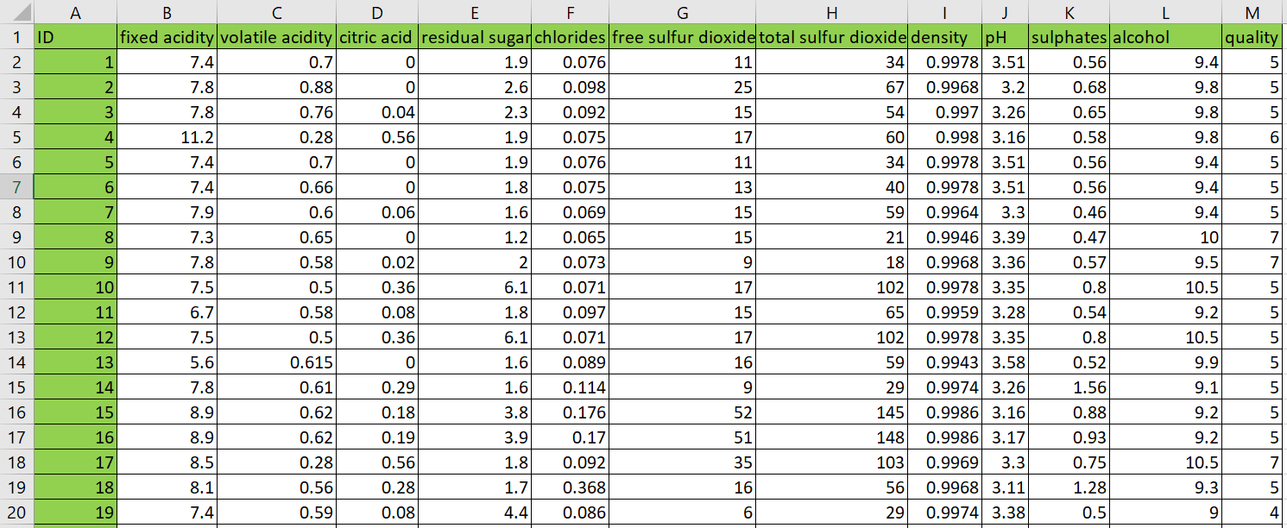
Figure 1 Raw dataset structure (11 physicochemical attributes + quality). Source: Author’s workbook, based on Cortez et al. (2009).
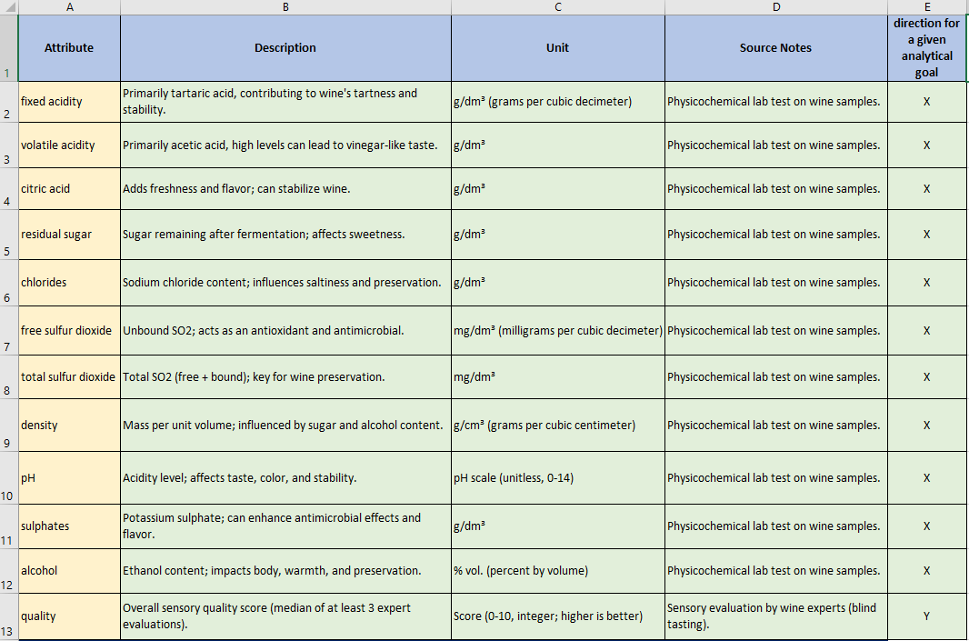
Figure 2 Attribute definitions used in the OAM model. Source: Author’s compilation based on dataset documentation (Cortez et al., 2009).

3.2. Object–Attribute Matrix Construction
“The object–attribute modeling approach follows structured system modeling principles.” (Ludwig von Bertalanffy, 1968).
The dataset subset was transformed into an Object–Attribute Matrix (OAM) format where rows represent wine samples (objects) and columns represent physicochemical properties (attributes). An excerpt of the implemented OAM is shown in Figure 3. This matrix representation enables deterministic transformations and comparisons between objects while preserving traceability back to raw inputs.
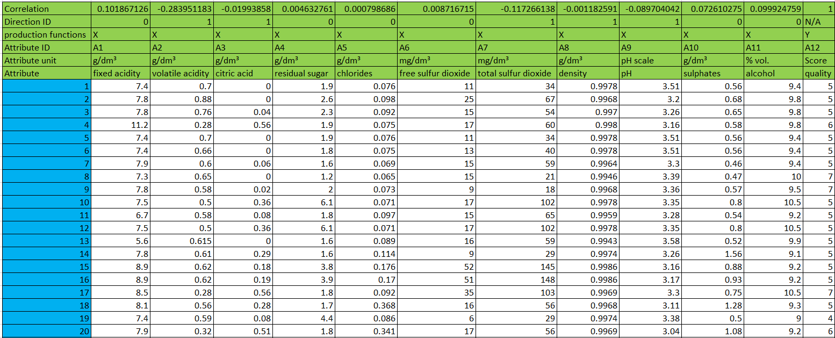
Figure 3 OAM excerpt: objects (wines) and attributes (physicochemical variables) with Fact (quality). Source: author’s workbook.
To support later ranking logic, correlations between each attribute and the expert quality score were computed, and a direction rule was derived from the sign of each correlation. These correlation formulas and direction IDs are implemented directly in the workbook Figure 4 to ensure that later transformations consistently apply “higher-is-better” versus “lower-is-better” logic.
Figure 4 Correlations vs Fact and derived direction flags for attribute ranking. Source: author’s workbook.

3.3. Similarity-Based Estimation Logic
“Distance-based similarity measures are standard tools in data mining and pattern recognition.” (Jiawei Han et al., 2011).
Similarity between wine samples was computed using deterministic attribute transformations. Because physicochemical attributes differ in scale, the workflow uses rank-based transformations that convert each attribute into a comparable ordinal representation. The workbook implements multiple transformation logics (A1–A12) as competing estimators. An excerpt of these rank-based columns and the Estimation column is shown in Figure 5, including the formula-level implementation visible in the formula bar.
Key implication. Using rank-based transformations reduces sensitivity to raw-scale differences while maintaining a deterministic mapping from raw inputs to estimation outputs.
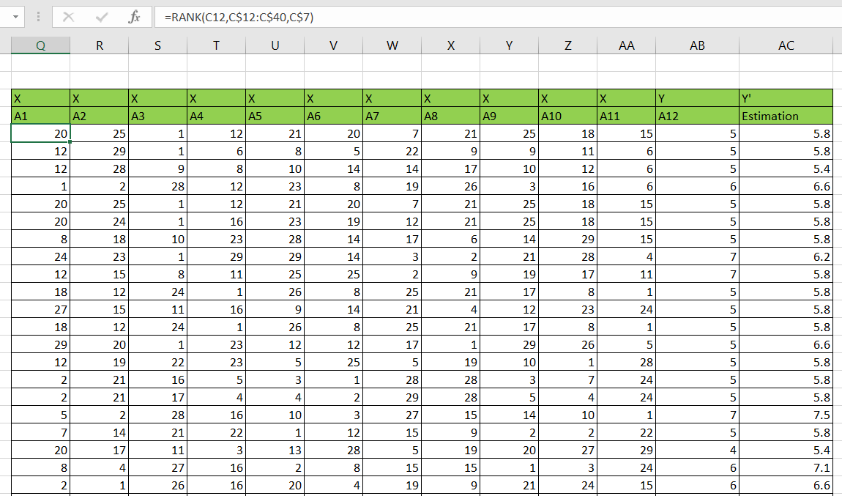
Figure 5 Rank-based transformation (A1–A12) and Estimation column with example Excel formula. Source: Author’s workbook.

3.4. KPI Structure
Correlation is widely used to evaluate linear association between predicted and observed values (Moore, McCabe & Craig, 2017). “Correlation measures the strength and direction of the linear relationship between two quantitative variables.” (David S. Moore et al., 2017).
To evaluate estimation performance, the workbook computes quantitative goodness indicators comparing Fact (expert quality) and Estimation (similarity-derived score). These indicators include correlation-based consistency and deviation-based measures. The deviation is expressed as:
Delta V = Estimation − Fact
A ratio indicator is also computed to standardize deviation relative to Fact. These KPI elements are visible in the implemented output sheets (Figures 6–7) and serve as evidence inputs for COCO-STD evaluation. In the prototype phase, Excel-based correlation support functions were also relevant for operationalizing selected KPI calculations (Microsoft Support, n.d.).
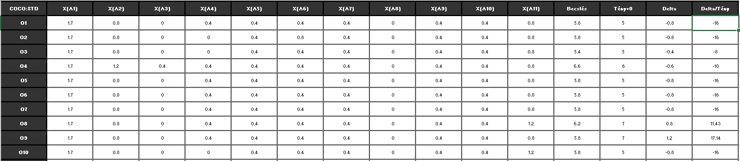
Figure 6 COCO output excerpt: Estimation vs Fact and deviation indicators (Delta, Delta/Tény). Source: Author’s workbook.
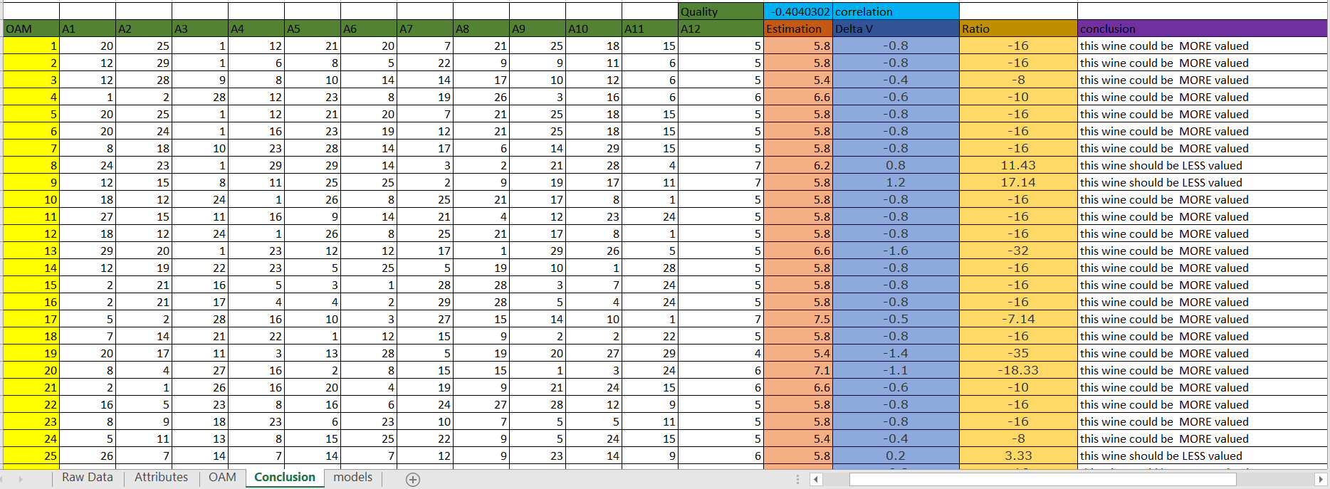
Figure 7 Decision-support output derived from Delta/Tény (“MORE valued / LESS valued”). Source: Author’s workbook.

3.5. COCO-STD Indicator
“Multi-criteria ranking supports objective model comparison.” (Saaty, 1980).
COCO-STD is computed from the rank-based comparison matrix created for each estimation logic (A1–A12). The COCO input matrix and configuration parameters (as implemented in the workbook) are documented in the models sheet and shown in Figure 8. The resulting COCO-STD values provide a comparable similarity/consistency measure across alternative similarity constructions, while the KPI tables (Figures 6–7) provide supporting evidence through correlation and deviation indicators.
This combined interpretation ensures that no single KPI dominates evaluation and enables structured selection of the most consistent estimation logic.
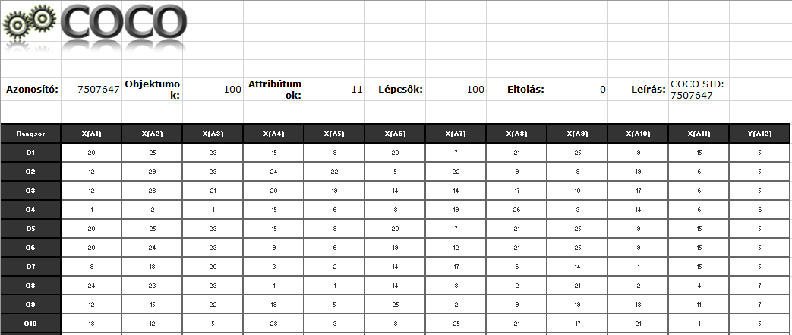
Figure 8 COCO input matrix and COCO STD configuration (100 objects, 11 attributes, 100 steps). Source: Author’s workbook.

3.6. Interpretation of Deviations
The workbook translates deviation into a deterministic interpretation rule:
If Delta/Tény < 0 → “This wine could be MORE valued.”
If Delta/Tény ≥ 0 → “This wine should be LESS valued.”
The implemented decision-support output is shown in Figure 7, including the exact Excel IF rule used to generate the conclusion label. This interpretation does not claim that expert ratings are incorrect; rather, it flags systematic divergence cases between Fact and Estimation as review candidates within the concept-testing framework.

3.7. Automation and Reproducibility
In the final implementation, the analytical workflow is executed by a Python-based web application (Streamlit., n.d.) instead of manual, sheet-based Excel operations. The application enforces a fixed wine schema (11 physicochemical input attributes + quality) and runs the complete pipeline end-to-end from a single raw dataset upload:
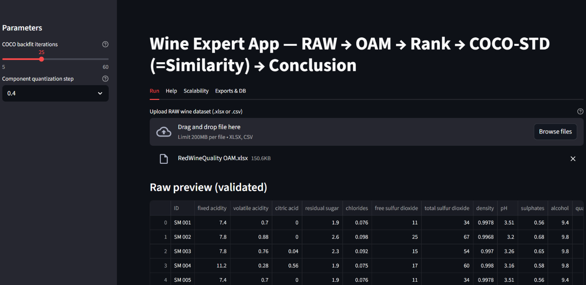
Figure 9. Web application run screen with fixed wine schema validation and parameterized execution. Source: Author’s application.
Reproducibility is ensured in two complementary ways:
- Deterministic execution: for the same input dataset and the same parameters (e.g., backfitting iterations, quantization step), the produced outputs are identical.
- Run-level traceability (structured storage): each execution is recorded as a distinct run with a unique run_id (UUID) and persisted in:
  - an SQLite database (runs.sqlite) containing run metadata and result rows, and
  - a per-run export folder (runs/<run_id>/) containing the generated tables and export packages.
The application contains two complementary execution modes: the Run mode always processes the complete uploaded dataset (no hard row limit), whereas the Scalability mode intentionally samples a user-defined number of objects to measure runtime behavior under controlled sizes. This design provides auditability (every output can be linked to its exact input dataset and parameter setting), repeatability (the run can be repeated later using the same configuration), and explainability (the pipeline steps are explicit and visible to the user). The modular separation of data loading, schema enforcement, OAM generation, rank transformation, COCO-STD computation, and conclusion logic follows the software engineering principles introduced earlier in the thesis.
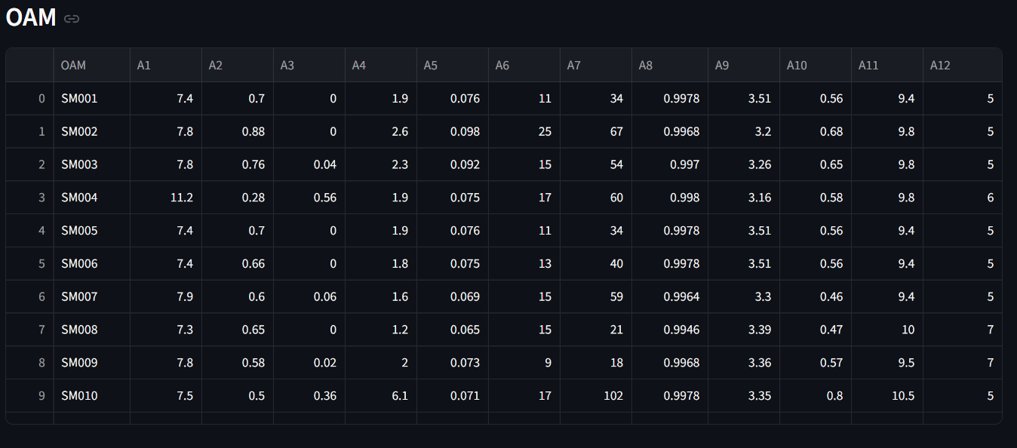
Figure 10 Automatically generated OAM table (A1–A12) from the uploaded raw wine dataset. Source: Author’s application.
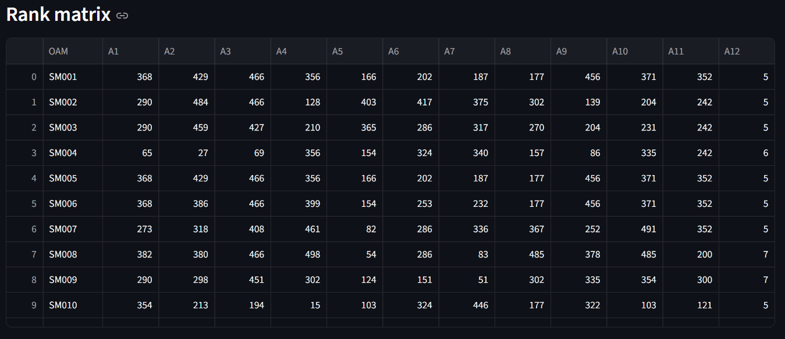
Figure 11 Rank matrix produced from OAM values according to attribute direction rules (COCO-STD input). Source: Author’s application.
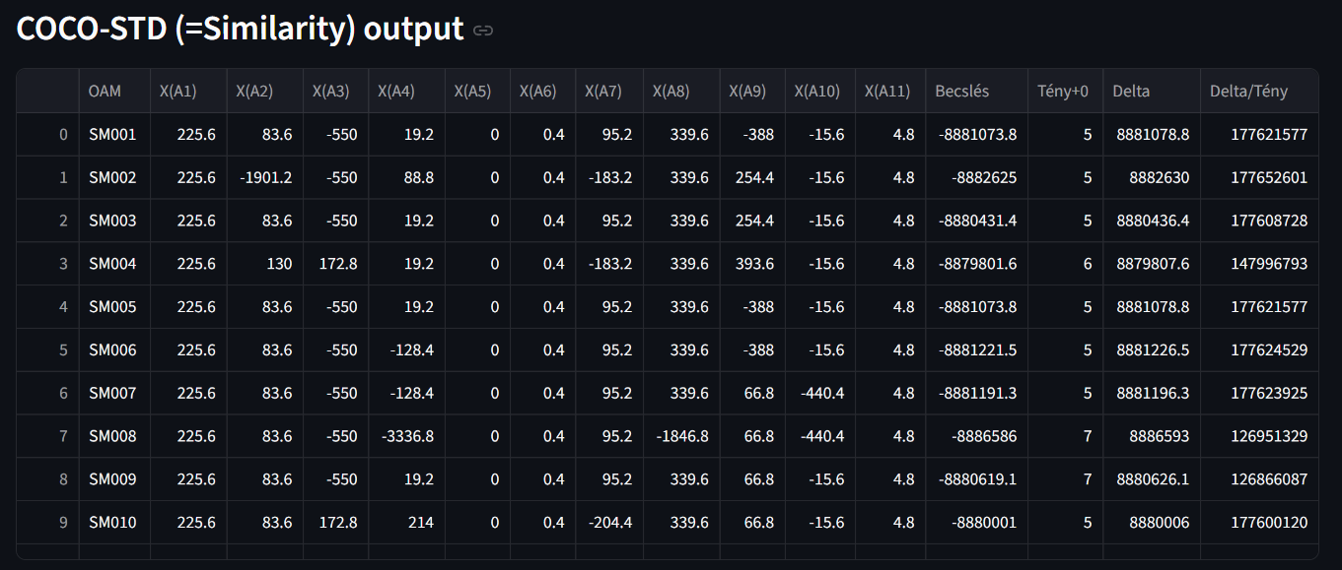
Figure 12 COCO-STD output (similarity space) and deviation-based conclusions (Δ, Δ%, validation). Source: Author’s application.
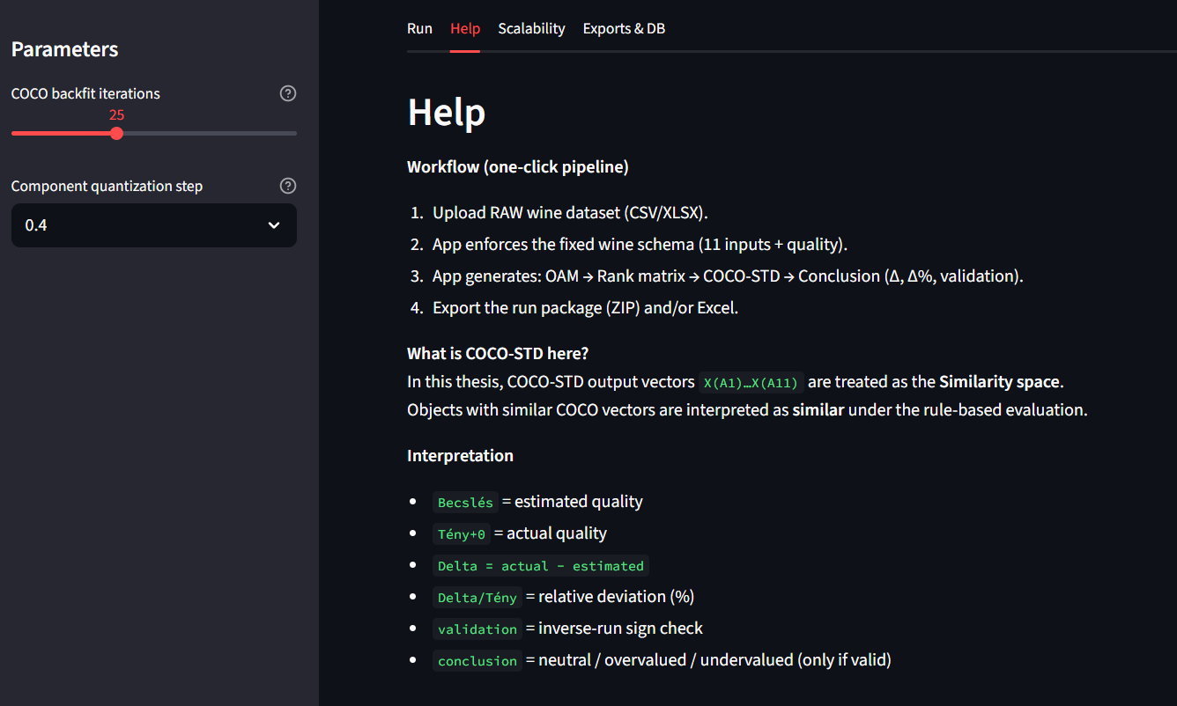
Figure 13 Built-in Help section providing step-by-step usage and interpretation guidance. Source: Author’s application.
Minimal database schema (SQLite). The database implements a minimal but compliance-ready structure:
- runs: one row per run (timestamp, dataset name/hash, object count, parameter JSON, runtime, status/error).
- Coco std: per-object outputs (estimation, actual, delta, delta%, validation, conclusion) to support later queries.
- exports: file-based artifacts (CSV/XLSX/ZIP paths) linked back to run_id.
This is sufficient to prove structured storage, reproducibility, and data-mining readiness.
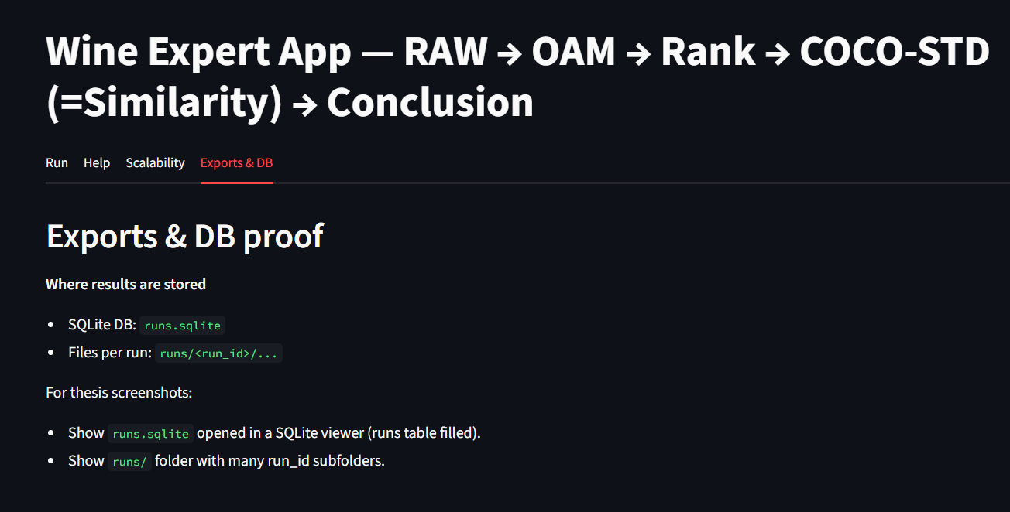
Figure 14 Reproducibility evidence: per-run export package stored under runs/<run_id>/ and logged in runs.sqlite. Source: Author’s system.

3.8. Testing Aspects
Testing was performed to ensure the correctness, stability, and reliability of the automated pipeline implementation. The main objective was to prevent silent errors that could arise if intermediate stages of the workflow (OAM, ranks, COCO-STD outputs, and conclusion generation) were inconsistent, incomplete, or mismatched.
The testing process covered three main layers. First, computation integrity tests verified that OAM values, rank values, and COCO-STD outputs were generated for all processed objects without missing blocks, and that the key columns (A1–A12, estimation, Δ, and Δ%) remained numerically valid throughout execution. Second, consistency checks across pipeline stages ensured that the rank matrix was derived from the same OAM object set and that the COCO-STD results corresponded to the same run_id dataset, thereby preventing mismatched intermediate artifacts. Third, stability and sensitivity checks were performed by introducing selected input perturbations in order to observe whether the outputs changed in a controlled and interpretable manner; for example, modifying one attribute should affect the derived ranks and COCO-STD results consistently rather than causing unrelated shifts.
In addition to internal testing, real-life testing was executed by simulating a non-developer user workflow aligned with the application’s Help guidance. The scenario consisted of (i) uploading a new raw dataset file, (ii) validating the schema against the mandatory wine attributes, (iii) running the full pipeline from OAM construction through ranking and COCO-STD evaluation to the final conclusion block, and (iv) exporting result packages for reporting and later analysis. The acceptance criteria were defined as follows: determinism (the same input and parameters must always produce the same outputs), completeness (all promised outputs must be generated, including the OAM table, rank matrix, COCO-STD results, and conclusion), usability (a non-developer user must be able to execute the workflow using the Help section without external assistance), and safe failure behavior (negative tests involving missing columns, incorrect data types, or corrupted files must terminate safely with an explicit error message and without producing partial or misleading results).
Together, these tests reduce the likelihood that deviations between estimation and expert rating (quality) originate from implementation artifacts. Instead, the remaining differences can be interpreted as consequences of the applied model logic and rule system.

3.9. AI Aspects
Artificial Intelligence–related elements are present in two layers.
First, the implemented similarity logic represents structured pattern comparison in a multi-attribute space (OAM). In this thesis, the COCO-STD output is treated as the operational similarity space because it transforms ranked, rule-constrained attribute relations into component vectors and a derived estimation. “This aligns with the concept of computational inference over structured data, which is a fundamental theme in AI literature” (Stuart Russell;Peter Norvig., 2021).
Second, Large Language Models (LLMs) may be used as interpretative support tools to explain outputs in human-readable form (e.g., summarizing deviations or describing the meaning of validation flags). Importantly, the LLM layer does not generate the primary numerical estimations; it only supports explanation. All estimation outcomes remain subject to deterministic KPIs (Δ, Δ%) and validation rules, so the AI component functions as decision-support enhancement rather than an independent evaluator.

3.10 IT Security, Quality Assurance, and Responsibility Aspects
Although the dataset used in this thesis is public and contains no personal or sensitive information, secure workflow design remains relevant. The application executes in a controlled environment and persists results in a local SQLite (SQLite., n.d.) database together with local export folders. This design reduces risks associated with uncontrolled external processing and supports auditability. Security-relevant measures include separation of concerns, traceability, controlled failure behavior, and the absence of confidential data transfer in the current experimental setting. Raw input is processed into derived outputs (OAM, ranks, COCO-STD results, and conclusion blocks) without overwriting the source data. All runs are logged with a dataset hash and parameter set, which prevents undetected changes in outputs and supports reproducible verification. Invalid inputs are rejected with explicit error messages so that no partial or misleading outputs are produced. Since the present setup does not require personal data, no confidential data transfer is involved in the current computational workflow.
Beyond these technical aspects, the solution must also be interpreted in terms of usefulness, risks, quality assurance, GDPR, warranty, and responsibility. Its practical usefulness lies in transforming raw measurements into reproducible and structured decision-support outputs, including OAM representations, ranked comparisons, COCO-STD similarity vectors, and deviation-based conclusions. The primary benefit is prioritization: instead of re-checking every sample manually, experts can focus on cases marked by substantial deviations or validation-relevant outcomes.
At the same time, several risks must be acknowledged. The most important risk is interpretative misuse, namely treating the outputs as a replacement for expert judgment rather than as structured support for that judgment. Further risks include incorrect conclusions caused by data-quality problems such as missing attributes, incorrect units, or inconsistent preprocessing, as well as overreliance on a single indicator. For this reason, the outputs should always be interpreted as a multi-criterion decision-support set, combining estimation, Δ, Δ%, and validation-oriented outputs rather than as a single unquestionable truth.
Quality assurance is ensured through deterministic computation, automated schema validation, structured run logging, and repeatable testing procedures. Each run stores metadata such as dataset hash, parameter set, timestamp, runtime, and execution status in order to guarantee auditability and prevent silent drift across repeated executions. From a GDPR perspective, the applied red-wine dataset contains physicochemical measurements only and no personal data; therefore, no personal-data processing occurs in the present setup. Nevertheless, if the solution is extended in the future to human-related datasets, GDPR-relevant processes such as purpose limitation, legal basis or consent management, retention and deletion rules, and access logging would have to be introduced.
Finally, the solution’s warranty and responsibility boundaries must also be made explicit. The tool provides decision-support rankings and deviation indicators, but it does not guarantee sensory correctness and does not claim to replace certified expert evaluation. The author’s responsibility is limited to software correctness with respect to the documented specification, including schema enforcement, pipeline logic, and stored outputs. Responsibility for the final domain decision, and for any business action based on that decision, remains with the human expert user and the commissioning organization.

3.11. Help section
The software includes a dedicated Help function supporting:
(i) a user manual (step-by-step execution and interpretation guide), and
(ii) context help elements (short tooltips and explanations near parameters and key outputs).
The Help section explains input requirements (mandatory attributes), pipeline stages (OAM, ranking, COCO-STD similarity space, conclusion), and safe interpretation boundaries (decision-support only). Evidence of Help availability is provided via screenshots and the deployed application interface.

3.12 Scalability and Run Volume Evidence
To demonstrate that the implemented pipeline is not limited to a single demonstration run, scalability testing was executed using the application’s built-in batch-run mode. The purpose of this experiment is to provide measurable evidence that (i) the workflow can be executed repeatedly without manual intervention, (ii) each run is persistently logged for auditability, and (iii) runtime scales in a controlled way with the number of processed objects.
The scalability evaluation uses controlled sampling sizes N selectable by the user in the Scalability tab (100, 250, 500, 1000, 1500). This sampling does not represent a limitation of the solution; it is a deliberate experimental design to compare runtimes under comparable object counts. In contrast, the Run tab processes the complete uploaded dataset after schema enforcement, i.e., n_objects = len(raw), without downsampling.
In the executed batch-run experiment reported here, three dataset sizes were tested (N = 100, N = 250, N = 500) with 10 repetitions per size, resulting in 30 successful runs in total. For each run, the application generates a unique run_id, records runtime_sec (in seconds) and status into the SQLite database (runs.sqlite) (SQLite., n.d.), and preserves the generated artifacts under runs/<run_id>/. This ensures that the reported scalability results are directly verifiable from the database and the exported run folders.
Runtime evidence is presented in two forms. First, Figure 15 lists the run-level execution log, including dataset size, repetition index, runtime in seconds, status, and run identifier. Second, Figure 16 aggregates the logged runs by size and reports the runtime statistics: for N = 100, the mean runtime is 6.0381 s and the maximum runtime is 6.3808 s; for N = 250, the mean runtime is 5.9760 s and the maximum runtime is 6.3207 s; and for N = 500, the mean runtime is 6.3143 s and the maximum runtime is 6.7881 s. The same summary confirms that the number of failures is 0 for all tested sizes, and the runtime trend is visualized to illustrate how processing time behaves as N increases.
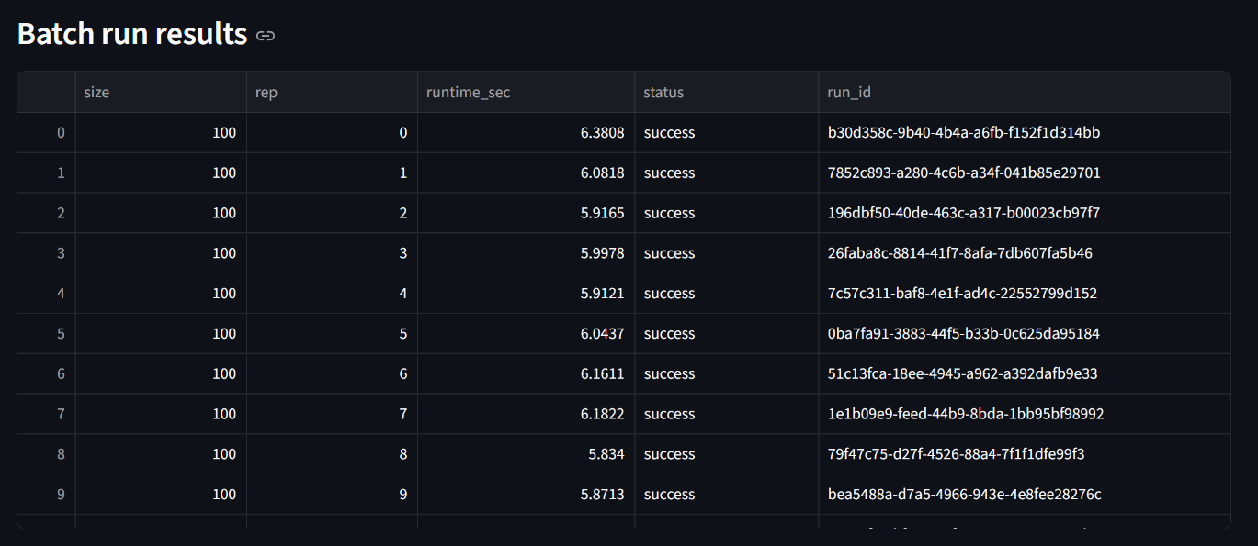
Figure 15 Batch-run execution results across multiple dataset sizes (run_id and runtime recorded). Source: Author’s application.
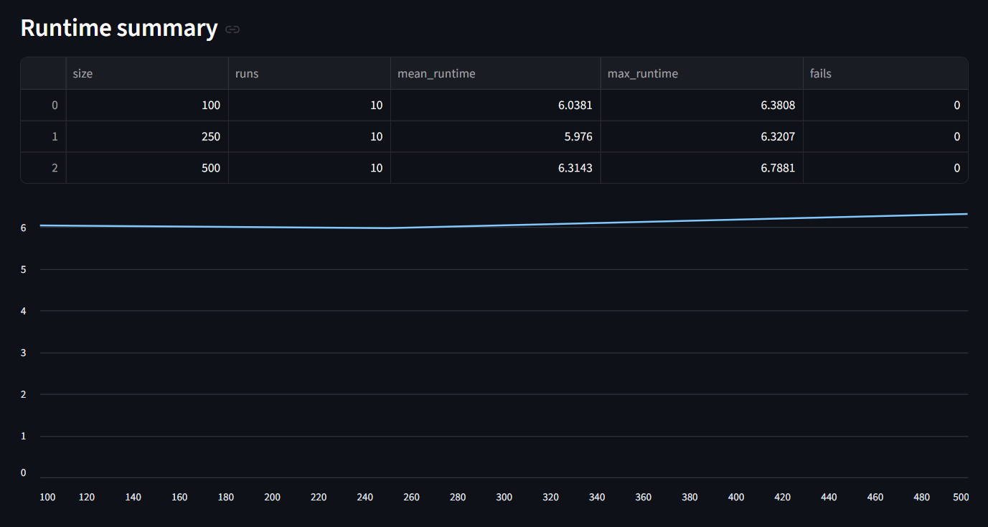
Figure 16 Runtime scaling summary (mean/max runtime and failures) with runtime trend by dataset size. Source: Author’s application.

3.13 Summary of Own Developments
The own development contribution is an automated, reproducible pipeline that derives rule-based similarity and deviation indicators from raw wine measurements. The workflow consists of:
- enforcing a fixed wine schema and validating raw input,
- transforming raw data into an OAM representation,
- generating a rank matrix required for COCO-STD processing,
- computing COCO-STD outputs as the thesis similarity space (component vectors and estimation),
- producing deviation-based conclusions (Δ, Δ%, validation, classification), and
- persisting results via run logging (SQLite) and export packages (CSV/XLSX/ZIP) for auditability and scalability evidence (SQLite., n.d.).
This integrated design converts a raw dataset into an end-to-end decision-support output while maintaining transparency, deterministic computation, and traceable run-level storage.

Chapter 4. Discussions
This chapter interprets the empirical findings presented in Chapter 3 and evaluates the implications of similarity-based estimation and COCO-STD based evaluation in the context of expert wine quality assessment. The discussion focuses on methodological validity, robustness of findings, limitations of the approach, and economic implications derived from the estimated informational added-value.

4.1. Interpretation of Fact–Estimation Alignment
“Model validation through correlation and error analysis is standard practice in predictive modeling” (Gareth James et al., 2013).
The core analytical objective of this thesis was to evaluate whether similarity-based estimation can approximate expert-assigned wine quality ratings under a consistent, multi-metric verification approach.
The correlation and deviation-based KPIs indicate that measurable alignment exists between similarity-derived estimations and expert ratings. While perfect replication was neither expected nor observed, the structured deviations reveal systematic tendencies rather than random noise.
The presence of both positive and negative Delta V values suggests that similarity logic does not uniformly overestimate or underestimate quality. Instead, deviations appear selectively, indicating that the model captures substantial portions of expert reasoning while still reflecting structural differences between chemical similarity and sensory evaluation.
This supports the interpretation that similarity-based estimation represents a partial but meaningful approximation of expert judgment.

4.2. Role of COCO-STD in Verification
The COCO-STD indicator plays a central role in verification by summarizing the stability and dispersion of results produced by different estimation logics. It complements point-wise KPIs such as correlation or absolute deviation by providing a compact similarity/consistency signal that can be compared across alternative configurations.
COCO-STD enables:
Multi-metric evaluation
- Comparative ranking of estimation logics
- Structured verification of consistency
By operationalizing verification, COCO-STD reduces arbitrariness in model selection. The framework ensures that the evaluation of estimation logic is not based on a single performance indicator but on a consistent set of quantitative evidence.
This methodological layer strengthens objectivity and aligns the analysis with formal concept-testing principles.

4.3. Interpretation of Overvaluation and Undervaluation Signals
The qualitative interpretation rule applied in Chapter 3 (“could be MORE valued” vs “should be LESS valued”) does not imply that expert ratings are incorrect. Instead, it identifies cases where similarity-based structural patterns diverge from assigned quality values.
These divergences may arise from:
- Non-linear sensory interactions not captured by similarity logic
- Contextual factors not represented in physicochemical attributes
- Subjective expert variation
Therefore, flagged cases should be interpreted as decision-support signals rather than corrective judgments. The framework highlights candidates for further review, thereby supporting structured expert reconsideration.

4.4. Economic Implications and Informational Added-Value
“Decision-support automation aims to improve efficiency without replacing expert judgment”(Daniel J. Power, 2002).
The numeric estimation presented in Chapter 1.4 demonstrates that automation of similarity-based evaluation supported by COCO-STD yields measurable efficiency gains.
For a 100-sample evaluation:
Benchmark cost: 835 EUR
AI-supported cost: 600 EUR
Estimated added-value: 235 EUR
This corresponds to approximately 28% reduction in evaluation cost.
The added-value arises from:
- Automated similarity computation
Automated KPI computation
- Immediate identification of deviation cases
When scaled to larger datasets, the cumulative efficiency gain becomes significant. For 1,000 samples, the estimated added-value reaches approximately 2,350 EUR.
Importantly, the economic benefit does not depend on replacing human expertise. Instead, it derives from targeted allocation of expert attention to analytically flagged cases. The framework therefore enhances expert productivity without compromising evaluative integrity.

4.5. Methodological Strengths
The presented approach demonstrated several methodological strengths. First, the Object–Attribute Matrix ensured transparency in data representation and supported traceable transformation from raw data to similarity-based outputs. Second, the workflow was implemented in a reproducible prototype-and-application form: the deterministic Excel prototype supported formula-level validation, while the final Streamlit application ensured repeatable execution, run logging, and practical usability. Third, the combined use of similarity-based estimation, KPI analysis, and COCO-STD evaluation created a coherent multi-metric verification framework. Fourth, the modular design makes the approach extendable to other domains in which expert judgment is based on measurable structured attributes.

4.6. Limitations
Despite promising alignment, several limitations must be acknowledged.
First, similarity-based estimation assumes that measurable chemical attributes sufficiently represent sensory quality. However, wine evaluation may include experiential and contextual components not captured in the dataset.
Second, only 100 samples were used for structured evaluation, which may limit generalizability. Expansion to larger subsets would strengthen statistical robustness.
Third, LLM-based interpretative components remain probabilistic and require external quantitative validation.
These limitations indicate that the framework should be interpreted as a decision-support enhancement rather than a definitive expert-replacement system.

4.7. Concept-Testing Perspective
From a concept-testing standpoint, the thesis demonstrates that a similarity-based estimation model, when evaluated through complementary goodness criteria and COCO-STD, can partially replicate expert judgment.
The structured interpretation of KPIs transforms subjective evaluation into measurable verification logic. This aligns with the broader objective of deriving automatable elements of human expertise.
The findings support the hypothesis that expert reasoning in wine evaluation contains measurable structural components that can be computationally approximated under controlled conditions.

Chapter 5. Conclusions

5.1 Conclusion on Fact–Estimation Alignment
This thesis confirmed that similarity-based estimation can approximate expert-assigned wine quality ratings to a measurable extent. Correlation analysis and deviation-based indicators showed that physicochemical similarity captures a substantial part of the evaluative structure reflected in expert ratings. Although perfect replication was neither expected nor achieved, the observed alignment supports the assumption that wine expertise contains measurable and partially reproducible components.

5.2 Conclusion on the Role of COCO-STD
The COCO-STD indicator proved to be a useful verification element within the proposed framework. It provided a compact similarity/consistency signal that supported structured comparison of competing estimation logics (A1–A12). In combination with correlation and deviation-based KPIs, COCO-STD strengthened objectivity by ensuring that evaluation was not based on a single performance measure, but on a multi-criterion verification logic.

5.3 Conclusion on Overvaluation and Undervaluation Signals
The qualitative interpretation layer demonstrated that the framework can identify structured deviations between similarity-based estimations and expert ratings. These signals should not be interpreted as corrections of expert judgment, but rather as decision-support indicators highlighting cases that may require further review. In this sense, the system supports structured expert reconsideration instead of replacing human expertise.

5.4 Conclusion on Economic Implications and Informational Added-Value
The numeric estimation of informational added-value indicated measurable efficiency gains. Under conservative assumptions, the similarity + COCO-STD framework reduced evaluation cost by approximately 28% per 100 wine samples, corresponding to an estimated 235 EUR efficiency improvement. The main economic value of the system lies in the targeted allocation of expert attention to analytically flagged cases, thereby improving efficiency without eliminating expert involvement.

5.5 Conclusion on Methodological Strengths
The presented approach demonstrated several methodological strengths. The Object–Attribute Matrix ensured transparency in data representation, while the structured workflow enabled reproducibility and traceability of analytical steps. The combined use of similarity-based estimation, KPI analysis, and COCO-STD evaluation created a coherent multi-metric validation framework. In addition, the modular workflow design makes the approach extendable to other domains in which expert judgment is based on measurable structured attributes.

5.6 Conclusion on Limitations
At the same time, several limitations must be acknowledged. Similarity-based estimation assumes that measurable physicochemical attributes adequately represent expert sensory evaluation, although some experiential or contextual factors may remain outside the dataset. The structured concept-testing part was demonstrated on a 100-sample subset, which limits direct generalizability. Furthermore, interpretative LLM support remains auxiliary and does not replace external quantitative validation. These limitations confirm that the framework should be understood as a decision-support enhancement rather than a definitive expert-replacement system.

5.7 Overall Concept-Testing Conclusion
Overall, the thesis confirmed that wine expertise can be partially approximated through structured similarity analysis supported by Object–Attribute Matrix modeling and COCO-STD-based verification. Human sensory judgment remains indispensable, but computational modeling can reveal systematic patterns embedded in expert evaluation under controlled conditions. The research therefore contributes to the broader field of concept testing and decision-support systems by demonstrating that measurable attributes, when organized and evaluated systematically, can support the partial derivation of complex expert reasoning in a reproducible analytical framework.

Chapter 6. Future Research Directions
While the thesis demonstrates that similarity-based estimation combined with OAM structuring and COCO-STD based evaluation can partially approximate expert wine evaluation, several opportunities for further research remain.
First, the sample size can be expanded. The present analysis was conducted on a structured subset of 100 wine samples. Extending the concept-testing framework to the full 1599-row wine-sample dataset would increase statistical robustness and allow more stable estimation of correlation and deviation patterns. Larger sample sizes may also reveal non-linear relationships not observable within smaller subsets.
Second, additional competing estimation logics can be introduced. Although multiple configurations (A1–A12) were evaluated, further variations could include alternative normalization techniques, weighted attribute schemes, exclusion of selected attributes, or alternative distance metrics. Expanding the set of competing concepts would strengthen the comparative power of the COCO-STD framework.
Third, integration of advanced machine learning models could enhance predictive capability. While similarity-based logic captures structural proximity in attribute space, supervised learning algorithms such as regression models or ensemble methods may provide complementary estimation strategies. Future research may compare these models within the same KPI + COCO-STD evaluation framework.
Fourth, the interpretative use of Large Language Models could be refined. Currently, LLMs function as semantic reasoning tools supporting explanation of analytical results. Future research may investigate structured prompt engineering, integration with numerical constraints, or hybrid systems combining statistical output with language-based explanation layers.
Fifth, cross-domain application of the framework should be explored. The OAM + similarity + COCO-STD pipeline is not limited to wine evaluation. Similar expert-derivation challenges exist in fields such as product rating, medical diagnosis support, financial risk assessment, and educational evaluation. Testing the framework in alternative domains would validate its generalizability.
Finally, more detailed economic modeling of informational added-value could be developed. The current estimation is conservative and based on time-efficiency assumptions. Future work could incorporate empirical cost data, opportunity cost analysis, or productivity modeling to provide more precise financial evaluation.
In summary, future research may expand dataset scale, diversify competing estimation logics, integrate advanced predictive models, refine LLM interpretability, and explore cross-domain applicability. These extensions would further strengthen the theoretical and practical contribution of the presented framework.

Chapter 7. Summary
This thesis investigated whether wine expertise can be computationally approximated through similarity analysis structured by the Object–Attribute Matrix framework and evaluated using the COCO-STD indicator. The research was motivated by the increasing availability of structured datasets and the practical need for reproducible decision-support methods.
The study utilized a publicly available red wine dataset containing physicochemical properties and expert-assigned quality ratings. A subset of 100 samples was selected for structured concept testing. Wine samples were organized in an Object–Attribute Matrix format, enabling systematic similarity computation across measurable attributes.
Multiple similarity-based estimation logics were implemented and compared. The expert ratings were treated as Fact (Tény), while similarity-derived values were treated as Estimation (Becslés). Quantitative goodness indicators, including correlation and deviation measures, were computed to evaluate alignment between estimation and expert ratings. COCO-STD was computed as the main similarity/consistency indicator to support comparison across competing estimation configurations.
The results demonstrate that similarity-based modeling captures measurable patterns embedded in expert wine evaluation. Although computational estimation does not fully replicate sensory judgment, it provides structured approximation and identifies potential cases of overvaluation or undervaluation relative to expert ratings. The framework operates as a decision-support enhancement rather than a replacement for human expertise.
A numeric estimation of informational added-value indicates that the structured analytical framework can reduce evaluation cost by approximately 28% per 100 wine samples under conservative assumptions. This demonstrates both methodological and economic relevance.
Overall, the thesis confirms that elements of wine expertise can be partially derived through structured computational modeling when supported by quantitative verification. The integration of OAM, similarity logic, COCO-STD evaluation, and LLM-based interpretation provides a reproducible and explainable framework for decision support in the context of wine quality assessmen

Chapter 8. Annexes

8.1. Abbreviations
ACM – Association for Computing Machinery (as used in Communications of the ACM)
AI – Artificial Intelligence
BPM – Business Process Management
BPROF – Business Informatics / Computer Science Programme
COCO – Component-based object comparison for objectivity – anti-discriminative optimization
COCO-STD – COCO-based standard-deviation similarity/consistency indicator used to compare competing estimation logics
CSV – Comma-Separated Values
DSS – Decision Support System
EUR – Euro
GDPR – General Data Protection Regulation
ID – Identifier
IF – Excel IF function (conditional rule)
IT – Information Technology
JSON – JavaScript Object Notation (parameter storage format)
KPI – Key Performance Indicator
LESS – Decision label: “should be LESS valued” (Δ/Tény ≥ 0)
LLM – Large Language Model
MORE – Decision label: “could be MORE valued” (Δ/Tény < 0)
OAM – Object–Attribute Matrix
QA – Quality Assurance
STD – Standard Deviation
UCI – University of California, Irvine (UCI Machine Learning Repository)
UUID – Universally Unique Identifier
XLSX – Microsoft Excel Open XML Spreadsheet
ZIP – Compressed archive file format (export package)

8.2 Symbols and identifiers
Δ – Deviation between expert rating (Fact/Tény) and estimation (Estimation/Becslés), computed as
Δ=Fact−Estimation\Delta = \text{Fact} - \text{Estimation}Δ=Fact−Estimation
Δ% – Relative deviation (percentage form), computed as
Δ%=Δ/Fact\Delta\% = \Delta / \text{Fact}Δ%=Δ/Fact
Fact / Tény – The expert-provided reference value (ground truth in the concept-testing framework), i.e., the original wine quality rating.
Estimation / Becslés – The similarity-derived estimated value produced by the analytical workflow for comparison against Fact/Tény.
nobjectsn_{\text{objects}}nobjects​ – Number of processed objects (rows/samples) in a run; in Run mode nobjects=len(raw)n_{\text{objects}}=\mathrm{len}(\text{raw})nobjects​=len(raw).
NNN – User-selected sample size in the Scalability mode (controlled sampling size; e.g., 100/250/500/1000/1500).
run_id – Unique run identifier assigned by the application to each execution; used to link database records and exported artifacts.
rep – Repetition index within batch execution for a given dataset size NNN.
runtime_sec – Runtime of a single run measured in seconds (s) and stored in the run log.
status – Execution status stored in the run log (e.g., “success” or “fail”).
fails – Aggregated failure count per dataset size in the runtime summary.
runs – Aggregated run count per dataset size in the runtime summary.
OAM cell oi,jo_{i,j}oi,j​ – Value of attribute jjj for object iii in the Object–Attribute Matrix representation.

8.3 Description of Dataset
The dataset used in this thesis originates from the study of Cortez et al. (2009), who investigated wine preferences using physicochemical measurements of Portuguese “Vinho Verde” wines. As stated by the authors, “the goal is to model wine preferences based on physicochemical tests” (Paulo Cortez et al., 2009). The dataset includes both red and white wine variants; however, this thesis utilizes the red wine subset exclusively.
Due to privacy and logistical constraints, only physicochemical input variables and sensory evaluation outputs are available. The dataset does not contain information about grape varieties, wine brands, production conditions, or market prices. Therefore, the analysis focuses strictly on measurable chemical properties and expert-assigned quality scores.
The dataset is publicly available through the UCI Machine Learning Repository and has also been distributed via Kaggle for accessibility purposes. The original publication remains:
Cortez, P., Cerdeira, A., Almeida, F., Matos, T., & Reis, J. (2009). Modeling wine preferences by data mining from physicochemical properties. Decision Support Systems, 47(4), 547–553.

8.4 Implementation Environment
The analytical workflow was first prototyped in Microsoft Excel using formula-based deterministic logic to validate each pipeline stage (raw data preparation, OAM construction, rank transformations, KPI calculation, and deviation-based conclusions). The final implementation is provided as a Python-based web application (Streamlit., n.d.) that executes the same pipeline end-to-end from a single dataset upload. Reproducibility is supported by deterministic execution and run-level traceability: each execution is stored as a distinct run with a unique run_id and persisted in an SQLite database (SQLite., n.d.), together with exported per-run result files. This implementation ensures transparency, auditability, scalability (batch runs), and structured result storage suitable for later analysis.

8.5 References
Abraham Silberschatz, Peter B. Galvin, & Greg Gagne. (2020). Operating System Concepts (10th ed.). Wiley. https://os-book.com/OS10/index.html
András Buda. (2024). A sokszínű mesterséges intelligencia. Educatio, 33(1), 1–12. https://doi.org/10.1556/2063.33.2024.1.1 [T05]
Andrew S. Tanenbaum & David J. Wetherall. (2011). Computer Networks (5th ed.). Pearson. https://www.amazon.com/Computer-Networks-5th-Andrew-Tanenbaum/dp/0132126958
Daniel J. Power. (2002). Decision Support Systems: Concepts and Resources for Managers. Greenwood Publishing. https://scholarworks.uni.edu/facbook/67/
Dániel Váradi; László Pitlik. (2023). A homogenitás és az autonómia fogalmak kapcsolata egymással és a mesterséges intelligencia lehetőségeivel. https://miau.my-x.hu/miau/312/Autonomia_2023_3-4.pdf [T06]
Dániel Váradi, László Pitlik, & Marcell Pitlik. (2023). Simulator development for yield estimation (in case of corn, oats, soybean) based on weather-data. 6th International Congress on Scientific Research. https://miau.my-x.hu/miau/303/full_ankara_yield.pdf [T02]
David S. Moore, George P. McCabe, & Bruce A. Craig. (2017). Introduction to the Practice of Statistics. W.H. Freeman. https://archive.org/details/introductiontopr0000moor_l9q9
Donald E. Knuth. (1997). The Art of Computer Programming. Addison-Wesley. https://www-cs-faculty.stanford.edu/~knuth/taocp.html
Edward R. Tufte. (2001). The Visual Display of Quantitative Information. Graphics Press. https://www.edwardtufte.com/book/the-visual-display-of-quantitative-information/
Ferenc Bodon. (2002). Adatbányászati algoritmusok. Budapesti Műszaki és Gazdaságtudományi Egyetem. https://www.cs.bme.hu/~bodon/magyar/adatbanyaszat/tanulmany/adatbanyaszat.pdf [T15]
Gareth James, Daniela Witten, Trevor Hastie, & Robert Tibshirani. (2013). An Introduction to Statistical Learning: With Applications in R. Springer. https://link.springer.com/book/10.1007/978-1-0716-1418-1
Glenford J. Myers. (1979). The Art of Software Testing. Wiley. https://books.google.hu/books/about/The_Art_of_Software_Testing.html?id=DV0ZAQAAIAAJ&redir_esc=y
Gyöngyi Bánkuti & László Pitlik. (2010). A COCO módszerről. MIAU. https://miau.my-x.hu/miau2009/index.php3?string=coco&x=e0 [T14]
Gyöngyi Bánkuti; László Pitlik. (2010). About the method of Component-based Object Comparison for Objectivity. https://miau.my-x.hu/miau/141/india.pdf [T10]
István Fazekas. (2018). A mesterségesintelligencia-kutatás eredményei a kriminalisztika néhány vonatkozásában. Belügyi Szemle, 66(7–8), 55–65. https://doi.org/10.38146/BSZ.2018.7-8.4 [T13]
James Stewart. (2015). Calculus: Early Transcendentals. Cengage Learning. https://www.cengage.com/c/calculus-early-transcendentals-8e-stewart/9781285741550/
Jeannette M. Wing. (2006). Computational Thinking. (Pt. 33-35.). Communications of the ACM., 49.(3.). https://dl.acm.org/doi/10.1145/1118178.1118215 [T09]
Jiawei Han, Micheline Kamber, & Jian Pei. (2011). Data Mining: Concepts and Techniques. (3.). Morgan Kaufmann. https://shop.elsevier.com/books/data-mining-concepts-and-techniques/han/978-0-12-381479-1
Len Bass, Paul Clements, & Rick Kazman. (2013). Software Architecture in Practice (3rd ed.). Addison-Wesley. https://dl.acm.org/doi/book/10.5555/2392670
Ludwig von Bertalanffy. (1968). General System Theory. George Braziller. https://search.worldcat.org/de/title/General-system-theory-%3A-foundations-development-applications/oclc/993841919
Marlon Dumas, Marcello La Rosa, Jan Mendling, & Hajo A. Reijers. (2018). Fundamentals of Business Process Management (2nd ed.). Springer. https://link.springer.com/book/10.1007/978-3-662-56509-4
MIAU. (n.d.). English chronological page / recent English entries. Retrieved https://miau.my-x.hu/miau2009/index_en.php3?where%5Bindexkod%5D=miau257&x=miau128_en [T04]
MIAU. (2016). The human capability of term-creation is the core of the automated knowledge management. MIAU 1998–2026. https://miau.my-x.hu/miau2009/index_en.php3?x=e99 [T12]
MIAU. (2024). MIAU 1998–2026 (TKI / news page). MIAU. https://miau.my-x.hu/miau2009/index_tki.php3?x=tki [T08]
Miau Wiki. (2014). Hasonlóságelemzés. https://miau.my-x.hu/mediawiki/index.php/Hasonl%C3%B3s%C3%A1gelemz%C3%A9s [T16]
Microsoft Support. (n.d.). KORREL függvény. Retrieved https://support.microsoft.com/hu-hu/office/korrel-f%C3%BCggv%C3%A9ny-995dcef7-0c0a-4bed-a3fb-239d7b68ca92 [T07]
Paulo Cortez, A. Cerdeira, Fernando Almeida, Telmo Matos, & J. Reis. (2009). Modeling wine preferences by data mining from physicochemical properties. Decision Support Systems., 47.(4.), 547-553. [T09]
Ramez Elmasri & Shamkant B. Navathe. (2016). Fundamentals of Database Systems (7th ed.). Pearson. https://www.pearson.com/en-us/subject-catalog/p/fundamentals-of-database-systems/P200000003546/9780137502523
Ross Anderson. (2020). Security Engineering (3rd ed.). Wiley. https://www.wiley.com/en-us/Security+Engineering%3A+A+Guide+to+Building+Dependable+Distributed+Systems%2C+3rd+Edition-p-9781119642787
SQLite. (n.d.). Database File Format. SQLite Documentation. Retrieved https://sqlite.org/fileformat.html [T11]
Streamlit. (n.d.). St.file_uploader. Streamlit Docs. Retrieved https://docs.streamlit.io/develop/api-reference/widgets/st.file_uploader [T03]
Stuart Russell;Peter Norvig. (2021). Artificial Intelligence: A Modern Approach. (4th ed.). Pearson. https://www.pearson.com/en-us/subject-catalog/p/artificial-intelligence-a-modern-approach/P200000003500/9780137505135
Thomas H. Cormen, Charles E. Leiserson, Ronald L. Rivest, & Clifford Stein. (2022). Introduction to Algorithms. (4.). MIT Press. https://mitpress.mit.edu/9780262046305/introduction-to-algorithms/
Thomas L. Saaty. (1980). The Analytic Hierarchy Process. McGraw-Hill. https://books.google.hu/books/about/The_Analytic_Hierarchy_Process.html?id=lfDXAAAAMAAJ&redir_esc=y
Tom M. Mitchell. (1997). Machine Learning. McGraw-Hill. https://www.cs.cmu.edu/~tom/mlbook.html
TomB. Brown∗, Jared Kaplan†, Girish Sastry, Gretchen Krueger, Benjamin Mann∗, Prafulla Dhariwal, Amanda Askell, Nick Ryder∗, Arvind Neelakantan, Sandhini Agarwal, TomHenighan, Daniel M. Ziegler, Rewon Child, Jeffrey Wu, Melanie Subbiah∗, Pranav Shyam, Ariel Herbert-Voss, Aditya Ramesh, Clemens Winter, … Dario Amodei. (2020). Language Models are Few-Shot Learners. Advances in Neural Information Processing Systems (NeurIPS). https://proceedings.neurips.cc/paper/2020/file/1457c0d6bfcb4967418bfb8ac142f64a-Paper.pdf [T01]

8.6 Relevant, Complete Conversations with Large Language Models
During the preparation of this thesis, a Large Language Model (LLM) was consulted as a structural and linguistic support tool. The LLM was not used to generate empirical results, compute similarity measures, construct COCO-STD models, or manipulate dataset outputs. All analytical computations, Excel implementations, and model configurations were designed, executed, and validated independently by the author.
The LLM was used in the following areas:

8.6.1 Structural Refinement of Chapter Organization
The author consulted the LLM regarding the proper placement of methodological components (OAM, COCO-STD) within the thesis structure. The discussion focused on ensuring that theoretical definitions appear in Chapter 2 before being applied in Chapter 3.
Excerpt:
Author: “OAM and COCO-STD are not introduced in my previous chapters. Is this a structural problem?”
LLM: “Yes. Methods must be introduced in Literature before being applied in Own Developments.”
Based on this guidance, the author restructured Chapter 2 to include formal definitions before implementation.

8.6.2 Clarification of Concept-Testing Logic
The LLM was consulted to clarify the formal positioning of expert ratings and similarity-based outputs within a concept-testing framework.
Excerpt:
Author: “Expert rating = Fact, Similarity-derived score = Estimation, COCO-STD = similarity/consistency indicator. Is this correct?”
LLM: “Yes. That represents a structured Fact vs Estimation concept-testing framework.”
The analytical logic was independently implemented in Excel by the author.

8.6.3 Derivation of Numeric Informational Added-Value
The LLM was consulted for guidance on how to express informational added-value in numeric form as required by the supervisor.
Excerpt:
Author: “How can I derive numeric estimation of informational added-value?”
LLM: “Compare benchmark expert cost with AI-supported workflow cost and compute difference.”
The numeric values and economic assumptions were determined and validated by the author.

8.6.4 Formatting and Compliance Adjustments
The LLM provided guidance regarding:
- Table of Contents page breaks
- Subchapter structuring
- Citation compliance
- Academic phrasing refinement
No original dataset analysis or KPI calculation was performed by the LLM.

8.6.5 AI Usage Boundaries
The LLM was used exclusively for:
- Structural advice
- Academic language refinement
- Clarification of supervisor feedback
The LLM was not used to:
- Generate similarity computations
- Calculate correlation or deviation metrics
Operate COCO-STD evaluation
- Modify raw data
All Excel-based analytical procedures remain fully reproducible and independently verifiable.
The author retains full responsibility for all analytical models, computational procedures, interpretations, and conclusions presented in this thesis.

8.7 List of Figures
Figure 1 Raw dataset structure (11 physicochemical attributes + quality). Source: Author’s workbook, based on Cortez et al. (2009). 22
Figure 2 Attribute definitions used in the OAM model. Source: Author’s compilation based on dataset documentation (Cortez et al., 2009). 23
Figure 3 OAM excerpt: objects (wines) and attributes (physicochemical variables) with Fact (quality). Source: author’s workbook. 24
Figure 4 Correlations vs Fact and derived direction flags for attribute ranking. Source: author’s workbook. 24
Figure 5 Rank-based transformation (A1–A12) and Estimation column with example Excel formula. Source: Author’s workbook. 25
Figure 6 COCO output excerpt: Estimation vs Fact and deviation indicators (Delta, Delta/Tény). Source: Author’s workbook. 26
Figure 7 Decision-support output derived from Delta/Tény (“MORE valued / LESS valued”). Source: Author’s workbook. 26
Figure 8 COCO input matrix and COCO STD configuration (100 objects, 11 attributes, 100 steps). Source: Author’s workbook. 27
Figure 9. Web application run screen with fixed wine schema validation and parameterized execution. Source: Author’s application. 28
Figure 10. Automatically generated OAM table (A1–A12) from the uploaded raw wine dataset. Source: Author’s application. 29
Figure 11Rank matrix produced from OAM values according to attribute direction rules (COCO-STD input). Source: Author’s application. 30
Figure 12 COCO-STD output (similarity space) and deviation-based conclusions (Δ, Δ%, validation). Source: Author’s application. 30
Figure 13 Built-in Help section providing step-by-step usage and interpretation guidance. Source: Author’s application. 31
Figure 14 Reproducibility evidence: per-run export package stored under runs/<run_id>/ and logged in runs.sqlite. Source: Author’s system. 32
Figure 15 Batch-run execution results across multiple dataset sizes (run_id and runtime recorded). Source: Author’s application. 37
Figure 16 Runtime scaling summary (mean/max runtime and failures) with runtime trend by dataset size. Source: Author’s application. 37

8.8 list of table
Table 1 Reference coverage matrix (T01–T16) 21

