Kodolányi János Egyetem

Computer Science Operational Engineering BPROF

THESIS

Computational Approximation of Wine Expertise Using Object–Attribute Matrix Modeling and COCO-STD

Author: Tsetsgesuren Namjiljav/BEVGH5
Contact: nazuu1188@gmail.com
Supervisor Professor, Head of Department: Dr László Pitlik

2026.03.21
Abstract
This thesis investigates whether wine expertise can be computationally approximated from measurable physicochemical attributes in a reproducible and transparent way. Using the publicly available red wine quality dataset of Cortez et al. (2009), the study applies a fixed wine-attribute schema and transforms raw records into an Object–Attribute Matrix (OAM). On this basis, ranked comparisons, structured estimation logic, and COCO-STD indicators are used to quantify deviations between expert-assigned quality scores (Fact) and computed estimations (Estimation).
The developed solution is implemented as an automated software pipeline with a user-facing interface, contextual explanations, and a Help/manual section. The pipeline supports end-to-end processing from schema-validated raw input to OAM construction, rank transformation, COCO-STD computation, deviation-based interpretation, and exportable outputs. In addition, the system supports repeated execution, structured run logging, and batch-oriented scalability analysis, thereby enabling reproducibility, traceability, and later data mining of stored results.
The intended users of the developed approach include quality-control and production decision makers, wine analytics and education stakeholders, and data-science practitioners interested in transparent expert-oriented evaluation. The practical usefulness of the solution lies not in replacing human wine tasting, but in prioritizing expert attention by highlighting atypical cases and by providing repeatable, auditable, and interpretable analytical outputs. The thesis also documents testing procedures, quality-assurance considerations, and responsible usage boundaries relevant to practical deployment.
Keywords
Red wine quality, Object–Attribute Matrix, COCO-STD, structured estimation, automated pipeline, decision support, reproducibility

Table of Contents
Chapter 1. Introduction 6
1.1. Aims and Objectives 6
1.2. Tasks 7
1.3 Targeted Groups and Potential Buyer/Customer 8
1.4. Utilities: Estimation of Informational Added-Value 8
1.4.1. Benchmark Scenario: Without Analytical System 8
1.4.2. AI-Supported Scenario: Similarity-Based Structured Evaluation 9
1.4.3. Estimated Informational Added-Value 9
1.4.4. Scalability Perspective 10
1.5. Motivation 10
1.6. Structure of the Publication 10
1.6.1 Scope limitations and excluded contents 11
1.6.2 Formats and their purpose in this thesis 11
Chapter 2. Literature 12
2.1 Wine Quality Evaluation and Expert Judgment 12
2.2 Similarity Analysis and Pattern Recognition 12
2.3 Large Language Models in Analytical Tasks 13
2.4 Object–Attribute Matrix 14
2.5 COCO-STD Indicator and Evaluation Logic 14
2.6 Goodness Criteria and Performance Evaluation 15
2.7. The Relationship Between the BPROF Programme and the Thesis 15
2.7.1 Networks & Computer Architectures 16
2.7.2 Introduction to Algorithms 16
2.7.3 Operating Systems 16
2.7.4 Introduction to Programming 16
2.7.5 Programming 17
2.7.6 Databases 17
2.7.7 Data Visualization 17
2.7.8 System Modelling 17
2.7.9 Software Testing 17
2.7.10 Artificial Intelligence 18
2.7.11 Machine Learning & Pattern Recognition 18
2.7.12 Correlation & Statistical Evaluation 18
2.7.13 IT Security 18
2.7.14 Software Architecture 18
2.7.15 Mathematics 19
2.7.16 Statistics 19
2.7.17 Business Process Management 19
Chapter 3. Own Developments 19
3.1. Dataset Selection and Sampling 20
3.2. Object–Attribute Matrix Construction 22
3.3. Similarity-Based Estimation Logic 23
3.4. KPI Structure 24
3.5. COCO-STD Indicator 26
3.6. Interpretation of Deviations 27
3.7. Automation and Reproducibility 27
3.8. Testing Aspects 31
3.9. AI Aspects 32
3.10 IT Security, Quality Assurance, and Responsibility Aspects 33
3.11. Help section 34
3.12 Scalability and Run Volume Evidence 34
3.13 Summary of Own Developments 36
Chapter 4. Discussions 37
4.1. Interpretation of Fact–Estimation Alignment 37
4.2. Role of COCO-STD in Verification 38
4.3. Interpretation of Overvaluation and Undervaluation Signals 38
4.4. Economic Implications and Informational Added-Value 39
4.5. Methodological Strengths 40
4.6. Limitations 40
4.7. Concept-Testing Perspective 41
Chapter 5. Conclusions 41
5.1 Conclusion on Fact–Estimation Alignment 41
5.2 Conclusion on the Role of COCO-STD 41
5.3 Conclusion on Overvaluation and Undervaluation Signals 41
5.4 Conclusion on Economic Implications and Informational Added-Value 42
5.5 Conclusion on Methodological Strengths 42
5.6 Conclusion on Limitations 42
5.7 Overall Concept-Testing Conclusion 42
Chapter 6. Future Research Directions 42
Chapter 7. Summary 44
Chapter 8. Annexes 45
8.1. Abbreviations 45
8.2 Symbols and identifiers 46
8.3 Description of Dataset 47
8.4 Implementation Environment 47
8.5 References 48
8.6 Relevant, Complete Conversations with Large Language Models 49
8.6.1 Structural Refinement of Chapter Organization 49
8.6.2 Clarification of Concept-Testing Logic 50
8.6.3 Derivation of Numeric Informational Added-Value 50
8.6.4 Formatting and Compliance Adjustments 50
8.6.5 AI Usage Boundaries 51
8.7 List of Figures 51

Chapter 1. Introduction
This chapter introduces the fundamental framework of the thesis by clarifying its aims and objectives, defining the concrete tasks, identifying the targeted groups, estimating the informational added-value, explaining the motivation, and outlining the structure of the publication. Its purpose is to ensure consistency between the promises formulated in the title and abstract and the analytical, methodological, and implementation-oriented work presented in the subsequent chapters.
The thesis addresses the challenge of whether selected components of wine quality expertise can be computationally approximated through structured data-driven analysis. Wine quality assessment is traditionally performed by human experts on the basis of sensory experience and professional knowledge. At the same time, the growing availability of structured wine datasets makes it possible to examine whether measurable physicochemical attributes can support transparent and reproducible estimation procedures related to expert judgment.
Rather than attempting to replace human expertise, the thesis focuses on the development of a structured evaluation framework in which wine records are represented in Object–Attribute Matrix form, processed through alternative estimation logics, and assessed by quantitative consistency indicators. In this way, the study examines how far expert-rated quality judgments can be approximated under explicit, auditable, and automatable analytical rules.

1.1. Aims and Objectives
The primary aim of this thesis is to investigate whether wine expertise can be computationally approximated through structured Object–Attribute Matrix (OAM) modeling, estimation logic, and COCO-STD-based evaluation. Within this thesis, COCO is understood as “Component-based object comparison for objectivity – anti-discriminative optimization,” while COCO-STD is applied as a COCO-based standard analysis (production function generating) similarity/consistency indicator used to compare competing estimation logics.
To avoid unrealistic or unfulfilled promises, each objective is explicitly linked to the chapter and subchapter in which it is addressed.
Objective 1: To define wine quality evaluation as a structured concept-testing problem based on measurable physicochemical attributes and expert-assigned quality scores (Chapter 2.1–2.6).
Objective 2: To construct an Object–Attribute Matrix representation of the dataset and implement structured estimation logic for wine comparison (Chapter 3.2–3.3).
Objective 3: To implement quantitative performance indicators and COCO-STD-based evaluation for the structured comparison of competing estimation logics (Chapter 3.4–3.5).
Objective 4: To interpret deviations between expert ratings (Fact) and computed estimations (Estimation), and to evaluate their informational added-value and methodological implications (Chapters 3.6, 4.1–4.4).
Objective 5: To design and implement an automated software pipeline, including a Help/manual and contextual explanations, that executes the full analytical process from raw data to OAM, rankings, COCO-STD outputs, and conclusions in a reproducible way (Chapter 3.7, Annex 8.3).
Objective 6: To demonstrate scalability through repeated automated runs and to store the results in a structured form suitable for later data mining and analysis (Chapters 3.8, 4.1–4.3).
The thesis assumes that wine quality expertise can be partially modeled as a measurable relationship between observable attributes and evaluative outcomes, and that this relationship can be reconstructed to a limited extent through explicit analytical procedures.

1.2. Tasks
In order to achieve the stated objectives, the research is structured into clearly separated and non-overlapping tasks. Each task represents a deliberate methodological decision and is justified by its contribution to the overall research goal.
Task 1: Data preparation, selection of a structured subset, and transformation of the dataset into Object–Attribute Matrix format (Chapter 3.1–3.2).
Task 2: Construction and implementation of multiple structured estimation logics (A1–A12) for modeling expert-oriented comparison processes (Chapter 3.3).
Task 3: Computation of quantitative goodness indicators and evaluation using the COCO-STD indicator, that is, the COCO-based standard analysis (production function generating) similarity/consistency indicator used to compare competing estimation logics (Chapter 3.4–3.5).
Task 4: Interpretation of Estimation–Fact deviations and discussion of their methodological and economic implications (Chapters 3.6, 4.4).
Task 5: Development of a user-facing automated software tool that enforces the fixed wine schema, executes the analytical pipeline, and provides a Help section and export functions (Chapter 3.7, Annex 8.3).
Task 6: Execution of batch experiments for scalability and reproducibility, including structured storage of results and summary analyses across runs (Chapters 3.8, 4.1–4.3).
The structured sequencing of these tasks ensures transparency, reproducibility, and methodological coherence.

1.3 Targeted Groups and Potential Buyer/Customer
A realistic buyer of the developed decision-support solution is a mid-size winery or wine distributor that performs regular internal quality-control activities and needs to allocate expert tasting capacity efficiently. In such an organization, the potential commissioning role is typically a quality manager or production manager responsible for selecting samples for expert review, documenting quality trends, and monitoring the consistency between measured physicochemical properties and expert-assigned quality outcomes.
From the buyer’s perspective, the value of the product is not to replace human tasting, but to reduce unnecessary manual re-checks by automatically flagging atypical cases through Fact–Estimation deviations and by providing transparent, reproducible outputs that can be stored, reviewed, and later mined. This supports time-saving, auditability, and the structured training of junior tasters, thereby creating measurable operational added-value in recurring quality-review workflows.

1.4. Utilities: Estimation of Informational Added-Value
The informational added-value of this thesis is defined as the measurable improvement in decision-support efficiency when the developed analytical framework is applied instead of relying exclusively on manual expert re-evaluation. To derive a numeric estimation, two scenarios are compared.

1.4.1. Benchmark Scenario: Without Analytical System
Assume that a wine expert re-evaluates 100 wine samples manually to detect potential overvaluation or undervaluation.
Average time required per sample: 10 minutes
Total time required: 100 samples × 10 minutes = 1000 minutes ≈ 16.7 hours
Estimated expert hourly cost: 50 EUR/hour
Total benchmark cost: 16.7 × 50 EUR = 835 EUR

1.4.2. Automated Analytical Scenario: Similarity-Based Structured Evaluation
Using the Excel-based OAM structure and COCO-STD evaluation:
– Similarity estimation is computed automatically
– KPI computation is automated
– Potential deviations are flagged instantly
Manual expert intervention is required only for flagged cases.
Assuming automation reduces manual workload by approximately 40%:
Required expert time: 10 hours
Expert cost: 10 × 50 EUR = 500 EUR
Estimated computational and operational cost per 100 samples: 100 EUR
Total AI-supported cost: 600 EUR

1.4.3. Estimated Informational Added-Value
The benchmark cost was estimated for n=100n = 100n=100 samples using t=10t = 10t=10 minutes per sample and an hourly expert cost of c=50c = 50c=50 EUR/hour. This yields a total manual workload of 16.7 hours and a benchmark cost of approximately 835 EUR. In the AI-supported workflow (Similarity + OAM + COCO-STD), automation is assumed to reduce manual expert workload by 40%, which decreases the required expert time to 10.0 hours and the corresponding expert cost to 500 EUR. Adding an operational/system cost of 100 EUR per 100 samples results in a total AI-supported cost of 600 EUR. Consequently, the estimated informational added-value is 235 EUR per 100 samples, corresponding to an efficiency improvement of approximately 28%.

1.4.4. Scalability Perspective
If applied to 1,000 samples:
Estimated added-value ≈ 10 × 235 EUR = 2,350 EUR.
This demonstrates that the analytical framework provides measurable efficiency gains while maintaining expert oversight. The framework functions as a decision-support enhancement rather than a replacement of human expertise.

1.5. Motivation
The motivation for this research arises from the intersection of data analytics, structured evaluation, and expert decision-making. Wine quality assessment represents a complex domain in which subjective sensory judgment interacts with measurable physicochemical properties. Investigating whether structured analytical methods can approximate selected components of expert reasoning is therefore both scientifically relevant and practically valuable.
In addition, the thesis aims to demonstrate how abstract analytical concepts, such as Object–Attribute Matrix modeling, structured estimation logic, and multi-indicator evaluation, can be applied to a well-defined real-world dataset in a transparent and reproducible manner.

1.6. Structure of the Publication
Section 2 synthesizes the relevant literature and defines the concepts required for the empirical work, including wine-quality evaluation, Object–Attribute Matrix (OAM) modeling, structured estimation logic, COCO-STD evaluation, automated analytical pipelines, and quantitative goodness measures.
Section 3 presents the implemented workflow in methodological and technical terms. It describes dataset preparation, OAM construction, structured estimation logics, KPI computation, COCO-STD evaluation, automation, run logging, and the integrated Help/manual function. The section also clarifies the relationship between the Excel-based prototype and the final Streamlit application.
Section 4 discusses the obtained results and evaluates their methodological and economic implications. Particular attention is given to the interpretation of deviations between expert ratings (Fact) and computed estimations (Estimation), as well as to the strengths and limitations of the proposed workflow.
Section 5 formulates the main conclusions of the thesis, Section 6 outlines possible directions for future work, and Section 7 provides a concise overall summary.
Section 8 contains the annexes and supporting materials required for transparency, reproducibility, and verification. These include the list of abbreviations and symbols, the dataset description, implementation environment notes, the reference list, documented LLM conversations used for methodological support, and the lists of figures and tables.

1.6.1. Scope Limitations and Excluded Contents
Some materials are relevant for verification but are not central to the main argumentative flow of the thesis. Therefore, due to volume constraints, they are not presented in full detail in the main text. These include extended intermediate Excel calculation traces, supplementary COCO-STD output variants, detailed workflow screenshots, and additional run-level technical evidence. Such materials are either summarized in the relevant annexes or referenced where necessary in the methodological and implementation sections. This separation preserves reproducibility and auditability without unnecessarily reducing readability.

1.6.2. Formats and Their Purpose in This Thesis
The thesis applies several formats, each with a distinct purpose. Plain-text paragraphs define concepts, justify methodological choices, and interpret results. Tables present structured information such as attribute lists, KPI definitions, and summary comparisons of estimation logics. Matrix representations express the dataset in Object–Attribute Matrix form and support structured comparison procedures. Ranked output tables document object comparisons and intermediate rankings used for evaluation. COCO-STD result tables quantify similarity and consistency and support the transparent comparison of competing estimation logics. Formulas and operational definitions specify deterministic procedures in order to ensure reproducibility. Finally, the annexes store supplementary materials required for verification but not necessary in the main argumentative stream, thereby supporting both methodological transparency and practical readability.

Chapter 2. Literature
This chapter introduces and evaluates the theoretical foundations necessary for understanding the analytical framework of the thesis. Its purpose is to define the key concepts applied in the research before their methodological implementation in Chapter 3. The discussion covers wine quality evaluation and expert judgment, structured comparison logic, Object–Attribute Matrix (OAM) modeling, COCO and COCO-STD evaluation logic, quantitative goodness criteria, and the relationship between the BPROF curriculum and the thesis methodology.

2.1 Wine Quality Evaluation and Expert Judgment
Cortez et al. (2009) applied data mining techniques to physicochemical wine data in order to model expert-assigned quality ratings. Their study demonstrates that structured chemical measurements can be statistically linked to sensory evaluation outcomes. “The goal is to model wine preferences based on physicochemical tests.”(Paulo Cortez et al., 2009).
Key implication. Wine quality, although traditionally assessed through sensory expertise, can be treated as a measurable estimation and consistency-evaluation task in which physicochemical attributes provide the underlying attribute space for structured comparison, while the resulting estimations can be assessed against expert ratings.
Thesis relevance. By modeling wine preferences from physicochemical properties, Cortez et al. (2009) show that expert-assigned wine quality can be approached through measurable input attributes and structured analytical relationships. This establishes the central starting point of the present thesis. However, their work focuses primarily on predictive performance and does not provide a transparent framework for comparing multiple competing estimation logics. The present thesis extends this line of inquiry by applying an Object–Attribute Matrix (OAM) representation together with COCO-STD, that is, a COCO-based standard analysis (production function generating) similarity/consistency indicator used to compare competing estimation logics, in order to evaluate alternative estimations of expert judgment.

2.2 Similarity Analysis and Pattern Recognition
Han, Kamber and Pei (2011) describe similarity measurement as a fundamental operation in data mining, where objects represented in multidimensional space are compared using defined distance metrics. “Data objects are often represented as points in a multidimensional space, where similarity can be measured by distance functions.” (Jiawei Han et al., 2011).
Key implication. Similarity-based conclusions do not emerge automatically from the data. They are shaped by the selected representation, transformation rules, and comparison logic. Therefore, any similarity-oriented analytical result must be interpreted within the framework of the chosen methodology rather than as an unconditional reflection of intrinsic truth.
Thesis relevance. In the present thesis, similarity-related reasoning appears as one component of a broader structured analytical framework. Wine samples are represented as objects described by physicochemical attributes in an Object–Attribute Matrix (OAM), and their relationships are examined through alternative estimation logics. Because different normalization, ranking, and comparison procedures may lead to different outputs, multiple competing estimation logics (A1–A12) are implemented and evaluated. Their relative consistency is then assessed by COCO-STD, that is, a COCO-based standard analysis (production function generating) similarity/consistency indicator used to compare competing estimation logics. Recent KJU/MIAU-related analytical work also demonstrates the applicability of structured similarity-based modeling in empirical problem-solving contexts, as similarity analysis is used there to identify the most similar known region from weather-pattern data and to support simulator development for yield estimation. (Dániel Váradi et al., 2023). Earlier English-language MIAU materials describe automated knowledge management as being based on artificial term-creation, and they connect this process to similarity analyses characterized as anti-discriminative and consistency-driven (MIAU, 2016). Hungarian data-mining-oriented educational materials also present knowledge discovery as a structured multi-phase workflow that moves from source data through selection, cleaning, reduction and transformation to data mining, interpretation, evaluation, and documentation. This makes the source relevant background for understanding structured analytical workflows and pattern-based evaluation (Ferenc Bodon, 2002). Earlier KJU/MIAU methodological materials also present software-based similarity analysis as a method family, within which COCO-STD appears as one operational variant, thereby directly supporting the similarity-analysis background of the present thesis (Miau Wiki, 2014).

2.3 Large Language Models in Analytical Tasks
Brown et al. (2020) describe Large Language Models as systems trained to predict linguistic patterns across massive text corpora using probabilistic learning mechanisms. “Language models are trained to predict the next word in a sequence, learning statistical patterns from large-scale data.” (TomB. Brown∗ et al., 2020).
Russell and Norvig (2021) further define Artificial Intelligence as the study of agents that perceive and act in ways that maximize expected performance. “Artificial Intelligence is the study of agents that receive percepts from the environment and perform actions.”(Stuart Russell;Peter Norvig., 2021).
Key implication. Large language models are effective in tasks such as explanation, summarization, reformulation, and contextual interpretation. However, their outputs are generated through probabilistic language modeling rather than through deterministic numerical computation. Therefore, although they can support analytical understanding, they do not by themselves constitute a transparent quantitative evaluation framework.
Thesis relevance. In the present thesis, large language models are not used as the core methodological engine of the analysis. Their role is limited to interpretative and linguistic support, for example in clarifying analytical outputs, improving textual explanations, and assisting the documentation process. They do not construct the Object–Attribute Matrix, do not execute the competing estimation logics, and do not compute the quantitative indicators used for evaluation. All numerical validation in the thesis remains grounded in explicit analytical procedures, including COCO-STD, that is, a COCO-based standard analysis (production function generating) similarity/consistency indicator used to compare competing estimation logics. Accordingly, LLM usage in this work is supplementary and explanatory in nature, and does not replace deterministic verification.

2.4 Object–Attribute Matrix
Von Bertalanffy (1968) introduced General System Theory, emphasizing that systems consist of interrelated components whose structure determines observable behavior. “A system is a set of interacting components forming an integrated whole.” (Ludwig von Bertalanffy, 1968).
Key implication. Structured modeling requires a clear separation between objects and their measurable attributes. Without such an explicit representation, analytical operations become less transparent, less traceable, and more difficult to reproduce.
Thesis relevance. In the present thesis, the Object–Attribute Matrix (OAM) provides the structural basis of the analysis by representing wine samples as objects and their physicochemical characteristics as attributes. This matrix-based representation ensures a transparent separation between input variables and evaluative outputs, thereby supporting consistent analytical processing. On this foundation, alternative estimation logics can be implemented and compared in a structured manner, while their outputs are evaluated using COCO-STD, that is, a COCO-based standard analysis (production function generating) similarity/consistency indicator used to compare competing estimation logics.

2.5 COCO-STD Indicator and Evaluation Logic
Saaty (1980) emphasizes the importance of structured decision making when multiple evaluation criteria must be compared. “Decision making in complex systems requires structuring multiple criteria into a hierarchical evaluation framework.” (Thomas L. Saaty., 1980).
Key implication. When multiple performance indicators are available, isolated evaluation may lead to fragmented or even conflicting interpretations. Therefore, a structured evaluation logic is necessary in order to support coherent and transparent conclusions.
Thesis relevance. In the present thesis, competing estimation logics are evaluated by means of several quantitative indicators, including correlation- and deviation-related measures. Within this framework, COCO-STD is applied as the main summary indicator, that is, a COCO-based standard analysis (production function generating) similarity/consistency indicator used to compare competing estimation logics. Its role is to support the structured comparison of alternative outputs and to show how stable and coherent the resulting rankings remain under different estimation procedures. The practical applicability of structured similarity-based modeling is also illustrated in recent KJU/MIAU-related work, where similarity analysis is used to match unknown regions to the most similar known ones and thereby support simulator development for yield estimation (Dániel Váradi et al., 2023).The COCO methodological background applied here is rooted in earlier KJU/MIAU-related work on component-based object comparison for objectivity (Gyöngyi Bánkuti; László Pitlik., 2010). English-language MIAU materials further frame automated knowledge management and concept formation as methodological issues in structured analytical systems (MIAU, 2016), while the Hungarian methodological background of COCO is documented in earlier KJU/MIAU-related literature as part of a broader similarity-analysis approach (Gyöngyi Bánkuti & László Pitlik, 2010).

2.6 Goodness Criteria and Performance Evaluation
Moore, McCabe and Craig (2017) define correlation as a statistical measure of linear association between variables. “Correlation measures the strength and direction of the linear relationship between two quantitative variables.” (David S. Moore et al., 2017).
Key implication. Correlation is useful for evaluating directional consistency, but it does not measure the magnitude of deviation between observed and estimated values. Therefore, correlation should be complemented by deviation-based indicators in order to provide a more comprehensive performance assessment.
Thesis relevance. In the present thesis, computed wine-quality estimations are evaluated against expert-assigned ratings by means of both correlation-related and deviation-based measures. These indicators are interpreted jointly, since no single metric is sufficient to characterize analytical performance on its own. Within this evaluation framework, COCO-STD is applied as the main summary indicator, that is, a COCO-based standard analysis (production function generating) similarity/consistency indicator used to compare competing estimation logics. Its role is to support the structured comparison of alternative outputs and to indicate how coherent and stable the resulting rankings remain across different estimation procedures.

2.7. The Relationship Between the BPROF Programming and the Thesis
This section contextualizes the research within the BPROF (Computer Science) curriculum. The thesis integrates Object–Attribute Matrix structuring, competing estimation logics, COCO-STD-based evaluation, automated pipeline implementation, testing, and documentation, and it demonstrates how programming knowledge was applied during planning, implementation, validation, and presentation. The English-language MIAU environment documents ongoing KJU-related methodological outputs and thus provides evidence of a broader institutional background for similarity-based analytical work (MIAU, n.d.). The Hungarian-language KJU/MIAU web environment likewise reflects this methodological context through current web-based outputs relevant to the analytical orientation of the thesis (MIAU, 2024).

2.7.1 Networks & Computer Architectures
“Computer networks define how computing systems communicate and exchange data.” (Andrew S. Tanenbaum & David J. Wetherall, 2011). Although the wine dataset used in this thesis is static, knowledge of networked computing remains relevant because the implemented web-based application operates in an environment where responsiveness, access, and system interaction must be understood in practical terms. This subject therefore contributed indirectly to the implementation perspective of the thesis.

2.7.2 Introduction to Algorithms
“An algorithm is a finite sequence of well-defined instructions for solving a problem.” (Thomas H. Cormen et al., 2022). The estimation procedures, ranking mechanisms, and COCO-STD-based evaluation processes implemented in this thesis are algorithmic in nature. This subject provided an essential formal foundation for structuring the wine-quality approximation process into logically ordered computational steps.

2.7.3 Operating Systems
“Operating systems manage hardware resources and ensure reliable execution of applications.” (Abraham Silberschatz et al., 2020). Knowledge of operating-system principles supported reproducible execution, structured file handling, and stable management of the automated analytical workflow implemented in the thesis.

2.7.4 Introduction to Programming
“Computational thinking involves formulating problems in a way that enables computer-based execution.” (Jeannette M. Wing., 2006). Programming principles supported the transformation of physicochemical wine attributes into structured matrices, ranked outputs, and repeatable computational procedures. Deterministic implementation contributed to the transparency and repeatability of the analytical process.

2.7.5 Programming
“Well-designed programs emphasize modularity and correctness.” (Donald E. Knuth, 1997). The analytical framework of this thesis is organized in a modular way: data preparation, Object–Attribute Matrix construction, estimation logic, COCO-STD-based evaluation, and result presentation are treated as distinct but connected layers. This structure supports maintainability, transparency, and controlled extension of the implemented solution.

2.7.6 Databases
“A database is an organized collection of related data.” (Ramez Elmasri & Shamkant B. Navathe, 2016). The wine dataset used in this thesis can be interpreted as a structured data environment in which wine samples represent objects and physicochemical properties represent attributes. Understanding database principles supported correct data organization, selection, and processing within the Object–Attribute Matrix framework and the automated pipeline.

2.7.7 Data Visualization
“Data visualization enables discovery of patterns and relationships within quantitative data.” (Edward R. Tufte, 2001). Visualization techniques were used in the thesis to support the interpretation of estimation outputs, ranking behavior, and deviation-related results. This subject therefore contributed to clearer presentation of the analytical findings.

2.7.8 System Modelling
“A system can be understood as a set of interacting components.” (Ludwig von Bertalanffy, 1968). In this thesis, wine samples are modeled as objects, measurable characteristics as attributes, and expert-assigned quality scores as evaluative outputs. This systemic interpretation supported the structured modeling logic of the Object–Attribute Matrix and the subsequent COCO-STD-based evaluation.

2.7.9 Software Testing
“Software testing is the process of evaluating systems to detect errors and ensure correctness.” (Glenford J. Myers, 1979). Testing principles were applied in the thesis to verify the correctness of implemented formulas, validate ranking behavior, and confirm consistency between computed outputs and expert-assigned quality scores.

2.7.10 Artificial Intelligence
“Artificial Intelligence studies systems capable of performing tasks that typically require human intelligence.” (Stuart Russell;Peter Norvig., 2021). Within this thesis, AI-related knowledge is relevant primarily at the level of interpretative support and contextual understanding, not as the core numerical engine of the method. The main analytical results are generated by explicit computational procedures rather than by AI-based inference.

2.7.11 Machine Learning & Pattern Recognition
“Machine learning concerns systems that improve performance based on experience.” (Tom M. Mitchell, 1997). In the present thesis, these subjects are relevant as conceptual background because the work examines whether structured relationships between physicochemical attributes and expert-assigned quality scores can be approximated through analytical comparison procedures.

2.7.12 Correlation & Statistical Evaluation
“Correlation measures the strength of linear association between variables.” (David S. Moore et al., 2017). In this thesis, correlation analysis was used to evaluate alignment between computed estimations and expert-assigned wine-quality scores. Statistical evaluation is essential because it helps ensure that conclusions are grounded in measurable relationships rather than in impressionistic interpretation.

2.7.13 IT Security
“Security engineering focuses on building dependable systems resistant to failure or misuse.” (Ross Anderson, 2020). Although the dataset used in the thesis is publicly available, secure and controlled handling of the implemented workflow still supports result integrity, stable execution, and responsible use of the analytical application.

2.7.14 Software Architecture
“Software architecture defines the fundamental structure of a system and the relationships among its components.” (Len Bass et al., 2013). This subject contributed to the structured design of the implemented analytical solution. The separation of data preparation, Object–Attribute Matrix construction, estimation logic, COCO-STD evaluation, and output generation reflects architectural layering principles. By isolating these components, the system supports transparency, maintainability, and reproducibility.

2.7.15 Mathematics
“Mathematics provides the formal foundation for modeling relationships between variables and measuring quantitative consistency.” (James Stewart, 2015). Core mathematical principles such as matrix representation, vector-based thinking, ranking logic, and statistical relationships are directly applied in this thesis. These principles support the formal structure of the Object–Attribute Matrix and the evaluation of alternative estimation logics.

2.7.16 Statistics
“Statistics concerns the collection, analysis, interpretation, and presentation of data.” (David S. Moore et al., 2017). Statistical methods are central to evaluating the relationships between physicochemical attributes and wine-quality ratings. Correlation coefficients, deviation-based indicators, and other complementary goodness measures provide objective support for comparing computed estimations with expert-assigned outcomes.

2.7.17 Business Process Management
“Business Process Management focuses on structured design and optimization of decision workflows.” (Marlon Dumas et al., 2018). Wine evaluation is interpreted as a structured decision-support process rather than as an isolated calculation. The analytical sequence of data preparation, structured estimation, COCO-STD-based comparison, and result interpretation reflects a process-oriented logic. This supports repeatability and potential adaptation of the framework to other domains requiring structured expert-oriented evaluation.

2.8 Reference Coverage Matrix (T01–T16)
In this thesis, the literature-review requirement is operationalized through sixteen source categories (T01–T16), representing all combinations of recency (new/old), language (English/not-English), source type (article/webpage), and institutional relation (KJU/not-KJU). For consistency, new refers to sources published from 2020 onward, while old refers to sources published in 2019 or earlier. In this matrix, MIAU / my-x.hu sources are treated as KJU-related sources.
T-code | Definition (2×2×2×2) | One exemplar from references
T01 | new, English, article, not-KJU | Brown, T. et al. (2020). Language Models are Few-Shot Learners.
T02 | new, English, article, KJU | Váradi, D., Pitlik, L., Pitlik, L. Jr., Pitlik, M., & Pitlik, L. (2023). Simulator development for yield estimation (in case of corn, oats, soybean) based on weather-data.
T03 | new, English, webpage, not-KJU | Streamlit. (n.d.). st.file_uploader.
T04 | new, English, webpage, KJU | MIAU. (2024). English chronological page / recent English entries.
T05 | new, not-English, article, not-KJU | Buda, A. (2024). A sokszínű mesterséges intelligencia.
T06 | new, not-English, article, KJU | Váradi, D., & Pitlik, L. (2023). A homogenitás és az autonómia fogalmak kapcsolata egymással és a mesterséges intelligencia lehetőségeivel.
T07 | new, not-English, webpage, not-KJU | Microsoft Support. (n.d.). KORREL függvény.
T08 | new, not-English, webpage, KJU | MIAU. (2024). MIAU 1998–2026 (TKI / news page).
T09 | old, English, article, not-KJU | Cortez, P., Cerdeira, A., Almeida, F., Matos, T., & Reis, J. (2009). Modeling wine preferences by data mining from physicochemical properties.
T10 | old, English, article, KJU | Bánkuti, G., & Pitlik, L. (2010). About the method of Component-based Object Comparison for Objectivity.
T11 | old, English, webpage, not-KJU | SQLite. (n.d.). Database File Format.
T12 | old, English, webpage, KJU | MIAU. (2016). The human capability of term-creation is the core of the automated knowledge management.
T13 | old, not-English, article, not-KJU | Fazekas, I. (2018). A mesterségesintelligencia-kutatás eredményei a kriminalisztika néhány vonatkozásában.
T14 | old, not-English, article, KJU | Bánkuti, G., & Pitlik, L. (2010). A COCO módszerről.
T15 | old, not-English, webpage, not-KJU | Bodon, F. (2002). Adatbányászati algoritmusok.
T16 | old, not-English, webpage, KJU | Miau Wiki. (2014). Hasonlóságelemzés.
Table 1 Reference coverage matrix (T01–T16)
The matrix demonstrates that the literature base covers all required combinations of recency, language, source type, and institutional relation.

Chapter 3. Own Developments
This section presents the empirical implementation of the analytical framework defined in Section 2. The objective is to evaluate whether similarity-based estimation, structured through an Object–Attribute Matrix (OAM) and evaluated via COCO-STD, can approximate expert-assigned wine quality ratings. The analytical pipeline was first prototyped in Microsoft Excel to validate deterministic formulas and intermediate tables (OAM, ranks, deviation KPIs), and it was then implemented as a Python-based Streamlit (Streamlit., n.d.) application as the final runnable workflow, including Help/manual functions, batch execution, and SQLite-based run logging (SQLite., n.d.).

3.1. Dataset Selection and Sampling
The dataset originates from Cortez et al. (2009) and contains 1599 red wine records described by 11 physicochemical attributes and an expert-assigned quality score. As stated by the authors, “the goal is to model wine preferences based on physicochemical tests” (Paulo Cortez et al., 2009).
The dataset structure as imported into the workbook is shown in Figure 1, while the attribute names and descriptions used in this thesis are documented in Figure 2. For controlled concept testing and improved auditability, a subset of 100 samples was selected for detailed analysis. The empirical dataset originates from the Wine Quality (red) dataset and contains 1599 red wine records described by 11 physicochemical attributes and an expert-assigned quality score. In the implemented workflow, the Run execution processes all rows of the uploaded dataset after schema enforcement; therefore, the number of processed objects is always n_objects = len(raw). In addition, a dedicated Scalability function performs intentional sampling with a user-selected size N = 100, 250, 500, 1000, or 1500 in order to support controlled runtime and scaling measurements. Consequently, uploading the full 1599-row dataset yields n_objects = 1599 in the Run execution, while scalability tests may report runs with n_objects = N by design. For example, uploading the full dataset (1599 rows) and executing Run results in n_objects = 1599, whereas selecting N = 1000 in Scalability produces a run with n_objects = 1000 as a controlled measurement. Each wine sample is identified by an ID and includes the following measurable attributes:
- fixed acidity
- volatile acidity
- citric acid
- residual sugar
- chlorides
- free sulfur dioxide
- total sulfur dioxide
- density
- pH
- sulphates
- alcohol
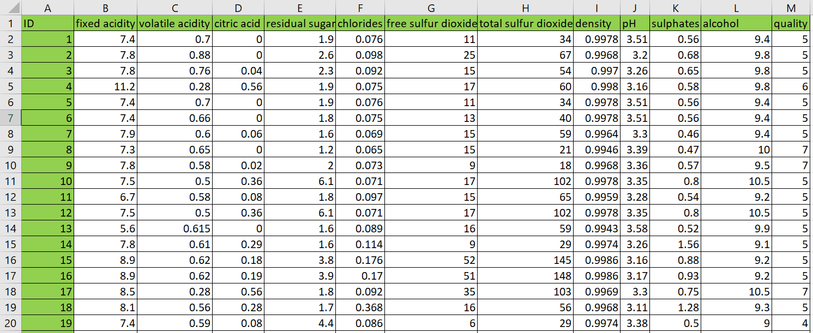
Figure 1 Raw dataset structure (11 physicochemical attributes + quality). Source: Author’s workbook, based on Cortez et al. (2009).
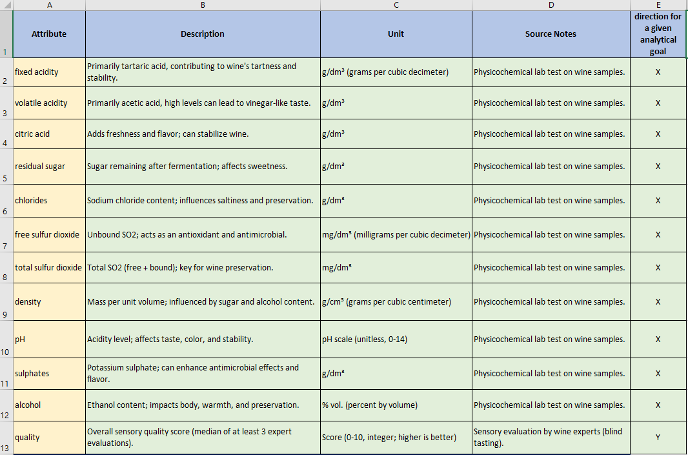
Figure 2 Attribute definitions used in the OAM model. Source: Author’s compilation based on dataset documentation (Cortez et al., 2009).

3.2. Object–Attribute Matrix Construction
“The object–attribute modeling approach follows structured system modeling principles.” (Ludwig von Bertalanffy, 1968).
The dataset subset was transformed into an Object–Attribute Matrix (OAM) format where rows represent wine samples (objects) and columns represent physicochemical properties (attributes). An excerpt of the implemented OAM is shown in Figure 3. This matrix representation enables deterministic transformations and comparisons between objects while preserving traceability back to raw inputs.
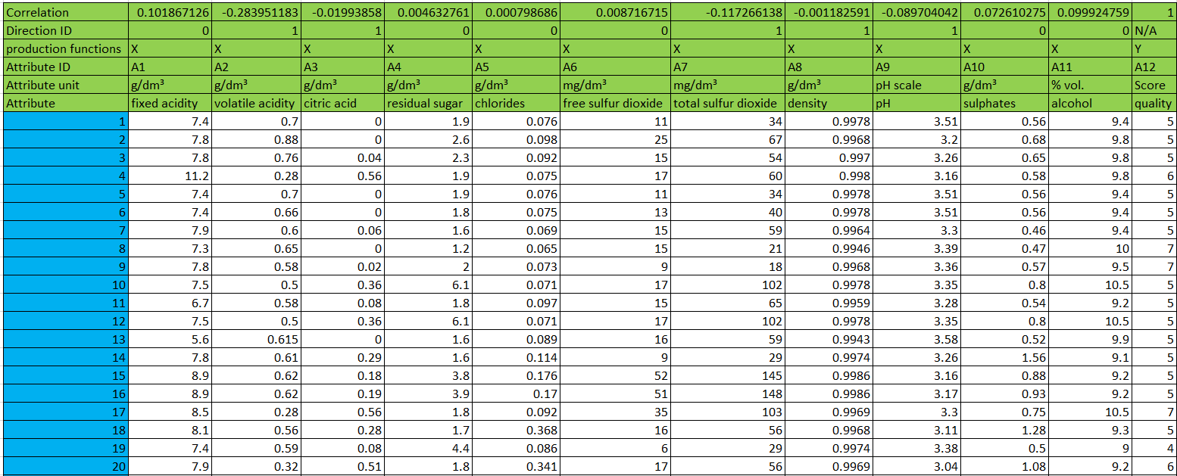
Figure 3 OAM excerpt: objects (wines) and attributes (physicochemical variables) with Fact (quality). Source: author’s workbook.
To support later ranking logic, correlations between each attribute and the expert quality score were computed, and a direction rule was derived from the sign of each correlation. These correlation formulas and direction IDs are implemented directly in the workbook Figure 4 to ensure that later transformations consistently apply “higher-is-better” versus “lower-is-better” logic.
Figure 4 Correlations vs Fact and derived direction flags for attribute ranking. Source: author’s workbook.

3.3. Structured Estimation Logic
“Distance-based similarity measures are standard tools in data mining and pattern recognition.” (Jiawei Han et al., 2011).
Han, Kamber, and Pei (2011) note that distance-based similarity measures are standard tools in data mining and pattern recognition. In the present thesis, this general methodological background is adapted into a structured estimation framework in which wine samples are compared through deterministic attribute transformations rather than through raw-value comparison alone.
Because physicochemical attributes differ substantially in scale and measurement range, direct comparison of raw values would distort the analytical process. To address this problem, the workflow applies rank-based transformations that convert each attribute into a comparable ordinal representation. This approach preserves the relative ordering of wine samples while reducing sensitivity to raw-scale differences across attributes.
The workbook implements multiple transformation logics (A1–A12) as competing estimation procedures. Each logic represents a distinct but deterministic way of transforming and aggregating the attribute information for the purpose of deriving estimated wine-quality outputs. An excerpt of these rank-based columns and the resulting Estimation column is shown in Figure 5, including the formula-level implementation visible in the formula bar.
Key implication. Rank-based transformations support comparability across heterogeneous attributes while maintaining a deterministic mapping from raw inputs to estimation outputs. As a result, alternative estimation logics can be implemented transparently, recalculated consistently, and compared in a structured way within the broader Object–Attribute Matrix and COCO-STD-based evaluation framework.
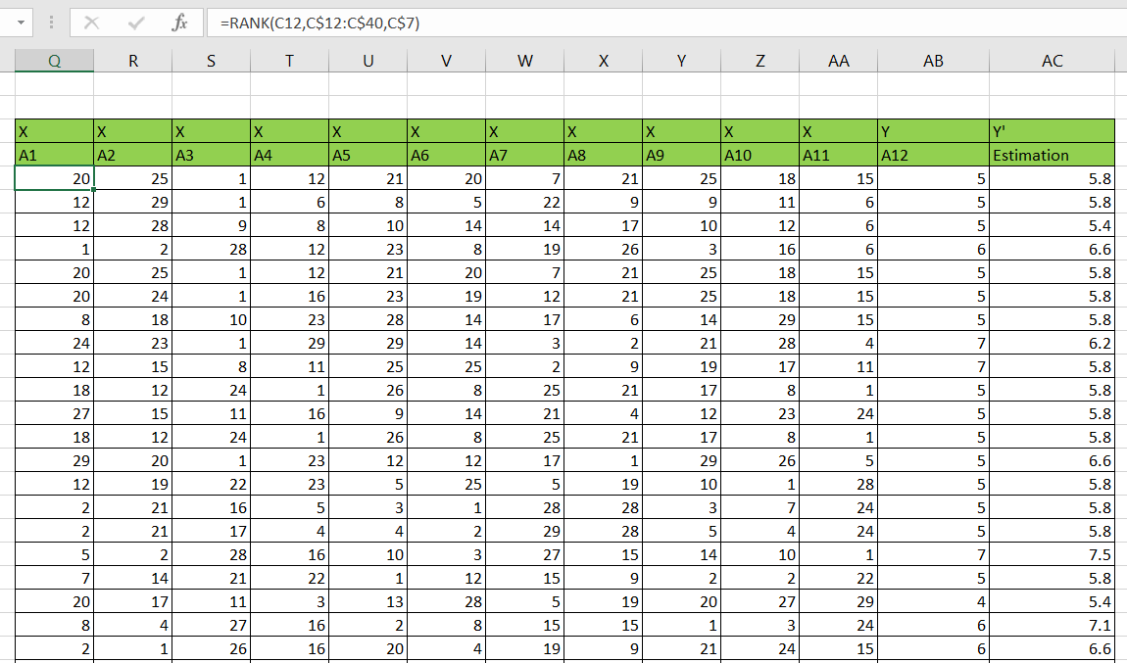
Figure 5 Rank-based transformation (A1–A12) and Estimation column with example Excel formula. Source: Author’s workbook.

3.4. KPI Structure
Correlation is widely used to evaluate linear association between predicted and observed values (Moore, McCabe & Craig, 2017). “Correlation measures the strength and direction of the linear relationship between two quantitative variables.” (David S. Moore et al., 2017).
In order to evaluate estimation performance, the workbook computes several quantitative goodness indicators comparing Fact (expert quality) and Estimation (computed score). These indicators include both correlation-related consistency measures and deviation-based measures, since a meaningful assessment requires attention to both directional alignment and numerical difference.
The primary deviation measure is defined as:
Delta V = Fact – Estimation
In addition, a ratio-based indicator is computed in order to standardize deviation relative to the Fact value.
Ratio = (Delta V / Fact) × 100
Together, these KPI elements provide the quantitative basis for evaluating the behavior of the competing estimation logics. They are visible in the implemented output sheets (Figures 6–7) and serve as evidence inputs for the subsequent COCO-STD-based comparison. In the prototype phase, Excel-based correlation support functions were also relevant for operationalizing selected KPI calculations (Microsoft Support, n.d.).
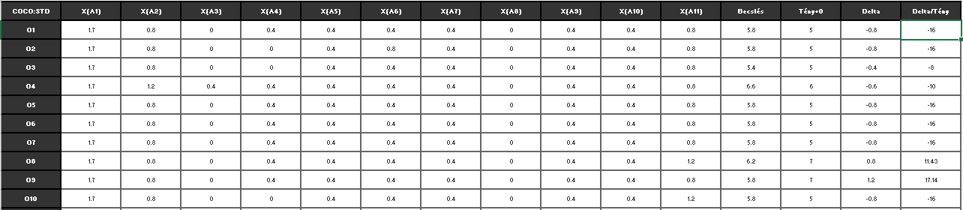
Figure 6 COCO output excerpt: Estimation vs Fact and deviation indicators (Delta, Delta/Tény). Source: Author’s workbook.
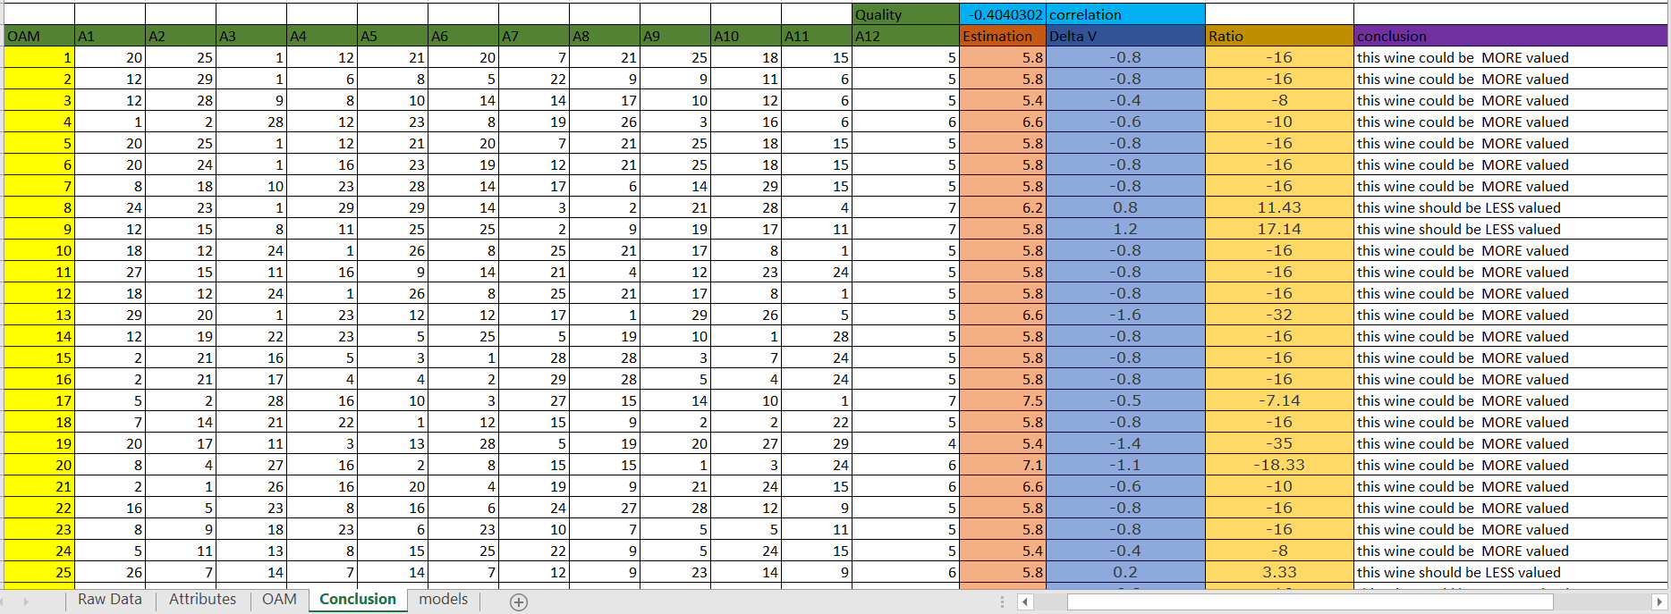
Figure 7 Decision-support output derived from Delta/Tény (“MORE valued / LESS valued”). Source: Author’s workbook.

3.5. COCO-STD Indicator
“Multi-criteria ranking supports objective model comparison.” (Saaty, 1980).
Structured ranking supports objective comparison among alternative evaluation logics when multiple criteria and outputs must be interpreted jointly. In the present thesis, COCO-STD is used as the main summary indicator for this purpose. COCO-STD is computed from the rank-based comparison matrix generated for each competing estimation logic (A1–A12). The corresponding COCO input matrix and the applied configuration parameters, as implemented in the workbook, are documented in the models sheet and illustrated in Figure 8. Within this thesis, COCO-STD is interpreted as a COCO-based standard analysis (production function generating) similarity/consistency indicator used to compare competing estimation logics. The resulting COCO-STD values provide a comparable consistency-oriented signal across alternative estimation constructions. At the same time, the KPI tables shown in Figures 6–7 provide supporting evidence through correlation-related and deviation-based indicators. In this way, the evaluation does not rely on any single isolated metric. Instead, COCO-STD functions as the main summary indicator within a broader quantitative assessment framework. This combined interpretation ensures that no single KPI dominates evaluation and enables structured selection of the most consistent estimation logic.
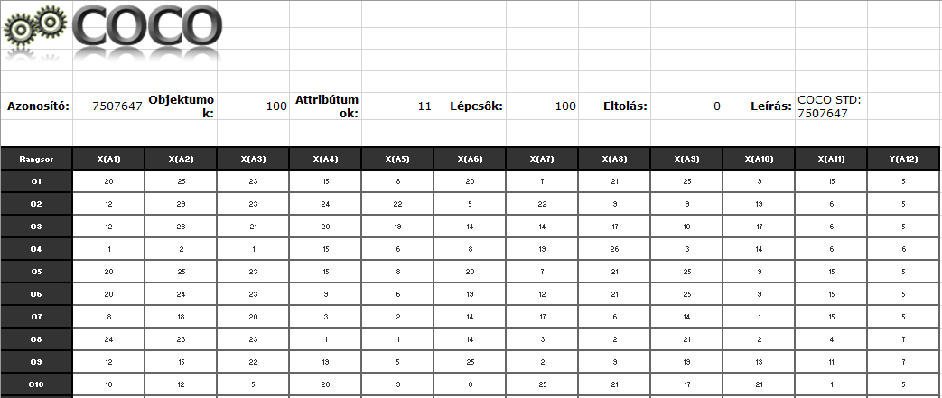
Figure 8 COCO input matrix and COCO STD configuration (100 objects, 11 attributes, 100 steps). Source: Author’s workbook.

3.6. Interpretation of Deviations
The workbook translates numerical deviation into a deterministic interpretation rule based on the relationship between Fact and Estimation.
If Delta/Tény < 0, the output is: “This wine could be MORE valued.”
If Delta/Tény ≥ 0, the output is: “This wine should be LESS valued.”
The implemented decision-support output is shown in Figure 7, including the exact Excel IF rule used to generate the conclusion label. This interpretation does not claim that the expert-assigned rating is incorrect. Instead, it identifies systematic divergence cases between Fact and Estimation as review candidates within the concept-testing framework.

3.7. Automation and Reproducibility
In the final implementation, the analytical workflow is executed by a Python-based web application (Streamlit., n.d.) instead of manual, sheet-based Excel operations. The application enforces a fixed wine schema (11 physicochemical input attributes + quality) and runs the complete pipeline end-to-end from a single raw dataset upload:
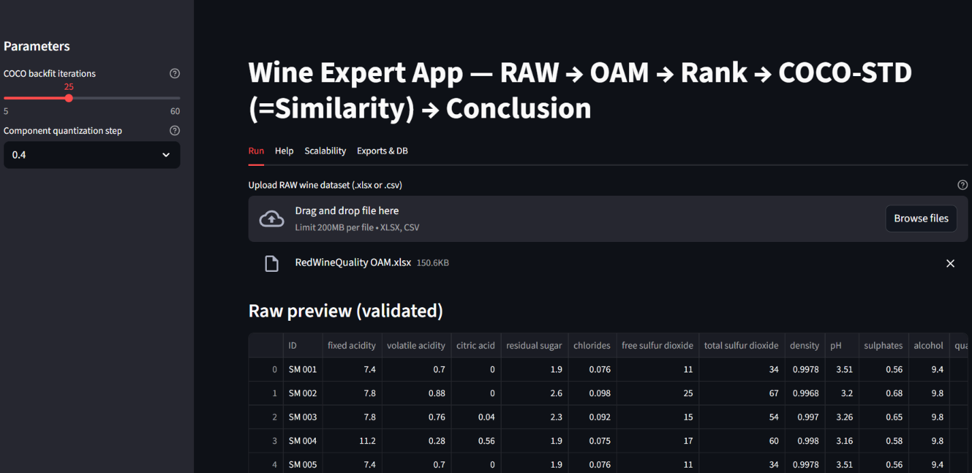
Figure 9. Web application run screen with fixed wine schema validation and parameterized execution. Source: Author’s application.
Reproducibility is ensured in two complementary ways:
- Deterministic execution: for the same input dataset and the same parameters (e.g., backfitting iterations, quantization step), the produced outputs are identical.
- Run-level traceability (structured storage): each execution is recorded as a distinct run with a unique run_id (UUID) and persisted in:
  - an SQLite database (runs.sqlite) containing run metadata and result rows, and
  - a per-run export folder (runs/<run_id>/) containing the generated tables and export packages.
The application contains two complementary execution modes: the Run mode always processes the complete uploaded dataset (no hard row limit), whereas the Scalability mode intentionally samples a user-defined number of objects to measure runtime behavior under controlled sizes. This design provides auditability (every output can be linked to its exact input dataset and parameter setting), repeatability (the run can be repeated later using the same configuration), and explainability (the pipeline steps are explicit and visible to the user). The modular separation of data loading, schema enforcement, OAM generation, rank transformation, COCO-STD computation, and conclusion logic follows the software engineering principles introduced earlier in the thesis.
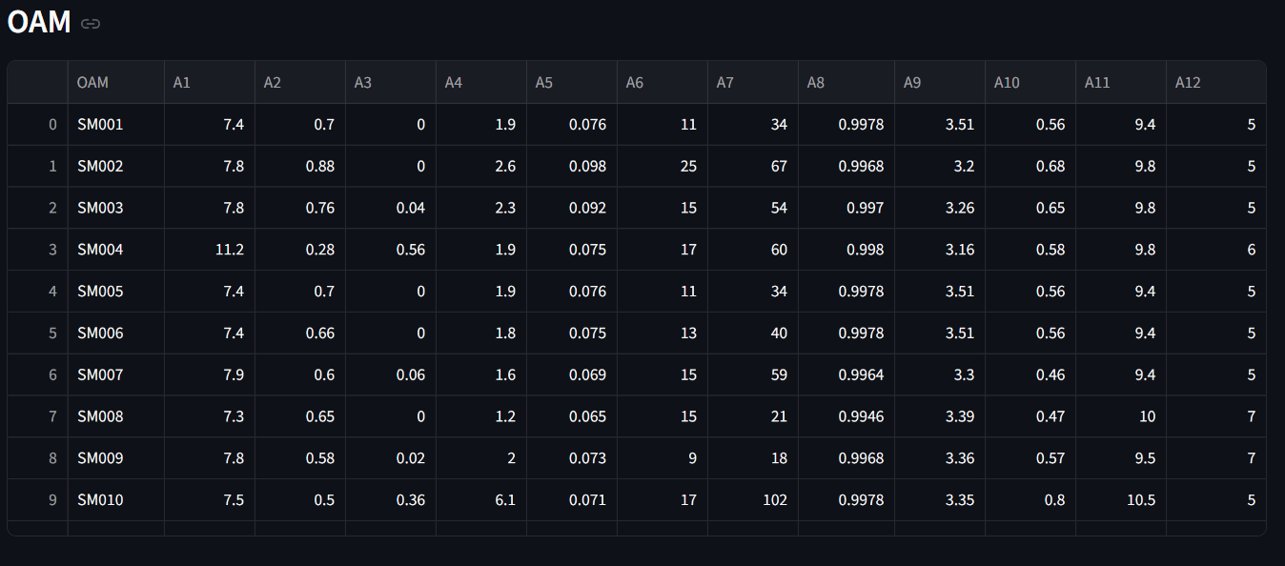
Figure 10 Automatically generated OAM table (A1–A12) from the uploaded raw wine dataset. Source: Author’s application.
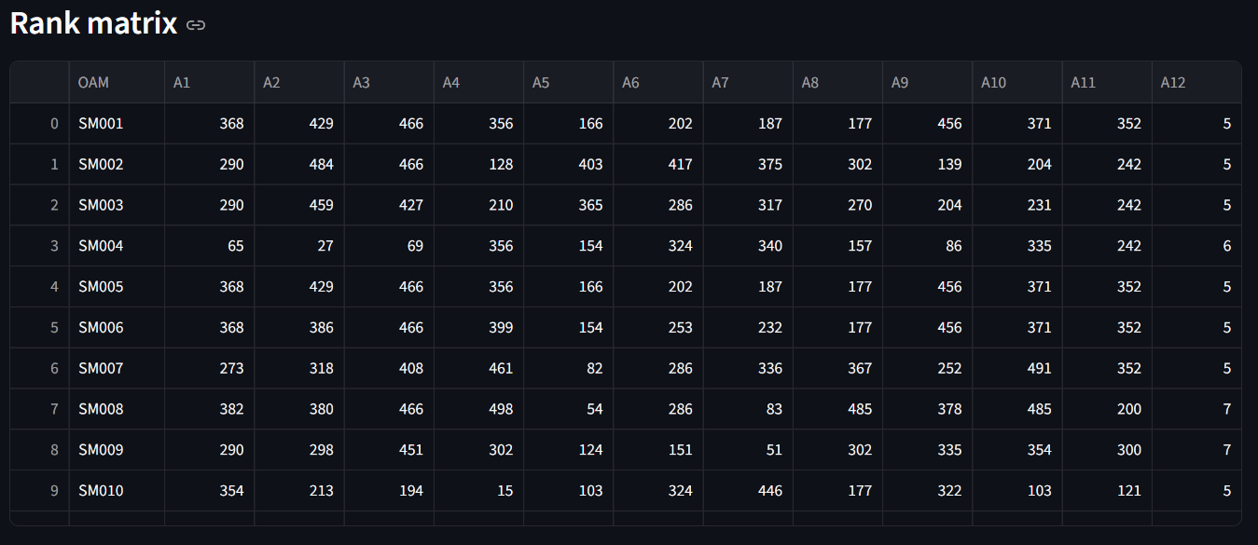
Figure 11 Rank matrix produced from OAM values according to attribute direction rules (COCO-STD input). Source: Author’s application.
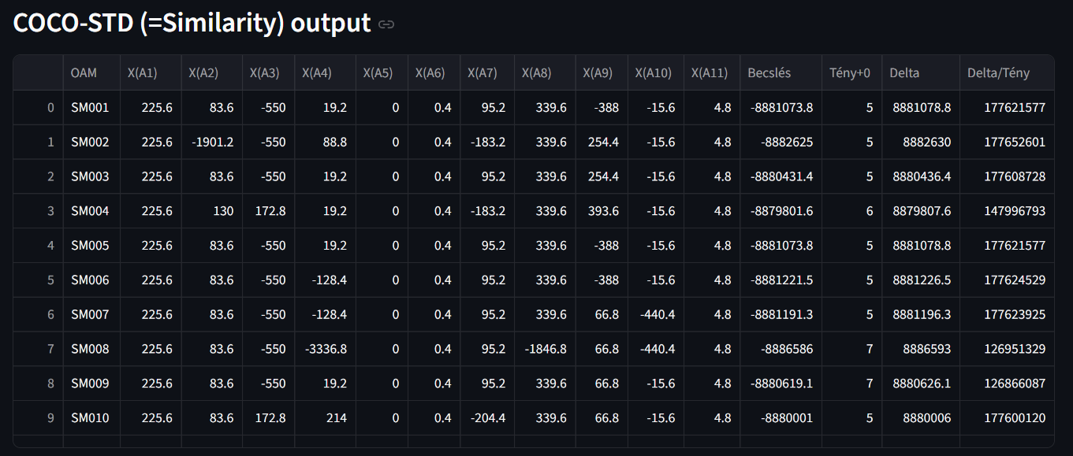
Figure 12 COCO-STD output (similarity space) and deviation-based conclusions (Δ, Δ%, validation). Source: Author’s application.
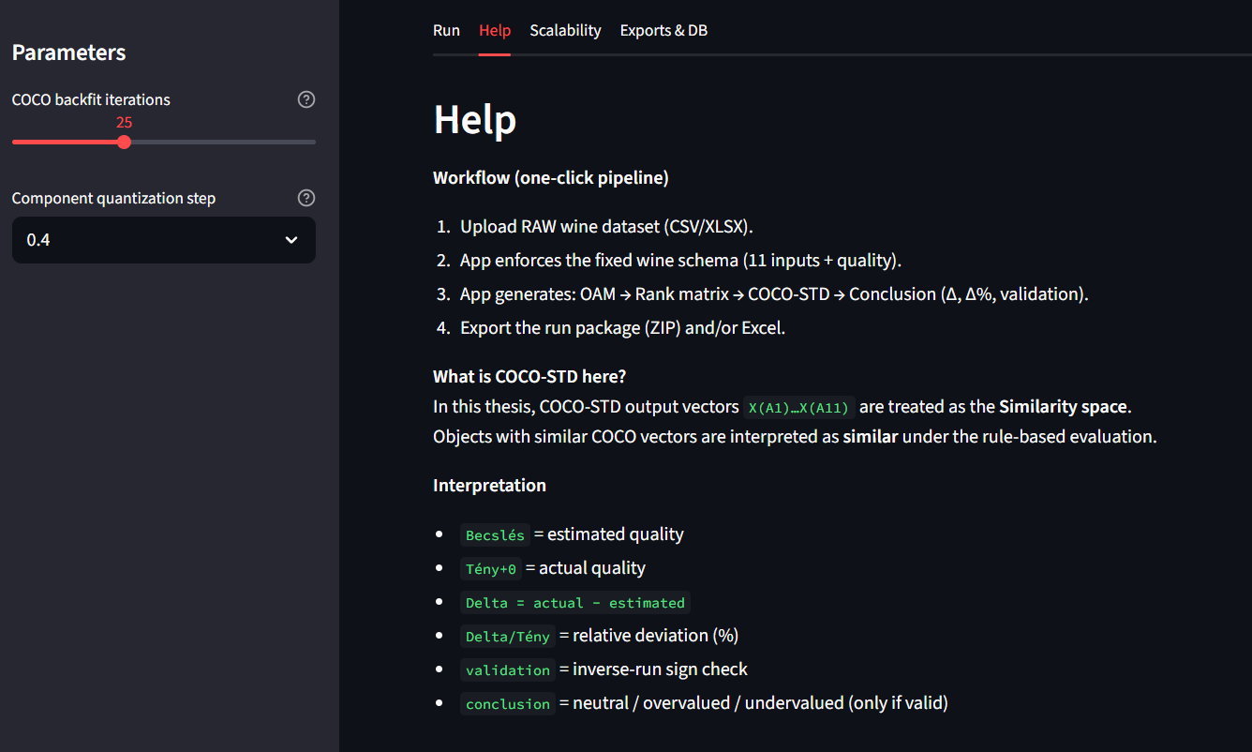
Figure 13 Built-in Help section providing step-by-step usage and interpretation guidance. Source: Author’s application.
Minimal database schema (SQLite). The database implements a minimal but compliance-ready structure:
- runs: one row per run (timestamp, dataset name/hash, object count, parameter JSON, runtime, status/error).
- Coco std: per-object outputs (estimation, actual, delta, delta%, validation, conclusion) to support later queries.
- exports: file-based artifacts (CSV/XLSX/ZIP paths) linked back to run_id.
This is sufficient to prove structured storage, reproducibility, and data-mining readiness.
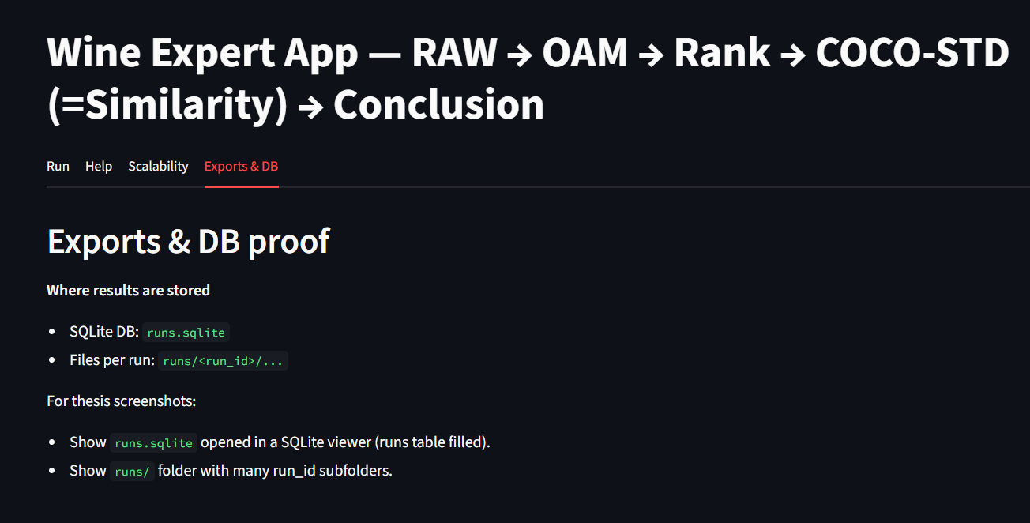
Figure 14 Reproducibility evidence: per-run export package stored under runs/<run_id>/ and logged in runs.sqlite. Source: Author’s system.

3.8. Testing Aspects
Testing was performed in order to ensure the correctness, stability, and reliability of the implemented automated pipeline. The main objective was to prevent silent errors that could arise if intermediate stages of the workflow, such as OAM generation, rank transformation, COCO-STD computation, and conclusion generation, became inconsistent, incomplete, or mismatched.
The testing process covered three main layers. First, computation-integrity tests verified that OAM values, rank values, and COCO-STD outputs were generated for all processed objects without missing blocks, and that the key columns, including A1–A12, Estimation, Delta, and Delta%, remained numerically valid throughout execution. Second, cross-stage consistency checks ensured that the rank matrix was derived from the same OAM object set and that the COCO-STD results corresponded to the same run_id dataset, thereby preventing mismatched intermediate artifacts. Third, stability and sensitivity checks were performed by introducing selected input perturbations in order to observe whether the outputs changed in a controlled and interpretable manner. For example, modifying one attribute should affect the derived ranks and COCO-STD results consistently rather than causing unrelated shifts elsewhere in the workflow.
In addition to internal testing, real-life testing was carried out by simulating a non-developer user workflow aligned with the application’s Help guidance. This scenario consisted of four steps: (i) uploading a new raw dataset file, (ii) validating the schema against the mandatory wine attributes, (iii) executing the full pipeline from OAM construction through ranking and COCO-STD evaluation to the final conclusion block, and (iv) exporting result packages for reporting and later analysis.
The acceptance criteria were defined as follows. Determinism required that the same input data and parameter settings always produce the same outputs. Completeness required that all promised outputs be generated, including the OAM table, rank matrix, COCO-STD results, and conclusion block. Usability required that a non-developer user be able to execute the workflow on the basis of the built-in Help section without external assistance. Safe failure behavior required that negative test cases involving missing columns, invalid data types, or corrupted files terminate safely with explicit error messages and without producing partial or misleading outputs.
Taken together, these tests reduce the likelihood that deviations between Estimation and expert-assigned quality arise from implementation artifacts. Accordingly, the remaining differences can be interpreted more confidently as consequences of the applied model logic and rule system rather than as technical errors in the workflow.
What is the evidence, that all these testing steps are really realized?

3.9. AI-Related Support and Boundaries
AI-related considerations appear in this thesis only at a supplementary level and not as the core methodological engine of the analysis.
First, the implemented analytical workflow operates on structured object–attribute data and applies explicit rule-based transformations in order to derive estimations and evaluation outputs. Although such structured computational processing may be discussed in a broader AI-related context, the present thesis does not treat the Object–Attribute Matrix, the competing estimation logics, or the COCO-STD-based evaluation as artificial-intelligence methods in themselves. Their role is to provide a transparent, deterministic, and reproducible analytical framework for approximating expert-assigned wine-quality judgments.
Second, Large Language Models (LLMs) may be used as supplementary interpretative tools in order to explain outputs in human-readable form, for example by summarizing deviations or clarifying the meaning of validation-related labels. However, the LLM layer does not generate the primary numerical estimations, does not construct the OAM, and does not compute the quantitative indicators applied in the evaluation. All core analytical results remain grounded in explicit computational procedures, including Delta, Delta%, and COCO-STD-based comparison logic.
Accordingly, AI-related elements in this thesis should be understood as supportive and explanatory rather than as primary evaluative mechanisms. The scientific contribution of the work lies in the structured analytical framework itself, namely the Object–Attribute Matrix representation, the competing estimation logics, the automated pipeline, and the COCO-STD-based evaluation of alternative outputs.
We need a benchmark solution from one or more LLM! The same goals/tasks should be formulated as a GOOD prompt, and the LLM-output should be compared with the own solution. Are you really better?

3.10 IT Security, Quality Assurance, and Responsibility Aspects
Although the dataset used in this thesis is public and contains no personal or sensitive information, secure workflow design remains relevant. The implemented application operates in a controlled environment and stores results locally in an SQLite database together with local export folders. This design reduces the risks associated with uncontrolled external processing and supports traceability and auditability. Security-relevant measures include separation of concerns, explicit run logging, controlled failure behavior, and the absence of confidential data transfer in the present experimental setting.
Raw input is transformed into derived outputs, including Object–Attribute Matrix tables, rank matrices, COCO-STD results, and conclusion blocks, without overwriting the original source data. Each run is recorded together with a dataset hash and parameter set, thereby supporting reproducible verification and helping to prevent undetected changes in outputs across repeated executions. Invalid inputs are rejected with explicit error messages so that no partial or misleading outputs are produced. Since the present setup does not involve personal data, no confidential data transfer is required within the current computational workflow.
Beyond these technical aspects, the solution must also be interpreted in terms of usefulness, risks, quality assurance, GDPR, warranty, and responsibility. Its practical usefulness lies in transforming raw physicochemical measurements into structured and reproducible decision-support outputs, including OAM representations, ranked comparisons, COCO-STD-based results, and deviation-oriented conclusions. The main practical benefit is prioritization: instead of manually re-checking every sample, experts can focus their attention on cases marked by substantial deviations or validation-relevant outcomes.
At the same time, several risks must be acknowledged. The most important risk is interpretative misuse, namely treating the outputs as a replacement for expert judgment rather than as structured support for that judgment. Further risks include incorrect conclusions caused by data-quality problems such as missing attributes, incorrect units, or inconsistent preprocessing, as well as overreliance on a single indicator. For this reason, the outputs should always be interpreted as a multi-criterion decision-support set combining Estimation, Delta, Delta%, and validation-oriented outputs, rather than as a single unquestionable truth.
Quality assurance is supported by deterministic computation, automated schema validation, structured run logging, and repeatable testing procedures. Each run stores metadata such as dataset hash, parameter set, timestamp, runtime, and execution status in order to ensure auditability and reduce the risk of silent drift across repeated executions. From a GDPR perspective, the applied red-wine dataset contains physicochemical measurements only and no personal data; therefore, no personal-data processing occurs in the present setup. Nevertheless, if the solution is extended in the future to human-related datasets, GDPR-relevant processes such as purpose limitation, legal basis or consent management, retention and deletion rules, and access logging would need to be introduced.
Finally, the warranty and responsibility boundaries of the solution must also be made explicit. The tool provides decision-support outputs, rankings, and deviation indicators, but it does not guarantee sensory correctness and does not claim to replace certified expert evaluation. The author’s responsibility is limited to software correctness with respect to the documented specification, including schema enforcement, pipeline logic, and stored outputs. Responsibility for the final domain decision, and for any business action based on that decision, remains with the human expert user and the commissioning organization.

3.11. Help section
The software includes a dedicated Help function that supports users in two complementary ways:
(i) through a user manual providing step-by-step execution and interpretation guidance, and
(ii) through contextual help elements, such as short tooltips and explanatory notes placed near parameters and key outputs.
The Help section explains the input requirements, including the mandatory wine attributes, and describes the main stages of the analytical pipeline, namely Object–Attribute Matrix generation, ranking, COCO-STD-based evaluation, and conclusion generation. It also clarifies the safe interpretation boundaries of the system by emphasizing that the application provides decision-support outputs rather than domain-final judgments.
Evidence for the availability and practical use of the Help function is provided through screenshots and through the interface of the deployed application.

3.12 Scalability and Run Volume Evidence
To demonstrate that the implemented pipeline is not limited to a single demonstration run, scalability testing was executed using the application’s built-in batch-run mode. The purpose of this experiment is to provide measurable evidence that (i) the workflow can be executed repeatedly without manual intervention, (ii) each run is persistently logged for auditability, and (iii) runtime scales in a controlled way with the number of processed objects.
The scalability evaluation uses controlled sampling sizes N selectable by the user in the Scalability tab (100, 250, 500, 1000, 1500). This sampling does not represent a limitation of the solution; it is a deliberate experimental design to compare runtimes under comparable object counts. In contrast, the Run tab processes the complete uploaded dataset after schema enforcement, i.e., n_objects = len(raw), without downsampling.
In the executed batch-run experiment reported here, three dataset sizes were tested (N = 100, N = 250, N = 500) with 10 repetitions per size, resulting in 30 successful runs in total. For each run, the application generates a unique run_id, records runtime_sec (in seconds) and status into the SQLite database (runs.sqlite) (SQLite., n.d.), and preserves the generated artifacts under runs/<run_id>/. This ensures that the reported scalability results are directly verifiable from the database and the exported run folders.
Runtime evidence is presented in two forms. First, Figure 15 lists the run-level execution log, including dataset size, repetition index, runtime in seconds, status, and run identifier. Second, Figure 16 aggregates the logged runs by size and reports the runtime statistics: for N = 100, the mean runtime is 6.0381 s and the maximum runtime is 6.3808 s; for N = 250, the mean runtime is 5.9760 s and the maximum runtime is 6.3207 s; and for N = 500, the mean runtime is 6.3143 s and the maximum runtime is 6.7881 s. The same summary confirms that the number of failures is 0 for all tested sizes, and the runtime trend is visualized to illustrate how processing time behaves as N increases.
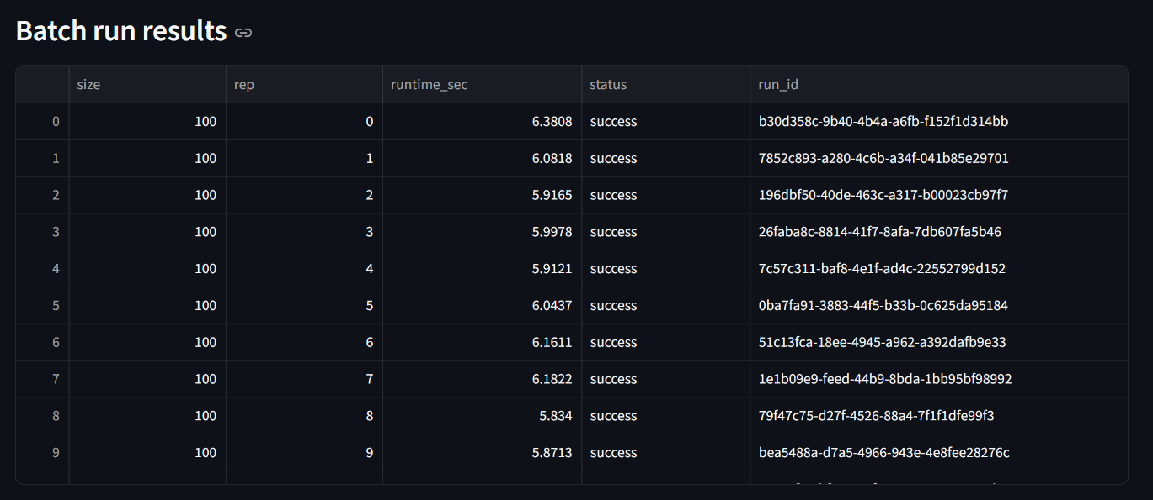
Figure 15 Batch-run execution results across multiple dataset sizes (run_id and runtime recorded). Source: Author’s application.
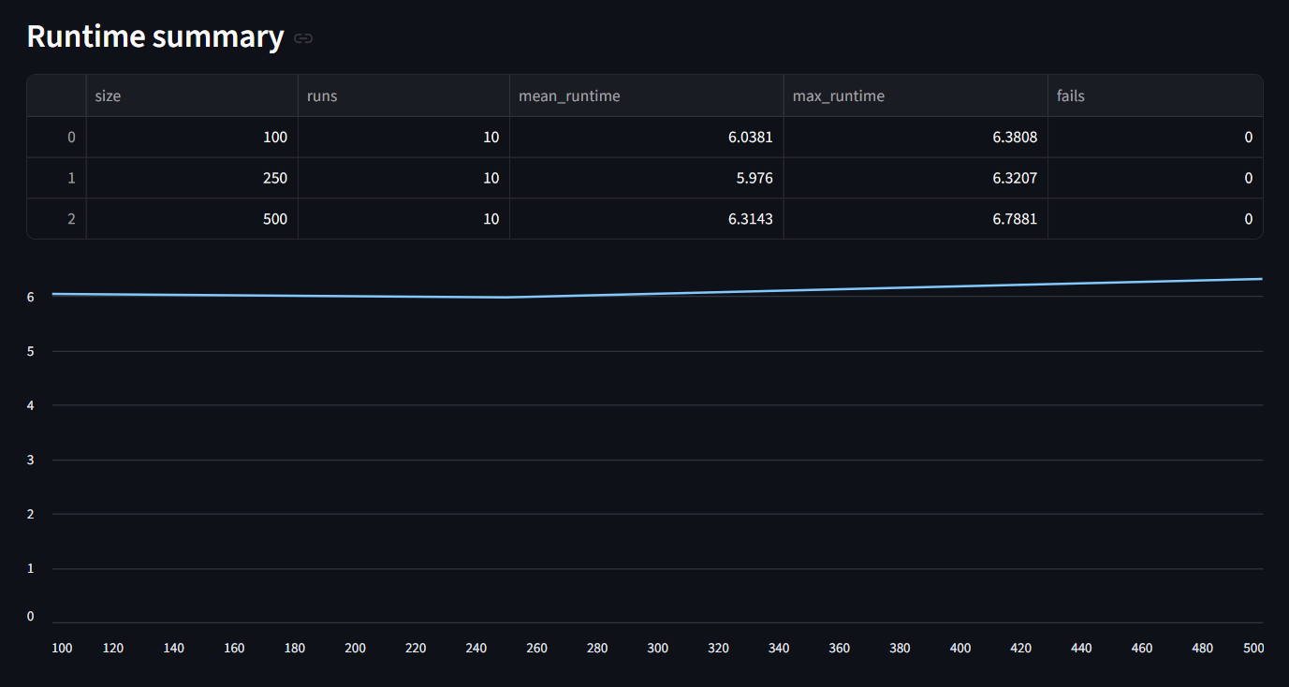
Figure 16 Runtime scaling summary (mean/max runtime and failures) with runtime trend by dataset size. Source: Author’s application.

3.13 Summary of Own Developments
The original development contribution of this thesis is an automated and reproducible analytical pipeline that transforms raw wine measurements into structured evaluation outputs. The implemented workflow combines fixed-schema validation, Object–Attribute Matrix construction, rank-based transformation, COCO-STD-based evaluation, deviation interpretation, and structured run logging within a single end-to-end system.
More specifically, the workflow performs the following steps:
- enforcing a fixed wine schema and validating the uploaded raw input,
- transforming the validated data into an Object–Attribute Matrix representation,
- generating the rank matrix required for COCO-STD processing,
- computing COCO-STD-based outputs, including the estimation-related result space,
- producing deviation-based conclusions, including Delta, Delta%, validation-related outputs, and classification, and
- storing the results through structured run logging in SQLite together with export packages such as CSV, XLSX, and ZIP files in order to support traceability, auditability, and scalability evidence.
This integrated design converts a raw dataset into an end-to-end decision-support output while maintaining transparency, deterministic computation, and run-level traceability. In this sense, the thesis contribution is not limited to a theoretical analytical concept, but also includes a functioning software implementation capable of executing the proposed workflow in a controlled and verifiable way.<--justified? Row-height?

Chapter 4. Discussions
This chapter interprets the empirical findings presented in Chapter 3 and evaluates the implications of the developed analytical framework in the context of expert wine-quality assessment. The discussion focuses on methodological validity, the role of COCO-STD-based evaluation, the interpretation of deviation signals, economic implications, methodological strengths, limitations, and the broader concept-testing perspective of the thesis.

4.1. Interpretation of Fact–Estimation Alignment
“Model validation through correlation and error analysis is standard practice in predictive modeling” (Gareth James et al., 2013).
the core analytical objective was to examine whether structured estimation logic can approximate expert-assigned wine-quality ratings under a consistent multi-metric verification framework.
The correlation-related and deviation-based KPIs indicate that measurable alignment exists between computed estimations and expert-assigned ratings. Although perfect replication was neither expected nor observed, the structured deviations suggest the presence of systematic tendencies rather than random noise.
The occurrence of both positive and negative Delta values indicates that the applied estimation logic does not uniformly overestimate or underestimate wine quality. Instead, the deviations appear selectively, which suggests that the model captures meaningful parts of the evaluative structure reflected in expert judgment, while still preserving visible differences between analytically derived outputs and sensory evaluation.
This supports the interpretation that the implemented framework provides a partial but meaningful computational approximation of expert judgment rather than a full replacement of expert wine evaluation.

4.2. Role of COCO-STD in Verification
The COCO-STD indicator plays a central role in the verification framework by summarizing the stability and consistency of results produced by the competing estimation logics. It complements pointwise KPIs such as correlation and deviation by providing a compact summary signal that can be compared across alternative estimation procedures.
Within this thesis, COCO-STD is understood as a COCO-based standard analysis (production function generating) similarity/consistency indicator used to compare competing estimation logics. Its methodological importance lies in the fact that it supports structured comparison when multiple outputs and performance indicators must be interpreted jointly.
In this way, COCO-STD enables:
- multi-indicator evaluation,
- comparative ranking of estimation logics, and
- structured verification of consistency across alternative procedures.
By operationalizing comparison in this manner, COCO-STD reduces arbitrariness in model selection. The framework therefore ensures that the evaluation of estimation logic is not based on a single isolated performance measure, but on a coherent set of quantitative evidence. This methodological layer strengthens transparency and supports the concept-testing orientation of the thesis.

4.3. Interpretation of Overvaluation and Undervaluation Signals
The qualitative interpretation rule introduced in Chapter 3, namely “could be MORE valued” versus “should be LESS valued,” should not be understood as a direct correction of expert-assigned wine ratings. Rather, it identifies cases in which the structured analytical output diverges from the assigned quality value.
Such divergences may arise for several reasons. First, sensory evaluation may involve nonlinear interactions that are not fully captured by the applied estimation logic. Second, contextual factors influencing expert judgment may not be represented in the physicochemical dataset. Third, expert evaluation itself may contain subjective variation that cannot be fully reconstructed through structured analytical rules.
Accordingly, the flagged cases should be interpreted as decision-support signals rather than as categorical corrections. Their practical function is to identify review candidates and thereby support a more focused and structured reconsideration process by human experts.

4.4. Economic Implications and Informational Added-Value
“Decision-support automation aims to improve efficiency without replacing expert judgment”(Daniel J. Power, 2002).
the numerical estimation presented in Chapter 1.4 indicates that the automated analytical framework can generate measurable efficiency gains in recurring quality-review workflows.
For an evaluation involving 100 samples, the benchmark cost was estimated at 835 EUR, whereas the automated analytical scenario was estimated at 600 EUR. This results in an estimated informational added-value of 235 EUR, corresponding to an efficiency improvement of approximately 28%.
The added-value arises primarily from three factors:
- automated execution of the analytical workflow,
- automated computation of KPI elements and COCO-STD-related outputs, and
- immediate identification of deviation cases requiring expert attention.
When the same logic is scaled to larger datasets, the cumulative efficiency gain becomes more substantial. For 1,000 samples, the estimated added-value reaches approximately 2,350 EUR.
Importantly, this economic benefit does not depend on replacing human expertise. Rather, it arises from a more targeted allocation of expert attention to analytically flagged cases. In this sense, the developed framework enhances expert productivity while preserving evaluative responsibility at the human level.

4.5. Methodological Strengths
First, the Object–Attribute Matrix ensured transparency in data representation and supported a traceable transformation from raw input data to structured analytical outputs.
Second, the workflow was implemented in a reproducible prototype-and-application form. The Excel-based prototype supported formula-level validation and transparent inspection of intermediate calculations, while the final Streamlit application enabled repeatable execution, run logging, structured export generation, and practical usability.
Third, the combined use of estimation logic, KPI analysis, and COCO-STD-based evaluation created a coherent multi-indicator verification framework. This reduced the risk that evaluation would depend excessively on any single isolated metric.
Fourth, the modular design of the implemented solution supports further extension to other domains in which expert judgment is based on measurable structured attributes and where transparent decision-support workflows are required.

4.6. Limitations
First, the implemented estimation framework assumes that measurable physicochemical attributes can represent at least part of the structure underlying sensory wine quality. However, wine evaluation may also include experiential, contextual, and perceptual components that are not captured in the available dataset.
Second, the structured evaluation was carried out on a limited subset of observations. Although this was sufficient for controlled concept testing, broader datasets and additional experiments would strengthen the robustness and generalizability of the findings.
Third, the analytical results depend on the selected transformation and evaluation logic. Even though multiple competing estimation logics were compared, the framework still remains method-dependent, and alternative analytical constructions may yield different outputs.
Fourth, any supplementary AI-related interpretative support remains external to the numerical core of the method. Such support may help explain results in human-readable form, but it does not replace explicit quantitative verification.
Taken together, these limitations indicate that the developed framework should be interpreted as a structured decision-support enhancement rather than as a definitive expert-replacement system.

4.7. Concept-Testing Perspective
From a concept-testing perspective, the thesis demonstrates that a structured estimation framework, when evaluated through complementary goodness criteria and COCO-STD, can partially approximate expert judgment in the domain of wine-quality assessment.
The interpretation of KPI results transforms a traditionally subjective evaluation problem into a measurable verification logic. In this way, the thesis does not claim to reproduce sensory expertise in its entirety. Instead, it shows that selected components of expert reasoning can be represented, processed, and evaluated under explicit analytical rules.
The findings therefore support the hypothesis that expert wine evaluation contains measurable structural components that can be computationally approximated under controlled conditions. This result is important because it shows that expert-oriented decision-support can be grounded in transparent analytical procedures rather than in opaque or purely impressionistic reasoning alone.

Chapter 5. Conclusions

5.1 Conclusion on Fact–Estimation Alignment
This thesis confirmed that structured estimation logic can approximate expert-assigned wine-quality ratings to a measurable extent. Correlation-related and deviation-based indicators showed that physicochemical attributes capture a substantial part of the evaluative structure reflected in expert ratings. Although perfect replication was neither expected nor achieved, the observed alignment supports the assumption that wine expertise contains measurable and partially reproducible components.

5.2 Conclusion on the Role of COCO-STD
The COCO-STD indicator proved to be a useful verification element within the proposed framework. It provided a compact consistency-oriented summary signal that supported the structured comparison of competing estimation logics (A1–A12). Within this thesis, COCO-STD is understood as a COCO-based standard analysis (production function generating) similarity/consistency indicator used to compare competing estimation logics. In combination with correlation-related and deviation-based KPIs, COCO-STD strengthened objectivity by ensuring that evaluation was not based on a single isolated performance measure, but on a multi-criterion verification logic.

5.3 Conclusion on Overvaluation and Undervaluation Signals
The qualitative interpretation layer demonstrated that the framework can identify structured deviations between computed estimations and expert-assigned ratings. These signals should not be interpreted as direct corrections of expert judgment, but rather as decision-support indicators highlighting cases that may require further review. In this sense, the system supports structured expert reconsideration instead of replacing human expertise.

5.4 Conclusion on Economic Implications and Informational Added-Value
The numerical estimation of informational added-value indicated measurable efficiency gains. Under conservative assumptions, the developed analytical framework reduced evaluation cost by approximately 28% per 100 wine samples, corresponding to an estimated efficiency improvement of 235 EUR. The main economic value of the system lies in the targeted allocation of expert attention to analytically flagged cases, thereby improving efficiency without eliminating expert involvement.

5.5 Conclusion on Methodological Strengths
The presented approach demonstrated several methodological strengths. The Object–Attribute Matrix ensured transparency in data representation, while the structured workflow enabled reproducibility and traceability of analytical steps. The combined use of competing estimation logics, KPI analysis, and COCO-STD-based evaluation created a coherent multi-indicator validation framework. In addition, the modular workflow design makes the approach extendable to other domains in which expert judgment is based on measurable structured attributes.

5.6 Conclusion on Limitations
At the same time, several limitations must be acknowledged. The implemented framework assumes that measurable physicochemical attributes can adequately represent at least part of expert sensory evaluation, although experiential and contextual factors may remain outside the dataset. The structured concept-testing part was demonstrated on a 100-sample subset, which limits direct generalizability. In addition, any LLM-related interpretative support remains auxiliary and does not replace explicit quantitative validation. These limitations confirm that the framework should be understood as a decision-support enhancement rather than as a definitive expert-replacement system.

5.7 Overall Concept-Testing Conclusion
Overall, the thesis confirmed that wine expertise can be partially approximated through structured Object–Attribute Matrix modeling, competing estimation logics, and COCO-STD-based verification. Human sensory judgment remains indispensable, but computational modeling can reveal systematic patterns embedded in expert evaluation under controlled conditions. The research therefore contributes to the broader field of concept testing and decision-support systems by demonstrating that measurable attributes, when organized and evaluated systematically, can support the partial approximation of complex expert reasoning in a transparent and reproducible analytical framework.

Chapter 6. Future Research Directions

Chapter 6. Future Research Directions
The results of this thesis indicate several directions for future research. First, the analysis could be extended to a larger dataset. The present concept-testing exercise was carried out on a structured subset of 100 wine samples, while application to a broader sample would improve robustness and allow more stable observation of correlation and deviation patterns.
Second, additional competing estimation logics could be developed and compared. Although the thesis evaluated multiple alternatives, further research could examine different normalization strategies, attribute-weighting schemes, or modified transformation rules within the same COCO-STD-based verification framework.
Third, the framework could be compared with other predictive approaches, including supervised machine-learning models. Such comparison would help clarify the relative strengths of the proposed structured estimation method in relation to alternative computational strategies.
Fourth, the interpretative support layer could be refined further. While any LLM-related usage in the present thesis remains supplementary, future work could examine how explanatory support can be improved without weakening the role of explicit quantitative verification.
Fifth, the framework could be tested in other application domains where expert judgment is linked to measurable attributes. This would help evaluate the broader transferability of the Object–Attribute Matrix and COCO-STD-based approach.
Finally, the estimation of informational added-value could be developed further through more detailed empirical cost analysis and productivity measurement.
Overall, future research may strengthen the present framework by expanding the dataset, refining the competing estimation logics, comparing alternative predictive methods, improving interpretative support, and exploring cross-domain applicability.

Chapter 7. Summary
This thesis investigated whether wine expertise can be computationally approximated through structured Object–Attribute Matrix modeling and COCO-STD-based evaluation. The research was motivated by the growing availability of structured datasets and by the practical need for transparent and reproducible decision-support methods.
The study used a publicly available red wine dataset containing physicochemical properties and expert-assigned quality ratings. A subset of 100 samples was selected for structured concept testing. The wine samples were organized in Object–Attribute Matrix form, thereby enabling systematic comparison across measurable attributes.
Rank-based components were constructed across the 11 physicochemical attributes (A1–A11), while A12 represented the expert-assigned quality score. The expert ratings were treated as Fact (Tény) and the computed output as Estimation (Becslés). To evaluate alignment between these two, the thesis applied quantitative goodness indicators. In the 100-sample subset, the overall correlation between Fact and Estimation was -0.4040, while deviation was assessed using Delta V and Ratio. COCO-STD served as the main summary indicator for interpreting the consistency of the ranked attribute structure and for comparing competing estimation logics.
The results demonstrated that the developed analytical framework captures measurable patterns embedded in expert wine evaluation. Although computational estimation does not fully replicate sensory judgment, it provides a structured approximation and highlights cases in which the computed estimation differs from the corresponding expert-assigned rating. These cases should be interpreted as decision-support signals for further review rather than as corrections of expert judgment.
A numerical estimation of informational added-value indicated that the structured analytical framework can reduce evaluation cost by approximately 28% per 100 wine samples under conservative assumptions. This demonstrates both methodological and economic relevance.
Overall, the thesis confirms that selected elements of wine expertise can be partially approximated through structured computational modeling when supported by explicit quantitative verification. The integration of Object–Attribute Matrix representation, competing estimation logics, COCO-STD-based evaluation, and an automated analytical pipeline provides a transparent, reproducible, and explainable framework for decision support in the context of wine-quality assessment. In the present thesis, any LLM-related support did not serve as a source of empirical accuracy, but only as a supplementary aid for interpretation and documentation.

Chapter 8. Annexes

8.1. Abbreviations
ACM – Association for Computing Machinery (as used in Communications of the ACM)
AI – Artificial Intelligence
BPM – Business Process Management
BPROF – Business Informatics / Computer Science Programme
COCO – Component-based object comparison for objectivity – anti-discriminative optimization
COCO-STD – COCO-based standard analysis (production function generating) similarity/consistency indicator used to compare competing estimation logics
CSV – Comma-Separated Values
DSS – Decision Support System
EUR – Euro
GDPR – General Data Protection Regulation
ID – Identifier
IF – Excel IF function (conditional rule)
IT – Information Technology
JSON – JavaScript Object Notation (parameter storage format)
KPI – Key Performance Indicator
LESS – Decision label: “should be LESS valued” (Δ/Tény ≥ 0)
LLM – Large Language Model
MORE – Decision label: “could be MORE valued” (Δ/Tény < 0)
OAM – Object–Attribute Matrix
QA – Quality Assurance
UCI – University of California, Irvine (UCI Machine Learning Repository)
UUID – Universally Unique Identifier
XLSX – Microsoft Excel Open XML Spreadsheet
ZIP – Compressed archive file format (export package)

8.2 Symbols and identifiers
Δ – Deviation between expert rating (Fact/Tény) and estimation (Estimation/Becslés), computed as
Δ=Fact−Estimation\Delta = \text{Fact} - \text{Estimation}Δ=Fact−Estimation
Δ% – Relative deviation (percentage form), computed as
Δ%=Δ/Fact\Delta\% = \Delta / \text{Fact}Δ%=Δ/Fact
Fact / Tény – The expert-provided reference value (ground truth in the concept-testing framework), i.e., the original wine quality rating.
Estimation / Becslés – The similarity-derived estimated value produced by the analytical workflow for comparison against Fact/Tény.
nobjectsn_{\text{objects}}nobjects​ – Number of processed objects (rows/samples) in a run; in Run mode nobjects=len(raw)n_{\text{objects}}=\mathrm{len}(\text{raw})nobjects​=len(raw).
NNN – User-selected sample size in the Scalability mode (controlled sampling size; e.g., 100/250/500/1000/1500).
run_id – Unique run identifier assigned by the application to each execution; used to link database records and exported artifacts.
rep – Repetition index within batch execution for a given dataset size NNN.
runtime_sec – Runtime of a single run measured in seconds (s) and stored in the run log.
status – Execution status stored in the run log (e.g., “success” or “fail”).
fails – Aggregated failure count per dataset size in the runtime summary.
runs – Aggregated run count per dataset size in the runtime summary.
OAM cell oi,jo_{i,j}oi,j​ – Value of attribute jjj for object iii in the Object–Attribute Matrix representation.

8.3 Description of Dataset
The dataset used in this thesis originates from the study of Cortez et al. (2009), who investigated wine preferences using physicochemical measurements of Portuguese “Vinho Verde” wines. As stated by the authors, “the goal is to model wine preferences based on physicochemical tests” (Paulo Cortez et al., 2009). The dataset includes both red and white wine variants; however, this thesis utilizes the red wine subset exclusively.
Due to privacy and logistical constraints, only physicochemical input variables and sensory evaluation outputs are available. The dataset does not contain information about grape varieties, wine brands, production conditions, or market prices. Therefore, the analysis focuses strictly on measurable chemical properties and expert-assigned quality scores.
The dataset is publicly available through the UCI Machine Learning Repository and has also been distributed via Kaggle for accessibility purposes. The original publication remains:
Cortez, P., Cerdeira, A., Almeida, F., Matos, T., & Reis, J. (2009). Modeling wine preferences by data mining from physicochemical properties. Decision Support Systems, 47(4), 547–553.

8.4 Implementation Environment
The analytical workflow was first prototyped in Microsoft Excel using formula-based deterministic logic to validate each pipeline stage (raw data preparation, OAM construction, rank transformations, KPI calculation, and deviation-based conclusions). The final implementation is provided as a Python-based web application (Streamlit., n.d.) that executes the same pipeline end-to-end from a single dataset upload. Reproducibility is supported by deterministic execution and run-level traceability: each execution is stored as a distinct run with a unique run_id and persisted in an SQLite database (SQLite., n.d.), together with exported per-run result files. This implementation ensures transparency, auditability, scalability (batch runs), and structured result storage suitable for later analysis.

8.5 References
Code note. The labels [T01]–[T16] indicate the mandatory literature categories defined in Section 2.8 Reference Coverage Matrix. The present bibliography contains 17 T-coded references, covering all 16 required categories (with two exemplars in T09).
Abraham Silberschatz, Peter B. Galvin, & Greg Gagne. (2020). Operating System Concepts (10th ed.). Wiley. https://os-book.com/OS10/index.html
András Buda. (2024). A sokszínű mesterséges intelligencia. Educatio, 33(1), 1–12. https://doi.org/10.1556/2063.33.2024.1.1 [T05]
Andrew S. Tanenbaum & David J. Wetherall. (2011). Computer Networks (5th ed.). Pearson. https://www.amazon.com/Computer-Networks-5th-Andrew-Tanenbaum/dp/0132126958
Daniel J. Power. (2002). Decision Support Systems: Concepts and Resources for Managers. Greenwood Publishing. https://scholarworks.uni.edu/facbook/67/
Dániel Váradi; László Pitlik. (2023). A homogenitás és az autonómia fogalmak kapcsolata egymással és a mesterséges intelligencia lehetőségeivel. https://miau.my-x.hu/miau/312/Autonomia_2023_3-4.pdf [T06]
Dániel Váradi, László Pitlik, & Marcell Pitlik. (2023). Simulator development for yield estimation (in case of corn, oats, soybean) based on weather-data. 6th International Congress on Scientific Research. https://miau.my-x.hu/miau/303/full_ankara_yield.pdf [T02]
David S. Moore, George P. McCabe, & Bruce A. Craig. (2017). Introduction to the Practice of Statistics. W.H. Freeman. https://archive.org/details/introductiontopr0000moor_l9q9
Donald E. Knuth. (1997). The Art of Computer Programming. Addison-Wesley. https://www-cs-faculty.stanford.edu/~knuth/taocp.html
Edward R. Tufte. (2001). The Visual Display of Quantitative Information. Graphics Press. https://www.edwardtufte.com/book/the-visual-display-of-quantitative-information/
Ferenc Bodon. (2002). Adatbányászati algoritmusok. Budapesti Műszaki és Gazdaságtudományi Egyetem. https://www.cs.bme.hu/~bodon/magyar/adatbanyaszat/tanulmany/adatbanyaszat.pdf [T15]
Gareth James, Daniela Witten, Trevor Hastie, & Robert Tibshirani. (2013). An Introduction to Statistical Learning: With Applications in R. Springer. https://link.springer.com/book/10.1007/978-1-0716-1418-1
Glenford J. Myers. (1979). The Art of Software Testing. Wiley. https://books.google.hu/books/about/The_Art_of_Software_Testing.html?id=DV0ZAQAAIAAJ&redir_esc=y
Gyöngyi Bánkuti & László Pitlik. (2010). A COCO módszerről. MIAU. https://miau.my-x.hu/miau2009/index.php3?string=coco&x=e0 [T14]
Gyöngyi Bánkuti; László Pitlik. (2010). About the method of Component-based Object Comparison for Objectivity. https://miau.my-x.hu/miau/141/india.pdf [T10]
István Fazekas. (2018). A mesterségesintelligencia-kutatás eredményei a kriminalisztika néhány vonatkozásában. Belügyi Szemle, 66(7–8), 55–65. https://doi.org/10.38146/BSZ.2018.7-8.4 [T13]
James Stewart. (2015). Calculus: Early Transcendentals. Cengage Learning. https://www.cengage.com/c/calculus-early-transcendentals-8e-stewart/9781285741550/
Jeannette M. Wing. (2006). Computational Thinking. (Pt. 33-35.). Communications of the ACM., 49.(3.). https://dl.acm.org/doi/10.1145/1118178.1118215 [T09]
Jiawei Han, Micheline Kamber, & Jian Pei. (2011). Data Mining: Concepts and Techniques. (3.). Morgan Kaufmann. https://shop.elsevier.com/books/data-mining-concepts-and-techniques/han/978-0-12-381479-1
Len Bass, Paul Clements, & Rick Kazman. (2013). Software Architecture in Practice (3rd ed.). Addison-Wesley. https://dl.acm.org/doi/book/10.5555/2392670
Ludwig von Bertalanffy. (1968). General System Theory. George Braziller. https://search.worldcat.org/de/title/General-system-theory-%3A-foundations-development-applications/oclc/993841919
Marlon Dumas, Marcello La Rosa, Jan Mendling, & Hajo A. Reijers. (2018). Fundamentals of Business Process Management (2nd ed.). Springer. https://link.springer.com/book/10.1007/978-3-662-56509-4
MIAU. (n.d.). English chronological page / recent English entries. Retrieved https://miau.my-x.hu/miau2009/index_en.php3?where%5Bindexkod%5D=miau257&x=miau128_en [T04]
MIAU. (2016). The human capability of term-creation is the core of the automated knowledge management. MIAU 1998–2026. https://miau.my-x.hu/miau2009/index_en.php3?x=e99 [T12]
MIAU. (2024). MIAU 1998–2026 (TKI / news page). MIAU. https://miau.my-x.hu/miau2009/index_tki.php3?x=tki [T08]
Miau Wiki. (2014). Hasonlóságelemzés. https://miau.my-x.hu/mediawiki/index.php/Hasonl%C3%B3s%C3%A1gelemz%C3%A9s [T16]
Microsoft Support. (n.d.). KORREL függvény. Retrieved https://support.microsoft.com/hu-hu/office/korrel-f%C3%BCggv%C3%A9ny-995dcef7-0c0a-4bed-a3fb-239d7b68ca92 [T07]
Paulo Cortez, A. Cerdeira, Fernando Almeida, Telmo Matos, & J. Reis. (2009). Modeling wine preferences by data mining from physicochemical properties. Decision Support Systems., 47.(4.), 547-553. [T09]
Ramez Elmasri & Shamkant B. Navathe. (2016). Fundamentals of Database Systems (7th ed.). Pearson. https://www.pearson.com/en-us/subject-catalog/p/fundamentals-of-database-systems/P200000003546/9780137502523
Ross Anderson. (2020). Security Engineering (3rd ed.). Wiley. https://www.wiley.com/en-us/Security+Engineering%3A+A+Guide+to+Building+Dependable+Distributed+Systems%2C+3rd+Edition-p-9781119642787
SQLite. (n.d.). Database File Format. SQLite Documentation. Retrieved https://sqlite.org/fileformat.html [T11]
Streamlit. (n.d.). St.file_uploader. Streamlit Docs. Retrieved https://docs.streamlit.io/develop/api-reference/widgets/st.file_uploader [T03]
Stuart Russell;Peter Norvig. (2021). Artificial Intelligence: A Modern Approach. (4th ed.). Pearson. https://www.pearson.com/en-us/subject-catalog/p/artificial-intelligence-a-modern-approach/P200000003500/9780137505135
Thomas H. Cormen, Charles E. Leiserson, Ronald L. Rivest, & Clifford Stein. (2022). Introduction to Algorithms. (4.). MIT Press. https://mitpress.mit.edu/9780262046305/introduction-to-algorithms/
Thomas L. Saaty. (1980). The Analytic Hierarchy Process. McGraw-Hill. https://books.google.hu/books/about/The_Analytic_Hierarchy_Process.html?id=lfDXAAAAMAAJ&redir_esc=y
Tom M. Mitchell. (1997). Machine Learning. McGraw-Hill. https://www.cs.cmu.edu/~tom/mlbook.html
TomB. Brown∗, Jared Kaplan†, Girish Sastry, Gretchen Krueger, Benjamin Mann∗, Prafulla Dhariwal, Amanda Askell, Nick Ryder∗, Arvind Neelakantan, Sandhini Agarwal, TomHenighan, Daniel M. Ziegler, Rewon Child, Jeffrey Wu, Melanie Subbiah∗, Pranav Shyam, Ariel Herbert-Voss, Aditya Ramesh, Clemens Winter, … Dario Amodei. (2020). Language Models are Few-Shot Learners. Advances in Neural Information Processing Systems (NeurIPS). https://proceedings.neurips.cc/paper/2020/file/1457c0d6bfcb4967418bfb8ac142f64a-Paper.pdf [T01]

8.6 Relevant, Complete Conversations with Large Language Models
During the preparation of this thesis, a Large Language Model (LLM) was consulted as a structural and linguistic support tool. The LLM was not used to generate empirical results, compute similarity measures, construct COCO-STD models, or manipulate dataset outputs. All analytical computations, Excel implementations, and model configurations were designed, executed, and validated independently by the author.
The LLM was used in the following areas:

8.6.1 Structural Refinement of Chapter Organization
The author consulted the LLM regarding the proper placement of methodological components (OAM, COCO-STD) within the thesis structure. The discussion focused on ensuring that theoretical definitions appear in Chapter 2 before being applied in Chapter 3.
Excerpt:
Author: “OAM and COCO-STD are not introduced in my previous chapters. Is this a structural problem?”
LLM: “Yes. Methods must be introduced in Literature before being applied in Own Developments.”
Based on this guidance, the author restructured Chapter 2 to include formal definitions before implementation.

8.6.2 Clarification of Concept-Testing Logic
The LLM was consulted to clarify the formal positioning of expert ratings and similarity-based outputs within a concept-testing framework.
Excerpt:
Author: “Expert rating = Fact, Similarity-derived score = Estimation, COCO-STD = similarity/consistency indicator. Is this correct?”
LLM: “Yes. That represents a structured Fact vs Estimation concept-testing framework.”
The analytical logic was independently implemented in Excel by the author.

8.6.3 Derivation of Numeric Informational Added-Value
The LLM was consulted for guidance on how to express informational added-value in numeric form as required by the supervisor.
Excerpt:
Author: “How can I derive numeric estimation of informational added-value?”
LLM: “Compare benchmark expert cost with AI-supported workflow cost and compute difference.”
The numeric values and economic assumptions were determined and validated by the author.

8.6.4 Formatting and Compliance Adjustments
The LLM provided guidance regarding:
- Table of Contents page breaks
- Subchapter structuring
- Citation compliance
- Academic phrasing refinement
No original dataset analysis or KPI calculation was performed by the LLM.

8.6.5 AI Usage Boundaries
The LLM was used exclusively for:
- Structural advice
- Academic language refinement
- Clarification of supervisor feedback
The LLM was not used to:
- Generate similarity computations
- Calculate correlation or deviation metrics
Operate COCO-STD evaluation
- Modify raw data
All Excel-based analytical procedures remain fully reproducible and independently verifiable.
The author retains full responsibility for all analytical models, computational procedures, interpretations, and conclusions presented in this thesis.

8.7 List of Figures
Figure 1 Raw dataset structure (11 physicochemical attributes + quality). Source: Author’s workbook, based on Cortez et al. (2009). 22
Figure 2 Attribute definitions used in the OAM model. Source: Author’s compilation based on dataset documentation (Cortez et al., 2009). 23
Figure 3 OAM excerpt: objects (wines) and attributes (physicochemical variables) with Fact (quality). Source: author’s workbook. 24
Figure 4 Correlations vs Fact and derived direction flags for attribute ranking. Source: author’s workbook. 24
Figure 5 Rank-based transformation (A1–A12) and Estimation column with example Excel formula. Source: Author’s workbook. 25
Figure 6 COCO output excerpt: Estimation vs Fact and deviation indicators (Delta, Delta/Tény). Source: Author’s workbook. 26
Figure 7 Decision-support output derived from Delta/Tény (“MORE valued / LESS valued”). Source: Author’s workbook. 26
Figure 8 COCO input matrix and COCO STD configuration (100 objects, 11 attributes, 100 steps). Source: Author’s workbook. 27
Figure 9. Web application run screen with fixed wine schema validation and parameterized execution. Source: Author’s application. 28
Figure 10. Automatically generated OAM table (A1–A12) from the uploaded raw wine dataset. Source: Author’s application. 29
Figure 11Rank matrix produced from OAM values according to attribute direction rules (COCO-STD input). Source: Author’s application. 30
Figure 12 COCO-STD output (similarity space) and deviation-based conclusions (Δ, Δ%, validation). Source: Author’s application. 30
Figure 13 Built-in Help section providing step-by-step usage and interpretation guidance. Source: Author’s application. 31
Figure 14 Reproducibility evidence: per-run export package stored under runs/<run_id>/ and logged in runs.sqlite. Source: Author’s system. 32
Figure 15 Batch-run execution results across multiple dataset sizes (run_id and runtime recorded). Source: Author’s application. 37
Figure 16 Runtime scaling summary (mean/max runtime and failures) with runtime trend by dataset size. Source: Author’s application. 37

8.8 list of table
Table 1 Reference coverage matrix (T01–T16) 21

