Deriving Wine Experts Based on LLM and Similarity Analysis
Tsetsgesuren Namjiljav
Supervisors: László Pitlik, László Pitlik (Jr)
Kodolányi János University
Email: nazuu1188@gmail.com

Abstract
In recent years, artificial intelligence and large language models (LLMs) have transformed data interpretation and decision support systems across multiple domains, including food and beverage research. This study introduces an innovative approach to deriving wine expertise by combining similarity analysis and LLM-based evaluation. Using a dataset of red wine characteristics and expert-rated quality scores, an LLM-driven framework was applied to identify patterns that align with human expert judgment. Similarity analysis was employed to compare wine samples based on their physicochemical attributes, aiming to simulate how professional sommeliers evaluate wine quality. The integration of statistical correlations, semantic reasoning, and model-based assessment demonstrates that LLMs can replicate expert-level insights with promising accuracy.

Keywords
Red wine, Large Language Models, similarity analysis, artificial intelligence
Please, study each parallel project and each step of them in order to identify a lot of micro-rules (always valid for the entire thesis), and please, follow these rules in your case systematically, consequently!
e.g.
<https://miau.my-x.hu/miau/327/hdi/?C=M;O=D>
<https://miau.my-x.hu/miau/327/bn/?C=M;O=D>
<https://miau.my-x.hu/miau/327/pswd/?C=M;O=D>
<https://miau.my-x.hu/miau/328/gb/?C=M;O=D>
<https://miau.my-x.hu/miau/328/bor/?C=M;O=D>
<https://miau.my-x.hu/miau/329/jj/?C=M;O=D>
<https://miau.my-x.hu/miau/327/ya/?C=M;O=D> +
<https://miau.my-x.hu/mediawiki/index.php/CT_00>
<https://miau.my-x.hu/mediawiki/index.php/Vita:CT_00>
Contents
Deriving Wine Experts Based on LLM and Similarity Analysis 1
Abstract 1
Keywords 1
1. Introduction 1
2. Objective and Research Framework 2
3. Dataset Description 2
4. Methodology 2
4.1 Object–Attribute Matrix (OAM) 2
4.2 Similarity Analysis 2
4.3 LLM-Based Interpretative Layer 2
4.4 Methodological Validation 2
5. Results and Interpretation 3
6. Discussion 3
7. Conclusion 3
References 3

1. Introduction
Wine quality evaluation has traditionally relied on human sensory experts, whose judgments are influenced by experience, context, and subjective perception. While expert evaluation is valuable, it is not always scalable, reproducible, or fully objective. In recent years, artificial intelligence (AI) and data-driven methods have offered new possibilities for supporting or partially replicating expert-level decision-making.
Large Language Models (LLMs) represent a new generation of AI systems capable of semantic reasoning, pattern recognition, and contextual interpretation. When combined with quantitative similarity analysis, LLMs provide a promising framework for simulating expert-like evaluations. This study explores how such a hybrid approach can be applied to wine quality assessment using physicochemical data.

2. Objective and Research Framework
The primary objective of this research is to examine whether expert-level wine evaluation can be approximated through the integration of similarity analysis and LLM-based reasoning. The study focuses on identifying relationships between physicochemical attributes and expert-rated quality scores, grouping wines based on similarity metrics, and evaluating the consistency between AI-derived insights and human expert judgments.

3. Dataset Description
The empirical basis of the study is a red wine quality dataset containing 1,599 samples. Each wine sample is described by eleven physicochemical attributes, including fixed acidity, volatile acidity, citric acid, residual sugar, chlorides, sulfur dioxide levels, density, pH, sulphates, and alcohol content. The target variable is an expert-assigned quality score on a discrete scale.

4. Methodology

4.1 Object–Attribute Matrix (OAM)
To ensure transparent and reproducible data representation, an Object–Attribute Matrix (OAM) was constructed. Each object represents an individual wine sample, while attributes correspond to physicochemical properties. The expert-rated quality score was retained as a reference variable for validation rather than as an optimization target. The structure of the Object–Attribute Matrix used in this study is illustrated in Figure 1.
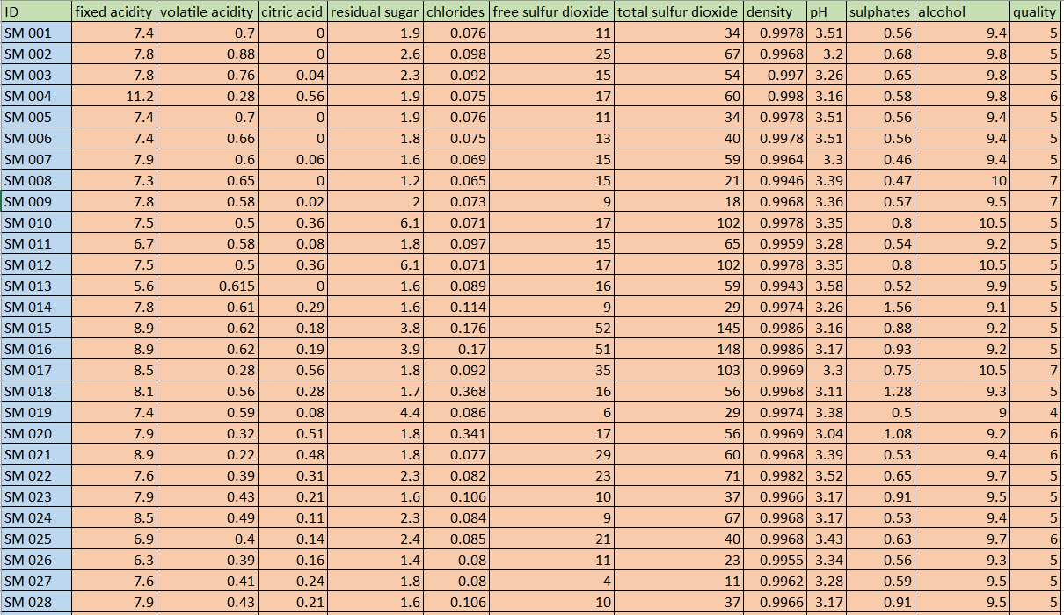
Figure 1. Object–Attribute Matrix (OAM) representing red wine samples and physicochemical attributes.

4.2 Similarity Analysis
Similarity analysis was applied using distance-based metrics such as Euclidean distance and cosine similarity. These metrics quantify the resemblance between wine samples and enable multidimensional comparison, reflecting the comparative reasoning applied by professional sommeliers. The normalized and structured form of the OAM applied for similarity comparison is shown in Figure 2.
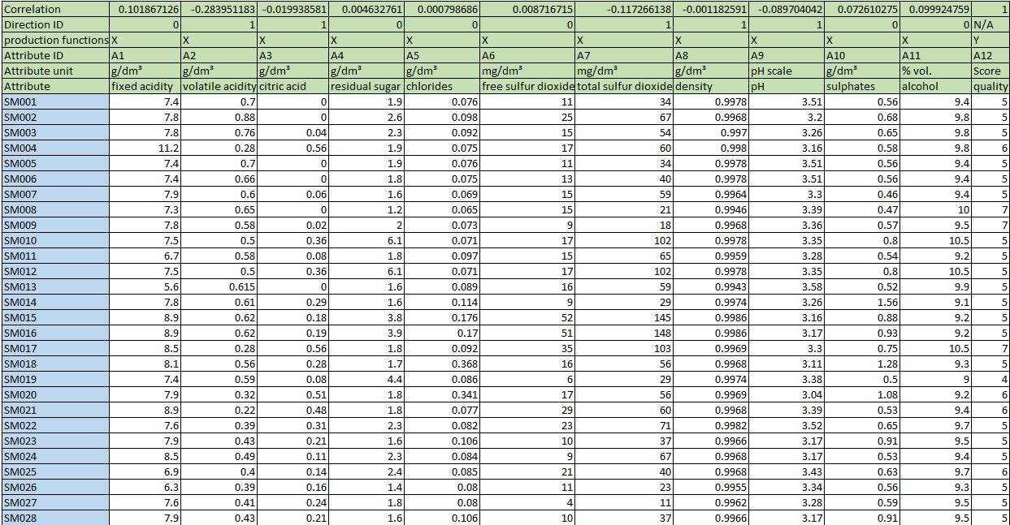
Figure 2. Structured OAM with normalized attributes used for similarity comparison.

4.3 LLM-Based Interpretative Layer
Large Language Models were incorporated as an interpretative layer to contextualize numerical outputs. The LLM was used to identify influential attributes, interpret correlation structures, and generate expert-like explanations consistent with observed data patterns.

4.4 Methodological Validation
Validation was conducted by comparing similarity-based groupings and LLM interpretations with expert-rated wine quality scores. Alignment between AI-supported analysis and expert judgment was treated as an indicator of methodological reliability.

5. Results and Interpretation
The analysis revealed that alcohol content and sulphates exhibit positive correlations with wine quality, while volatile acidity and density show negative relationships. Wines with similar physicochemical profiles generally received comparable quality scores. A comparison between expert-rated quality scores and AI-supported similarity-based evaluation is presented in Figure 3.
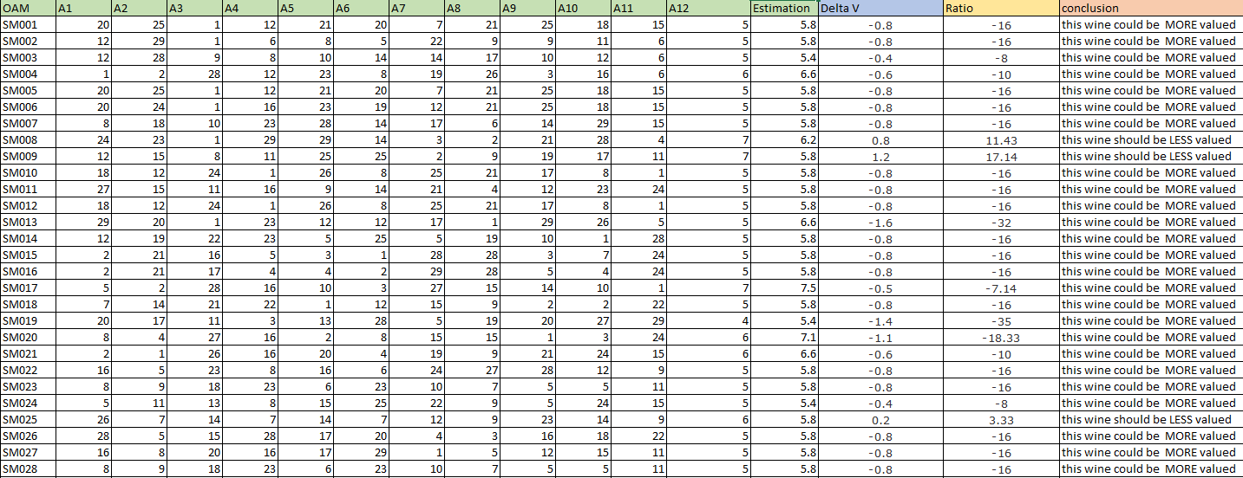
Figure 3. Expert-rated quality and AI-supported similarity-based evaluation.

6. Discussion
The findings indicate that expert reasoning can be partially formalized through structured data analysis and semantic AI interpretation. The framework supports scalability and reproducibility while preserving interpretability.

7. Conclusion
The use of an Object–Attribute Matrix combined with similarity analysis and LLM-based interpretation enables expert-level insight generation in wine quality assessment. The proposed framework demonstrates that AI can support objective, reproducible evaluation while complementing human expertise.

References
Cortez, P., Cerdeira, A., Almeida, F., Matos, T., & Reis, J. (2009). Modeling wine preferences by data mining.
ChatGPT (OpenAI).

