Kodolányi János University

THESIS

BOLDSUKH GANZORIG
Computer Science Operational Engineering – NBCSIK (BA/BSc)

Budapest
2026

Kodolányi János University Department of Informatics

Cross-Sector Evaluation of AI-Related Workplace Efficiency
  - A Benchmark-Aware OAM and COCO Y0-Based Framework

Supervisor: Dr. Pitlik László

Author: Boldsukh Ganzorig
Department of Informatics

Budapest
2026

Abstract
Artificial intelligence has become an increasingly important part of workplace transformation, yet its efficiency effects are still difficult to compare across sectors in a transparent and reproducible way. In many cases, discussions focus either on general technological expectations or on isolated success stories, while a structured cross-sector evaluation logic remains underdeveloped. This thesis addresses that gap by examining whether AI has a measurable and comparable relationship with workplace efficiency and by identifying which sectors appear to use AI more or less effectively within a unified analytical framework. To answer these questions, the thesis develops a benchmark-aware and multi-attribute evaluation model. The analysis combines 20 workplace sectors, 22 AI-related workplace-efficiency attributes, and 15 specialized AI benchmark models. These inputs are formalized through Object–Attribute Matrices, transformed through direction-aware ranking, and evaluated by the COCO Y0 engine under a constant ideal reference. The workflow also includes internal-consistency checks based on inverse ranking and symmetric inversion, the integration of partial analytical views, the exclusion of weaker attributes, and the construction of a reduced final model. To improve repeatability and reduce manual handling, the analytical process is also implemented in a software-supported prototype. The thesis contributes both a comparative result and a reusable methodological workflow. At the same time, the framework is intended as structured decision-support rather than universal causal proof. Future work may extend the model with broader datasets, refined benchmark layers, and stronger external validation perspectives.
Keywords: Artificial intelligence, workplace efficiency, cross-sector evaluation, specialized AI models, Object–Attribute Matrix, COCO Y0, rank transformation, decision-support, reproducibility, automation.
Contents
Abstract 1
Introduction 7
1.1 Aims and Objectives 7
1.2 Tasks 8
1.3 Targeted Groups 9
1.4 Utilities (Estimation of Informational Added-Values) 10
1.4.1 Legend 12
1.4.2 Workload Hours Calculation 12
1.4.3 Income Model 14
1.5 Motivations 15
1.6 About the Structure of the Publication 16
2 Literature 17
2.1 About the Phenomenon of Efficiency 18
2.1.1 Efficiency before Artificial Intelligence 18
2.1.2 Efficiency after Artificial Intelligence 19
2.2 AI and workplace efficiency as a sector-dependent phenomenon 19
2.2.1 AI as a driver of productivity and process performance 19
2.2.2 Why AI adoption alone is not enough 20
2.2.3 Sectoral heterogeneity in AI-related efficiency 21
2.3 Benchmark logic. Specialized AI models as sectoral reference points 22
2.3.1 Domain-trained models and benchmark superiority 23
2.3.2 Benchmark capability versus workplace applicability 24
2.3.3 Alignment between sectoral needs and AI capability 24
2.4 Comparative evaluation design for cross-sector analysis 26
2.4.1 Cross-sector comparison as evaluative design 26
2.4.2 Decision-support logic instead of casual proof 27
2.4.3 Multi-attribute evaluation of complex organizational phenomena 27
2.5 Object-Attribute Matrix as formal analytical representation 28
2.5.1 Objects and attributes in evaluative modelling 29
2.5.2 Metadata fields and interpretability 30
2.5.3 Directionality and mixed measurement scales 32
2.5.4 OAM as the bridge between empirical data and evaluation engine 33
2.6 Multi-criteria evaluation and COCO Y0 34
2.6.1 Multi-criteria decision support in comparative evaluation 34
2.6.2 Ideal-seeking and anti-discriminative evaluation logic 35
2.6.3 Why COCO Y0 is suitable for this thesis 36
2.7 Rank transformation and harmonization of heterogeneous indicators 37
2.7.1 The comparability problem of heterogeneous raw indicators 37
2.7.2 Ordinal transformation as standardization 38
2.7.3 Direction-aware ranking 39
2.8 Validation and internal consistency of the model 40
2.8.1 Validation in comparative evaluation models 40
2.8.2 Internal consistency versus external ground truth 41
2.8.3 Symmetric inversion and inverse ranking as robustness procedures 42
2.9 Integration of analytical views and attribute reduction 43
2.9.1 Integration of partial analytical perspectives 43
2.9.2 Attribute contribution and model simplification 44
2.9.3 Parsimony in multi-attribute evaluation 44
2.10 Reproducibility, automation and software-supported evaluation 45
2.10.1 Reproducibility in analytical workflow 46
2.10.2 Automation as reduction of manual error 46
2.10.3 Software implementation and workflow operationalization 47
2.10.4 Testing and faithful implementation 48
2.11 Boundary conditions and limits of interpretation 49
2.11.1 Strategic and organizational moderators 49
2.11.2 Regulatory and socio-technical constraints 50
2.11.3 Scope limits of benchmark-based sector evaluation 51
2.12 BPROF Subjects 52
2.12.1 Business Law and Regulation 52
2.12.2 Business Process Management 52
2.12.3 Database 1 and 2 53
2.12.4 Data Visualization 53
2.12.5 Electronic Circuits 53
2.12.6 Globalization and Social Problems 53
2.12.7 Intercultural Communication 53
2.12.8 Introduction to Algorithms 54
2.12.9 Introduction to Electronics 54
2.12.10 Introduction to Mathematics 54
2.12.11 Introduction to Programming 54
2.12.12 IT-Security 54
2.12.13 Network and Computer Architectures 55
2.12.14 Programming 1, 2, 3 55
2.12.15 Software Architectures 55
2.12.16 Software Testing 55
2.12.17 System Modelling 55
2.12.18 System Operation 55
2.12.19 System Planning 56
3 Own Development 56
3.1 Data Basis and Analytical preparation 56
3.1.1 Data Collection and empirical scope 56
3.1.2 Data cleaning consistency Checks 57
3.2 Construction of the analytical input metrics 57
3.2.1 COCO Y0 as evaluation engine 57
3.2.2 OAM Structure and metadata fields 58
3.2.3 Definition of object sets 59
3.2.4 Definition of Attribute sets 62
3.2.5 Construction of the two OAM variants 64
3.3 Rank transformation and first COCO execution 65
3.3.1 Ranked table generation and COCO Y0 input preparation 65
3.3.2 First COCO Y0 estimation 66
3.4 Validation of the initial estimations 66
3.4.1 Inversed ranked table construction 66
3.4.2 Symmetric inversion validation 67
3.5 Integration of datasets and attribute reduction 67
3.5.1 Construction of the combined OAM 67
3.5.2 COCO Y0 execution on the combined OAM 68
3.5.3 Attribute exclusion 68
3.5.4 Construction of the Super OAM 68
3.6 Final estimation and sector ranking 69
3.6.1 Final COCO Y0 execution on the Super OAM 69
3.6.2 Final validation of the reduced model 69
3.6.3 Final ranking of workplace sectors 70
3.6.4 Interpretation of the final results 70
3.7 Result 70
3.8 Automation 71
3.8.1 Introduction 71
3.8.2 Functions 72
3.8.3 Flexibility 74
3.8.4 Conclusion 74
3.9 Testing 75
3.10 Comparison to the Another Thesis 75
4 Discussion 75
5 Conclusion 77
6 Future 79
7 Summary 80
8 Annexes 83
8.1 Abbreviations 83
8.2 Figures 84
8.3 References 104
8.3.1 Bibliography 104
8.3.2 Types 110
8.4 Conversation with LLM 119

Introduction
Artificial intelligence has become an increasingly important part of workplace transformation, yet its efficiency effects remain difficult to compare across sectors in a transparent and reproducible way. Public and professional discussions often focus on technological breakthroughs, isolated benchmark results, or general adoption trends, but these do not automatically explain whether AI leads to measurable workplace-efficiency gains, whether such gains are comparable across sectors, or why some sectors appear to benefit more strongly than others. For this reason, the present thesis examines whether AI-related workplace efficiency can be structured, measured, compared, and interpreted within one coherent evaluative framework. In the present thesis, artificial intelligence is understood as a set of data-driven and model-based capabilities that may support automation, prediction, optimization, decision support, and human–machine collaboration. Workplace efficiency is understood as the relative improvement of organizational performance through better use of time, resources, quality, and operational capacity. On this basis, the thesis approaches AI-related workplace efficiency as a sector-dependent phenomenon, meaning that the observable effects of AI are expected to vary according to sectoral task structures, implementation conditions, benchmark-relevant model capability, and organizational readiness. To investigate this problem, the thesis develops a benchmark-aware and multi-attribute comparative evaluation framework. Workplace sectors, specialized AI benchmark models, and workplace-efficiency attributes are formalized in Object–Attribute Matrix form, harmonized through direction-aware ranking, and evaluated through the COCO Y0 engine. The workflow is complemented by internal-consistency checks, integration of analytical perspectives, attribute reduction, and software-supported operationalization.

Aims and Objectives
The primary aim of this thesis is to determine whether artificial intelligence has a measurable and comparable impact on workplace efficiency across multiple sectors. More specifically, the research seeks to move beyond general claims about AI adoption and to evaluate whether efficiency gains can be identified, structured, and compared in a transparent analytical framework. This aim is directly linked to the two central research questions of the thesis. First, whether artificial intelligence has a measurable impact on workplace efficiency. Second, which workplace sectors demonstrate the most effective and least effective use of artificial intelligence. To achieve this overall aim, the thesis pursues four interrelated objectives
- The first objective is to establish a structured cross-sector evaluation framework by representing sectors and efficiency indicators in Object–Attribute Matrix form. This objective is developed in chapter §§3.1-§§3.2.5.
- The second objective is to examine workplace efficiency not only in relation to general AI adoption, but in relation to the alignment between sectoral needs and specialized, domain-trained AI capabilities. In this way, the thesis seeks to explain why some sectors achieve higher measurable efficiency gains than others. This objective is operationalized in chapter §§3.1.1, interpreted in chapter §§3.6.4.
- The third objective is to produce an explainable and reproducible sector ranking through COCO Y0, rank transformation, validation and attribute reduction. This objective is implemented in chapter §§3.3-§§3.6.2.
- The fourth objective is to convert the analytical logic into an automation prototype that supports repeatable evaluation and reduced manual error. This objective is implemented in chapter §§3.8-§§3.9.

Tasks
In order to realize the above aims and objectives, the thesis carries out a sequence of interrelated research and implementation tasks. These tasks form the operational backbone of the study and are primarily executed in chapter §§3. To accomplish the stated aims, the research was organized into the following tasks:
- To define the empirical basis of the study by selecting workplace sectors, AI-specialization domains, efficiency attributes and benchmark AI models. This task is carried out in chapter §§3.1.1.
- To clean and check the data so that later estimations are based on coherent and comparable inputs. This task is carried out in chapter §§3.1.2.
- To construct the analytical input by defining COCO Y0, the OAM structure, the object set, the attribute set and the initial OAM variants. This task is completed in chapter §§3.2.1-§§3.2.5 and finalized in chapter §§3.5-§§3.6.
- To transform the matrices into ranked form and run the first COCO Y0 estimation. This task is carried out in chapter §§3.3.1-§§3.3.2.
- To validate the internal consistency of the estimation process through inverse-ranked tables and symmetric inversion checks. This task is completed in chapter §§3.4.1-§§3.4.2.
- To integrate the datasets, exclude low-contribution attributes and construct the excluded Super OAM. This task is interpreted in chapter §§3.5.1-§§3.5.4 and final model is executed in chapter §§3.6.1-§§3.6.2
- To generate the final validated ranking of workplace sectors and interpret the comparative pattern of results. This task is carried out in chapter §§3.6.3-§§3.7.
- To implement the workflow demo software form through the OAM to COCO Y0 Automator. This task is completed in §§3.8.1-§§3.8.4.
- To test the automation tool on the main and randomized datasets to confirm repeatability and faithful implementation of the method. This task is carried out in chapter §§3.9.

Targeted Groups
This thesis has dual purpose. First, it answers the research questions concerning whether artificial intelligence has a measurable efficiency on workplace sectors and which sectors use artificial intelligence more or less effectively. Second, it converts the resulting evaluation outputs into practical decision-support for real users. Accordingly, the targeted groups are defined as those actors for whom the proposed framework can generate a concrete information added-value through benchmarking, prioritization and repeatable re-evaluation.
- Micro and small enterprises (primary users). Organizations that cannot afford large scale consulting projects, but they still need structured support for deciding where artificial intelligence can create the highest operational benefit. For this group, the framework provides a low-cost, auditable way to compare efficiency-related factors, identify likely drivers of improvement and avoid poorly aligned AI investments.
- Small and Medium-sized enterprises (SME) focused consultants and implementation partners. This group includes advisors, analysts and implementation specialists who support organizations in AI-related decision-making. For them, the framework is rational because it offers a transparent and repeatable evaluation logic based on OAM construction, COCO Y0 estimation, validation and automated execution, thereby making prioritization decisions easier to justify to clients.
- Sector associations and business network. These actors coordinate shared training, awareness, benchmarking or readiness programs across multiple organizations. They are included because they need cross-organizational comparability rather than isolated case descriptions and the framework provides a common structure for comparing sectors and identifying where AI-related efficiency conditions appear stronger or weaker.
- Public benchmarking and policy-support units. Certain public or institutions actors may require a structured method for longitudinal benchmarking, especially where sector-level comparison and documented evaluation logic are important. Their inclusion is rational to the extent that the framework is used for comparative decision-support. However, application in purely public-service contexts may require adaptation of efficiency objective and attributes to ensure measurement alignment.
- Academic researchers (secondary users). Researchers are treated as secondary than primary customers because their main interest is methodological reuse, reproducibility and longitudinal comparison rather than commercial deployment. For this group, the added-value lies the auditable structure of the framework and in the possibility of adapting the method for further empirical studies.
These targeted groups are served through the thesis’ operationalized workflow developed in chapter §§3. The practical basis of this support is the structured evaluation pipeline, from data preparation and OAM construction to COCO Y0 estimation, validation, exclusion and the OAM to COCO Y0 Automator prototype in chapter §§3.1-§§3.9. In this sense, the targeted groups are not defined abstractly, but in direct relation to the base outputs of the thesis (comparable rankings, attribute-based interpretation and repeatable re-evaluation).

Utilities (Estimation of Informational Added-Values)
The utility of the proposed AI Efficiency Framework is that it transforms fragmented AI-related information into structured, comparable and repeatable decision-support output. In the benchmark situation organizations often rely on fragmented indicators, generic AI narratives or ad hoc judgement. In this project situation, they receive an auditable basis for benchmarking, prioritization and yearly re-evaluation through the workflow developed in chapter §§3. The main user-side benefit is therefore not only technical output, but better prioritization of AI-related decisions at relatively low cost. The framework’s recurring cost can remain low because public data sources may be accessed free of charge, while baseline deployment and version control can also be maintained on free plans. Under this logic, the main recurring cost is internal staff time for data preparation and interpretation rather than heavy infrastructure cost. For a conservative labor-based estimate, internal time can be valued using Eurostat’s 2024 EU average hourly labor cost of EUR €33.5 per hour (Source: https://ec.europa.eu/eurostat/web/products-eurostat-news/w/ddn-20250328-1).
Table 1 Scenario based information added-value (Source: Own presentation)
Target group | Benchmark situation: manual yearly workload | Benchmark cost (€) | Project situation: workflow-based yearly workload | Project cost (€) | Positive informational added-value (€) | Basis of estimation
Micro and small enterprises | 12 h × €33.5 | € 402.00 | 5 h × €33.5 + €50 | € 217.50 | € 184.50 | One annual evaluation cycle with lower manual workload due to automation
SME-focused consultants and implementation partners | 24 h × €33.5 | € 804.00 | 10 h × €33.5 + €50 | € 385.00 | € 419.00 | One representative annual client-support cycle with reusable workflow
Sector associations and business networks | 36 h × €33.5 | € 1,206.00 | 14 h × €33.5 + €50 | € 519.00 | € 687.00 | One annual benchmarking cycle across multiple member organizations
Public benchmarking and policy-support units | 40 h × €33.5 | € 1,340.00 | 16 h × €33.5 + €50 | € 586.00 | € 754.00 | One annual longitudinal benchmarking cycle with stronger documentation burden
Academic researchers (secondary users) | 16 h × €33.5 | € 536.00 | 8 h × €33.5 + €0 | € 268.00 | € 268.00 | One annual research-use cycle, no fee under non-commercial use logic
Grand total (all groups) |  | € 4,288.00 |  | € 1,975.50 | € 2,312.50 | Sum of rows above
Grand total (primary commercial groups only) |  | € 3,752.00 |  | € 1,707.50 | € 2,044.50 | Excludes academic secondary users
The estimations in table above are based on two-layer utility logic. First, the benchmark situation represents the yearly cost of carrying out the evaluation without the thesis workflow, where steps remain manual. Second, the project situation represents the yearly cost of carrying out the same evaluation with the thesis workflow, where repeated processing is reduced through automation. This approach follows the thesis logic that the workflow reduces manual effort, shortens the analysis cycle and supports repeatable yearly re-evaluation. The table therefore interprets positive informational added-value as a yearly cost saving. Labor cost is valued at €33.5 per hour on Eurostat’s 2024 EU average hourly labor cost, while €50 annual access fee reflects the low-cost organizational use model defined in the table above.

Legend
- Benchmark cost. Estimated annual cost of performing the evaluation without the thesis workflow, calculated as manual yearly workload * hourly labor cost.
- Project cost. Estimated annual cost of performing the evaluation with the thesis workflow, calculated as workflow-based yearly workload * hourly labor cost + annual access fee where applicable.
- Positive informational added-value. Benchmark cost – Project cost.
- Hourly labor cost. €33.5/hour
- Annual access fee. €50 for primary organizational users, €0 for secondary non-commercial academic use.
- Grand total. Sum of the relevant rows in the table.
The workload hours are conservative author assumptions based on the manual-versus-automated workflow logic of the thesis and used only for scenario-based estimation.

Workload Hours Calculation
The workload hours represent on representative yearly evaluation cycle. In the benchmark situation, the user is assumed to perform data preparation, manual transformation or repeated handling, interpretation and checking and yearly update effort. In the project situation, the user is still assumed to perform data preparation and part of the interpretation. But the manual transformation and repeated computation steps are reduced by automation.
- Micro and small enterprises.
- Benchmark
  - 4 hours of data preparation
  - 4 hours of manual matrix, ranking, computation handling
  - 4 hours of interpretation and checking
- Project
  - 2 hours of data preparation
  - 1 hour of workflow execution
  - 2 hours of interpretation and checking
- SME consultants and implementation partners.
  - Benchmark
    - 8 hours of data preparation and client-specific setup
    - 8 hours of manual processing and repeated handling
    - 8 hours of interpretation and reporting
- Project
  - 4 hours of data preparation
  - 2 hours of workflow execution
  - 4 hours of interpretation and reporting
- Sector associations and business networks.
  - Benchmark
    - 12 hours of data collection and preparation
    - 12 hours of manual processing and comparison
    - 12 hours of interpretation and coordination
- Project
  - 6 hours of data preparation
  - 3 hours of workflow execution
  - 5 hours of interpretation and coordination
- Public benchmarking and policy support units.
  - Benchmark
    - 14 hours of data preparation
    - 12 hours of manual processing
    - 14 hours of interpretation and documentation
- Project
  - 7 hours of data preparation
  - 3 hours of workflow execution
  - 6 hours of interpretation and documentation
- Academic researchers
  - Benchmark
    - 6 hours of data preparation
    - 5 hours of manual processing
    - 5 hours of interpretation
  - Project
    - 4 hours of data preparation
    - 1 hour of workflow execution
    - 3 hours of interpretation
The annual workload hours are conservative scenario assumptions defined by author on the basis of the user-side cost components. This represents one illustrative yearly evaluation cycle and is used only to operationalize the required comparison between the benchmark situation and the post-project situation.

Income Model
The income of the proposed framework is intentionally conservative. In the project situation, the framework is not treated as a high-price consulting product, but as a low-cost, reusable evaluation service whose primary organizational users may access it through a modest annual fee. In line with the utility model presented in Table 1, the direct provider-side income is therefore defined as the annual access fee of €50 per primary organizational user, while secondary academic use remains fee-free under a non-commercial logic. This low-fee structure is consistent with the thesis objective of providing auditable and repeatable decision-support at relatively low adoption cost for the targeted groups defined in Chapter §§1.3. From the user perspective, the main financial return does not arise from direct cash income, but from avoided evaluation cost. More specifically, the framework reduces the yearly labor input required for data preparation, manual transformation, repeated computation, interpretation and checking by replacing part of the benchmark workflow with an automated and repeatable process developed in Chapter §§3. As a result, the positive informational added-value can be interpreted as a user-side monetary return, because the benchmark cost remains higher than the project cost for all targeted groups included in Table 1. Accordingly, the sustainability logic of the project has two complementary sides. On the provider side, a small recurring access fee supports continued availability and maintenance of the workflow. On the user side, the framework remains rational because even after including the annual fee, the scenario-based calculations still show positive net benefit for the primary user groups. In this sense, the income model of the thesis is not based on aggressive revenue expectations, but on a low-cost sustainability approach combined with measurable user-side savings. Therefore, the framework’s economic rationale lies in small provider-side recurring income and larger user-side avoided cost, rather than in high upfront pricing or speculative market projections.

Motivations
The motivation of this thesis is twofold. First, there is a research-side motivation. Although artificial intelligence is widely presented as a driver of productivity and workplace improvements, the actual efficiency gains achieved across sectors remain difficult to compare in a transparent and reproducible way. Existing discussion often remains fragmented across separate indicators, isolated case examples, or general adoption narratives, while the relationship between sector-specific needs and domain-trained AI capability is rarely evaluated through one structured and repeatable framework. For this reason, the thesis is motivated by the need to replace general claims about AI with a comparative, auditable and quantitatively interpretable evaluation logic. Second, there is practical motivation linked directly to the targeted groups identified in Chapter §§1.3. Micro and small enterprises, SME-focused consultants, sector associations, public benchmarking units and secondary academic users all face a similar problem. They may need structured decision-support about AI-related efficiency, but they often lack a low-cost, repeatable and explainable evaluation method. In the benchmark situation, such users would need to rely on fragmented information, manual comparison and partly ad hoc interpretation. In the project situation, the workflow developed in Chapter §§3 provides a more structure basis for benchmarking, prioritization and repeated re-evaluation. This practical relevance is reinforced by the utility estimations presented in Chapter §§1.4. The scenario-based calculations show positive informational added-value for all targeted groups, meaning that the proposed workflow is not only methodologically justified, but also rational from a user-side perspective. Accordingly, the thesis is motivated not only by the academic question of whether AI has measurable sector-level efficiency effects, but also by the practical need for an evaluation framework whose outputs can support better decisions at relatively low recurring cost. The motivation of the thesis therefore lies in the combination of three factors. The lack of coherent and reproducible cross-sector evaluation, the need to distinguish domain-aligned AI effectiveness from AI adoption general and the positive user side added-value of workflow that reduces manual effort through repeatable analytical automation. In this sense, the project is motivated both as a methodological contribution and as a practical decision-support solution for the identified user groups.

About the Structure of the Publication
This thesis is structured so that conceptual and methodological justification precedes implementation, implementation precedes interpretation, and interpretation remains within explicitly declared limits. Accordingly, the publication first defines the research problem, conceptual background, and evaluation logic, then presents the own development and software-supported workflow, and only after that discusses the results, conclusions, future directions, and supporting annex materials. This structure is necessary because the thesis combines literature-based foundation, formal modelling, comparative evaluation, and operational implementation in one coherent artifact-centered work. The structure of the publication is the following:
- Chapter §§1. Introduces the topic and defines the aims, tasks, targeted groups, utilities, motivation and the structure of the thesis.
- Chapter §§2. Presents the literature review and establishes the conceptual and methodological foundation of the thesis, including AI and workplace efficiency as a sector-dependent phenomenon, benchmark logic, comparative evaluation design, the Object–Attribute Matrix, COCO Y0, rank transformation, validation, integration, reproducibility, automation, and interpretation limits.
- Chapter §§3. Documents the own development, including the analytical workflow, OAM construction, ranking, COCO Y0 execution, validation, integration of analytical views, attribute exclusion, final model construction, and the software-supported prototype.
- Chapter §§4. Discusses the results critically and interprets them within the previously declared methodological and practical limits.
- Chapter §§5. Presents the conclusions of the thesis and formulates the final answers on the basis of the previous discussion.
- Chapter §§6. Outlines possible future extensions, refinements, and follow-up directions.
- Chapter §§7. Provides a concise summary of the thesis.
- Chapter §§8. Contains the annexes, including abbreviations, figures, references, supporting documentation, and the documented conversations with large language models.
Several methodological elements are introduced earlier than they are explained in detail. These include the sector-based comparison logic, specialized benchmark models, the Object–Attribute Matrix, rank transformation, COCO Y0 evaluation, inverse-based internal-consistency checks, attribute reduction, and the software-supported workflow. In this subchapter these elements are mentioned only as structural components of the thesis, while their detailed explanation is provided later in the literature review and the own development chapter. Accordingly, the publication is defined in advance as a structured academic work in which theoretical grounding, methodological justification, implementation, interpretation, and annex-based traceability follow a consistent and transparent order. This structure supports the central claim of the thesis that the developed evaluation workflow is not only analytically interpretable, but also auditable and repeatable.

Literature
This chapter establishes the theoretical and methodological foundation of the thesis. Its purpose is not only to summarize prior literature on artificial intelligence and workplace efficiency, but also to justify the analytical logic through which the research questions are later examined. Since the thesis investigates whether artificial intelligence has a measurable impact on workplace efficiency across sectors, the literature review must first clarify what efficiency means in an organizational context, how artificial intelligence can influence it, and why such effects should not be expected to appear uniformly across different workplace environments. The chapter therefore proceeds in a structured sequence. It begins by defining efficiency as the central outcome variable of the thesis and by distinguishing traditional process-based efficiency from AI-enabled forms of efficiency. It then explains why AI-related efficiency is sector-dependent, why specialized benchmark models are relevant as reference points, and why the problem is best approached as a comparative multi-attribute evaluation task rather than as a simple causal claim. On this basis, the chapter introduces the methodological concepts required for the later empirical work, including the Object–Attribute Matrix, the COCO Y0 evaluation logic, rank transformation, validation procedures, attribute reduction, and workflow reproducibility. Accordingly, chapter §§2 functions as a bridge between the research problem stated in chapter §§1 and the Own Development presented in chapter §§3. It provides the conceptual definitions, methodological justification, and interpretation boundaries necessary for transforming a broad question about AI and workplace efficiency into a transparent, structured, and reproducible comparative evaluation framework.

About the Phenomenon of Efficiency
Efficiency is a foundational concept in organizational analysis and serves as the primary outcome variable of this research. “It will unlock innovative products and services, especially in the areas of energy, safety and health, as well as higher productivity and more efficient production” (Kommunikációs Főigazgatóság, 2024). Policy documents frequently emphasize that AI can deliver efficiency across a wide range of sectors, motivating the need for systematic, reproducible methods to operationalize and evaluate such efficiency claims. Before evaluating the impact of artificial intelligence on workplace performance, it is necessary to clarify what efficiency means in an organizational context and how it has traditionally been understood and measured. This chapter introduces the phenomenon of efficiency by outlining its conceptual interpretation in business and operational environments, both prior to and following the widespread adoption of artificial intelligence. By establishing this conceptual baseline, the chapter provides the theoretical foundation required to distinguish between efficiency improvements driven by traditional process optimization and those enabled by AI-supported automation, decision-making, and human–machine collaboration. This clarification is essential for ensuring that subsequent sectoral comparisons and quantitative evaluations are based on a consistent and well-defined understanding of efficiency.

Efficiency before Artificial Intelligence
“Efficiency is doing things right. Effectiveness is doing the right things. For knowledge work, productivity depends primarily on the quality of processes rather than sheer speed.” (Drucker, 1999). This citation defines efficiency in the pre-AI era as fundamentally process-driven and human-centered. It directly supports conceptual baseline of this thesis for efficiency before AI. This establishes the pre-AI reference point against which this thesis’ AI-driven efficiency measurements are compared. “You can see the computer age everywhere but in the productivity statistics.” (Robert M. Solow, 1987). This famous observation highlights the historical difficulty of converting technological adoption into measurable efficiency gains. It directly supports its motivation for developing a quantitative, validated framework (OAM + COCO Y0) rather than relying on adoption narratives alone.

Efficiency after Artificial Intelligence
“Digital technologies are transforming work by enabling machines to perform cognitive tasks that previously required human intelligence.” (Brynjolfsson & McAfee, 2016). This quotation defines the post-AI shift in efficiency, where gains are no longer limited to physical automation but extend to cognitive and decision-intensive tasks. This thesis operationalizes this shift through attributes such as Real-Time Decision Ratio, Model Accuracy and AI-Human Collaboration Index, making post-AI efficiency measurable across sectors. “The primary impact of artificial intelligence is not full automation but the augmentation of human work.” (Thomas H. Davenport & Julia Kirby, 2016). This directly supports treatment of efficiency as a hybrid outcome rather than pure automation. This thesis findings show that sectors performing best are those where AI augments human capability, reinforcing why collaboration-based attributes matter in the rankings.

AI and workplace efficiency as a sector-dependent phenomenon
After defining efficiency, the next step is to clarify why artificial intelligence should not be expected to affect all workplace sectors in the same way. In the present thesis, this point is essential because in the chapter §§3 does not treat AI as a single universal input, but compares 20 sectors through 22 efficiency-related attributes and interprets the results together with a second benchmark layer of specialized AI models. Accordingly, this subchapter first shows that AI can improve productivity and process performance, then explains why adoption alone is not sufficient and finally justifies why cross-sector comparison is rational in the first place. In this way, chapter §§2.2 provides the conceptual bridge toward the later benchmark logic in chapter §§2.3, the comparative design in chapter §§2.4 and then formal multi-attribute modelling in chapter §§3.

AI as a driver of productivity and process performance
The literature provides strong claim that AI can improve workplace productivity and process performance in measurable ways. (Noy & Zhang, 2023) report that, with generative AI support, the “average time taken decreased by 40% and output quality rose by 18%”. In a field setting, (Brynjolfsson et al., 2025) likewise find that AI assistance “increase worker productivity… by 15% on average”. These citations are integrated positively in the present thesis because they support the claim that AI-related efficiency is not merely rhetorical or speculative, but can be observed through measurable output, speed and quality effects. This directly supports the inclusion of performance-oriented attributes in chapter §§3.2.4, such as productivity growth, task automation, cycle-time reduction and error-related improvements. The relevance of these findings for the present thesis is that they justify a broad understanding of workplace efficiency rather than a narrow one. The point is not only that AI may accelerate output, but also that it can affect the quality and consistency of work processes. (Brynjolfsson et al., 2025) further report that AI assistance improves customer-related outcomes and learning-related dynamics, while effects remain heterogeneous across workers. This integrated positively because chapter §§3 does not define efficiency as sheer speed alone. Instead, the thesis operationalizes AI-related efficiency through a broader performance structure that includes process quality, decision support, collaboration and organizational outcome variables. Therefore, the literature in this subsection supports not only the topic of the thesis, but also the methodological decision to represent workplace efficiency as multi-dimensional attribute set instead of a one-variable productivity claim.

Why AI adoption alone is not enough
Although AI can improve measurable performance, the literature also makes clear that adoption alone is not a sufficient explanation of workplace efficiency. (Brynjolfsson et al., 2017) argue that “The most impressive capabilities of AI, particularly those based on machine learning, have not yet diffused widely” and that their full effects will not be realized until complementary innovation and skills are developed and implemented. Closely related, (Brynjolfsson et al., 2021a) state that ”General purpose technologies (GPTs) like AI enable and require significant complementary investments”. These citations are integrated positively because they directly support one of the core design principles of this thesis. Sectoral AI efficiency cannot be inferred from adoption presence alone, but must be interpreted together with organizational capability, skills, process redesign and digital maturity. This logic is reinforced by earlier complementarity literature. (Bresnahan et al., 2002) show that “The effects of IT on labor demand are greater when IT is combined with the particular organizational investments we identify, highlighting the importance of IT-enabled organizational change”. Even though this stud predates contemporary generative AI, it is integrated positively because its logic remains highly relevant that technological tools create value only when embedded in a suitable organizational context. (BECSEI JÓZSEF et al., 2024) supports the claim that AI adoption alone is not enough for effective organizational transformation “a legnagyobb akadályok a szakképzett munkaerő hiányában, a digitális írástudatlanság mértékében és az elavult gyártósorokban keresendőek (“the greatest obstacles are to be found in the lack of skilled labour, the level of digital illiteracy, and outdated production lines.”. My translation)”. This citation is integrated positively because it directly identifies the kinds of organizational and capability-side bottlenecks that prevent technological availability from becoming real efficiency gains. In the context of the present thesis, it strengthens the argument that sectoral AI efficiency depends not only on adoption, but also on preparedness, skills, and the broader maturity of the operational environment. In the present thesis, this is precisely why chapter §§3.2.4 includes not only adoption-related indicators but also attributes such as employee AI usage rate, AI skill penetration, AI-human collaboration index and industry digitalization index. In other words, this thesis treats adoption as one factor among several enabling conditions, not as a direct proxy for efficiency. Further reason why adoption alone is not enough is that AI effects are uneven within a single workplace setting. (Brynjolfsson et al., 2025) report and note that the effects vary across different agents. This citation is integrated positively because it weakens any simple interpretation in which AI presence is automatically equivalent to performance gain. It supports the methodological position of the thesis that sector-level AI efficiency must be estimated through a structured set of attributes rather than assumed from adoption intensity alone. This prepares the later logic of chapter §§2.4, where the thesis is framed as comparative evaluation design rather than a simple causal claim about technology presence.

Sectoral heterogeneity in AI-related efficiency
The literature further supports the expectation that AI-related efficiency differs across sectors because work tasks are not exposed to AI capability. (Eloundou et al., 2023) find that “both human and GPT-4 annotations that most occupations exhibit some degree of exposure to LLMs, with varying exposure levels across different types of work” and estimate that the effect of LLM’s are distributed unevenly across tasks and occupations. This citation integrated positively because it gives a direct theoretical and empirical basis for cross-sector comparison. If different work profiles are differently exposed to AI capability, then sectors cannot be expected to exhibit uniform efficiency outcomes. The present thesis therefore treats cross-sector variation as something to be measured systematically, not explained away as noise. A Hungarian institutional source also supports the argument that sectoral AI use is heterogeneous by nature. (Európai Parlament, 2020) states that “A mesterséges intelligencia rendkívül fontos az online kereskedelemben például a termékek optimalizálása, vagy a készletek és a logisztika megtervezése miatt. (“Artificial intelligence is extremely important in online commerce, for example because of product optimization, or the planning of inventories and logistics.”. My translation)”. This citation is integrated positively because it illustrates, in a concise and non-technical form, that AI is already associated with different sector-specific functions and process logics. For the present thesis, this supports the methodological rationale of cross-sector comparison. Sectors are not expected to benefit from AI in identical ways, because their task profiles and operational priorities differ from the outset. A more fine-grained explanation of such heterogeneity appears in (Dell’Acqua et al., 2023), who describe a jagged technological frontier in which AI is highly useful for some tasks but not for others. In their field experiment, AI were more productive on tasks within the capability frontier, but for a task outside that frontier “consultants using AI were 19 percentage points less likely to produce correct solutions compared to those without AI”. This citation is integrated very positively because it closely matches the central interpretive logic of the thesis. AI-related efficiency depends on the fit between sectoral task requirements and actual AI capability, not on the mere availability of AI tools. This is exactly the logic that later leads into chapter §§2.3.3 on alignment between sectoral needs and AI capability and finally into chapter §§3.6.4, where sector-level results are interpreted in terms of strategic and operational fit rather than universal AI benefit. Taken together. The literature in this subchapter supports three methodological conclusions that are necessary for the rest of the thesis. First, AI can improve productivity and process performance in measurable ways. Second, such gains cannot be inferred from adoption alone, because organizational capabilities, digital maturity, skill structures and complementary investments matter. Third, these effects are uneven across sectors because sectors differ in task structure, implementation conditions and the degree to which their core activities fall inside or outside current AI capability frontiers. For that reason, the thesis does not model AI efficiency as a universal constant. Instead, it proceeds toward a benchmark-aware, cross-sector, multi-attribute evaluation framework in chapter §§3, where heterogeneity is treated as the central object of analysis rather than as a secondary complication.

Benchmark logic. Specialized AI models as sectoral reference points
This subchapter explains why the present thesis does not evaluate sectoral AI efficiency only through general adoption or general-purpose model narratives. In the Own Development chapter, the analytical design already combines 20 workplace sectors, their AI-specialization domains, 22 efficiency attributes and 15 specialized benchmark models such as BloombergGPT and AlphaFold 2. Therefore, benchmark literature is not a side example here, but a second conceptual foundation of the methodology. It proves a reference layer for technical capability that can later be compared with sector-level workplace conditions and then integrated in the combined OAM and final interpretation. In this sense, chapter §§2.3 prepares bridge from the sector-dependent logic of chapter §§2.2 toward the multi-attribute design and chapter §§3.

Domain-trained models and benchmark superiority
The first reason why benchmark logic deserves a separate place in the thesis is that specialized, domain-trained models often outperform more general systems on domain-specific tasks. (Wu et al., 2023) report that BloombergGPT “a model that outperforms existing models on financial tasks by significant margins without sacrificing performance on general LLM benchmarks”. This citation is integrated positively because it directly supports the thesis assumption that sector-specific AI capability should not be inferred only from general AI visibility. Instead, technical readiness may be stronger where a model is trained on domain-relevant data and evaluated on domain-relevant tasks. That logic fits the methodological role of the benchmark layer in chapter §§3, where specialized models are treated as capability references linked to particular sectoral task families rather than as generic symbols of more AI. A similar pattern appears in very different domain. (Jumper et al., 2021) show that AlphaFold “demonstrating accuracy competitive with experimental structures in a majority of cases and greatly outperforming other methods”. This citation also integrated positively because it shows that benchmark superiority is not limited to finance or language tasks. Rather, it illustrates a broader methodological point where the model architecture, training data, benchmark task are closely matched to the domain problem, performance may become substantially stronger than in a generic setting. For the present thesis, this supports the use of specialized benchmark models as a rational analytical layer in later cross-sector comparison. Taken together, these sources justify the first benchmark claim of the thesis. Specialized models can provide a stronger a stronger signal of domain-level AI capability than general-purpose systems. This matters methodologically because the own development chapter is not trying to compare sectors only by public AI enthusiasm or generic adoption rates. It is also trying to capture whether a given sector is associated with a mature, domain-relevant AI capability frontier. Therefore, these citations are integrated positively into the thesis as direct support for constructing a benchmark layer that reflects sector-specific technical readiness.

Benchmark capability versus workplace applicability
At the same time, benchmark superiority must not be confused with proven workplace effectiveness. This distinction is essential for the present thesis because the benchmark layer is used as a reference signal, not as direct evidence that a sector already achieves the corresponding real-world productivity gains. (Hager et al., 2024) state that “medical licensing exams do not test the capabilities required for real-world clinical decision-making” and show that, in realistic autonomous clinical scenarios, current LLMs remain unsuitable without extensive clinical supervision. This citation integrated positively but with caution. It is integrated positively because it directly supports the thesis decision to separate benchmark capability from observed workplace applicability. It is used with caution because it warns that strong performance on a benchmark or exam-like proxy does not automatically mean safe or effective operational deployment. This distinction is methodologically crucial for the later chapters. In the thesis workflow, benchmark models are not treated as final sector scores. Instead, they function as a second analytical perspective that must later be interpreted together with sector-level efficiency attributes, implementation realities and operational conditions. That is why the benchmark layer belongs in the literature chapter as a formal foundation. It justifies the inclusion of sector-specific model references, while simultaneously preventing an overclaim that benchmark success alone proves workplace value. In other words, the literature supports using benchmark results as proxies for technical capability, but not as substitutes for measured organizational performance. For this reason, the present thesis does not read BloombergGPT, AlphaFold 2 or any other specialized model as direct proof that finance, pharmaceuticals or other sectors are automatically the most efficient in practice. Instead, benchmark capability is interpreted as structured signal of what is technically possible under domain-aligned conditions. This preserves relation with chapter §§3, where final sectorial interpretation is produced only after the benchmark perspective has been combined with workplace-efficiency attributes, validation steps and model refinement. Thus, the literature here is integrated both positively and restrictively. Positively, because benchmark literature is relevant. Restrictively, because benchmark literature alone is insufficient.

Alignment between sectoral needs and AI capability
The third and most important benchmark argument for the thesis is that sector-level AI efficiency depends on the alignment between sectoral needs and actual AI capability. (Dell’Acqua et al., 2023) describe a jagged technological frontier in which some tasks are well supported by AI while others remain outside its effective capability range. In their field experiment, consultants using AI on tasks within the frontier completed more tasks, finished them faster, and produced higher-quality results, whereas on a task outside the frontier they were “19 percentage points less likely to produce correct solutions”. This citation is integrated very positively because it matches the core interpretive logic of the thesis almost exactly that AI effectiveness is conditional on task–model fit, not on the mere presence of an AI tool. This idea provides the conceptual justification for why specialized AI benchmarks are useful as sectoral reference points. A benchmark model matters not because it automatically proves realized business impact, but because it indicates that there is a technically mature capability frontier associated with a certain task family. Where a sector’s core processes are closer to that frontier, stronger measurable efficiency gains are more plausible, where sectoral tasks are weakly aligned, highly constrained, or partly outside the frontier, weaker gains should be expected even if AI adoption is visible. This is exactly the logic that in chapter §§3 aims already state that workplace efficiency is examined not only through general AI adoption, but through “the alignment between sectoral needs and specialized, domain-trained AI capabilities.” Accordingly, the benchmark layer in this thesis should be read as an alignment layer. It links a sector to a task-family capability signal, then later allows the final framework to evaluate whether this signal corresponds to observed efficiency-related conditions in the sectoral attribute set. In that sense, BloombergGPT and AlphaFold 2 are not merely topical illustrations from finance and pharmaceuticals. They are methodological examples of the broader principle that sectoral AI efficiency is more likely when domain problems and model capabilities fit each other closely. This argument is integrated positively because it directly prepares the later comparative design, the structure of the OAM variants, and the final interpretation of sector ranking in Chapter §§3.5-§§3.6. Taken together, this chapter §§2.3 supports three methodological conclusions. First, domain-trained models may outperform general-purpose systems on in-domain tasks. Second, such benchmark superiority is a reference signal of technical capability, not direct proof of real-world workplace performance. Third, sector-level efficiency depends on alignment between sectoral needs and AI capability, which is why benchmark logic must be integrated into the framework before the thesis proceeds to comparative evaluation design and formal multi-attribute modelling. For the present thesis, these conclusions are not decorative background claims; they are direct foundations for why benchmark models appear as a separate analytical layer in the methodology.

Comparative evaluation design for cross-sector analysis
This subchapter explains the methodological form of the present thesis before the literature moves into the more formal representation of the problem in chapter §§2.5 and evaluation engine in chapter §§2.6. The Own Development chapter already shows that the thesis proceeds by selecting 20 workplace sectors, describing them through 22 attributes, transforming the resulting OAM structures, running COCO Y0 estimations, validating the ranked outputs and then interpreting the comparative pattern of results rather than estimating a casual treatment effect. In other words, the thesis behaves as a structured comparative evaluation framework and as a decision-support pipeline, not as a casual experiment. This is fully related to chapter §§3, where the workflow is explicitly organized around OAM construction, rank transformation, validation, integration, reduction and final comparative ranking, and where the practical output is described as auditable decision-support for real users.

Cross-sector comparison as evaluative design
The first methodological point is that cross-sector comparison is rational here because the thesis works with a set of heterogeneous but comparable alternatives. (Corrente et al., 2021a) state that “Multiple criteria decision support methodologies aim to assist decision makers in making difficult decisions when many conflicting viewpoints have to be considered”. This citation is integrated positively because it directly supports the structure of the present thesis. Workplace sectors are treated as comparable alternatives, while the different efficiency-related indicators act as multiple viewpoints or criteria through which these alternatives can be examined. (Handbook on Constructing Composite Indicators: Methodology and User Guide, 2008) similarly explains that “While there are several types of composite indicators, this Handbook is concerned with those which compare and rank” performance across entities in complex domains such as competitiveness, innovation, and development. This is also integrated positively, because the thesis likewise compares and ranks sectoral alternatives under a transparent methodological framework rather than presenting isolated case descriptions.

Decision-support logic instead of casual proof
The second methodological point is that the thesis should be understood as decision support rather than as causal proof. (Roy, 1996) writes that multicriteria methodology should “scientifically assist decision-making processes” and help in “separating robust from fragile conclusions”. This citation is integrated very positively because it closely matches the role of the present thesis. The goal here is not to prove a universal causal law that AI always increases efficiency by a fixed amount across all sectors. Instead, the goal is to construct a transparent framework that supports comparison, prioritization, and interpretation under explicit assumptions. That is exactly how chapter §§3 workflow behaves. It produces ranked comparative outputs, validates transformation consistency, and refines the model through attribute exclusion and repeated estimation rather than identifying an externally verified treatment effect. This distinction is important because it protects the thesis from methodological overclaiming. A causal design would require a different kind of evidence structure, such as experimental or quasi-experimental identification. The present thesis does not do that. Instead, it organizes available indicators into a structured comparative model that can inform users about relative positioning, plausible patterns, and stronger or weaker alignment conditions. This is also coherent with the practical logic stated earlier in the thesis, where the framework is intended for benchmarking, prioritization, and repeatable re-evaluation by SMEs (Small Medium-sized Enterprises), consultants, sector associations, public benchmarking units, and researchers. Therefore, the literature is integrated positively and restrictively at the same time. Positively, because MCDA (Multi-Criteria Decision Analysis) literature supports a decision-aiding interpretation. Restrictively, because that same literature implies that the framework should not be presented as proof of universal causal truth.

Multi-attribute evaluation of complex organizational phenomena
The third methodological point is that workplace efficiency is too complex to be represented adequately by a single variable. (Constructing Valid Geospatial Tools for Environmental Justice, 2024) state that “a composite indicator represents a complex, multidimensional concept or condition” and that combining multiple measurements is useful when the concept is “better represented through a combination of different factors”. This citation is integrated positively because it provides a very clear methodological parallel to the present thesis. AI-related workplace efficiency is not directly observable through one single raw measure. It involves multiple dimensions such as productivity, automation, cycle-time reduction, error reduction, cost effects, collaboration, skills, digitalization, and risk-related conditions. For this reason, the use of 22 attributes in chapter §§3 is not an unnecessary complication but a methodologically coherent response to a multidimensional phenomenon. The (Handbook on Constructing Composite Indicators: Methodology and User Guide, 2008) reinforces this point by emphasizing that composite indicators require structured methodological choices about indicator selection, normalization, aggregation, and interpretation, precisely because such concepts are complex and cannot be reduced safely to one raw metric. This citation is also integrated positively, because your methodology does exactly that kind of structuring work. It defines the indicators, harmonizes them through ranking, preserves directionality, and later evaluates them through a formal engine rather than by ad hoc averaging or narrative judgment. In this way, the literature supports one of the central design choices of the thesis. A single-metric view of AI efficiency would hide too much of the organizational reality, whereas a multi-attribute framework makes the phenomenon more analyzable, more transparent, and more interpretable. This provides the direct bridge to chapter §§2.5, where the Object–Attribute Matrix is introduced as the formal representation of that multidimensional problem. Taken together, the literature in §2.4 supports three methodological conclusions that are necessary for the rest of the thesis. First, cross-sector comparison is rational when sectors are treated as alternatives evaluated under explicit and shared comparison rules. Second, the present thesis is a decision-support framework, not a causal proof design, and its outputs should therefore be interpreted as structured comparative recommendations rather than universal causal laws. Third, workplace efficiency in the AI era is a multidimensional organizational phenomenon, so a multi-attribute framework is methodologically more appropriate than a single-metric approach. These conclusions directly prepare the next stages of the literature chapter, where the problem is formalized as an OAM in §§2.5 and then linked to COCO Y0 and rank-based evaluation in §§2.6-§§2.7.

Object-Attribute Matrix as formal analytical representation
This subchapter introduces the Object–Attribute Matrix (OAM) as the formal representation through which the present thesis converts a complex workplace-efficiency problem into an analyzable comparative structure. This step is necessary because the Own Development chapter already operates through explicit object sets, attribute sets, metadata fields, directionality rules, and a fixed ideal value before any COCO Y0 estimation is performed. In the current workflow, the thesis uses OAM not merely as a storage sheet, but as the structured input from which later ranking, validation, integration, and reduction become possible. That same logic is already visible in chapter §§3, where sectors and benchmark-linked task domains are organized into OAM variants, enriched by metadata, and then transformed for direction-aware evaluation. The literature directly supports this formalization. (Pitlik & Zoltán, 2015) state that similarity analysis “it needs an object-attribute matrix” and that the “raw inputs of X(i) should be ranked”. These statements are integrated positively because they support the exact methodological sequence followed in this thesis. First the evaluation problem must be represented in OAM form, and only after that can the heterogeneous input values be transformed into a ranked structure suitable for further analysis. (Pitlik & Gyongyi Bankuti, 2010) further describe COCO as a “context-free similarity analysis method” that can handle “evaluation, benchmarking, forecasting problems”. This citation is also integrated positively because it shows that the thesis is not using OAM as a casual spreadsheet layout, but as the formal input representation of a broader evaluation method whose purpose is structured comparison across heterogeneous objects. For the present thesis, the consequence is methodological rather than cosmetic. AI-related workplace efficiency is treated here as a multidimensional phenomenon that cannot be represented adequately through one undifferentiated value. The OAM therefore becomes the place where the compared entities and their descriptive dimensions are separated explicitly, kept interpretable, and prepared for later direction-aware transformation and COCO Y0 estimation. In this sense, the cited literature is integrated positively not as general background but as a direct theoretical justification for why the empirical material in chapter §§3 must first appear in OAM form before any ranking or estimation is attempted.

Objects and attributes in evaluative modelling
In evaluative modelling, objects are the comparable entities under analysis, while attributes are the measurable or interpretable properties through which those entities are described. This distinction is methodologically important because structured comparison is only possible if the alternatives and their descriptive criteria are kept analytically separate. (Corrente et al., 2021b) describe multiple-criteria decision support as a framework for difficult decisions involving multiple viewpoints, which in practice means that alternatives must be assessed through more than one criterion rather than by narrative impression alone. (OECD. et al., 2007) the handbook on composite indicators similarly defines a composite indicator as one built from individual indicators under a multidimensional conceptual model. These citations are integrated positively because they support the exact formal logic of the thesis which workplace sectors are treated as objects, while AI-related efficiency indicators function as attributes describing those objects. This logic is fully related to chapter §§3. In the Own Development chapter, the thesis explicitly constructs one object set from 20 workplace sectors and a second object set from benchmark-linked task domains, while the attribute side is built from 22 AI-related workplace-efficiency indicators and a second benchmark-oriented attribute layer. The OAM is therefore the formal place where these analytical roles become stable and comparable. This literature is integrated positively because it helps prevent a conceptual confusion that would otherwise weaken the thesis. Sectors, models, tasks, indicators, and benchmarks are not all the same type of analytical element. The OAM makes these roles explicit by assigning objects and attributes distinct functions within one common comparison structure. In the context of the present thesis, this means that the OAM is not an arbitrary spreadsheet arrangement. It is the formal representation of the evaluation problem itself. Once sectors are defined as objects and efficiency-related indicators as attributes, the later methodological steps become logically possible. Metadata can be attached systematically, directionality can be encoded explicitly, heterogeneous raw values can be transformed consistently, and the resulting structure can be processed by COCO Y0. For that reason, the cited literature is integrated positively into the thesis not as general background, but as direct theoretical support for why the empirical material in chapter §§3 must first be represented in object–attribute form before any ranking or estimation is attempted.

Metadata fields and interpretability
A formal matrix becomes analytically useful only when its contents are interpretable and reproducible. For that reason, metadata are not secondary ornaments but necessary explanatory elements of the model. (Handbook on Constructing Composite Indicators: Methodology and User Guide, 2008) explains that “This skepticism is partially due to the lack of transparency of some existing indicators, especially as far as methodologies and basic data are concerned. To avoid these risks, the Handbook puts special emphasis on documentation and metadata.” and recommends that relevant methodological documentation be prepared throughout the construction process to ensure coherence. This citation explains that comparison requires access to metadata that outline definitions, sources and methods so that users do not misinterpret the resulting indicators and integrated positively because it directly justifies one of the main design decisions of the thesis. In the OAM-oriented literature, this requirement appears directly in connection with the internal conditions of similarity analysis. (Pitlik & Zoltán, 2015) explain that optimized staircase functions are calculated only when the direction of evaluation is given, referring to the “preferred orientation like the more the more, or the less the more are given for each attribute”. This citation is integrated positively because it directly justifies one of the main design decisions of the thesis. The OAM must include explicit metadata so that later rankings are traceable, interpretable, and not mistaken for opaque spreadsheet output. In other words, the method itself requires more than raw values and it requires formally specified reading rules for those values. A further COCO-related formulation (Tomori Pál Főiskola, 2018) appears where the OAM explicitly includes “Y0: Modellkonstant für eine anti-diskriminative Modellierung, (“Y0: model constant for anti-discriminative modelling.” My translation)”. The same source continues with “Basierend auf OAM wurde eine Anti-Diskriminanz-Analyse durchgeführt, (“Based on OAM, an anti-discrimination analysis was carried out.” My translation)”. These formulations are integrated positively because they support the thesis practice of treating the ideal value Y not as a spare cell in a spreadsheet but as a formal part of the evaluative structure itself. They also reinforce the thesis logic that OAM plus Y0 is a structured modeling input, not just an intermediate table. This logic matches the present thesis implementation very closely. In chapter §§3, each OAM includes Direction ID, Type, Attribute ID, Attribute Name, Attribute Unit, and the constant ideal value Y, while the automation prototype later requires the same fields again in order to parse, rank, and process the matrix consistently. This internal consistency is important for the literature chapter because it shows that metadata are not only theorized but operationalized in the actual workflow. Therefore, the cited literature is integrated positively because it supports the thesis decision to use metadata as a formal interpretability layer rather than as optional annotation. More specifically, Attribute ID secures traceability, Attribute Name secures semantic clarity, Attribute Unit clarifies whether a value is a percentage, integer, decimal, or index, Type distinguishes the ordinary attribute space from the ideal reference row, Direction ID encodes whether higher or lower values are preferable, and Y provides a constant ideal target for later orientation and estimation. These fields reduce ambiguity at every later stage of the workflow. Without them, a ranked result could be numerically reproducible yet conceptually opaque. With them, the same result becomes auditable and interpretable, which is one of the core promises of the thesis methodology.

Directionality and mixed measurement scales
One of the main reasons why the Object–Attribute Matrix must be formalized carefully is that the attributes in the present thesis do not share a single natural measurement scale or a single preferred direction. Some indicators are percentages, some are counts, some are indices, and some are desirable when larger, whereas others are desirable when smaller. This is not a minor technical detail, because the later evaluation depends on whether the raw inputs can be transformed into a common comparison structure without losing their evaluative meaning. (Pitlik & Zoltán, 2015) address this issue directly when they state that similarity analysis calculates optimized staircase functions “if direction (preferred orientation like the more the more, or the less the more are given for each attribute)” and that “the raw inputs of X(i) should be ranked”. This citation is integrated very positively because it supports the exact methodological logic of the thesis. Mixed raw indicators cannot be sent directly into the evaluation engine, but must first be directionally interpreted and rank-transformed into a common ordinal frame. This logic is fully coherent with the Own Development chapter. In Chapter §§3, the OAM contains attributes measured in different units and formats, while the workflow explicitly distinguishes between benefit-type and cost-type indicators through the Direction ID field before the ranked matrix is generated. Therefore, the citation from (Pitlik & Zoltán, 2015) is not merely a general methodological ornament. It is integrated positively because it gives direct literature support for one of the thesis’s core preprocessing steps. Rank transformation is not an Excel convenience, but the formal solution to the problem that heterogeneous indicators with different directions cannot be compared meaningfully in raw form. This also prepares the transition to chapter §§2.6, where COCO Y0 will be introduced as the method that works on the direction-aware, rank-based representation rather than on the untreated original values. A second directly relevant implication follows from the OAM/Y0 example in the COCO-related literature. In (Tomori Pál Főiskola, 2018), the model description explicitly links ranked attributes, staircase-function search, and an anti-discriminative constant dependent variable. “Die Anti-Diskriminanz-Analyse sucht nach einer solchen Treppenfunktion, wonach die unterschiedlichen Betroffenheitsschichten nach Attributen und deren Rangzahlen die perfekteste Annäherung an das Gleichheitsprinzip … ermöglicht. (“The anti-discrimination analysis searches for such a staircase function according to which the different impact layers, based on attributes and their rank numbers, enable the most perfect approximation to the principle of equality.”. My translation)”. The same passage also states that this equality principle is represented by “eine konstante Zahl als abhängige Variable, (“a constant number as dependent variable.”. My translation)”. This citation is integrated positively because it supports the thesis argument that ranking is not an isolated numerical trick. It is part of the internal logic of the anti-discriminative model itself. In other words, directionality and ranking belong to the formal architecture of the method, not only to the data-cleaning stage. For the present thesis, the methodological conclusion is therefore clear. Directionality and mixed measurement scales are constitutive properties of the evaluation problem. If they are ignored, later COCO Y0 outputs could reflect hidden inconsistencies instead of interpretable sectoral differences. If they are handled explicitly through Direction ID and rank transformation, the workflow becomes more transparent, more auditable, and more faithful to the multidimensional nature of AI-related workplace efficiency. The citations used above are integrated positively because they support the exact sequence implemented later in chapter §§3, the formal OAM construction, explicit directional encoding, ordinal transformation, and only then formal evaluation.

OAM as the bridge between empirical data and evaluation engine
Once objects, attributes, metadata, directionality, and the ideal reference are made explicit, the Object–Attribute Matrix becomes the bridge between empirical data and the evaluation engine. This bridge function is essential in the present thesis because the workflow does not move directly from collected sector information to final ranking. Instead, the empirical material is first organized into OAM form, then transformed into a direction-aware ranked matrix, and only after that processed through COCO Y0, validation steps, and model reduction. (Pitlik & Gyongyi Bankuti, 2010) describe COCO as a “Linear Programming based context-free similarity analysis method” and explain that it investigates the relationship between the independent variables and the dependent variable through staircase-function logic rather than through fixed multiplicative weights. This citation is integrated positively because it directly supports the thesis interpretation of OAM as more than a storage table. The OAM is the formally prepared input required before the context-free comparison logic of COCO can operate. The bridge function of OAM is also stated very clearly in the OAM/Y0 application example. The source explicitly says “Basierend auf OAM wurde eine Anti-Diskriminanz-Analyse durchgeführt, (“Based on OAM, an anti-discrimination analysis was carried out.”. My translation)”. It continues by explaining that the procedure searches for a staircase function that gives the best approximation to the equality principle represented by a constant dependent variable. This citation is integrated very positively because it expresses almost exactly the same methodological role that OAM has in the present thesis. The OAM is the intermediate analytical structure through which empirical observations become computationally evaluable under a Y0-type logic. It is therefore not merely a descriptive table but the formal interface between observed sectoral data and the anti-discriminative estimation method. For the present thesis, the methodological conclusion is therefore straightforward. The OAM is the formal analytical bridge that preserves interpretability, keeps the relationship between objects and attributes explicit, carries the metadata needed for direction-aware processing, and prepares the dataset for the later evaluation engine. Without this bridge, the final ranking would risk appearing as opaque output. With it, the whole workflow becomes reproducible and logically staged, which is one of the central promises of the thesis methodology. The cited literature is integrated positively because it supports exactly this interpretation and aligns directly with the later implementation in chapter §§3.

Multi-criteria evaluation and COCO Y0
After formalizing the problem through the Object–Attribute Matrix, the next step is to clarify the evaluation logic applied to that structure. In the present thesis, the goal is not to describe sectors only narratively, but to compare them systematically across multiple attributes and to derive a transparent, reproducible ranking under explicit assumptions. For this reason, the literature foundation of this subchapter must explain three things. First, why multi-criteria decision support is methodologically appropriate. Second, why the evaluation logic is ideal-seeking and anti-discriminative rather than based on subjective weights and third, why COCO Y0 is suitable for the specific data conditions of the thesis. These points are directly coherent with the own development chapter, where ranked OAMs, COCO Y0 execution, validation, exclusion, and automation are all treated as connected stages of one evaluation workflow.

Multi-criteria decision support in comparative evaluation
The first methodological point is that the present thesis belongs to the field of multi-criteria decision support because it compares a finite set of alternatives under multiple viewpoints rather than under a single criterion. (Figueira et al., 2005) write that, given the basic ingredients of alternatives, criteria, and a decision-maker, “MCDA is an activity which helps making decisions mainly in terms of choosing, ranking or sorting the actions”. This citation is integrated positively because it matches the present thesis very closely. The sectors function as the alternatives, the efficiency indicators function as the criteria, and the final output is explicitly a ranking-oriented decision-support result rather than a descriptive list of observations. This general MCDA logic is further strengthened by the COCO-specific literature. (Pitlik & Gyongyi Bankuti, 2010) describe COCO as a “context-free similarity analysis method” and note that “method can handle evaluation, benchmarking, forecasting problems”. This citation is integrated positively because it shows that COCO belongs naturally to the family of structured comparative methods rather than to ad hoc scoring procedures. In the context of the present thesis, this is important because the framework is intended to support benchmarking across sectors under explicit rules, not to produce impression-based judgments. Accordingly, the cited source supports the thesis logic that cross-sector AI-efficiency estimation is a decision-support task in which multiple criteria must be evaluated together.

Ideal-seeking and anti-discriminative evaluation logic
The second methodological point is that the logic of COCO Y0 is not simply multi-criteria in a generic sense, but specifically ideal-seeking. (Pitlik & Zoltán, 2015) state that “Constellations of phenomena can be seen as sustainable, if the facts of the past in case of each object and attribute are arbitrary close to the norm values,” and they add that “Similarity analysis is a modelling tool, which is able to build models in an automated way to detect lacks of sustainable constellation”. These citations are integrated positively because they support one of the core interpretive ideas of the thesis that the evaluation does not merely compare sectors against one another in a relative vacuum, but compares them in relation to an explicitly defined ideal reference. This is fully coherent with the Own Development chapter, where the constant ideal value Y is inserted into the OAM and later used as the target point for the COCO Y0 calculations. The anti-discriminative side of the logic is also directly visible in the COCO-related literature. In (Tomori Pál Főiskola, 2018), the matrix includes “Y0: Modellkonstant für eine anti-diskriminative Modellierung (“Y0: model constant for anti-discriminative modelling.”. My translation)”. The same source states “Basierend auf OAM wurde eine Anti-Diskriminanz-Analyse durchgeführt (“Based on OAM an anti-discrimination analysis was carried out”. My translation)”. This citation is integrated positively because it shows that the Y0 idea is not an informal interpretation added later by the thesis, but part of the formal modelling logic already presents in the COCO-related literature. In other words, COCO Y0 does not seek to reward arbitrary advantage structures through manually assigned preference weights. It seeks the most appropriate approximation to an explicitly constant reference. A related argument appears in (László Pitlik)’s earlier COCO paper, where complete objectivity is defined as analysis conducted “Die vollkommene Objektivität wird dadurch gekennzeichnet, dass eine Analyse ohne jegliche, individuelle Wertbestimmungen (“Complete objectivity is characterized by an analysis without any individual value determinations”. My translation)”. This citation is integrated very positively because it helps explain why the present thesis does not rely on hand-assigned expert weights for the 22 efficiency attributes. Instead, the method is designed to minimize individually imposed valuation structures and to derive the evaluation result from the formal interaction between ranked attributes and the ideal reference. For the thesis, this is a major advantage that it allows the framework to present itself as an auditable and weight-avoiding comparative model rather than as a disguised subjective scoring system.

Why COCO Y0 is suitable for this thesis
COCO Y0 is suitable for the present thesis because the data structure of the study matches the formal conditions required by the method. (László Pitlik) explains that the COCO procedure can work with a arbitary large number of objects and attributes “Für das COCO-Verfahren wird folgende OAM gebraucht: beliebig große Anzahl von Objekten und Attributen, beliebig-skalierte Attribute, eine mit Daten vollständig gefüllte Matrix, Richtungsangaben für jedes Attribut (max, min, opt). (“For the COCO method, the following OAM (object-attribute matrix) is required: an arbitrarily large number of objects and attributes, attributes measured on any scale, a matrix completely filled with data, and directional specifications for each attribute (max, min, opt).”. My translation)”. This citation is integrated positively because it fits the data conditions of the thesis very closely. The study compares many objects, uses mixed-scale attributes, and explicitly encodes benefit/cost direction through metadata before estimation. These are not accidental similarities but direct reasons why COCO Y0 is methodologically appropriate here. A second reason is that COCO does not reduce evaluation to a naive constant-weight average. (Pitlik & Gyongyi Bankuti, 2010) write that “this method has not got only one constant multiplicative weight in the approximating formula, but the weight is a staircase function of the variable value”. This citation is integrated positively because it explains why COCO Y0 is especially well suited to the present thesis’s complex efficiency problem. AI-related workplace efficiency is unlikely to behave as a simple linear weighted sum across all indicators. By using staircase-function logic instead of one fixed weight per attribute, the method is better aligned with the thesis’s aim to represent structured, non-trivial relationships between sectoral attribute profiles and the ideal reference. For the present thesis, these points lead to a clear methodological conclusion. COCO Y0 is suitable because it supports multi-object comparison, handles heterogeneous and direction-sensitive attributes, works with an explicit ideal reference, avoids reliance on hand-assigned weights, and fits the thesis’s staged workflow from OAM construction through rank transformation to final estimation. The literature is therefore integrated positively and directly into the thesis. The MCDA literature justifies the comparative decision-support perspective, while the COCO-specific literature explains why this particular engine is appropriate for the formal problem representation already developed in §§2.5. This also prepares the transition to §§2.7, where the rank transformation step can be justified in its own right as the mechanism that harmonizes heterogeneous raw indicators before formal estimation.

Rank transformation and harmonization of heterogeneous indicators
This subchapter explains why the present thesis does not send the raw sectoral indicators directly into the evaluation engine. In chapter §§3, the compared attributes already differ in unit, scale, and preferred direction. Some are percentages, some are counts, some are indices, and some are desirable when larger while others are desirable when smaller. For that reason, the workflow first constructs the OAM, then transforms the raw values into ranked form, and only after that proceeds to COCO Y0. The literature supports this sequence directly. (OECD, 2008) warns “Avoid adding up apples and oranges” and states that “Normalisation is required prior to any data aggregation as the indicators in a data set often have different measurement units”. This citation is integrated positively because it describes exactly the problem faced in the present thesis that the raw AI-efficiency indicators are heterogeneous and therefore not directly comparable in their untreated form.

The comparability problem of heterogeneous raw indicators
The first methodological issue is that heterogeneous raw indicators cannot be compared meaningfully without prior harmonization. (OECD, 2008) formulates this very clearly under the heading “Avoid adding up apples and oranges” and states that “Normalisation is required prior to any data aggregation as the indicators in a data set often have different measurement units”. This citation is integrated very positively because it offers a direct methodological rationale for the thesis. The present study combines indicators such as adoption rates, cost reductions, risk measures, collaboration-related values, and benchmark-linked quantities. These do not share one common raw scale, so any direct aggregation or comparison at the raw-value level would risk numerical distortion rather than interpretable evaluation. The same problem is also visible in the COCO literature itself. (László Pitlik) states that for the COCO procedure the OAM may contain “beliebig große Anzahl von Objekten und Attributen, beliebig-skalierte Attribute (“arbitrarily large number of objects and attributes, attributes measured on any scale”. My translation)”, but at the same time the method requires structured preprocessing before estimation. This citation is integrated positively because it shows that scale heterogeneity is not an exceptional side issue but a built-in data condition that the method is explicitly designed to address. In the context of the present thesis, this is especially important because the cross-sector framework combines mixed measurement formats by design. Therefore, the literature supports the methodological decision that comparability must be constructed through preprocessing rather than assumed to exist in the raw data from the beginning.

Ordinal transformation as standardization
Once the comparability problem is recognized, the next methodological question is how it should be handled. The thesis uses ordinal transformation, that is, ranking, as the harmonization step. (OECD, 2008) states that “Ranking is the simplest normalisation technique” and adds that it “allows the performance of countries to be followed over time in terms of relative positions (rankings),” even though “information on levels is lost”. This citation is integrated positively, but also with an explicit methodological limitation. It is integrated positively because the present thesis is indeed interested in the relative comparative position of sectors under a common multi-attribute framework. It is integrated with caution because rank transformation does reduce raw-level information. However, that limitation is acceptable here because the aim of the thesis is structured comparison and ranking, not cardinal measurement of absolute effect size across incompatible units. The same transformation logic is stated even more directly in the OAM/COCO-related literature. (Pitlik & Zoltán, 2015) write that similarity analysis “needs an object-attribute matrix” and that “the raw inputs of X(i) should be ranked”. This citation is integrated very positively because it supports the exact workflow later implemented in chapter §§3. Ranking is not treated there as a spreadsheet convenience or a secondary formatting choice, but as a formal transformation step required before the similarity-based evaluation can proceed. In other words, ordinal transformation is the method by which heterogeneous raw indicators are converted into a common analytical frame. This is why the ranked OAM becomes the proper input for the later COCO Y0 stage. A closely related formulation appears in (László Pitlik), where the method description states “die primären Daten … werden anhand der Richtungsvorgaben zu Rangzahlenvektoren transformiert. (“the primary data … are transformed into rank-number vectors on the basis of the direction specifications”. My translation)”. This citation is integrated positively because it confirms that the transformation into ranked form is part of the formal method description itself. Thus, the thesis does not add ranking as an external convenience layer, but follows a methodologically grounded preprocessing step already present in the COCO tradition.

Direction-aware ranking
The third methodological point is that ranking alone is not enough unless it is also direction-aware. Some attributes represent benefit-type performance, where higher values are preferable, while others represent cost-type or risk-type performance, where lower values are preferable. (Pitlik & Zoltán, 2015) make this explicit by stating that optimized staircase functions can be calculated only “if direction (preferred orientation like the more the more, or the less the more are given for each attribute)”. This citation is integrated very positively because it matches the thesis methodology exactly. In chapter §§3, the OAM includes Direction ID precisely so that the later ranking step preserves evaluative meaning rather than merely sorting raw numbers without context. (László Pitlik) expresses the same requirement in a more formal way when he states that the COCO procedure requires “Richtungsangaben für jedes Attribut (max, min, opt). (“direction indications for each attribute (max, min, opt)”. My translation)”. This citation is integrated positively because it strengthens the thesis claim that direction-aware ranking is not an optional refinement but a necessary condition of meaningful evaluation. In the present thesis, this is crucial because attributes such as productivity growth, skill penetration, or customer-satisfaction change must not be interpreted in the same evaluative direction as incident rate or job-displacement risk. Therefore, the direction-aware transformation step protects the model from hidden inversions of meaning and ensures that later COCO Y0 outputs remain interpretable. For the present thesis, the methodological conclusion is clear. The raw indicators are heterogeneous, so direct comparison would be misleading. Ranking provides a common ordinal comparison frame, but only if it is carried out with explicit directional rules. The literature is integrated positively here because it directly supports the exact preprocessing sequence later used in chapter §§3. First acknowledge the comparability problem, then standardize through ordinal transformation, and finally apply direction-aware ranking before formal evaluation. This also provides the direct bridge to the next literature block, where validation and internal consistency can be discussed not as external prediction, but as robustness checks on the ranked evaluative model.

Validation and internal consistency of the model
After the ranked OAM has been evaluated through COCO Y0, the next methodological question is how the credibility of the resulting structure should be checked. In the present thesis, this issue is addressed not through external predictive testing, but through internal robustness procedures that examine whether the transformation and estimation logic behave consistently under controlled reversal. This is fully coherent with chapter §§3, where the task is explicitly defined as the validation of internal consistency through inverse-ranked tables and symmetric inversion checks and where the later methodological clarification states that this procedure should not be confused with external validity. The COCO-related literature supports this interpretation. In the methodological steps described in the My-X similarity-analysis handbook, the procedure includes “Implementing the above mentioned steps on inverse learning pattern (where directions are the opposite of the direct run)” and then “Confronting direct and inverse estimations and fact apropos of consequence-variable with IF-function” (My-X Team). These citations are integrated positively because they show that direct–inverse confrontation is not an ad hoc addition in the present thesis, but part of the internal control logic of similarity-analysis-based modelling itself.

Validation in comparative evaluation models
In comparative evaluation models, validation does not always mean prediction against an externally observed ground truth. In many multi-attribute settings, the first task of validation is to test whether the internal structure of the model behaves coherently under the rules it claims to follow. This interpretation fits the present thesis because the framework is not a causal experiment and not a forecasting model in the narrow predictive sense. Rather, it is a structured comparative evaluation system that transforms heterogeneous indicators into a ranked, direction-aware representation and then derives sectoral estimates under an ideal-seeking logic. For such a framework, a central validation question is whether the model preserves logical consistency when its ranking directions are systematically reversed. This understanding is directly supported by the COCO-related literature. The My-X handbook includes, as part of the formal procedure, the inverse-run step and the confrontation of direct and inverse estimations. It also explains that the method develops “models which can be compared with each other at logical level and which lead to comparable partial results” (My-X Team). This citation is integrated positively because it supports the thesis view that validation, at this stage, is mainly a matter of checking logical and structural coherence inside the evaluative model rather than proving a real-world causal claim. A closely related formulation appears in another MIAU methodological source, which states “To confirm authenticity, a credibility test, a ‘counter-test’, is prepared, which in the normal run is based on an inverse ranking in the opposite direction” (Dániel Czúni et al.,). This citation is integrated very positively because it provides a direct terminology match for the present thesis. The phrase “credibility test” captures well what in chapter §§3 validation stage actually does. It checks whether the model remains credible under controlled reversal of the ranking logic. It therefore supports the thesis decision to present validation here as a robustness-oriented internal test rather than as empirical proof of external truth.

Internal consistency versus external ground truth
A second methodological clarification is necessary in order to avoid overclaiming. The validation logic used in the present thesis should be interpreted as internal consistency testing, not as validation against an independent external ground truth. This distinction is already important in chapter §§3 framing, where the workflow validates the transformation and model behavior under inversion, but does not claim that the resulting sector ranking has been externally verified against a real-world gold-standard outcome variable. The COCO literature helps justify this careful interpretation. (László Pitlik) defines the method as a comparison approach aiming at “Die vollkommene Objekti vität wird dadurch gekennzeichnet, dass eine Analyse ohne jegliche, individuelle Wert bestimmungen durchzuführen ist, (“Complete objectivity is characterized by conducting an analysis without any individual value judgments”. My translation)”. This citation is integrated positively because it clarifies the kind of objectivity sought by the method. The model tries to minimize individually imposed valuation structures and to behave consistently under its own formal rules. However, this is not the same as demonstrating external truth in the empirical world. For the present thesis, the implication is that the validation chapter must be written carefully. The results support the structural consistency of the evaluative model, but they do not by themselves prove that the sector ranking is externally correct in an absolute sense. The same conclusion is reinforced by the direct–inverse logic itself. If a model gives coherent inverse behavior under reversed directions, that shows robustness of the internal transformation and estimation pipeline. It does not automatically show that the underlying phenomenon has been perfectly measured in real life. For this reason, the thesis should present the validation stage as a reference-compatible agreement, within-model robustness, or internal consistency check, rather than as external validation. This interpretation is integrated positively because it protects the thesis from methodological overstatement while remaining fully faithful to what the model actually tests.

Symmetric inversion and inverse ranking as robustness procedures
The third methodological point is that symmetric inversion and inverse ranking function as robustness procedures inside the model. In practical terms, the thesis first creates the ranked OAM, then constructs the inverse-ranked version by reversing the evaluative directions, and then checks whether the resulting estimations behave symmetrically relative to the original run. This logic is directly coherent with chapter §§3 structure, where §§3.4.1–§§3.4.2 are explicitly titled Inversed ranked table construction and Symmetric inversion validation. The strongest direct methodological support comes again from the similarity-analysis literature. (My-X Team) lists as explicit procedural steps “Implementing the above mentioned steps on inverse learning pattern (where directions are the opposite of the direct run)” and “Confronting direct and inverse estimations and fact apropos of consequence-variable”. These citations are integrated very positively because they describe the exact logic used in the present thesis. The inverse-ranked table is not an auxiliary spreadsheet curiosity. It is the formal basis of the counter-test. Likewise, the symmetric confrontation of direct and inverse estimates is not an afterthought, it is the robustness check through which the analyst can see whether the model reacts coherently to controlled reversal. An even more targeted formulation appears in the MIAU index of later methodological work, which refers explicitly to “Symmetry of direct and inverse layers as warn system for overlearning effects in frame of staircase functions. This citation is integrated positively because it shows that symmetric direct–inverse comparison is also understood in the COCO tradition as a warning mechanism against model distortions or overfitting-like incoherence. In the context of the present thesis, this means that the inversion procedure does not merely duplicate the first run. It helps test whether the staircase-function-based evaluative structure remains logically stable when the ranking orientation is reversed. That is why it is best described as a robustness procedure. For the present thesis, the methodological conclusion is therefore clear. Validation is treated here as a comparative-model consistency problem. Internal consistency is separated carefully from external ground truth, and symmetric inversion plus inverse ranking are used as formal robustness procedures that test whether the evaluative structure behaves coherently under reversal. The cited literature is integrated positively because it supports the exact logic later implemented in chapter §§3 and because it helps frame the validation stage honestly, as an engineering-strength check of the model pipeline rather than as a claim of universal external correctness. This also prepares the next subchapter well, where the thesis can move from robustness checking to the integration of analytical views and attribute reduction.

Integration of analytical views and attribute reduction
After the initial estimations have been validated, the next methodological step is to move from separated analytical views toward a more concentrated evaluative structure. In the present thesis, this step is necessary because the framework does not rely on only one isolated matrix perspective. Instead, the sector-level and benchmark-linked analytical views are first preserved separately for transparency, then integrated, and only after that reduced to a more selective final model. This logic is supported by the OAM/COCO-related literature. (Pitlik & Zoltán, 2015) describe a stepwise analytical organization in which “partial data assets” are monitored, “complex databases” are analyzed, and “parts of databases should be integrated in a virtual system”. This citation is integrated positively because it supports the same methodological sequence used in the present thesis. First preserve analytically distinct parts, then integrate them into a larger evaluative structure. The same article also notes that similarity-based tools can function as a “decision support system,” which is integrated positively because the purpose of this integration step is not only technical merging, but a more decision-relevant representation of the phenomenon.

Integration of partial analytical perspectives
The integration stage is methodologically justified when the partial analytical perspectives describe different but related dimensions of the same problem. (Pitlik & Zoltán, 2015) write that “partial data assets … should be monitored,” that “complex databases … should be analyzed,” and that “parts of databases should be integrated in a virtual system”. This citation is integrated very positively because it matches the analytical logic of the present thesis almost exactly. One initial view represents workplace sectors through AI-related efficiency attributes, while the second represents benchmark-linked domain capability. These two views are not redundant duplicates, but complementary analytical perspectives. Therefore, integrating them after successful initial validation is methodologically rational rather than arbitrary. The same source also outlines the need for an “OAM-generator, where the potential learning patterns should be extracted from the databases with the raw/measured data incl. pattern-generation for symmetry-analyses in the quality assurance/consistence-control layers”. This citation is integrated positively because it supports the thesis view that integration is not a simple append-only data operation. The combined OAM must remain a formally interpretable analytical structure that still supports validation, pattern recognition, and later refinement. For this reason, the integration stage in the present thesis is best understood as the transition from validated partial models to a unified evaluative representation, not as a loss of analytical transparency.

Attribute contribution and model simplification
Once the analytical perspectives have been integrated, the next methodological question is whether all retained attributes contribute equally to stable estimation. The COCO literature suggests that they do not. (Pitlik & Gyongyi Bankuti, 2010) explain that in the COCO method a variable has “not got only one constant multiplicative weight,” but rather “the weight is a staircase function of the variable value”. This citation is integrated positively because it implies that the contribution of an attribute is not uniform and not reducible to one fixed manual weight. In the context of the present thesis, this supports the later exclusion logic that some attributes contribute more strongly to stable estimation, while others contribute less and can therefore be candidates for removal when the model is simplified. A more targeted support for attribute reduction appears in (Gyula Bán et al.,). It states “Relevant is, that we should be capable of integrating all potential changes (attributes/variables)”. This citation is integrated positively but also with methodological caution. It is integrated positively because it supports the thesis decision to begin from a broad attribute space rather than from premature simplification. It is interpreted with caution because broad initial inclusion does not mean that all attributes must remain in the final reduced model. On the contrary, once the integrated structure has been evaluated, the contribution pattern can be examined and weakly contributing variables can be excluded in a controlled way. This is exactly the logic followed later in the thesis, where the combined OAM is used diagnostically before constructing the reduced Super OAM.

Parsimony in multi-attribute evaluation
The final methodological principle of this subchapter is parsimony. In a multi-attribute evaluation model, parsimony does not mean reducing the model arbitrarily, but retaining only as much complexity as is needed for stable and interpretable estimation. (Pitlik & Zoltán, 2015) make this point in an especially useful form when they write “To be able to define, which phase can be seen as the best approximation, a kind of analysis based on the idea of Occam’s razor” is needed. This citation is integrated very positively because it offers a direct methodological rationale for the present thesis. After integration, the model should not remain unnecessarily broad merely because more variables are available. Instead, the aim is to identify the best approximation under the model logic and to prefer the more concentrated structure when it preserves explanatory strength. The same passage continues by framing approximation quality through consequences such as lower unnecessary change and stronger stability-oriented patterns. This is integrated positively because it supports the thesis logic that a reduced attribute set can be methodologically stronger than a larger undifferentiated one. In the present thesis, parsimony therefore functions as a refinement principle that the model moves from partial OAMs to a combined OAM, and from there to a reduced Super OAM, not because complexity is undesirable in itself, but because stable and interpretable estimation requires the retention of the most informative attributes and the exclusion of weaker ones. This interpretation remains coherent with the later final estimation stage, where the reduced model is treated as the most concentrated version of the evaluation framework rather than as a simplified shortcut. Taken together, the literature in this section supports three methodological conclusions. First, partial analytical perspectives may be processed separately and then integrated into a common evaluative structure. Second, attributes do not contribute uniformly to estimation, so contribution-aware simplification is methodologically justified. Third, parsimony in multi-attribute evaluation should follow an Occam-type logic of best approximation rather than arbitrary reduction. These citations are integrated positively because they support the exact sequence used later in the thesis, validated partial OAMs, combined OAM, contribution-based exclusion, and final reduced Super OAM as the basis of the concluding sector ranking.

Reproducibility, automation and software-supported evaluation
After defining the evaluative logic of the model, it is also necessary to explain why the present thesis treats reproducibility, automation, and software implementation as methodological foundations rather than as secondary technical conveniences. The Own Development chapter does not stop at conceptual modelling. It operationalizes the workflow into a repeatable sequence consisting of OAM construction, rank transformation, COCO Y0 execution, validation, exclusion, and final ranking, and it further implements this sequence in software form. For that reason, the literature foundation must clarify why reproducible workflows matter, why automation can reduce manual error, why analytical logic should be operationalized in software, and why testing is required to ensure faithful implementation of the intended method. Recent workflow literature supports this position directly. (Stoudt et al., 2021) write that “A systematic and reproducible ‘workflow’” should be “a fundamental part” of data-intensive research practice. This citation is integrated positively because it fits the methodological intention of the thesis exactly that the evaluation framework should not exist only as a one-time calculation, but as a structured analytical process that can be repeated, checked, and reused.

Reproducibility in analytical workflow
Reproducibility in the present thesis means more than the ability to rerun a single formula. It refers to a structured analytical workflow in which the transformation from raw input to final result remains transparent, documented, and repeatable. (Stoudt et al., 2021) define such a workflow as the process that moves an investigation “from raw data to coherent research question to insightful contribution” and argue that this workflow should be systematic and reproducible. This citation is integrated very positively because it closely matches the structure of the thesis. The analytical chain begins with prepared sectoral inputs, proceeds through OAM construction and ranking, and culminates in validated comparative output. In this sense, reproducibility is not an optional extra but a defining property of the framework itself. A second direct support comes from (Sandve et al., 2013), who formulate as their first rule “For Every Result, Keep Track of How It Was Produced”. This citation is integrated positively because the present thesis follows exactly this logic. Final sector rankings are not treated as free-standing outputs, but as the consequence of an explicitly staged process including cleaning, matrix construction, direction-aware ranking, COCO Y0 execution, validation, integration, exclusion, and retesting. Therefore, reproducibility in this thesis is not merely the possibility of reusing the code later. It is the methodological principle that every result must remain traceable to the sequence of transformations that produced it.

Automation as reduction of manual error
The case for automation in the present thesis follows directly from the risks of manual analytical handling. (Sandve et al., 2013) state that researchers should “rely on the execution of programs instead of manual procedures” because manual procedures are “inefficient and error-prone” and also difficult to reproduce. This citation is integrated very positively because it directly justifies one of the central implementation choices of the thesis. The workflow includes repeated operations such as ranking, inverse ranking, COCO input preparation, exclusion, and output handling. When these are done manually, the risk of inconsistency rises. When they are automated, the same logic can be executed repeatedly under the same rules. A more operational formulation appears in (Lam et al., 2025), who describe an automated tabular-data workflow and state “This approach speeds up data processing and avoids errors introduced by manual data processing”. This citation is integrated positively because it parallels the present thesis closely. The analytical input is also tabular, heterogeneous, and multi-step. Therefore, the automation prototype in the thesis is not justified only by convenience or speed. It is justified methodologically as a way to reduce the error risk introduced by repeated manual preprocessing and transfer steps.

Software implementation and workflow operationalization
Once an analytical logic has been defined, the next methodological issue is how that logic becomes operational. In the present thesis, software implementation is not a separate practical add-on, but the means by which the formal evaluation workflow becomes executable, repeatable, and usable beyond one isolated run. (Oliveira & Oliveira, 2025) state that data workflows are often built through ad hoc approaches and therefore propose “a structured, three-level methodology—conceptual, logical, and physical—for modeling data workflows”. This citation is integrated positively because it provides a very strong methodological analogy for the thesis. The conceptual level corresponds to the evaluative design of OAM, ranking, and COCO Y0, the logical level corresponds to the formal sequencing of these transformations and the physical level corresponds to the automation prototype that executes them. The same source further explains that “Execution-ready primitives are derived” through an intermediate layer that bridges “abstract models and concrete implementations”. This citation is integrated positively because it supports the thesis view that software implementation should preserve the analytical logic rather than replace it. The purpose of the software layer is to operationalize the already-defined method faithfully, not to invent a new method during programming. In that sense, the prototype in chapter §§3 functions as the physical realization of the workflow already established analytically in the earlier sections. A complementary argument comes from (Di Tommaso et al., 2017), who present Nextflow as a “workflow management system” for “containerized computation” designed to address computational irreproducibility across environments. This citation is integrated positively because it reinforces the thesis argument that software-supported evaluation should not only execute the method, but do so in a way that stabilizes and standardizes repeated runs. Even though the present thesis does not use Nextflow itself, the methodological principle is the same that implementation in workflow-oriented software turns a fragile sequence of manual steps into a controlled and repeatable analytical process. (Bálint Kovács & László Pitlik, 2025) supports the operationalization of analytical logic into an executable software framework “The AiFusion platform is currently under development, with ongoing expansion to larger datasets and additional AI models” and further states that the study “establishes a structured framework and methodology for systematically exploring these emerging questions.” These citations are integrated positively because they directly support the methodological logic of the present thesis. Analytical ideas become more valuable when they are translated into a structured platform that can handle repeated evaluation, larger datasets, and systematic testing. This is especially coherent with the software-supported workflow of the thesis, where the conceptual logic of the method is not left at the theoretical level but is operationalized into an executable evaluation pipeline.

Testing and faithful implementation
The final methodological issue is that a software-supported workflow cannot be considered credible merely because it runs. It must also be tested so that the implementation remains faithful to the intended analytical logic. (Porter et al., 2020) define software quality assurance by stating that “SQA is the process of detecting coding mistakes in software” and add that code verification ensures “a faithful representation of the underlying mathematical model”. These citations are integrated very positively because they fit the present thesis especially well. The automation prototype is valuable only if its ranking, inversion, COCO submission, exclusion, and output logic remain faithful to the intended methodological model. Therefore, testing is not included merely as a software-development formality, but as a methodological requirement for credibility. A broader credibility perspective is provided by (Viceconti et al., 2021), who argue that before a computational method can be accepted in serious use, “the method itself must be considered ‘qualified’,” which requires an assessment of its overall “credibility” for a specific use context. This citation is integrated positively because it helps frame the testing chapter of the thesis more precisely. The purpose of testing the automation workflow on the main and randomized datasets is to strengthen confidence that the implemented software behaves consistently and faithfully under the intended use conditions. In this way, testing supports not only technical correctness but also methodological trustworthiness. Taken together, the literature in this section supports four methodological conclusions. First, reproducibility requires a structured workflow in which the path from input to result remains traceable. Second, automation is justified when it replaces inefficient and error-prone manual procedures with repeatable program execution. Third, software implementation is the operational realization of the analytical workflow and should preserve the conceptual logic of the method. Fourth, testing is necessary because a running implementation is not sufficient, the implementation must also remain faithful to the intended model. These conclusions fit the thesis directly, because chapter §§3 already presents the framework not only as an analytical design, but as a reproducible and automated evaluation pipeline whose credibility depends on both operationalization and testing.

Boundary conditions and limits of interpretation
This final literature subchapter clarifies the conditions under which the analytical framework of the thesis should be interpreted. Up to this point, the literature chapter has justified a sector-dependent view of AI efficiency, the benchmark logic of specialized models, the comparative evaluation design, the OAM representation, the COCO Y0 logic, the ranking procedure, the validation strategy, and the reproducible software-supported workflow. However, these methodological choices do not remove the need for interpretive caution. Sector-level AI efficiency remains shaped by organizational strategy, implementation capability, regulatory context, and the gap between benchmark performance and real-world work settings. For that reason, the present section consolidates the boundary conditions of the framework before the thesis moves into the own development chapter. This is coherent with the overall argument of the thesis, because the final rankings are intended as structured comparative outputs, not as context-free proofs of universal technological impact.

Strategic and organizational moderators
A first boundary condition is that AI-related efficiency depends not only on technical availability, but also on strategic and organizational complements. (Brynjolfsson et al., 2021) state that general-purpose technologies such as AI “enable and require significant complementary investments” and show that productivity effects may be delayed while such complements are being built. This is directly relevant for the present thesis because sectoral performance cannot be inferred from AI visibility alone. The realized effects depend on whether organizations possess the necessary skills, process redesign, governance capacity, and digital maturity to transform potential into measurable workplace improvement. The citation is integrated very positively because it explains why the framework includes not only AI-related benefits, but also organizational and implementation-oriented attributes in the later model. The same interpretive caution follows from the trustworthiness literature. (Tabassi, 2023) states that trustworthy AI characteristics must be balanced “based on the AI system’s context of use,” and adds that “all characteristics are socio-technical system attributes.” These statements are integrated positively because they reinforce a central implication of the thesis. The same technical AI capability may lead to different efficiency outcomes depending on the organizational setting in which it is deployed. In other words, strategic intent, governance quality, skills, oversight capacity, and institutional context function as moderators of AI-related workplace efficiency. (Butor Klára et al., 2016) supports the importance of organizational and motivational moderators “A gamifikáció megoldást jelenthet a Y generációhoz tartozó munkavállalók megtartására. (“Gamification may offer a solution for retaining employees belonging to Generation Y.”. My translation)”. The same text adds that “A vállalatok kettős céllal rendelkeznek: a vásárlóik elköteleződését szeretnék megerősíteni és a dolgozóik hatékonyságát szeretnék növelni. (“Companies have a dual objective: they want to strengthen the engagement of their customers and increase the efficiency of their employees.”. My translation)”. These citations are integrated positively because they support a key interpretive limit of the thesis. Workplace efficiency is not determined by technology alone, but is also shaped by organizational design, motivation structures, feedback systems, and retention logic. (KáVé, 2025) reinforces the strategic and organizational side of workplace adaptation “Egyre hangsúlyosabbá válik a munkaerő megszerzése, megtartása és menedzselése. (“The acquisition, retention, and management of labour are becoming increasingly emphasized.”. My translation)”. The same page further notes that the Academy aims to support the recruitment of employees “akikkel utána minőségi és hatékony munkát tudnak folytatni. (“with whom high-quality and efficient work can later be carried out.”. My translation)”. These citations are integrated positively because they support the thesis argument that organizational capability, HR strategy, skills, and labour-market adaptation moderate the efficiency effects of AI-related transformation. For this reason, the sector rankings produced later in the thesis should be read as structured estimates under explicit model conditions, not as universal claims that any sector will realize the same outcome once AI tools become available.

Regulatory and socio-technical constraints
A second boundary condition is that AI deployment is constrained not only by organizational readiness but also by legal, ethical, and socio-technical requirements. (EUR-Lex, 2024) “aims to encourage the development and uptake of safe and trustworthy artificial intelligence (AI) systems” and explicitly lays down requirements for certain categories of AI systems, including high-risk cases. This is integrated positively because it shows that sectoral AI efficiency cannot be interpreted solely as a technical optimization problem. In many domains, especially those involving sensitive data, fundamental rights, or high-stakes decision-making, regulatory compliance conditions shape what kinds of AI use are possible, how they must be governed, and which efficiency gains are realistically attainable. (OECD, 2023) reinforce this point by requiring that AI actors respect “human rights and democratic values” and implement safeguards, including “human agency and oversight,” across the AI system lifecycle. This citation is integrated positively because it extends the regulatory boundary into a socio-technical one. Efficiency gains cannot be interpreted as sufficient on their own if they depend on deployments that undermine privacy, fairness, accountability, or meaningful human oversight. (Tabassi, 2023) makes the same issue more operational by linking trustworthiness to social and organizational behavior, datasets, design choices, and human interaction. (Stefán, 2025) supports the regulatory and socio-technical interpretation limits of workplace AI use “a technológia alapjogokra gyakorolt hatását, különösen a személyes adatok védelméhez való jog és a hátrányos megkülönböztetés tilalma vonatkozásában. (“the impact of the technology on fundamental rights, especially with regard to the right to the protection of personal data and the prohibition of discrimination.”. My translation)”. This citation is integrated very positively because it directly supports the thesis claim that AI-related efficiency cannot be interpreted as a purely technical issue. In several sectors, especially those involving workers, hiring, monitoring, or sensitive data, the attainable form of AI deployment is shaped by privacy, non-discrimination, and broader legal-protective requirements. For the present thesis, this means that even if a sector appears technically well positioned for AI adoption, the attainable and acceptable form of that adoption may still be shaped by compliance burdens, fairness expectations, transparency requirements, and human-in-the-loop obligations. These constraints are therefore not external to interpretation. They are part of the conditions under which the framework’s results remain meaningful.

Scope limits of benchmark-based sector evaluation
A third boundary condition concerns the scope of benchmark-based sector evaluation itself. Specialized benchmarks are useful because they signal the maturity of AI capability in a given task domain, but they do not constitute direct proof of workplace applicability. (Hager et al., 2024) state that “medical licensing exams do not test the capabilities required for real-world clinical decision-making” and conclude that current leading models were unsuitable for autonomous clinical decision-making in their real-world evaluation. This citation is integrated very positively because it captures the methodological limit that also applies to the present thesis. Benchmark success can function as a reference signal of technical capability, but it does not automatically demonstrate real-world sectoral efficiency under operational constraints. The same limitation appears in (Dell’Acqua et al., 2023) who describe a jagged technological frontier in which some tasks are well supported by AI while others remain outside current capability. This citation is integrated very positively because it supports the thesis interpretation that task–model fit matters more than generalized AI optimism. Even within a sector that appears benchmark-strong, not all work processes will necessarily fall inside the effective frontier of the model. Therefore, the final sectoral ranking in the thesis should be read as a structured comparative estimate of likely alignment between sectoral needs, workplace conditions, and specialized AI capability. It should not be interpreted as a direct causal measurement of realized productivity in every concrete organization, nor as proof that benchmark-leading sectors are universally superior in all implementation settings. In this sense, the benchmark layer remains analytically valuable, but only within the interpretive limits established by real-world task diversity, organizational variation, and regulatory context. Taken together, the literature in this section supports three final interpretive conclusions. First, AI-related workplace efficiency is moderated by strategic and organizational conditions, not only by technology presence. Second, regulatory and socio-technical constraints shape which forms of deployment are permissible, trustworthy, and practically sustainable. Third, benchmark-based sector evaluation can reveal technical capability alignment, but it cannot by itself prove real-world workplace performance across all contexts. These points are integrated positively because they keep the thesis methodologically balanced. The framework remains useful as a comparative decision-support model, while its scope and claims remain bounded by the conditions under which AI is actually implemented and governed. This provides an appropriate closure to the literature chapter and prepares the transition to chapter §§3, where the framework is operationalized step by step.

BPROF Subjects
This section outlines the relationship between the subjects completed during Kodolányi János University’s BPROF program and the present thesis, Measuring AI’s Efficiency on Workplace Efficiency: A Cross-Sector Analysis. The purpose of this chapter is to explain how the subjects completed in the BPROF program are specifically applied within this thesis. Each subsection highlights the unique methodological or analytical role of the subject in developing, validating, or interpreting the AI Efficiency Framework based on the Object–Attribute Matrix and the COCO Y0 model.

Business Law and Regulation
“Regulation shapes how organizations adopt and deploy information technologies, influencing compliance costs, operational processes and overall efficiency.” (DiMaggio & Powell, 2010). Business law and regulation define the institutional constraints under which organizations operate. In this thesis, regulatory conditions explain why certain sectors (e.g. Government, Legal Services, Healthcare) demonstrate lower AI efficiency scores, as legal constraints directly affect AI adoption rate, operational risk reduction, and incident frequency within the OAM.

Business Process Management
“Business Process Management is the discipline of identifying, designing, executing, measuring and improving business processes.” (Dumas et al., 2018). Business Process Management focuses on analyzing and improving organizational workflows. In this thesis, BPM concepts underpin the definition of efficiency-related attributes such as task automation rate, process cycle time reduction, and productivity growth, which are quantitatively evaluated across sectors using COCO Y0.

Database 1 and 2
“Database provide mechanisms for the efficient storage, retrieval and management of structured data.” (Silberschatz et al., 2020). Database systems enable structured storage and retrieval of data. In this thesis, database principles are essential for organizing multi-sector benchmark data and attribute values, ensuring consistency, traceability, and repeatability of yearly COCO Y0 computations.

Data Visualization
“The purpose of data visualization is to communicate information clearly and efficiently through graphical representations.” (Tufte. E. R, 2001). Data visualization supports the interpretation of quantitative results clearly and efficiently. In this thesis, visualization techniques are used to interpret ranked sector outputs, attribute exclusion results, and validation checks, making COCO Y0 estimations transparent and examinable.

Electronic Circuits
“Electronic circuits form the physical foundation of all digital computing systems.” (Sedra & Smith, 2015). AI systems rely on electronic hardware for computation. Understanding electronic circuits supports awareness of physical constraints that influence computational performance, scalability and energy efficiency of AI systems used across different workplace sectors.

Globalization and Social Problems
“Globalization reshapes labor markets and redistributes productivity gains unevenly across industries and regions.” (Stiglitz, 2003). This subject is relevant because AI efficiency gains are not evenly distributed across sectors. My thesis reflects these inequalities by ranking industries that benefit most and least from AI, helping explain structural differences driven by global economic forces.

Intercultural Communication
“Effective intercultural communication is essential for collaboration and organizational performance in global environments.” (Hofstede et al., 2010). Intercultural communication influences collaboration in global organizations. In this thesis, cultural and organizational acceptance factors affect employee AI usage rate and consumer AI acceptance attributes, helping explain adoption–efficiency mismatches.

Introduction to Algorithms
“An algorithm is a finite sequence of well-defined instructions used to solve problem.” (Cormen et al., 2009). Algorithms define formal problem-solving procedures. In this thesis, AI models, the COCO Y0 engine and automated formulas are treated as algorithmic systems, making algorithmic efficiency, optimization, and ranking logic central to the evaluation process.

Introduction to Electronics
“Electronics enables the processing and control of electrical signals in information systems.” (Floyd, 2018). In this thesis, understanding the electronics, its feasibility limits AI execution speed, reliability, and energy efficiency, indirectly influencing sectoral efficiency outcomes.

Introduction to Mathematics
“Mathematics provides the tools necessary for modeling, analyzing and optimizing complex systems.” (Stewart, 2016). Mathematics is fundamental to my thesis because, in this thesis, mathematical concepts underpin ranking, normalization, correlation, optimization, and validation rules used in OAM construction and COCO Y0 analysis.

Introduction to Programming
“Programming allows algorithms to be expressed, tested and executed by computers.” (Sebesta, 2019). Programming enables the implementation of algorithms. In this thesis, programming logic is applied through Excel-based automation to ensure deterministic, auditable, extendable and repeatable data transformation across all OAM iterations.

IT-Security
“Information security ensures the confidentiality, integrity and availability of information systems.” (Stallings, 2018). AI efficiency cannot be separated from system reliability and security. In this thesis, security considerations are reflected in incident rate and operational risk reduction attributes, influencing AI efficiency outcomes in sensitive sectors.

Network and Computer Architectures
“Computer networks enable communication and resource sharing between distributed systems.” (Tanenbaum et al., 2021). AI systems often operate in networked environments. This subject explains that efficiency differences in sectors requiring real-time data processing and cloud-based AI deployment in this thesis.

Programming 1, 2, 3
“Programming skills are essential for developing, testing, and maintaining complex software systems.” (Sommerville, 2016). In this thesis, these skills enabled the implementation of validation logic, rank inversion, and automated recalculation, ensuring methodological robustness.

Software Architectures
“Software architecture defines the fundamental organization of a software system and its components.” (Bass et al., 2013). Well-designed architectures enable scalable and efficient AI deployment. This subject explains why certain sectors integrate AI more effectively.

Software Testing
“Software testing is the process of evaluating a system to detect errors.” (Myers et al., 2012). My thesis applies testing logic through symmetric inversion and validation rules in COCO Y0, ensuring result reliability.

System Modelling
“Models are simplified representations of reality used to understand and predict system behavior.” (Sterman, 2000). The Object–Attribute Matrix used in my thesis is a formal system model that enables structured cross-sector analysis.

System Operation
“Operational performance depends on how systems are monitored, maintained, and controlled.” (Slack & Brandon-Jones, 2019). AI efficiency is influenced by operational stability, which explains variations in performance and incident rates across sectors.

System Planning
“Effective system planning aligns technological solutions with organizational goals.” (Peppard & Ward, 2016). In this thesis, strategical system planning explains why alignment between AI capabilities and core tasks is a stronger efficiency driver than adoption alone.

Own Development
This chapter presents the original analytical and implementation work of the thesis. The research is based on a structured synthesized dataset covering 20 workplace sectors, their associated AI-specialization domains, multiple AI-related performance indicators and a set of sector-relevant domain-trained artificial intelligence models. After data cleaning and consistency checks, these inputs were transformed into Object-Attribute Matrix (OAM) representations that enabled transparent, multi-attribute evaluation. The central methodological contribution of this chapter is the development of a reproducible evaluation workflow that constructs alternative OAM variants, applies direction-aware rank transformation, executes COCO Y0 estimation, validates results through symmetric inversion and refines the model through attribute exclusion. On this basis, a final OAM was created with high-contributed attributes and used to derive the final comparative estimations across workplace sectors. To reduce manual handling and improve repeatability, the analytical workflow was also implemented in an automation prototype tool that supports data import, OAM generation, ranking, validation, exclusion and export in a consistent and reproducible way. Accordingly, this chapter presents both the analytical logic of the model and its operational realization in software form.

Data Basis and Analytical preparation
This section explains the empirical foundation of the thesis and the preparatory steps required before formal estimation. The purpose of this stage is to ensure that the later evaluation is based on coherent, comparable and structurally consistent inputs rather than on isolated variables or unprocessed raw observations. In methodological terms, this stage established the data logic on which the later OAM construction, rank transformation and COCO Y0 estimation depend.

Data Collection and empirical scope
The empirical basis of the research consists of four interconnected components that directly from primary sources and secondary analysis of research papers. The first component is a set of 20 workplace sectors selected a broad cross-section of economic and organizational environments in which artificial intelligence may influence efficiency. The second component is a corresponding set of AI-specialization domains associated with those sectors. The third component is a set of 22 attributes representing AI-related workplace efficiency indicators. The fourth component is a set of 15 sector-specific, domain-trained artificial intelligence models, including specialized models such as BloombergGPT and AlphaFold 2, which were used as benchmark references for AI capability. The purpose of this design was to build an evaluative structure in which sectoral performance, AI specialization, and benchmark model capability could be analyzed jointly rather than in isolation.

Data cleaning consistency Checks
Before constructing the analytical matrices, the collected data were subjected to cleaning and consistency checks. This step was necessary to ensure that the values used in later ranking and estimation stages were internally coherent and comparable across objects and attributes. The cleaning process focused on eliminating obvious inconsistencies, harmonizing variable naming and formatting, and verifying that the selected attributes were represented in a sufficiently stable manner for cross-object comparison. Consistency checking was particularly important because the later COCO Y0 estimation depends on the integrity of the ranked input matrix. Therefore, the preparation stage was treated as a formal part of the analytical workflow rather than as a purely technical preliminary step.

Construction of the analytical input metrics
This section presents the formal construction of the analytical input structures used by the thesis. It explains the evaluation engine, the structure of Object-Attribute Matrix, the definition of the object and attribute sets and the construction of the two OAM variants that later serve as basis for ranking, estimation, validation and integration.

COCO Y0 as evaluation engine
This study applies the COCO online analysis tool to generate validated estimations from the prepared Object–Attribute Matrix structures. COCO stands for Component-based Object Comparison for Objectivity and the specific module used in this research is COCO Y0. Within the logic of the present thesis, COCO Y0 serves as the core estimation engine through which the prepared multi-attribute inputs are transformed into object-level performance estimations. The Y0 module can be interpreted as an ideal-seeking and anti-discriminative calculation model. In practical terms, it evaluates object performance in relation to a specified ideal reference value while respecting the directionality of each attribute. This makes it suitable for situations in which the goal is to derive a balanced and comparable estimation across objects described by multiple attributes with different scales and directional meanings. (Source: https://miau.my-x.hu/myx-free/coco/beker_y0.php, Figure 7 COCO Y0 engine interface)

OAM Structure and metadata fields
The Object–Attribute Matrix (OAM) is the primary data structure used in this thesis. In its standard form, an OAM represents a set of objects described by multiple attributes. In the present study, objects were arranged in columns and attributes in rows. In addition to the empirical values, each OAM also included metadata rows necessary for direction-aware and reproducible computation. Specifically, each OAM included the metadata fields Direction ID, Type, Attribute ID, Attribute Name, Attribute Unit, and the ideal value (Y). These metadata elements ensure that each attribute is interpreted correctly during the ranking and estimation process. The Direction ID specifies how values in a given attribute are oriented toward the ideal value. Two direction identifiers are applied. Direction ID=1 indicates that the lower values are preferable (less is better), whereas Direction ID=0 indicates that higher values are preferable (greater is better). The Type field supports geometric interpretations of the matrix by distinguishing between the attribute space (X values) and the outcome space (ideal Y value), thereby enabling correlation and comparability across rows and columns. The Attribute ID provides a unique identifier for each attribute (e.g., A1, A2, A3,) ensuring traceability and unambiguous referencing throughout the analysis. The Attribute Name specifies the semantic meaning in variable, while the Attribute Unit indicates the measurement scale (e.g., percentage, decimal or integer), which is necessary when attributes consist of mixed data types. Finally, each OAM includes a constant ideal value (Y), which serves as the target toward which attribute values are oriented based on their Direction ID. In this study, the recommended ideal value is set to Y=1000, providing a uniform reference point for the subsequent rank transformation and COCO Y0 estimation procedures. As a result, the OAM functions not only as a storage table, but as a structured analytical input that connects empirical observations with the formal requirements of the COCO Y0 engine. (Figure 1 Object-Attribute Matrix framework. Objects, Attributes, Y-value)

Definition of object sets
Object is the name of comparable phenomena. For example, people, objects, processes, concepts, businesses and countries, etc. Objects can be practiced along the time dimensions of the phenomena already listed (e.g., country-year units). This study selects 2 related categories of objects, 20 distinct workplace domains as first objects that evaluated against 22 performance attributes, while another set of second objects were chosen as special sectors that training AI most within the workplace domains and compared to 15 specialized AI models benchmarks. Although object names are not mandatory inputs in the COCO Y0 engine, Object Naming field was used in this case to ensure clear identification and classification of the sectors (Figure 8 Inserting the data into COCO Y0 engine, Object Naming). When this field is empty, COCO Y0 assigns default object labels automatically, typically in the form of 01…0n.

First Object set
Information Technology (Development, implementation, and maintenance of computer systems and software)
Finance & Insurance (Banking, investment, insurance, and financial risk management services)
Healthcare (Medical services, patient care, hospital management, and clinical operations)
Manufacturing (Production of goods through industrial processes and factory operations)
Professional Services (Consulting, accounting, advisory, and business optimization services)
Retail & E-commerce (Sale of goods to consumers through physical stores and online platforms)
Transportation & Logistics (Movement of goods and people, supply chain management, and distribution)
Energy & Utilities (Power generation, distribution, and utility services management)
Agriculture (Farming, crop production, livestock management, and agricultural technology)
Education (Learning institutions, educational services, and knowledge dissemination)
Construction (Building infrastructure, residential/commercial construction, and civil engineering)
Media & Entertainment (Content creation, distribution, and consumption across digital and traditional platforms)
Government & Public (Public administration, civic services, and governmental operations)
Pharmaceuticals (Drug discovery, development, manufacturing, and distribution of medications)
Telecommunications (Communication services including mobile, internet, and data transmission)
Legal Services (Legal advice, contract review, litigation, and regulatory compliance services)
Insurance (Banking, investment, insurance, and financial risk management services)
Automotive (Vehicle design, manufacturing, sales, and automotive technology development)
Aerospace & Defense (Aircraft, spacecraft, defense systems, and national security technologies)
Consumer Packaged Goods (Production and distribution of fast-moving consumer products)
(Can be seen on the Descriptions sheet in https://view.officeapps.live.com/op/view.aspx?src=https%3A%2F%2Fmiau.my-x.hu%2Fmiau%2F328%2Fgb%2FOAM_AI%2520(3).xlsx&wdOrigin=BROWSELINK)

Second Object set
Code Generation Accuracy (HumanEval): Measures AI's ability to write functional, correct code from natural language descriptions
Financial Sentiment Analysis (F1 Score): Measures accuracy in analyzing market sentiment from financial texts
Medical Licensing Exam Performance: Scores AI performance on standardized medical knowledge tests
Defect Detection & Process Optimization: Measures AI's ability to identify manufacturing flaws and improve production efficiency
Complex Document Analysis & Reasoning: Evaluates AI's ability to understand, analyze, and reason about complex business documents
Customer Service Resolution Rate: Measures percentage of customer issues resolved successfully by AI systems
Autonomous Operation Safety: Evaluates reliability and safety of AI-controlled systems in real-world operations
Grid Management & Predictive Maintenance: Measures AI's effectiveness in managing energy distribution and predicting equipment failures
Yield Prediction & Resource Optimization: Evaluates AI's accuracy in predicting agricultural outputs and optimizing resource use
Personalized Learning & Content Generation: Measures effectiveness in creating tailored educational content and learning experiences
Project Management & Safety Compliance: Scores AI's ability to manage construction timelines and ensure regulatory compliance
Image Generation Quality (Human Preference): Measures how humans prefer AI-generated images over real or other AI images
Document Processing & Compliance Accuracy: Measures efficiency and accuracy in handling government documents and ensuring compliance
Protein Structure Prediction (GDT_TS): Scores accuracy of predicting 3D protein structures from amino acid sequences
Network Management & Optimization: Scores AI's effectiveness in managing telecommunications infrastructure and optimizing performance
Legal Document Review Accuracy: Evaluates precision in analyzing legal contracts, cases, and regulatory documents
Risk Assessment & Fraud Detection: Scores AI's ability to identify potential risks and fraudulent activities
Autonomous Driving Safety & Navigation: Evaluates performance of self-driving systems in real-world road conditions
System Reliability & Predictive Maintenance: Measures AI's ability to ensure system uptime and predict maintenance needs
Demand Forecasting & Supply Chain Optimization: Measures accuracy in predicting market demand and optimizing inventory/logistics
(Can be seen on the Descriptions sheet in https://view.officeapps.live.com/op/view.aspx?src=https%3A%2F%2Fmiau.my-x.hu%2Fmiau%2F328%2Fgb%2FOAM_AI%2520(3).xlsx&wdOrigin=BROWSELINK)

Definition of Attribute sets
(Gyula Bán et al., 2024) “Relevant is, that we should be capable of integrating all potential changes (attributes/variables)”. This citation supports that the attribute (characteristic, variable, indicator, indicator number, component, parameter) is a property of objects with a specific (essentially measurable, observable) unit of measurement, whose representation scale can also be a nominal scale (e.g., colors). In this case, two categorized objects were collected means it needs two sets of attributes for each set of objects. Firstly, there are 22 attributes that represents AI related performance score in each field. Secondly, 15 specialized AI models benchmarks that trained for specific sectors. Similar to object names, attribute names are not mandatory inputs in the COCO Y0 engine. In this study, however, the Attribute Naming field was used to assign Attribute IDs, thereby improving the clarity and interpretability of the analysis (Figure 9 Inserting the data into COCO Y0 engine, Attribute Naming). This approach is consistent with the system’s default attribute-labeling convention, which typically ranges from A1…An.

First Attribute Set
AI Adoption Rate (%): Percentage of companies in a sector that have implemented AI solutions
Productivity Growth (AI-Driven %): Percentage increase in output per hour/work unit due to AI
Task Automation Rate (%): Percentage of routine tasks automated by AI systems
Process Cycle Time Reduction (%): Percentage decrease in time to complete business processes
Error Reduction Rate (%): Percentage decrease in mistakes/defects due to AI quality control
Operational Cost Reduction (%): Percentage decrease in operating expenses from AI implementation
Employee AI Usage Rate (%): Percentage of employees regularly using AI tools in their daily work
AI Skill Penetration (%): Percentage of workforce with AI-related skills or training
Job Transformation Index (%): Percentage of jobs significantly changed by AI integration
AI-Human Collaboration Index (0-100): Effectiveness score of human-AI teamwork (0=poor, 100=excellent)
Job Displacement Risk (%): Percentage of jobs at high risk of full automation
Real-Time Decision Ratio (%): Percentage of decisions made instantly using AI analysis
Revenue Growth Post-AI (%): Percentage revenue increase attributed to AI adoption
Market Share Change (%): Change in market position due to AI competitive advantages
Customer Satisfaction Change (%): Percentage improvement in customer satisfaction scores
Operational Risk Reduction (%): Percentage decrease in business risks through AI monitoring
AI Investment Share (%): Percentage of total IT/digital budget allocated to AI initiatives
Model Accuracy (%): Performance score of AI models on specific tasks (0-100%)
Incident Rate (AI Failures per Year): Number of AI system failures or errors annually
Industry Digitalization Index (0-100): Overall digital maturity score of an industry (0=low, 100=high)
Competition Intensity Index: Level of competitive pressure for AI adoption in the sector
Consumer AI Acceptance (%): Percentage of consumers comfortable with AI-driven products/services
(Can be seen on the Descriptions sheet in https://view.officeapps.live.com/op/view.aspx?src=https%3A%2F%2Fmiau.my-x.hu%2Fmiau%2F328%2Fgb%2FOAM_AI%2520(3).xlsx&wdOrigin=BROWSELINK)

Second Attribute set
GPT-4: Widely used AI Model in certain fields
Claude 3: Widely used AI Model in certain fields
Gemini Pro: Widely used AI Model in certain fields
Llama 3: Widely used AI Model in certain fields
Mixtral 8x7B: Widely used AI Model in certain fields
BloombergGPT: Widely used AI Model in certain fields
Med-PaLM 2: Widely used AI Model in certain fields
AlphaFold 2: Widely used AI Model in certain fields
DALL-E 3: Widely used AI Model in certain fields
Stable Diffusion 3: Widely used AI Model in certain fields
Codex: Widely used AI Model in certain fields
Watsonx.ai: Widely used AI Model in certain fields
Amazon Q: Widely used AI Model in certain fields
Tesla FSD: Widely used AI Model in certain fields
Salesforce Einstein: Widely used AI Model in certain fields
(Can be seen on the Descriptions sheet in https://view.officeapps.live.com/op/view.aspx?src=https%3A%2F%2Fmiau.my-x.hu%2Fmiau%2F328%2Fgb%2FOAM_AI%2520(3).xlsx&wdOrigin=BROWSELINK)

Construction of the two OAM variants
Based on the two object sets and two attribute sets, two OAM variants were constructed. Each variant was designed to represent one analytical perspective of the study while maintaining the same structural logic required for later comparison and integration. In both matrices, objects were placed in columns, attributes in rows, and the metadata fields were retained in a standardized format. The creation of two OAM variants served two purposes. First, it allowed the two analytical dimensions of the thesis to be processed independently in the initial stages. Second, it created the basis for their later combination into a larger OAM. This two-stage design improved transparency by making it possible to validate each part of the workflow before integration. (Can be seen on OAM and OAM2 sheets in https://view.officeapps.live.com/op/view.aspx?src=https%3A%2F%2Fmiau.my-x.hu%2Fmiau%2F328%2Fgb%2FOAM_AI%2520(3).xlsx&wdOrigin=BROWSELINK)

Rank transformation and first COCO execution
This section explains how the constructed OAM variants were transformed into a format suitable for COCO Y0 processing and how the first estimation runs were produced. Because the input attributes differ in scale, unit and preferred direction. A preparatory ranking step was required before estimation. In addition, the naming logic of object was retained to improve interpretability and traceability during later validation and exclusion stages.

Ranked table generation and COCO Y0 input preparation
Creating a ranked table is a necessary preprocessing step that transforms the raw OAM into a format suitable for the COCO Y0 analysis engine. Because the OAM may contain heterogeneous measurement scales (e.g., percentages, integers and index values), direct comparison across attributes is not meaningful without standardization. The ranking procedure therefore converted the original values into a common ordinal structure while preserving the relative position of each object within each attribute using a simple Excel formula (e.g., =RANK(B6,B$6:B$25,B$1)) (Figure 2 Excel Ranking Formula). In the expression, B6 is the value to be ranked, B$6:B$25 defines the reference range within the same attribute column, and B$1 provides the Direction ID that determines whether higher or lower values are preferable. The dollar sign ($) is used to enforce absolute references so that the reference range and direction cell remain constant when the formula is copied across the table. The ideal value (Y) is excluded from ranking, as it serves only as a constant reference point and not an attribute observation (Table 2 Constant Y-value.). For example, if B6 value is 3rd lowest in the column and the Direction ID is 1 (less is better), the resulting rank is 3. Conversely, if the Direction ID is 0 (greater is better), the same value would receive a lower performance rank within the column (e.g., 17 in this illustrative case). Once all attribute values are transformed into ranks, the matrix becomes scale-invariant and therefore suitable for input into the COCO Y0 analysis tool.

First COCO Y0 estimation
After the ranked OAM variants had been prepared and the naming fields had been specified, the matrices were submitted to the COCO Y0 engine for initial estimation. At this stage, the ranked input matrix served as the primary computational input, while the object and attribute names supported transparent interpretation of the resulting estimations. The purpose of the initial COCO runs was to generate the first object-level estimations for each OAM variant and thereby establish the basis for subsequent validation. These first results were not treated as final outcomes. Instead, they functioned as intermediate analytical products that had to be checked through the inverse-validation procedure before being accepted as reliable.

Validation of the initial estimations
This section explains the consistency-oriented validation stage applied after the first COCO runs. The purpose of validation in this thesis is not to claim external real-world truth, but to test whether the estimation logic remains internally consistent when the ranked inputs are reversed in a controlled manner. This step is therefore a methodological robustness check built into the workflow itself.

Inversed ranked table construction
To ensure the reliability and accuracy of the estimations generated by COCO Y0 tool from ranked-table inputs, the study applies a two-stage validation procedure. First, the fact-estimation discrepancy is evaluated, where outcomes are considered valid when the discrepancy is ≤0. Second, a symmetry-effect validation is performed to test methodological consistency. This approach examines whether differences in attribute ranks between objects remain coherently aligned with the resulting performance estimations, thereby reinforcing the model’s scalability and predictive reliability. To construct the inversed ranked table, each ranked value is transformed using the deterministic formula (NumberOfObject-RankedValue+1) (Figure 3 Inverse Ranking Formula). This operation reverses the rank order while preserving the structure of the matrix. The COCO Y0 engine is then executed again using the inversed dataset. Consistency is assessed by computing key metrics based on the product of the original delta values and the inversed delta values (delta product). These delta-based metrics serve as a critical indicator of validation, as they quantify whether the estimation behavior remains symmetric under rank inversion, which is expected for a robust and methodologically consistent evaluation process.

Symmetric inversion validation
To validate the estimation produced by the COCO Y0 engine on both the direct ranked table and the inversed ranked table, a formal validation rule is applied. Specifically, if the product of the estimated delta fact values is zero or less (≤0), the model outcome is accepted as valid and reliable. In contrast, a positive product (>0) indicates potential inconsistency, which may reflect errors in the underlying object data, improper direction settings or limitations in the model’s ability to produce symmetric estimations under rank inversion. To operationalize this validation within the spreadsheet workflow, a simple Excel condition is used (e.g., =IF(DirectRanking*InversedRanking<=0,1,0) (Figure 4 Direct Ranking and Inverse Ranking Validation). This rule returns 1 when the validation condition is satisfied and 0 otherwise. Conceptually, the direct and inversed rankings are expected to exhibit complementary behavior supports the methodological soundness of the ranked-table preparation and the reliability of the resulting COCO Y0 estimations.

Integration of datasets and attribute reduction
This section presents the stage at which the previously separated analytical perspectives were brought together and then refined. The two OAM variants had initially been processed independently in order to preserve transparency, after successful validation, they served as the basis of integration into a larger evaluative structure. The purpose of this stage was to remove from partial analytical views toward a more concentrated model that retained only the attributes contributing most strongly to stable estimation.

Construction of the combined OAM
After both OAM variants had been validated, they were merged into a combined OAM. This integration step was undertaken because the second object set is analytically derived from the first object set and can therefore be incorporated into a unified evaluative structure. At the same time, the second attribute set was appended alongside the first attribute set, thereby expanding the explanatory basis of the matrix. In the combined OAM, the ideal value (Y) remained fixed at 1000 in the final column. This ensured continuity with the preceding stages of the analysis and preserved the common reference logic of the Y0 estimation model. The combined OAM therefore represents the crucial stage at which the separate analytical perspectives of AI performance scores and sector-specific trained AI model benchmarks were integrated into a single structure for object-level comparison.

COCO Y0 execution on the combined OAM
Once the combined OAM had been constructed, it was processed again using COCO Y0. The purpose of this stage was to examine the estimation behavior of the integrated matrix and to generate the diagnostic outputs needed for attribute reduction. In contrast to the earlier initial estimations, the emphasis here was not only on object scores but also on the contribution pattern of the attributes within the larger matrix. This stage was therefore transitional in nature. It linked the integration of the two initial analytical dimensions with the later refinement of the model through exclusion. The combined OAM can thus be understood as the bridge between initial validated estimation and final reduced-model estimation.

Attribute exclusion
This technique is applied to distinguish the most influential (high-contribution) attributes from low-contribution attributes. Attributes that contribute least to stable estimation are excluded, while the remaining high-contribution attributes are retained and consolidated into a single Super OAM. The final outcome of the study is then computed using the COCO Y0 analysis tool on this reduced matrix, with the objective of obtaining the most accurate, consistent and methodologically bold estimation based on the strongest explanatory attribute set. The selection of super attributes is guided by the Stairs(2) output produced by COCO. In this study, attributes are considered highly influential when the value in the first row of the Stairs(2) table equals ObjectNum-1, where ObjectNum is the total number of objects in the matrix (Figure 6 Attribute Exclusion by using Object Numbers-1). This rule is used as a systematic filter to retain attributes that provide the greatest discriminatory contribution while supporting stable estimation behavior across the object set.

Construction of the Super OAM
Based on the exclusion procedure, a reduced Super OAM was constructed. This matrix contained only the high-contribution attributes retained after the Stairs(2)-based filtering step. In methodological terms, the Super OAM represents the most concentrated version of the evaluation model, because it excludes lower-contribution attributes and preserves only those variables that most strongly support stable estimation. The Super OAM is therefore the central analytical input for the final stage of the thesis. It transforms the broader combined-OAM structure into a more selective and performance-oriented matrix while preserving the same general logic of direction-aware ranked estimation.

Final estimation and sector ranking
This section presents the final stage of the methodology, in which the reduced model was executed, checked for consistency and converted into the final comparative ranking of workplace sectors. At this point, the workflow moves from intermediate validation products to the final estimation outputs reported by the thesis.

Final COCO Y0 execution on the Super OAM
After the Super OAM had been constructed, COCO Y0 was executed once again in order to generate the final estimations used for interpretation. These outputs represent the most refined results of the thesis because they are based on cleaned inputs, validated ranking logic, integrated object–attribute structure, and reduced high-contribution attribute content. The final COCO run therefore serves as the endpoint of the analytical development described in this chapter. All previous stages, including preparation, ranking, validation, integration, and exclusion, converge in this final estimation procedure.

Final validation of the reduced model
The outputs of the Super OAM were treated as analytically meaningful only after validation. This maintained continuity with the methodological logic applied earlier in the chapter, namely that estimations should not be accepted without explicit consistency checking. Validation at this stage ensures that the final reduced model remains aligned with the robustness requirements established for the initial OAM variants. By applying the same methodological discipline to the final model as to the earlier stages, the thesis reinforces the credibility of the reported outcomes. The final estimations are therefore not merely reduced outputs, but validated reduced outputs. (Figure 10 Results, Objects ranked by its estimations)

Final ranking of workplace sectors
After the final estimations had been accepted as valid, the objects were ranked according to their estimated performance values. This ranking was carried out using a transparent rule in which higher delta estimation values correspond to stronger relative performance. Because the Y0 framework is centered on a constant ideal value, the final estimations can be interpreted in relation to that ideal reference while still allowing meaningful relative comparison among the objects. The ranking stage converts the final estimations into an interpretable comparative order. This is especially important in the context of the thesis, because the research questions do not concern only the existence of AI-related efficiency effects, but also the relative position of sectors within the cross-sector analytical frame. (Figure 5 Object Ranking by Using Excel Formula, Figure 10 Results, Objects ranked by its estimations)

Interpretation of the final results
The validated final results provide a comparative picture of AI-related workplace efficiency across the examined sectors. In substantive terms, the findings suggest that sectors characterized by stronger alignment between domain-specific AI capabilities and operational demands tend to achieve more favorable estimation outcomes. Conversely, sectors in which such alignment is weaker, more difficult to measure, or less supported by benchmark evidence tend to occupy lower positions in the final ranking. For the final version of this section, the exact ranking order and all numerical scores reported directly from the validated Super OAM output table. This is important because only the final verified spreadsheet outputs should be treated as authoritative for thesis interpretation. Once those values are confirmed, this subsection should present the highest- and lowest-performing sectors, summarize the broader distribution of outcomes, and interpret the results in relation to the central thesis argument that AI-related efficiency depends not only on adoption, but on the quality of alignment between sectoral needs, specialized AI capability, and measurable organizational performance. (Figure 11 Most contributed sectors by estimation)

Result
This chapter reports the results produced by the COCO Y0 engine across previous processes. All outputs were validated super OAM estimations, Information Technology achieved the highest performance score (1165.9), whereas the Government and Public ranked the lowest with 799.4 estimation (Finance and Insurance-2nd with 1146.7, Pharmaceutical-3rd with 1128.5, Media Entertainment-4th with 1118.7, Insurance-5th with 1092.7, Professional Services-6th with 1092.2, Telecommunications-7th with 1083.3, Manufacturing-8th with 1080.9, Healthcare-9th with 1043.5, Automotive-10th with 1030.8, Aerospace and Defense-11th with 1013.6, Retail and E-commerce-12th with 1001.8, Consumer Packaged Goods-13th with 990.5, Legal Services-14th with 925.1, Education-15th with 910.4, Transportation and Logistics-16th with 905, Energy and Utilities-17th with 862.7, Agriculture-18th with 814.6, Construction-19th with 799.9 estimated scores. Figure 10 Results, Objects ranked by its estimations, Figure 11 Most contributed sectors by estimation). To ensure repeatability and reduce manual handling, the workflow was implemented in an automation software tool that executes the previously manual stages of the pipeline, including data import, OAM generation, rank transformation, COCO Y0 input preparation, validation, attribute exclusion and result export. It was performed automatically and reproducibly, minimizing manual intervention and reducing the risk of human error while enabling repeated yearly evaluations on updated datasets

Automation
“Automated techniques can do jobs faster and more efficiently than manual ones.” (Nalgozhina et al., 2023). This insight motivated the evaluation workflow to be fully automated, replacing the previously manual assessment process. Automation of repetitive analytical tasks can reduce operational costs, minimize human error, and improve consistency in execution. Based on these principles, a custom software tool was developed to formalize the evaluation logic into a deterministic computational pipeline.

Introduction
OAM to COCO Y0 Automator software was developed to reduce the operational cost, minimize human error and shorten the analysis cycle time associated with manual data preparation and repeated computations (Source: https://oam-coco-automation-boldsukh.streamlit.app/). The tool is implemented in Python as the core programming language and is maintained using GitHub as the open-source version control platform (Source: https://github.com). GitHub supports systematic code storage, change tracking and collaborative development through a centralized cloud repository and continuous integration support. To ensure practical usability and accessibility, the application is delivered through Streamlit (Source: https://streamlit.io/), an open-source Python library for rapidly building interactive web applications for data analysis and visualization . Streamlit enables the development of web-based analytical interfaces directly from Python scripts, automatically handing user interaction, interface rendering and deployment-related components. This approach allows the automated workflow to be shared and reused without requiring dedicated front-end development (e.g., HTML, CSS or JavaScript), thereby supporting reproducible, user-friendly execution of the OAM preparation, COCO Y0 input generation and result reporting processes.

Functions
The OAM to COCO Y0 Automator implements end-to-end automation for the core analytical procedures described in the preceding sections. The application provides a sidebar for uploading the input CSV dataset and for accessing a history of recently processed files (Figure 12 User Interface for the Sidebar. Inputs and History section). The main interface is organized into seven functional pages (Figure 13 The Main Interface), each corresponding to a distinct stage of the workflow:

Input Data
After user upload a CSV file, this system automatically parses and validates the dataset and displays a structured intake summary, including the number of objects, attributes and the ideal value (Y). The application then assigns the Y values to the object list and displays the attribute definitions together with their Direction IDs and Direction Rules. Based on this metadata, the tool generates and presents the full OAM as an input sheet (Objects + Attributes + Y). A rank button triggers automatic rank transformation and navigates the user to the next page (Figure 14 Input Data Page UI, Figure 15 Input Data Page UI, Figure 16 Input Data Page UI, Figure 17 Input Data Page UI).

Ranked Data
This page displays the ranked matrix using a method consistent with the Excel RANK.EQ logic. During implementation, handling issue was observed in which the final Y value was interpreted with reduced precision (i.e., two trailing zeros were lost), affecting the estimation output. To prevent this artifact, the tool applies a corrective adjustment by scaling the final Y entry (e.g., representing 1000 as 100000) to preserve numerical consistency. When the user selects Run COCO Y0, the ranked data are automatically submitted to the COCO Y0 engine and the output is retrieved and displayed in the next stage (Figure 18 Ranked Data Page UI, Figure 19 Ranked Data Page UI).

COCO Y0 Estimation
This section presents the full estimation output returned by the COCO Y0 engine. After reviewing the estimation, the user can proceed by selecting Exclude. Upon activation, the application automatically analyzes the Stairs(2) output and identifies the most influential attributes using the criterion described previously (i.e., selecting attributes for which the first-row value equals ObjectNumber-1). The filtered attribute set is then passed to the subsequent stage (Figure 20 COCO Y0 Estimation Page UI, Figure 21 COCO Y0 Estimation Page UI).

Excluded OAM
This page lists the excluded attributes and constructs the reduced (excluded) OAM that retains only the selected high-contribution attributes. By selecting Estimate, the tool automatically ranks the reduced matrix, submits it to the COCO Y0 engine, retrieves the output and navigates to the next stage (Figure 22 Excluded OAM Page UI, Figure 23 Excluded OAM Page UI).

Estimation 2
This section displays the COCO Y0 estimation produced for the excluded OAM. After verifying the final estimation, the user selects Get a Result, which triggers automated ranking of objects based on the estimation outputs and forwards the user to the final result page (Figure 24 Estimation 2 Page UI, Figure 25 Estimation 2 Page UI).

Result
The result page provides the final ranked list of objects, including estimation scores and corresponding performance ranks from highest to lowest. A graphical representation of the ranking is also generated to support interpretation. Once the evaluation is completed, the tool stores the dataset identifier and associated results for later retrieval (Figure 26 Result Page UI, Figure 27 Result Page UI, Graph).

History
The History page enables longitudinal review and comparison of previously processed datasets. When the user selects a stored file from the sidebar, the application displays the archived ranked results together with the corresponding visualization, allowing comparisons across multiple runs or yearly dataset updates (Figure 28 History Page UI).
This interface design operationalizes the thesis methodology into a reproducible workflow that minimizes manual intervention while maintaining transparency of each transformation step. (Open-source code: https://github.com/Bobylzgono/COCO_OAM_Automation.git)

Flexibility
The OAM to COCO Y0 Automator is designed to operate with any number of objects, attributes and attribute values, provided that the input dataset is formatted correctly as an Excel worksheet and exported as a CSV file. To use the tool, the user is required only to structure the data according to the predefined template. Specifically, the input file must include:
- The data must have Direction ID (0, 1)
- The data must have Type (x, y)
- The data must have Attribute ID (A1, A2, A3…)
- The data must have Attribute (Name of the attributes)
- The data must have Attribute Unit (Integer, Decimal, Percentage)
- The data must have Objects (Any number of objects)
- The data must have values (Any values)
(The well detailed example of the format can be seen on Figure 29 Detailed Example Structure of OAM that saved as CSV file)

Conclusion
The implementation of the automated OAM to COCO Y0 workflow prototype eliminates the previously manual processing steps, thereby significantly reducing operational costs and minimizing the risk of human error. The demo automation enables efficient, repeatable analysis with reduced processing time, improved computational accuracy and consistent methodological execution. In addition, the integrated user interface supports clear and accessible data visualization, enhancing interpretability and facilitating user-friendly interaction with the analytical results.

Testing
This chapter needs to have a lot of evidence! (e.g. randomized datasetshow to buildexact count
What is with formatting problems? Are all formatting problems lethal or not? If not and a formatting problem leads to seemingly acceptable running, what is the result? Etc.
The OAM to COCO Y0 Automator was tested using both main and randomized datasets formatted according to the required input structure. The real datasets correspond to the same sectoral OAM data that had previously been processed through the full manual workflow, thereby enabling direct comparison between automated and manual outputs. In addition, randomized datasets were generated to evaluate boldness under varying matrix sizes and value distributions. These randomized inputs were produced in Excel using the formula (=RANDBETWEEN(0,100)) and included varying numbers of objects and attributes. Across all test cases, the Automator produced results that were consistent with the corresponding manual calculations and validation procedures. The observed agreement between automated outputs and manually verified estimations confirms that the software correctly implements the intended workflow, including input parsing, rank transformation, COCO Y0 execution and result extraction while maintaining methodological consistency across different dataset configurations.

Comparison to the Another Thesis
This chapter could be done after finishing the rest of the thesis.

Discussion
This chapter presents a self-critical interpretation of the results obtained in the thesis. The purpose of the discussion is not to repeat the ranking outcomes, but to evaluate what those outcomes mean, under which methodological conditions they remain valid, and where the interpretive boundaries of the framework begin. In this sense, the discussion connects the theoretical expectations of chapter §§2 with the analytical workflow and results of chapter §§3. The first main interpretive conclusion is that artificial intelligence appears as a measurable and comparable factor of workplace efficiency within the analytical framework developed in this thesis. However, the results also show clearly that this effect is not universal and not uniform across sectors. The final ranking suggests that stronger estimated performance is associated with sectors in which AI capability, sectoral task structure, and operational conditions are more closely aligned. This pattern is visible in the leading positions of Information Technology, Finance and Insurance, Pharmaceuticals, and Media and Entertainment, while lower estimated positions appear in Government and Public, Construction, Agriculture, and Energy and Utilities. Therefore, the results support the thesis argument that the decisive issue is not AI adoption alone, but the quality of alignment between sectoral needs and specialized AI capability. This interpretation is consistent with the Literature review. Earlier chapters argued that AI-related efficiency is sector-dependent, that specialized benchmark models can function as technical reference points, and that benchmark performance must not be confused with direct workplace applicability. The final ranking pattern supports this logic. Sectors with stronger task–model fit and clearer benchmark relevance tend to occupy stronger positions, whereas sectors characterized by higher implementation friction, more complex compliance burdens, weaker benchmark coverage, or less direct task alignment tend to rank lower. In that sense, the empirical outcomes of chapter §§3 are coherent with the conceptual framework established in chapter §§2. At the same time, the ranking results must not be interpreted as absolute or context-free truths about the sectors themselves. The estimations are produced within a formal model and are therefore conditional on the selected object set, the selected attribute set, the benchmark layer, the direction settings, the use of rank transformation, the constant ideal value, and the exclusion logic applied through the Stairs-based reduction procedure. For this reason, the reported sector positions are best understood as model-based comparative estimations rather than as direct measurements of objective real-world performance in every organization belonging to a sector. This limitation is not a weakness of the framework alone, but a normal consequence of multi-attribute decision-support modelling. A further interpretive boundary concerns the nature of validation in the thesis. The direct and inverse ranking procedures, together with the symmetric inversion checks, strengthen the internal consistency of the model. They show that the transformation and estimation pipeline behaves coherently under controlled reversal. However, this should not be interpreted as external validation in the stronger sense of proving that the final ranking corresponds perfectly to real-world sector performance. The method supports reference-compatible agreement and within-model robustness, but it does not by itself establish external ground truth. Therefore, the thesis remains methodologically strongest when the validation stage is presented as an internal consistency check rather than as empirical proof of universal correctness. Another important limitation concerns the empirical basis of the cross-sector comparison. Although the thesis works with a broad cross-section of sectors, benchmark availability and data richness are not equally strong in all cases. In some sectors, especially those with less standardized or less publicly visible AI benchmarks, the evaluative input necessarily rests on a more indirect basis than in sectors with clearer model references and more mature benchmark ecosystems. This means that stronger sectors in the ranking should not automatically be interpreted as universally more advanced in every operational sense, while lower-ranked sectors should not be interpreted as inherently unsuitable for AI. Rather, the ranking reflects relative positioning under the present data and modelling conditions. The discussion also highlights an important practical insight. The results weaken any simplified narrative according to which more AI automatically means more efficiency. Some sectors may show visible AI adoption without achieving the strongest estimated efficiency positions, while other sectors perform more strongly because AI is embedded into clearly defined and high-value operational tasks. This is one of the key practical contributions of the thesis. It redirects attention from the quantity of AI adoption toward the quality of AI integration, organizational readiness, skills, workflow redesign, and benchmark-relevant task alignment. From a methodological perspective, the thesis also demonstrates that the OAM, direction-aware ranking, COCO Y0 estimation, internal-consistency testing, attribute reduction, and workflow automation can function as one coherent analytical system. The software-supported implementation is especially important here. It does not change the conceptual logic of the thesis, but it strengthens reproducibility, reduces repeated manual handling, and makes yearly re-evaluation more realistic for the targeted user groups. This means that the contribution of the thesis is not only the final sector ranking, but also the development of a reusable evaluative workflow. Overall, the discussion leads to a balanced interpretation. The thesis provides evidence that AI-related workplace efficiency can be compared in a structured way across sectors, and that stronger efficiency is associated with better alignment between specialized AI capability and sectoral task demands. At the same time, the results remain conditional on the design of the model, the availability and quality of the underlying inputs, and the limits of comparative decision-support logic. Therefore, the framework should be read as a transparent and practically useful estimation model, but not as a causal or universally final statement about the nature of AI in all workplaces.

Conclusion
The main conclusion is that artificial intelligence has a measurable and comparable relationship with workplace efficiency within the cross-sector analytical framework developed in this thesis. Accordingly, the first research question can be answered positively, but with methodological precision. The thesis does not prove a universal causal law according to which AI always increases efficiency in every workplace. Rather, it demonstrates that AI-related efficiency differences can be identified, structured, and compared transparently through a benchmark-aware, multi-attribute, reproducible evaluation model. The second research question can also be answered on the basis of the final validated ranking. Within the present model, Information Technology achieved the strongest estimated position, followed by Finance and Insurance, Pharmaceuticals, and Media and Entertainment, while Government and Public, Construction, Agriculture, and Energy and Utilities appeared at the lower end of the ranking. The central meaning of this result is not that some sectors simply “have AI” and others do not. The more important conclusion is that sectors differ in the extent to which their core task structures, benchmark-relevant AI capabilities, implementation conditions, and organizational readiness allow measurable efficiency gains to emerge. The thesis also fulfilled its four main objectives. First, it established a structured cross-sector evaluation framework through the formal use of Object–Attribute Matrices. Second, it examined workplace efficiency in relation not only to general AI adoption, but to the alignment between sectoral needs and specialized, domain-trained AI capabilities. Third, it produced an explainable and reproducible ranking through rank transformation, COCO Y0 estimation, internal-consistency testing, and attribute reduction. Fourth, it operationalized the analytical logic in the form of an automation prototype that supports repeatable execution and reduced manual error. In this respect, the thesis contributes both a comparative analytical result and a reusable methodological workflow. At the same time, the conclusion must remain consistent with the limitations identified in the discussion. The final ranking is model-based and conditional. It depends on the selected sectors, attributes, benchmark references, transformation rules, and reduction logic. The validation procedures strengthen internal consistency, but they do not substitute for external real-world ground truth. In addition, sector coverage is broader than in many narrow case studies, but still not complete enough to justify unconditional generalization to all organizational settings, especially not to all public-service or non-profit contexts. These limitations narrow the scope of the claims, but they do not invalidate the contribution of the thesis. The negotiated conclusion is therefore the following. Even under these limitations, the thesis succeeds in moving the discussion beyond general optimism about AI adoption toward a more disciplined form of comparative evaluation. It shows that the value of AI in workplace contexts should be interpreted primarily through alignment, readiness, and measurable organizational fit, not through technological presence alone. This is both a theoretical and a practical contribution. Theoretically, it connects sectoral heterogeneity, benchmark logic, and multi-attribute evaluation into one coherent framework. Practically, it offers targeted groups a transparent basis for benchmarking, prioritization, and repeated reassessment. In summary, the thesis concludes that artificial intelligence can function as a meaningful driver of workplace efficiency, but only under conditions that support the translation of technical capability into organizational performance. The developed framework does not eliminate complexity, rather, it organizes that complexity into an auditable comparative model. For that reason, the thesis contributes not only a ranking of sectors, but also a method for thinking about AI-related efficiency in a more rigorous, reproducible, and decision-relevant way.

Future
The future development of this thesis should proceed from the limits identified in the discussion and conclusion. The first and most important direction is longitudinal extension. The present study offers a cross-sectional comparative model, but AI-related efficiency is not static. Sectoral conditions, benchmark capabilities, adoption intensity, organizational skills, and regulatory constraints change over time. For this reason, future work should repeat the evaluation on yearly or multi-year datasets in order to observe whether sectoral positions remain stable, converge, or diverge. Such a longitudinal design would strengthen the framework by allowing dynamic rather than one-time interpretation. A second future direction is greater analytical granularity. The current thesis compares broad sectors, which is rational for an initial cross-sector framework, but each sector contains substantial internal diversity. Future research should therefore move from sector-level comparison toward sub-sector, organizational, or even task-level analysis. For example, the same broad sector may contain work processes that are highly compatible with AI in one subdomain and only weakly compatible in another. A finer-grained design would make the framework more sensitive to internal heterogeneity and would allow more precise interpretation of task–model fit. A third future direction concerns the empirical refinement of the attribute set and the benchmark layer. Future studies should expand the coverage of sector-specific benchmark references, especially in domains where current public benchmark availability is weak. This would reduce the need for indirect approximation and strengthen the empirical foundation of lower-visibility sectors. At the same time, the attribute system itself may be revised through additional sensitivity analysis. Future work should examine how much the final ranking changes under alternative attribute sets, different direction assignments, modified exclusion thresholds, or different treatments of missing and uncertain information. Such sensitivity analysis would further strengthen methodological transparency. A fourth direction is the extension of the framework toward broader forms of validation. The present thesis already includes strong internal-consistency procedures through inverse ranking and symmetric inversion. However, future research should add external reference points where possible. This may include case-based organizational studies, sector-specific performance datasets, expert-reviewed benchmark mappings, or repeated application of the framework to independently assembled datasets. Such developments would not replace the current methodological contribution, but would deepen its empirical credibility and clarify the relationship between model-based comparative estimation and real-world organizational outcomes. A fifth future direction concerns the treatment of sector-specific constraints. The thesis already recognizes that strategic, organizational, regulatory, and socio-technical conditions shape the attainable efficiency of AI. Future work should operationalize these constraints more explicitly within the model itself. In particular, public-sector, non-profit, high-risk, and heavily regulated domains may require adapted attribute structures, because their performance logic cannot always be captured adequately through productivity, cost, or revenue-oriented indicators alone. Future versions of the framework should therefore include alternative attribute profiles for contexts in which accountability, safety, access, fairness, or public value are central evaluative goals. A sixth future direction is the continued development of the automation prototype. The current software already demonstrates that the workflow can be executed in a reproducible and user-friendly way. Future versions should incorporate stronger input validation, missing-value checks, version-controlled storage of historical runs, richer visualization, scenario comparison, exportable audit logs, and more direct integration with external data sources such as databases, APIs, or standardized survey inputs. These improvements would enhance both practical usability and methodological traceability, especially if the framework is used repeatedly by organizations or researchers. Overall, the future of the thesis lies not in replacing the current framework, but in deepening and extending it. The model developed here should be understood as a first structured platform for cross-sector AI-efficiency evaluation. Its next stage is a broader, more granular, more empirically grounded, and more continuously updated analytical system that supports repeated benchmarking under changing technological and organizational conditions.

Summary
This thesis examined whether artificial intelligence has a measurable and comparable relationship with workplace efficiency across sectors, and which sectors appear to use artificial intelligence more or less effectively within a structured analytical framework. The starting point of the research was the observation that public and professional discourse often presents AI as a general driver of productivity, while the actual efficiency consequences of AI remain difficult to compare transparently across different workplace environments. For this reason, the thesis aimed to move beyond general adoption narratives and to develop a reproducible comparative framework through which sectoral AI-related efficiency could be evaluated more systematically. The Literature review established the conceptual and methodological basis of the thesis. First, it clarified efficiency as the central outcome variable and distinguished traditional process-based efficiency from AI-enabled efficiency. Second, it showed that AI-related efficiency is sector-dependent and cannot be inferred from adoption alone, because organizational readiness, digital maturity, complementary investments, and task structure also matter. Third, it introduced specialized benchmark models as reference points for sectoral capability, while also clarifying that benchmark performance is not identical with real-world workplace applicability. Fourth, it justified the use of comparative multi-attribute evaluation, the Object–Attribute Matrix, COCO Y0, direction-aware rank transformation, internal-consistency testing, attribute reduction, and workflow reproducibility as the methodological foundation of the thesis. On this basis, the Own Development chapter operationalized the framework. The empirical design combined 20 workplace sectors, 22 AI-related efficiency attributes, and 15 specialized AI model benchmarks. These elements were structured into Object–Attribute Matrices with explicit metadata fields, directional rules, and a constant ideal value. The workflow then proceeded through rank transformation, first COCO Y0 estimation, inverse-ranked testing, symmetric inversion checks, integration of analytical perspectives, exclusion of lower-contribution attributes, construction of a reduced Super OAM, and final estimation. In addition, the thesis implemented the workflow in the form of an automation prototype, the OAM to COCO Y0 Automator, in order to reduce manual handling and support repeatable execution. The final validated results showed that artificial intelligence has a measurable and comparable relationship with workplace efficiency within the analytical framework developed in the thesis. At the same time, the results also showed that the effect is conditional rather than universal. The strongest estimated sectoral positions appeared in Information Technology, Finance and Insurance, Pharmaceuticals, and Media and Entertainment, while weaker positions appeared in Government and Public, Construction, Agriculture, and Energy and Utilities. The central interpretive finding of the thesis is therefore that sectoral AI efficiency is shaped less by the mere presence of AI and more by the degree of alignment between sectoral task requirements, benchmark-relevant AI capability, organizational readiness, and measurable operational conditions. The thesis also made a methodological and practical contribution. Methodologically, it demonstrated that OAM, direction-aware ranking, COCO Y0 estimation, internal-consistency checking, attribute reduction, and automation can be combined into one coherent evaluative workflow. Practically, it provided a transparent decision-support structure that can be used for benchmarking, prioritization, and repeated reassessment by targeted user groups such as micro and small enterprises, SME-focused consultants, sector associations, public benchmarking units, and academic researchers. The utility logic of the thesis further argued that such a workflow may create positive informational added-value by reducing repeated manual analytical effort. At the same time, the thesis recognized important interpretive limits. The final sector ranking is conditional on the chosen model design, including the object and attribute sets, benchmark references, directional assumptions, rank transformation, and exclusion rules. The validation procedures strengthen the internal consistency of the model, but they do not by themselves establish external ground truth. In addition, some sectors are supported by richer benchmark ecosystems than others, which affects the empirical strength of the comparison. For these reasons, the final results should be interpreted as structured comparative estimations rather than as universal causal facts about all organizations in all sectors. Taken together, the thesis concludes that artificial intelligence can be evaluated as a meaningful component of workplace efficiency in a transparent and reproducible way, but that the realized value of AI depends fundamentally on alignment rather than adoption alone. The main contribution of the work is therefore twofold. First, it offers a defensible comparative answer to the research questions, and second, it provides a reusable methodological framework for future cross-sector evaluation of AI-enabled workplace efficiency.

Annexes

Abbreviations
AI – Artificial Intelligence
API – Application Programming Interface
BPM – Business Process Management
BPROF – Business Professional
COCO – Component-based Object Comparison for Objectivity
COCO Y0 – The Y0 variant of the COCO evaluation engine
CSV – Comma-Separated Values
EU – European Union
EUR – Euro
GPT – Generative Pre-trained Transformer
GPT-4 – Generative Pre-trained Transformer 4
ID – Identifier
LLM – Large Language Model
LLMs – Large Language Models
MCDA – Multi-Criteria Decision Analysis
MCDM – Multiple Criteria Decision Making
OAM – Object-Attribute Matrix
ObjectNum – Object Number
SME – Small and Medium-sized Enterprise
UI – User Interface
Y – Ideal value
Y0 – The Ideal-reference output level used by the COCO engine in this thesis

Figures
Figure 1 Object-Attribute Matrix framework. Objects, Attributes, Y-value. Source: Author’s own screenshot for OAM framework (https://view.officeapps.live.com/op/view.aspx?src=https%3A%2F%2Fmiau.my-x.hu%2Fmiau%2F328%2Fgb%2FOAM_AI%2520(3).xlsx&wdOrigin=BROWSELINK)
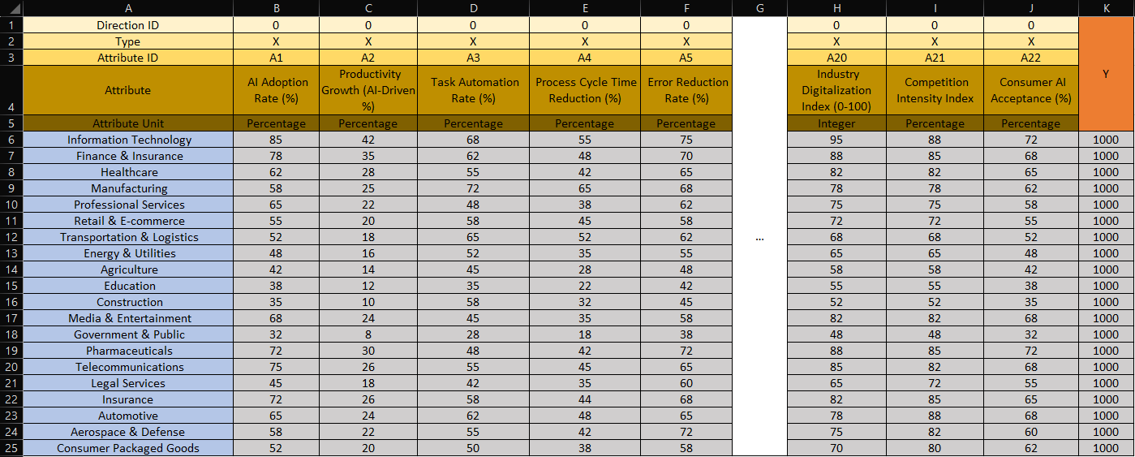
Figure 2 Excel Ranking Formula. Source: Author’s own screen shot for Excel Ranking Formula (https://view.officeapps.live.com/op/view.aspx?src=https%3A%2F%2Fmiau.my-x.hu%2Fmiau%2F328%2Fgb%2FOAM_AI%2520(3).xlsx&wdOrigin=BROWSELINK)
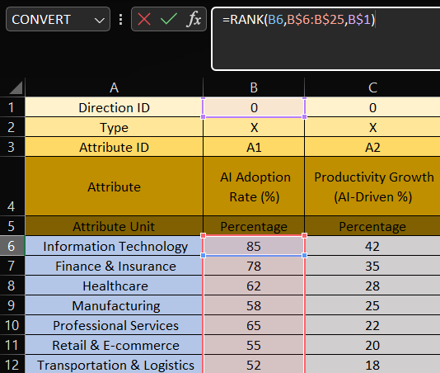

Table 2 Constant Y-value. Source: Author’s example table for Constant Y-value (https://view.officeapps.live.com/op/view.aspx?src=https%3A%2F%2Fmiau.my-x.hu%2Fmiau%2F328%2Fgb%2FOAM_AI%2520(3).xlsx&wdOrigin=BROWSELINK)
Y
1000
1000
1000
1000
1000
1000
1000
1000
1000
1000

Figure 3 Inverse Ranking Formula. Source: Author’s own screenshot for Inverse Ranking Formula (https://view.officeapps.live.com/op/view.aspx?src=https%3A%2F%2Fmiau.my-x.hu%2Fmiau%2F328%2Fgb%2FOAM_AI%2520(3).xlsx&wdOrigin=BROWSELINK)
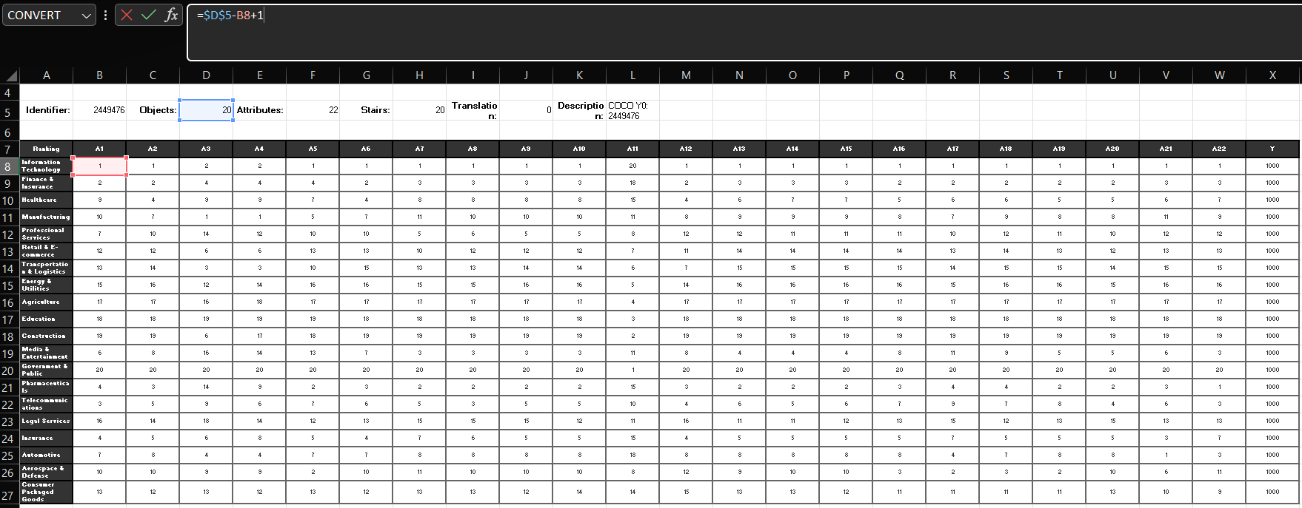
Figure 4 Direct Ranking and Inverse Ranking Validation. Source: Author’s own screenshot for Inverse Ranking (https://view.officeapps.live.com/op/view.aspx?src=https%3A%2F%2Fmiau.my-x.hu%2Fmiau%2F328%2Fgb%2FOAM_AI%2520(3).xlsx&wdOrigin=BROWSELINK)
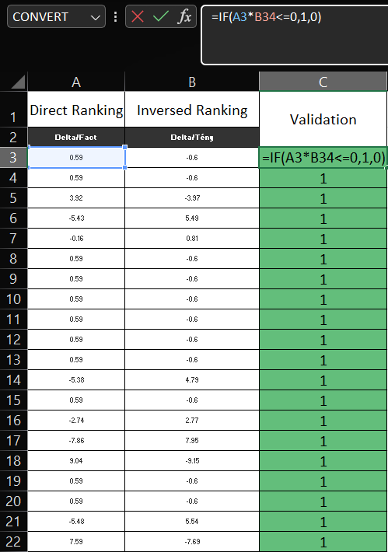
Figure 5 Object Ranking by Using Excel Formula. Source: Author’s own screenshot for Object Ranking (https://view.officeapps.live.com/op/view.aspx?src=https%3A%2F%2Fmiau.my-x.hu%2Fmiau%2F328%2Fgb%2FOAM_AI%2520(3).xlsx&wdOrigin=BROWSELINK)
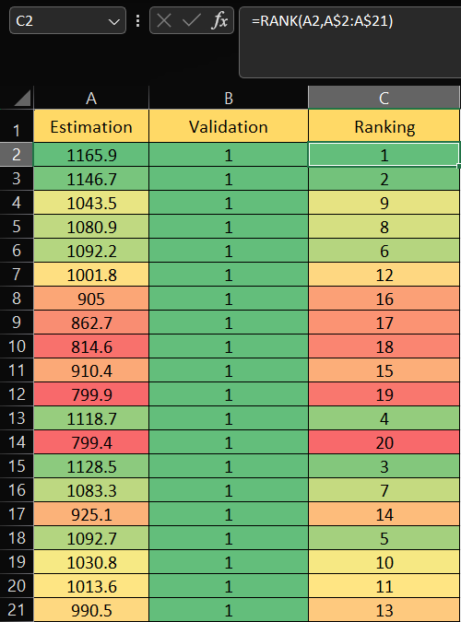
Figure 6 Attribute Exclusion by using Object Numbers-1. Source: Author’s own screenshot for Attribute Exclusion (https://view.officeapps.live.com/op/view.aspx?src=https%3A%2F%2Fmiau.my-x.hu%2Fmiau%2F328%2Fgb%2FOAM_AI%2520(3).xlsx&wdOrigin=BROWSELINK)

Figure 7 COCO Y0 engine interface. Source: Author’s own screenshot of COCO Y0 interface (https://miau.my-x.hu/myx-free/coco/beker_y0.php)


Figure 8 Inserting the data into COCO Y0 engine, Object Naming. Source: Author’s own screenshot for Inserting Data into COCO Y0 (https://miau.my-x.hu/myx-free/coco/beker_y0.php)
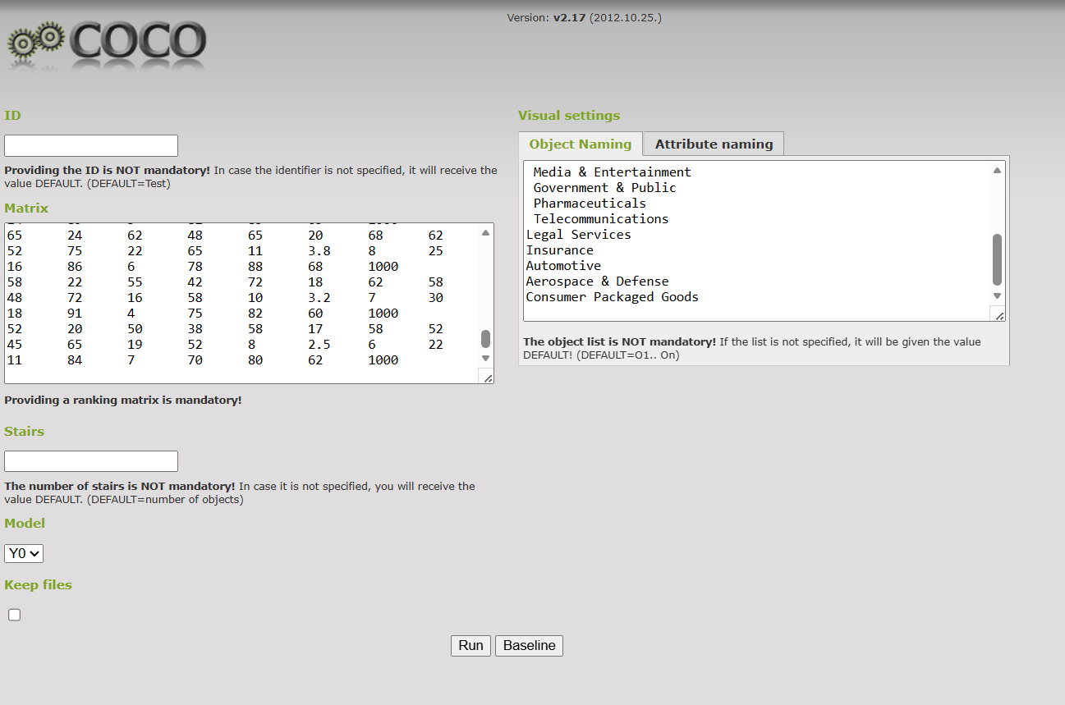
Figure 9 Inserting the data into COCO Y0 engine, Attribute Naming. Source: Author’s own screenshot for Inserting Data into the COCO Y0 (https://miau.my-x.hu/myx-free/coco/beker_y0.php)
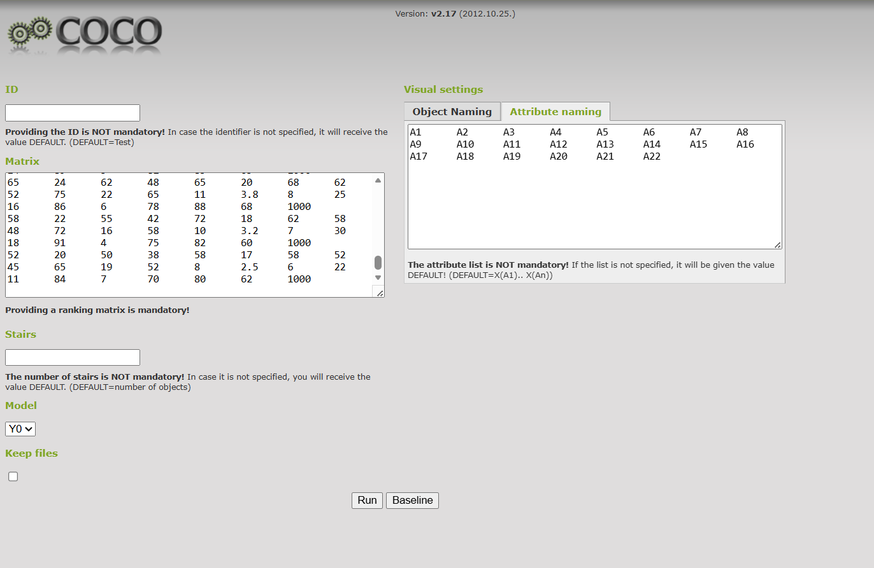
Figure 10 Results, Objects ranked by its estimations. Source: Author’s own screenshot for Results and Object rank (https://view.officeapps.live.com/op/view.aspx?src=https%3A%2F%2Fmiau.my-x.hu%2Fmiau%2F328%2Fgb%2FOAM_AI%2520(3).xlsx&wdOrigin=BROWSELINK)
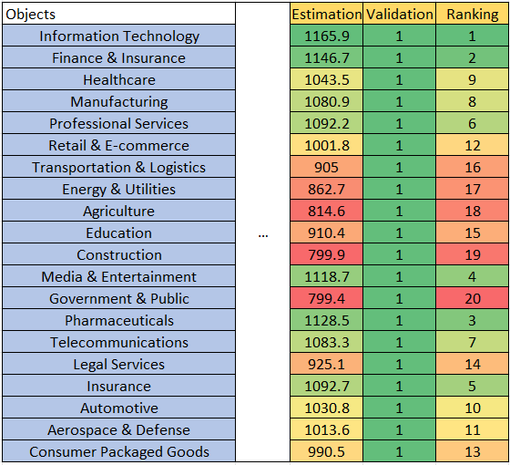
Figure 11 Most contributed sectors by estimation. Source: Author’s own screenshot for Most Contributed Sectors (https://view.officeapps.live.com/op/view.aspx?src=https%3A%2F%2Fmiau.my-x.hu%2Fmiau%2F328%2Fgb%2FOAM_AI%2520(3).xlsx&wdOrigin=BROWSELINK)

Figure 12 User Interface for the Sidebar. Inputs and History section. Source: Author’s own screenshot for UI of the Sidebar (https://oam-coco-automation-boldsukh.streamlit.app/)
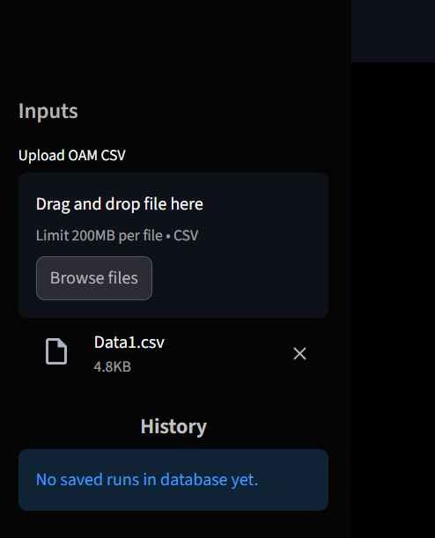
Figure 13 The Main Interface. Source: Author’s own screenshot for the Main Interface (https://oam-coco-automation-boldsukh.streamlit.app/)
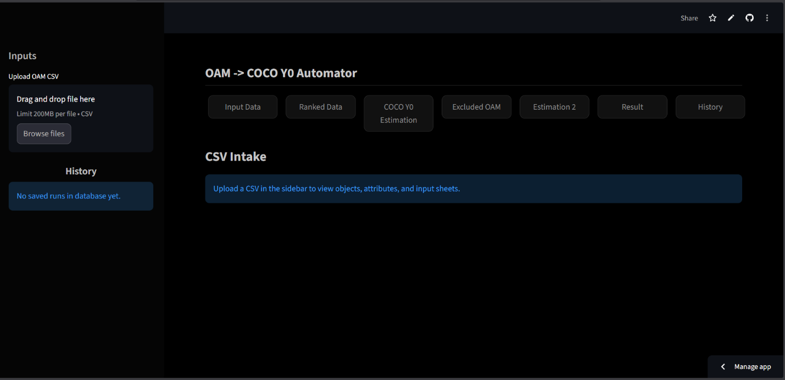
Figure 14 Input Data Page UI. Source: Author’s own screenshot for Input Data Page UI (https://oam-coco-automation-boldsukh.streamlit.app/)
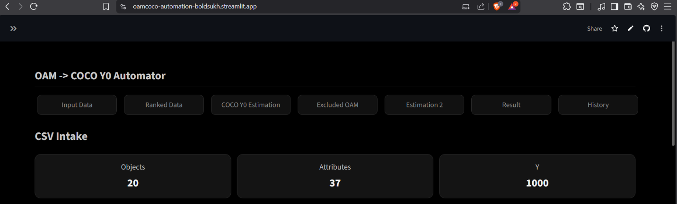
Figure 15 Input Data Page UI. Source: Author’s own screenshot for Input Data Page (https://oam-coco-automation-boldsukh.streamlit.app/)
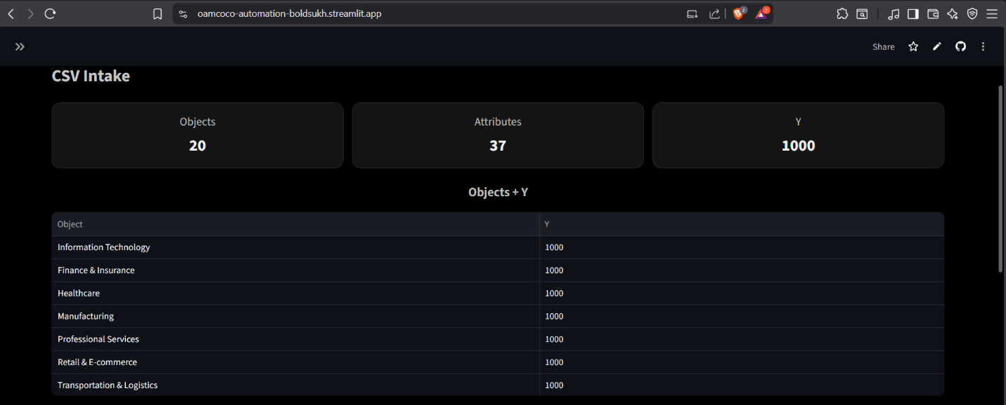
Figure 16 Input Data Page UI. Source: Author’s own screenshot for Input Data Page (https://oam-coco-automation-boldsukh.streamlit.app/)
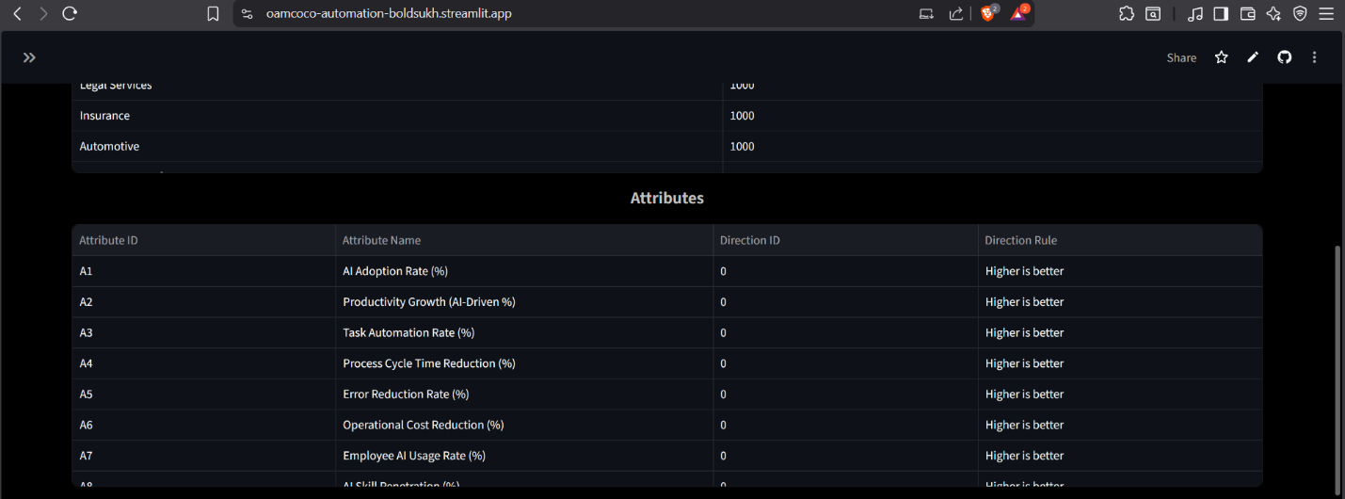
Figure 17 Input Data Page UI. Source: Author’s own screenshot for Input Data Page UI (https://oam-coco-automation-boldsukh.streamlit.app/)
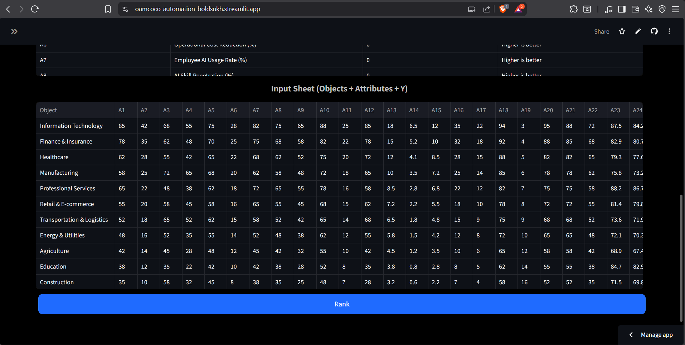
Figure 18 Ranked Data Page UI. Source: Author’s own screenshot for Ranked Data Page (https://oam-coco-automation-boldsukh.streamlit.app/)
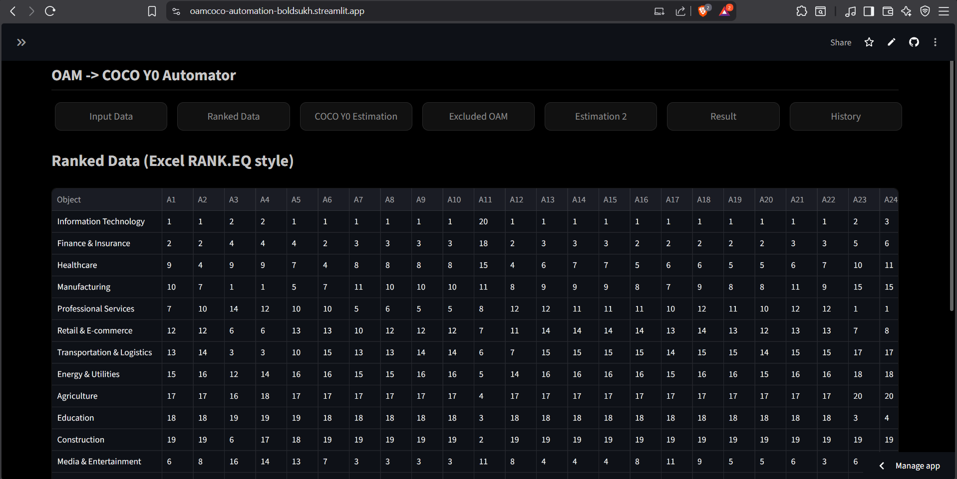
Figure 19 Ranked Data Page UI. Source: Author’s own screenshot for Ranked Data Page UI (https://oam-coco-automation-boldsukh.streamlit.app/)

Figure 20 COCO Y0 Estimation Page UI. Source: Author’s own screenshot for COCO Y0 Estimation Page UI (https://oam-coco-automation-boldsukh.streamlit.app/)
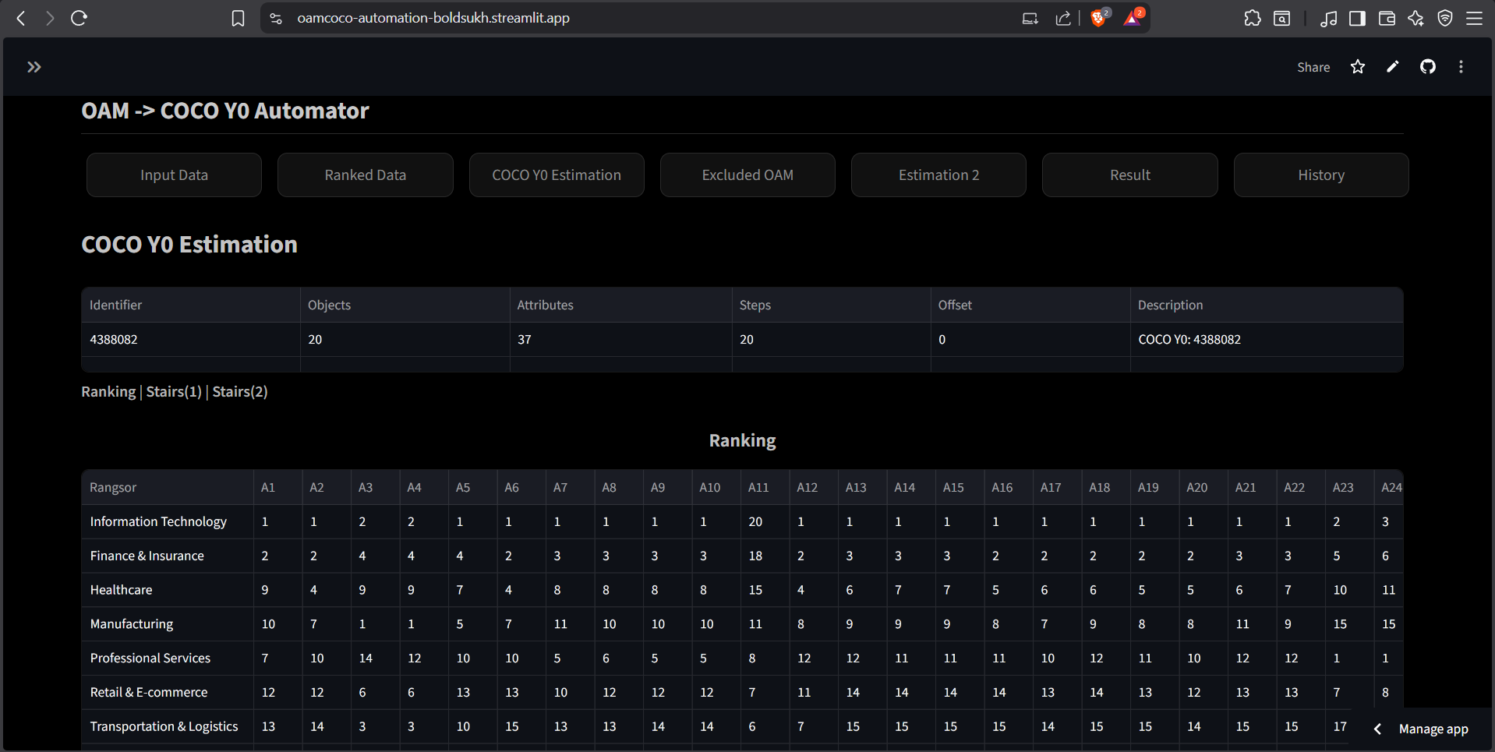
Figure 21 COCO Y0 Estimation Page UI. Source: Author’s own screenshot for COCO Y0 Estimation Page UI (https://oam-coco-automation-boldsukh.streamlit.app/)
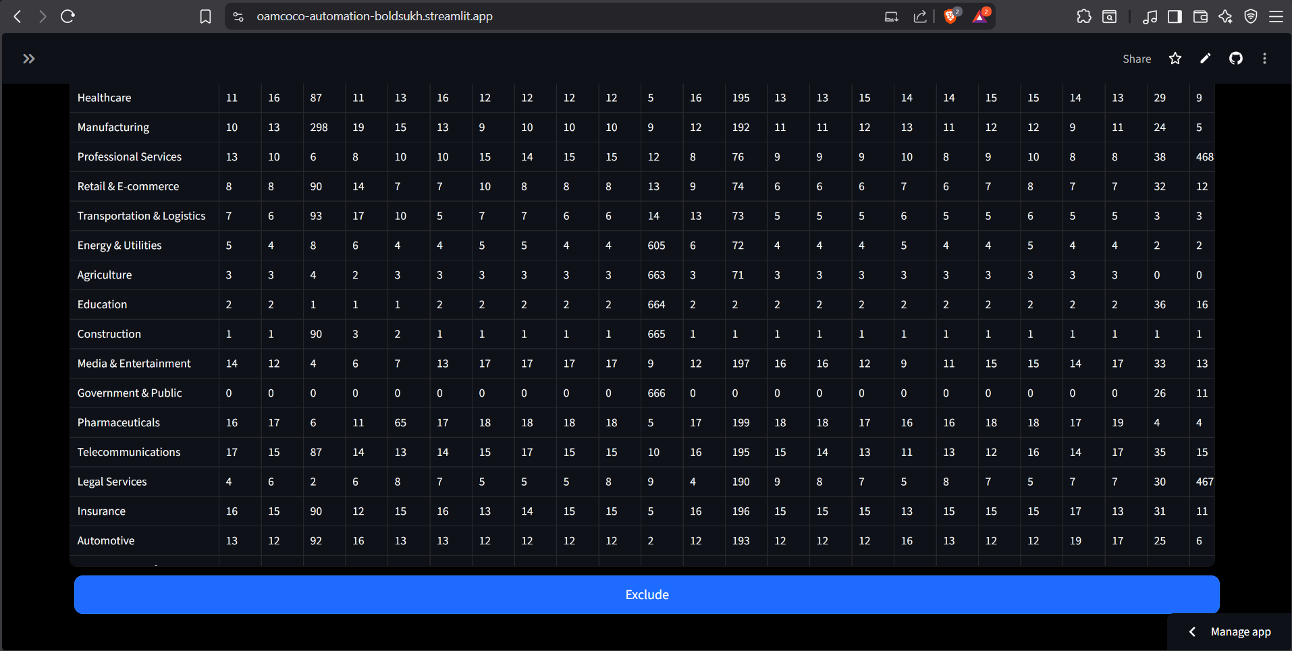
Figure 22 Excluded OAM Page UI. Source: Author’s own screenshot for Excluded OAM Page UI (https://oam-coco-automation-boldsukh.streamlit.app/)
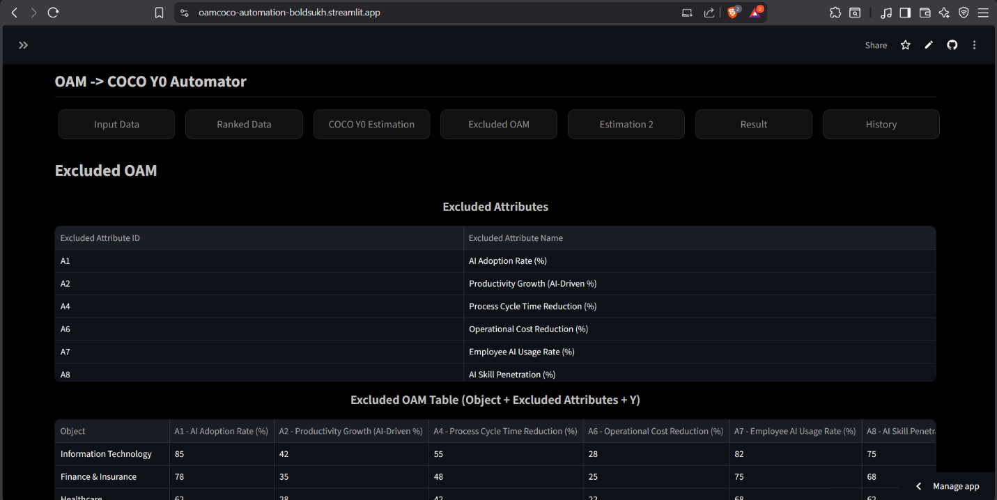
Figure 23 Excluded OAM Page UI. Source: Author’s own screenshot for Excluded OAM Page UI (https://oam-coco-automation-boldsukh.streamlit.app/)

Figure 24 Estimation 2 Page UI. Source: Author’s own screenshot for Estimation 2 Page UI (https://oam-coco-automation-boldsukh.streamlit.app/)
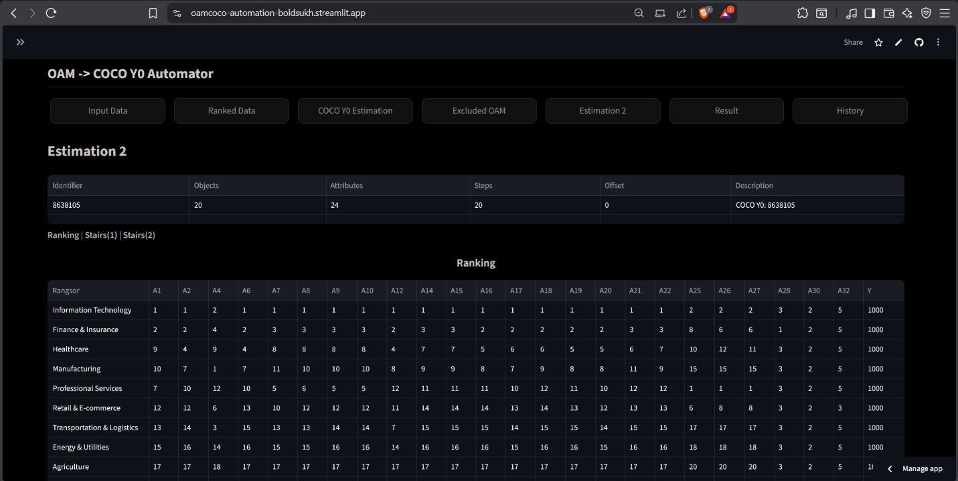
Figure 25 Estimation 2 Page UI. Source: Author’s own screenshot for Estimation 2 Page UI (https://oam-coco-automation-boldsukh.streamlit.app/)

Figure 26 Result Page UI. Source: Author’s own screenshot for Result Page UI (https://oam-coco-automation-boldsukh.streamlit.app/)
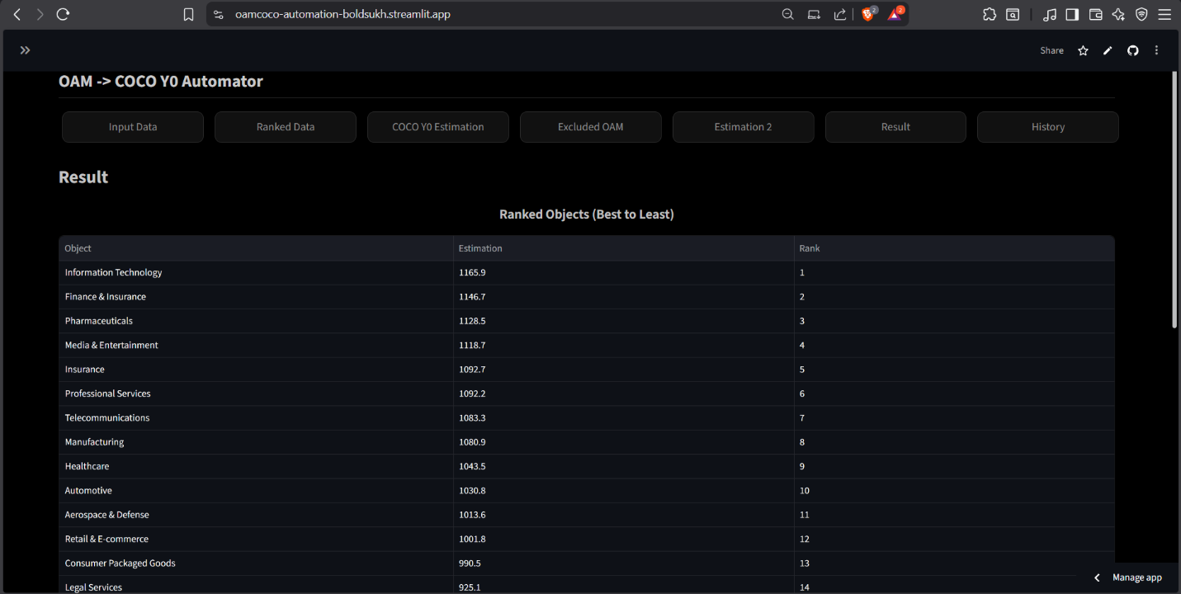
Figure 27 Result Page UI, Graph. Source: Author’s own screenshot for Result Page UI, Graph (https://oam-coco-automation-boldsukh.streamlit.app/)
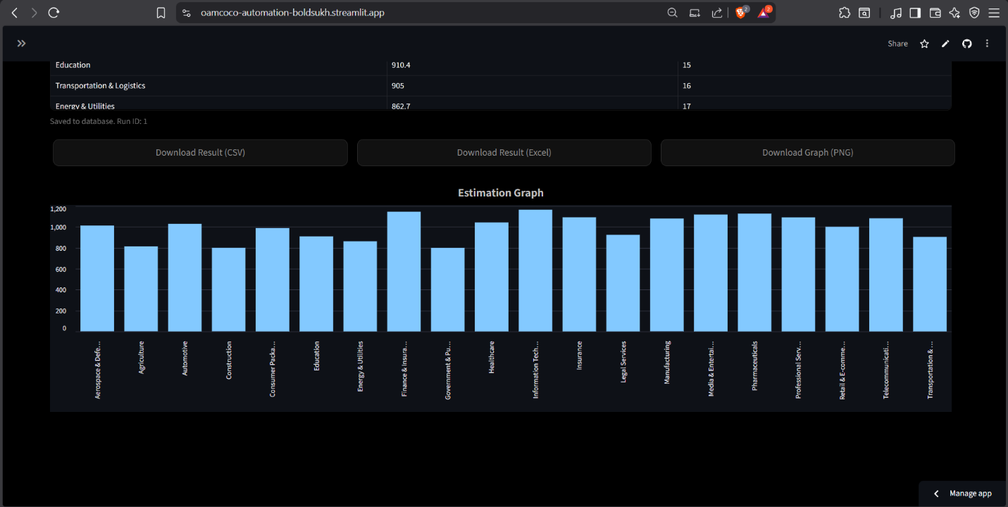
Figure 28 History Page UI. Source: Author’s own screenshot for History Page UI (https://oam-coco-automation-boldsukh.streamlit.app/)
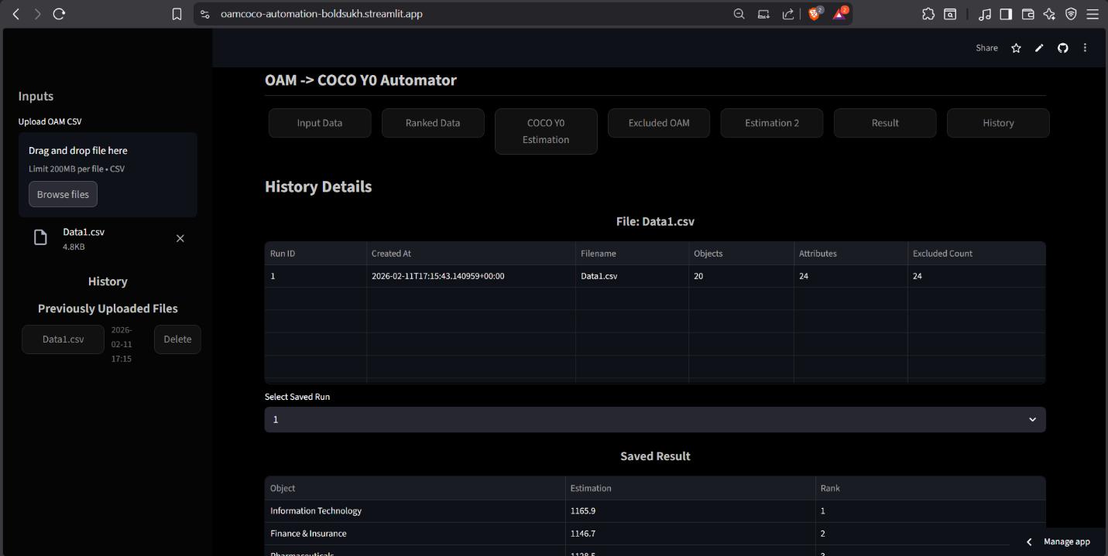
Figure 29 Detailed Example Structure of OAM that saved as CSV file. Source: Author’s own screenshot for Example Structure of OAM
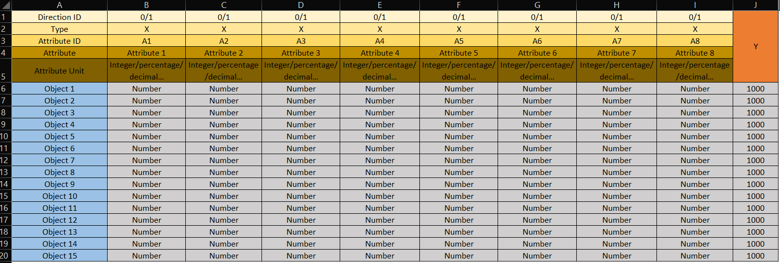

References

Bibliography
Bálint Kovács, & László Pitlik. (2025). AiFusion: A Collaborative AI Testing Platform and the Emergence of AI Self-Criticism. https://miau.my-x.hu/miau/323/judging/FullText_BalintKovacs_Ahi%20Evran18-05-2025_SESSION3-HALL6_AI-SELF-CRITICISM.pdf
Bass, Len., Clements, Paul., & Kazman, Rick. (2013). Software architecture in practice. Addison-Wesley. https://www.researchgate.net/publication/224001127_Software_Architecture_In_Practice
BECSEI JÓZSEF, DUGASZ LILI, FEKETE IBOLYA, GULYÁS EMESE ZSANETT, HORVÁTH GÉZA, ISPÁN TÍMEA M., KISSNÉ HUSZÁR BEÁTA, KÓNYA KITTI MÓNIKA, KULCSÁR-TÓTH CSILLA, MALATYINSZKI SZILÁRD, MINDLER ÁGNES, NAGY ÁKOS GÁBOR, NGAMBA, D. E., SZABÓ MÁTÉ GÁBOR, SZABÓ PÉTER, & TÉNYI VIRÁG. (2024). Új eszközök a szervezeti kultúrában és versenyképességben. In KODOLÁNYI JÁNOS EGYETEM. https://backend.kodolanyi.hu/images/tartalom/File/mtmt-35434234_v.17.pdf
Bresnahan, T. F., Brynjolfsson, E., & Hitt, L. M. (2002). Information Technology, Workplace Organization, and the Demand for Skilled Labor: Firm-Level Evidence. The Quarterly Journal of Economics, 117(1), 339–376. https://doi.org/10.1162/003355302753399526
Brynjolfsson, E., Li, D., & Raymond, L. (2025). Generative AI at Work. The Quarterly Journal of Economics, 140(2), 889–942. https://doi.org/10.1093/qje/qjae044
Brynjolfsson, E., Rock, D., & Syverson, C. (2017). Artificial Intelligence and the Modern Productivity Paradox: A Clash of Expectations and Statistics. https://doi.org/10.3386/w24001
Brynjolfsson, E., Rock, D., & Syverson, C. (2021a). The Productivity J-Curve: How Intangibles Complement General Purpose Technologies. American Economic Journal: Macroeconomics, 13(1), 333–372. https://doi.org/10.1257/mac.20180386
Brynjolfsson, E., Rock, D., & Syverson, C. (2021b). The Productivity J-Curve: How Intangibles Complement General Purpose Technologies. American Economic Journal: Macroeconomics, 13(1), 333–372. https://doi.org/10.1257/mac.20180386
Brynjolfsson, Erik., & McAfee, Andrew. (2016). The second machine age : work, progress, and prosperity in a time of brilliant technologies. W. W. Norton & Company. https://wwnorton.com/books/the-second-machine-age/
Butor Klára, Folmeg Márta, Hervainé, Dr. S. G., Dr. Hoffmann Orsolya, P., Dr. Majorosi Anna, P., Müller Vanessa, Dr. Mócz Dóra, P., Dr.N.Kovács Tímea, P., Dr. Schuchmann Júlia, P., Somorjai Noémi, Szondy Réka, Dr. Torgyik Judit, P., Vidó Judit, & Vincze Viktória. (2016). A közösségfejlesztés új útjai. Kodolányi János Főiskola. https://backend.kodolanyi.hu/images/tartalom/File/kiadvanyok/kozossegfejlesztes.pdf
Constructing Valid Geospatial Tools for Environmental Justice. (2024). National Academies Press. https://doi.org/10.17226/27317
Cormen, T. H. ., Leiserson, C. Eric., Rivest, R. L. ., & Stein, Clifford. (2009). Introduction to algorithms. MIT Press. https://mitpress.mit.edu/9780262533058/introduction-to-algorithms/
Corrente, S., Figueira, J. R., Greco, S., & Słowiński, R. (2021a). Multiple Criteria Decision Support. In Handbook of Group Decision and Negotiation (pp. 893–920). Springer International Publishing. https://doi.org/10.1007/978-3-030-49629-6_33
Corrente, S., Figueira, J. R., Greco, S., & Słowiński, R. (2021b). Multiple Criteria Decision Support. In Handbook of Group Decision and Negotiation (pp. 893–920). Springer International Publishing. https://doi.org/10.1007/978-3-030-49629-6_33
Dániel Czúni, Gyöngyi Bánkuti, & László Pitlik. (n.d.). INTRODUCTION OF A TEXT MINING-BASED DECISION SUPPORT TECHNIQUE. Retrieved March 22, 2026, from https://view.officeapps.live.com/op/view.aspx?src=https%3A%2F%2Fmiau.my-x.hu%2Fmiau%2F297%2Fczuni_03_10_full.docx&wdOrigin=BROWSELINK
Dell’Acqua, F., McFowland, E., Mollick, E. R., Lifshitz-Assaf, H., Kellogg, K., Rajendran, S., Krayer, L., Candelon, F., & Lakhani, K. R. (2023). Navigating the Jagged Technological Frontier: Field Experimental Evidence of the Effects of AI on Knowledge Worker Productivity and Quality. SSRN Electronic Journal. https://doi.org/10.2139/ssrn.4573321
Di Tommaso, P., Chatzou, M., Floden, E. W., Barja, P. P., Palumbo, E., & Notredame, C. (2017). Nextflow enables reproducible computational workflows. Nature Biotechnology, 35(4), 316–319. https://doi.org/10.1038/nbt.3820
DiMaggio, P., & Powell, W. W. (2010). The Iron Cage Revisited: Institutional Isomorphism and Collective Rationality in Organizational Fields (translated by G. Yudin). Journal of Economic Sociology, 11(1), 34–56. https://doi.org/10.17323/1726-3247-2010-1-34-56
Drucker, P. F. (1999). Knowledge-Worker Productivity: The Biggest Challenge. California Management Review, 41(2), 79–94. https://doi.org/10.2307/41165987
Dumas, M., La Rosa, M., Mendling, J., & Reijers, H. A. (2018). Fundamentals of Business Process Management. Springer Berlin Heidelberg. https://doi.org/10.1007/978-3-662-56509-4
Eloundou, T., Manning, S., Mishkin, P., & Rock, D. (2023). GPTs are GPTs: An Early Look at the Labor Market Impact Potential of Large Language Models. https://arxiv.org/abs/2303.10130
EUR-Lex. (2024). Rules for trustworthy artificial intelligence in the EU. https://eur-lex.europa.eu/EN/legal-content/summary/rules-for-trustworthy-artificial-intelligence-in-the-eu.html
Európai Parlament. (2020, September 4). Mi az a mesterséges intelligencia és mire használják? https://www.europarl.europa.eu/topics/hu/article/20200827STO85804/mi-az-a-mesterseges-intelligencia-es-mire-hasznaljak
Figueira, J., Greco, S., & Ehrogott, M. (2005). Multiple Criteria Decision Analysis: State of the Art Surveys (Vol. 78). Springer New York. https://doi.org/10.1007/b100605
Floyd, T. L. . (2018). Electronic devices : conventional current version. Pearson. https://www.pearson.com/en-us/subject-catalog/p/electronic-devices-conventional-current-version/P200000001047/9780137526642
Gyula Bán, János Rikk, & László Pitlik. (2024). AI-based derivation of the importance of attributes in case of evaluation models. https://view.officeapps.live.com/op/view.aspx?src=https%3A%2F%2Fmiau.my-x.hu%2Fmiau%2F314%2Ffull_importance_of_attributes_in_evaluation_models.docx&wdOrigin=BROWSELINK
Hager, P., Jungmann, F., Holland, R., Bhagat, K., Hubrecht, I., Knauer, M., Vielhauer, J., Makowski, M., Braren, R., Kaissis, G., & Rueckert, D. (2024). Evaluation and mitigation of the limitations of large language models in clinical decision-making. Nature Medicine, 30(9), 2613–2622. https://doi.org/10.1038/s41591-024-03097-1
Handbook on Constructing Composite Indicators: Methodology and User Guide. (2008). OECD. https://doi.org/10.1787/9789264043466-en
Hofstede, Geert., Hofstede, G. Jan., & Minkov, Michael. (2010). Cultures and organizations : software of the mind : intercultural cooperation and its importance for survival. McGraw-Hill. https://www.mheducation.com/highered/mhp/product/cultures-organizations-software-mind-third-edition.html?viewOption=student
Jumper, J., Evans, R., Pritzel, A., Green, T., Figurnov, M., Ronneberger, O., Tunyasuvunakool, K., Bates, R., Žídek, A., Potapenko, A., Bridgland, A., Meyer, C., Kohl, S. A. A., Ballard, A. J., Cowie, A., Romera-Paredes, B., Nikolov, S., Jain, R., Adler, J., … Hassabis, D. (2021). Highly accurate protein structure prediction with AlphaFold. Nature, 596(7873), 583–589. https://doi.org/10.1038/s41586-021-03819-2
KáVé. (2025, February 2). HR Akadémia a Kodolányin. https://www.kodolanyi.hu/kv/cikk/hr-akademia-a-kodolanyin-1809
Kommunikációs Főigazgatóság. (2024, August 1). Hatályba lépett a mesterséges intelligenciáról szóló jogszabály. Sajtócikk. https://commission.europa.eu/news-and-media/news/ai-act-enters-force-2024-08-01_hu
Lam, E., Maury, T., Preiss, S., Hou, Y., Frey, H., Barillari, C., & Laveille, P. (2025). General data management workflow to process tabular data in automated and high-throughput heterogeneous catalysis research. Digital Discovery, 4(2), 539–547. https://doi.org/10.1039/D4DD00350K
László Pitlik. (n.d.). Component-based Object Comparison for Objectivity. Retrieved March 22, 2026, from https://gil-net.de/Publikationen/17_197.pdf
Myers, G. J. ., Sandler, Corey., & Badgett, Tom. (2012). The art of software testing. John Wiley & Sons. https://www.wiley.com/en-in/The+Art+of+Software+Testing%2C+3rd+Edition-p-9781119202486
My-X Team. (n.d.). My-X similarity-analysis handbook. Retrieved March 22, 2026, from https://miau.my-x.hu/miau/196/My-X%20Team_A5%20fuzet_EN_jav.pdf
Nalgozhina, N., Razaque, A., Raissa, U., & Yoo, J. (2023). Developing Robotic Process Automation to Efficiently Integrate Long-Term Business Process Management. Technologies, 11(6), 164. https://doi.org/10.3390/technologies11060164
Noy, S., & Zhang, W. (2023). Experimental evidence on the productivity effects of generative artificial intelligence. Science, 381(6654), 187–192. https://doi.org/10.1126/science.adh2586
OECD. (2008). Handbook on Constructing Composite Indicators: Methodology and User Guide. OECD. https://doi.org/10.1787/9789264043466-en
OECD. (2023). AI principles. https://www.oecd.org/en/topics/ai-principles.html
OECD., Organisation for Economic Co-operation and Development, ., & Ward, Denis. (2007). Data and Metadata Reporting and Presentation Handbook. Organisation for Economic Co-operation and Development. https://tile.loc.gov/storage-services/master/gdc/gdcebookspublic/20/21/76/29/44/2021762944/2021762944.pdf
Oliveira, B., & Oliveira, Ó. (2025). Developing Data Workflows: From Conceptual Blueprints to Physical Implementation. Data, 10(7), 97. https://doi.org/10.3390/data10070097
Peppard, Joe., & Ward, John. (2016). The strategic management of information systems : building a digital strategy. Wiley. https://www.wiley.com/en-it/The+Strategic+Management+of+Information+Systems%3A+Building+a+Digital+Strategy%2C+4th+Edition-p-9780470034675
Pitlik, L., & Gyongyi Bankuti. (2010). About the method of Component-based Object Comparison for Objectivity (COCO). Magyar Internetes Agrárinformatikai Újság (MIAÚ), 13. https://www.researchgate.net/publication/270576061_About_the_method_of_Component-based_Object_Comparison_for_Objectivity_COCO
Pitlik, L., & Zoltán, V. (2015, March). The operationalism of sustainability is a mathematical issue. https://www.researchgate.net/publication/284282845_The_operationalism_of_sustainability_is_a_mathematical_issue
Porter, N. W., Salko, R. K., & Pilch, M. (2020). Development and implementation of a CTF code verification suite. Nuclear Engineering and Design, 370, 110879. https://doi.org/10.1016/j.nucengdes.2020.110879
Robert M. Solow. (1987). We’d Better Watch Out. In New York Times Book Review. New York Times. http://digamo.free.fr/solow87.pdf
Roy, B. (1996). Multicriteria Methodology for Decision Aiding (Vol. 12). Springer US. https://doi.org/10.1007/978-1-4757-2500-1
Sandve, G. K., Nekrutenko, A., Taylor, J., & Hovig, E. (2013). Ten Simple Rules for Reproducible Computational Research. PLoS Computational Biology, 9(10), e1003285. https://doi.org/10.1371/journal.pcbi.1003285
Sebesta, R. W. . (2019). Concepts of programming languages. Pearson. https://www.pearson.com/en-us/subject-catalog/p/concepts-of-programming-languages/P200000003361/9780134997186
Sedra, A. S. ., & Smith, K. C. . (2015). Microelectronic circuits. Oxford University Press. https://global.oup.com/ukhe/product/microelectronic-circuits-9780190853501?cc=us&lang=en
Silberschatz, Abraham., Korth, H. F. ., & Sudarshan, S. . (2020). Database system concepts. McGraw-Hill. http://eng1.mu.edu.tr/~pembeci/tmp/Korth/DBMS%20Korth-%20Solution.pdf
Slack, Nigel., & Brandon-Jones, Alistair. (2019). Operations management. Pearson. https://www.pearson.com/se/Nordics-Higher-Education/subject-catalogue/decision-science/slack-operations-management-9thedition.html
Sommerville, Ian. (2016). Software engineering. Pearson. https://www.pearson.com/en-us/subject-catalog/p/software-engineering/P200000003258/9780133943030
Stallings, William. (2018). Computer security : principles and practice. Pearson. https://www.pearson.com/en-us/subject-catalog/p/computer-security-principles-and-practice/P200000010333/9780138091712
Stefán, I. (2025). A mesterséges intelligencia munkahelyi alkalmazása és annak hatása a munkavállalók alapjogaira. Publicationes Universitatis Miskolcinensis, Sectio Juridica et Politica, 43(1), 255–271. https://doi.org/10.32978/sjp.2025.013
Sterman, John. (2000). Business dynamics : systems thinking and modeling for a complex world. Irwin/McGraw-Hill. https://www.mheducation.com/highered/product/business-dynamics-sterman.html?viewOption=student
Stewart, James. (2016). Single variable calculus : early transcendentals. Cengage Learning. https://www.cengage.com/c/calculus-early-transcendentals-8e-stewart/9781285741550/
Stiglitz, J. E. . (2003). Globalization and its discontents. W.W. Norton. https://wwnorton.com/books/globalization-and-its-discontents/
Stoudt, S., Vásquez, V. N., & Martinez, C. C. (2021). Principles for data analysis workflows. PLOS Computational Biology, 17(3), e1008770. https://doi.org/10.1371/journal.pcbi.1008770
Tabassi, E. (2023). Artificial Intelligence Risk Management Framework (AI RMF 1.0). https://doi.org/10.6028/NIST.AI.100-1
Tanenbaum, A. S. ., Feamster, Nickolas., & Wetherall, D. . (2021). Computer networks. Pearson. https://www.pearson.com/en-us/subject-catalog/p/computer-networks/P200000003188/9780136764052
Thomas H. Davenport, & Julia Kirby. (2016, March 15). Just How Smart Are Smart Machines? MIT Sloan Management Review. https://sloanreview.mit.edu/article/just-how-smart-are-smart-machines/
Tomori Pál Főiskola. (2018). TUDOMÁNYOS MOZAIK 14. kötet. https://miau.my-x.hu/miau/229/enyedi2/Tud_Mozaik_14.pdf
Tufte. E. R. (2001). The visual display of quantitative informations 2nd ed. Graphics Press. https://www.edwardtufte.com/book/the-visual-display-of-quantitative-information/
Viceconti, M., Pappalardo, F., Rodriguez, B., Horner, M., Bischoff, J., & Musuamba Tshinanu, F. (2021). In silico trials: Verification, validation and uncertainty quantification of predictive models used in the regulatory evaluation of biomedical products. Methods, 185, 120–127. https://doi.org/10.1016/j.ymeth.2020.01.011
Wu, S., Irsoy, O., Lu, S., Dabravolski, V., Dredze, M., Gehrmann, S., Kambadur, P., Rosenberg, D., & Mann, G. (2023). BloombergGPT: A Large Language Model for Finance. https://arxiv.org/abs/2303.17564

Types
T01: new, English, article, not-KJU
Brynjolfsson, E., Li, D., & Raymond, L. (2025). Generative AI at Work. The Quarterly Journal of Economics, 140(2), 889–942. https://doi.org/10.1093/qje/qjae044
Brynjolfsson, E., Rock, D., & Syverson, C. (2021a). The Productivity J-Curve: How Intangibles Complement General Purpose Technologies. American Economic Journal: Macroeconomics, 13(1), 333–372. https://doi.org/10.1257/mac.20180386
Brynjolfsson, E., Rock, D., & Syverson, C. (2021b). The Productivity J-Curve: How Intangibles Complement General Purpose Technologies. American Economic Journal: Macroeconomics, 13(1), 333–372. https://doi.org/10.1257/mac.20180386
Constructing Valid Geospatial Tools for Environmental Justice. (2024). National Academies Press. https://doi.org/10.17226/27317
Corrente, S., Figueira, J. R., Greco, S., & Słowiński, R. (2021a). Multiple Criteria Decision Support. In Handbook of Group Decision and Negotiation (pp. 893–920). Springer International Publishing. https://doi.org/10.1007/978-3-030-49629-6_33
Corrente, S., Figueira, J. R., Greco, S., & Słowiński, R. (2021b). Multiple Criteria Decision Support. In Handbook of Group Decision and Negotiation (pp. 893–920). Springer International Publishing. https://doi.org/10.1007/978-3-030-49629-6_33
Dell’Acqua, F., McFowland, E., Mollick, E. R., Lifshitz-Assaf, H., Kellogg, K., Rajendran, S., Krayer, L., Candelon, F., & Lakhani, K. R. (2023). Navigating the Jagged Technological Frontier: Field Experimental Evidence of the Effects of AI on Knowledge Worker Productivity and Quality. SSRN Electronic Journal. https://doi.org/10.2139/ssrn.4573321
Eloundou, T., Manning, S., Mishkin, P., & Rock, D. (2023). GPTs are GPTs: An Early Look at the Labor Market Impact Potential of Large Language Models. https://arxiv.org/abs/2303.10130
Hager, P., Jungmann, F., Holland, R., Bhagat, K., Hubrecht, I., Knauer, M., Vielhauer, J., Makowski, M., Braren, R., Kaissis, G., & Rueckert, D. (2024). Evaluation and mitigation of the limitations of large language models in clinical decision-making. Nature Medicine, 30(9), 2613–2622. https://doi.org/10.1038/s41591-024-03097-1
Jumper, J., Evans, R., Pritzel, A., Green, T., Figurnov, M., Ronneberger, O., Tunyasuvunakool, K., Bates, R., Žídek, A., Potapenko, A., Bridgland, A., Meyer, C., Kohl, S. A. A., Ballard, A. J., Cowie, A., Romera-Paredes, B., Nikolov, S., Jain, R., Adler, J., … Hassabis, D. (2021). Highly accurate protein structure prediction with AlphaFold. Nature, 596(7873), 583–589. https://doi.org/10.1038/s41586-021-03819-2
Lam, E., Maury, T., Preiss, S., Hou, Y., Frey, H., Barillari, C., & Laveille, P. (2025). General data management workflow to process tabular data in automated and high-throughput heterogeneous catalysis research. Digital Discovery, 4(2), 539–547. https://doi.org/10.1039/D4DD00350K
Nalgozhina, N., Razaque, A., Raissa, U., & Yoo, J. (2023). Developing Robotic Process Automation to Efficiently Integrate Long-Term Business Process Management. Technologies, 11(6), 164. https://doi.org/10.3390/technologies11060164
Noy, S., & Zhang, W. (2023). Experimental evidence on the productivity effects of generative artificial intelligence. Science, 381(6654), 187–192. https://doi.org/10.1126/science.adh2586
Oliveira, B., & Oliveira, Ó. (2025). Developing Data Workflows: From Conceptual Blueprints to Physical Implementation. Data, 10(7), 97. https://doi.org/10.3390/data10070097
Stoudt, S., Vásquez, V. N., & Martinez, C. C. (2021). Principles for data analysis workflows. PLOS Computational Biology, 17(3), e1008770. https://doi.org/10.1371/journal.pcbi.1008770
Tabassi, E. (2023). Artificial Intelligence Risk Management Framework (AI RMF 1.0). https://doi.org/10.6028/NIST.AI.100-1
Tanenbaum, A. S. ., Feamster, Nickolas., & Wetherall, D. . (2021). Computer networks. Pearson. https://www.pearson.com/en-us/subject-catalog/p/computer-networks/P200000003188/9780136764052
Viceconti, M., Pappalardo, F., Rodriguez, B., Horner, M., Bischoff, J., & Musuamba Tshinanu, F. (2021). In silico trials: Verification, validation and uncertainty quantification of predictive models used in the regulatory evaluation of biomedical products. Methods, 185, 120–127. https://doi.org/10.1016/j.ymeth.2020.01.011
Wu, S., Irsoy, O., Lu, S., Dabravolski, V., Dredze, M., Gehrmann, S., Kambadur, P., Rosenberg, D., & Mann, G. (2023). BloombergGPT: A Large Language Model for Finance. https://arxiv.org/abs/2303.17564
T02: new, English, article, KJU
Dániel Czúni, Gyöngyi Bánkuti, & László Pitlik. (n.d.). INTRODUCTION OF A TEXT MINING-BASED DECISION SUPPORT TECHNIQUE. Retrieved March 22, 2026, from https://view.officeapps.live.com/op/view.aspx?src=https%3A%2F%2Fmiau.my-x.hu%2Fmiau%2F297%2Fczuni_03_10_full.docx&wdOrigin=BROWSELINK
Gyula Bán, János Rikk, & László Pitlik. (n.d.). AI-based derivation of the importance of attributes in case of evaluation models. Retrieved March 22, 2026, from https://view.officeapps.live.com/op/view.aspx?src=https%3A%2F%2Fmiau.my-x.hu%2Fmiau%2F314%2Ffull_importance_of_attributes_in_evaluation_models.docx&wdOrigin=BROWSELINK
T03: new, English, webpage, not-KJU
https://oam-coco-automation-boldsukh.streamlit.app/
https://github.com
https://streamlit.io
https://github.com/Bobylzgono/COCO_OAM_Automation.git
EUR-Lex. (2024). Rules for trustworthy artificial intelligence in the EU. https://eur-lex.europa.eu/EN/legal-content/summary/rules-for-trustworthy-artificial-intelligence-in-the-eu.html
OECD. (2023). AI principles. https://www.oecd.org/en/topics/ai-principles.html
T04: new, English, webpage, KJU
Kovács, B. (2025). AiFusion: A Collaborative AI Testing Platform and the Emergence of AI Self-Criticism. Source: https://miau.my-x.hu/miau/323/judging/FullText_BalintKovacs_Ahi%20Evran18-05-2025_SESSION3-HALL6_AI-SELF-CRITICISM.pdf
T05: new, not-English, article, not-KJU
Stefán, I. (2025). A mesterséges intelligencia munkahelyi alkalmazása és annak hatása a munkavállalók alapjogaira. Publicationes Universitatis Miskolcinensis Sectio Juridica et Politica, 43(1), 255–271. DOI: 10.32978/sjp.2025.013. Source: https://ojs.uni-miskolc.hu/index.php/juridicaetpolitica/article/download/4201/3026/17314
T06: new, not-English, article, KJU
Kissné Huszár, B. (2024). Átalakuló munkahelyek, generációk a robotok világában. In S. Malatyinszki, J. Róka, & B. G. Kálmán (Eds.), Új eszközök a szervezeti kultúrában és versenyképességben. Kodolányi János Egyetem Gazdaságtudományi Kar. Source: https://backend.kodolanyi.hu/images/tartalom/File/mtmt-35434234_v.17.pdf
T07: new, not-English, webpage, not-KJU
Kommunikációs Főigazgatóság. (2024, August 1). Hatályba lépett a mesterséges intelligenciáról szóló jogszabály. Sajtócikk. https://commission.europa.eu/news-and-media/news/ai-act-enters-force-2024-08-01_hu
T08: new, not-English, webpage, KJU
KáVé. (2025, February 2). HR Akadémia a Kodolányin. Kodolányisok világa. Source: https://www.kodolanyi.hu/kv/cikk/hr-akademia-a-kodolanyin-1809
T09: old, English, article, not-KJU
Bass, Len., Clements, Paul., & Kazman, Rick. (2013). Software architecture in practice. Addison-Wesley. https://www.researchgate.net/publication/224001127_Software_Architecture_In_Practice
Bresnahan, T. F., Brynjolfsson, E., & Hitt, L. M. (2002). Information Technology, Workplace Organization, and the Demand for Skilled Labor: Firm-Level Evidence. The Quarterly Journal of Economics, 117(1), 339–376. https://doi.org/10.1162/003355302753399526
Brynjolfsson, E., Rock, D., & Syverson, C. (2017). Artificial Intelligence and the Modern Productivity Paradox: A Clash of Expectations and Statistics. https://doi.org/10.3386/w24001
Brynjolfsson, Erik., & McAfee, Andrew. (2016). The second machine age : work, progress, and prosperity in a time of brilliant technologies. W. W. Norton & Company. https://wwnorton.com/books/the-second-machine-age/
Cormen, T. H. ., Leiserson, C. Eric., Rivest, R. L. ., & Stein, Clifford. (2009). Introduction to algorithms. MIT Press. https://mitpress.mit.edu/9780262533058/introduction-to-algorithms/
Di Tommaso, P., Chatzou, M., Floden, E. W., Barja, P. P., Palumbo, E., & Notredame, C. (2017). Nextflow enables reproducible computational workflows. Nature Biotechnology, 35(4), 316–319. https://doi.org/10.1038/nbt.3820
DiMaggio, P., & Powell, W. W. (2010). The Iron Cage Revisited: Institutional Isomorphism and Collective Rationality in Organizational Fields (translated by G. Yudin). Journal of Economic Sociology, 11(1), 34–56. https://doi.org/10.17323/1726-3247-2010-1-34-56
Drucker, P. F. (1999). Knowledge-Worker Productivity: The Biggest Challenge. California Management Review, 41(2), 79–94. https://doi.org/10.2307/41165987
Dumas, M., La Rosa, M., Mendling, J., & Reijers, H. A. (2018). Fundamentals of Business Process Management. Springer Berlin Heidelberg. https://doi.org/10.1007/978-3-662-56509-4
Figueira, J., Greco, S., & Ehrogott, M. (2005). Multiple Criteria Decision Analysis: State of the Art Surveys (Vol. 78). Springer New York. https://doi.org/10.1007/b100605
Floyd, T. L. . (2018). Electronic devices : conventional current version. Pearson. https://www.pearson.com/en-us/subject-catalog/p/electronic-devices-conventional-current-version/P200000001047/9780137526642
Handbook on Constructing Composite Indicators: Methodology and User Guide. (2008). OECD. https://doi.org/10.1787/9789264043466-en
Hofstede, Geert., Hofstede, G. Jan., & Minkov, Michael. (2010). Cultures and organizations : software of the mind : intercultural cooperation and its importance for survival. McGraw-Hill. https://www.mheducation.com/highered/mhp/product/cultures-organizations-software-mind-third-edition.html?viewOption=student
Myers, G. J. ., Sandler, Corey., & Badgett, Tom. (2012). The art of software testing. John Wiley & Sons. https://www.wiley.com/en-in/The+Art+of+Software+Testing%2C+3rd+Edition-p-9781119202486
OECD. (2008). Handbook on Constructing Composite Indicators: Methodology and User Guide. OECD. https://doi.org/10.1787/9789264043466-en
OECD., Organisation for Economic Co-operation and Development, ., & Ward, Denis. (2007). Data and Metadata Reporting and Presentation Handbook. Organisation for Economic Co-operation and Development. https://tile.loc.gov/storage-services/master/gdc/gdcebookspublic/20/21/76/29/44/2021762944/2021762944.pdf
Peppard, Joe., & Ward, John. (2016). The strategic management of information systems : building a digital strategy. Wiley. https://www.wiley.com/en-it/The+Strategic+Management+of+Information+Systems%3A+Building+a+Digital+Strategy%2C+4th+Edition-p-9780470034675
Porter, N. W., Salko, R. K., & Pilch, M. (2020). Development and implementation of a CTF code verification suite. Nuclear Engineering and Design, 370, 110879. https://doi.org/10.1016/j.nucengdes.2020.110879
Roy, B. (1996). Multicriteria Methodology for Decision Aiding (Vol. 12). Springer US. https://doi.org/10.1007/978-1-4757-2500-1
Sandve, G. K., Nekrutenko, A., Taylor, J., & Hovig, E. (2013). Ten Simple Rules for Reproducible Computational Research. PLoS Computational Biology, 9(10), e1003285. https://doi.org/10.1371/journal.pcbi.1003285
Sebesta, R. W. . (2019). Concepts of programming languages. Pearson. https://www.pearson.com/en-us/subject-catalog/p/concepts-of-programming-languages/P200000003361/9780134997186
Sedra, A. S. ., & Smith, K. C. . (2015). Microelectronic circuits. Oxford University Press. https://global.oup.com/ukhe/product/microelectronic-circuits-9780190853501?cc=us&lang=en
Silberschatz, Abraham., Korth, H. F. ., & Sudarshan, S. . (2020). Database system concepts. McGraw-Hill. http://eng1.mu.edu.tr/~pembeci/tmp/Korth/DBMS%20Korth-%20Solution.pdf
Slack, Nigel., & Brandon-Jones, Alistair. (2019). Operations management. Pearson. https://www.pearson.com/se/Nordics-Higher-Education/subject-catalogue/decision-science/slack-operations-management-9thedition.html
Sommerville, Ian. (2016). Software engineering. Pearson. https://www.pearson.com/en-us/subject-catalog/p/software-engineering/P200000003258/9780133943030
Stallings, William. (2018). Computer security : principles and practice. Pearson. https://www.pearson.com/en-us/subject-catalog/p/computer-security-principles-and-practice/P200000010333/9780138091712
Sterman, John. (2000). Business dynamics : systems thinking and modeling for a complex world. Irwin/McGraw-Hill. https://www.mheducation.com/highered/product/business-dynamics-sterman.html?viewOption=student
Stewart, James. (2016). Single variable calculus : early transcendentals. Cengage Learning. https://www.cengage.com/c/calculus-early-transcendentals-8e-stewart/9781285741550/
Stiglitz, J. E. . (2003). Globalization and its discontents. W.W. Norton. https://wwnorton.com/books/globalization-and-its-discontents/
Tufte. E. R. (2001). The visual display of quantitative informations 2nd ed. Graphics Press. https://www.edwardtufte.com/book/the-visual-display-of-quantitative-information/
T10: old, English, article, KJU
Pitlik, L., & Gyongyi Bankuti. (2010). About the method of Component-based Object Comparison for Objectivity (COCO). Magyar Internetes Agrárinformatikai Újság (MIAÚ), 13. https://www.researchgate.net/publication/270576061_About_the_method_of_Component-based_Object_Comparison_for_Objectivity_COCO
Pitlik, L., & Zoltán, V. (2015, March). The operationalism of sustainability is a mathematical issue. https://www.researchgate.net/publication/284282845_The_operationalism_of_sustainability_is_a_mathematical_issue
T11: old, English, webpage, not-KJU
Robert M. Solow. (1987). We’d Better Watch Out. In New York Times Book Review. New York Times. http://digamo.free.fr/solow87.pdf
Thomas H. Davenport, & Julia Kirby. (2016, March 15). Just How Smart Are Smart Machines? MIT Sloan Management Review. https://sloanreview.mit.edu/article/just-how-smart-are-smart-machines/
T12: old, English, webpage, KJU
László Pitlik. (n.d.). Component-based Object Comparison for Objectivity. Retrieved March 22, 2026, from https://gil-net.de/Publikationen/17_197.pdf
My-X Team. (n.d.). My-X similarity-analysis handbook. Retrieved March 22, 2026, from https://miau.my-x.hu/miau/196/My-X%20Team_A5%20fuzet_EN_jav.pdf
T13: old, not-English, article, not-KJU
Tomori Pál Főiskola. (2018). TUDOMÁNYOS MOZAIK 14. kötet. https://miau.my-x.hu/miau/229/enyedi2/Tud_Mozaik_14.pdf
T14: old, not-English, article, KJU
Majorosi, A., Müller, V., & Vincze, V. (2016). Gamifikáció cégeknél és az iskolában, mint az elégedettség fokozásának eszköze. In J. Schuchmann (Ed.), A közösségfejlesztés új útjai. Kodolányi János Főiskola. ISBN: 978-615-5075-33-9. Source: https://backend.kodolanyi.hu/images/tartalom/File/kiadvanyok/kozossegfejlesztes.pdf
T15: old, not-English, webpage, not-KJU
Európai Parlament. (2020, September 4). Mi az a mesterséges intelligencia és mire használják? Source: https://www.europarl.europa.eu/topics/hu/article/20200827STO85804/mi-az-a-mesterseges-intelligencia-es-mire-hasznaljak
T16: old, not-English, webpage, KJU
COCO. URL: https://miau.my-x.hu/myx-free/coco/
COCO Y0 Engine. URL: https://miau.my-x.hu/myx-free/coco/beker_y0.php

Conversation with LLM
First LLM – ChatGPT
Title
Critical Reflection on Cross-Sector Evaluation of AI-Related Workplace Efficiency
Author
Boldsukh Ganzorig
Overview
This bachelor thesis addresses a relevant and difficult problem: whether AI-related workplace efficiency can be measured and compared across sectors within one transparent analytical framework. As presented in the thesis itself, the work combines 20 workplace sectors, 22 AI-related efficiency attributes, and 15 specialized AI benchmark models, formalized through Object–Attribute Matrices, direction-aware ranking, COCO Y0 estimation, internal-consistency checks, attribute reduction, and a software-supported prototype. Just as importantly, the thesis explicitly frames its output as structured decision-support rather than as universal causal proof, which gives the project a more disciplined methodological position.
Strengths of the project
One of the strongest qualities of the thesis is its overall structural coherence. The work is deliberately organized so that conceptual and methodological justification comes before implementation, and implementation comes before interpretation. This is a sound academic choice, because it prevents the empirical and software chapters from appearing detached from the literature and makes the “golden thread” of the thesis visible from introduction to conclusion. The explicit alignment between aims, objectives, tasks, and later chapter placement further strengthens this internal organization.
A second major strength is methodological clarity. The thesis does not present OAM and COCO Y0 as isolated technical devices, but as parts of one staged evaluative workflow. The reader is shown how the framework moves from object–attribute formalization to ranking, validation, integration, exclusion, and final estimation, and the automation prototype extends that same logic into operational form. This gives the work a level of procedural transparency that is valuable in a bachelor thesis, especially because the method is presented as reproducible rather than impressionistic.
A third strength is the thesis’s relative restraint in claim-making. The text repeatedly acknowledges that the final ranking is model-based and conditional, that validation strengthens internal consistency rather than proving external truth, and that the framework should not be read as a universally final statement about AI in all workplaces. That self-limitation is academically important. It shows awareness that a comparative evaluation model, however carefully built, remains dependent on the chosen sectors, attributes, benchmark references, and transformation logic.
A fourth strength lies in the project’s dual contribution. The thesis is not only trying to produce a comparative ranking; it also aims to create a reusable methodological workflow for benchmarking, prioritization, and repeated reassessment. This practical orientation is strengthened by the identification of targeted user groups and by the attempt to translate the analytical logic into a software-supported tool. In academic terms, this gives the work both theoretical and applied value.
Suggestions for enhancement
The first area for improvement is empirical exposition. The thesis clearly states the scale of the framework and the logic of the workflow, but the explanation of how synthesized, partially analyzed, and directly gathered inputs are merged could be made even sharper. A more explicit account of data provenance, normalization choices, and pre-OAM harmonization would strengthen reproducibility and reduce any possible ambiguity about how heterogeneous evidence enters the model.
A second area for enhancement concerns the language of validation. The thesis already makes the important distinction between internal consistency and external ground truth, which is methodologically correct. However, this distinction should remain especially visible wherever results are summarized, so that inversion-based robustness is never read as full empirical verification. The project is strongest when it describes its validation as within-model credibility testing rather than external proof, and this careful phrasing should be preserved consistently throughout the work.
A third area is stylistic and editorial tightening. The thesis is conceptually serious, but some sections repeat the same methodological positioning more than once, and some grammatical or phrasing irregularities weaken the precision of the academic voice. More compression in repeated explanatory passages would improve readability and would make the strongest insights stand out more clearly.
A fourth enhancement would be a more concentrated discussion of construct sensitivity. Since the thesis itself states that the ranking depends on selected sectors, attributes, benchmark references, transformation rules, and reduction logic, the discussion chapter could benefit from an even more explicit subsection reflecting on how these design choices shape the resulting comparative picture. That would deepen the self-critical quality of the study without changing its findings.
A fifth point concerns the prototype. Its inclusion is a clear asset, but the thesis would benefit from an even sharper separation between methodological feasibility and fully mature software credibility. The text already moves in this direction through its testing discussion; still, making that distinction more explicit would help readers see exactly what has been demonstrated and what remains to be extended in later work.
Future-oriented reflection
The future directions identified in the thesis are well chosen and intellectually consistent with the project’s current scope. Longitudinal repetition would address the limits of one-time cross-sectional comparison. Finer-grained analysis at sub-sector, organizational, or task level would better capture internal heterogeneity. Expanded benchmark coverage and sensitivity analysis would strengthen empirical robustness. Broader external reference points would deepen credibility, while more explicit modelling of sector-specific constraints would help adapt the framework to public, non-profit, or highly regulated contexts. Further development of the automation prototype through stronger validation, auditability, and data integration would also make the framework more usable in repeated real-world applications. These are not cosmetic add-ons; they are precisely the kinds of extensions that could turn the thesis from a strong bachelor-level framework into a broader research platform.
Final thought
Overall, this is an ambitious and methodologically thoughtful bachelor thesis. Its strongest contribution is not merely the ranking of sectors, but the attempt to build an auditable comparative language for thinking about AI-related workplace efficiency. The project shows real strength in structural planning, procedural transparency, and conceptual discipline. Its main weaknesses are not fatal flaws, but rather the expected limits of an initial framework: the need for sharper empirical provenance, tighter editorial control, and stronger external validation horizons. Read in that light, the thesis stands as a serious and promising piece of work that already exceeds a purely descriptive treatment of AI adoption and moves toward a more rigorous evaluative methodology.
Second LLM – Gemini
Title
Cross-Sector Evaluation of AI-Related Workplace Efficiency
Author
Boldsukh Ganzorig
Overview
The thesis addresses a critical gap in contemporary organizational analysis by examining whether artificial intelligence yields measurable and comparable efficiency gains across different workplace sectors. To move beyond anecdotal success stories and general adoption trends, the research employs a structured, multi-attribute evaluation framework. The study analyzes 20 workplace sectors against 22 AI-related efficiency attributes and 15 specialized benchmark models. Methodologically, the empirical data is formalized into Object–Attribute Matrices (OAM), transformed via direction-aware ranking, and evaluated using the COCO Y0 estimation engine. Furthermore, the thesis operationalizes its analytical logic into a reproducible software prototype—the OAM to COCO Y0 Automator—to minimize manual error and facilitate repeated evaluations.
Strengths of the Project
- Methodological Rigor and Clarity: The thesis demonstrates a strong grasp of data harmonization by addressing the comparability problem of heterogeneous raw indicators. Utilizing direction-aware rank transformation ensures that variables with mixed measurement scales and opposing evaluative directions are standardized logically before processing.
- Robust Internal Validation Strategy: Rather than overclaiming external predictive validity, the research correctly frames its validation as an internal robustness check. The use of inverse ranking and symmetric inversion procedures effectively tests the structural coherence of the COCO Y0 model under controlled reversal.
- Practical Operationalization (Automation): Translating the theoretical methodology into a functional Python and Streamlit-based prototype bridges the gap between conceptual modeling and practical application. This software implementation significantly enhances the reproducibility of the workflow and reduces the risks associated with manual data handling.
- Nuanced and Bounded Interpretation: The thesis exercises excellent academic restraint. It explicitly defines its framework as a decision-support tool rather than a definitive causal proof of AI's impact. By concluding that efficiency depends heavily on the alignment between sectoral task requirements and specialized AI capabilities, the analysis avoids the trap of generic technological determinism.
Suggestions for Enhancement
- Longitudinal Extension: While the current cross-sectional model provides a valuable snapshot, AI capability and sectoral adoption are highly dynamic. Applying the framework to multi-year datasets would allow for the observation of evolving trends, demonstrating whether sectoral efficiency gaps are widening or converging over time.
- Increased Analytical Granularity: Broad sector classifications contain immense internal diversity. Future iterations could shift from macro-sector comparisons to sub-sector or specific task-level analyses, providing a more sensitive and precise evaluation of task-model fit.
- Integration of External Validation: The internal consistency checks are strong, but the framework would benefit from external reference points. Incorporating case-based organizational studies or independently assembled performance datasets could bridge the gap between model-based estimations and real-world outcomes.
- Context-Specific Constraint Modeling: The thesis acknowledges regulatory and socio-technical constraints. Future work could formalize these by developing alternative attribute profiles specifically tailored for high-risk, public-sector, or non-profit domains, where accountability and fairness are as critical as traditional productivity metrics.
Final Thought
This thesis successfully transitions the discourse surrounding workplace AI from speculative optimism to an auditable, comparative discipline. By tightly integrating the Object-Attribute Matrix with the COCO Y0 engine and delivering a functional software prototype, the research provides both a compelling analytical result and a highly reusable methodological workflow. It is a methodologically sound and practically valuable piece of academic work.

