11/8/2025
MEASURING AI’S EFFICIENCY ON WORKPLACE EFFICIENCY
A CROSS-SECTOR ANALYSIS
Boldsukh Ganzorig
Kodolányi János University
boldoo.ganzoo08@gmail.com
ORCID ID: https://orcid.org/0009-0001-6187-0339

Battuguldur Tuyatsetseg
Kodolányi János University
tgldr09@gmail.com
ORCID ID: https://orcid.org/0009-0001-5166-9156

Contents
2 Authors 4
2.1 Primary Author Responsibilities and Contributions (Boldsukh Ganzorig) 4
2.2 Co-Author Responsibilities and Contributions (Battuguldur Tuyatsetseg) 4
2.3 Responsibility Demarcation 5
3 Abstract 5
4 Introduction 5
4.1 Aims and Objectives 5
4.2 Tasks 6
4.3 Targeted Group 6
4.4 Utilities 6
4.5 Motivations 7
4.6 About the Structure of the Publication 7
5 Literature 7
5.1 About the Phenomenon of Efficiency 8
5.1.1 Efficiency before Artificial Intelligence 8
5.1.2 Efficiency after Artificial Intelligence 9
5.2 Methodology for the Cross-Sector Analyses 9
5.3 AI and Workplace Efficiency 10
5.3.1 AI as a Driver of Workplace Productivity 10
5.3.2 AI Adoption is Not Sufficient on Its Own 10
5.3.3 Sectoral Differences in AI Efficiency 10
5.4 Benchmarks – Specialized AI Models 10
5.5 AI, Automation and Process Optimization 11
5.5.1 Automation and Cycle Time Reduction 11
5.5.2 Cost Reduction Through AI 11
5.6 Augmentation Rather Than Replacement 11
5.7 AI Skills as a Performance Multiplier 11
5.8 Strategy Over Technology 12
5.9 BPROF Subjects 12
5.9.1 Business Law and Regulation 12
5.9.2 Business Process Management 12
5.9.3 Database 1 and 2 12
5.9.4 Data Visualization 13
5.9.5 Electronic Circuits 13
5.9.6 Globalization and Social Problems 13
5.9.7 Intercultural Communication 13
5.9.8 Introduction to Algorithms 13
5.9.9 Introduction to Electronics 14
5.9.10 Introduction to Mathematics 14
5.9.11 Introduction to Programming 14
5.9.12 IT-Security 14
5.9.13 Network and Computer Architectures 14
5.9.14 Programming 1, 2, 3 14
5.9.15 Software Architectures 15
5.9.16 Software Testing 15
5.9.17 System Modelling 15
5.9.18 System Operation 15
5.9.19 System Planning 15
6 Own Development 15
6.1 COCO Y0 17
6.2 OAM 17
6.3 Objects 18
6.3.1 Descriptions of the first Objects set 18
6.3.2 Description of the second Objects set 19
6.4 Attributes 20
6.4.1 Descriptions of the first Attributes set 20
6.4.2 Description of the second Attributes set 21
6.5 Ranked Table 22
6.6 Inversed Ranked Table 22
6.7 Validation of the Ranked Table and Inversed Ranked Table 22
6.8 Ranking the Objects 22
6.9 Attribute Exclusion 23
6.10 Automation 23
6.11 Testing 23
6.12 Comparison to the Another Thesis 23
6.12.1 Similarities 24
6.12.2 Differences 24
6.12.3 Automation and Implementation 25
6.12.4 Use of AI 25
6.12.5 Results and Outputs 26
7 Discussion 26
8 Future 27
9 Conclusion 28
10 Annexes 29
10.1 Abbreviations 29
10.2 Figures 29
10.3 References 39
10.4 Conversation with LLM 42

Authors
This research represents a cooperative effort with clearly defined individual responsibilities to ensure academic integrity and legal accountability.

Primary Author Responsibilities and Contributions (Boldsukh Ganzorig)
Conceptualization & Design-Originated research question, designed methodology, developed OAM framework.
Development & Analysis-Implemented COCO Y0 engine, conducted all statistical analyses, performed iterative analyzing.
Data Collection & Validation-Compiled all sector data, AI benchmarks, efficiency metrics and other necessary data.
Automation – Designed and implemented formula-based automation in Microsoft Excel for data ranking, rank inversion, validation checks, and attribute exclusion within all OAM iterations.
Process Consistency – Ensured identical computational logic across datasets through fixed formulas, enabling repeatable and unbiased data processing.
Recalculation Control – Enabled efficient precomputations of results upon data updates without manual intervention.
Results & Discussion-Interpreted all findings, developed the AI Efficiency Framework.
Manuscript Preparation-Wrote all sections except literature review, edited complete manuscript.
Overall Supervision-Managed research timeline, ensured methodological rigor.

Co-Author Responsibilities and Contributions (Battuguldur Tuyatsetseg)
Literature Review-Conducted systematic literature search for Literature chapter.
Citation Analysis-Evaluated and selected relevant academic sources.
Theoretical Framework-Developed the structure for literature synthesis.
Citation Formatting-Ensured proper referencing according to guidelines.
Testing – Reviewed tables, figures, and calculations for structural consistency and logical correctness across the document.
Quality Assurance – Verified clarity, coherence, and alignment between methodological descriptions, results, and references to ensure overall documentation reliability.
Relationship between the project and the subjects of the BPROF education

Responsibility Demarcation
While the Literature chapter was developed collaboratively, all interpretations, applications, and methodological implementations derived from this literature remain the sole responsibility of the primary author. The co-author's contribution was limited to sourcing and preliminary organization of academic references. All analytical conclusions, methodological choices, and final research outcomes are attributed to and legally assumed by the primary author.

Abstract
In the era of information technology, artificial intelligence plays a crucial role in daily life and professional environments. Despite its rapid development and increased efficiency in certain sectors, the absence of targeted model training has limited measurable improvements in specific fields. This raises two core research questions for an increasingly AI-dependent world: First, does artificial intelligence have a measurable impact on workplace efficiency? Second, which sectors demonstrate the most effective use of AI, and which utilize it the least? To address these questions, the impact of artificial intelligence must be assessed using narrowed performance indicators within selected sectors. Following data collection on AI’s influence in the workplace, this data will be fine-tuned, validated, analyzed, compared, and ranked to draw meaningful conclusions.

Introduction
This study presents a quantitative analysis of whether advancements in artificial intelligence (AI) directly enhance workplace efficiency. Drawing on 22 performance attributes—including productivity, cost reduction, and operational metrics—across 20 diverse industries, the research benchmarks outcomes compared 15 specialized AI models such as BloombergGPT and AlphaFold. Using the COCO Y0 engine for rigorous data validation, ranking, and iterative correlation testing, we developed a refined Objective-Attribute Matrix (OAM) to isolate the most influential factors. Findings demonstrate that AI development significantly improves workplace efficiency; however, the impact is highly context-dependent. Peak efficiency emerges in sectors with high AI adoption rates and domain-specific model deployment aligned with core operational tasks. In contrast, industries relying on generic AI tools or lacking targeted model training exhibit markedly lower gains. Overall, the results highlight that strategic alignment between AI capabilities and organizational functions is the primary determinant of measurable performance improvements.

Aims and Objectives
The primary aim of this research is to determine whether artificial intelligence has a measurable and comparable impact on workplace efficiency across multiple sectors. To achieve this, the study develops and applies a quantitative, attribute-based evaluation framework capable of objectively ranking sectors based on AI-driven performance outcomes. The specific objectives of the study are:
- To design a structured Objective–Attribute Matrix (OAM) capturing AI-related efficiency indicators across diverse industries.
- To benchmark sectoral AI performance against specialized, domain-trained AI models.
- To apply the COCO Y0 ideal-seeking model to ensure objective, anti-discriminatory estimation.
- To validate results using symmetric ranking inversion to guarantee methodological consistency.
- To identify which sectors, benefit most and least from AI adoption and why.

Tasks
To accomplish the stated aims, the research was structured into the following tasks:
- Identification of relevant workplace sectors and AI-trained specialization domains.
- Selection and definition of measurable efficiency-related attributes.
- Construction of multiple OAM configurations for different object–attribute sets.
- Transformation of varied data into ranked tables suitable for COCO Y0 analysis.
- Execution of COCO Y0 computations on both direct and inversed ranked datasets.
- Validation of results using symmetric effect testing.
- Attribute exclusion to isolate the most influential performance drivers.
- Final ranking and interpretation of sectoral AI efficiency outcomes.

Targeted Group
This study pursues a dual objective, to systematically address its core research questions and to convert the findings into practical insights for professionals and organizations utilizing artificial intelligence. By identifying which sectors leverage AI most and least effectively, it aims to provide actionable guidance for stakeholders seeking to optimize its implementation in the workplace.

Utilities
The source of income in the proposed micro-business model does not stem from direct commercialization of the framework itself, which is provided free of charge for non-commercial use. Instead, income is realized indirectly through measurable productivity gains, operational cost reductions, and opportunity-driven benefits enabled by improved workplace efficiency. By identifying and prioritizing AI initiatives that yield the highest efficiency impact, micro businesses can increase output capacity, reduce avoidable expenses, and exploit additional business opportunities. These efficiency-driven gains constitute the primary economic return generated by applying the proposed framework. This project could be completely covered by opportunity-driven benefits. Estimated opportunity-driven gain would be cheaper than the average project value (2000$-4000$) based on our annual operation cost.
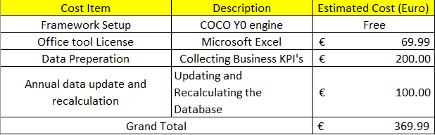
I can not see any cost for automation?! Re-calculation means: manually recalculation?! A thesis must have real automated solutions! This remark should have impact to the subchapter: automation, testing, etc.
The proposed project is designed to operate as a longitudinal and extensible framework, allowing it to be updated annually with new datasets, revised attributes, and extended analytical configurations. Each yearly iteration would result in a new version of the framework, reflecting updated sectoral data and refined efficiency measurements. Organizations would have the option to subscribe to the most recent yearly framework, while previous versions would be released for open use after the update cycle, ensuring transparency and broader accessibility. The expected subscription fee is estimated at approximately €50 per business per year, which is intentionally kept low to remain accessible for micro and small enterprises. Based on the cost estimations presented earlier, eight active business subscriptions would be sufficient to fully cover the annual operational expenses of maintaining, updating, and validating the framework. This model demonstrates that the project is financially sustainable while preserving its primary objective of providing an affordable, objective, and reusable AI efficiency evaluation service.

Motivations
The motivation for this study arises from the growing disparity between AI adoption rates and realized efficiency gains in real-world workplaces. While AI technologies are widely promoted, empirical evidence comparing sector-level outcomes remains fragmented and inconsistent.
This research is driven by the need to:
- Move beyond qualitative narratives toward validated quantitative evaluation.
- Address the lack of standardized benchmarking across sectors.
- Provide clarity on whether specialization, rather than adoption alone, determines AI effectiveness.

About the Structure of the Publication
This publication is organized to guide the reader from conceptual foundations to validated empirical conclusions. Following the introduction and literature review, the own development chapter details the OAM construction, ranking logic, COCO Y0 computation, and validation mechanisms. Results are presented through ranked sectoral estimations, followed by discussion, limitations, and future research directions. This structure ensures transparency, reproducibility, and logical progression.

Literature
The investigation into the efficiency of the artificial intelligence in enhancing workplace efficiency is situated within a broader discourse on technology-driven productivity. A report by the McKinsey Global Institute (Bughin et al., 2018) projects massive economic potential from AI while acknowledging implementation challenges. (Source: Bughin, J., et al. (2018). Modeling the impact of AI on the world economy. McKinsey Global Institute. URL: https://www.mckinsey.com/featured-insights/artificial-intelligence/notes-from-the-ai-frontier-modeling-the-impact-of-ai-on-the-world-economy). It provides essential macro level data on AI’s projected economic impact, setting the stage for the more granular, sector specific analysis conducted in this study. Therefore, the breakthrough performance of AlphaFord 2 in predicting protein structures, as detailed by Jumper et al. (2021), serves as a paradigm for sector specific AI success. (Source: Jumper, J., et al. (2021). Highly accurate protein structure prediction with AlphaFold. Nature, 596(7873), 583–589. URL: https://www.nature.com/articles/s41586-021-03819-2). This is the central and will be integrated into the 3.4.1 Descriptions of the first Objects set as a benchmark case study for the pharmaceuticals sector. Similarly, the development of BloombergGPT by Wu et al. (2023) demonstrates superior performance in financial language tasks compared to general purpose models. (Source: Wu, S., et al. (2023). BloombergGPT: A Large Language Model for Finance. arXiv preprint. URL: https://arxiv.org/abs/2303.17564). These sources provide a concrete of peer reviewed standard for high model accuracy and supporting hypothesis that specialized models yield higher accuracy and by extension, it is leading a greater potential and sector specific revolutionary efficiency in research and development. Abdi and Williams (2013) detail Canonical Correlation Analysis (CCA) as the standard technique for assessing the relationship between two sets of variables, such as a set of AI benchmarks and a set of workplace efficiency metrics (3.5 Attributes). (Source: Abdi, H., & Williams, L. J. (2013). Canonical correlation analysis: An overview with application to learning methods. Neural Computation, 25(9), 2633–2664. URL: https://doi.org/10.1162/NECO_a_00477). This citation is essential and will be integrated into 5 Methodology chapter to underpin the core analytical strategy of relating the two variable sets. It provides the mathematical and theoretical justification for the chosen correlation validation method.

About the Phenomenon of Efficiency
Efficiency is a foundational concept in organizational analysis and serves as the primary outcome variable of this research. Before evaluating the impact of artificial intelligence on workplace performance, it is necessary to clarify what efficiency means in an organizational context and how it has traditionally been understood and measured. This chapter introduces the phenomenon of efficiency by outlining its conceptual interpretation in business and operational environments, both prior to and following the widespread adoption of artificial intelligence. By establishing this conceptual baseline, the chapter provides the theoretical foundation required to distinguish between efficiency improvements driven by traditional process optimization and those enabled by AI-supported automation, decision-making, and human–machine collaboration. This clarification is essential for ensuring that subsequent sectoral comparisons and quantitative evaluations are based on a consistent and well-defined understanding of efficiency.

Efficiency before Artificial Intelligence
Drucker, P. F. (1999). Knowledge-Worker Productivity: The Biggest Challenge. California Management Review (https://journals.sagepub.com/doi/pdf/10.2307/41165987?download=true&_gl=1*jsy5eb*_up*MQ..*_ga*Mzg5NTMxNTI3LjE3Njg4MjExNDk.*_ga_60R758KFDG*czE3Njg4MjExNDgkbzEkZzAkdDE3Njg4MjExNDgkajYwJGwwJGgxNTMyNjE1NDEx). “Efficiency is doing things right. Effectiveness is doing the right things. For knowledge work, productivity depends primarily on the quality of processes rather than sheer speed.”. This citation defines efficiency in the pre-AI era as fundamentally process-driven and human-centered. It directly supports conceptual baseline of this thesis for efficiency before AI. This establishes the pre-AI reference point against which this thesis’ AI-driven efficiency measurements are compared. Solow, R. M. (1987). We’d Better Watch Out. New York Times Book Review (http://digamo.free.fr/solow87.pdf). “You can see the computer age everywhere but in the productivity statistics.”. This famous observation highlights the historical difficulty of converting technological adoption into measurable efficiency gains. It directly supports our motivation for developing a quantitative, validated framework (OAM + COCO Y0) rather than relying on adoption narratives alone.

Efficiency after Artificial Intelligence
Brynjolfsson, E., and McAfee, A. (2014). The Second Machine Age. W. W. Norton and Company (https://wwnorton.com/books/the-second-machine-age/). “Digital technologies are transforming work by enabling machines to perform cognitive tasks that previously required human intelligence.”. This quotation defines the post-AI shift in efficiency, where gains are no longer limited to physical automation but extend to cognitive and decision-intensive tasks. This thesis operationalizes this shift through attributes such as Real-Time Decision Ratio, Model Accuracy and AI-Human Collaboration Index, making post-AI efficiency measurable across sectors. Davenport, T. H., and Kirby, J. (2016). Just How Smart Are Smart Machines? MIT Sloan Management Review (https://sloanreview.mit.edu/article/just-how-smart-are-smart-machines/). “The primary impact of artificial intelligence is not full automation but the augmentation of human work.” This directly supports treatment of efficiency as a hybrid outcome rather than pure automation. This thesis findings show that sectors performing best are those where AI augments human capability, reinforcing why collaboration-based attributes matter in the rankings.

Methodology for the Cross-Sector Analyses
Porter, M. E. (1985). Competitive Advantage: Creating and Sustaining Superior Performance. Free Press (https://hollis.harvard.edu/primo-explore/search?tab=everything&search_scope=everything&vid=HVD2&lang=en_US&mode=basic&offset=0&query=lsr01,contains,000473683). “The value chain provides a systematic way of examining all activities a firm performs and how they interact to create competitive advantage.”. This citation justifies Object-Attribute decomposition of workplace sectors. OAM mirrors Porter’s analytical logic by breaking complex organizational performance into comparable attributes, allowing efficiency to be evaluated consistently across industries. Abdi, H., and Williams, L. J. (2013). Canonical Correlation Analysis: An Overview with Application to Learning Methods. Neural Computation (https://direct.mit.edu/neco/article-abstract/25/9/2303/7913/Spike-Based-Probabilistic-Inference-in-Analog?redirectedFrom=fulltext). “Canonical correlation analysis examines the relationship between two multivariate sets of variables.” This quotation provides statistical foundation for the cross-sector methodology. This thesis adapts this logic by correlating AI benchmarks with workplace efficiency attributes through COCO Y0, making the multi-dimensional comparison mathematically defensible. Zavadskas, E. K., and Turskis, Z. (2011). Multiple Criteria Decision Making (MCDM) Methods in Economics. Technological and Economic Development of Economy (https://www.tandfonline.com/doi/abs/10.3846/20294913.2011.593291). “Multiple criteria decision-making methods allow complex alternatives to be evaluated based on numerous, often conflicting, criteria.” This citation directly legitimizes the use of COCO Y0 as an MCDM tool. The cross-sector analysis relies on precisely this principle. Evaluating industries using many efficiency-related attributes without collapsing them into a single subjective metric. Roy, B. (1996). Multicriteria Methodology for Decision Aiding. Kluwer Academic Publishers (https://link.springer.com/book/10.1007/978-1-4757-2500-1). “The objective of multicriteria analysis is not to find an optimal solution, but to provide a structured comparison among alternatives.”. This quotation aligns perfectly with our methodological stance. This thesis does not claim absolute truth but provides a validated, relative ranking of sectors, consistent with multicriteria decision theory and the anti-discriminatory logic of COCO Y0.

AI and Workplace Efficiency
Artificial intelligence is increasingly recognized as a significant driver of workplace efficiency due to its ability to automate tasks, enhance decision-making, and support human performance. This chapter reviews how AI influences productivity, process efficiency, and cost reduction, and establishes the conceptual link between AI capabilities and measurable efficiency outcomes. The discussion provides the theoretical foundation for the quantitative, cross-sector evaluation applied in the subsequent analysis.

AI as a Driver of Workplace Productivity
Brynjolfsson, E., Hitt, L., and Kim, H. (2011). Strength in Numbers: How Does Data-Driven Decision-making Affect Firm Performance? Management Science (https://papers.ssrn.com/sol3/papers.cfm?abstract_id=1819486). “Firms that adopt data-driven decision making have output and productivity that is 5 to 6 percent higher than what would be expected given their other investments and information technology usage.” This citation directly underpins our Productivity Growth (AI-Driven %) and Real-Time Decision Ratio (%) attributes. This thesis extends this firm-leveling finding into a cross-sector comparison, qualifying how AI-driven decision-making converts into different efficiency outcomes depending on industry context.

AI Adoption is Not Sufficient on Its Own
Brynjolfsson, E., Rock, D., and Syverson, C. (2021). The Productivity J-Curve. American Economic Journal: Macroeconomics (https://www.aeaweb.org/articles?id=10.1257/mac.20180386). “Artificial Intelligence often requires significant complementary investments in organizational capital before productivity gains can be realized.” This citation directly explains why the results show high adoption but low efficiency in sectors such as Construction and Government. OAM framework captures these missing complementary investments through attributes like AI Skill Penetration and Industry Digitalization Index.

Sectoral Differences in AI Efficiency
Acemoglu, D., and Restrepo, P. (2020). The Wrong Kind of AI? Artificial Intelligence and the Future of Labor Demand. Journal of Economic Perspectives (https://www.nber.org/papers/w25682). “The impact of artificial intelligence on productivity and labor demand varies significantly across sectors depending on task composition and implementation.” This directly justifies the cross-sector object selection. This thesis Operationalizes Acemoglu and Restrepo’s theoretical claim by ranking 20 workplace sectors and empirically demonstrating how task structure and implementation strategy shape efficiency outcomes.

Benchmarks – Specialized AI Models
Jumper, J., et al. (2021). Highly accurate protein structure prediction with AlphaFold. Nature (https://www.nature.com/articles/s41586-021-03819-2). “The accuracy of AlphaFold far exceeds that of previous methods, enabling practical applications in biological research.”. Wu, S., et al. (2023). BloombergGPT: A Large Language Model for Finance. arXiv (https://arxiv.org/abs/2303.17564). “BloombergGPT achieves substantially better performance on financial NLP tasks than general-purpose language models.”. These studies validate the use of specialized, domain-trained AI models as performance benchmarks rather than as prescriptive solutions. Within the context of this thesis, such benchmarks serve as reference points for evaluating how closely workplace sectors align with optimal AI utilization patterns. The higher rankings observed for sectors associated with domain-trained models in the COCO Y0 results therefore do not imply direct technology adoption recommendations, but instead illustrate a generalizable principle. Measurable efficiency gains emerge when AI capabilities are aligned with domain-specific operational tasks. This interpretation applies across all sectors, models, and datasets examined in the thesis.

AI, Automation and Process Optimization
Artificial intelligence enhances workplace efficiency primarily through task automation and process optimization. This chapter reviews how AI-driven automation reduces process cycle time, operational costs, and error rates, establishing the conceptual basis for evaluating automation-related efficiency gains.

Automation and Cycle Time Reduction
Davenport, T. H., and Ronanki, R. (2018). Artificial Intelligence for the Real World. Harvard Business Review (https://www.the-digital-insurer.com/library/artificial-intelligence-for-the-real-world-by-thomas-h-davenport-and-rajeev-ronanki-deloitte/). “The most common AI applications involve automating digital and physical tasks, especially those that are routine and high-volume.” This directly supports Task Automation Rate (%) and Process Cycle Time Reduction (%) attributes. This thesis quantitatively evaluates exactly the types of automation Davenport and Ronanki describe qualitatively.

Cost Reduction Through AI
McKinsey Global Institute (2017). Artificial Intelligence: The Next Digital Frontier ( https://apo.org.au/node/210501)? “AI-driven automation can reduce operating cost by up to 20 percent in some business processes.” This citation highlights the Operation Cost Reduction (%) attribute and explains why sectors with mature automation pipelines score higher in the final COCO estimation.

Augmentation Rather Than Replacement
Wilson, H. J., and Daugherty, P. R. (2018). Collaborative Intelligence. Harvard Business Review (https://hometownhealthonline.com/wp-content/uploads/2019/02/ai2-R1804J-PDF-ENG.pdf). “The most effective AI systems are those in which humans and machines work together, each complementing the other’s strengths.”. This directly validates the AI-Human Collaboration Index (0-100). This thesis empirically shows that sectors with higher collaboration scores achieve superior efficiency outcomes, aligning with this literature.

AI Skills as a Performance Multiplier
Autor, D., Mindell, D., and Reynold, E. (2022). The Work of the Future. MIT Press (https://mitpress.mit.edu/9780262547307/the-work-of-the-future/). “Technology delivers productivity gains only when workers posses the skills required to use it effectively.” This directly supports AI Skill Penetration (%) and Employee AI Usage Rate (%) attributes and explains why high-investment but low-skill sectors underperform in the ranking.

Strategy Over Technology
Kane, G. C., et al. (2015). Strategy, Not Technology, Drives Digital Transformation. MIT Sloan Management Review (https://sloanreview.mit.edu/projects/strategy-drives-digital-transformation/). “Digital maturity is driven more by organizational strategy and culture than by the technologies themselves.”. This citation explains Industry Digitalization Index (0-100) and why digital maturity acts as a moderating variable in AI efficiency, reinforcing the sectoral differentiation.

BPROF Subjects
This section outlines the relationship between the subjects completed during Kodolányi János University’s BPROF program and the present thesis, Measuring AI’s Efficiency on Workplace Efficiency: A Cross-Sector Analysis. The purpose of this chapter is to explain how the subjects completed in the BPROF program are specifically applied within this thesis. Each subsection highlights the unique methodological or analytical role of the subject in developing, validating, or interpreting the AI Efficiency Framework based on the Object–Attribute Matrix and the COCO Y0 model.

Business Law and Regulation
DiMaggo, P. J., and Powell, W. W. (1983). The Iron Cage Revisited: Institutional Isomorphism and Collective Rationality in Organizational Fields. American Sociological Review (https://www.enriquedans.com/wp-content/uploads/2021/11/The_Iron_Cage_Revisted_Institutional_Isomorphism_a.pdf). “Regulation shapes how organizations adopt and deploy information technologies, influencing compliance costs, operational processes and overall efficiency.” Business law and regulation define the institutional constraints under which organizations operate. In this thesis, regulatory conditions explain why certain sectors (e.g. Government, Legal Services, Healthcare) demonstrate lower AI efficiency scores, as legal constraints directly affect AI adoption rate, operational risk reduction, and incident frequency within the OAM.

Business Process Management
Dumas, M., La Rosa, M., Mendling, J., and Reijers, H. A. (2018). Fundamentals of Business Process Management. Springer (https://link.springer.com/book/10.1007/978-3-662-56509-4). “Business Process Management is the discipline of identifying, designing, executing, measuring and improving business processes.”. Business Process Management focuses on analyzing and improving organizational workflows. In this thesis, BPM concepts underpin the definition of efficiency-related attributes such as task automation rate, process cycle time reduction, and productivity growth, which are quantitatively evaluated across sectors using COCO Y0.

Database 1 and 2
Silberschatz, A., Korth, H. F. and Sudarshan, S. (2019). Database System Concepts. McGraw-Hill (https://www.amazon.com/Database-System-Concepts-Abraham-Silberschatz/dp/9390727502). “Database provide mechanisms for the efficient storage, retrieval and management of structured data.” Database systems enable structured storage and retrieval of data. In this thesis, database principles are essential for organizing multi-sector benchmark data and attribute values, ensuring consistency, traceability, and repeatability of yearly COCO Y0 computations.

Data Visualization
Tufte. E. R. (2001). The Visual Display of Quantitative Information. Graphics Press (https://www.edwardtufte.com/book/the-visual-display-of-quantitative-information/). “The purpose of data visualization is to communicate information clearly and efficiently through graphical representations.” Data visualization supports the interpretation of quantitative results clearly and efficiently. In this thesis, visualization techniques are used to interpret ranked sector outputs, attribute exclusion results, and validation checks, making COCO Y0 estimations transparent and examinable.

Electronic Circuits
Sedra, A. S., and Smith, K. C. (2014). Microelectronic Circuits. Oxford University Press (https://global.oup.com/ukhe/product/microelectronic-circuits-9780190853501?cc=us&lang=en). “Electronic circuits form the physical foundation of all digital computing systems.” AI systems rely on electronic hardware for computation. Understanding electronic circuits supports awareness of physical constraints that influence computational performance, scalability and energy efficiency of AI systems used across different workplace sectors.

Globalization and Social Problems
Stiglitz, J. E. (2002). Globalization and its Discontents. W. W. Norton and Company (https://wwnorton.com/books/globalization-and-its-discontents/). “Globalization reshapes labor markets and redistributes productivity gains unevenly across industries and regions.” This subject is relevant because AI efficiency gains are not evenly distributed across sectors. My thesis reflects these inequalities by ranking industries that benefit most and least from AI, helping explain structural differences driven by global economic forces.

Intercultural Communication
Hofstede, G., Hofstede, G. J., and Minkov, M. (2010). Cultures and Organizations: Software of the Mind. McGraw-Hill (https://www.mheducation.com/highered/mhp/product/cultures-organizations-software-mind-third-edition.html?viewOption=student). “Effective intercultural communication is essential for collaboration and organizational performance in global environments.” Intercultural communication influences collaboration in global organizations. In this thesis, cultural and organizational acceptance factors affect employee AI usage rate and consumer AI acceptance attributes, helping explain adoption–efficiency mismatches.

Introduction to Algorithms
Cormen, T. H., Leiserson, C. E., Rivest, R. L., and Stein, C. (2009). Introduction to Algorithms. MIT Press (https://mitpress.mit.edu/9780262533058/introduction-to-algorithms/). “An algorithm is a finite sequence of well-defined instructions used to solve problem.” Algorithms define formal problem-solving procedures. In this thesis, AI models, the COCO Y0 engine and automated formulas are treated as algorithmic systems, making algorithmic efficiency, optimization, and ranking logic central to the evaluation process.

Introduction to Electronics
Floyd, T. L. (2015). Electronic Devices. Personal Education (https://www.pearson.com/en-us/subject-catalog/p/electronic-devices-conventional-current-version/P200000001047/9780137526642). “Electronics enables the processing and control of electrical signals in information systems.”. In this thesis, understanding the electronics, it feasibility limits AI execution speed, reliability, and energy efficiency, indirectly influencing sectoral efficiency outcomes.

Introduction to Mathematics
Stewart, J. (2015). Calculus: Early Transcendentals. Cengage Learning (https://www.cengage.com/c/calculus-early-transcendentals-8e-stewart/9781285741550/). “Mathematics provides the tools necessary for modeling, analyzing and optimizing complex systems.” Mathematics is fundamental to my thesis because, in this thesis, mathematical concepts underpin ranking, normalization, correlation, optimization, and validation rules used in OAM construction and COCO Y0 analysis.

Introduction to Programming
Sebesta, R. W. (2016). Concepts of Programming Languages. Pearson Education (https://www.pearson.com/en-us/subject-catalog/p/concepts-of-programming-languages/P200000003361/9780135102268). “Programming allows algorithms to be expressed, tested and executed by computers.”. Programming enables the implementation of algorithms. In this thesis, programming logic is applied through Excel-based automation to ensure deterministic, auditable, extendable and repeatable data transformation across all OAM iterations.

IT-Security
Stallings, W., and Brown, L. (2018). Computer Security: Principles and Practice. Pearson Education (https://www.pearson.com/en-us/subject-catalog/p/computer-security-principles-and-practice/P200000010333/9780138091712). “Information security ensures the confidentiality, integrity and availability of information systems.”. AI efficiency cannot be separated from system reliability and security. In this thesis, security considerations are reflected in incident rate and operational risk reduction attributes, influencing AI efficiency outcomes in sensitive sectors.

Network and Computer Architectures
Tanenbaum, A. S., & Wetherall, D. J. (2011). Computer Networks. Pearson Education (https://www.pearson.com/en-us/subject-catalog/p/computer-networks/P200000003188/9780137523214). “Computer networks enable communication and resource sharing between distributed systems.”. AI systems often operate in networked environments. This subject explains that efficiency differences in sectors requiring real-time data processing and cloud-based AI deployment in this thesis.

Programming 1, 2, 3
Sommerville, I. (2016). Software Engineering. Pearson Education (https://www.pearson.com/en-us/subject-catalog/p/software-engineering/P200000003258/9780137503148). “Programming skills are essential for developing, testing, and maintaining complex software systems.”. In this thesis, these skills enabled the implementation of validation logic, rank inversion, and automated recalculation, ensuring methodological robustness.

Software Architectures
Bass, L., Clements, P., & Kazman, R. (2013). Software Architecture in Practice. Addison-Wesley (https://www.researchgate.net/publication/224001127_Software_Architecture_In_Practice). “Software architecture defines the fundamental organization of a software system and its components.”. Well-designed architectures enable scalable and efficient AI deployment. This subject explains why certain sectors integrate AI more effectively.

Software Testing
Myers, G. J., Sandler, C., & Badgett, T. (2011). The Art of Software Testing. Wiley (https://www.wiley.com/en-in/The+Art+of+Software+Testing%2C+3rd+Edition-p-9781119202486). “Software testing is the process of evaluating a system to detect errors.”. My thesis applies testing logic through symmetric inversion and validation rules in COCO Y0, ensuring result reliability.

System Modelling
Sterman, J. D. (2000). Business Dynamics. McGraw-Hill (https://www.mheducation.com/highered/product/business-dynamics-sterman.html?viewOption=student). “Models are simplified representations of reality used to understand and predict system behavior.”. The Object–Attribute Matrix used in my thesis is a formal system model that enables structured cross-sector analysis.

System Operation
Slack, N., Brandon-Jones, A., and Johnston, R. (2019). Operations Management. Pearson Education (https://www.pearson.com/se/Nordics-Higher-Education/subject-catalogue/decision-science/slack-operations-management-9thedition.html). “Operational performance depends on how systems are monitored, maintained, and controlled.”. AI efficiency is influenced by operational stability, which explains variations in performance and incident rates across sectors.

System Planning
Ward, J., & Peppard, J. (2016). The Strategic Management of Information Systems. Wiley (https://www.wiley.com/en-it/The+Strategic+Management+of+Information+Systems%3A+Building+a+Digital+Strategy%2C+4th+Edition-p-9780470034675). “Effective system planning aligns technological solutions with organizational goals.”. In this thesis, strategical system planning explains why alignment between AI capabilities and core tasks is a stronger efficiency driver than adoption alone.

Own Development
20 workplaces and its AI performance specific-sectors, 22 attributes that represents AI related performance scores and 15 specialized sector specific trained artificial intelligence models’ data are gathered in each field. After polishing the data, OAM will be made. In this study case, two variations of objects and attributes are gathered that means two types of OAM will be made. Firstly, in the both of the objects aligned in the columns then attributes aligned in the rows. Above the attribute, there must be Direction ID, Type, Attribute ID, Attribute, Attribute unit and also the ideal value as mentioned in 3.3 OAM. After creating those, values of each OAM are ranked by using formula that compares the value to the its attribute column by following the Direction ID (Can be seen on: https://view.officeapps.live.com/op/view.aspx?src=https%3A%2F%2Fmiau.my-x.hu%2Fmiau%2F328%2Fgb%2FOAM_AI%2520(3).xlsx&wdOrigin=BROWSELINK, OAM and OAM2). After setting the OAMs, we put the values into the COCO Y0 engine. There are seven visual settings for COCO (ID, Matrix, Stairs, Model, Keep Files, Object naming, Attribute naming). But, only Matrix, Object Naming and Attribute naming is needed in this study (Figure8). We put the ranked value into the Matrix and put the names of objects and attributes into the Object Naming and Attribute naming sections. Some attributes could have confusing names, so the attribute id is used as attribute name (Figure9, Figure10). In order to receive the estimations, filled COCO should run by pressing the run button. After getting the estimation (Can be seen on: https://view.officeapps.live.com/op/view.aspx?src=https%3A%2F%2Fmiau.my-x.hu%2Fmiau%2F328%2Fgb%2FOAM_AI%2520(3).xlsx&wdOrigin=BROWSELINK, COCO_Y0 and COCO_Y0_2 sheets), it should be validated by reversing the ranked value (symmetric effect. 3.7 Inversed Ranked Table chapter) and we run COCO Y0 tool on the inversed ranked data again. Furthermore, direct ranked value and reversed ranked value are compared to each other and if the result is 0 or less, it is valid while, the result is greater than 0 considered invalid (3.8 Validation of the Ranked Table and Inversed Ranked Table). This process done on both of the OAM. In order to correlate both OAMs, one big OAM is made after validating. The second set of Objects are the specific AI training sectors from the workplace fields (first set of objects), so we can combine them as one object set in the greater OAM. For the attributes, the second attribute set can align next to the first set of the attributes. Ideal (Y) value stays same as 1000 in the last column (Can be seen on: https://view.officeapps.live.com/op/view.aspx?src=https%3A%2F%2Fmiau.my-x.hu%2Fmiau%2F328%2Fgb%2FOAM_AI%2520(3).xlsx&wdOrigin=BROWSELINK, ALL_OAM sheet). Combined OAM repeatedly computed by the COCO again. Once COCO ran on the entire data, seeing the stairs(2) section in the estimation crucial to exclude the big object attribute matrix. If the values of the attributes in the first row of the stairs(2) are one less than the number of the objects (ObjectNumber-1), that columns are chosen while others are excluded (Can be seen on: https://view.officeapps.live.com/op/view.aspx?src=https%3A%2F%2Fmiau.my-x.hu%2Fmiau%2F328%2Fgb%2FOAM_AI%2520(3).xlsx&wdOrigin=BROWSELINK, ALL_COCO). This technique used to classify the least contributable attributes from the attributes that the best performing attributes. After filtering the best attributes, the last super OAM is made. In the super OAM, 24 super attributes are included (A1-AI Adoption Rate (%), A2-Productivity Growth (AI-Driven %), A4-Process Cycle Time Reduction (%), A6-Operational Cost Reduction (%), A7-Employee AI Usage Rate (%), A8-AI Skill Penetration (%), A9-Job Transformation Index (%), A10-AI-Human Collaboration Index (0-100), A12-Real-Time Decision Ratio (%), A14-Market Share Change (%), A15-Customer Satisfaction Change (%), A16-Operational Risk Reduction (%), A17-AI Investment Share (%), A18-Model Accuracy (%), A19-Incident Rate (AI Failures per Year), A20-Industry Digitalization Index (0-100), A21-Competition Intensity Index, A22-Consumer AI Acceptance (%), A25-Gemini Pro, A26-Llama 3, A27-Mixtral 8x7B, A28-BloombergGPT, A30-AlphaFold 2, A32-Stable Diffusion 3). The super OAM consists of the super out-performing attributes that contributes the most in the estimation (Can be seen on: https://view.officeapps.live.com/op/view.aspx?src=https%3A%2F%2Fmiau.my-x.hu%2Fmiau%2F328%2Fgb%2FOAM_AI%2520(3).xlsx&wdOrigin=BROWSELINK, OAM_EXCLUDED). COCO Y0 analyzing model ran on the super OAM and makes the potential best output for this study and evaluating the objects by its performance scores (Can be seen on: https://view.officeapps.live.com/op/view.aspx?src=https%3A%2F%2Fmiau.my-x.hu%2Fmiau%2F328%2Fgb%2FOAM_AI%2520(3).xlsx&wdOrigin=BROWSELINK, COCO_EXCLUDED). All estimations validated by the reversing symmetric effect and also compared to get the result of the project. Based on the best attributes and valid estimations, the highest performing workplace field is Information Technology ranked the first place with 1165.9 estimation score, while the Government and Public field ranked the last place with 799.4 estimation (Finance and Insurance-2nd with 1146.7, Pharmaceutical-3rd with 1128.5, Media Entertainment-4th with 1118.7, Insurance-5th with 1192.7, Professional Services-6th with 1092.2, Telecommunications-7th with 1083.3, Manufacturing-8th with 1080.9, Healthcare-9th with 1043.5, Automotive-10th with 1030.8, Aerospace and Defense-11th with 1013.6, Retail and E-commerce-12th with 1001.8, Consumer Packaged Goods-13th with 990.5, Legal Services-14th with 925.1, Education-15th with 910.4, Transportation and Logistics-16th with 905, Energy and Utilities-17th with 862.7, Agriculture-18th with 814.6, Construction-19th with 799.9 estimated scores. Figure11, Figure12).

COCO Y0
This study utilizes the COCO online analysis tool that operating since 2003 to produce a validation and estimation for the OAM database. COCO stands for Component-based Object Comparison for Objectivity (Source: https://miau.my-x.hu/myx-free/coco/) COCO Y0 is an anti-discrimination calculating tool, that known as the ideal-seeking model, for each attribute (X value) after defining specific direction towards the ideal value (Y value). An optimization is carried out to find the object that deviates the most from the average. In such way, the goal of the optimization is all to enforce the sameness of the objects (Source: https://miau.my-x.hu/myx-free/coco/beker_y0.php). Anti-discrimination calculation is an optimization procedure aimed at ensuring that each individual object described by many attributes can be assigned the same outcome value as a result of the calculation. It is the mathematical implementation of the 'everyone equally different' principle. Within the framework of similarity analysis, this is the Y0-MIN model, where 'min' means that the goal of the optimization is to minimize some aggregate of the deviations of estimates from a hypothetical, constant outcome variable (Y0) for every object (as opposed to the Y0-MAX analysis, where the goal is to produce the largest possible total difference between actual and estimated values, corresponding to classical discrimination, grouping, or classification).

OAM
OAM stands for Object-Attribute Matrix, in other words a learning sample, in which, traditionally, the rows represent the objects (cases) and the columns represent their characteristics (attributes, aspects, variables, etc.). It also has ideal (Y) value that is constant for every object which X value towards to the Y value by its defined direction. For each attribute, it must have direction id, type, attribute id, attribute and attribute unit (Figure1). Direction ID is necessary in OAM that indicates each column should towards ideal value by itself. There are two direction id 1 and 0. 1 is for less is better, while 0 is greater is better for its column values. Giving a type to each attribute requires basics of geometric coordinates. For example, coordinate X-axis as X (attribute) value, while coordinate Y-axis as Y (ideal) value that could correlate and compare to each other by row and column. Attribute ID is for classifying your attributes a unique value. For instance, A1, A2, A3… etc. In the attribute, name of the attribute should be displayed. Attribute unit is the indicator of your attribute value. If OAM consists of many types of values (percentage, decimal, integer… etc.), it has to be classified. Lastly, each OAM has its ideal value (Y) as mentioned above. The recommended ideal value considered as 1000.

Objects
Object is the name of comparable phenomena. For example, people, objects, processes, concepts, businesses and countries, etc. Objects can be practiced along the time dimensions of the phenomena already listed (e.g., country-year units). This study selects 2 related categories of objects, 20 distinct workplace domains as first objects that evaluated against 22 performance attributes, while another set of second objects were chosen as special sectors that training AI most within the workplace domains and compared to 15 specialized AI models benchmarks.

Descriptions of the first Objects set
Information Technology (Development, implementation, and maintenance of computer systems and software)
Finance & Insurance (Banking, investment, insurance, and financial risk management services)
Healthcare (Medical services, patient care, hospital management, and clinical operations)
Manufacturing (Production of goods through industrial processes and factory operations)
Professional Services (Consulting, accounting, advisory, and business optimization services)
Retail & E-commerce (Sale of goods to consumers through physical stores and online platforms)
Transportation & Logistics (Movement of goods and people, supply chain management, and distribution)
Energy & Utilities (Power generation, distribution, and utility services management)
Agriculture (Farming, crop production, livestock management, and agricultural technology)
Education (Learning institutions, educational services, and knowledge dissemination)
Construction (Building infrastructure, residential/commercial construction, and civil engineering)
Media & Entertainment (Content creation, distribution, and consumption across digital and traditional platforms)
Government & Public (Public administration, civic services, and governmental operations)
Pharmaceuticals (Drug discovery, development, manufacturing, and distribution of medications)
Telecommunications (Communication services including mobile, internet, and data transmission)
Legal Services (Legal advice, contract review, litigation, and regulatory compliance services)
Insurance (Banking, investment, insurance, and financial risk management services)
Automotive (Vehicle design, manufacturing, sales, and automotive technology development)
Aerospace & Defense (Aircraft, spacecraft, defense systems, and national security technologies)
Consumer Packaged Goods (Production and distribution of fast-moving consumer products)
(Can be seen on the Descriptions sheet in https://view.officeapps.live.com/op/view.aspx?src=https%3A%2F%2Fmiau.my-x.hu%2Fmiau%2F328%2Fgb%2FOAM_AI%2520(3).xlsx&wdOrigin=BROWSELINK)

Description of the second Objects set
Code Generation Accuracy (HumanEval): Measures AI's ability to write functional, correct code from natural language descriptions
Financial Sentiment Analysis (F1 Score): Measures accuracy in analyzing market sentiment from financial texts
Medical Licensing Exam Performance: Scores AI performance on standardized medical knowledge tests
Defect Detection & Process Optimization: Measures AI's ability to identify manufacturing flaws and improve production efficiency
Complex Document Analysis & Reasoning: Evaluates AI's ability to understand, analyze, and reason about complex business documents
Customer Service Resolution Rate: Measures percentage of customer issues resolved successfully by AI systems
Autonomous Operation Safety: Evaluates reliability and safety of AI-controlled systems in real-world operations
Grid Management & Predictive Maintenance: Measures AI's effectiveness in managing energy distribution and predicting equipment failures
Yield Prediction & Resource Optimization: Evaluates AI's accuracy in predicting agricultural outputs and optimizing resource use
Personalized Learning & Content Generation: Measures effectiveness in creating tailored educational content and learning experiences
Project Management & Safety Compliance: Scores AI's ability to manage construction timelines and ensure regulatory compliance
Image Generation Quality (Human Preference): Measures how humans prefer AI-generated images over real or other AI images
Document Processing & Compliance Accuracy: Measures efficiency and accuracy in handling government documents and ensuring compliance
Protein Structure Prediction (GDT_TS): Scores accuracy of predicting 3D protein structures from amino acid sequences
Network Management & Optimization: Scores AI's effectiveness in managing telecommunications infrastructure and optimizing performance
Legal Document Review Accuracy: Evaluates precision in analyzing legal contracts, cases, and regulatory documents
Risk Assessment & Fraud Detection: Scores AI's ability to identify potential risks and fraudulent activities
Autonomous Driving Safety & Navigation: Evaluates performance of self-driving systems in real-world road conditions
System Reliability & Predictive Maintenance: Measures AI's ability to ensure system uptime and predict maintenance needs
Demand Forecasting & Supply Chain Optimization: Measures accuracy in predicting market demand and optimizing inventory/logistics
(Can be seen on the Descriptions sheet in https://view.officeapps.live.com/op/view.aspx?src=https%3A%2F%2Fmiau.my-x.hu%2Fmiau%2F328%2Fgb%2FOAM_AI%2520(3).xlsx&wdOrigin=BROWSELINK)

Attributes
Attribute (characteristic, variable, indicator, indicator number, component, parameter) is a property of objects with a specific (essentially measurable, observable) unit of measurement, whose representation scale can also be a nominal scale (e.g., colors). In this case, two categorized objects were collected means it needs two sets of attributes for each set of objects. Firstly, there are 22 attributes that represents AI related performance score in each field. Secondly, 15 specialized AI models benchmarks that trained for specific sectors.

Descriptions of the first Attributes set
AI Adoption Rate (%): Percentage of companies in a sector that have implemented AI solutions
Productivity Growth (AI-Driven %): Percentage increase in output per hour/work unit due to AI
Task Automation Rate (%): Percentage of routine tasks automated by AI systems
Process Cycle Time Reduction (%): Percentage decrease in time to complete business processes
Error Reduction Rate (%): Percentage decrease in mistakes/defects due to AI quality control
Operational Cost Reduction (%): Percentage decrease in operating expenses from AI implementation
Employee AI Usage Rate (%): Percentage of employees regularly using AI tools in their daily work
AI Skill Penetration (%): Percentage of workforce with AI-related skills or training
Job Transformation Index (%): Percentage of jobs significantly changed by AI integration
AI-Human Collaboration Index (0-100): Effectiveness score of human-AI teamwork (0=poor, 100=excellent)
Job Displacement Risk (%): Percentage of jobs at high risk of full automation
Real-Time Decision Ratio (%): Percentage of decisions made instantly using AI analysis
Revenue Growth Post-AI (%): Percentage revenue increase attributed to AI adoption
Market Share Change (%): Change in market position due to AI competitive advantages
Customer Satisfaction Change (%): Percentage improvement in customer satisfaction scores
Operational Risk Reduction (%): Percentage decrease in business risks through AI monitoring
AI Investment Share (%): Percentage of total IT/digital budget allocated to AI initiatives
Model Accuracy (%): Performance score of AI models on specific tasks (0-100%)
Incident Rate (AI Failures per Year): Number of AI system failures or errors annually
Industry Digitalization Index (0-100): Overall digital maturity score of an industry (0=low, 100=high)
Competition Intensity Index: Level of competitive pressure for AI adoption in the sector
Consumer AI Acceptance (%): Percentage of consumers comfortable with AI-driven products/services
(Can be seen on the Descriptions sheet in https://view.officeapps.live.com/op/view.aspx?src=https%3A%2F%2Fmiau.my-x.hu%2Fmiau%2F328%2Fgb%2FOAM_AI%2520(3).xlsx&wdOrigin=BROWSELINK)

Description of the second Attributes set
GPT-4: Widely used AI Model in certain fields
Claude 3: Widely used AI Model in certain fields
Gemini Pro: Widely used AI Model in certain fields
Llama 3: Widely used AI Model in certain fields
Mixtral 8x7B: Widely used AI Model in certain fields
BloombergGPT: Widely used AI Model in certain fields
Med-PaLM 2: Widely used AI Model in certain fields
AlphaFold 2: Widely used AI Model in certain fields
DALL-E 3: Widely used AI Model in certain fields
Stable Diffusion 3: Widely used AI Model in certain fields
Codex: Widely used AI Model in certain fields
Watsonx.ai: Widely used AI Model in certain fields
Amazon Q: Widely used AI Model in certain fields
Tesla FSD: Widely used AI Model in certain fields
Salesforce Einstein: Widely used AI Model in certain fields
(Can be seen on the Descriptions sheet in https://view.officeapps.live.com/op/view.aspx?src=https%3A%2F%2Fmiau.my-x.hu%2Fmiau%2F328%2Fgb%2FOAM_AI%2520(3).xlsx&wdOrigin=BROWSELINK)

Ranked Table
Creating a ranked table is the step to set up the raw OAM data more suitable for the COCO Y0 analyzing engine. OAM could consist of variations of data that could not correlate or compared to each other (for example, percentage and integer cannot be directly evaluated to each other). So, simple excel formula (for example, =RANK(B6,B$6:B$25,B$1)) able to rank the OAM (Figure2). The first B6 is the cell that is going to be compared to the B6 to B25 cells and ranked by the direction cell B1. Whole column (B6:B25) and direction (B1) are constant that they must not move through any other cells, which you can simply put $ sign to indicate as absolute reference in excel. Only Y value (ideal value) must not be ranked (Figure3). For example, if B6 value is 3rd lowest in the column and the direction id is 1, the whole column (B6 to B25) compared to each other by direction id (B1) and gives a rank to the B6 cell as 3. On the other hand, the direction id is 0, the B6 column ranked as 17. After ranking all the cell values, it became suitable to put it in to the COCO analyzing tool.

Inversed Ranked Table
To ensure the generated estimation’s reliability and accuracy from the COCO Y0 computing tool by using ranked table data, fact-estimation discrepancy will be checked (<=0 considered valid). Furthermore, the validation process based on symmetry effect will be done. This method verifies whether the differences in attribute values between the objects aligned consistently with their performance rankings, reinforcing the model’s predictive reliability. In order to reverse ranked table, simple formula (NumberOfObjects-EstimatedValue+1) will be used (Figure4). After creating the flipped original ranked value, COCO Y0 engine will run on the adjusted data. Computing key metrics of known as the product of the original delta values and the inverted delta values considered as delta calculation. Those metrics act as a critical indicator of the model’s consistency.

Validation of the Ranked Table and Inversed Ranked Table
To validate the results of the analyzed ranked table and inversed ranked table by COCO Y0 engine, the validation rule must be followed. If the product of the estimated delta fact values is zero or less, the result of the models is confirmed to be valid and reliable. If the result of the product is greater than zero, it indicates the potential inconsistencies. This could signal errors in certain objects’ data or weakness in the model itself. To prevent this inconsistency, another simple excel formula will be used (=IF(DirectRanking*InversedRanking<=0,1,0). Figure5). Direct ranking versus inverse ranking should produce inverted result with differences centered around ideal value (Y) 1000.

Ranking the Objects
When the generated estimations were validated by symmetric effect, ranking the objects has done to evaluate the workplaces performance accurately. This method has basic logic and uses the ranking formula (=RANK(DeltaEstimationCell:DeltaEstimationColumn,0). Figure6) that compares the estimated delta cell to the whole estimated delta fact column and places the rank of the cell from the zero to the number of the objects. The delta estimation calculated from the ideal value (Y) 1000. If the performance of the object is better or less, it calculated from the ideal value (+/-1000). Highest computed value considered as the best, while lowest estimation value as the least.

Attribute Exclusion
This technique is used for classifying the most contributing attributes from the least performing attributes. The least performing attributes are excluded, while filtered super attributes (most contributing attributes) combined into the single super OAM. The result of the project is computed by COCO Y0 analyzing tool and filtered by those super attributes to obtain the most possible, accurate, consistent output. To filter the super attributes, the Stairs(2) table from the COCO estimation is crucial. The first row of the attributes is one less than the numbers of the objects (ObjectNum-1) considered the most influential attributes among the whole attribute (Figure7).

Automation
Automation in this study was implemented exclusively through spreadsheet-based formulas within Microsoft Excel. All data transformation processes including ranking, inversion of ranked values, validation of symmetric effects, and attribute exclusion were executed using predefined Excel functions. These formula-driven operations ensured consistent and repeatable data handling while minimizing manual intervention and subjective influence. By applying identical formulas across all Object–Attribute Matrixes (OAMs), the study achieved uniform processing logic and enabled efficient recalculation whenever input data were modified.

Testing
Testing focused on validating the robustness and reliability of the estimation outputs. This included:
- Symmetric inversion testing of ranked tables.
- Delta-product validation rules to confirm consistency.
- Comparative analysis between direct and inversed COCO outputs. Only estimations satisfying the defined validation criteria were accepted as reliable.

Comparison to the Another Thesis
This section presents a comparative analysis between the present thesis, Measuring AI’s Efficiency on Workplace Efficiency, and the BPROF thesis by Aadi Rajesh titled Risk-evaluation possibilities concerning IT-activities in home-office (Source: https://miau.my-x.hu/miau/323/rw1/). The purpose of this comparison is to contextualize the current research within related academic work conducted under the same educational framework and to highlight both methodological overlaps and conceptual distinctions. While both studies employ the COCO Y0 model and Object–Attribute Matrix (OAM) methodology to ensure objective, anti-discriminative evaluation, they address fundamentally different research problems, operate at different analytical scales, and assign distinct roles to artificial intelligence. By examining similarities and differences in scope, object definition, attribute design, automation, and outcomes, this comparison clarifies the unique contribution and positioning of the present study.

Similarities

Development Foundation
Both of those theses are grounded in the Component-based Object Comparison for Objectivity (COCO) methodology and utilize Object–Attribute Matrices (OAM) as their core analytical structure.
Both studies:
- Define objects and attributes explicitly.
- Apply ranking and normalization prior to COCO evaluation.
- Use anti-discriminative, ideal-seeking logic (COCO Y0) to ensure fairness and objectivity.
- Excel is used in both works as the primary computational environment, emphasizing transparency and reproducibility rather than black-box automation.

Applied, Practice-Oriented Research Focus
Neither thesis is purely theoretical.
- Aadi’s thesis focuses on practical cybersecurity risk evaluation in home-office environments.
- This thesis evaluates real workplace efficiency impacts of AI adoption across industries.
Both aim to:
- Support managerial or organizational decision-making
- Translate abstract concepts (risk, efficiency, AI impact) into measurable indicators

Validation and Testing Logic
Both studies explicitly emphasize testing and validation:
- Use of rank inversion and symmetric validation
- Cross-checking outcomes with alternative data configurations
- Acceptance of results only when consistency rules are satisfied
This reflects a shared methodological culture rooted in robustness over novelty.

Differences

Research Scope and Phenomenon
Aspect | Aadi Rajesh | This Thesis
Core phenomenon | IT security risk in home-office | AI-driven workplace efficiency
Scope | Narrow, context-specific | Broad, cross-sector
Environment | Remote work / home-office | 20 workplace sectors
Aadi’s work is deep but narrow, while ours is broad and comparative.

Objects and Attributes
Aadi’s Thesis
Objects: Individual workers or organizational cases (often anonymized)
Attributes: Security, compliance, business continuity, cost, reputation
Attribute count: Moderate, tightly focused on risk
This Thesis
Objects:
- 20 workplace sectors
- AI specialization domains
Attributes:
- 22 workplace efficiency metrics
- 15 AI model benchmarks
Attribute logic: Multi-layered, hierarchical, and filtered
This work introduces attribute exclusion and super-OAM construction, which is not present in Aadi’s thesis.

Automation and Implementation
Aadi’s thesis:
- Mentions potential software systems, AI tools, and real-time data pipelines.
- Includes a working prototype concept.
This thesis:
Uses Excel-based formula automation only.
Automation is:
- Deterministic
- Fully auditable
- Methodologically conservative
This makes my automation less speculative and more suitable for academic reproducibility.

Use of AI
Dimension | Aadi Rajesh | This Thesis
Role of AI | Support tool in risk evaluation | Central object of evaluation
AI models | Generic AI assistance | Specialized models (BloombergGPT, AlphaFold 2, etc.)
AI evaluation | Qualitative + structural | Quantitative + benchmark-driven
This thesis evaluates AI itself, whereas Aadi’s uses AI as a helper.

Results and Outputs
Aadi’s thesis:
- Produces a risk-evaluation framework
- Emphasizes mitigation and awareness
- Results are context-specific
This thesis:
- Produces ranked sectoral efficiency scores
- Identifies best and worst AI-performing industries
- Delivers a reusable AI Efficiency Framework
Our outputs are comparative, ranked, and generalizable, while Aadi’s are diagnostic and situational.

Discussion
Our data indicates the strong correlation between specialized AI models and work field sector efficiency that showing the highest potential results. Immediately frame these findings not as absolute truth, but as outcomes contingent on the specific methodological choices (e.g. Rankings, however, are a product of attributes selected and filtered by computing with COCO Y0 engine). The superior performance of domain-specific models (e.g. BloombergGPT, AlphaFold 2 etc.) likely stems from training on proprietary, high quality of sector-specific data. A factor of the models represents but do not decompose. This interpretation assumes that benchmark performance directly converts to in-practice utility, an assumption that may overlook implementation challenges like user adoption resistance. Our reliance on synthetic data for sectors like Agriculture and Construction, due to scarce public benchmarks, means findings for these sectors are more speculative and must be viewed as preliminary projections rather than empirical confirmations. Also, this study's focus on 20 sectors, though broad, excludes non-profit and governmental contexts. Therefore, the derived 'AI Efficiency Framework' may not be generalizable to organizations without profit-driven efficiency metrics. Contrary to some optimistic projections (e.g., Bughin et al., 2018), our sector-level breakdown reveals that high adoption rates (e.g. in Professional Services) do not guarantee top-tier efficiency, suggesting that 'how you adopt' is more critical than 'if you adopt,' a nuance broader reports may overlook. This research provides a validated quantitative framework for a sector-specific theory of AI value capture, moving beyond generic models, which for practitioners, the clear ranking suggests investing in AI-skills training before major software acquisition in lagging sectors like Construction.

Future
While this study establishes a robust correlative framework for understanding AI efficiency, its cross-sectional and sector-level design inevitably surfaces questions of causality, granularity, and context. The efficiency cannot be measured immediately, but are proposed as essential sequels to validate, refine, and expand the core model eventually. Each addresses a specific critical limitation outlined in the discussion. We highly positive about our research that could continuously fine-tuned day by day with embellished fresh data.

Conclusion
This research embarked on a critical investigation to answer pressing contemporary questions: Does artificial intelligence have a measurable impact on workplace efficiency? Second, which sectors demonstrate the most effective use of AI, and which utilize it the least? Through a novel, data-driven methodology employing an Objective-Attribute Matrix (OAM) and the iterative validation of the COCO Y0 engine across 20 sectors, 22 performance attributes, and 15 AI model benchmarks, we arrive at a nuanced but definitive conclusion.
The central finding is that AI's efficacy is not universal but conditional. Efficiency gains are not an automatic byproduct of adoption or investment. Instead, they are predominantly a function of strategic alignment, the precise matching of specialized, domain-specific AI model capabilities to core operational challenges within a sector. Our analysis conclusively ranks sectors Information Technology and Finance and Insurance sectors as high efficiency adopters, demonstrating that specialized models can drive productivity growth, cost reduction, and innovation while, Construction and Government and Public are the least.
The proposed AI Efficiency Framework, derived from correlating model benchmarks with workplace outcomes. This framework provides a practical roadmap for organizations, shifting the focus from technological acquisition to holistic integration.
However, this conclusion is reached with scholarly humility, acknowledging the study's inherent limitations, the use of synthetic data for some sectors, the cross-sectional nature of correlation, and the focus on quantifiable metrics potentially overlooking qualitative human factors. These limitations do not invalidate the core findings but precisely define their scope and necessitate the future research trajectories outlined.
Ultimately, this work moves the discourse beyond the hype cycle to deliver an evidence-based verdict. AI is a powerful engine for workplace efficiency, but it is not a self-driving one. Its success is contingent on deliberate strategy, domain expertise, and human capital. The promise of AI is realized not when it is simply present, but when it is purposefully and skillfully applied. This research provides the empirical framework and diagnostic tools to guide that essential process, offering a critical step toward harnessing artificial intelligence not just as a technological novelty, but as a reliable catalyst for meaningful human productivity.

Annexes

Abbreviations
OAM-Object-Attribute Matrix
COCO-Component-based Object Comparison
AI-Artificial Intelligence
ObjectNum-Number of the Object

Figures
Figure1. (Object-Attribute Matrix framework. Objects, Attributes, Y-value)
Source:https://view.officeapps.live.com/op/view.aspx?src=https%3A%2F%2Fmiau.my-x.hu%2Fmiau%2F328%2Fgb%2FOAM_AI%2520(3).xlsx&wdOrigin=BROWSELINK
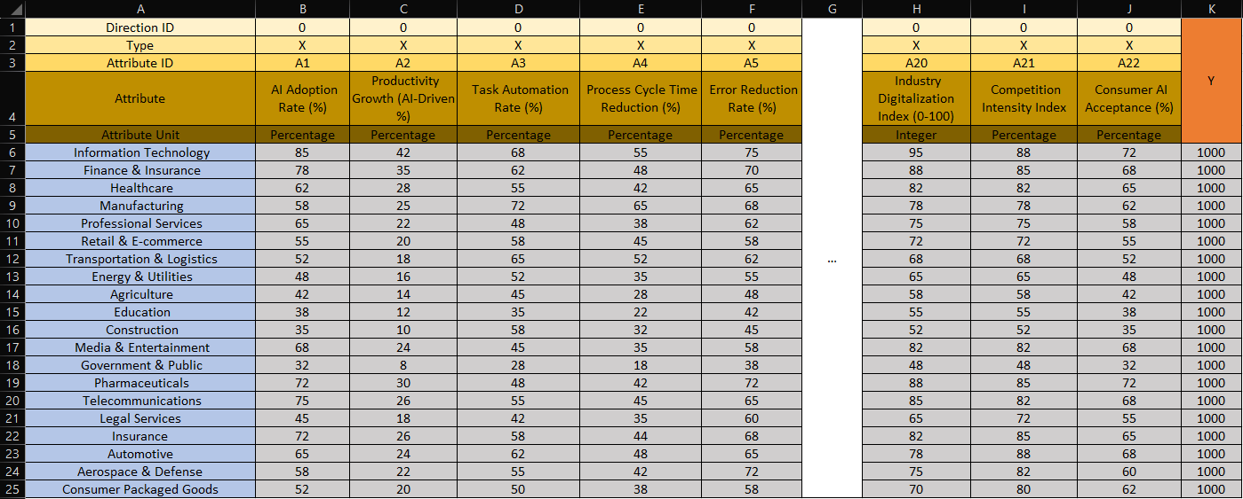

Figure2. (Excel Ranking Formula)
Source:https://view.officeapps.live.com/op/view.aspx?src=https%3A%2F%2Fmiau.my-x.hu%2Fmiau%2F328%2Fgb%2FOAM_AI%2520(3).xlsx&wdOrigin=BROWSELINK
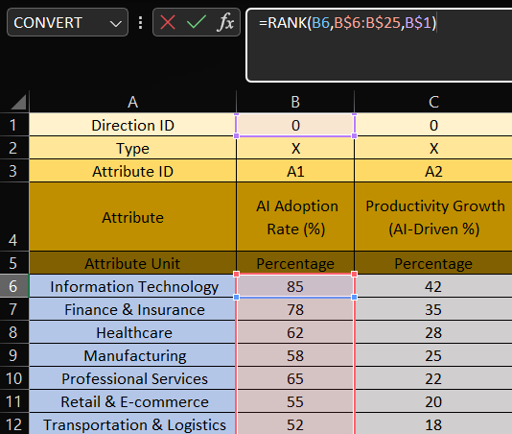
Figure3. (Constant Y-value)
Source:https://view.officeapps.live.com/op/view.aspx?src=https%3A%2F%2Fmiau.my-x.hu%2Fmiau%2F328%2Fgb%2FOAM_AI%2520(3).xlsx&wdOrigin=BROWSELINK
Y
1000
1000
1000
1000
1000
1000
1000
1000
1000
1000
Figure4. (Inverse Ranking Formula)
Source:https://view.officeapps.live.com/op/view.aspx?src=https%3A%2F%2Fmiau.my-x.hu%2Fmiau%2F328%2Fgb%2FOAM_AI%2520(3).xlsx&wdOrigin=BROWSELINK
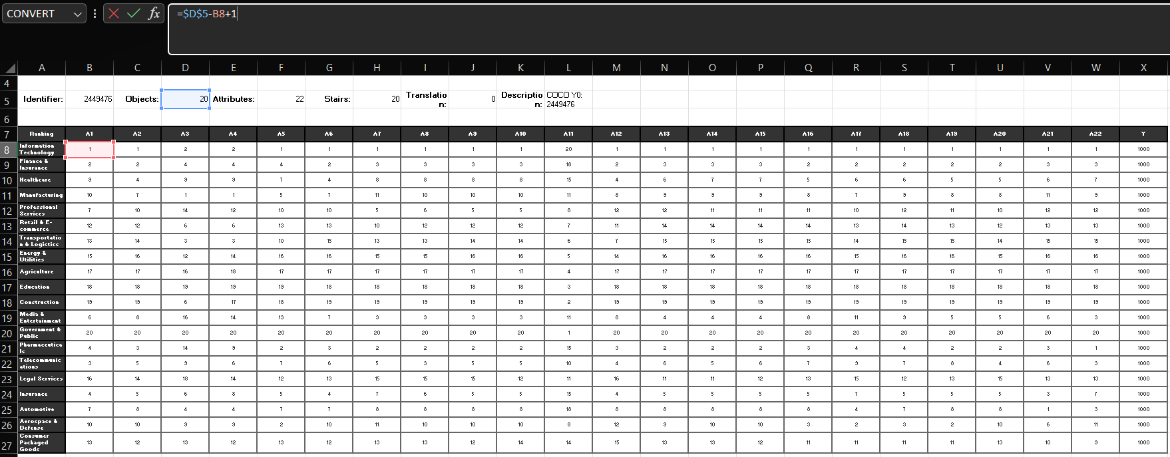

Figure5. (Direct Ranking and Inverse Ranking Validation)
Source:https://view.officeapps.live.com/op/view.aspx?src=https%3A%2F%2Fmiau.my-x.hu%2Fmiau%2F328%2Fgb%2FOAM_AI%2520(3).xlsx&wdOrigin=BROWSELINK
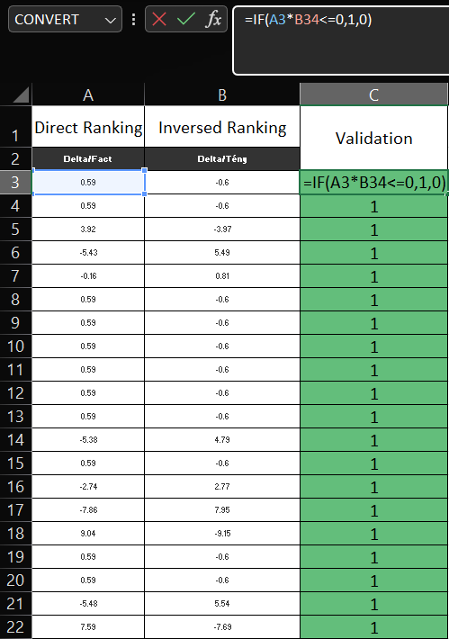

Figure6. (Object ranking by using excel formula)
Source:https://view.officeapps.live.com/op/view.aspx?src=https%3A%2F%2Fmiau.my-x.hu%2Fmiau%2F328%2Fgb%2FOAM_AI%2520(3).xlsx&wdOrigin=BROWSELINK
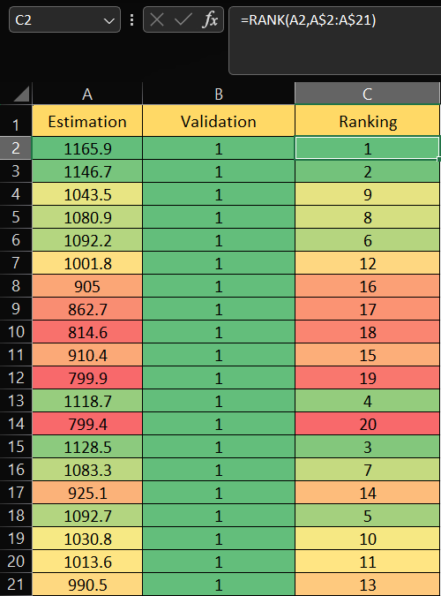

Figure7. (Attribute Exclusion by using Object Numbers-1)
Source:https://view.officeapps.live.com/op/view.aspx?src=https%3A%2F%2Fmiau.my-x.hu%2Fmiau%2F328%2Fgb%2FOAM_AI%2520(3).xlsx&wdOrigin=BROWSELINK
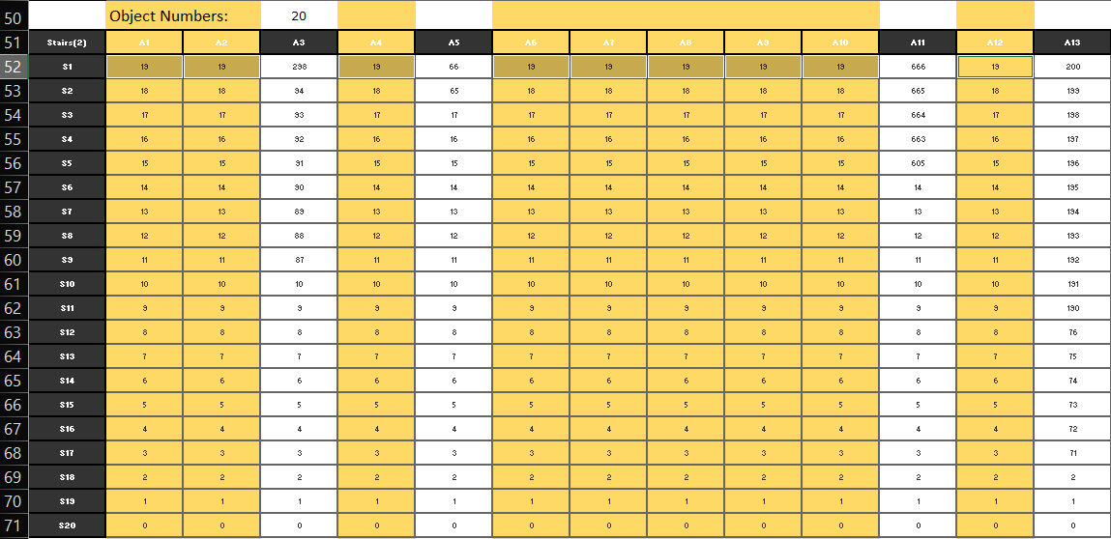

Figure8. (COCO Y0 engine interface)
Source: https://miau.my-x.hu/myx-free/coco/beker_y0.php
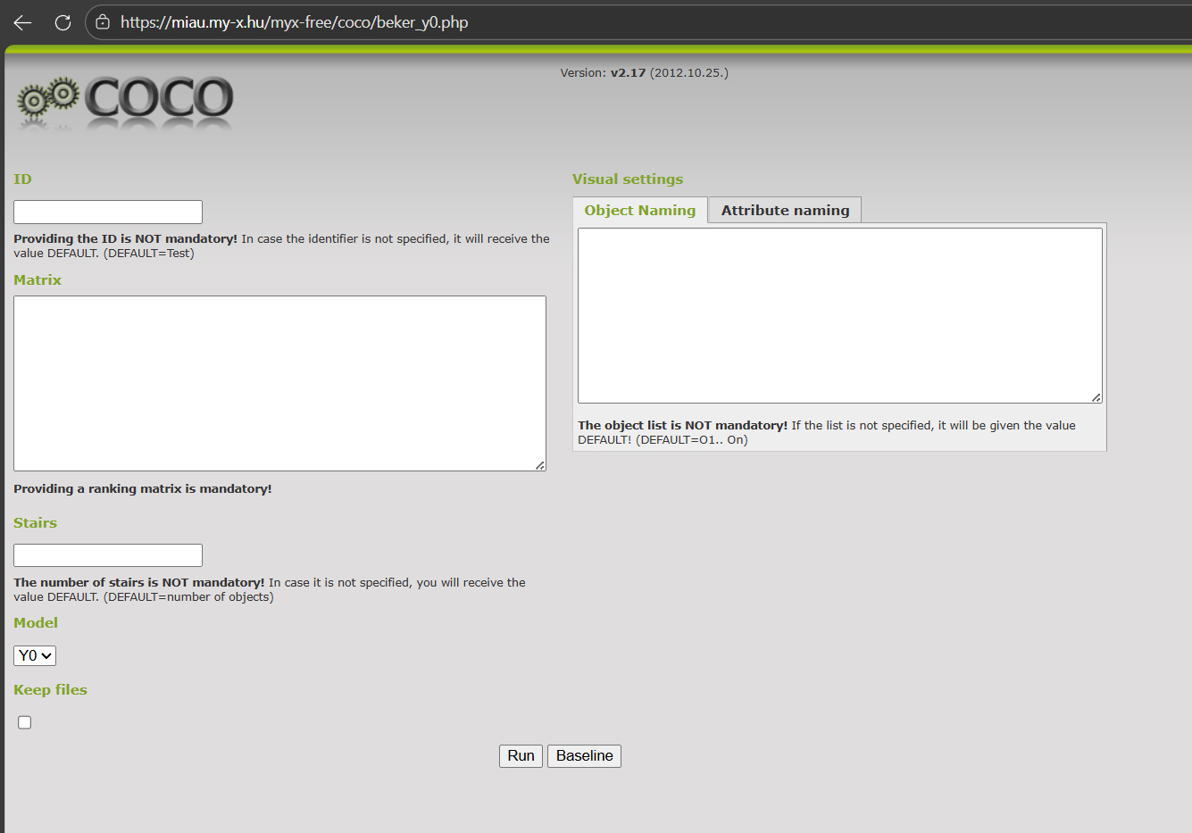

Figure9. (Inserting the data into COCO Y0 engine, Object Naming)
Source: https://miau.my-x.hu/myx-free/coco/beker_y0.php
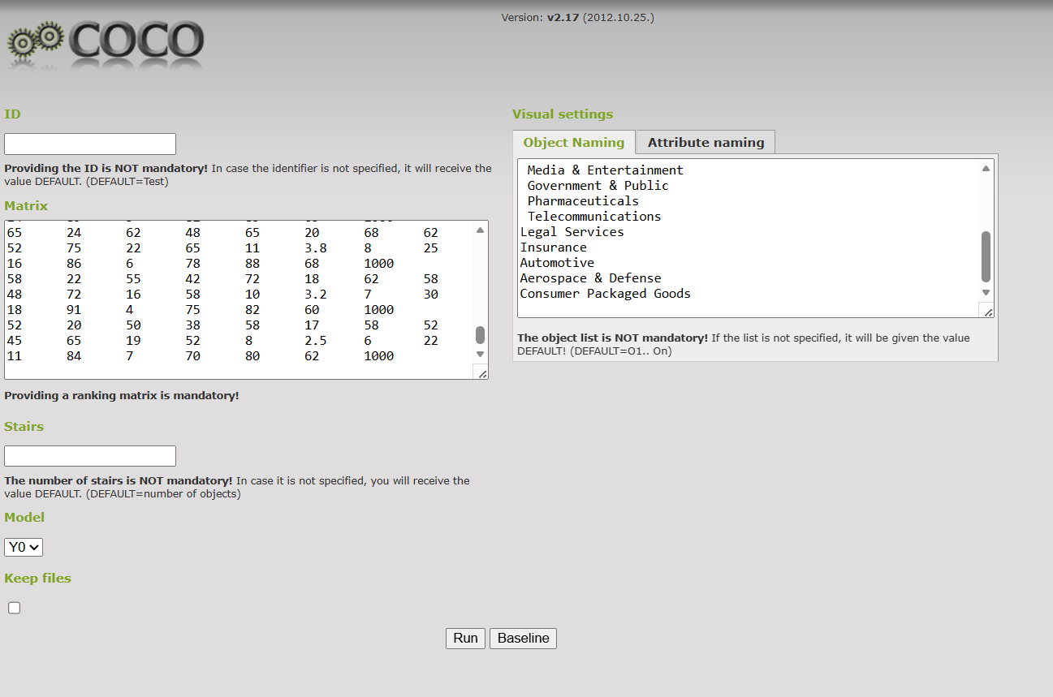

Figure10. (Inserting the data into COCO Y0 engine, Attribute Naming)
Source: https://miau.my-x.hu/myx-free/coco/beker_y0.php
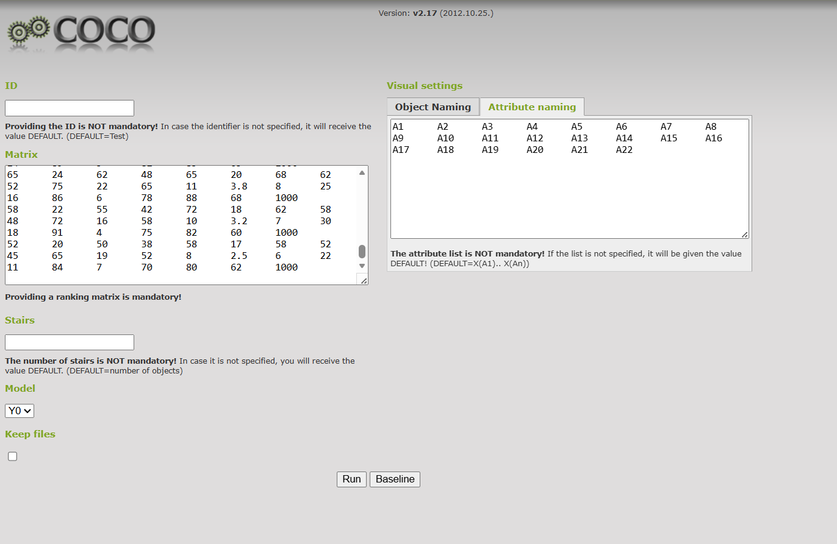

Figure11. (Results, Objects ranked by its estimations)
Source:https://view.officeapps.live.com/op/view.aspx?src=https%3A%2F%2Fmiau.my-x.hu%2Fmiau%2F328%2Fgb%2FOAM_AI%2520(3).xlsx&wdOrigin=BROWSELINK
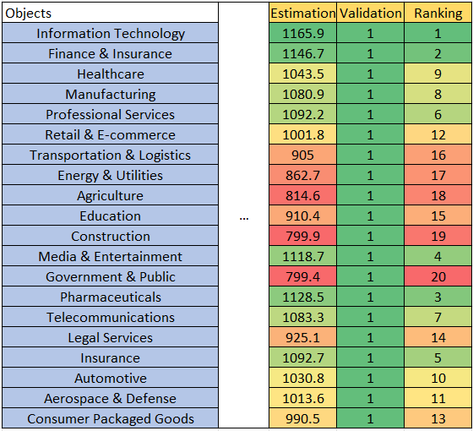

Figure12. (Most contributed sectors by estimation)
Source:https://view.officeapps.live.com/op/view.aspx?src=https%3A%2F%2Fmiau.my-x.hu%2Fmiau%2F328%2Fgb%2FOAM_AI%2520(3).xlsx&wdOrigin=BROWSELINK

References
https://view.officeapps.live.com/op/view.aspx?src=https%3A%2F%2Fmiau.my-x.hu%2Fmiau%2F328%2Fgb%2FOAM_AI%2520(3).xlsx&wdOrigin=BROWSELINK
https://miau.my-x.hu/myx-free/coco/
https://miau.my-x.hu/myx-free/coco/beker_y0.php
: Bughin, J., et al. (2018). Modeling the impact of AI on the world economy. McKinsey Global Institute. URL: https://www.mckinsey.com/featured-insights/artificial-intelligence/notes-from-the-ai-frontier-modeling-the-impact-of-ai-on-the-world-economy (08/11/2025)
Jumper, J., et al. (2021). Highly accurate protein structure prediction with AlphaFold. Nature, 596(7873), 583–589. URL: https://www.nature.com/articles/s41586-021-03819-2 (08/11/2025)
Wu, S., et al. (2023). BloombergGPT: A Large Language Model for Finance. arXiv preprint. URL: https://arxiv.org/abs/2303.17564 (08/11/2025)
Abdi, H., & Williams, L. J. (2013). Canonical correlation analysis: An overview with application to learning methods. Neural Computation, 25(9), 2633–2664. URL: https://doi.org/10.1162/NECO_a_00477 (16/01/2026)
Drucker, P. F. (1999). Knowledge-Worker Productivity: The Biggest Challenge. California Management Review. URL: https://journals.sagepub.com/doi/pdf/10.2307/41165987?download=true&_gl=1*jsy5eb*_up*MQ..*_ga*Mzg5NTMxNTI3LjE3Njg4MjExNDk.*_ga_60R758KFDG*czE3Njg4MjExNDgkbzEkZzAkdDE3Njg4MjExNDgkajYwJGwwJGgxNTMyNjE1NDEx (16/01/2026)
Solow, R. M. (1987). We’d Better Watch Out. New York Times Book Review. URL: http://digamo.free.fr/solow87.pdf (16/01/2026)
Brynjolfsson, E., and McAfee, A. (2014). The Second Machine Age. W. W. Norton and Company. URL: https://wwnorton.com/books/the-second-machine-age/ (16/01/2026)
Davenport, T. H., and Kirby, J. (2016). Just How Smart Are Smart Machines? MIT Sloan Management Review. URL: https://sloanreview.mit.edu/article/just-how-smart-are-smart-machines/ (16/01/2026)
Porter, M. E. (1985). Competitive Advantage: Creating and Sustaining Superior Performance. Free Press. URL: https://hollis.harvard.edu/primo-explore/search?tab=everything&search_scope=everything&vid=HVD2&lang=en_US&mode=basic&offset=0&query=lsr01,contains,000473683 (16/01/2026)
Abdi, H., and Williams, L. J. (2013). Canonical Correlation Analysis: An Overview with Application to Learning Methods. Neural Computation. URL: https://direct.mit.edu/neco/article-abstract/25/9/2303/7913/Spike-Based-Probabilistic-Inference-in-Analog?redirectedFrom=fulltext (18/01/2026)
Zavadskas, E. K., and Turskis, Z. (2011). Multiple Criteria Decision Making (MCDM) Methods in Economics. Technological and Economic Development of Economy. URL: https://www.tandfonline.com/doi/abs/10.3846/20294913.2011.593291 (17/01/2026)
Roy, B. (1996). Multicriteria Methodology for Decision Aiding. Kluwer Academic Publishers. URL: https://link.springer.com/book/10.1007/978-1-4757-2500-1 (17/01/2026)
Brynjolfsson, E., Hitt, L., and Kim, H. (2011). Strength in Numbers: How Does Data-Driven Decision-making Affect Firm Performance? Management Science. URL: https://papers.ssrn.com/sol3/papers.cfm?abstract_id=1819486 (17/01/2026)
Brynjolfsson, E., Rock, D., and Syverson, C. (2021). The Productivity J-Curve. American Economic Journal: Macroeconomics. URL: https://www.aeaweb.org/articles?id=10.1257/mac.20180386 (17/01/2026)
Acemoglu, D., and Restrepo, P. (2020). The Wrong Kind of AI? Artificial Intelligence and the Future of Labor Demand. Journal of Economic Perspectives. URL: https://www.nber.org/papers/w25682 (17/01/2026)
Jumper, J., et al. (2021). Highly accurate protein structure prediction with AlphaFord. Nature. URL: https://www.nature.com/articles/s41586-021-03819-2 (17/01/2026)
Wu, S., et al. (2023). BloombergGPT: A Large Language Model for Finance. arXiv. URL: https://arxiv.org/abs/2303.17564 (17/01/2026)
Davenport, T. H., and Ronanki, R. (2018). Artificial Intelligence for the Real World. Harvard Business Review. URL: https://www.the-digital-insurer.com/library/artificial-intelligence-for-the-real-world-by-thomas-h-davenport-and-rajeev-ronanki-deloitte/ (17/01/2026)
McKinsey Global Institute (2017). Artificial Intelligence: The Next Digital Frontier? URL: https://apo.org.au/node/210501 (17/01/2026)
Wilson, H. J., and Daugherty, P. R. (2018). Collaborative Intelligence. Harvard Business Review. URL: https://hometownhealthonline.com/wp-content/uploads/2019/02/ai2-R1804J-PDF-ENG.pdf (17/01/2026)
Autor, D., Mindell, D., and Reynold, E. (2022). The Work of the Future. MIT Press. URL: https://mitpress.mit.edu/9780262547307/the-work-of-the-future/ (17/01/2026)
Kane, G. C., et al. (2015). Strategy, Not Technology, Drives Digital Transformation. MIT Sloan Management Review. URL: https://sloanreview.mit.edu/projects/strategy-drives-digital-transformation/ (17/01/2026)
DiMaggo, P. J., and Powell, W. W. (1983). The Iron Cage Revisited: Institutional Isomorphism and Collective Rationality in Organizational Fields. American Sociological Review. URL: https://www.enriquedans.com/wp-content/uploads/2021/11/The_Iron_Cage_Revisted_Institutional_Isomorphism_a.pdf (17/01/2026)
Dumas, M., La Rosa, M., Mendling, J., and Reijers, H. A. (2018). Fundamentals of Business Process Management. Springer. URL: https://link.springer.com/book/10.1007/978-3-662-56509-4 (17/01/2026)
Silberschatz, A., Korth, H. F. and Sudarshan, S. (2019). Database System Concepts. McGraw-Hill. URL: https://www.amazon.com/Database-System-Concepts-Abraham-Silberschatz/dp/9390727502 (17/01/2026)
Tufte. E. R. (2001). The Visual Display of Quantitative Information. Graphics Press. URL: https://www.edwardtufte.com/book/the-visual-display-of-quantitative-information/ (17/01/2026)
Sedra, A. S., and Smith, K. C. (2014). Microelectronic Circuits. Oxford University Press. URL: https://global.oup.com/ukhe/product/microelectronic-circuits-9780190853501?cc=us&lang=en (17/01/2026)
Stiglitz, J. E. (2002). Globalization and its Discontents. W. W. Norton and Company. URL: https://wwnorton.com/books/globalization-and-its-discontents/ (17/01/2026)
Hofstede, G., Hofstede, G. J., and Minkov, M. (2010). Cultures and Organizations: Software of the Mind. McGraw-Hill. URL: https://www.mheducation.com/highered/mhp/product/cultures-organizations-software-mind-third-edition.html?viewOption=student (17/01/2026)
Cormen, T. H., Leiserson, C. E., Rivest, R. L., and Stein, C. (2009). Introduction to Algorithms. MIT Press. URL: https://mitpress.mit.edu/9780262533058/introduction-to-algorithms/ (17/01/2026)
Floyd, T. L. (2015). Electronic Devices. Personal Education. URL: https://www.pearson.com/en-us/subject-catalog/p/electronic-devices-conventional-current-version/P200000001047/9780137526642 (17/01/2026)
Stewart, J. (2015). Calculus: Early Transcendentals. Cengage Learning. URL: https://www.cengage.com/c/calculus-early-transcendentals-8e-stewart/9781285741550/
Sebesta, R. W. (2016). Concepts of Programming Languages. Pearson Education. URL: https://www.pearson.com/en-us/subject-catalog/p/concepts-of-programming-languages/P200000003361/9780135102268 (17/01/2026)
Stallings, W., and Brown, L. (2018). Computer Security: Principles and Practice. Pearson Education. URL: https://www.pearson.com/en-us/subject-catalog/p/computer-security-principles-and-practice/P200000010333/9780138091712 (17/01/2026)
Tanenbaum, A. S., & Wetherall, D. J. (2011). Computer Networks. Pearson Education. URL: https://www.pearson.com/en-us/subject-catalog/p/computer-networks/P200000003188/9780137523214 (17/01/2026)
Sommerville, I. (2016). Software Engineering. Pearson Education. URL: https://www.pearson.com/en-us/subject-catalog/p/software-engineering/P200000003258/9780137503148 (17/01/2026)
Bass, L., Clements, P., & Kazman, R. (2013). Software Architecture in Practice. Addison-Wesley. URL: https://www.researchgate.net/publication/224001127_Software_Architecture_In_Practice (17/01/2026)
Myers, G. J., Sandler, C., & Badgett, T. (2011). The Art of Software Testing. Wiley. URL: https://www.wiley.com/en-in/The+Art+of+Software+Testing%2C+3rd+Edition-p-9781119202486 (17/01/2026)
Sterman, J. D. (2000). Business Dynamics. McGraw-Hill. URL: https://www.mheducation.com/highered/product/business-dynamics-sterman.html?viewOption=student (17/01/2026)
Slack, N., Brandon-Jones, A., and Johnston, R. (2019). Operations Management. Pearson Education. URL: https://www.pearson.com/se/Nordics-Higher-Education/subject-catalogue/decision-science/slack-operations-management-9thedition.html (17/01/2026)
Ward, J., & Peppard, J. (2016). The Strategic Management of Information Systems. Wiley. URL: https://www.wiley.com/en-it/The+Strategic+Management+of+Information+Systems%3A+Building+a+Digital+Strategy%2C+4th+Edition-p-9780470034675 (17/01/2026)

Conversation with LLM
This research was supervised by professionals, and no Large Language Models were used to develop its core findings.

