2/12/2026
MEASURING AI’S EFFICIENCY ON WORKPLACE EFFICIENCY
A CROSS-SECTOR ANALYSIS
Boldsukh Ganzorig
Kodolányi János University
boldoo.ganzoo08@gmail.com
ORCID ID: https://orcid.org/0009-0001-6187-0339
Contents
2 Abstract 4
3 Introduction 4
3.1 Aims and Objectives 4
3.2 Tasks 5
3.3 Targeted Group 5
3.4 Utilities 5
3.5 Motivations 6
3.6 About the Structure of the Publication 7
4 Literature 7
4.1 About the Phenomenon of Efficiency 8
4.1.1 Efficiency before Artificial Intelligence 8
4.1.2 Efficiency after Artificial Intelligence 8
4.2 Methodology for the Cross-Sector Analyses 9
4.3 AI and Workplace Efficiency 9
4.3.1 AI as a Driver of Workplace Productivity 10
4.3.2 AI Adoption is Not Sufficient on Its Own 10
4.3.3 Sectoral Differences in AI Efficiency 10
4.4 Benchmarks – Specialized AI Models 10
4.5 AI, Automation and Process Optimization 11
4.5.1 Automation and Cycle Time Reduction 11
4.5.2 Cost Reduction Through AI 11
4.6 Augmentation Rather Than Replacement 11
4.7 AI Skills as a Performance Multiplier 11
4.8 Strategy Over Technology 12
4.9 Quality Assurance Check 12
4.10 Policy Context 12
4.11 BPROF Subjects 13
4.11.1 Business Law and Regulation 13
4.11.2 Business Process Management 13
4.11.3 Database 1 and 2 13
4.11.4 Data Visualization 13
4.11.5 Electronic Circuits 14
4.11.6 Globalization and Social Problems 14
4.11.7 Intercultural Communication 14
4.11.8 Introduction to Algorithms 14
4.11.9 Introduction to Electronics 14
4.11.10 Introduction to Mathematics 15
4.11.11 Introduction to Programming 15
4.11.12 IT-Security 15
4.11.13 Network and Computer Architectures 15
4.11.14 Programming 1, 2, 3 15
4.11.15 Software Architectures 15
4.11.16 Software Testing 16
4.11.17 System Modelling 16
4.11.18 System Operation 16
4.11.19 System Planning 16
5 Own Development 16
5.1 COCO Y0 18
5.2 OAM 18
5.3 Objects 19
5.3.1 Descriptions of the first Objects set 19
5.3.2 Description of the second Objects set 20
5.4 Attributes 21
5.4.1 Descriptions of the first Attributes set 21
5.4.2 Description of the second Attributes set 22
5.5 Ranked Table 23
5.6 Inversed Ranked Table 23
5.7 Validation of the Ranked Table and Inversed Ranked Table 24
5.8 Ranking the Objects 24
5.9 Attribute Exclusion 24
5.10 Automation 25
5.10.1 Introduction 25
5.10.2 Functions 25
5.10.3 Flexibility 27
5.10.4 Conclusion 27
5.11 Testing 27
5.12 Comparison to the Another Thesis 27
5.12.1 Similarities 28
5.12.2 Differences 29
5.12.3 Use of AI 30
5.12.4 Results and Outputs 30
6 Discussion 30
7 Future 31
8 Conclusion 32
9 Annexes 33
9.1 Abbreviations 33
9.2 Figures 33
9.3 References 53
9.4 Conversation with LLM 58

Abstract
In the era of information technology, artificial intelligence plays a crucial role in daily life and professional environments. Despite its rapid development and increased efficiency in certain sectors, the absence of targeted model training has limited measurable improvements in specific fields. This raises two core research questions for an increasingly AI-dependent world: First, does artificial intelligence have a measurable impact on workplace efficiency? Second, which sectors demonstrate the most effective use of AI, and which utilize it the least? To address these questions, the impact of artificial intelligence must be assessed using narrowed performance indicators within selected sectors. Following data collection on AI’s influence in the workplace, this data will be fine-tuned, validated, analyzed, compared, and ranked to draw meaningful conclusions.

Introduction
This study presents a quantitative analysis of whether advancements in artificial intelligence (AI) directly enhance workplace efficiency. Drawing on 22 performance attributes, including productivity, cost reduction, and operational metrics, across 20 diverse industries. The research benchmarks outcomes compared 15 specialized AI models such as BloombergGPT and AlphaFold. To ensure methodological rigor and repeatability, an automated software tool was developed to replace manual steps, including data ingestion, Object-Attribute Matrix (OAM) construction, rank transformation, COCO Y0 execution and validation output. Using the COCO Y0 engine for systematic ranking, data validation and iterative correlation-based testing, a refined Objective-Attribute Matrix (OAM) was generated to isolate the most influential factors. Findings demonstrate that AI development significantly improves workplace efficiency. However, the impact is highly context-dependent. Peak efficiency emerges in sectors characterized by high AI adoption rates and domain-specific model deployment aligned with core operational tasks. In contrast, industries relying primarily on generic AI tools or lacking targeted model training exhibit substantially lower gains. Overall, the results highlight that strategic alignment between AI capabilities and organizational functions is the primary determinant of measurable performance improvements.

Aims and Objectives
The primary aim of this research is to determine whether artificial intelligence has a measurable and comparable impact on workplace efficiency across multiple sectors. To achieve this aim, the study develops and applies a quantitative, attribute-based evaluation framework capable of objectively ranking sectors according to AI-driven performance outcomes. The specific objectives of the research are:
- To design a structured Objective–Attribute Matrix (OAM) that captures AI-related efficiency indicators across diverse industries.
- To benchmark sectoral AI performance against specialized, domain-trained AI models.
- To apply the COCO Y0 ideal-seeking model to support objective, anti-discriminatory estimation.
- To validate the robustness of results through symmetric ranking inversion to ensure methodological consistency.
- To identify which sector benefits most and least from AI adoption and why.
- To develop a software solution that fully automates the manual processes of data preparation, evaluation and result generation.

Tasks
To accomplish the stated aims, the research was organized into the following tasks:
- Identifying relevant workplace sectors and AI-trained specialization domains.
- Selection and defining measurable efficiency-related attributes.
- Constructing multiple Object-Attribute Matrix (OAM) configurations for different object–attribute sets.
- Transforming heterogeneous input data into ranked tables suitable for COCO Y0 analysis.
- Executing COCO Y0 computations on both direct and inversed ranked datasets.
- Validating the results through symmetric effect testing to ensure methodological consistency.
- Performing attribute exclusion to isolate the most influential performance drivers.
- Producing the final ranking and interpreting sectoral AI efficiency outcomes.
- Developing a software solution that fully automates all manual processing steps withing the analytical workflow.

Targeted Group
This study pursues a dual objective, to systematically address its core research questions and to convert the findings into practical insights for professionals and organizations utilizing artificial intelligence. By identifying which sectors leverage AI most and least effectively, it aims to provide actionable guidance for stakeholders seeking to optimize its implementation in the workplace.

Utilities
The source of income in the proposed micro-business model does not stem from direct commercialization of the framework itself, which is provided free of charge for non-commercial use. Instead, income is realized indirectly through measurable productivity gains, operational cost reductions, and opportunity-driven benefits enabled by improved workplace efficiency. By identifying and prioritizing AI initiatives that yield the highest efficiency impact, micro businesses can increase output capacity, reduce avoidable expenses, and exploit additional business opportunities. These efficiency-driven gains constitute the primary economic return generated by applying the proposed framework. This project cost could be completely covered by opportunity-driven benefits. Estimated opportunity-driven gain would be cheaper than the average project value (2000$-4000$) based on its annual operation cost.
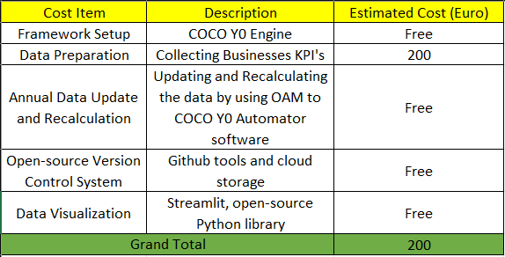
Figure#x: title, source: own presentation
Income? (targeted groups)
Operation cost concerning the real users?
Informational added-value?
The proposed project is designed to operate as a longitudinal and extensible framework, allowing it to be updated annually with new datasets, revised attributes, and extended analytical configurations. Each yearly iteration would result in a new version of the framework, reflecting updated sectoral data and refined efficiency measurements. Organizations would have the option to subscribe to the most recent yearly framework, while previous versions would be released for open use after the update cycle, ensuring transparency and broader accessibility. The expected subscription fee is estimated at approximately €50 per business per year, which is intentionally kept low to remain accessible for micro and small enterprises. Based on the cost estimations presented earlier, eight active business subscriptions would be sufficient to fully cover the annual operational expenses of maintaining, updating, and validating the framework. This model demonstrates that the project is financially sustainable while preserving its primary objective of providing an affordable, objective, and reusable AI efficiency evaluation service.

Motivations
The motivation for this study arises from the growing disparity between increasing AI adoption rates and the efficiency gains actually realized in real-world workplaces. Although AI technologies are widely promoted as productivity-enhancing solutions, empirical evidence compares sector-level outcomes remains fragmented, methodologically inconsistent and often difficult to reproduce. In addition to the need for clearer evaluation, many existing assessments rely on manual data handling which limits scalability and increases the risk of human error.
Accordingly, this research is driven by the need to:
- Move beyond qualitative narratives toward a validated, quantitative evaluation framework.
- Address the lack of standardized, cross sector benchmarking for AI-enabled efficiency outcomes.
- Clarify whether domain specialization, rather than adoption alone that determines AI effectiveness.
- Develop an automated analytical workflow that replaces manual processing with repeatable computation, enabling consistent yearly re-evaluation on updated datasets.

About the Structure of the Publication
This publication is structured to guide the reader from conceptual foundations of AI-enabled workplace efficiency to empirically validated conclusions. Following the introduction and literature review, the chapter on own development presents the methodological design in detail, including the construction of the OAM, the rank transformation procedure, COCO Y0 computation, benchmarking and validation mechanisms and the implementation of the automation software that operationalize the workflow. The results chapter reports the ranked sectorial estimations and related outputs, which are subsequently interpreted in the discussion. The publication concludes with a summary of limitations and directions for future research. Overall, this structure is intended to ensure methodological transparency, analytical reproducibility and a coherent logical progression across chapters.
What should still have been mentioned, but the volume of the thesis is limited?
Which formats serve which goals?

Literature
IF you use a source - e.g. (Bughin et al., 2018) – it is necessary to have a cited text! Source+citation + own interpretation = standard literature element!!! EACH subchapter needs at least one citation!
The investigation into the efficiency of the artificial intelligence in enhancing workplace efficiency is situated within a broader discourse on technology-driven productivity. A report by the McKinsey Global Institute (Bughin et al., 2018) projects massive economic potential from AI while acknowledging implementation challenges. (Source: Bughin, J., et al. (2018). Modeling the impact of AI on the world economy. McKinsey Global Institute. URL: https://www.mckinsey.com/featured-insights/artificial-intelligence/notes-from-the-ai-frontier-modeling-the-impact-of-ai-on-the-world-economy). It provides essential macro level data on AI’s projected economic impact, setting the stage for the more granular, sector specific analysis conducted in this study. Therefore, the breakthrough performance of AlphaFord 2 in predicting protein structures, as detailed by Jumper et al. (2021), serves as a paradigm for sector specific AI success. (Source: Jumper, J., et al. (2021). Highly accurate protein structure prediction with AlphaFold. Nature. URL: https://www.nature.com/articles/s41586-021-03819-2). This is the central and will be integrated into the 3.4.1 Descriptions of the first Objects set as a benchmark case study for the pharmaceuticals sector. Similarly, the development of BloombergGPT by Wu et al. (2023) demonstrates superior performance in financial language tasks compared to general purpose models. (Source: Wu, S., et al. (2023). BloombergGPT: A Large Language Model for Finance. arXiv preprint. URL: https://arxiv.org/abs/2303.17564). These sources provide a concrete of peer reviewed standard for high model accuracy and supporting hypothesis that specialized models yield higher accuracy and by extension, it is leading a greater potential and sector specific revolutionary efficiency in research and development. Abdi and Williams (2013) detail Canonical Correlation Analysis (CCA) as the standard technique for assessing the relationship between two sets of variables, such as a set of AI benchmarks and a set of workplace efficiency metrics (3.5 Attributes). (Source: Abdi, H., & Williams, L. J. (2013). Canonical correlation analysis: An overview with application to learning methods. Neural Computation, 25(9), 2633–2664. URL: https://doi.org/10.1162/NECO_a_00477). This citation is essential and will be integrated into 5 Methodology chapter to underpin the core analytical strategy of relating the two variable sets. It provides the mathematical and theoretical justification for the chosen correlation validation method.

About the Phenomenon of Efficiency
Efficiency is a foundational concept in organizational analysis and serves as the primary outcome variable of this research. Policy documents frequently emphasize that AI can deliver “…greater productivity and more efficient production for businesses,” (Source: https://commission.europa.eu/news-and-media/news/ai-act-enters-force-2024-08-01_hu) motivating the need for systematic, reproducible methods to operationalize and evaluate such efficiency claims across sectors. Before evaluating the impact of artificial intelligence on workplace performance, it is necessary to clarify what efficiency means in an organizational context and how it has traditionally been understood and measured. This chapter introduces the phenomenon of efficiency by outlining its conceptual interpretation in business and operational environments, both prior to and following the widespread adoption of artificial intelligence. By establishing this conceptual baseline, the chapter provides the theoretical foundation required to distinguish between efficiency improvements driven by traditional process optimization and those enabled by AI-supported automation, decision-making, and human–machine collaboration. This clarification is essential for ensuring that subsequent sectoral comparisons and quantitative evaluations are based on a consistent and well-defined understanding of efficiency.

Efficiency before Artificial Intelligence
Drucker, P. F. (1999). Knowledge-Worker Productivity: The Biggest Challenge. California Management Review (https://journals.sagepub.com/doi/pdf/10.2307/41165987?download=true&_gl=1*jsy5eb*_up*MQ..*_ga*Mzg5NTMxNTI3LjE3Njg4MjExNDk.*_ga_60R758KFDG*czE3Njg4MjExNDgkbzEkZzAkdDE3Njg4MjExNDgkajYwJGwwJGgxNTMyNjE1NDEx). “Efficiency is doing things right. Effectiveness is doing the right things. For knowledge work, productivity depends primarily on the quality of processes rather than sheer speed.”. This citation defines efficiency in the pre-AI era as fundamentally process-driven and human-centered. It directly supports conceptual baseline of this thesis for efficiency before AI. This establishes the pre-AI reference point against which this thesis’ AI-driven efficiency measurements are compared. Solow, R. M. (1987). We’d Better Watch Out. New York Times Book Review (http://digamo.free.fr/solow87.pdf). “You can see the computer age everywhere but in the productivity statistics.”. This famous observation highlights the historical difficulty of converting technological adoption into measurable efficiency gains. It directly supports its motivation for developing a quantitative, validated framework (OAM + COCO Y0) rather than relying on adoption narratives alone.

Efficiency after Artificial Intelligence
Brynjolfsson, E., and McAfee, A. (2014). The Second Machine Age. W. W. Norton and Company (https://wwnorton.com/books/the-second-machine-age/). “Digital technologies are transforming work by enabling machines to perform cognitive tasks that previously required human intelligence.”. This quotation defines the post-AI shift in efficiency, where gains are no longer limited to physical automation but extend to cognitive and decision-intensive tasks. This thesis operationalizes this shift through attributes such as Real-Time Decision Ratio, Model Accuracy and AI-Human Collaboration Index, making post-AI efficiency measurable across sectors. Davenport, T. H., and Kirby, J. (2016). Just How Smart Are Smart Machines? MIT Sloan Management Review (https://sloanreview.mit.edu/article/just-how-smart-are-smart-machines/). “The primary impact of artificial intelligence is not full automation but the augmentation of human work.” This directly supports treatment of efficiency as a hybrid outcome rather than pure automation. This thesis findings show that sectors performing best are those where AI augments human capability, reinforcing why collaboration-based attributes matter in the rankings.

Methodology for the Cross-Sector Analyses
Porter, M. E. (1985). Competitive Advantage: Creating and Sustaining Superior Performance. Free Press (https://hollis.harvard.edu/primo-explore/search?tab=everything&search_scope=everything&vid=HVD2&lang=en_US&mode=basic&offset=0&query=lsr01,contains,000473683). “The value chain provides a systematic way of examining all activities a firm performs and how they interact to create competitive advantage.”. This citation justifies Object-Attribute decomposition of workplace sectors. OAM mirrors Porter’s analytical logic by breaking complex organizational performance into comparable attributes, allowing efficiency to be evaluated consistently across industries. Abdi, H., and Williams, L. J. (2013). Canonical Correlation Analysis: An Overview with Application to Learning Methods. Neural Computation (https://direct.mit.edu/neco/article-abstract/25/9/2303/7913/Spike-Based-Probabilistic-Inference-in-Analog?redirectedFrom=fulltext). “Canonical correlation analysis examines the relationship between two multivariate sets of variables.” This quotation provides statistical foundation for the cross-sector methodology. This thesis adapts this logic by correlating AI benchmarks with workplace efficiency attributes through COCO Y0, making the multi-dimensional comparison mathematically defensible. Zavadskas, E. K., and Turskis, Z. (2011). Multiple Criteria Decision Making (MCDM) Methods in Economics. Technological and Economic Development of Economy (https://www.tandfonline.com/doi/abs/10.3846/20294913.2011.593291). “Multiple criteria decision-making methods allow complex alternatives to be evaluated based on numerous, often conflicting, criteria.” This citation directly legitimizes the use of COCO Y0 as an MCDM tool. The cross-sector analysis relies on precisely this principle. Evaluating industries using many efficiency-related attributes without collapsing them into a single subjective metric. Roy, B. (1996). Multicriteria Methodology for Decision Aiding. Kluwer Academic Publishers (https://link.springer.com/book/10.1007/978-1-4757-2500-1). “The objective of multicriteria analysis is not to find an optimal solution, but to provide a structured comparison among alternatives.”. This quotation aligns perfectly with its methodological stance. This thesis does not claim absolute truth but provides a validated, relative ranking of sectors, consistent with multicriteria decision theory and the anti-discriminatory logic of COCO Y0. The structure of the methodological COCO system is also documented in Hungarian-language institution materials (My-X Research Team. 2024. https://miau.my-x.hu/miau2009/index.php3). The previous version of the COCO evaluation framework was documented in institutional online materials (My-X Research Team. 2013. https://miau.my-x.hu/miau2009/index.php3).

AI and Workplace Efficiency
Ministry of Digital Development and Communications of Mongolia (2023). Comparative study of services based on advanced information and communication technologies (Big Data, Artificial Intelligence). “As of October 2022, 44 countries around the world have adopted national-level strategic plans focused on artificial intelligence, following trend of increasing AI-based products and services.” (https://www.slideshare.net/slideshow/ss-630d/274866030). This article supports that the artificial intelligence is increasingly recognized as a significant driver of workplace efficiency due to its ability to automate tasks, enhance decision-making, and support human performance in workplaces. This chapter reviews how AI influences productivity, process efficiency, and cost reduction, and establishes the conceptual link between AI capabilities and measurable efficiency outcomes. The discussion provides the theoretical foundation for the quantitative, cross-sector evaluation applied in the subsequent analysis.

AI as a Driver of Workplace Productivity
Brynjolfsson, E., Hitt, L., and Kim, H. (2011). Strength in Numbers: How Does Data-Driven Decision-making Affect Firm Performance? Management Science (https://papers.ssrn.com/sol3/papers.cfm?abstract_id=1819486). “Firms that adopt data-driven decision making have output and productivity that is 5 to 6 percent higher than what would be expected given their other investments and information technology usage.” This citation directly underpins its Productivity Growth (AI-Driven %) and Real-Time Decision Ratio (%) attributes. This thesis extends this firm-leveling finding into a cross-sector comparison, qualifying how AI-driven decision-making converts into different efficiency outcomes depending on industry context.

AI Adoption is Not Sufficient on Its Own
Brynjolfsson, E., Rock, D., and Syverson, C. (2021). The Productivity J-Curve. American Economic Journal: Macroeconomics (https://www.aeaweb.org/articles?id=10.1257/mac.20180386). “Artificial Intelligence often requires significant complementary investments in organizational capital before productivity gains can be realized.” This citation directly explains why the results show high adoption but low efficiency in sectors such as Construction and Government. OAM framework captures these missing complementary investments through attributes like AI Skill Penetration and Industry Digitalization Index.

Sectoral Differences in AI Efficiency
Acemoglu, D., and Restrepo, P. (2020). The Wrong Kind of AI? Artificial Intelligence and the Future of Labor Demand. Journal of Economic Perspectives (https://www.nber.org/papers/w25682). “The impact of artificial intelligence on productivity and labor demand varies significantly across sectors depending on task composition and implementation.” This directly justifies the cross-sector object selection. This thesis Operationalizes Acemoglu and Restrepo’s theoretical claim by ranking 20 workplace sectors and empirically demonstrating how task structure and implementation strategy shape efficiency outcomes.

Benchmarks – Specialized AI Models
Jumper, J., et al. (2021). Highly accurate protein structure prediction with AlphaFold. Nature (https://www.nature.com/articles/s41586-021-03819-2). “The accuracy of AlphaFold far exceeds that of previous methods, enabling practical applications in biological research.”. Wu, S., et al. (2023). BloombergGPT: A Large Language Model for Finance. arXiv (https://arxiv.org/abs/2303.17564). “BloombergGPT achieves substantially better performance on financial NLP tasks than general-purpose language models.”. These studies validate the use of specialized, domain-trained AI models as performance benchmarks rather than as prescriptive solutions. Within the context of this thesis, such benchmarks serve as reference points for evaluating how closely workplace sectors align with optimal AI utilization patterns. The higher rankings observed for sectors associated with domain-trained models in the COCO Y0 results therefore do not imply direct technology adoption recommendations, but instead illustrate a generalizable principle. Measurable efficiency gains emerge when AI capabilities are aligned with domain-specific operational tasks. This interpretation applies across all sectors, models, and datasets examined in the thesis.

AI, Automation and Process Optimization
Artificial intelligence enhances workplace efficiency primarily through task automation and process optimization. This chapter reviews how AI-driven automation reduces process cycle time, operational costs, and error rates, establishing the conceptual basis for evaluating automation-related efficiency gains.

Automation and Cycle Time Reduction
Davenport, T. H., and Ronanki, R. (2018). Artificial Intelligence for the Real World. Harvard Business Review (https://www.the-digital-insurer.com/library/artificial-intelligence-for-the-real-world-by-thomas-h-davenport-and-rajeev-ronanki-deloitte/). “The most common AI applications involve automating digital and physical tasks, especially those that are routine and high-volume.” This directly supports Task Automation Rate (%) and Process Cycle Time Reduction (%) attributes. This thesis quantitatively evaluates exactly the types of automation Davenport and Ronanki describe qualitatively.

Cost Reduction Through AI
McKinsey Global Institute (2017). Artificial Intelligence: The Next Digital Frontier ( https://apo.org.au/node/210501)? “AI-driven automation can reduce operating cost by up to 20 percent in some business processes.” This citation highlights the Operation Cost Reduction (%) attribute and explains why sectors with mature automation pipelines score higher in the final COCO estimation. European Commission (2020). White Paper on Artificial Intelligence – A European approach to excellence and trust. ”…improving the efficiency of production systems through predictive maintenance” (Source: https://commission.europa.eu/document/download/d2ec4039-c5be-423a-81ef-b9e44e79825b_en?filename=commission-white-paper-artificial-intelligence-feb2020_en.pdf). The statement that AI can improve efficiency through predictive maintenance provides a concrete operational pathway linking AI adoption to measurable gains such as reduced downtime, improved asset availability and lower maintenance-related costs that dimensions directly aligned with organizational efficiency evaluation.

Augmentation Rather Than Replacement
Wilson, H. J., and Daugherty, P. R. (2018). Collaborative Intelligence. Harvard Business Review (https://hometownhealthonline.com/wp-content/uploads/2019/02/ai2-R1804J-PDF-ENG.pdf). “The most effective AI systems are those in which humans and machines work together, each complementing the other’s strengths.”. This directly validates the AI-Human Collaboration Index (0-100). This thesis empirically shows that sectors with higher collaboration scores achieve superior efficiency outcomes, aligning with this literature.

AI Skills as a Performance Multiplier
Autor, D., Mindell, D., and Reynold, E. (2022). The Work of the Future. MIT Press (https://mitpress.mit.edu/9780262547307/the-work-of-the-future/). “Technology delivers productivity gains only when workers possess the skills required to use it effectively.” This directly supports AI Skill Penetration (%) and Employee AI Usage Rate (%) attributes and explains why high-investment but low-skill sectors underperform in the ranking. Magyarország Kormánya. Magyarország Mesterséges Intelligencia Stratégiája 2020–2030. “…radically transforms the expectations of the labor market, as well as the way of working.” (Source: https://cdn.kormany.hu/uploads/document/6/67/676/676186555d8df2b1408982bb6ce81c643d5fa4ab.pdf). The observation that AI “radically transforms the expectations of the labor market, as well as the way of working” motivates evaluating efficiency as a socio-technical outcome shaped by task redesign, skill requirements, and human–machine collaboration, not solely by tool performance.

Strategy Over Technology
Kane, G. C., et al. (2015). Strategy, Not Technology, Drives Digital Transformation. MIT Sloan Management Review (https://sloanreview.mit.edu/projects/strategy-drives-digital-transformation/). “Digital maturity is driven more by organizational strategy and culture than by the technologies themselves.”. This citation explains Industry Digitalization Index (0-100) and why digital maturity acts as a moderating variable in AI efficiency, reinforcing the sectoral differentiation.

Quality Assurance Check
Pitlik László (KJE/MY-X team). Mire lehet alkalmas az LLM a bankszektorban? “The LLM should be immediately tasked with conducting a kind of quality assurance check and listing any detected potential anomalies into (risk-based) categories.” (Source: https://miau.my-x.hu/miau/328/copilot_bank.pdf). This supports the design choice of introducing an automated “quality assurance gate” prior to ranking, where anomalies are detected and categorized by severity to prevent invalid inputs from propagating into COCO-based outputs. Pitlik László. Journal of the Knowledge Economy. “Similarity analysis is an artificial intelligence-based approach with its own consistence-oriented quality assurance layers.” (https://miau.my-x.hu/miau/216/JKEC-S-16-00168.pdf). This supports the methodological requirement that multi-attribute AI-based evaluation (e.g., similarity-analysis/COCO-family approaches) should be accompanied by consistence-oriented quality assurance layers, ensuring that rankings remain interpretable and traceable under input variability.

Policy Context
Jogtár (HU). White Paper. “The white paper emphasizes the fundamental rights implications of artificial intelligence” (Source: https://net.jogtar.hu/jogszabaly?docid=a20v0080.egb). The White Paper’s emphasis on the fundamental rights implications of AI motivates treating efficiency as a constrained socio-technical outcome: productivity gains must be evaluated alongside compliance, accountability, and fairness requirements that shape feasible deployment across sectors.

BPROF Subjects
This section outlines the relationship between the subjects completed during Kodolányi János University’s BPROF program and the present thesis, Measuring AI’s Efficiency on Workplace Efficiency: A Cross-Sector Analysis. The purpose of this chapter is to explain how the subjects completed in the BPROF program are specifically applied within this thesis. Each subsection highlights the unique methodological or analytical role of the subject in developing, validating, or interpreting the AI Efficiency Framework based on the Object–Attribute Matrix and the COCO Y0 model.

Business Law and Regulation
DiMaggo, P. J., and Powell, W. W. (1983). The Iron Cage Revisited: Institutional Isomorphism and Collective Rationality in Organizational Fields. American Sociological Review (https://www.enriquedans.com/wp-content/uploads/2021/11/The_Iron_Cage_Revisted_Institutional_Isomorphism_a.pdf). “Regulation shapes how organizations adopt and deploy information technologies, influencing compliance costs, operational processes and overall efficiency.” Business law and regulation define the institutional constraints under which organizations operate. In this thesis, regulatory conditions explain why certain sectors (e.g. Government, Legal Services, Healthcare) demonstrate lower AI efficiency scores, as legal constraints directly affect AI adoption rate, operational risk reduction, and incident frequency within the OAM.

Business Process Management
Dumas, M., La Rosa, M., Mendling, J., and Reijers, H. A. (2018). Fundamentals of Business Process Management. Springer (https://link.springer.com/book/10.1007/978-3-662-56509-4). “Business Process Management is the discipline of identifying, designing, executing, measuring and improving business processes.”. Business Process Management focuses on analyzing and improving organizational workflows. In this thesis, BPM concepts underpin the definition of efficiency-related attributes such as task automation rate, process cycle time reduction, and productivity growth, which are quantitatively evaluated across sectors using COCO Y0.

Database 1 and 2
Silberschatz, A., Korth, H. F. and Sudarshan, S. (2019). Database System Concepts. McGraw-Hill (https://www.amazon.com/Database-System-Concepts-Abraham-Silberschatz/dp/9390727502). “Database provide mechanisms for the efficient storage, retrieval and management of structured data.” Database systems enable structured storage and retrieval of data. In this thesis, database principles are essential for organizing multi-sector benchmark data and attribute values, ensuring consistency, traceability, and repeatability of yearly COCO Y0 computations.

Data Visualization
Tufte. E. R. (2001). The Visual Display of Quantitative Information. Graphics Press (https://www.edwardtufte.com/book/the-visual-display-of-quantitative-information/). “The purpose of data visualization is to communicate information clearly and efficiently through graphical representations.” Data visualization supports the interpretation of quantitative results clearly and efficiently. In this thesis, visualization techniques are used to interpret ranked sector outputs, attribute exclusion results, and validation checks, making COCO Y0 estimations transparent and examinable.

Electronic Circuits
Sedra, A. S., and Smith, K. C. (2014). Microelectronic Circuits. Oxford University Press (https://global.oup.com/ukhe/product/microelectronic-circuits-9780190853501?cc=us&lang=en). “Electronic circuits form the physical foundation of all digital computing systems.” AI systems rely on electronic hardware for computation. Understanding electronic circuits supports awareness of physical constraints that influence computational performance, scalability and energy efficiency of AI systems used across different workplace sectors.

Globalization and Social Problems
Stiglitz, J. E. (2002). Globalization and its Discontents. W. W. Norton and Company (https://wwnorton.com/books/globalization-and-its-discontents/). “Globalization reshapes labor markets and redistributes productivity gains unevenly across industries and regions.” This subject is relevant because AI efficiency gains are not evenly distributed across sectors. My thesis reflects these inequalities by ranking industries that benefit most and least from AI, helping explain structural differences driven by global economic forces.

Intercultural Communication
Hofstede, G., Hofstede, G. J., and Minkov, M. (2010). Cultures and Organizations: Software of the Mind. McGraw-Hill (https://www.mheducation.com/highered/mhp/product/cultures-organizations-software-mind-third-edition.html?viewOption=student). “Effective intercultural communication is essential for collaboration and organizational performance in global environments.” Intercultural communication influences collaboration in global organizations. In this thesis, cultural and organizational acceptance factors affect employee AI usage rate and consumer AI acceptance attributes, helping explain adoption–efficiency mismatches.

Introduction to Algorithms
Cormen, T. H., Leiserson, C. E., Rivest, R. L., and Stein, C. (2009). Introduction to Algorithms. MIT Press (https://mitpress.mit.edu/9780262533058/introduction-to-algorithms/). “An algorithm is a finite sequence of well-defined instructions used to solve problem.” Algorithms define formal problem-solving procedures. In this thesis, AI models, the COCO Y0 engine and automated formulas are treated as algorithmic systems, making algorithmic efficiency, optimization, and ranking logic central to the evaluation process.

Introduction to Electronics
Floyd, T. L. (2015). Electronic Devices. Personal Education (https://www.pearson.com/en-us/subject-catalog/p/electronic-devices-conventional-current-version/P200000001047/9780137526642). “Electronics enables the processing and control of electrical signals in information systems.”. In this thesis, understanding the electronics, it feasibility limits AI execution speed, reliability, and energy efficiency, indirectly influencing sectoral efficiency outcomes.

Introduction to Mathematics
Stewart, J. (2015). Calculus: Early Transcendentals. Cengage Learning (https://www.cengage.com/c/calculus-early-transcendentals-8e-stewart/9781285741550/). “Mathematics provides the tools necessary for modeling, analyzing and optimizing complex systems.” Mathematics is fundamental to my thesis because, in this thesis, mathematical concepts underpin ranking, normalization, correlation, optimization, and validation rules used in OAM construction and COCO Y0 analysis.

Introduction to Programming
Sebesta, R. W. (2016). Concepts of Programming Languages. Pearson Education (https://www.pearson.com/en-us/subject-catalog/p/concepts-of-programming-languages/P200000003361/9780135102268). “Programming allows algorithms to be expressed, tested and executed by computers.”. Programming enables the implementation of algorithms. In this thesis, programming logic is applied through Excel-based automation to ensure deterministic, auditable, extendable and repeatable data transformation across all OAM iterations.

IT-Security
Stallings, W., and Brown, L. (2018). Computer Security: Principles and Practice. Pearson Education (https://www.pearson.com/en-us/subject-catalog/p/computer-security-principles-and-practice/P200000010333/9780138091712). “Information security ensures the confidentiality, integrity and availability of information systems.”. AI efficiency cannot be separated from system reliability and security. In this thesis, security considerations are reflected in incident rate and operational risk reduction attributes, influencing AI efficiency outcomes in sensitive sectors.

Network and Computer Architectures
Tanenbaum, A. S., & Wetherall, D. J. (2011). Computer Networks. Pearson Education (https://www.pearson.com/en-us/subject-catalog/p/computer-networks/P200000003188/9780137523214). “Computer networks enable communication and resource sharing between distributed systems.”. AI systems often operate in networked environments. This subject explains that efficiency differences in sectors requiring real-time data processing and cloud-based AI deployment in this thesis.

Programming 1, 2, 3
Sommerville, I. (2016). Software Engineering. Pearson Education (https://www.pearson.com/en-us/subject-catalog/p/software-engineering/P200000003258/9780137503148). “Programming skills are essential for developing, testing, and maintaining complex software systems.”. In this thesis, these skills enabled the implementation of validation logic, rank inversion, and automated recalculation, ensuring methodological robustness.

Software Architectures
Bass, L., Clements, P., & Kazman, R. (2013). Software Architecture in Practice. Addison-Wesley (https://www.researchgate.net/publication/224001127_Software_Architecture_In_Practice). “Software architecture defines the fundamental organization of a software system and its components.”. Well-designed architectures enable scalable and efficient AI deployment. This subject explains why certain sectors integrate AI more effectively.

Software Testing
Myers, G. J., Sandler, C., & Badgett, T. (2011). The Art of Software Testing. Wiley (https://www.wiley.com/en-in/The+Art+of+Software+Testing%2C+3rd+Edition-p-9781119202486). “Software testing is the process of evaluating a system to detect errors.”. My thesis applies testing logic through symmetric inversion and validation rules in COCO Y0, ensuring result reliability.

System Modelling
Sterman, J. D. (2000). Business Dynamics. McGraw-Hill (https://www.mheducation.com/highered/product/business-dynamics-sterman.html?viewOption=student). “Models are simplified representations of reality used to understand and predict system behavior.”. The Object–Attribute Matrix used in my thesis is a formal system model that enables structured cross-sector analysis.

System Operation
Slack, N., Brandon-Jones, A., and Johnston, R. (2019). Operations Management. Pearson Education (https://www.pearson.com/se/Nordics-Higher-Education/subject-catalogue/decision-science/slack-operations-management-9thedition.html). “Operational performance depends on how systems are monitored, maintained, and controlled.”. AI efficiency is influenced by operational stability, which explains variations in performance and incident rates across sectors.

System Planning
Ward, J., & Peppard, J. (2016). The Strategic Management of Information Systems. Wiley (https://www.wiley.com/en-it/The+Strategic+Management+of+Information+Systems%3A+Building+a+Digital+Strategy%2C+4th+Edition-p-9780470034675). “Effective system planning aligns technological solutions with organizational goals.”. In this thesis, strategical system planning explains why alignment between AI capabilities and core tasks is a stronger efficiency driver than adoption alone.

Own Development
In this research, data were collected for 20 workplace sectors, their associated AI-specialization domains, 22 attributes representing AI related performance indicators and 15 sector-specific, domain-trained artificial intelligence models’ (e.g., BloombergGPT, Alphafold etc.). After data cleaning and consistency checks, the OAM was constructed. In this study, two objects and attributes were defined therefore, two OAM variants were created. In both variants, objects were arranged in columns and attributes in rows. In accordance with the OAM specification introduced in chapter 5.2 OAM, each OAM includes the metadata rows Direction ID, Type, Attribute ID, Attribute name, Attribute unit and the ideal value (Y). After creating the OAM, attribute values were transformed into ranked values using a deterministic formula that compares each value against its attribute column while respecting the Direction ID (Can be seen on: https://view.officeapps.live.com/op/view.aspx?src=https%3A%2F%2Fmiau.my-x.hu%2Fmiau%2F328%2Fgb%2FOAM_AI%2520(3).xlsx&wdOrigin=BROWSELINK, OAM and OAM2).The ranked OAM tables were then provided to the COCO Y0 engine. Although COCO offers seven interface settings (ID, Matrix, Stairs, Model, Keep Files, Object naming, Attribute naming). Only Matrix, Object Naming and Attribute naming were required for this study (Figure8). The ranked values were entered into the Matrix and object and attribute identifiers were inserted into the naming fields. To avoid ambiguity arising from long or similar attribute descriptions, Attribute IDs were used as attribute labels where necessary (Figure9, Figure10). In order to receive the estimations, filled COCO should run by pressing the run button. After configuration, the estimation was produced by executing the COCO run operation (Can be seen on: https://view.officeapps.live.com/op/view.aspx?src=https%3A%2F%2Fmiau.my-x.hu%2Fmiau%2F328%2Fgb%2FOAM_AI%2520(3).xlsx&wdOrigin=BROWSELINK, COCO_Y0 and COCO_Y0_2 sheets). All estimations were subsequently validated using the symmetric inversion procedure (Described in Chapter 5.6 Inversed Ranked Table). Specially, the ranked table were reversed, reprocessed using COCO Y0, and the direct and inversed results were compared. Results were considered valid when the comparison output was 0 or less, whereas values greater than 0 indicated inconsistency and were treated as invalid (Chapter 5.7 Validation of the Ranked Table and Inversed Ranked Table). This validation process was performed for both OAM variants. Following validation, a combined datasets was created to correlate both OAMs. The second object set (AI training specialization domains) is derived from the workplace sectors (The first object set) and can therefore be merged into a unified object set within a larger OAM. Similarly, the second attribute set was appended alongside the first attribute set. The ideal (Y) value remained fixed at 1000 in the last column (Can be seen on: https://view.officeapps.live.com/op/view.aspx?src=https%3A%2F%2Fmiau.my-x.hu%2Fmiau%2F328%2Fgb%2FOAM_AI%2520(3).xlsx&wdOrigin=BROWSELINK, ALL_OAM sheet). The combined OAM was then processed again using COCO Y0. After running COCO on the combined matrix, the Stairs(2) output was used to support attribute reduction. In this study, attributes were retained when the value in the first row of Stairs(2) equaled ObjectNumber-1. Attributes not satisfying this criterion were excluded (Can be seen on: https://view.officeapps.live.com/op/view.aspx?src=https%3A%2F%2Fmiau.my-x.hu%2Fmiau%2F328%2Fgb%2FOAM_AI%2520(3).xlsx&wdOrigin=BROWSELINK, ALL_COCO). This procedure enables separation of low-contributing attributes from those that most strongly support stable estimation outcomes. Based on this filtering, a final Super OAM was constructed, consisting of 24 high contribution attributes (A1-AI Adoption Rate (%), A2-Productivity Growth (AI-Driven %), A4-Process Cycle Time Reduction (%), A6-Operational Cost Reduction (%), A7-Employee AI Usage Rate (%), A8-AI Skill Penetration (%), A9-Job Transformation Index (%), A10-AI-Human Collaboration Index (0-100), A12-Real-Time Decision Ratio (%), A14-Market Share Change (%), A15-Customer Satisfaction Change (%), A16-Operational Risk Reduction (%), A17-AI Investment Share (%), A18-Model Accuracy (%), A19-Incident Rate (AI Failures per Year), A20-Industry Digitalization Index (0-100), A21-Competition Intensity Index, A22-Consumer AI Acceptance (%), A25-Gemini Pro, A26-Llama 3, A27-Mixtral 8x7B, A28-BloombergGPT, A30-AlphaFold 2, A32-Stable Diffusion 3). The super OAM consists of the super out-performing attributes that contributes the most in the estimation (Can be seen on: https://view.officeapps.live.com/op/view.aspx?src=https%3A%2F%2Fmiau.my-x.hu%2Fmiau%2F328%2Fgb%2FOAM_AI%2520(3).xlsx&wdOrigin=BROWSELINK, OAM_EXCLUDED). COCO Y0 was then executed on this super OAM to produce the final estimations used for interpretation (Can be seen on: https://view.officeapps.live.com/op/view.aspx?src=https%3A%2F%2Fmiau.my-x.hu%2Fmiau%2F328%2Fgb%2FOAM_AI%2520(3).xlsx&wdOrigin=BROWSELINK, COCO_EXCLUDED). All outputs were validated super OAM estimations, Information Technology achieved the highest performance score (1165.9), whereas the Government and Public ranked the lowest with 799.4 estimation (Finance and Insurance-2nd with 1146.7, Pharmaceutical-3rd with 1128.5, Media Entertainment-4th with 1118.7, Insurance-5th with 1192.7, Professional Services-6th with 1092.2, Telecommunications-7th with 1083.3, Manufacturing-8th with 1080.9, Healthcare-9th with 1043.5, Automotive-10th with 1030.8, Aerospace and Defense-11th with 1013.6, Retail and E-commerce-12th with 1001.8, Consumer Packaged Goods-13th with 990.5, Legal Services-14th with 925.1, Education-15th with 910.4, Transportation and Logistics-16th with 905, Energy and Utilities-17th with 862.7, Agriculture-18th with 814.6, Construction-19th with 799.9 estimated scores. Figure11, Figure12). To ensure repeatability and reduce manual handling, the workflow was implemented in an automation software tool that executes the previously manual stages of the pipeline, including data import, OAM generation, rank transformation, COCO Y0 input preparation, validation, attribute exclusion and result export. It was performed automatically and reproducibly, minimizing manual intervention and reducing the risk of human error while enabling repeated yearly evaluations on updated datasets (See the detailed documentation of software on Chapter 5.10 Automation, Chapter 5.11 Testing)

COCO Y0
This study applies the COCO online analysis tool, which has been in continuous operation since 2003, to generate validated estimations for the OAM dataset. COCO stands for Component-based Object Comparison for Objectivity (Source: https://miau.my-x.hu/myx-free/coco/). In particular, the research uses the COCO Y0 module, an anti-discriminatory calculation method that also referred to as an ideal-seeking model, which evaluates each attribute (X value) after specifying its direction toward an ideal value (Y value). The method performs an optimization procedure to identify the object that deviates most from the average, while overall objective of the optimization is to enforce comparability by driving the estimates toward sameness across objects (Source: https://miau.my-x.hu/myx-free/coco/beker_y0.php). In sense, anti-discrimination calculation is an optimization-based procedure intended to ensure that each object described by multiple attributes, can be assigned the same outcome value as a result of the computation. It represents the mathematical implementation of the ‘everyone equally different’ principle. Whitin the broader framework of similarity analysis, the corresponds to the Y0-MIN model, where ‘MIN’ indicates that the optimization objective is to minimize an aggregate measure of deviations between the estimated values and a hypothetical constant outcome variable (Y0) for all objects. This is contrasted with Y0-MAX analysis, where the optimization aims to maximize total differences between actual and estimated values, reflecting classical discrimination, grouping or classification objectives (Full COCO article. My-X Team_A5 fuzet_HU_borito_jav.qxd).

OAM
The Object-Attribute Matrix (OAM) is the primary data structure that used in this research and can be interpreted as a structure learning sample. In its standard form, an OAM represents a set of objects (cases) described by multiple attributes (characteristics, aspects or variables). While traditional matrix notation often places objects in rows and attributes in columns, essential requirement is that each object is described consistently by the same attribute set. In addition to the attribute values (X), the OAM also includes a constant ideal value (Y) that is identical for all objects. Each attribute is evaluated with respect to this ideal value according to a predefined direction, enabling consistent comparison across objects. For methodological consistency, each attribute in the OAM is accompanied by metadata fields – Direction ID, Type, Attribute ID, Attribute Name and Attribute Unit (Figure1). The Direction ID specifies how values in a given attribute are oriented toward the ideal value. Two direction identifiers are applied. Direction ID=1 indicates that the lower values are preferable (less is better), whereas Direction ID=0 indicates that higher values are preferable (greater is better). The Type field supports geometric interpretations of the matrix by distinguishing between the attribute space (X values) and the outcome space (ideal Y value), thereby enabling correlation and comparability across rows and columns. The Attribute ID provides a unique identifier for each attribute (e.g., A1, A2, A3,) ensuring traceability and unambiguous referencing throughout the analysis. The Attribute Name specifies the semantic meaning in variable, while the Attribute Unit indicates the measurement scale (e.g., percentage, decimal or integer), which is necessary when attributes consist of mixed data types. Finally, each OAM includes a constant ideal value (Y), which serves as the target toward which attribute values are oriented based on their Direction ID. In this study, the recommended ideal value is set to Y=1000, providing a uniform reference point for the subsequent rank transformation and COCO Y0 estimation procedures.

Objects
Object is the name of comparable phenomena. For example, people, objects, processes, concepts, businesses and countries, etc. Objects can be practiced along the time dimensions of the phenomena already listed (e.g., country-year units). This study selects 2 related categories of objects, 20 distinct workplace domains as first objects that evaluated against 22 performance attributes, while another set of second objects were chosen as special sectors that training AI most within the workplace domains and compared to 15 specialized AI models benchmarks.

Descriptions of the first Objects set
Information Technology (Development, implementation, and maintenance of computer systems and software)
Finance & Insurance (Banking, investment, insurance, and financial risk management services)
Healthcare (Medical services, patient care, hospital management, and clinical operations)
Manufacturing (Production of goods through industrial processes and factory operations)
Professional Services (Consulting, accounting, advisory, and business optimization services)
Retail & E-commerce (Sale of goods to consumers through physical stores and online platforms)
Transportation & Logistics (Movement of goods and people, supply chain management, and distribution)
Energy & Utilities (Power generation, distribution, and utility services management)
Agriculture (Farming, crop production, livestock management, and agricultural technology)
Education (Learning institutions, educational services, and knowledge dissemination)
Construction (Building infrastructure, residential/commercial construction, and civil engineering)
Media & Entertainment (Content creation, distribution, and consumption across digital and traditional platforms)
Government & Public (Public administration, civic services, and governmental operations)
Pharmaceuticals (Drug discovery, development, manufacturing, and distribution of medications)
Telecommunications (Communication services including mobile, internet, and data transmission)
Legal Services (Legal advice, contract review, litigation, and regulatory compliance services)
Insurance (Banking, investment, insurance, and financial risk management services)
Automotive (Vehicle design, manufacturing, sales, and automotive technology development)
Aerospace & Defense (Aircraft, spacecraft, defense systems, and national security technologies)
Consumer Packaged Goods (Production and distribution of fast-moving consumer products)
(Can be seen on the Descriptions sheet in https://view.officeapps.live.com/op/view.aspx?src=https%3A%2F%2Fmiau.my-x.hu%2Fmiau%2F328%2Fgb%2FOAM_AI%2520(3).xlsx&wdOrigin=BROWSELINK)

Description of the second Objects set
Code Generation Accuracy (HumanEval): Measures AI's ability to write functional, correct code from natural language descriptions
Financial Sentiment Analysis (F1 Score): Measures accuracy in analyzing market sentiment from financial texts
Medical Licensing Exam Performance: Scores AI performance on standardized medical knowledge tests
Defect Detection & Process Optimization: Measures AI's ability to identify manufacturing flaws and improve production efficiency
Complex Document Analysis & Reasoning: Evaluates AI's ability to understand, analyze, and reason about complex business documents
Customer Service Resolution Rate: Measures percentage of customer issues resolved successfully by AI systems
Autonomous Operation Safety: Evaluates reliability and safety of AI-controlled systems in real-world operations
Grid Management & Predictive Maintenance: Measures AI's effectiveness in managing energy distribution and predicting equipment failures
Yield Prediction & Resource Optimization: Evaluates AI's accuracy in predicting agricultural outputs and optimizing resource use
Personalized Learning & Content Generation: Measures effectiveness in creating tailored educational content and learning experiences
Project Management & Safety Compliance: Scores AI's ability to manage construction timelines and ensure regulatory compliance
Image Generation Quality (Human Preference): Measures how humans prefer AI-generated images over real or other AI images
Document Processing & Compliance Accuracy: Measures efficiency and accuracy in handling government documents and ensuring compliance
Protein Structure Prediction (GDT_TS): Scores accuracy of predicting 3D protein structures from amino acid sequences
Network Management & Optimization: Scores AI's effectiveness in managing telecommunications infrastructure and optimizing performance
Legal Document Review Accuracy: Evaluates precision in analyzing legal contracts, cases, and regulatory documents
Risk Assessment & Fraud Detection: Scores AI's ability to identify potential risks and fraudulent activities
Autonomous Driving Safety & Navigation: Evaluates performance of self-driving systems in real-world road conditions
System Reliability & Predictive Maintenance: Measures AI's ability to ensure system uptime and predict maintenance needs
Demand Forecasting & Supply Chain Optimization: Measures accuracy in predicting market demand and optimizing inventory/logistics
(Can be seen on the Descriptions sheet in https://view.officeapps.live.com/op/view.aspx?src=https%3A%2F%2Fmiau.my-x.hu%2Fmiau%2F328%2Fgb%2FOAM_AI%2520(3).xlsx&wdOrigin=BROWSELINK)

Attributes
Bán, G.; Rikk, J.; Pitlik, L. (2024). AI-based derivation of the importance of attributes in case of evaluation models. “Relevant is, that we should be capable of integrating all potential changes (attributes/variables)” (Source: https://miau.my-x.hu/miau/314/full_importance_of_attributes_in_evaluation_models.docx). This citation supports that the attribute (characteristic, variable, indicator, indicator number, component, parameter) is a property of objects with a specific (essentially measurable, observable) unit of measurement, whose representation scale can also be a nominal scale (e.g., colors). In this case, two categorized objects were collected means it needs two sets of attributes for each set of objects. Firstly, there are 22 attributes that represents AI related performance score in each field. Secondly, 15 specialized AI models benchmarks that trained for specific sectors.

Descriptions of the first Attributes set
AI Adoption Rate (%): Percentage of companies in a sector that have implemented AI solutions
Productivity Growth (AI-Driven %): Percentage increase in output per hour/work unit due to AI
Task Automation Rate (%): Percentage of routine tasks automated by AI systems
Process Cycle Time Reduction (%): Percentage decrease in time to complete business processes
Error Reduction Rate (%): Percentage decrease in mistakes/defects due to AI quality control
Operational Cost Reduction (%): Percentage decrease in operating expenses from AI implementation
Employee AI Usage Rate (%): Percentage of employees regularly using AI tools in their daily work
AI Skill Penetration (%): Percentage of workforce with AI-related skills or training
Job Transformation Index (%): Percentage of jobs significantly changed by AI integration
AI-Human Collaboration Index (0-100): Effectiveness score of human-AI teamwork (0=poor, 100=excellent)
Job Displacement Risk (%): Percentage of jobs at high risk of full automation
Real-Time Decision Ratio (%): Percentage of decisions made instantly using AI analysis
Revenue Growth Post-AI (%): Percentage revenue increase attributed to AI adoption
Market Share Change (%): Change in market position due to AI competitive advantages
Customer Satisfaction Change (%): Percentage improvement in customer satisfaction scores
Operational Risk Reduction (%): Percentage decrease in business risks through AI monitoring
AI Investment Share (%): Percentage of total IT/digital budget allocated to AI initiatives
Model Accuracy (%): Performance score of AI models on specific tasks (0-100%)
Incident Rate (AI Failures per Year): Number of AI system failures or errors annually
Industry Digitalization Index (0-100): Overall digital maturity score of an industry (0=low, 100=high)
Competition Intensity Index: Level of competitive pressure for AI adoption in the sector
Consumer AI Acceptance (%): Percentage of consumers comfortable with AI-driven products/services
(Can be seen on the Descriptions sheet in https://view.officeapps.live.com/op/view.aspx?src=https%3A%2F%2Fmiau.my-x.hu%2Fmiau%2F328%2Fgb%2FOAM_AI%2520(3).xlsx&wdOrigin=BROWSELINK)

Description of the second Attributes set
GPT-4: Widely used AI Model in certain fields
Claude 3: Widely used AI Model in certain fields
Gemini Pro: Widely used AI Model in certain fields
Llama 3: Widely used AI Model in certain fields
Mixtral 8x7B: Widely used AI Model in certain fields
BloombergGPT: Widely used AI Model in certain fields
Med-PaLM 2: Widely used AI Model in certain fields
AlphaFold 2: Widely used AI Model in certain fields
DALL-E 3: Widely used AI Model in certain fields
Stable Diffusion 3: Widely used AI Model in certain fields
Codex: Widely used AI Model in certain fields
Watsonx.ai: Widely used AI Model in certain fields
Amazon Q: Widely used AI Model in certain fields
Tesla FSD: Widely used AI Model in certain fields
Salesforce Einstein: Widely used AI Model in certain fields
(Can be seen on the Descriptions sheet in https://view.officeapps.live.com/op/view.aspx?src=https%3A%2F%2Fmiau.my-x.hu%2Fmiau%2F328%2Fgb%2FOAM_AI%2520(3).xlsx&wdOrigin=BROWSELINK)

Ranked Table
Creating a ranked table is a necessary preprocessing step that transforms the raw OAM into a format suitable for the COCO Y0 analysis engine. Because the OAM may contain heterogeneous measurement scales (e.g., percentages, integers and index values), direct comparison across attributes is not meaningful without standardization. To solve this, the study applies a rank transformation using a simple Excel formula (e.g., =RANK(B6,B$6:B$25,B$1)) (Figure2). In the expression, B6 is the value to be ranked, B$6:B$25 defines the reference range within the same attribute column, and B$1 provides the Direction ID that determines whether higher or lower values are preferable. The dollar sign ($) is used to enforce absolute references so that the reference range and direction cell remain constant when the formula is copied across the table. The ideal value (Y) is excluded from ranking, as it serves only as a constant reference point and not an attribute observation (Figure3). For example, if B6 value is 3rd lowest in the column and the Direction ID is 1 (less is better), the resulting rank is 3. Conversely, if the Direction ID is 0 (greater is better), the same value would receive a lower performance rank within the column (e.g., 17 in this illustrative case). Once all attribute values are transformed into ranks, the matrix becomes scale-invariant and therefore suitable for input into the COCO Y0 analysis tool.

Inversed Ranked Table
To ensure the reliability and accuracy of the estimations generated by COCO Y0 tool from ranked-table inputs, the study applies a two-stage validation procedure. First, the fact-estimation discrepancy is evaluated, where outcomes are considered valid when the discrepancy is ≤0. Second, a symmetry-effect validation is performed to test methodological consistency. This approach examines whether differences in attribute ranks between objects remain coherently aligned with the resulting performance estimations, thereby reinforcing the model’s scalability and predictive reliability. To construct the inversed ranked table, each ranked value is transformed using the deterministic formula (NumberOfObject-RankedValue+1) (Figure4).This operation reverses the rank order while preserving the structure of the matrix. The COCO Y0 engine is then executed again using the inversed dataset. Consistency is assessed by computing key metrics based on the product of the original delta values and the inversed delta values (delta product). These delta-based metrics serve as a critical indicator of validation, as they quantify whether the estimation behavior remains symmetric under rank inversion, which is expected for a robust and methodologically consistent evaluation process.

Validation of the Ranked Table and Inversed Ranked Table
To validate the estimation produced by the COCO Y0 engine on both the direct ranked table and the inversed ranked table, a formal validation rule is applied. Specifically, if the product of the estimated delta fact values is zero or less (≤0), the model outcome is accepted as valid and reliable. In contrast, a positive product (>0) indicates potential inconsistency, which may reflect errors in the underlying object data, improper direction settings or limitations in the model’s ability to produce symmetric estimations under rank inversion. To operationalize this validation within the spreadsheet workflow, a simple Excel condition is used (e.g., =IF(DirectRanking*InversedRanking<=0,1,0) (Figure5). This rule returns 1 when the validation condition is satisfied and 0 otherwise. Conceptually, the direct and inversed rankings are expected to exhibit complementary behavior supports the methodological soundness of the ranked-table preparation and the reliability of the resulting COCO Y0 estimations.

Ranking the Objects
After the estimations were confirmed as valid through the symmetric-effect procedure, the objects (workplace sectors) were ranked to evaluate workplace performance accurately. This ranking step applies a straightforward and transparent rule using the Excel ranking function (e.g., =RANK(DeltaEstimationCell:DeltaEstimationColumn,0)). (Figure6). The formula compares the delta estimation value of a given object to the full delta estimation column and assigns a rank between 1 and the total number of objects, where a rank of 1 corresponds to the highest-performing object when the descending order setting (0) is applied. The delta estimations are interpreted relative to the constant ideal value Y=1000. Depending on whether an object performs above or below the ideal reference, its estimation deviates positively or negatively around the ideal value (±1000). Consequently, higher estimation values represent stronger performance and are ranked as superior, whereas lower estimation values indicate weaker performance and are ranked accordingly.

Attribute Exclusion
This technique is applied to distinguish the most influential (high-contribution) attributes from low-contribution attributes. Attributes that contribute least to stable estimation are excluded, while the remaining high-contribution attributes are retained and consolidated into a single Super OAM. The final outcome of the study is then computed using the COCO Y0 analysis tool on this reduced matrix, with the objective of obtaining the most accurate, consistent and methodologically bold estimation based on the strongest explanatory attribute set. The selection of super attributes is guided by the Stairs(2) output produced by COCO. In this study, attributes are considered highly influential when the value in the first row of the Stairs(2) table equals ObjectNum-1, where ObjectNum is the total number of objects in the matrix (Figure7). This rule is used as a systematic filter to retain attributes that provide the greatest discriminatory contribution while supporting stable estimation behavior across the object set.

Automation
Nalgozhina, N., Razaque, A., Raissa, U., & Yoo, J. (2023). Developing Robotic Process Automation to Efficiently Integrate Long-Term Business Process Management. (https://www.mdpi.com/2227-7080/11/6/164) “Automated techniques can do jobs faster and more efficiently than manual ones.” This insight motivated the evaluation workflow to be fully automated, replacing the previously manual assessment process. Automation of repetitive analytical tasks can reduce operational costs, minimize human error, and improve consistency in execution. Based on these principles, a custom software tool was developed to formalize the evaluation logic into a deterministic computational pipeline.

Introduction
OAM to COCO Y0 Automator software was developed to reduce the operational cost, minimize human error and shorten the analysis cycle time associated with manual data preparation and repeated computations (Source: https://oam-coco-automation-boldsukh.streamlit.app/). The tool is implemented in Python as the core programming language and is maintained using GitHub as the open-source version control platform (Source: https://github.com). GitHub supports systematic code storage, change tracking and collaborative development through a centralized cloud repository and continuous integration support. To ensure practical usability and accessibility, the application is delivered through Streamlit (Source: https://streamlit.io/), an open-source Python library for rapidly building interactive web applications for data analysis and visualization . Streamlit enables the development of web-based analytical interfaces directly from Python scripts, automatically handing user interaction, interface rendering and deployment-related components. This approach allows the automated workflow to be shared and reused without requiring dedicated front-end development (e.g., HTML, CSS or JavaScript), thereby supporting reproducible, user-friendly execution of the OAM preparation, COCO Y0 input generation and result reporting processes.

Functions
The OAM to COCO Y0 Automator implements end-to-end automation for the core analytical procedures described in the preceding sections. The application provides a sidebar for uploading the input CSV dataset and for accessing a history of recently processed files (Figure13). The main interface is organized into seven functional pages (Figure14), each corresponding to a distinct stage of the workflow:
- Input Data – After user upload a CSV file, this system automatically parses and validates the dataset and displays a structured intake summary, including the number of objects, attributes and the ideal value (Y). The application then assigns the Y values to the object list and displays the attribute definitions together with their Direction IDs and Direction Rules. Based on this metadata, the tool generates and presents the full OAM as an input sheet (Objects + Attributes + Y). A rank button triggers automatic rank transformation and navigates the user to the next page (Figure15,16,17,18).
- Ranked Data – This page displays the ranked matrix using a method consistent with the Excel RANK.EQ logic. During implementation, handling issue was observed in which the final Y value was interpreted with reduced precision (i.e., two trailing zeros were lost), affecting the estimation output. To prevent this artifact, the tool applies a corrective adjustment by scaling the final Y entry (e.g., representing 1000 as 100000) to preserve numerical consistency. When the user selects Run COCO Y0, the ranked data are automatically submitted to the COCO Y0 engine and the output is retrieved and displayed in the next stage (Figure19,20).
- COCO Y0 Estimation – This section presents the full estimation output returned by the COCO Y0 engine. After reviewing the estimation, the user can proceed by selecting Exclude. Upon activation, the application automatically analyzes the Stairs(2) output and identifies the most influential attributes using the criterion described previously (i.e., selecting attributes for which the first-row value equals ObjectNumber-1). The filtered attribute set is then passed to the subsequent stage (Figure21,22).
- Excluded OAM – This page lists the excluded attributes and constructs the reduced (excluded) OAM that retains only the selected high-contribution attributes. By selecting Estimate, the tool automatically ranks the reduced matrix, submits it to the COCO Y0 engine, retrieves the output and navigates to the next stage (Figure23,24).
- Estimation 2 – This section displays the COCO Y0 estimation produced for the excluded OAM. After verifying the final estimation, the user selects Get a Result, which triggers automated ranking of objects based on the estimation outputs and forwards the user to the final result page (Figure25,26).
- Result – The result page provides the final ranked list of objects, including estimation scores and corresponding performance ranks from highest to lowest. A graphical representation of the ranking is also generated to support interpretation. Once the evaluation is completed, the tool stores the dataset identifier and associated results for later retrieval (Figure27,28).
- History – The History page enables longitudinal review and comparison of previously processed datasets. When the user selects a stored file from the sidebar, the application displays the archived ranked results together with the corresponding visualization, allowing comparisons across multiple runs or yearly dataset updates (Figure29).
This interface design operationalizes the thesis methodology into a reproducible workflow that minimizes manual intervention while maintaining transparency of each transformation step. (Open-source code: https://github.com/Bobylzgono/COCO_OAM_Automation.git)

Flexibility
The OAM to COCO Y0 Automator is designed to operate with any number of objects, attributes and attribute values, provided that the input dataset is formatted correctly as an Excel worksheet and exported as a CSV file. To use the tool, the user is required only to structure the data according to the predefined template. Specifically, the input file must include:
- The data must have Direction ID (0, 1)
- The data must have Type (x, y)
- The data must have Attribute ID (A1, A2, A3…)
- The data must have Attribute (Name of the attributes)
- The data must have Attribute Unit (Integer, Decimal, Percentage)
- The data must have Objects (Any number of objects)
- The data must have values (Any values)
(The well detailed example of the format can be seen on Figure30)

Conclusion
The implementation of the automated OAM to COCO Y0 workflow eliminates the previously manual processing steps, thereby significantly reducing operational costs and minimizing the risk of human error. The automation enables efficient, repeatable analysis with reduced processing time, improved computational accuracy and consistent methodological execution. In addition, the integrated user interface supports clear and accessible data visualization, enhancing interpretability and facilitating user-friendly interaction with the analytical results.

Testing
The OAM to COCO Y0 Automator was tested using both real and randomized datasets formatted according to the required input structure. The real datasets correspond to the same sectoral OAM data that had previously been processed through the full manual workflow, thereby enabling direct comparison between automated and manual outputs. In addition, randomized datasets were generated to evaluate boldness under varying matrix sizes and value distributions. These randomized inputs were produced in Excel using the formula (=RANDBETWEEN(0,100)) and included varying numbers of objects and attributes. Across all test cases, the Automator produced results that were consistent with the corresponding manual calculations and validation procedures. The observed agreement between automated outputs and manually verified estimations confirms that the software correctly implements the intended workflow, including input parsing, rank transformation, COCO Y0 execution and result extraction while maintaining methodological consistency across different dataset configurations.

Comparison to the Another Thesis
This section presents a comparative analysis between the present thesis, Measuring AI’s Efficiency on Workplace Efficiency, and the BPROF thesis by Aadi Rajesh titled Risk-evaluation possibilities concerning IT-activities in home-office (Source: https://miau.my-x.hu/miau/323/rw1/). The purpose of this comparison is to contextualize the current research within related academic work conducted under the same educational framework and to highlight both methodological overlaps, conceptual distinctions and automated software development. While both studies employ the COCO Y0 model and Object–Attribute Matrix (OAM) methodology to ensure objective, anti-discriminative evaluation, they address fundamentally different research problems, operate at different analytical scales, and assign distinct roles to artificial intelligence. By examining similarities and differences in scope, object definition, attribute design, automation, and outcomes, this comparison clarifies the unique contribution and positioning of the present study.

Similarities

Development Foundation
Both of those theses are grounded in the Component-based Object Comparison for Objectivity (COCO) methodology and utilize Object–Attribute Matrices (OAM) as their core analytical structure and developed own automating software.
Both studies:
- Define objects and attributes explicitly.
- Apply ranking and normalization prior to COCO evaluation.
- Use anti-discriminative, ideal-seeking logic (COCO Y0) to ensure fairness and objectivity.
- Excel is used in both works as the primary computational environment, emphasizing transparency and reproducibility rather than black-box automation.
- The automating the manual processes by developing analytical software based on the data sets.

Applied, Practice-Oriented Research Focus
Neither thesis is purely theoretical.
- Aadi’s thesis focuses on practical cybersecurity risk evaluation in home-office environments.
- This thesis evaluates real workplace efficiency impacts of AI adoption across industries.
Both aim to:
- Support managerial or organizational decision-making
- Translate abstract concepts (risk, efficiency, AI impact) into measurable indicators

Validation and Testing Logic
Both studies explicitly emphasize testing and validation:
- Use of rank inversion and symmetric validation
- Cross-checking outcomes with alternative data configurations
- Acceptance of results only when consistency rules are satisfied
This reflects a shared methodological culture rooted in robustness over novelty.

Automation and Implementation
Both thesis:
- Mentions potential software systems, AI tools, and real-time data pipelines.
- Includes a working prototype concept.
Automation is:
- Deterministic
- Fully auditable
- Methodologically conservative
This makes both automations less speculative and more suitable for academic reproducibility, data recalculation and repeated validations.

Differences

Research Scope and Phenomenon
Aspect | Aadi Rajesh | This Thesis
Core phenomenon | IT security risk in home-office | AI-driven workplace efficiency
Scope | Narrow, context-specific | Broad, cross-sector
Environment | Remote work / home-office | 20 workplace sectors
Aadi’s work is deep but narrow, while mine is broad and comparative.

Objects and Attributes
Aadi’s Thesis
Objects: Individual workers or organizational cases (often anonymized)
Attributes: Security, compliance, business continuity, cost, reputation
Attribute count: Moderate, tightly focused on risk
This Thesis
Objects:
- 20 workplace sectors
- AI specialization domains
Attributes:
- 22 workplace efficiency metrics
- 15 AI model benchmarks
Attribute logic: Multi-layered, hierarchical, and filtered
This work introduces attribute exclusion and super-OAM construction, which is not present in Aadi’s thesis.

Use of AI
Dimension | Aadi Rajesh | This Thesis
Role of AI | Support tool in risk evaluation | Central object of evaluation
AI models | Generic AI assistance | Specialized models (BloombergGPT, AlphaFold 2, etc.)
AI evaluation | Qualitative + structural | Quantitative + benchmark-driven
This thesis evaluates AI itself, whereas Aadi’s uses AI as a helper.

Results and Outputs
Aadi’s thesis:
- Produces a risk-evaluation framework
- Emphasizes mitigation and awareness
- Results are context-specific
This thesis:
- Produces ranked sectoral efficiency scores
- Identifies best and worst AI-performing industries
- Delivers a reusable AI Efficiency Framework
My outputs are comparative, ranked, and generalizable, while Aadi’s are diagnostic and situational.

Discussion
The results indicate a strong association between the presence of specialized, domain-trained AI models and higher sector-level workplace efficiency, as reflected in the highest-ranking outcomes. These findings should not be interpreted as absolute claims about sector performance. Rather, they represent outcomes that are contingent on the methodological design of this study, particularly the selected attribute set, the rank transformation procedure, and the COCO Y0 estimation logic. In this sense, the reported rankings are not inherent properties of the sectors themselves, but empirically derived outputs produced under a transparent and reproducible evaluation framework. The superior performance observed for domain-specific models (e.g., BloombergGPT and AlphaFold 2) is plausibly explained by their training on high-quality, domain-relevant datasets, which may yield stronger task alignment than general-purpose models. However, the analysis captures the models’ benchmark-level capability without decomposing the underlying causal mechanisms, and it assumes that benchmark performance translates into practical workplace utility, an assumption that may be moderated by implementation barriers such as integration constraints, process redesign requirements, and user adoption resistance. Several limitations further qualify the interpretation. For sectors such as Agriculture and Construction, where publicly available benchmarks are scarce, the study relies partially on synthetic or extrapolated inputs. Therefore, results for these sectors should be treated as preliminary projections rather than empirical confirmations. In addition, although the study evaluates 20 sectors, it does not fully represent non-profit or purely public-service contexts, where efficiency is not always measured through profit-driven operational metrics. Consequently, the generalizability of the proposed AI Efficiency Framework may be reduced for organizations whose performance objectives diverge from cost, productivity, or revenue-oriented indicators. Notably, the sector-level breakdown also challenges overly optimistic adoption narratives: consistent with the study’s results, high adoption rates (e.g., in Professional Services) do not automatically produce top-tier efficiency, reinforcing the interpretation that how AI is adopted and aligned with operational tasks is more decisive than adoption alone that an important nuance that broad reports may underemphasize (cf. Bughin et al., 2018). From a practical standpoint, the development of the OAM to COCO Y0 Automator strengthens the contribution of this research by ensuring that the evaluation is not only quantitative but also operationally repeatable. Automation reduces manual processing effort, minimizes human error, and enables consistent re-evaluation on updated datasets, thereby supporting longitudinal comparison and year-by-year benchmarking. For practitioners, the framework provides decision-support grounded in validated estimation and transparent ranking logic. For example, in low-performing sectors such as Construction, the results suggest prioritizing AI skills development and organizational readiness before large-scale software acquisition. Overall, the study advances a sector-specific perspective on AI value capture by combining specialized benchmarks with an automated, reproducible evaluation pipeline, moving beyond generic adoption claims toward measurable and comparable efficiency outcomes.

Future
While this study establishes a robust correlative framework for evaluating AI-enabled workplace efficiency, its cross-sectional and sector-level design necessarily raises further questions regarding causality, analytical granularity, and contextual variability. Efficiency effects are rarely observable immediately after adoption, and therefore longitudinal and more fine-grained investigations are required to validate, refine, and extend the core model over time. The following directions are proposed as essential sequels to address the limitations identified in the discussion and to strengthen the explanatory and practical value of the framework. A key priority for future work is the continued development of the automation and operational infrastructure introduced in this thesis. The OAM-to-COCO Y0 Automator can be extended into a reusable evaluation service that supports standardized data ingestion, automated recalculation, systematic validation, and year-by-year benchmarking on newly collected datasets. Future versions may incorporate additional input connectors (e.g., direct database integration, API-based data import, or survey-based collection), automated quality checks for missing or inconsistent values, and fully versioned storage of yearly datasets and outputs to ensure auditability and reproducibility. These extensions would allow the framework to evolve continuously as new sectoral evidence becomes available, enabling incremental fine-tuning of the attribute set, benchmark references, and validation procedures. Overall, the research is intended as a living analytical development rather than a static one-time evaluation. With iterative updates supported by automation, the framework can be progressively enhanced through fresh data, improved measurement consistency, and broader sector coverage, thereby strengthening its ability to provide reliable decision-support for organizations assessing AI investments over time.

Conclusion
This research embarked on a critical investigation to answer pressing contemporary questions: Does artificial intelligence have a measurable impact on workplace efficiency? Second, which sectors demonstrate the most effective use of AI, and which utilize it the least? Through a novel, data-driven methodology employing an Objective-Attribute Matrix (OAM) and the iterative validation of the COCO Y0 engine across 20 sectors, 22 performance attributes, and 15 AI model benchmarks, we arrive at a nuanced yet defensible set of conclusions. To strengthen methodological rigor and operational reproducibility, the analytical workflow was additionally implemented as an automation software solution, ensuring consistent data processing, repeatable computation and reduced risk of manual error. The central finding is that AI's efficacy gains are conditional rather than universal. Efficiency gains are not an automatic byproduct of adoption or investment. Instead, they are predominantly a function of strategic alignment, the precise matching of specialized, domain-specific AI model capabilities to core operational challenges within a sector. Its analysis conclusively ranks sectors Information Technology and Finance and Insurance sectors as high efficiency adopters, demonstrating that specialized models can drive productivity growth, cost reduction, and innovation while, Construction and Government and Public are the least. The proposed AI Efficiency Framework, derived from correlating model benchmarks with workplace outcomes. This framework provides a practical roadmap for organizations, shifting the focus from technological acquisition to holistic integration. However, this conclusion is reached with scholarly humility, acknowledging the study's inherent limitations, the use of synthetic data for some sectors, the cross-sectional nature of correlation, and the focus on quantifiable metrics potentially overlooking qualitative human factors. These limitations do not invalidate the core findings but precisely define their scope and necessitate the future research trajectories outlined. Ultimately, this work moves the discourse beyond the hype cycle to deliver an evidence-based verdict. AI is a powerful engine for workplace efficiency, but it is not a self-driving one. Its success is contingent on deliberate strategy, domain expertise, and human capital. The promise of AI is realized not when it is simply present, but when it is purposefully and skillfully applied. This research provides the empirical framework and diagnostic tools to guide that essential process, offering a critical step toward harnessing artificial intelligence not just as a technological novelty, but as a reliable catalyst for meaningful human productivity.

Annexes

Abbreviations
OAM-Object-Attribute Matrix
COCO-Component-based Object Comparison
AI-Artificial Intelligence
ObjectNum-Number of the Object

Figures
Figure1. (Object-Attribute Matrix framework. Objects, Attributes, Y-value)
Source:https://view.officeapps.live.com/op/view.aspx?src=https%3A%2F%2Fmiau.my-x.hu%2Fmiau%2F328%2Fgb%2FOAM_AI%2520(3).xlsx&wdOrigin=BROWSELINK
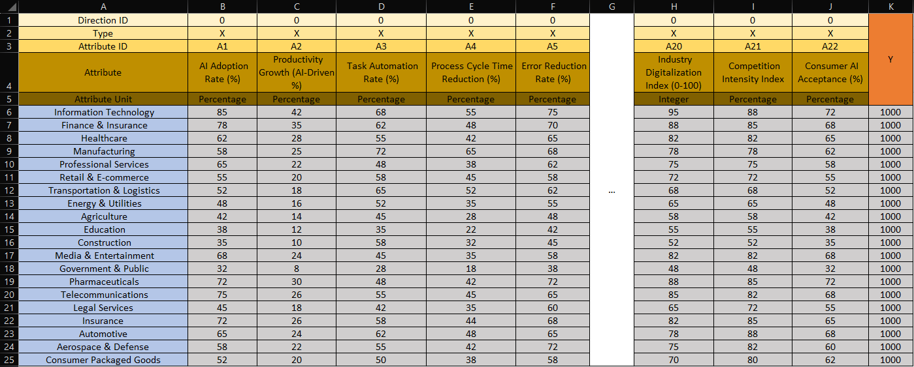

Figure2. (Excel Ranking Formula)
Source:https://view.officeapps.live.com/op/view.aspx?src=https%3A%2F%2Fmiau.my-x.hu%2Fmiau%2F328%2Fgb%2FOAM_AI%2520(3).xlsx&wdOrigin=BROWSELINK
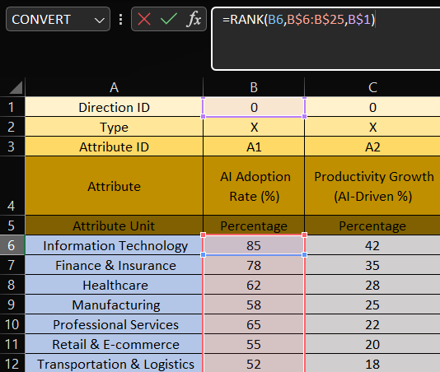
Figure3. (Constant Y-value)
Source:https://view.officeapps.live.com/op/view.aspx?src=https%3A%2F%2Fmiau.my-x.hu%2Fmiau%2F328%2Fgb%2FOAM_AI%2520(3).xlsx&wdOrigin=BROWSELINK
Y
1000
1000
1000
1000
1000
1000
1000
1000
1000
1000
Figure4. (Inverse Ranking Formula)
Source:https://view.officeapps.live.com/op/view.aspx?src=https%3A%2F%2Fmiau.my-x.hu%2Fmiau%2F328%2Fgb%2FOAM_AI%2520(3).xlsx&wdOrigin=BROWSELINK
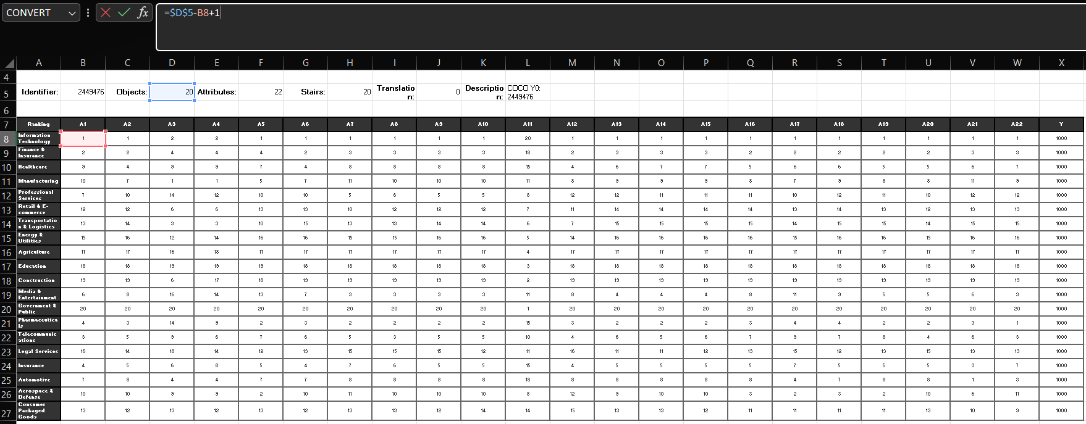

Figure5. (Direct Ranking and Inverse Ranking Validation)
Source:https://view.officeapps.live.com/op/view.aspx?src=https%3A%2F%2Fmiau.my-x.hu%2Fmiau%2F328%2Fgb%2FOAM_AI%2520(3).xlsx&wdOrigin=BROWSELINK
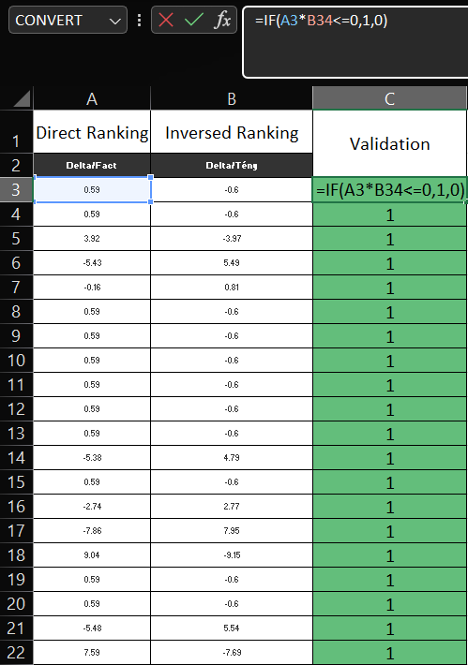

Figure6. (Object ranking by using excel formula)
Source:https://view.officeapps.live.com/op/view.aspx?src=https%3A%2F%2Fmiau.my-x.hu%2Fmiau%2F328%2Fgb%2FOAM_AI%2520(3).xlsx&wdOrigin=BROWSELINK
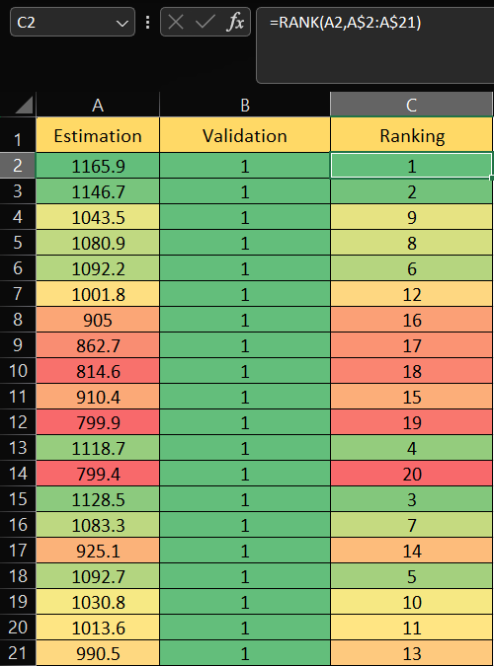

Figure7. (Attribute Exclusion by using Object Numbers-1)
Source:https://view.officeapps.live.com/op/view.aspx?src=https%3A%2F%2Fmiau.my-x.hu%2Fmiau%2F328%2Fgb%2FOAM_AI%2520(3).xlsx&wdOrigin=BROWSELINK
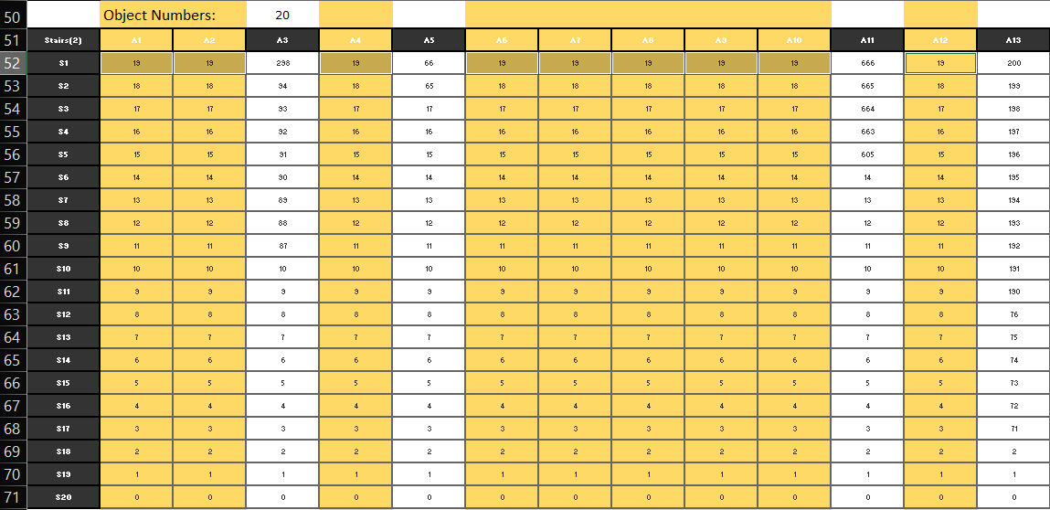

Figure8. (COCO Y0 engine interface)
Source: https://miau.my-x.hu/myx-free/coco/beker_y0.php
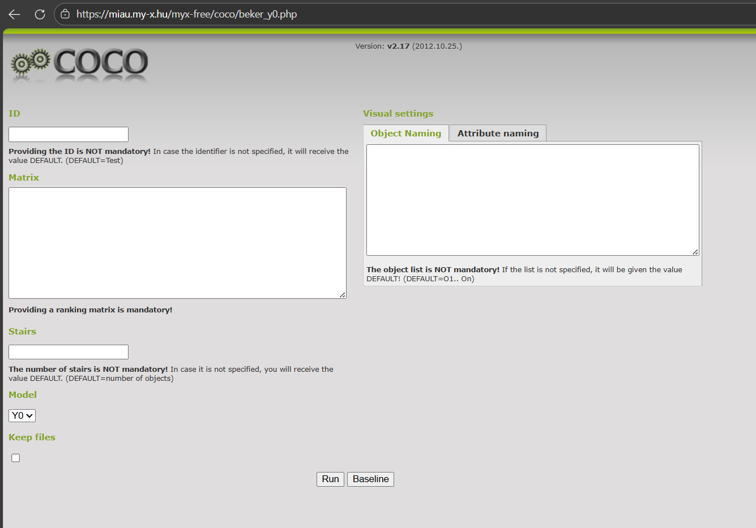

Figure9. (Inserting the data into COCO Y0 engine, Object Naming)
Source: https://miau.my-x.hu/myx-free/coco/beker_y0.php
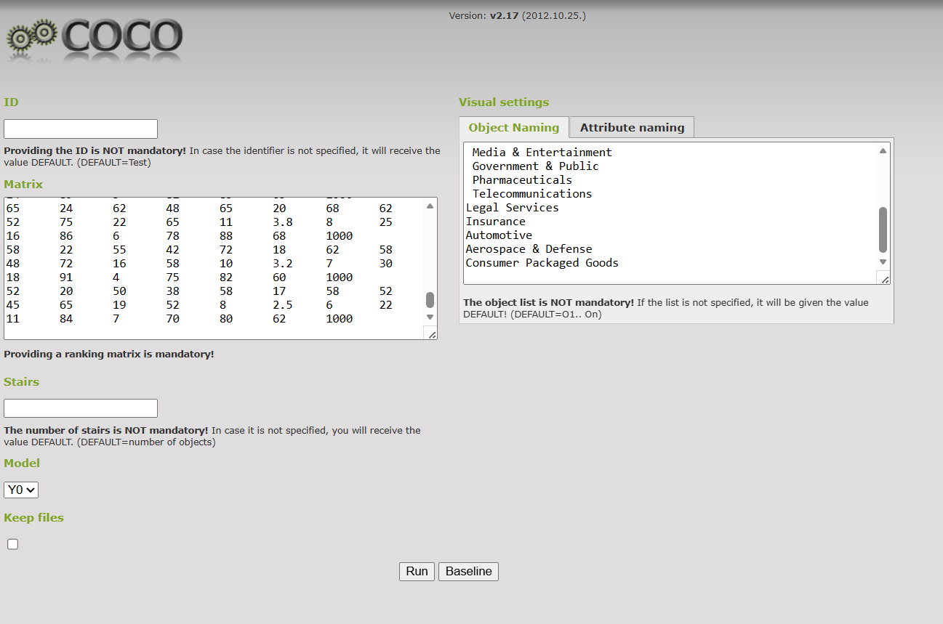

Figure10. (Inserting the data into COCO Y0 engine, Attribute Naming)
Source: https://miau.my-x.hu/myx-free/coco/beker_y0.php
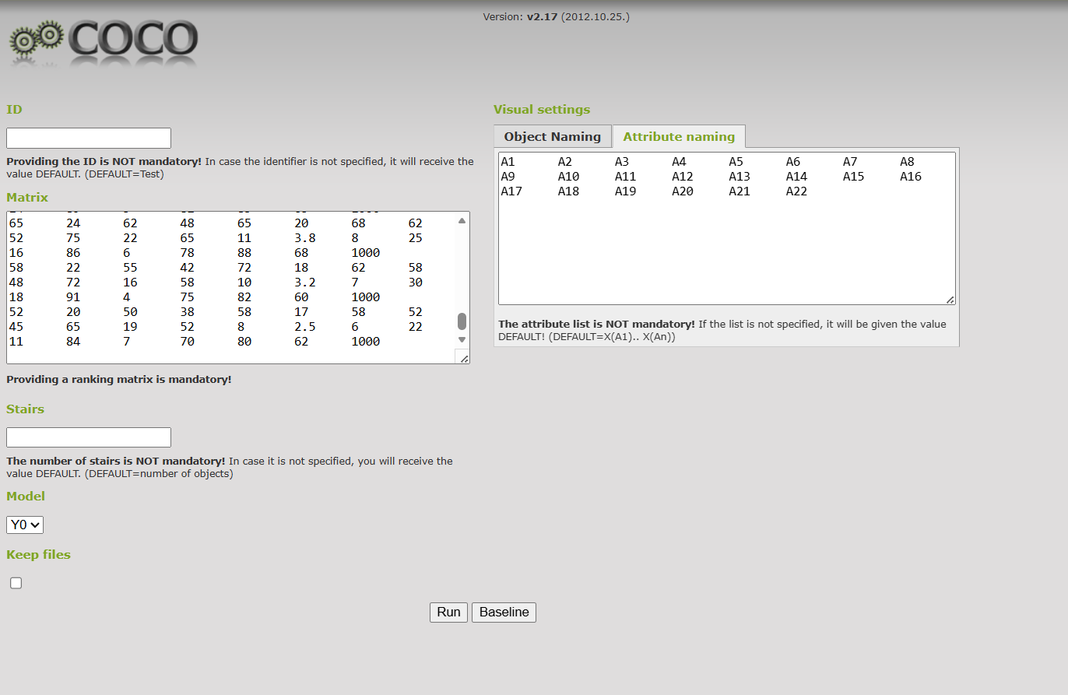

Figure11. (Results, Objects ranked by its estimations)
Source:https://view.officeapps.live.com/op/view.aspx?src=https%3A%2F%2Fmiau.my-x.hu%2Fmiau%2F328%2Fgb%2FOAM_AI%2520(3).xlsx&wdOrigin=BROWSELINK
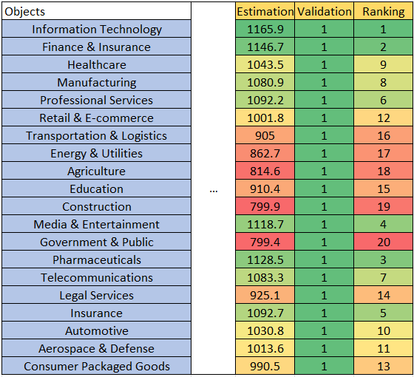

Figure12. (Most contributed sectors by estimation)
Source:https://view.officeapps.live.com/op/view.aspx?src=https%3A%2F%2Fmiau.my-x.hu%2Fmiau%2F328%2Fgb%2FOAM_AI%2520(3).xlsx&wdOrigin=BROWSELINK

Figure13. (User Interface for the Sidebar. Inputs and History section)
Source: https://oam-coco-automation-boldsukh.streamlit.app/
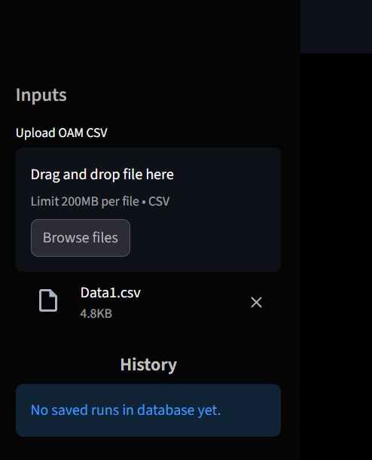

Figure14. (The Main Interface)
Source: https://oam-coco-automation-boldsukh.streamlit.app/
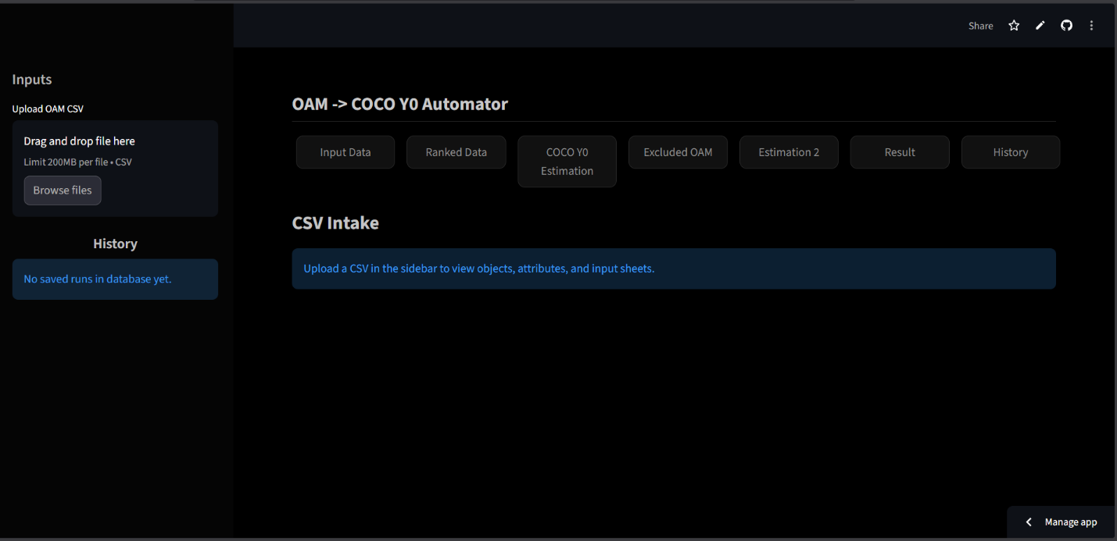
Figure15. (Input Data Page UI)
Source: https://oam-coco-automation-boldsukh.streamlit.app/
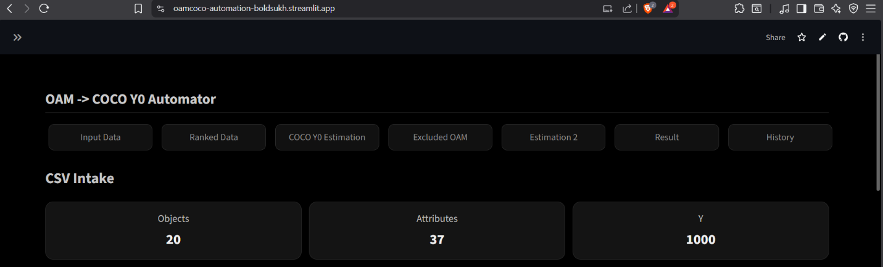

Figure16. (Input Data Page UI)
Source: https://oam-coco-automation-boldsukh.streamlit.app/
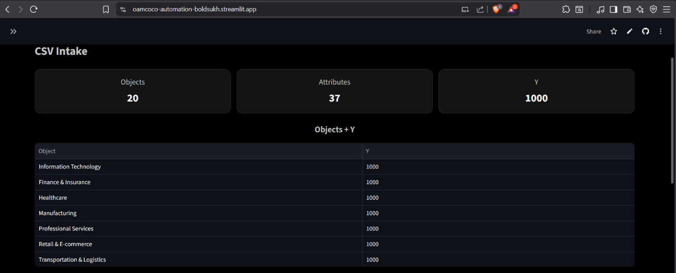
Figure17. (Input Data Page UI)
Source: https://oam-coco-automation-boldsukh.streamlit.app/
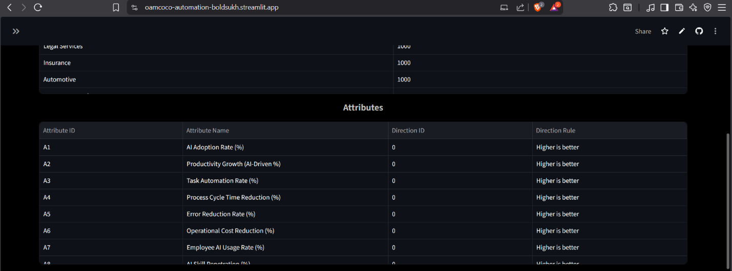

Figure18. (Input Data Page UI)
Source: https://oam-coco-automation-boldsukh.streamlit.app/
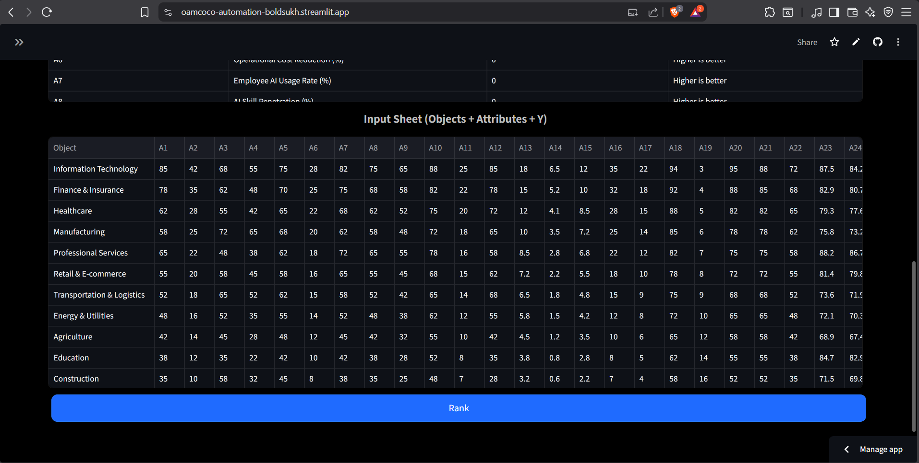
Figure19. (Ranked Data Page UI)
Source: https://oam-coco-automation-boldsukh.streamlit.app/
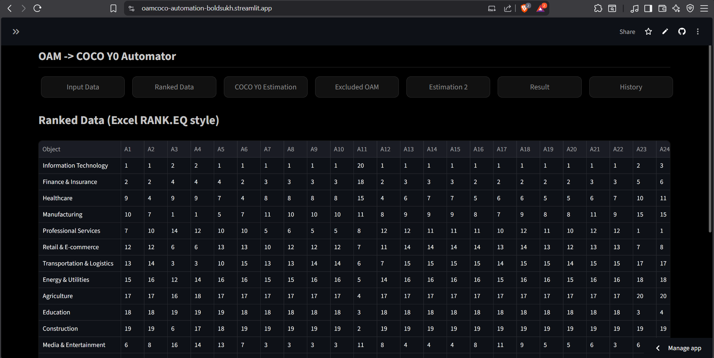

Figure20. (Ranked Data Page UI)
Source: https://oam-coco-automation-boldsukh.streamlit.app/

Figure21. (COCO Y0 Estimation Page UI)
Source: https://oam-coco-automation-boldsukh.streamlit.app/
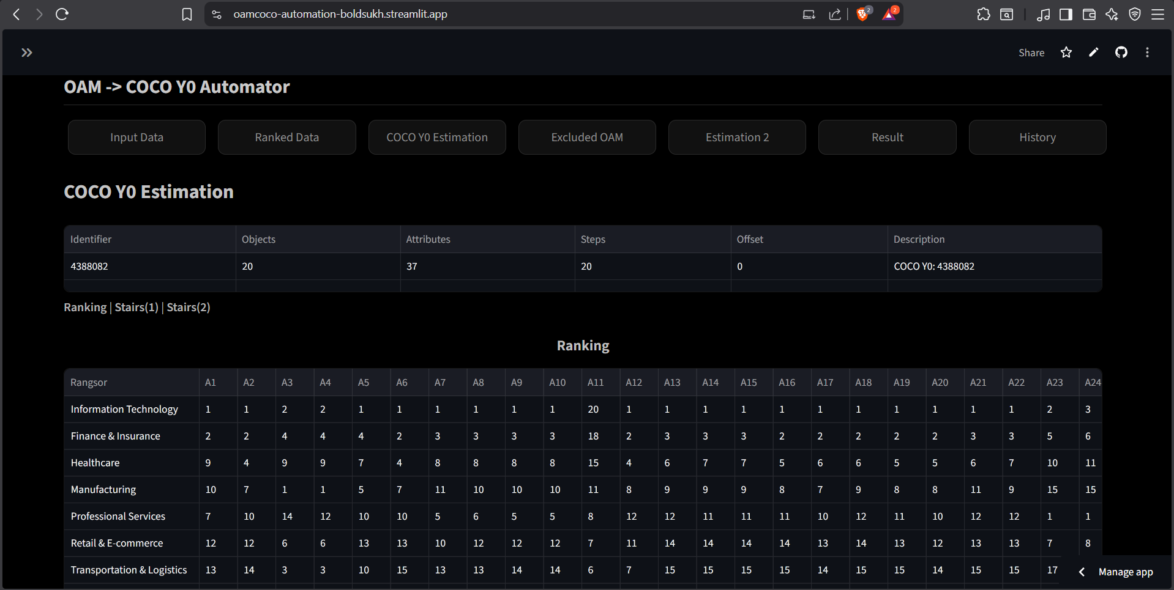

Figure22. (COCO Y0 Estimation Page UI)
Source: https://oam-coco-automation-boldsukh.streamlit.app/
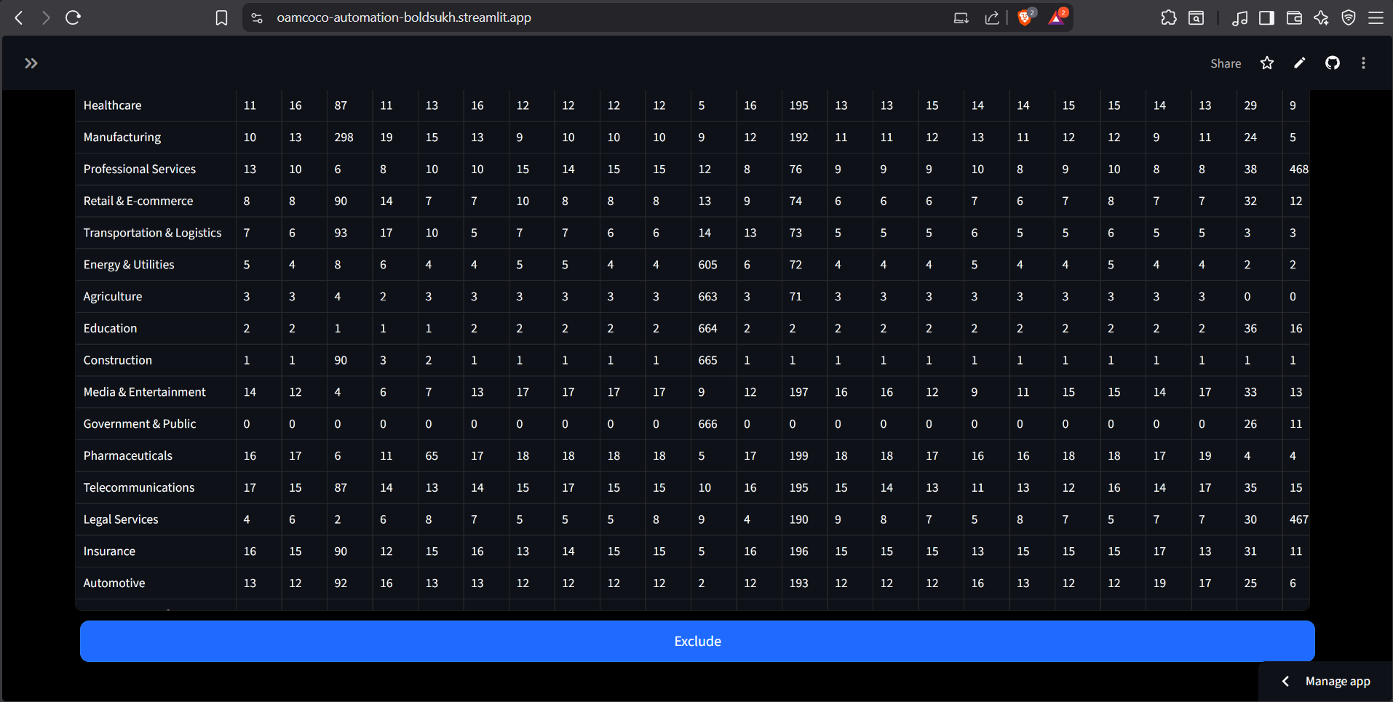
Figure23. (Excluded OAM Page UI)
Source: https://oam-coco-automation-boldsukh.streamlit.app/
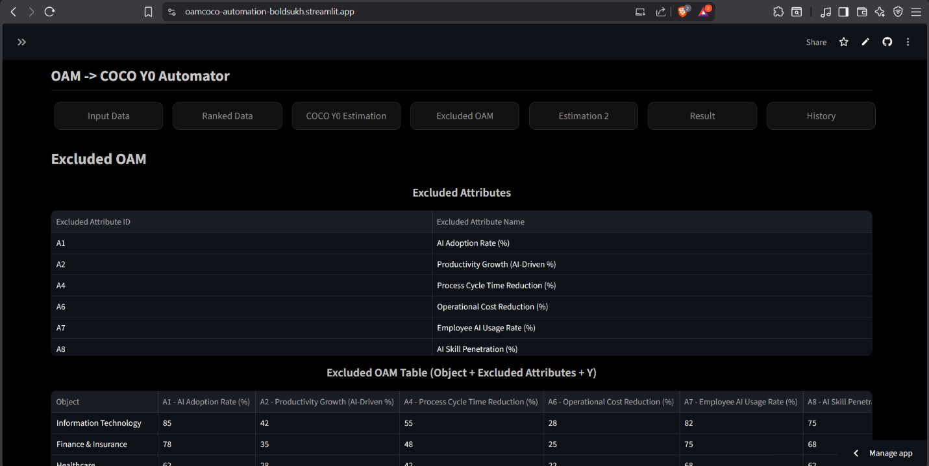

Figure24. (Excluded OAM Page UI)
Source: https://oam-coco-automation-boldsukh.streamlit.app/
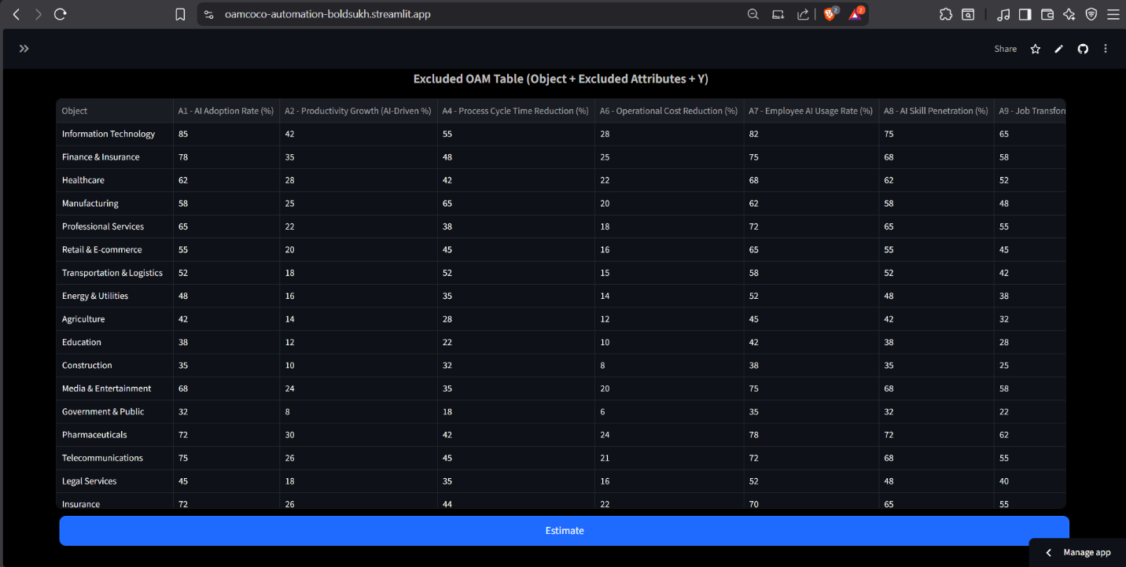
Figure25. (Estimation 2 Page UI)
Source: https://oam-coco-automation-boldsukh.streamlit.app/
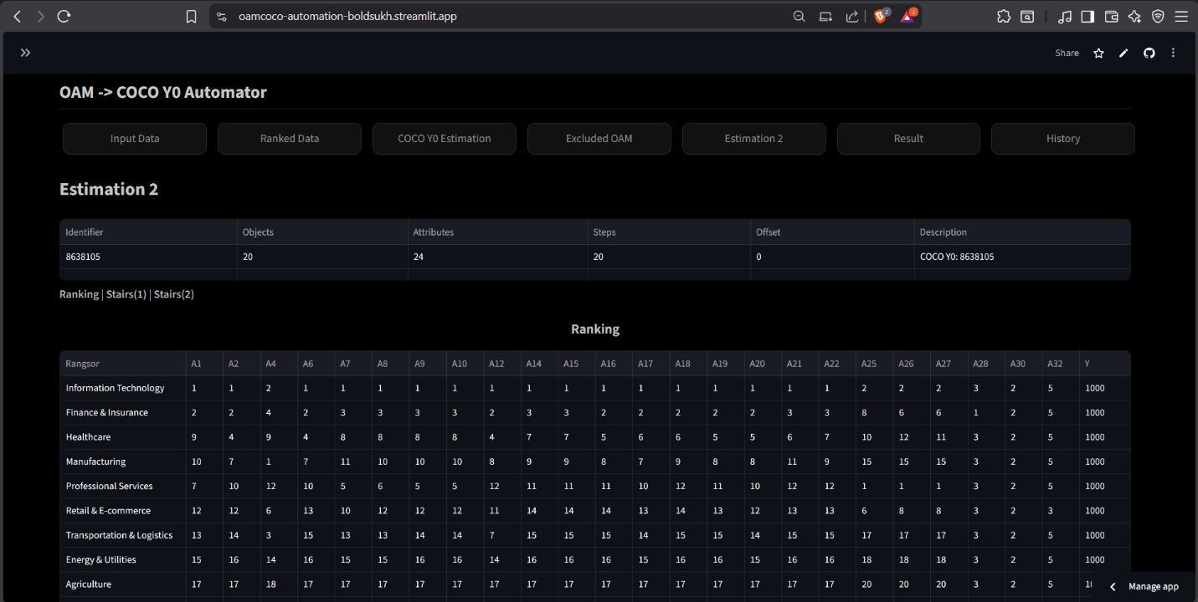

Figure26. (Estimation 2 Page UI)
Source: https://oam-coco-automation-boldsukh.streamlit.app/

Figure27. (Result Page UI)
Source: https://oam-coco-automation-boldsukh.streamlit.app/
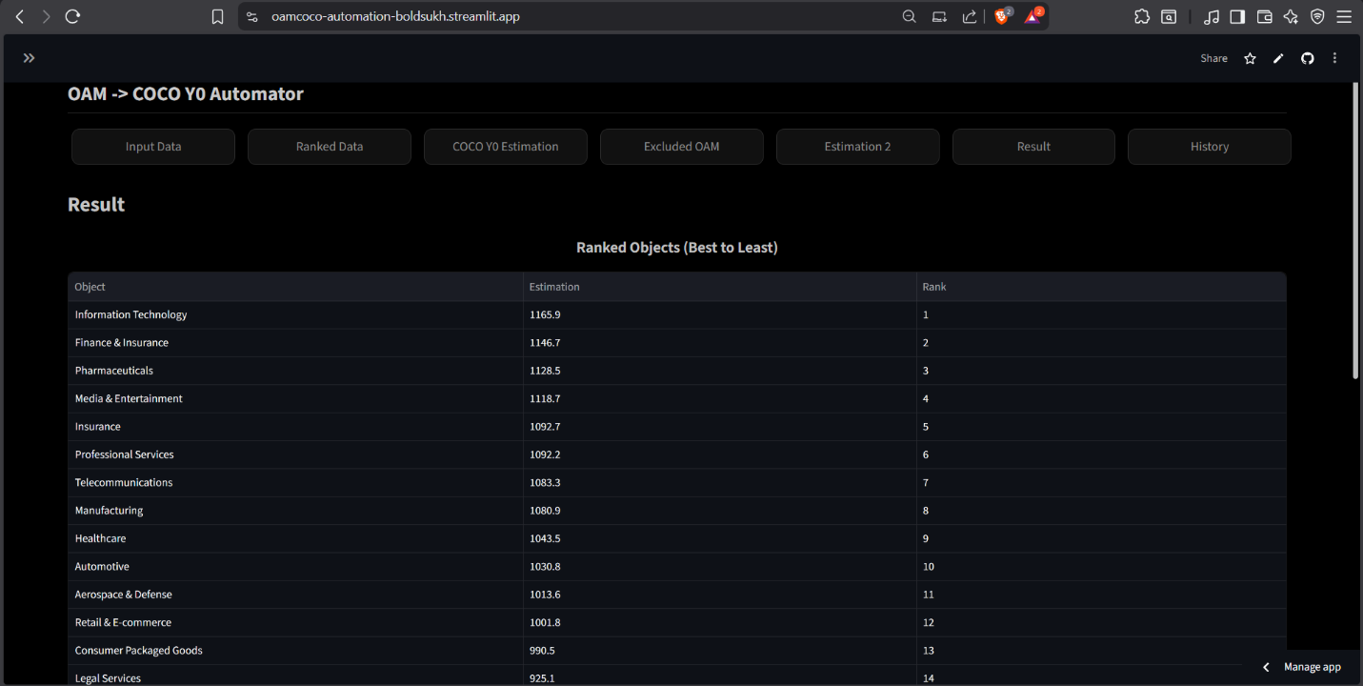

Figure28. (Result Page UI, Graph)
Source: https://oam-coco-automation-boldsukh.streamlit.app/
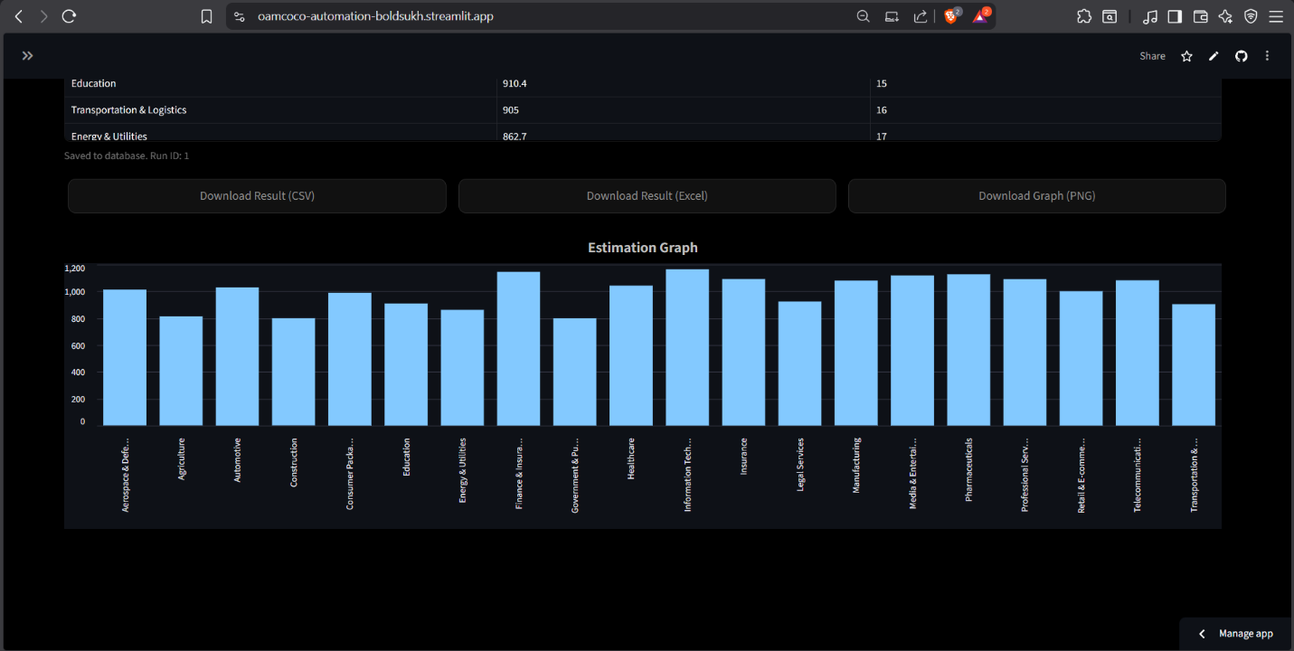
Figure29. (History Page UI)
Source: https://oam-coco-automation-boldsukh.streamlit.app/
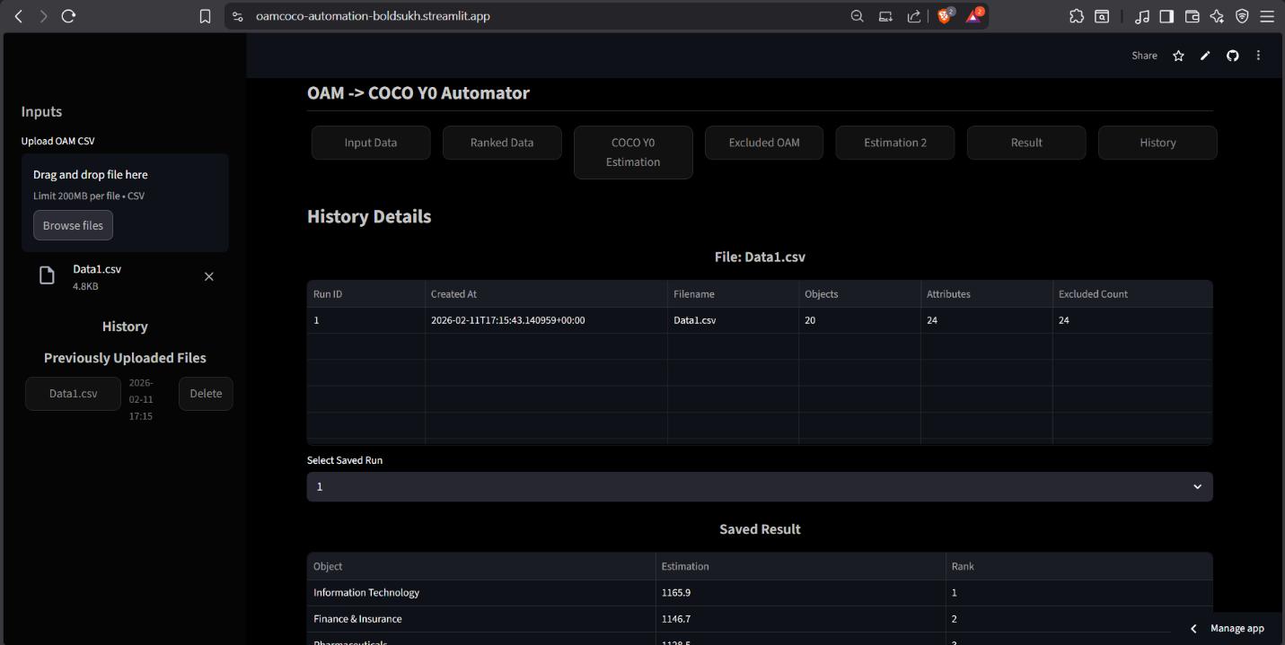

Figure30. (Detailed Example Structure of OAM that saved as CSV file)
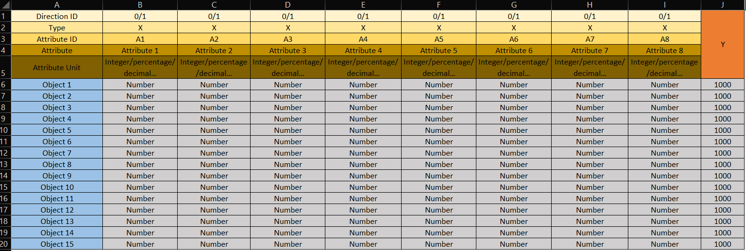

References
T01: new, English, article, not-KJU
Brynjolfsson, E., Rock, D., and Syverson, C. (2021). The Productivity J-Curve. American Economic Journal: Macroeconomics. URL: https://www.aeaweb.org/articles?id=10.1257/mac.20180386 (17/01/2026)
Jumper, J., et al. (2021). Highly accurate protein structure prediction with AlphaFold. Nature. URL: https://www.nature.com/articles/s41586-021-03819-2 (08/11/2025)
Autor, D., Mindell, D., and Reynold, E. (2022). The Work of the Future. MIT Press. URL: https://mitpress.mit.edu/9780262547307/the-work-of-the-future/ (17/01/2026)
Wu, S., et al. (2023). BloombergGPT: A Large Language Model for Finance. arXiv preprint. URL: https://arxiv.org/abs/2303.17564 (08/11/2025)
Nalgozhina, N., Razaque, A., Raissa, U., & Yoo, J. (2023). Developing Robotic Process Automation to Efficiently Integrate Long-Term Business Process Management. URL: https://www.mdpi.com/2227-7080/11/6/164 (12/02/2026)
T02: new, English, article, KJU
Bán, G.; Rikk, J.; Pitlik, L. (2024). AI-based derivation of the importance of attributes in case of evaluation models. URL: https://miau.my-x.hu/miau/314/full_importance_of_attributes_in_evaluation_models.docx (15/02/2026)
T03: new, English, webpage, not-KJU
https://oam-coco-automation-boldsukh.streamlit.app/
https://github.com
https://streamlit.io
https://github.com/Bobylzgono/COCO_OAM_Automation.git
T04: new, English, webpage, KJU
Full Excel file of this research. URL: https://view.officeapps.live.com/op/view.aspx?src=https%3A%2F%2Fmiau.my-x.hu%2Fmiau%2F328%2Fgb%2FOAM_AI%2520(3).xlsx&wdOrigin=BROWSELINK
Aadi Rajesh. Risk-evaluation possibilities concerning IT-activities in home-office. URL: https://miau.my-x.hu/miau/323/rw1/
T05: new, not-English, article, not-KJU
Ministry of Digital Development and Communications of Mongolia (2023). Comparative study of services based on advanced information and communication technologies (Big Data, Artificial Intelligence). URL: https://www.slideshare.net/slideshow/ss-630d/274866030 (15/02/2026)
T06: new, not-English, article, KJU
Pitlik László (KJE/MY-X team). Mire lehet alkalmas az LLM a bankszektorban? URL: https://miau.my-x.hu/miau/328/copilot_bank.pdf (15/02/2026)
T07: new, not-English, webpage, not-KJU
Európai Bizottság (EU-s híroldal, HU). AI Act / jogszabályi kontextus. URL: https://commission.europa.eu/news-and-media/news/ai-act-enters-force-2024-08-01_hu (15/02/2026)
T08: new, not-English, webpage, KJU
My-X Research Team. (2024). COCO. Kodolányi János Egyetem. URL: https://miau.my-x.hu/miau2009/index.php3 (15/02/2026)
T09: old, English, article, not-KJU
Bughin, J., et al. (2018). Modeling the impact of AI on the world economy. McKinsey Global Institute. URL: https://www.mckinsey.com/featured-insights/artificial-intelligence/notes-from-the-ai-frontier-modeling-the-impact-of-ai-on-the-world-economy (08/11/2025)
Abdi, H., & Williams, L. J. (2013). Canonical correlation analysis: An overview with application to learning methods. Neural Computation. URL: https://doi.org/10.1162/NECO_a_00477 (16/01/2026)
Drucker, P. F. (1999). Knowledge-Worker Productivity: The Biggest Challenge. California Management Review. URL: https://journals.sagepub.com/doi/pdf/10.2307/41165987?download=true&_gl=1*jsy5eb*_up*MQ..*_ga*Mzg5NTMxNTI3LjE3Njg4MjExNDk.*_ga_60R758KFDG*czE3Njg4MjExNDgkbzEkZzAkdDE3Njg4MjExNDgkajYwJGwwJGgxNTMyNjE1NDEx (16/01/2026)
Solow, R. M. (1987). We’d Better Watch Out. New York Times Book Review. URL: http://digamo.free.fr/solow87.pdf (16/01/2026)
Brynjolfsson, E., and McAfee, A. (2014). The Second Machine Age. W. W. Norton and Company. URL: https://wwnorton.com/books/the-second-machine-age/ (16/01/2026)
Davenport, T. H., and Kirby, J. (2016). Just How Smart Are Smart Machines? MIT Sloan Management Review. URL: https://sloanreview.mit.edu/article/just-how-smart-are-smart-machines/ (16/01/2026)
Porter, M. E. (1985). Competitive Advantage: Creating and Sustaining Superior Performance. Free Press. URL: https://hollis.harvard.edu/primo-explore/search?tab=everything&search_scope=everything&vid=HVD2&lang=en_US&mode=basic&offset=0&query=lsr01,contains,000473683 (16/01/2026)
Abdi, H., and Williams, L. J. (2013). Canonical Correlation Analysis: An Overview with Application to Learning Methods. Neural Computation. URL: https://direct.mit.edu/neco/article-abstract/25/9/2303/7913/Spike-Based-Probabilistic-Inference-in-Analog?redirectedFrom=fulltext (18/01/2026)
Zavadskas, E. K., and Turskis, Z. (2011). Multiple Criteria Decision Making (MCDM) Methods in Economics. Technological and Economic Development of Economy. URL: https://www.tandfonline.com/doi/abs/10.3846/20294913.2011.593291 (17/01/2026)
Roy, B. (1996). Multicriteria Methodology for Decision Aiding. Kluwer Academic Publishers. URL: https://link.springer.com/book/10.1007/978-1-4757-2500-1 (17/01/2026)
Brynjolfsson, E., Hitt, L., and Kim, H. (2011). Strength in Numbers: How Does Data-Driven Decision-making Affect Firm Performance? Management Science. URL: https://papers.ssrn.com/sol3/papers.cfm?abstract_id=1819486 (17/01/2026)
Acemoglu, D., and Restrepo, P. (2020). The Wrong Kind of AI? Artificial Intelligence and the Future of Labor Demand. Journal of Economic Perspectives. URL: https://www.nber.org/papers/w25682 (17/01/2026)
Davenport, T. H., and Ronanki, R. (2018). Artificial Intelligence for the Real World. Harvard Business Review. URL: https://www.the-digital-insurer.com/library/artificial-intelligence-for-the-real-world-by-thomas-h-davenport-and-rajeev-ronanki-deloitte/ (17/01/2026)
McKinsey Global Institute (2017). Artificial Intelligence: The Next Digital Frontier? URL: https://apo.org.au/node/210501 (17/01/2026)
Wilson, H. J., and Daugherty, P. R. (2018). Collaborative Intelligence. Harvard Business Review. URL: https://hometownhealthonline.com/wp-content/uploads/2019/02/ai2-R1804J-PDF-ENG.pdf (17/01/2026)
Kane, G. C., et al. (2015). Strategy, Not Technology, Drives Digital Transformation. MIT Sloan Management Review. URL: https://sloanreview.mit.edu/projects/strategy-drives-digital-transformation/ (17/01/2026)
DiMaggo, P. J., and Powell, W. W. (1983). The Iron Cage Revisited: Institutional Isomorphism and Collective Rationality in Organizational Fields. American Sociological Review. URL: https://www.enriquedans.com/wp-content/uploads/2021/11/The_Iron_Cage_Revisted_Institutional_Isomorphism_a.pdf (17/01/2026)
Dumas, M., La Rosa, M., Mendling, J., and Reijers, H. A. (2018). Fundamentals of Business Process Management. Springer. URL: https://link.springer.com/book/10.1007/978-3-662-56509-4 (17/01/2026)
Silberschatz, A., Korth, H. F. and Sudarshan, S. (2019). Database System Concepts. McGraw-Hill. URL: https://www.amazon.com/Database-System-Concepts-Abraham-Silberschatz/dp/9390727502 (17/01/2026)
Tufte. E. R. (2001). The Visual Display of Quantitative Information. Graphics Press. URL: https://www.edwardtufte.com/book/the-visual-display-of-quantitative-information/ (17/01/2026)
Sedra, A. S., and Smith, K. C. (2014). Microelectronic Circuits. Oxford University Press. URL: https://global.oup.com/ukhe/product/microelectronic-circuits-9780190853501?cc=us&lang=en (17/01/2026)
Stiglitz, J. E. (2002). Globalization and its Discontents. W. W. Norton and Company. URL: https://wwnorton.com/books/globalization-and-its-discontents/ (17/01/2026)
Hofstede, G., Hofstede, G. J., and Minkov, M. (2010). Cultures and Organizations: Software of the Mind. McGraw-Hill. URL: https://www.mheducation.com/highered/mhp/product/cultures-organizations-software-mind-third-edition.html?viewOption=student (17/01/2026)
Cormen, T. H., Leiserson, C. E., Rivest, R. L., and Stein, C. (2009). Introduction to Algorithms. MIT Press. URL: https://mitpress.mit.edu/9780262533058/introduction-to-algorithms/ (17/01/2026)
Floyd, T. L. (2015). Electronic Devices. Personal Education. URL: https://www.pearson.com/en-us/subject-catalog/p/electronic-devices-conventional-current-version/P200000001047/9780137526642 (17/01/2026)
Stewart, J. (2015). Calculus: Early Transcendentals. Cengage Learning. URL: https://www.cengage.com/c/calculus-early-transcendentals-8e-stewart/9781285741550/
Sebesta, R. W. (2016). Concepts of Programming Languages. Pearson Education. URL: https://www.pearson.com/en-us/subject-catalog/p/concepts-of-programming-languages/P200000003361/9780135102268 (17/01/2026)
Stallings, W., and Brown, L. (2018). Computer Security: Principles and Practice. Pearson Education. URL: https://www.pearson.com/en-us/subject-catalog/p/computer-security-principles-and-practice/P200000010333/9780138091712 (17/01/2026)
Tanenbaum, A. S., & Wetherall, D. J. (2011). Computer Networks. Pearson Education. URL: https://www.pearson.com/en-us/subject-catalog/p/computer-networks/P200000003188/9780137523214 (17/01/2026)
Sommerville, I. (2016). Software Engineering. Pearson Education. URL: https://www.pearson.com/en-us/subject-catalog/p/software-engineering/P200000003258/9780137503148 (17/01/2026)
Bass, L., Clements, P., & Kazman, R. (2013). Software Architecture in Practice. Addison-Wesley. URL: https://www.researchgate.net/publication/224001127_Software_Architecture_In_Practice (17/01/2026)
Myers, G. J., Sandler, C., & Badgett, T. (2011). The Art of Software Testing. Wiley. URL: https://www.wiley.com/en-in/The+Art+of+Software+Testing%2C+3rd+Edition-p-9781119202486 (17/01/2026)
Sterman, J. D. (2000). Business Dynamics. McGraw-Hill. URL: https://www.mheducation.com/highered/product/business-dynamics-sterman.html?viewOption=student (17/01/2026)
Slack, N., Brandon-Jones, A., and Johnston, R. (2019). Operations Management. Pearson Education. URL: https://www.pearson.com/se/Nordics-Higher-Education/subject-catalogue/decision-science/slack-operations-management-9thedition.html (17/01/2026)
Ward, J., & Peppard, J. (2016). The Strategic Management of Information Systems. Wiley. URL: https://www.wiley.com/en-it/The+Strategic+Management+of+Information+Systems%3A+Building+a+Digital+Strategy%2C+4th+Edition-p-9780470034675 (17/01/2026)
T10: old, English, article, KJU
Pitlik László. Journal of the Knowledge Economy. URL: https://miau.my-x.hu/miau/216/JKEC-S-16-00168.pdf (15/02/2026)
T11: old, English, webpage, not-KJU
European Commission (2020). White Paper on Artificial Intelligence – A European approach to excellence and trust. URL: https://commission.europa.eu/document/download/d2ec4039-c5be-423a-81ef-b9e44e79825b_en?filename=commission-white-paper-artificial-intelligence-feb2020_en.pdf (15/02/2026)
T12: old, English, webpage, KJU
My-X Research Team. (2013). Previous Documentation of COCO Evaluation Framework. URL: https://miau.my-x.hu/miau2009/index.php3 (15/02/2026)
T13: old, not-English, article, not-KJU
Magyarország Kormánya. Magyarország Mesterséges Intelligencia Stratégiája 2020–2030. URL: https://cdn.kormany.hu/uploads/document/6/67/676/676186555d8df2b1408982bb6ce81c643d5fa4ab.pdf (15/02/2026)
T14: old, not-English, article, KJU
My-x Team. Full COCO article. URL: My-X Team_A5 fuzet_HU_borito_jav.qxd (15/02/2026)
T15: old, not-English, webpage, not-KJU
Jogtár (HU). White Paper. URL: https://net.jogtar.hu/jogszabaly?docid=a20v0080.egb (15/02/2026)
T16: old, not-English, webpage, KJU
COCO. URL: https://miau.my-x.hu/myx-free/coco/
COCO Y0 Engine. URL: https://miau.my-x.hu/myx-free/coco/beker_y0.php

Conversation with LLM
LLM 1 – Copilot
- Critical Reflection on the Bachelor Thesis
Title: Measuring AI’s efficiency in workplaces efficiency – A cross-sector analysis Author: Ganzorig Boldsukh
- Overview
Your thesis undertakes an ambitious and timely investigation into the relationship between 20 distinct work sectors, 22 efficiency indices, and domain-specific performance of 15 AI models, evaluated through OAM (Object Attribute Matrix) and COCO Y0 benchmarking methodologies. By integrating sector-level efficiency metrics with technical AI performance indicators, the project positions itself at the intersection of labor studies, applied machine learning, and productivity analytics.
The work demonstrates a clear intention to bridge conceptual gaps between AI capability measurement and real-world workplace efficiency, an area that is increasingly relevant as organizations adopt AI tools across diverse domains.
- Strengths of the Project
- 1. Ambitious and Interdisciplinary Scope
The thesis successfully combines elements from:
- AI benchmarking
- Sector-specific efficiency analysis
- Dataset-driven empirical evaluation
This interdisciplinary approach is one of the project’s strongest features, as it mirrors the complexity of real-world AI deployment.
- 2. Structured Use of Benchmarking Frameworks
Employing OAM and COCO Y0 provides methodological grounding. These frameworks are well-established in evaluating object-attribute relationships and computer vision performance, respectively. Their inclusion signals methodological maturity and awareness of industry standards.
- 3. Clear Attempt to Operationalize Efficiency
The use of 22 efficiency indices suggests a thoughtful attempt to quantify workplace performance in a multidimensional way. This is particularly valuable because efficiency is often treated as a vague or monolithic concept.
- 4. Integration of Multiple AI Models
Analyzing 15 domain-specific AI models allows for comparative insights and avoids overgeneralization. This breadth strengthens the thesis by showing sensitivity to model-domain alignment.
- 5. Dataset-Driven Rigor
Your reliance on gathered datasets—rather than hypothetical or simulated data—adds empirical credibility. It demonstrates technical competence and an understanding of the importance of data quality in AI evaluation.
- Suggestions for Enhancement
- 1. Strengthen the Conceptual Bridge Between AI Benchmarks and Work Sectors
While the project connects AI model performance to workplace efficiency, future iterations could benefit from:
- More explicit theoretical justification for why specific benchmarks relate to specific sectors
- A clearer mapping framework that explains how technical metrics translate into sector-level implications
This would help readers unfamiliar with AI benchmarking understand the relevance of the chosen methodologies.
- 2. Clarify Methodological Flow
Given the complexity of the study, the methodology section could be strengthened by:
- A more linear, step-by-step explanation of the analytical pipeline
- Visual diagrams illustrating data flow, model evaluation, and sector comparison
- A brief rationale for selecting each efficiency index
This would enhance transparency and reproducibility.
- 3. Expand on Limitations
A more explicit limitations section would deepen the academic rigor. Potential areas include:
- Constraints of OAM and COCO Y0 when applied outside their original domains
- Possible biases in the datasets
- The challenge of correlating technical AI metrics with socio-economic sector data
Acknowledging these would not weaken the thesis; it would demonstrate critical awareness.
- 4. Future-Oriented Reflections
Your project opens several promising avenues for future research:
- Incorporating longitudinal data to track how AI efficiency impacts sectors over time
- Exploring causal inference methods rather than correlational analysis
- Expanding beyond computer vision benchmarks to include NLP, multimodal, or agent-based models
- Developing a unified efficiency-AI alignment index that could serve as a standardized tool for organizations
These directions would position your work as a foundation for more advanced studies.
- Final Thought
Your thesis stands out for its ambition, methodological breadth, and relevance to contemporary debates about AI in the workplace. By combining sector-level efficiency metrics with rigorous AI benchmarking, you have created a framework that is both innovative and practically meaningful. With further refinement in conceptual framing and methodological clarity, this work has the potential to evolve into a strong contribution to the emerging field of AI-driven productivity analysis.
LLM 2 – ChatGPT
- Title
Measuring AI’s Efficiency on Workplace Efficiency: A Cross-Sector Analysis
- Author
Boldsukh Ganzorig (Kodolányi János University)
- Overview
This bachelor thesis investigates whether artificial intelligence has a measurable and comparable relationship with workplace efficiency across industries, using a structured multi-criteria workflow. The study operationalizes “AI-enabled efficiency” through 20 workplace sectors, 22 efficiency-related attributes, and 15 domain-specific AI model benchmarks, integrated through an Object–Attribute Matrix (OAM) and evaluated using the COCO Y0 (ideal-seeking, anti-discriminatory) methodology. A notable engineering contribution is the development of an automation tool that implements the pipeline end-to-end (data intake → OAM construction → rank transformation → COCO execution → validation → attribute exclusion → reporting), aiming to strengthen reproducibility and reduce manual error.

- Strengths of the Project
- 1) Clear “evaluation-engine” framing and a defensible research objective
The thesis is organized around two explicit research questions (measurable impact; sectoral differences) and maintains a consistent focus on producing an auditable ranking output rather than claiming causal proof. This restraint aligns well with a cross-sector, multi-attribute design and keeps the thesis within an achievable and academically defensible scope.
- 2) Methodological structure: OAM → rank transformation → COCO Y0 → validation → exclusion
A major strength is that the thesis does not rely on informal scoring: it defines objects/attributes, introduces directionality, standardizes heterogeneous measures via rank transformation, and then applies COCO Y0 consistently. The addition of symmetric rank inversion as a validity check shows attention to internal consistency rather than “results-first” reporting.
- 3) Reproducibility and operational maturity via automation
Turning the methodological steps into a software tool is a strong “computer science / operational engineering” contribution. It supports the thesis claim of repeatable yearly re-evaluation and strengthens the credibility of the workflow as a reusable evaluation artifact rather than a one-off spreadsheet exercise. The documented page-flow (Input → Ranked → Estimation → Exclusion → Result → History) also improves transparency for readers and examiners.
- 4) Interdisciplinary bridging done with explicit structuring
The project meaningfully connects organizational efficiency discourse (productivity, cost, process performance) with AI benchmarking concepts and then formalizes the bridge through the attribute set and model-benchmark layer. Even when the mapping is imperfect (see enhancements below), the thesis demonstrates a serious attempt to translate a broad socio-technical question into an explicit measurement design.
- 5) Evidence awareness: explicit limitations and cautious interpretation signals
The discussion acknowledges that rankings are produced under the chosen attributes, preprocessing rules, and COCO logic, and that some sectors face scarcity of public benchmarks or rely partly on extrapolated inputs. This kind of boundary-setting is academically valuable because it prevents overclaiming and frames the framework as a structured comparator rather than ground truth.

- Suggestions for Enhancement
- A) Strengthen structural coherence and reduce “mixed-purpose” sections
The overall chapter structure is broad and generally logical, but some sections dilute the academic narrative (e.g., extended program-subject mapping and micro-business subscription framing). These elements can be retained, but they would benefit from clearer separation:
- Keep the research manuscript focused on problem → theory → method → results → discussion → limits → future.
- Move “program subject mapping,” business model, and extended tooling notes to appendices or a dedicated “engineering context” section with explicit rationale and concise length.
- B) Improve methodological clarity with a single “pipeline diagram + inputs/outputs table”
Your method is detailed, but the reader must reconstruct the flow across multiple subsections. Add one compact figure and one table:
- Figure: end-to-end pipeline (data sources → OAM variants → ranking → COCO runs → inversion validation → combined OAM → stairs-based exclusion → super OAM estimation).
- Table: each artifact’s purpose (what it is, what it outputs, what decision it supports).
This would materially improve examiner confidence in traceability without changing results.
- C) Tighten the conceptual bridge between “AI model benchmarks” and “sector efficiency”
The thesis asserts that domain-trained model benchmarks act as reference points for sector alignment; that logic is plausible, but it needs a slightly more formal mapping rule so it reads as methodology rather than narrative. Concretely:
- Provide a short mapping schema explaining how each benchmark/model is linked to a sectoral capability (task-family → benchmark indicator → expected operational area).
- State explicitly that the benchmark layer is a proxy for technical readiness, not an observed firm-level deployment metric (unless the dataset actually contains deployment evidence).
This would reduce the risk of readers interpreting benchmark performance as automatically equivalent to workplace performance.
- D) Formalize what validation does—and what it does not do
The inversion/symmetry validation is a strong engineering check, but some readers may misread it as external validity. A short clarification would help: it verifies internal consistency of transformations and model behavior under rank reversal, not real-world correctness. This distinction will protect your argument from methodological critique.
- E) Future-oriented reflections that build directly on your framework
Your future chapter points in the right direction; it can be strengthened by framing future work as “versioned upgrades” to a living framework:
- Longitudinal updates: yearly dataset refresh with versioning of attribute definitions and benchmark sets.
- Granularity: move from sector-level composites toward sub-sector or task-level profiles where feasible.
- Sensitivity analysis: systematic tests on directionality choices, attribute exclusion thresholds, and robustness to missingness.
- Governance/constraints layer: incorporate explicit constraints (compliance, safety incidents, workforce readiness) as first-class attributes rather than only discussion context.

- Final Thought
As a bachelor thesis, this work is notably ambitious and “engineering-real”: it does more than argue; it builds an auditable evaluation pipeline and demonstrates a repeatable methodology for cross-sector comparison under explicit assumptions. The most valuable next step is not expanding claims, but sharpening traceability—tightening how benchmarks, attributes, and sector-level efficiency are linked; improving dataset auditability; and making the methodological flow instantly legible through a small number of high-impact diagrams and artifact tables. With those refinements, the thesis reads not only as an applied analysis, but as a reusable methodological template for ongoing evaluation of AI-enabled workplace efficiency.

