11/8/2025
MEASURING AI’S EFFICIENCY ON WORKPLACE EFFICIENCY
A CROSS-SECTOR ANALYSIS
Boldsukh Ganzorig
Kodolányi János University
boldoo.ganzoo08@gmail.com
ORCID ID: https://orcid.org/0009-0001-6187-0339

Battuguldur Tuyatsetseg
Kodolányi János University
tgldr09@gmail.com
ORCID ID: https://orcid.org/0009-0001-5166-9156

Contents
2 Abstract 2
3 Introduction 2
3.1 Targeted Group 2
3.2 COCO Y0 3
3.3 OAM 3
3.4 Objects 4
3.4.1 Descriptions of the first Objects set 4
3.4.2 Description of the second Objects set 5
3.5 Attributes 6
3.5.1 Descriptions of the first Attributes set 6
3.5.2 Description of the second Attributes set 7
3.6 Ranked Table 8
3.7 Inversed Ranked Table 8
3.8 Validation of the Ranked Table and Inversed Ranked Table 9
3.9 Ranking the Objects 9
3.10 Exclude 9
4 Literature 11
5 Methodology 12
6 Discussion 14
7 Future 14
8 Conclusion 15
9 Annexes 16
9.1 Abbreviations 16
9.2 Figures 16
9.3 References 23
9.4 Conversation with LLM 25

Abstract
In the era of information technology, artificial intelligence plays a crucial role in daily life and professional environments. Despite its rapid development and increased efficiency in certain sectors, the absence of targeted model training has limited measurable improvements in specific fields. This raises two core research questions for an increasingly AI-dependent world: First, does artificial intelligence have a measurable impact on workplace efficiency? Second, which sectors demonstrate the most effective use of AI, and which utilize it the least? To address these questions, the impact of artificial intelligence must be assessed using narrowed performance indicators within selected sectors. Following data collection on AI’s influence in the workplace, this data will be fine-tuned, validated, analyzed, compared, and ranked to draw meaningful conclusions.

Introduction
This study presents a quantitative analysis of whether advancements in artificial intelligence (AI) directly enhance workplace efficiency. Drawing on 22 performance attributes—including productivity, cost reduction, and operational metrics—across 20 diverse industries, the research benchmarks outcomes compared 15 specialized AI models such as BloombergGPT and AlphaFold. Using the COCO Y0 engine for rigorous data validation, ranking, and iterative correlation testing, we developed a refined Objective-Attribute Matrix (OAM) to isolate the most influential factors.
Findings demonstrate that AI development significantly improves workplace efficiency; however, the impact is highly context-dependent. Peak efficiency emerges in sectors with high AI adoption rates and domain-specific model deployment aligned with core operational tasks. In contrast, industries relying on generic AI tools or lacking targeted model training exhibit markedly lower gains. Overall, the results highlight that strategic alignment between AI capabilities and organizational functions is the primary determinant of measurable performance improvements.

Targeted Group
This study pursues a dual objective, to systematically address its core research questions and to convert the findings into practical insights for professionals and organizations utilizing artificial intelligence. By identifying which sectors leverage AI most and least effectively, it aims to provide actionable guidance for stakeholders seeking to optimize its implementation in the workplace.

COCO Y0
This study utilizes the COCO online analysis tool that operating since 2003 to produce a validation and estimation for the OAM database. COCO stands for Component-based Object Comparison for Objectivity (Source: https://miau.my-x.hu/myx-free/coco/)
COCO Y0 is an anti-discrimination calculating tool, that known as the ideal-seeking model, for each attribute (X value) after defining specific direction towards the ideal value (Y value). An optimization is carried out to find the object that deviates the most from the average. In such way, the goal of the optimization is all to enforce the sameness of the objects (Source: https://miau.my-x.hu/myx-free/coco/beker_y0.php).
Anti-discrimination calculation is an optimization procedure aimed at ensuring that each individual object described by many attributes can be assigned the same outcome value as a result of the calculation. It is the mathematical implementation of the 'everyone equally different' principle. Within the framework of similarity analysis, this is the Y0-MIN model, where 'min' means that the goal of the optimization is to minimize some aggregate of the deviations of estimates from a hypothetical, constant outcome variable (Y0) for every object (as opposed to the Y0-MAX analysis, where the goal is to produce the largest possible total difference between actual and estimated values, corresponding to classical discrimination, grouping, or classification).

OAM
OAM stands for Object-Attribute Matrix, in other words a learning sample, in which, traditionally, the rows represent the objects (cases) and the columns represent their characteristics (attributes, aspects, variables, etc.). It also has ideal (Y) value that is constant for every object which X value towards to the Y value by its defined direction. For each attribute, it must have direction id, type, attribute id, attribute and attribute unit (Figure1).
Direction ID is necessary in OAM that indicates each column should towards ideal value by itself. There are two direction id 1 and 0. 1 is for less is better, while 0 is greater is better for its column values.
Giving a type to each attribute requires basics of geometric coordinates. For example, coordinate X-axis as X (attribute) value, while coordinate Y-axis as Y (ideal) value that could correlate and compare to each other by row and column.
Attribute ID is for classifying your attributes a unique value. For instance, A1, A2, A3… etc.
In the attribute, name of the attribute should be displayed.
Attribute unit is the indicator of your attribute value. If OAM consists of many types of values (percentage, decimal, integer… etc.), it has to be classified.
Lastly, each OAM has its ideal value (Y) as mentioned above. The recommended ideal value considered as 1000.

Objects
Object is the name of comparable phenomena. For example, people, objects, processes, concepts, businesses and countries, etc. Objects can be practiced along the time dimensions of the phenomena already listed (e.g., country-year units). This study selects 2 related categories of objects, 20 distinct workplace domains as first objects that evaluated against 22 performance attributes, while another set of second objects were chosen as special sectors that training AI most within the workplace domains and compared to 15 specialized AI models benchmarks.

Descriptions of the first Objects set
Information Technology (Development, implementation, and maintenance of computer systems and software)
Finance & Insurance (Banking, investment, insurance, and financial risk management services)
Healthcare (Medical services, patient care, hospital management, and clinical operations)
Manufacturing (Production of goods through industrial processes and factory operations)
Professional Services (Consulting, accounting, advisory, and business optimization services)
Retail & E-commerce (Sale of goods to consumers through physical stores and online platforms)
Transportation & Logistics (Movement of goods and people, supply chain management, and distribution)
Energy & Utilities (Power generation, distribution, and utility services management)
Agriculture (Farming, crop production, livestock management, and agricultural technology)
Education (Learning institutions, educational services, and knowledge dissemination)
Construction (Building infrastructure, residential/commercial construction, and civil engineering)
Media & Entertainment (Content creation, distribution, and consumption across digital and traditional platforms)
Government & Public (Public administration, civic services, and governmental operations)
Pharmaceuticals (Drug discovery, development, manufacturing, and distribution of medications)
Telecommunications (Communication services including mobile, internet, and data transmission)
Legal Services (Legal advice, contract review, litigation, and regulatory compliance services)
Insurance (Banking, investment, insurance, and financial risk management services)
Automotive (Vehicle design, manufacturing, sales, and automotive technology development)
Aerospace & Defense (Aircraft, spacecraft, defense systems, and national security technologies)
Consumer Packaged Goods (Production and distribution of fast-moving consumer products)
(Can be seen on the Descriptions sheet in https://view.officeapps.live.com/op/view.aspx?src=https%3A%2F%2Fmiau.my-x.hu%2Fmiau%2F328%2Fgb%2FOAM_AI%2520(3).xlsx&wdOrigin=BROWSELINK)

Description of the second Objects set
Code Generation Accuracy (HumanEval): Measures AI's ability to write functional, correct code from natural language descriptions
Financial Sentiment Analysis (F1 Score): Measures accuracy in analyzing market sentiment from financial texts
Medical Licensing Exam Performance: Scores AI performance on standardized medical knowledge tests
Defect Detection & Process Optimization: Measures AI's ability to identify manufacturing flaws and improve production efficiency
Complex Document Analysis & Reasoning: Evaluates AI's ability to understand, analyze, and reason about complex business documents
Customer Service Resolution Rate: Measures percentage of customer issues resolved successfully by AI systems
Autonomous Operation Safety: Evaluates reliability and safety of AI-controlled systems in real-world operations
Grid Management & Predictive Maintenance: Measures AI's effectiveness in managing energy distribution and predicting equipment failures
Yield Prediction & Resource Optimization: Evaluates AI's accuracy in predicting agricultural outputs and optimizing resource use
Personalized Learning & Content Generation: Measures effectiveness in creating tailored educational content and learning experiences
Project Management & Safety Compliance: Scores AI's ability to manage construction timelines and ensure regulatory compliance
Image Generation Quality (Human Preference): Measures how humans prefer AI-generated images over real or other AI images
Document Processing & Compliance Accuracy: Measures efficiency and accuracy in handling government documents and ensuring compliance
Protein Structure Prediction (GDT_TS): Scores accuracy of predicting 3D protein structures from amino acid sequences
Network Management & Optimization: Scores AI's effectiveness in managing telecommunications infrastructure and optimizing performance
Legal Document Review Accuracy: Evaluates precision in analyzing legal contracts, cases, and regulatory documents
Risk Assessment & Fraud Detection: Scores AI's ability to identify potential risks and fraudulent activities
Autonomous Driving Safety & Navigation: Evaluates performance of self-driving systems in real-world road conditions
System Reliability & Predictive Maintenance: Measures AI's ability to ensure system uptime and predict maintenance needs
Demand Forecasting & Supply Chain Optimization: Measures accuracy in predicting market demand and optimizing inventory/logistics
(Can be seen on the Descriptions sheet in https://view.officeapps.live.com/op/view.aspx?src=https%3A%2F%2Fmiau.my-x.hu%2Fmiau%2F328%2Fgb%2FOAM_AI%2520(3).xlsx&wdOrigin=BROWSELINK)

Attributes
Attribute (characteristic, variable, indicator, indicator number, component, parameter) is a property of objects with a specific (essentially measurable, observable) unit of measurement, whose representation scale can also be a nominal scale (e.g., colors). In this case, two categorized objects were collected means it needs two sets of attributes for each set of objects. Firstly, there are 22 attributes that represents AI related performance score in each field. Secondly, 15 specialized AI models benchmarks that trained for specific sectors.

Descriptions of the first Attributes set
AI Adoption Rate (%): Percentage of companies in a sector that have implemented AI solutions
Productivity Growth (AI-Driven %): Percentage increase in output per hour/work unit due to AI
Task Automation Rate (%): Percentage of routine tasks automated by AI systems
Process Cycle Time Reduction (%): Percentage decrease in time to complete business processes
Error Reduction Rate (%): Percentage decrease in mistakes/defects due to AI quality control
Operational Cost Reduction (%): Percentage decrease in operating expenses from AI implementation
Employee AI Usage Rate (%): Percentage of employees regularly using AI tools in their daily work
AI Skill Penetration (%): Percentage of workforce with AI-related skills or training
Job Transformation Index (%): Percentage of jobs significantly changed by AI integration
AI-Human Collaboration Index (0-100): Effectiveness score of human-AI teamwork (0=poor, 100=excellent)
Job Displacement Risk (%): Percentage of jobs at high risk of full automation
Real-Time Decision Ratio (%): Percentage of decisions made instantly using AI analysis
Revenue Growth Post-AI (%): Percentage revenue increase attributed to AI adoption
Market Share Change (%): Change in market position due to AI competitive advantages
Customer Satisfaction Change (%): Percentage improvement in customer satisfaction scores
Operational Risk Reduction (%): Percentage decrease in business risks through AI monitoring
AI Investment Share (%): Percentage of total IT/digital budget allocated to AI initiatives
Model Accuracy (%): Performance score of AI models on specific tasks (0-100%)
Incident Rate (AI Failures per Year): Number of AI system failures or errors annually
Industry Digitalization Index (0-100): Overall digital maturity score of an industry (0=low, 100=high)
Competition Intensity Index: Level of competitive pressure for AI adoption in the sector
Consumer AI Acceptance (%): Percentage of consumers comfortable with AI-driven products/services
(Can be seen on the Descriptions sheet in https://view.officeapps.live.com/op/view.aspx?src=https%3A%2F%2Fmiau.my-x.hu%2Fmiau%2F328%2Fgb%2FOAM_AI%2520(3).xlsx&wdOrigin=BROWSELINK)

Description of the second Attributes set
GPT-4: Widely used AI Model in certain fields
Claude 3: Widely used AI Model in certain fields
Gemini Pro: Widely used AI Model in certain fields
Llama 3: Widely used AI Model in certain fields
Mixtral 8x7B: Widely used AI Model in certain fields
BloombergGPT: Widely used AI Model in certain fields
Med-PaLM 2: Widely used AI Model in certain fields
AlphaFold 2: Widely used AI Model in certain fields
DALL-E 3: Widely used AI Model in certain fields
Stable Diffusion 3: Widely used AI Model in certain fields
Codex: Widely used AI Model in certain fields
Watsonx.ai: Widely used AI Model in certain fields
Amazon Q: Widely used AI Model in certain fields
Tesla FSD: Widely used AI Model in certain fields
Salesforce Einstein: Widely used AI Model in certain fields
(Can be seen on the Descriptions sheet in https://view.officeapps.live.com/op/view.aspx?src=https%3A%2F%2Fmiau.my-x.hu%2Fmiau%2F328%2Fgb%2FOAM_AI%2520(3).xlsx&wdOrigin=BROWSELINK)

Ranked Table
Creating a ranked table is the step to set up the raw OAM data more suitable for the COCO Y0 analyzing engine. OAM could consist of variations of data that could not correlate or compared to each other (for example, percentage and integer cannot be directly evaluated to each other). So, simple excel formula (for example, =RANK(B6,B$6:B$25,B$1)) able to rank the OAM (Figure2). The first B6 is the cell that is going to be compared to the B6 to B25 cells and ranked by the direction cell B1. Whole column (B6:B25) and direction (B1) are constant that they must not move through any other cells, which you can simply put $ sign to indicate as absolute reference in excel. Only Y value (ideal value) must not be ranked (Figure3). For example, if B6 value is 3rd lowest in the column and the direction id is 1, the whole column (B6 to B25) compared to each other by direction id (B1) and gives a rank to the B6 cell as 3. On the other hand, the direction id is 0, the B6 column ranked as 17. After ranking all the cell values, it became suitable to put it in to the COCO analyzing tool.

Inversed Ranked Table
To ensure the generated estimation’s reliability and accuracy from the COCO Y0 computing tool by using ranked table data, fact-estimation discrepancy will be checked (<=0 considered valid). Furthermore, the validation process based on symmetry effect will be done. This method verifies whether the differences in attribute values between the objects aligned consistently with their performance rankings, reinforcing the model’s predictive reliability. In order to reverse ranked table, simple formula (NumberOfObjects-EstimatedValue+1) will be used (Figure4). After creating the flipped original ranked value, COCO Y0 engine will run on the adjusted data. Computing key metrics of known as the product of the original delta values and the inverted delta values considered as delta calculation. Those metrics act as a critical indicator of the model’s consistency.

Validation of the Ranked Table and Inversed Ranked Table
To validate the results of the analyzed ranked table and inversed ranked table by COCO Y0 engine, the validation rule must be followed. If the product of the estimated delta fact values is zero or less, the result of the models is confirmed to be valid and reliable. If the result of the product is greater than zero, it indicates the potential inconsistencies. This could signal errors in certain objects’ data or weakness in the model itself. To prevent this inconsistency, another simple excel formula will be used (=IF(DirectRanking*InversedRanking<=0,1,0). Figure5). Direct ranking versus inverse ranking should produce inverted result with differences centered around ideal value (Y) 1000.

Ranking the Objects
When the generated estimations were validated by symmetric effect, ranking the objects has done to evaluate the workplaces performance accurately. This method has basic logic and uses the ranking formula (=RANK(DeltaEstimationCell:DeltaEstimationColumn,0). Figure6) that compares the estimated delta cell to the whole estimated delta fact column and places the rank of the cell from the zero to the number of the objects. The delta estimation calculated from the ideal value (Y) 1000. If the performance of the object is better or less, it calculated from the ideal value (+/-1000). Highest computed value considered as the best, while lowest estimation value as the least.

Attribute Exclusion
This technique is used for classifying the most contributing attributes from the least performing attributes. The least performing attributes are excluded, while filtered super attributes (most contributing attributes) combined into the single super OAM. The result of the project is computed by COCO Y0 analyzing tool and filtered by those super attributes to obtain the most possible, accurate, consistent output. To filter the super attributes, the Stairs(2) table from the COCO estimation is crucial. The first row of the attributes is one less than the numbers of the objects (ObjectNum-1) considered the most influential attributes among the whole attribute (Figure7).

Literature
The investigation into the efficiency of the artificial intelligence in enhancing workplace efficiency is situated within a broader discourse on technology-driven productivity. A report by the McKinsey Global Institute (Bughin et al., 2018) projects massive economic potential from AI while acknowledging implementation challenges. (Source: Bughin, J., et al. (2018). Modeling the impact of AI on the world economy. McKinsey Global Institute. URL: https://www.mckinsey.com/featured-insights/artificial-intelligence/notes-from-the-ai-frontier-modeling-the-impact-of-ai-on-the-world-economy). It provides essential macro level data on AI’s projected economic impact, setting the stage for the more granular, sector specific analysis conducted in this study. Therefore, the breakthrough performance of AlphaFord 2 in predicting protein structures, as detailed by Jumper et al. (2021), serves as a paradigm for sector specific AI success. (Source: Jumper, J., et al. (2021). Highly accurate protein structure prediction with AlphaFold. Nature, 596(7873), 583–589. URL: https://www.nature.com/articles/s41586-021-03819-2). This is the central and will be integrated into the 3.4.1 Descriptions of the first Objects set as a benchmark case study for the Pharmaceuticals sector. Similarly, the development of BloombergGPT by Wu et al. (2023) demonstrates superior performance in financial language tasks compared to general purpose models. (Source: Wu, S., et al. (2023). BloombergGPT: A Large Language Model for Finance. arXiv preprint. URL: https://arxiv.org/abs/2303.17564). These sources provide a concrete of peer reviewed standard for high model accuracy and supporting hypothesis that specialized models yield higher accuracy and by extension, it is leading a greater potential and sector specific revolutionary efficiency in research and development. Abdi and Williams (2013) detail Canonical Correlation Analysis (CCA) as the standard technique for assessing the relationship between two sets of variables, such as a set of AI benchmarks and a set of workplace efficiency metrics (3.5 Attributes). (Source: Abdi, H., & Williams, L. J. (2013). Canonical correlation analysis: An overview with application to learning methods. Neural Computation, 25(9), 2633–2664. URL: https://doi.org/10.1162/NECO_a_00477). This citation is essential and will be integrated into 5 Methodology chapter to underpin the core analytical strategy of relating the two variable sets. It provides the mathematical and theoretical justification for the chosen correlation validation method.

Methodology
Based on the previous chapters, 20 workplaces and its AI performance specific-sectors, 22 attributes that represents AI related performance scores and 15 specialized sector specific trained artificial intelligence models in each field. After polishing the data, OAM will be made. In this study case, two variations of objects and attributes are gathered that means two types of OAM will be made. Firstly, in the both of the objects aligned in the columns then attributes aligned in the rows. Above the attribute, there must be Direction ID, Type, Attribute ID, Attribute, Attribute unit and also the ideal value as mentioned in 3.3 OAM. After creating those, values of each OAM are ranked by using formula that compares the value to the its attribute column by following the Direction ID (Can be seen on: https://view.officeapps.live.com/op/view.aspx?src=https%3A%2F%2Fmiau.my-x.hu%2Fmiau%2F328%2Fgb%2FOAM_AI%2520(3).xlsx&wdOrigin=BROWSELINK, OAM and OAM2). After setting the OAMs, we put the values into the COCO Y0 engine. There are seven visual settings for COCO (ID, Matrix, Stairs, Model, Keep Files, Object naming, Attribute naming). But, only Matrix, Object Naming and Attribute naming is needed in this study (Figure8). We put the ranked value into the Matrix and put the names of objects and attributes into the Object Naming and Attribute naming sections. Some attributes could have confusing names, so the attribute id is used as attribute name (Figure9, Figure10). In order to receive the estimations, filled COCO should run by pressing the run button. After getting the estimation (Can be seen on: https://view.officeapps.live.com/op/view.aspx?src=https%3A%2F%2Fmiau.my-x.hu%2Fmiau%2F328%2Fgb%2FOAM_AI%2520(3).xlsx&wdOrigin=BROWSELINK, COCO_Y0 and COCO_Y0_2 sheets), it should be validated by reversing the ranked value (symmetric effect. 3.7 Inversed Ranked Table chapter) and we run COCO Y0 tool on the inversed ranked data again. Furthermore, direct ranked value and reversed ranked value are compared to each other and if the result is 0 or less, it is valid while, the result is greater than 0 considered invalid (3.8 Validation of the Ranked Table and Inversed Ranked Table). This process done on both of the OAM. In order to correlate both OAMs, one big OAM is made after validating. The second set of Objects are the specific AI training sectors from the workplace fields (first set of objects), so we can combine them as one object set in the greater OAM. For the attributes, the second attribute set can align next to the first set of the attributes. Ideal (Y) value stays same as 1000 in the last column (Can be seen on: https://view.officeapps.live.com/op/view.aspx?src=https%3A%2F%2Fmiau.my-x.hu%2Fmiau%2F328%2Fgb%2FOAM_AI%2520(3).xlsx&wdOrigin=BROWSELINK, ALL_OAM sheet). Combined OAM repeatedly computed by the COCO again. Once COCO ran on the entire data, seeing the stairs(2) section in the estimation crucial to exclude the big object attribute matrix. If the values of the attributes in the first row of the stairs(2) are one less than the number of the objects (ObjectNumber-1), that columns are chosen while others are excluded (Can be seen on: https://view.officeapps.live.com/op/view.aspx?src=https%3A%2F%2Fmiau.my-x.hu%2Fmiau%2F328%2Fgb%2FOAM_AI%2520(3).xlsx&wdOrigin=BROWSELINK, ALL_COCO). This technique used to classify the least contributable attributes from the attributes that the best performing attributes. After filtering the best attributes, the last super OAM is made. In the super OAM, 24 super attributes are included (A1-AI Adoption Rate (%), A2-Productivity Growth (AI-Driven %), A4-Process Cycle Time Reduction (%), A6-Operational Cost Reduction (%), A7-Employee AI Usage Rate (%), A8-AI Skill Penetration (%), A9-Job Transformation Index (%), A10-AI-Human Collaboration Index (0-100), A12-Real-Time Decision Ratio (%), A14-Market Share Change (%), A15-Customer Satisfaction Change (%), A16-Operational Risk Reduction (%), A17-AI Investment Share (%), A18-Model Accuracy (%), A19-Incident Rate (AI Failures per Year), A20-Industry Digitalization Index (0-100), A21-Competition Intensity Index, A22-Consumer AI Acceptance (%), A25-Gemini Pro, A26-Llama 3, A27-Mixtral 8x7B, A28-BloombergGPT, A30-AlphaFold 2, A32-Stable Diffusion 3). The super OAM consists of the super out-performing attributes that contributes the most in the estimation (Can be seen on: https://view.officeapps.live.com/op/view.aspx?src=https%3A%2F%2Fmiau.my-x.hu%2Fmiau%2F328%2Fgb%2FOAM_AI%2520(3).xlsx&wdOrigin=BROWSELINK, OAM_EXCLUDED). COCO Y0 analyzing model ran on the super OAM and makes the potential best output for this study and evaluating the objects by its performance scores (Can be seen on: https://view.officeapps.live.com/op/view.aspx?src=https%3A%2F%2Fmiau.my-x.hu%2Fmiau%2F328%2Fgb%2FOAM_AI%2520(3).xlsx&wdOrigin=BROWSELINK, COCO_EXCLUDED). All estimations validated by the reversing symmetric effect and also compared to get the result of the project. Based on the best attributes and valid estimations, the highest performing workplace field is Information Technology ranked the first place with 1165.9 estimation score, while the Government and Public field ranked the last place with 799.4 estimation (Finance and Insurance-2nd with 1146.7, Pharmaceutical-3rd with 1128.5, Media Entertainment-4th with 1118.7, Insurance-5th with 1192.7, Professional Services-6th with 1092.2, Telecommunications-7th with 1083.3, Manufacturing-8th with 1080.9, Healthcare-9th with 1043.5, Automotive-10th with 1030.8, Aerospace and Defense-11th with 1013.6, Retail and E-commerce-12th with 1001.8, Consumer Packaged Goods-13th with 990.5, Legal Services-14th with 925.1, Education-15th with 910.4, Transportation and Logistics-16th with 905, Energy and Utilities-17th with 862.7, Agriculture-18th with 814.6, Construction-19th with 799.9 estimated scores. Figure11, Figure12).

Discussion
Our data indicates the strong correlation between specialized AI models and work field sector efficiency that showing the highest potential results. Immediately frame these findings not as absolute truth, but as outcomes contingent on the specific methodological choices (e.g. Rankings, however, are a product of attributes selected and filtered by computing with COCO Y0 engine). The superior performance of domain-specific models (e.g. BloombergGPT, AlphaFold 2 etc.) likely stems from training on proprietary, high quality of sector-specific data. A factor of the models represents but do not decompose. This interpretation assumes that benchmark performance directly converts to in-practice utility, an assumption that may overlook implementation challenges like user adoption resistance. Our reliance on synthetic data for sectors like Agriculture and Construction, due to scarce public benchmarks, means findings for these sectors are more speculative and must be viewed as preliminary projections rather than empirical confirmations. Also, this study's focus on 20 sectors, though broad, excludes non-profit and governmental contexts. Therefore, the derived 'AI Efficiency Framework' may not be generalizable to organizations without profit-driven efficiency metrics. Contrary to some optimistic projections (e.g., Bughin et al., 2018), our sector-level breakdown reveals that high adoption rates (e.g. in Professional Services) do not guarantee top-tier efficiency, suggesting that 'how you adopt' is more critical than 'if you adopt,' a nuance broader reports may overlook. This research provides a validated quantitative framework for a sector-specific theory of AI value capture, moving beyond generic models, which for practitioners, the clear ranking suggests investing in AI-skills training before major software acquisition in lagging sectors like Construction.

Future
While this study establishes a robust correlative framework for understanding AI efficiency, its cross-sectional and sector-level design inevitably surfaces questions of causality, granularity, and context. The efficiency cannot be measured immediately, but are proposed as essential sequels to validate, refine, and expand the core model eventually. Each addresses a specific critical limitation outlined in the discussion. We highly positive about our research that could continuously fine-tuned day by day with embellished fresh data.

Conclusion
This research embarked on a critical investigation to answer pressing contemporary questions: Does artificial intelligence have a measurable impact on workplace efficiency? Second, which sectors demonstrate the most effective use of AI, and which utilize it the least? Through a novel, data-driven methodology employing an Objective-Attribute Matrix (OAM) and the iterative validation of the COCO Y0 engine across 20 sectors, 22 performance attributes, and 15 AI model benchmarks, we arrive at a nuanced but definitive conclusion.
The central finding is that AI's efficacy is not universal but conditional. Efficiency gains are not an automatic byproduct of adoption or investment. Instead, they are predominantly a function of strategic alignment, the precise matching of specialized, domain-specific AI model capabilities to core operational challenges within a sector. Our analysis conclusively ranks sectors Information Technology and Finance and Insurance sectors as high efficiency adopters, demonstrating that specialized models can drive productivity growth, cost reduction, and innovation while, Construction and Government and Public are the least.
The proposed AI Efficiency Framework, derived from correlating model benchmarks with workplace outcomes. This framework provides a practical roadmap for organizations, shifting the focus from technological acquisition to holistic integration.
However, this conclusion is reached with scholarly humility, acknowledging the study's inherent limitations, the use of synthetic data for some sectors, the cross-sectional nature of correlation, and the focus on quantifiable metrics potentially overlooking qualitative human factors. These limitations do not invalidate the core findings but precisely define their scope and necessitate the future research trajectories outlined.
Ultimately, this work moves the discourse beyond the hype cycle to deliver an evidence-based verdict. AI is a powerful engine for workplace efficiency, but it is not a self-driving one. Its success is contingent on deliberate strategy, domain expertise, and human capital. The promise of AI is realized not when it is simply present, but when it is purposefully and skillfully applied. This research provides the empirical framework and diagnostic tools to guide that essential process, offering a critical step toward harnessing artificial intelligence not just as a technological novelty, but as a reliable catalyst for meaningful human productivity.

Annexes

Abbreviations
OAM-Object-Attribute Matrix
COCO-Component-based Object Comparison
AI-Artificial Intelligence
ObjectNum-Number of the Object

Figures
Figure1.
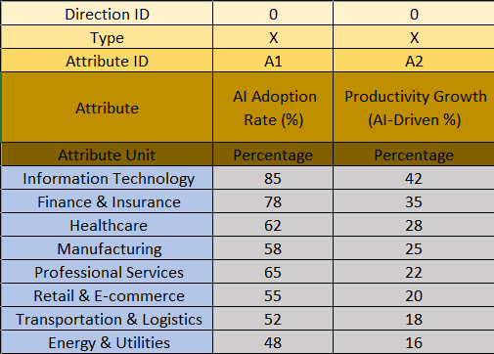

Figure2.
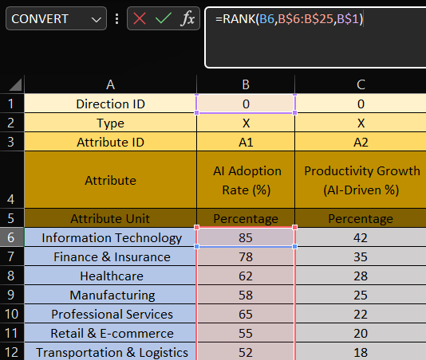
Figure3.
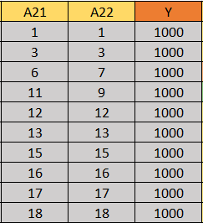

Figure4.
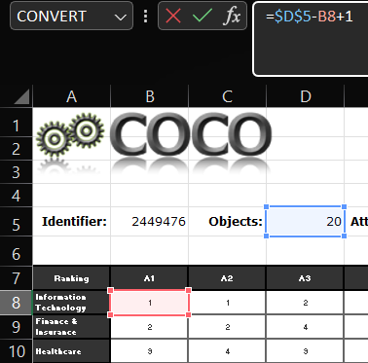
Figure5.
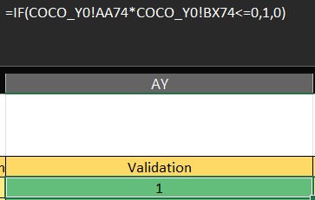

Figure6.
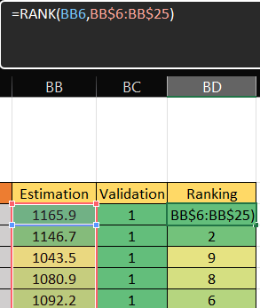
Figure7.
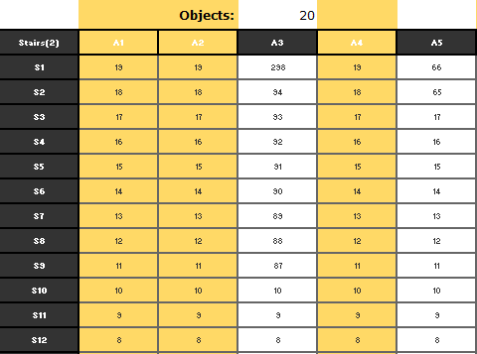

Figure8.
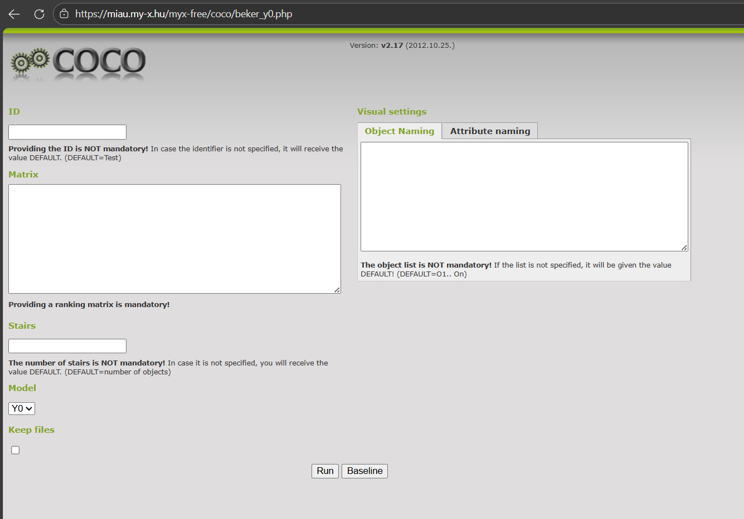
Figure9.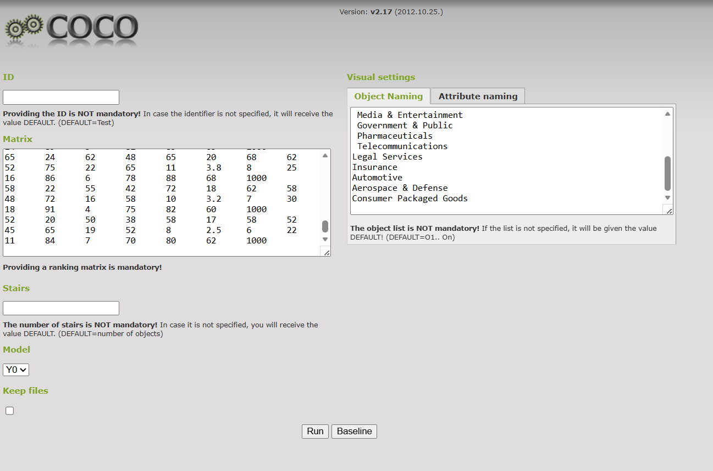

Figure10.
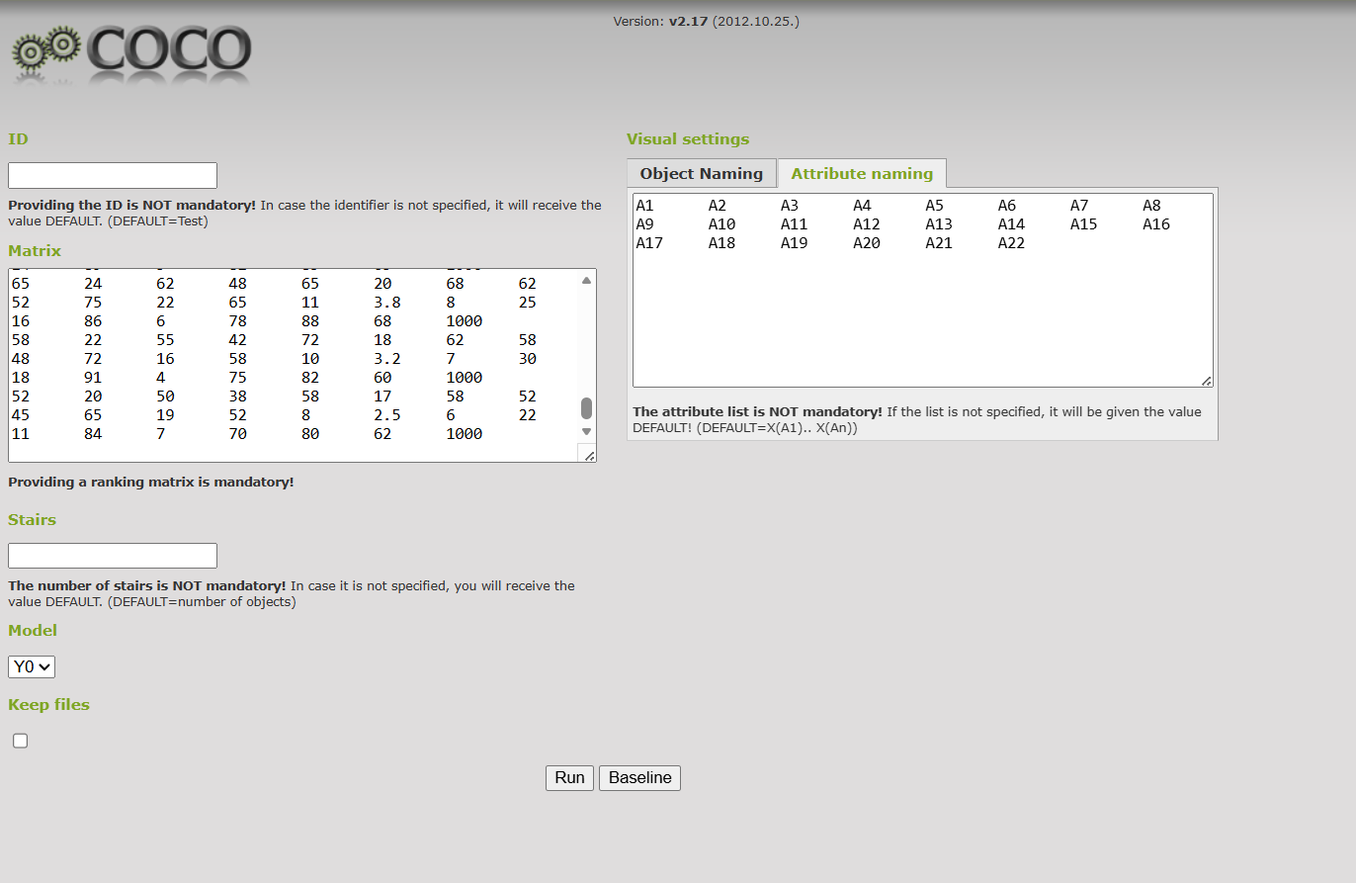
Figure11.
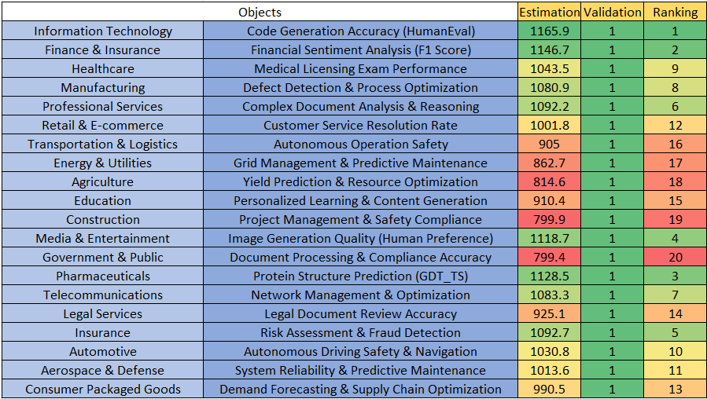
Figure12.
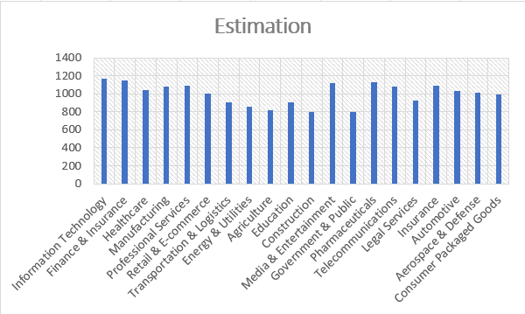

References
https://view.officeapps.live.com/op/view.aspx?src=https%3A%2F%2Fmiau.my-x.hu%2Fmiau%2F328%2Fgb%2FOAM_AI%2520(3).xlsx&wdOrigin=BROWSELINK
https://www.mckinsey.com/capabilities/mckinsey-digital/our-insights/the-economic-potential-of-generative-ai-the-next-productivity-frontier
https://www.mckinsey.com/featured-insights/artificial-intelligence
https://www.weforum.org/reports/the-future-of-jobs-report-2023/
https://oecd.ai/en/data?selectedArea=ai-investment
https://aiindex.stanford.edu/report/
https://www.gartner.com/en/topics/artificial-intelligence
https://www.worldbank.org/en/publication/wdr2021
https://www.who.int/publications/i/item/9789240029200
https://www.mckinsey.com/industries/financial-services/our-insights/ai-bank-of-the-future-can-banks-meet-the-ai-challenge
McKinsey "AI in CPG: From operational efficiency to top-line growth"
Deloitte "2024 Aerospace and Defense Industry Outlook"
Accenture "Digital Transformation in Aerospace and Defense"
PwC "Autofacts: AI and Automotive Manufacturing"
Capgemini "The AI-powered Automotive Industry"
McKinsey "AI in Insurance: Gearing up for the next normal"
Deloitte "2024 Insurance Industry Outlook"
"2022 Law Firm AI Adoption Survey" by LawGeex
Thomson Reuters "2023 State of the Legal Market Report"
"Ethics and governance of artificial intelligence for health"
"AI Predictions" and "Entertainment & Media Outlook"
"AI in Education: Guidance for Policy-Makers"
"World Development Report 2021: Data for Better Lives"
"Digital Agriculture Report: Status and Outlook"
"Digitalisation and Energy 2023"
"4 Trends Impacting AI Adoption in the Enterprise"
"AI Index Report 2024"
"AI investment by sector" and "AI job postings"
"AI Governance Alliance"
"The Future of Jobs Report 2023"
"State of AI in the Enterprise"
"AI adoption and use cases across industries"
"The economic potential of generative AI: The next productivity frontier"
McKinsey Global Institute (2023) "Technology Sector AI Adoption," World Economic Forum "Future of IT Jobs"
Deloitte (2023) "AI in Financial Services," OECD AI Policy Observatory "Finance Sector Metrics"
McKinsey Healthcare Analytics, WHO AI in Healthcare Guidelines
World Economic Forum "Advanced Manufacturing," MGI "Automation in Manufacturing"
Deloitte "Professional Services AI," MGI "Knowledge Worker Productivity"
MGI "Retail AI Applications," Gartner "Customer Experience AI"
MGI "Logistics Automation," OECD "Transportation AI"
International Energy Agency "AI in Energy," Deloitte "Utilities Digital Transformation"
FAO "Digital Agriculture," World Bank "AI in Developing Agriculture"
UNESCO "AI in Education," OECD "Education Digitalization"

Conversation with LLM
This research was supervised by professionals, and no Large Language Models were used to develop its core findings.

