Method-Development to Identify the Short-term Range of Factors Influential in Market Mechanisms
in CEE-Countries
~ Automating and Standardisation of Market Analyses ~
László, Pitlik ∗, István, Pető ∗
Abstract
The aim of this poster to demonstrate the interpretation possibilities of automatic data analysis based on the statistic data assets collected by FAO. This statistic data asset is consolidated centrally, and describes well the market processions. We believe that this method is able to discover the most critical strengths and weaknesses (cf. SWOT) in countries, years and market phenomena through a conclusive object comparison. The recognised weaknesses and potential strengths may serve as effectively generated basic data for the strategic and operational decisions of agricultural politics and market players – to control and complete the already used subjective analyses of experts.
Keywords: COCO, automation, decision support, FAO, market analysis.

Introduction
Motivation: IAMO forums have brought on important topics year by year, which support the economic self-examination of CEE countries and the East-West comparison. One of the most important lessons of the rural development topic in 2004 was that how desperate the need is for the operationisability of monitoring and planning the rural development policies, and how narrow the scientific and practical supply is in this field. The research group of Gödöllő has been trying to develop such methods/models for years, which are based on consistent data assets and ensure objectivity. A new achievement of this effort is the widely tested COCO-method, which offered among others (MIAÚ 2005/a) the numeric monitoring of development policies as a case study in the IAMO Forum 2004 (Pitlik, Pető, Bunkóczi 2004).
Choosing the topic (IAMO Forum 2005): Analysing the market mechanisms raises numerous open questions. Apropos of IAMO Forum 2005 we have looked for the answers for the following questions in order to demonstrate how the data assets of FAO can be used effectively:
- Where differ the price structure of the old and new EU member states in case of certain production lines, and the structure of consumption (per head)?
- What kind of influence has the basic structures of agricultural economics and commerce on the market balance of certain production lines in each country?
- How changes the food consumption (per head) in each country against income and price changes?
The first question leans on an object-attribute matrix, in that the EU15 and EU10 countries (plus a few countries waiting for joining) are segmented into groups by economic and historical evidences (see in Appendices). Coming into a certain group depends on the (producers’, export and import) prices of certain products in a product line (seed, wheat, flour and bread), and on the consumption per head of some major products. The goal of this survey is to demonstrate objectively, how homogenous the EU15 and EU10 group is, or which countries fit not in their original group. Depending on the rate of discovered homogeneity, it can be simulated on different values of factors in countries, which changes can be expected in the structure of prices and consumption, if we assume a continuously enlarging European Union.
The input of the second question is on one hand an artificial balance-indicator, which means the sum of price changes between two or more time units in countries. Namely the lower is the value of this indicator, the more stable is the redistribution in the given product line. On the other hand, we count the root causes of redistribution (production structure, export, import, consumption) among the input of this survey. The goal of this survey is to discover those mechanisms that might support the preservation of the state of equilibrium in each product line. These mechanisms are country-specific, but they can be enframed in a unified framework.
The starting matrix of the third question is a data set of export-/import-price indices, income index and consumption index in countries. The goal of this survey is to discover those impacts and their extent, which affects consumers’ behavior.
We processed every question with the same (COCO) methodology, in order to demonstrate those analysing possibilities, which might be appropriate to process automatically the data assets of FAO. This statistic data asset is consolidated centrally, and describes well the market processions. We believe that this method is able to discover the most critical strengths and weaknesses (cf. SWOT) in countries, years and market phenomena through a conclusive object comparison. The recognised weaknesses and potential strengths may serve as effectively generated basic data for the strategic and operational decisions of agricultural politics and market players – to control and complete the already used subjective analyses of experts.

Case Studies

Deviation from economic geographic grouping as an indicator
2.1.1. Start-up conditions
Media deliver comparative analyses of countries in regards with the EU enlargement day by day. These studies point out several interesting correspondences, but most of the time either the basic data, or the methods doesn’t proved adequately, and quite often the results bear the marks of certain economic or political interest-groups. It’d be important to know, what kind of conclusions we can draw, if:
- We choose countries and indicators almost randomly from well-maintained databases, which is organised in unified conceptual and technologic system,
- And organise them into a classic object (countries) – attribute (indicators) matrix.
- The point of this procedure is to demonstrate clearly, how and in what measure a given attribute of a country influences the economic geographic position of the country, and
- Which attribute of a country can be considered as a sensible field from the point of view of the globalisation, namely where will/should changes happen/ are performed?
The online database of FAO is an excellent example how the data providing should be realised (http://apps.fao.org/page/collections?subset=agriculture). GDP-indices come from OECD (http://dx.doi.org/10.1787/344630207118).
An important counter-argument would be: Why are the explanatory variables chosen quasi randomly? If a “context-generator” worked with clear target function, than it can interpret arbitrary input signals. After all the task of this analysing method is to be able decide, whether a factor is important or it can be considered as “noise” from the point of view of the given problem. COCO-method can perform such kind of evaluations; moreover it’s a special kind of inductive expert system.
It (discovering those factors which support or set back the country-specific economic geographic grouping) is the very universal question of (the mysterious?) benchmarking.

2.1.2. Processed data
Table 1: Market indicators chosen at random of certain European countries
in 2002
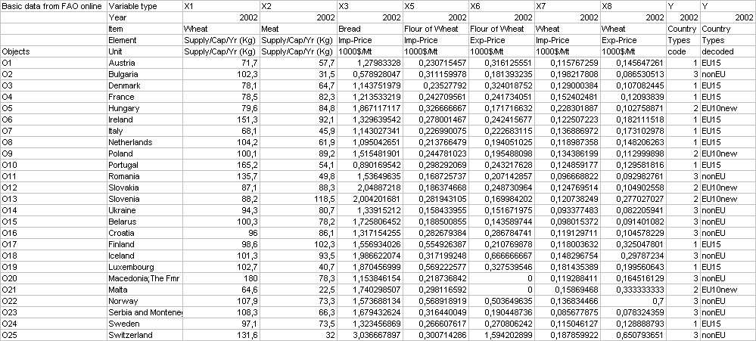
Explanation: We use names and measures of variables according to FAO methodology. Abbreviation EXP means “export”, abbreviation IMP means “import”. We chose only those countries among the objects, which has essentially full public set of data. We classified countries into three groups: EU15, EU10 and nonEU (1, 2, 3).
Interpretation: At first glance it wouldn’t be that clear, which points (which intersections of countries and indicators) are too weak or too strong, namely where the fastest/ most effective changes can be expected, or which countries don’t fulfil the requirements of their original group, or which the similarity conditions of belonging into a group are.
By the help of COCO method, we can gain answers to these questions quasi automatically according to the following steps.

2.1.3. Steps of analysis
First of all, we should specify for each attributes independently from the object and their amount, what kind of direction of change we prefer, namely the smaller or the bigger value counts better. In the course of this study we used such orientations, which correspond with the international dietetic trends (aim is the decreasing wheat and increasing meat consumption) and the economic logic (aim is cheaper import and more expensive export). Deciding on these orientations might require the decision of the model maker in case of less obvious problems.

2.1.4. Results and their interpretation
We made more sub-analyses based on the first table. In the first case we worked with only 14 instead of 25 countries. The Solver tool of MS Excel was able to handle this amount and all stairs of the COCO-function. In the output table the “penalties” can be found. The positions marked with yellow shows those positions that need extra interpretation (cf. SWOT). Using the COCO-stairs, every country was assigned to its original group.
Table 2. Results I (own calculations)
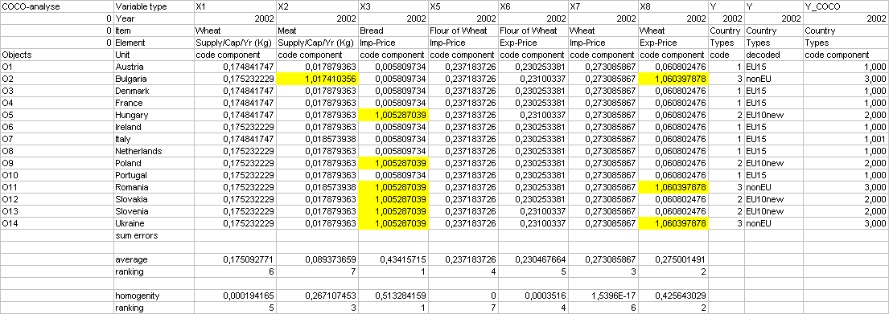
Interpretation of the marked positions:
Bulgaria/Meat consumption (O2:X2): COCO calculation was able to recognise Bulgaria as a non-EU country if it rates the quite low meat consumption with high penalty. In this way the Bulgarian meat consumption is expected to increase as one of the most sensible field.
Non-EU countries/Export price of wheat (Oi:X8): The lowest export prices of wheat belong to three non-EU countries, so this factor can be considered as weakness, which can be reduced through the globalisation (especially in case of Romania and Bulgaria).
Import price of bread (Oj:X3): This factor can be held for responsible for the objective difference between the old EU-members and new EU-members plus non-EU countries.
According to the two factors at the bottom of the second table and the above-mentioned positions, Variable X3, X8 and X7 have the most of penalties. But the third most effective factor is Variable X2 instead of X7, since X7 is homogenous factor with constant effect.
In the second analysis we don’t use single ranks but classify them into quartiles. The quartile-based approach is actually a willingly used filter. The role of this filter is to dissolve the perfect explanation of grouping in the previous analysis, namely to emphasize the most sensible fields.
Table 3. Results II (own calculations)
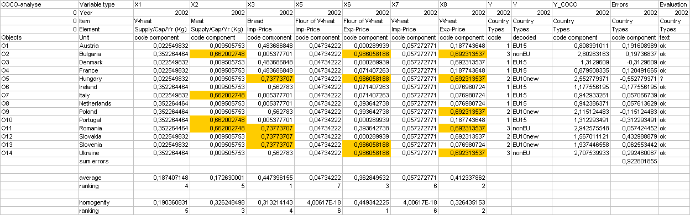
In this case it’s worth looking at the relations between the cumulated COCO-penalties /-errors and the country-groups instead of the marked positions (which are the maximum values of the columns). It can be seen, that the difference is only 0,15 (2,7-2,55) between the best non-EU country (Ukraine) and the weakest newly joined country (Hungary). Namely Hungary is the only one that should be classified into the non-EU group in case of export price of flour (X6), which carries the highest penalty. Moreover, Hungary has the most of the weak points (X3, X6 and X8), contrary to Slovakia (X3), Slovenia (X3) and Poland (X8).

In the third analysis we used the quartile-filter in case of all 25 countries.
Table 4. Results III (own calculations)
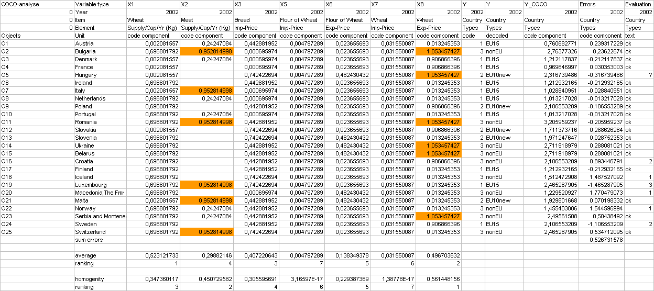
The similarity-field differs significantly from the previous one with 14 countries. Even so the position of Hungary is the worst among the newly joined EU-members. We should also emphasize, that certain South-Slavic states (Croatia, Macedonia) own quite good position. In the light of this fact, their admission to the EU is an expressly political issue. The similarity of well-developed but non-EU member countries (Norway, Iceland) to EU-members in unmistakable. Switzerland and Luxemburg place among the most developed countries might be ambiguous because of certain micro-effects.

2.1.5. Conclusions
As we can see, with the help of COCO-method expertises can be retrieved form an object-attribute matrix without contribution of experts, namely automatically. Sensitive (weak) points can be discovered in countries. It’s likely, that in case if them shifting towards averages will be happen. (Similarly, strong points can be found too, where the penalties are the lowest. In case of them, the country has to make arrangements for preserving these relative advantages.)
The core of these automatisms is developing simple rules (expert system), which are supportable by text-panels. For example, IF “y” attribute of “x” country exceeds “z” limit (or it’s the highest in a column), THAN there is a heavy pressure on this “y” attribute of “x” country in order to shift towards the average. Or contrary: IF penalty is zero or very low, THAN arrangements have to be made to preserve the relative advantages.
The best or worst members (who has to defend or develop themselves) of a given group can be also appointed. The homogeneity of groups and the distance between the extreme members become perceptible.

Analysis of market stability
2.2.1. Start-up conditions
It’s a well-known fact, that prices changes almost arbitrary measures and time-parameters. A market is stable and planning is simple when instability is low. To measure instability, in this study we bring in AEF (average equilibrium factor), which is counted from the time series 2000-2003 of FAO database: the deviation of 3 elements of the time series divided with the average of the 3 elements. In this way we get a standardised indicator, which characterise the fluctuation of price and quantity in a period. AEF values can be summarised and averaged, so we can get cumulated indicator of instability from more time series of prices. In this case we aggregated wheat-flour-bread export/import prices into the price-instability indicator.
We draw up as a hypothesis, that if we interpret the aggregated price-instability objectively, then weak and strong points of countries can be discovered on the basis of the similarity of AEF-values of other phenomena. In other words, the countries themselves can be classified potentially threaten (with high lobby-potency), underdeveloped (with poor lobby-potency) and balanced categories.
We consider as potentially threaten countries, of those counted price-instability value is higher than the real value. These countries are endangered by reason of the explanatory variables (AEF-values of export, import quantities, and AEF-value of food consumption), since their market stability can’t be deduced objectively from the balance of consumption and market supply. The possible reason of their relative success is some kind of economic political “lobby”.
Potentially underdeveloped countries are just in the opposite situation. In case of them the “market flows” (commercial quantities, consumption stability) taken into account should result better price stability, as the one in effect. Therefore the economic diplomats can reason standing on a good basis for shifting towards the “rightful” state of equilibrium. To conclude: COCO-method is able to point out the presence of relative advantages and disadvantage

2.2.2. Processed data
Table 5: AEF-values of certain European countries (own calculations)
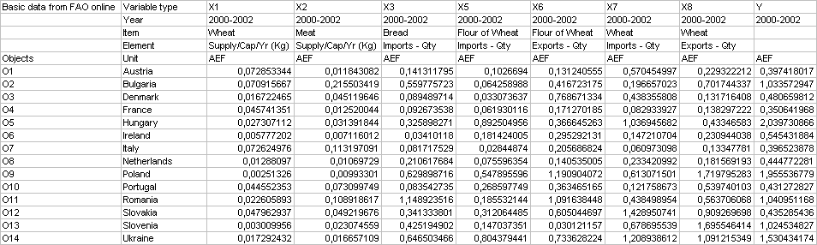
Remarks: The highest values can be found in Y-column at Hungary, so its AEF can point out as an “emergency signal” that Hungarian agricultural commerce is not very successful, contrary the work of the French, Austrian and Italian agro-lobby, whose AEF-value is the best at the first sight. In the end of the COCO-analysis it become clear, that high AEF-values alone don’t give us enough information. Comparison with other countries might shrink sometimes into relative advantage the good absolute values.

2.2.3. Steps of analysis
After specifying the basic data, the direction in case of each explanatory variable in this analysis too. In this case this direction is the same for every variables because of the identical measures:
Minden AEF érték (instabilitás) esetében a minél kisebb, annál jobb esetéből kell kiindulni. Hiszen a keresett (Y) AEF értékben a COCO-hibapontok azokban a pozíciókban kell, hogy megjelenjenek, melyek leginkább felelnek a hasonlósági erőterek alapján (szakértői befolyás nélkül megállapítva) az árak aggregált instabilitásáért.

2.2.4. Results and their interpretation
We made two sub-analyses based on the set-up data table: On one hand through the explanation of unique ranks of the 14 countries, on the other hand through the quartiles of variables, in order to be able to emphasize the sensible fields.
Table 6: AEF Results I. (own calculations)
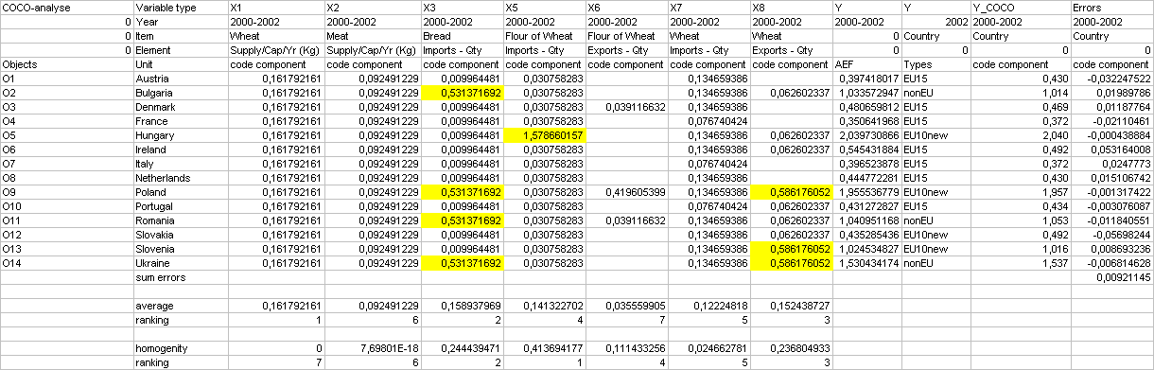
In fact the COCO-calculation finished without any error, namely each country has as estimated as real AEF-value. The analysis shows clearly, that the poor rank of Hungary is caused by a single factor: the flour of wheat import (O5:X5). We can found relatively high AEF values (Y) mostly in case of certain new members and countries waiting for joining to the EU. So Ukraine and Poland has two, Bulgaria, Slovenia and Romania has one weak position (besides Hungary).
Apart from the salient position of Hungary, X3 and X8 variables deliver the most of penalties and the most sensible explanatory variables at the same time
The quartile-based approach of the second analysis of lobby-potency has the important goal the salient position of Hungary (X5:O5) to eliminate. On the grounds of this change it develops slacker/broader similarity-fields, which will lead to the coming up of over- and under-rated positions (lobby-potency).
Table 7: AEF Results II. (own calculations)
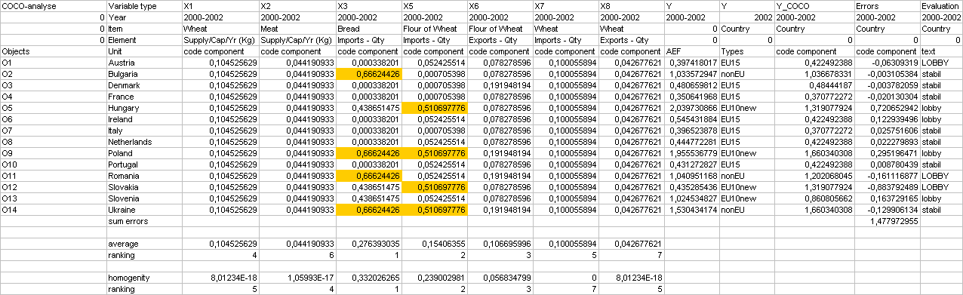
Interpretation: Those countries recon among countries with good lobby-potency (according to the values of the column on the right-hand side), of which real AEF-value more than 10% lower than its estimated AEF-value. Contrarily, those countries, of which real instability is more than 10% higher than the estimated AEF based on the objective similarity relations, have poor lobby-potency. When the changes don’t exceed ±10%, the countries are considered stable.
Good lobby-potency can be attributed to the following countries: AT, RO, SK, (namely only Austria can preserve the position that we assumed by the absolute values), while we suppose poor lobby-potency in case of: HU, IRL, PL, SLO. Hungary seems to have the worst lobby-position (the biggest difference between the estimated and the real AEF-value) – along with the high absolute AEF-value.

2.2.5. Conclusions
Of course we can found natural occurrences behind the (un)stability of markets and the course of prices. When very high yields are realised in more countries, relatively low prices can be assumed because of the pressure to get rid of stocks. To evince these impacts, further surveys are needed. But it’s important to emphasize, that numeric estimation of instability in case of the successfulness of trade policies (which is otherwise quite hard to handle) seems to be achievable using arbitrary explanatory variables.

Connection between GDP-changes and consumption-, price-changes
2.3.1. Start-up conditions
The change of GDP and its rate arises as the resultant of numerous factors. When we try to interpret the GDP-changes by arbitrary chosen, partial similarity-fields/-matrices, then every factor required having approximately the same importance, and the GDP-changes arise as the resultant of many lesser impacts.
In this study we attempt to interpret objectively the changes of GDP-expansion (Y-axis) by price- and consumption-indices of agricultural market.

2.3.2. Processed data
Table 8: Yearly changes by country. (Sources: FAO, OECD, other online source)
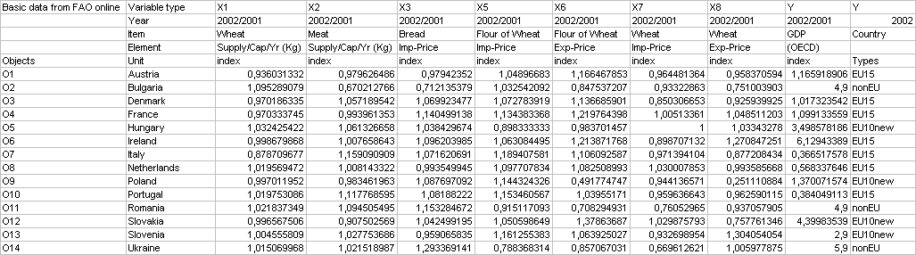
http://www.worldbank.org/data/countrydata/aag/svn_aag.pdf (GDP of Slovenia)
http://europa.eu.int/comm/enlargement/romania/#Country%20profile (GDP of Romania)
http://europa.eu.int/comm/enlargement/bulgaria/#Country%20profile (GDP of Bulgaria)
http://www.ukremb.com/business/business.html (GDP of Ukraine)

2.3.3. Steps of analysis
We set the direction of explanatory variable according these rules: Holding in the food consumption and increasing export prices increase the GDP. Increasing import prices take effect counter-side.

2.3.4. Results and their interpretation
In contrast with the hypothesis, Table 9 is quite leaky, namely the GDP-value of each country is based on relatively few explanatory variables and even this approximation is quite imprecise. Hungary is worth considering again, since the moderate (at least in this field) change of GDP is related to a single variable. This might be realised as a kind of distress signal: although we examined numerous factors in the similarity-field/-matrix of other countries, only in one, extreme case we succeeded in recognising a constellation of factors, which corresponds with the real conditions. Other factors became zero, which points out robust reactions.
The not too low COCO-error also indicates (according to our expectations), that quasi randomly chosen explanatory variables are not able to describe sufficiently the nexus behind GDP. The leeway from the estimated GDP-index might show, that economic politics behind the examined similarity-field/-matrix are indisposed in some EU15 and in the most developed EU10 countries as well as in the politically unstable area of East Europe (AT, DK, FR, PT, or SLO and UA). The previous survey also points out a kind of lobby-potencies. Regarding these potencies, only the role of Austria seems to be contradicted where prices and price indices induced by the strong lobby-potency should result higher rate of GDP-expansion than the real GDP values.
Table 9: Results of GDP-analysis (own calculations)
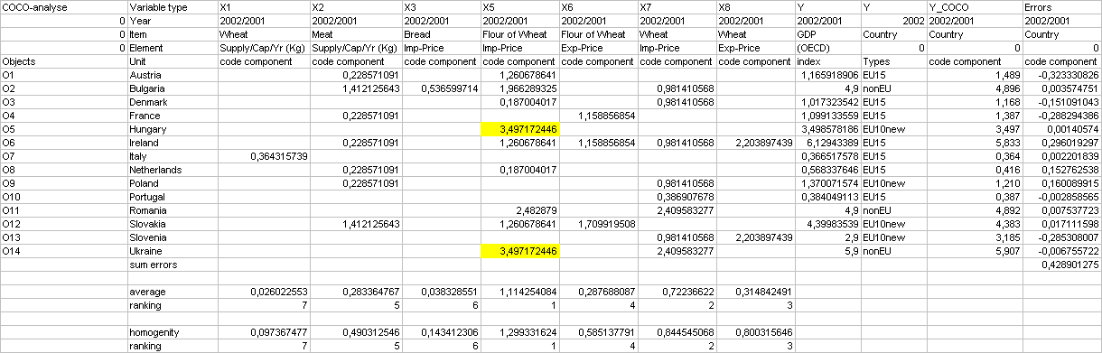

2.3.5. Conclusion
Is it possible to point out with the partial explanation of complex phenomena (cf. GDP): which objects carry the most of contradictions and in case of which objects can we assume that the aggregated influence of unexamined attributes allude to potential endangerment.

Summary
The role of statistics is gathering the data asstets, which is appropriate for the comparison of objects. The role of methodological research is developing such procedures, which are able to deliver after clear (even online) configuration such analyses (calculated values and their explanation with text), which should be the direct inputs of strategic and operational decisions.
The case studies in this paper would like to present a few typical market-situations when automatic analytical support might be needed. Besides this, the following references contain examples and interpretation in regards with numerous decision situations.
The core of the automatic similarity-analysis is the COCO method. It doesn’t need any decision from users except defining the direction of connections between explanatory variables and the examined phenomenon. In most cases these directions can be appointed detachedly.
References
MIAÚ 2005/a, COCO studies: http://miau.gau.hu/sitemap/kapcsolat.php3?where[kapcsolat]=coco&mod=l2003
Pitlik, L. Dr. - Pető,I. – Bunkóczi, L. (2004): Disadvantage: an idea being inconceivable by mathematic methods?, IAMO Forum 2004, Halle (Saale), Germany, 4-6 November 2004. - http://miau.gau.hu/miau/71/iamo_coco.doc
Pitlik, L. Dr. - Pető,I. (2004/f): Economical development of Hungary and the role of the local municipalities (methodological aspects of the comparison), Municipal Officials’ Competency and Co-operation as a Basis for Regional Economic Development N.O.R.T. Conference, Tartu, Estonia, 26-29 January 2004. - http://miau.gau.hu/miau/64/tartu1.doc
Orosz, E. - Pető,I. - Pitlik, L. Dr.(2004/e): Comparative Analysis of certain countries of IT and communications technologies endowment with COCO methodology, Within the European Union Conference, Mosonmagyaróvár, 6-7. May 2004. –
http://miau.gau.hu/miau/68/ovarposzter.doc
Orosz, E. - Pető,I. - Pisartsov, A.- Pitlik, L. Dr. (2004/d): Comparative analysis of some Hungarian regions by using „COCO” method, Information Systems at Agriculture, Forestry and Rural Areas – enlargement of EU – 10th International Conference, Seč u Chrudimi, Czech Republic, 2004.
http://miau.gau.hu/miau/68/poszterpraga.zip
Pitlik, L. Dr.(2004/c): Component-based Object Comparison for Objectivity, COCO-2004, 25. GIL - Jahrestagung, Bonn, 08-10. 09.2004
http://miau.gau.hu/miau/69/gilfull.doc
Pitlik, L. Dr.(2004/b): Case studies of Component-based Object Comparison for Objectivity in the field of farm management, 44. GEWISOLA -Jahrestagung in Berlin, http://miau.gau.hu/miau/66/gewisola2004_kurz.doc
Pitlik, L. Dr.(2004/a): Objectiv object comparison, The day of the Hungarian Science, Hungarian Scientific Academy, 11th November 2004.
http://miau.gau.hu/miau/70/mtn2004.doc

Appendices:
- Calculations for Case Study No.1: http://miau.gau.hu/miau/81/iamo_task1_coco.xls
- Calculations for Case Study No.2: http://miau.gau.hu/miau/81/iamo_task2_coco.xls
- Calculations for Case Study No.3: http://miau.gau.hu/miau/81/iamo_task3_coco.xls

Published by IAMO: http://www.iamo.de/forum2005/files/Pitlik%20Pet%C3%B6.pdf

-  Szent István University, Gödöllő, Hungary, Institute of Business Analysis, Department of Business Informatics. Email: pitlik@miau.gau.hu. (OTKA T049013)
 ∗ Szent István University, Gödöllő, Hungary, Institute of Business Analysis, Department of Business Informatics. Email: ipeto@miau.gau.hu.

