MIAU – HU ISSN 141921652 – Special Edition 2019. May
Editorials: The papers in MIAU Nr.249 (2019.V) are products of a new education frame “QuILT” (https://miau.my-x.hu/mediawiki/index.php/QuILT).
The goals of QuILT are supporting/conducting Students on the way of KNUTH, who said (1992): Knowledge is, what can be transformed into source code, each other human activity is a kind of artistic performance. It also means we need to leave the world of the magic of words step by step. A solid evidence that we all are capable of going this way is: creating publications behind which the human expertise and the robotized knowledge (like online engines: https://miau.my-x.hu/myx-free/coco/index.html --- offering context free = quasi General-Problem-Solving force fields) can be integrated in case of a rational and relevant decision making scenario. The cyborg effects make possible to face the classic naïve and/or intuitive approaches and parallel the optimized approximations. This way can be realized without deep competences about mathematics, Excel (spreadsheets), statistics, etc. The new (inter/trans/multi-disciplinary) way just expects from us to be able and willing to co-operate with the best moments of the history – it means, with the already prepared robotized elements in order to build something creative one!

What is the best country based on the distribution of inbound trips by regions?
Aftab Usama, Arham Abdul, KJU – 2019 - Budapest

Introduction
Decision makers could be interested to have an answer for the question: What is the most proportional country concerning the distribution of inbounds trips by regions in Hungary year by year. The appropriate data can be identified based on online searching (Google: tourism statistics Hungary site:ksh.hu): https://www.ksh.hu/docs/eng/xstadat/xstadat_annual/i_ogt007.html
The paper will present 4 approaches (3 of them are naïve statistical approaches and the 4th is a specific “joke” being able to test applicants of online analytical robots like https://miau.my-x.hu/myx-free/coco/index.html):
The paper shows two separate years (at first 2018 – Figure Nr1 and then 2017 – Figure Nr5).
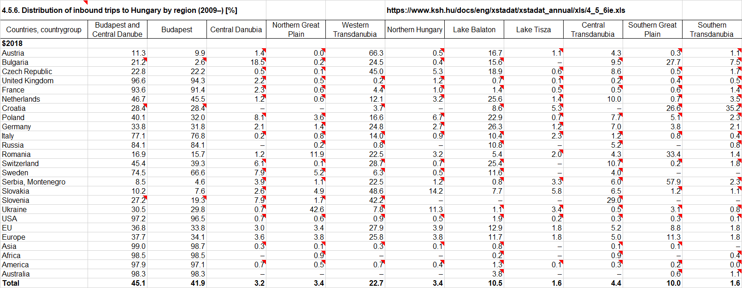
Figure Nr1: Raw data for 2018 (source: KSH)
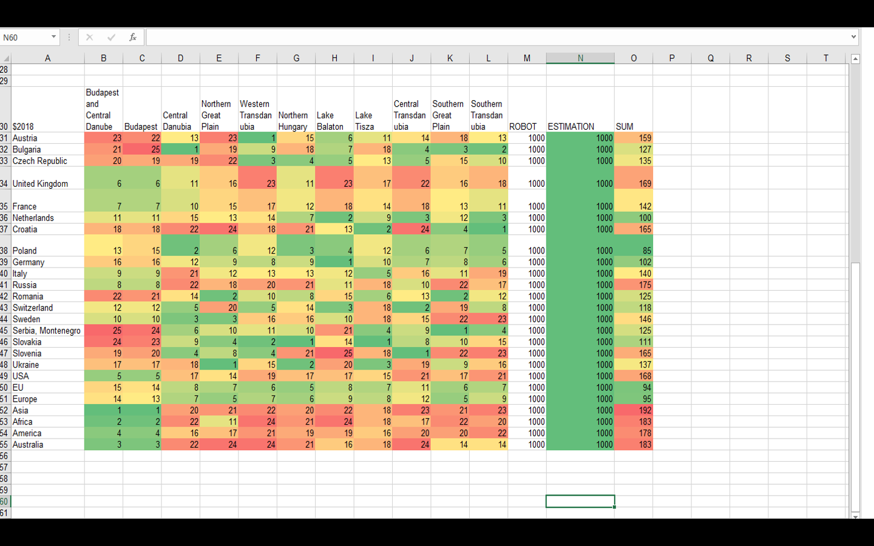
Figure Nr2: Ranking values for 2018 incl. results from the similarity-based optimzing process (MY-X FREE COCO Y0) and a naïve additive approach
INTERPRETATIONS
HERE WE USE ROBOT SYSTEM WHICH TELLS US NOT ABOUT THE BEST COUNTRY BUT TELL ABOUT OUR FIGURES THAT THEY ARE ALRIGHT OR NOT IN OTHER WORDS IT TELLS US ABOUT THE ACCURACY OF THE FIGURES WHICH WE GET AND THE CONCLUSION IS THAT OUR FIGURES ARE ALRIGHT. THE QUESTION HERE IS NOT THAT WHICH COUNTRIES ARE GOOD FOR THE PROPORTIONAL TOURISM IN HUNGARY BUT ABOUTH THE ACCURACY OF FIGURES AND DATA OF THE HUNGARIAN CENTRAL STSTISTICAL OFFICE. THE URL WE USED FOR ROBOT SYSTEM IS FOLLOWING:
https://miau.my-x.hu/myx-free/coco/beker_y0.php
THE STATISTICAL OFFICE DELIVERS FOR EACH COUNTRY THE DISTRIBITION VALUES, WHERE THE SUM OF THE DISTRIBUTION VALUES SHOULD ALWAYS BE 100%. IF IT IS SO (OR THE SUM IS NOT 100% BUT THE SAME VALUE FOR EACH COUNTRY) THEN THE ANTI-DISCRIMINATIVE ROBOT EVALUATOR WILL DERIVE THE SAME EVALUATION VALUE FOR EACH COUNTRY.
THE MODEL CONCEPTION IS THEREFORE CAPABLE OF TESTING THE USERS OF THE ONLINE ANTI-DISCRIMINATIVE ENGINE (COCO Y0) AND THE SOFISTICATED USERS SHOULD BE ABLE TO IDENTIFY, THAT THE STRONG PATTERN IN THE INPUT SIDE CAN NOT ALLOW TO FOLLOW THE REAL ANALYTICAL GOALS.
IF THE USERS OF THE ANTI-DISCRIMINATIVE TECHNIQUES DO NOT DERIVE THE SUSPICISION BASED ON ONE SINGLE YEAR, THEN IT IS TO EXPECT, TO HAVE THE SUSPICION AFTER THEY SEE TWO DIFFERENT YEARS WITH THE SAME ANTI-DISCRIMINATIVE RESULTS.

ATTENTION!!!!
THE FOLLOWING TABLES CONSISTS COLOURS SO THE GREEN COLOUR REPRESENTS THE BEST COUNTRY AND THE YELLOW COLOR REPRESENTS THE CONCERNED “BEST” COUNTRY BASED ON THE NAÏVE APPROACH USING THE MINIMIZED STANDARD DEVIATION FOR RANKING (FIGURE 2):
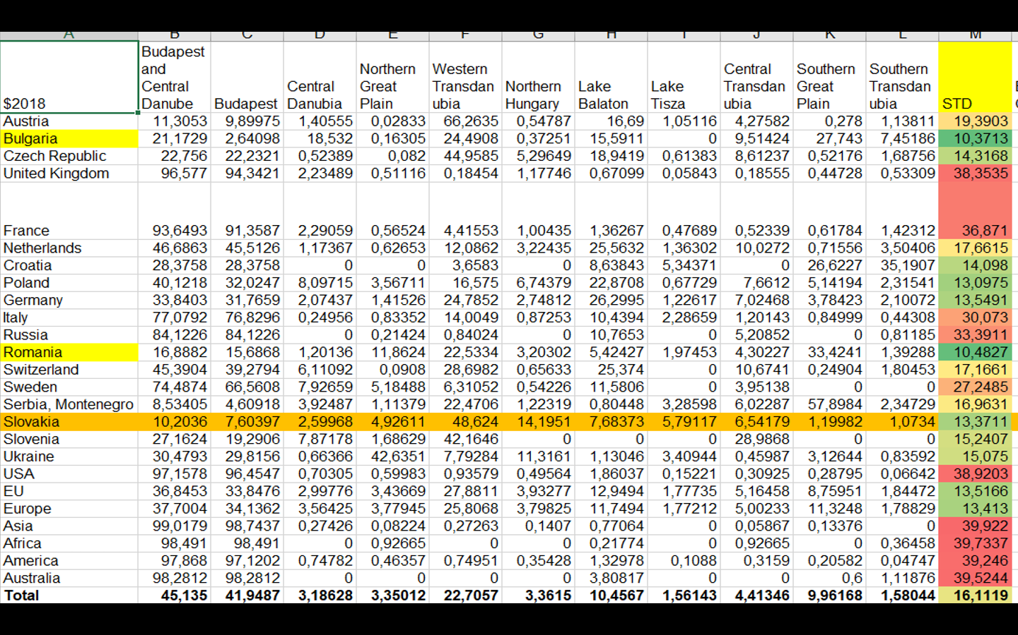
Figure Nr3 – Regional distributions (%) country by country 2018 (source: own presentation)
HERE (FIGURE NR3) WE USED STANDARED DEVIATION SYSTEM TO CHECK THE BEST COUNTRY AND IN RESULT WE GET ROMANIA WHICH IS LEADING THE CHART THE OTHER HAND WE HAVE BULGARIA SLIGHTLY LESS THEN ROMANIA LEADING WITH STD BY 10,3713.
THE COLOR “ORANGE” IS RESPONSIBLE FOR THE WINNER CONCERNING THE APPROACH “TRESHOLD-ORIENTED” RANKING:

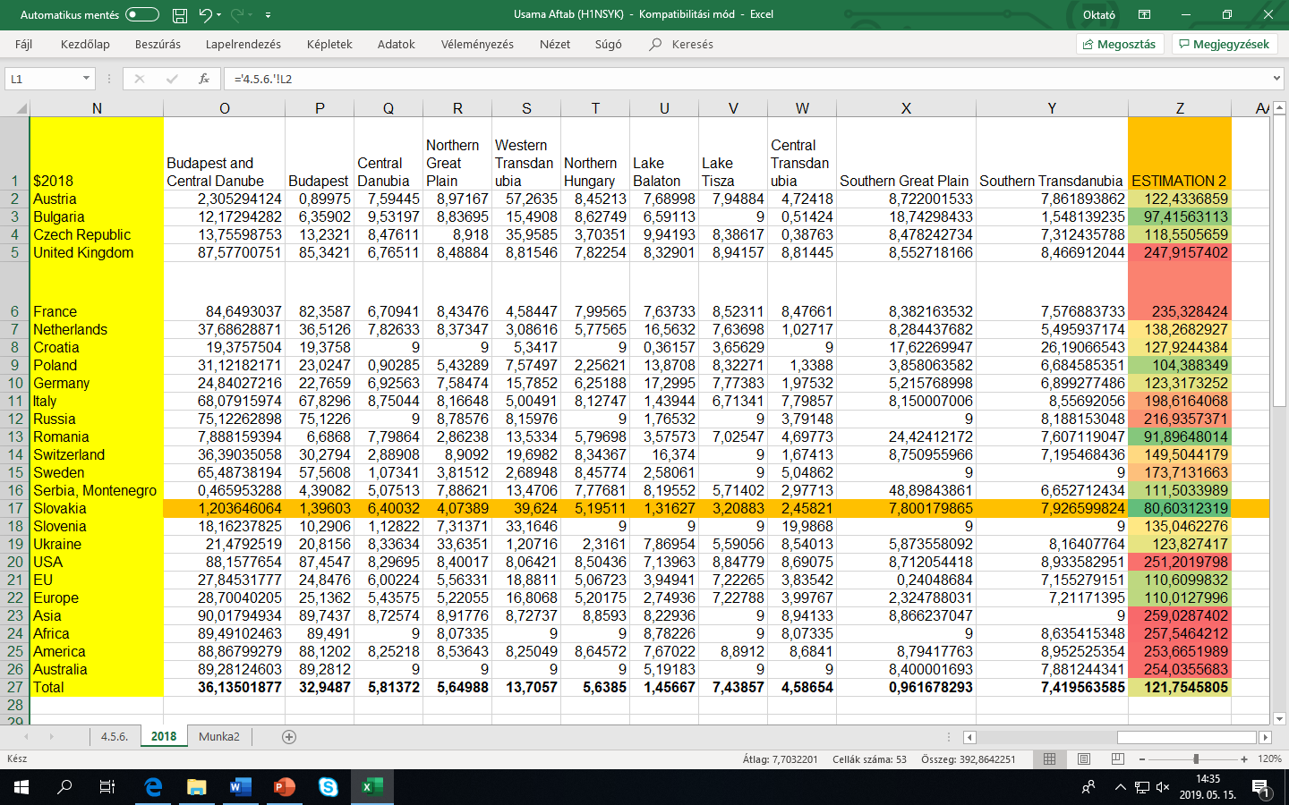
Figure Nr4 – Regional (11 regions) distributions compared to a general theoretical treshold (9%) country by country (source: own presentation)

HERE (FIGURE NR4) WE USED ABSOLUTE SYSTEM (WHERE THE DISTANCE OF EACH STATISTICAL DECLARED DISTRIBUTION VALUE GOT DERIVED COMPARED TO THE THEORETICAL TRESHOLD 100/11=9%) WE CHECKED FIGURES BY USING ABOLUTE FORMULA AND THE FIGHURE WHICH COUMES OUT IN A RESULT IS 80,60312319 AND THE FIGURE BELONGS TO BULGARIA

THE SAME ANALYTICAL STEPS COULD BE REALIZED IN CASE OF AN OTHER YEAR (2017 – SEE FIGURE NR5):
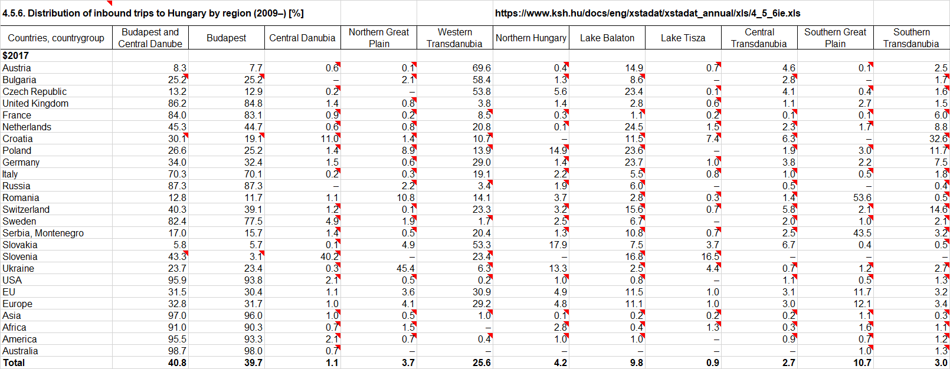
FIGURE NR5: RAW DATA FOR THE YEAR 2017 (SOURCE: KSH)

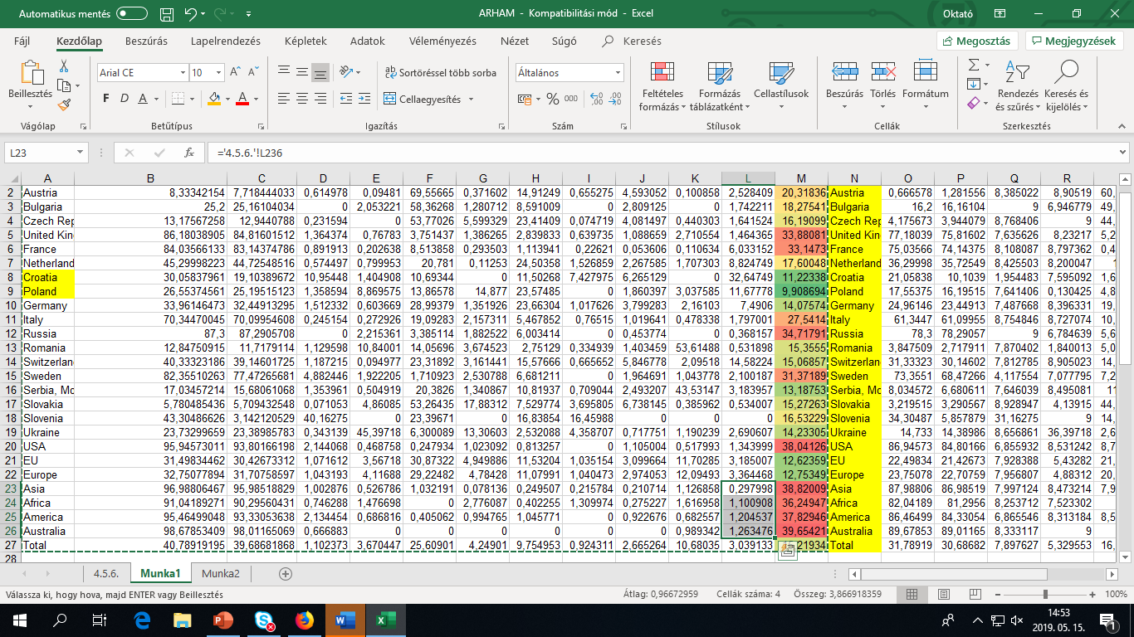
Figure Nr6 – Regional distributions (%) country by country 2017 (source: own presentation)

INTERPRETATION:
HERE (FIGURE NR6) THE TABLE DESCRIBES THE STANDARD DEVIATION SYSTEM (OF THE DISTRIBUTION VALUES FOR COUNTRIES). IN WHICH WE FOUND TWO BEST COUNTRIES WHICH ARE CROTIA AND POLAND. AND IMPORTANT LEGEND-ITEM IS THAT GREEN COLOR DESCRIBES THE BEST COUNTRY AND YELLOW COLOUR DESCRIBES THE COUNTRIES HAVING THE GREEN COLORING CODES BASED ON THE STANDARD DEVIATIONS.
REMARK: THE PUBLICATION CAN ALSO BE USED FOR TESTING THE SENSIBILITY OF READERS CONCERNING FIGURES. FIGURE NR6 HAS A LOT OF PROBLEMS:
- EACH COUNTRY NAME IS YELLOW-COLORED IN COLUMN “N”.
- THERE IS A SELECTION WITHOUT ANY WANTED MEANING.
- THERE IS A COPY-SIGN AROUND THE TABLE WITHOUT ANY MEANING.
- THE HEADER OF THE COLUMNS CAN NOT BE IDENTIFIED.
- THE REDDISCH AND THE YELLOWISH COLORS DO NOT HAVE ANY LEGENDS.

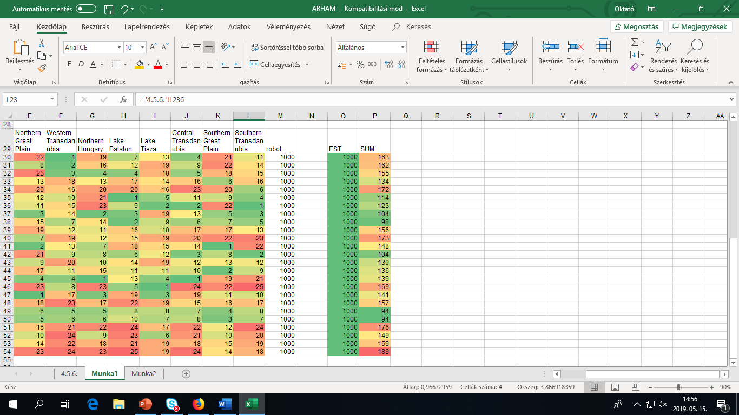
FIGURE NR7: ROBOT-ANALYSIS FOR THE YEAR 2017 (RANKED RAW DATA AND ESTIMATIONS)
HERE (FIGURE NR7) WE USED ROBOT SYSTEM IN WHICH WE DO NOT FIND THE BEST COUNTRY BUT WE FIND THE SIGN OF THE ACCURACY IN OUR DATA IN OTHER WORDS WE CHECK OUR FIGURES
URL: https://miau.my-x.hu/myx-free/coco/beker_y0.php
REMARKS (POTENTIAL TEST-QUESTION ABOUT QUALITY ASSURANCE):
- WHERE IS THE ROW-HEADER?

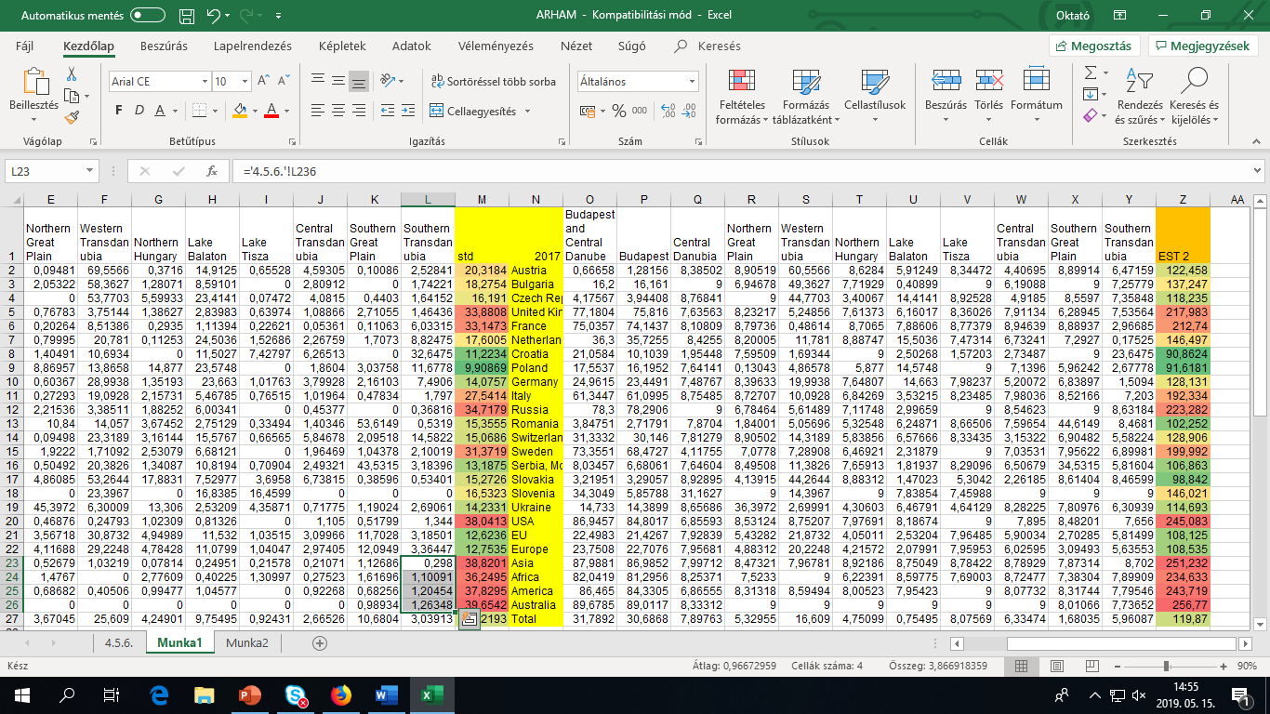
FIGURE NR8: TRESHOLD-BASED APPROACH FOR THE YEAR 2017
HERE (FIGURE NR8) WE USED ABSOLUTE SYSTEM WE USED ABSOLUTE FORMULA TO EVALUATE THE VALUES BUT IN MY CASE I GOT THE SAME COUNTRIES WHICH COMES OUT AFTER DOING STANDARD DEVIATION.
REMARKS (POTENTIAL TEST-QUESTION ABOUT QUALITY ASSURANCE):
- WHERE IS THE ROW-HEADER?

CONCLUSIONS
THE NAÏVE APPROACHES DELIVER “SOLUTIONS” FOR THE QUESTION: WHAT IS THE BEST COUNTRY IF WE SEARCH FOR THE MOST BALANCED COUNTRY CONCERNING THE HUNGARIAN TOURISTIC REGIONS. THE QUESTION COULD BE RELEVANT, IF THE RISK OF A MARKETING ACTION SHOULD BE MINIMIZED AND THE MOST BALANCED COUNTRY CAN REACT TO EACH KIND OF MARKETING MESSAGES. THE COUNTRIES WHERE THE BALANCING EFFECTS CAN NOT BE IDENTIFIED, WILL ONLY REACT IF THE PARTICULAR REGION IS PROMOTED…
THE JOKES HAVE A RELEVANT TESTING POTENTIAL TO SEE WHAT KIND OF THEORETICAL STABILITY CAN BE IDENTIFIED BEHIND OF ROUTINE ACTIONS?!

REFERENCES
https://miau.my-x.hu/miau/quilt/2017.xls
https://miau.my-x.hu/miau/quilt/2018.xls
https://miau.my-x.hu/myx-free/coco/index.html

