QuILT 2.0, or the new area of the asynchronous distance education/learning
László Pitlik, László Pitlik (jun) (MY-X team)
The HTML5-based streaming version can be used through this URL: https://miau.my-x.hu/miau/quilt/2020/quilt2/launching2020III25/part0.html, where part No.1 is a kind of warming up scene about the involved artificial actors/actresses based on the online services of ttsdemo.com
Abstract: The LLL (life-long-learning) is a mostly asynchronous process where the person who has in general ad hoc problems/questions tries to cover the lack of information/knowledge in an incalculable/iterative way through searching, interpreting, discussing, etc. The QuILT 1.0 demonstrated support materials for this complex phenomenon starting from 2019 (https://miau.my-x.hu/miau2009/index.php3?x=e0&string=quilt). The asynchronous learning expects that the Students want to increase the level of their sovereignty concerning problem solving. Now, in 2020 – after the prompt declaration of the necessity of distance education because of COVID-regulations, the situation is given to start with QuILT 2.0 where the role of synchronous lectures - having probably only a 5%-share in the knowledge management/cumulation (c.f. learning) processes (https://miau.my-x.hu/miau/quilt/2020/teaching_is_learning.png) - can be reduced (quasi to the zero-level) and each other alternatives/treatments may be involved in order to realize more and more learning success. QuILT 2.0 is the unlimited complexity of supports generating sovereignty of Students quasi without verbal/contact components in the communication processes concerning shifting paradigms and increasing the capability of qualitative publishing. The tutorials in frame of QuILT 2.0 simulates/demonstrates real/reality-oriented situations from the strategic level to the deep operationality. Each (written) question of the Students will be answered in an asynchronous way – and these question-answer pairs will build a kind of online FAQ behind each (mostly rel. short) tutorials. Spontaneous (also written) communication can also be realized in form of emails between conductors and Students. The QuILT 2.0 system works with artificial players generated by ttsdemo.com. The conductors/teachers become a kind of directors of content/speed/visualization like in case of a looper-driven one-man-show in the music industry.
Keywords: robot teacher, robot journalist, advanced Turing test, investigative journalism, automation, efficiency, big data, solver-based modelling/interpreting/hermeneutics, intuition generating process, artificial intelligence, OAM
Content
Prologue 3
Pre-history of robotized publishing 3
Robot-Teachers/Conductors vs. Robot-Journalists 3
Can complexity be demotivating? 4
How to use the QuILT 2.0 system 4
Story board: The case of H1N1! 7
Conclusions 33
Potential FAQ-elements 34

Prologue
Publishing as such seems to be an artistic performance where the personality of the author(s) should play a relevant role from point of view of the Readers. In the field of the scientific publications, the AWS (academic writing skills) are accepted as a frame for quality assurance. The AWS logic is a product of the magic of words. It is not a part of the KNUTH’s universe (where knowledge/science is what can be transformed/transferred/translated into source code).
This paper presents how and why it is possible to create a robot journalist who is capable of executing a kind of investigative journalism process in a way where the Turing-test should be positive. The Turing-test (https://en.wikipedia.org/wiki/Turing_test) is responsible for detecting robots with a low competence level. An advanced Turing-test could also be created where the human beings are compared with robot performances (e.g. on the field of the investigative journalism and/or on the field of the intuition generating processes). The advanced Turing-test means: Students may not have a lower level than robots because the existence of robots assumes that the components of the journalism (publishing as such) and connection between them could be identified and simplified for source code writing.

Pre-history of robotized publishing
The following articles/documents are worth reading in order to see the complexity and the simplicity in a parallel way:
- https://miau.my-x.hu/miau/258/kome_v1.docx - about robot writing
- https://miau.my-x.hu/miau/196/Pitlik_Robotlektor_Roll-up_85x203cm_HU_EN2.pdf & http://miau.my-x.hu/miau/181/etdk_2013_v4.doc - about robotized quality assurance (robot lector)
- http://miau.my-x.hu/miau/208/idealis_lektor_v1.doc - about the activity patterns of a lector
- https://miau.my-x.hu/myx-free/index.php3?x=test1 – Academic Writing Skills – from an other point of view
- https://miau.my-x.hu/myx-free/nos/ & https://miau.my-x.hu/myx-free/index_fifawc2010_en.php3?x=soccer_news_en- about the possibility of a robotized sport-journal
- http://miau.my-x.hu/miau/207/tdk_letra_v2.doc & http://miau.my-x.hu/miau/222/tdk_letra_v7.xls - about how to create a really good best student paper
- http://miau.my-x.hu/miau/224/jo_fogalma_otdk_biralat_anonimizalt_2.docx & http://miau.my-x.hu/miau/200/otdk_v2.doc & http://miau.my-x.hu/miau/200/otdk_v1.doc - about the anomalies in the competition of best student papers, etc.

Robot-Teachers/Conductors vs. Robot-Journalists
The Quilt-based (version 2.0) asynchronous distance education define artificial players as layers of the personality of a “schizoid” (multi-layered) conductor who should be able to demonstrate more point of views concerning teaching/learning methodologies and also involve virtual Students into the discussion processes (https://miau.my-x.hu/miau/quilt/2020/quilt2/lauching2020III25/part0.html) about KNUTH-relevant competences (like robotized publishing).
What the Part Nr1 of the new QuILT-services can offer is (see: https://miau.my-x.hu/miau/quilt/2020/quilt2/lauching2020III25/part1.html) which relevant steps/components can be identified in the process of intuition generating and publishing.
The robot conductor (Con-Duck-Thor) supported by virtual Students (Stew&Dent) helps for real Students to understand (step by step) the elementary components of publishing starting from one single keyword to the finalized article. Each step is that clear and clarified that the development of real source code is quasi trivial. What means: a robot journalist could be really existing based on a big-data-concept and solver-oriented analytical steps for interpretation of the pictures derived from the raw data assets.
What is not acceptable as human performance are the following publishing strategies:
- creating a stream of subjective opinions, (unproved conspiration) theories about WHY-syndromes (e.g. why is a corona virus exist?) by the author
- answering trivial questions (like how values of a phenomenon are changed where the answers can be derived e.g. in a spreadsheet-environment within seconds)
- creating questionnaires with attitude-question (like how import is for you to know about IT-solutions for the distance education? 1<10) and/or organising interviews in order to write arbitrary sentences,
- using questions like “how many percent can be realized in a knowledge acquiring process based only on lectures” – without declaring what the real unit and/or maximum of the expected “percent” is?
- etc.
What is complex enough to create an article about it are following approaches (c.f. previous list above):
- deriving/proving theories/hypotheses based on big-data (instead of conspiration theories)
- creating simulation systems to see connections between inputs and outputs (instead of why-oriented ideas)
- development of log-systems instead of self-“evaluation” processes
- creating artificial index-values (e.g. safety of the medical system of a country) in order to substitute entirely subjective abstraction (like subjective satisfaction concerning the medical system of a country), etc.

Can complexity be demotivating?
Complexity can be demotivating if the complexity can not be reduced and described in a way where the KNUTH’s universe is already existing. It means an article needs a lot of thinking experiments where the arch-stone and each other stone-part of the arch can be set to the right position on a totally empty/blank sheet of paper. A thinking experiment should always be as details as possible – using each components of the system of publishing. The following QuILT-performance tries to support the understanding of the logic of a particular thinking experiment with all their components, details and connections.

How to use the QuILT 2.0 system
If you see the first three parts (Part No.0 and Part No.1a and Part No.1b)
- https://miau.my-x.hu/miau/quilt/2020/quilt2/lauching2020III25/part0.html
- https://miau.my-x.hu/miau/quilt/2020/quilt2/lauching2020III25/part1a.html
- https://miau.my-x.hu/miau/quilt/2020/quilt2/lauching2020III25/part1b.html
then you will have a lot of critical impressions like
- why do we need artificial players at all?
- why not only texts?
- why it is that slow?
- why it is not cut?
- etc.
There are answers to these potential questions like
- it is important to impersonalize the knowledge, to make it independent from real persons because the further LLL activities will also bring contacts to strange sources and it is important to be capable of evaluating information independent from the person having it / parallel: it is also important to have the chance to demonstrate different thinking patterns (see both conductor-layers and Student’s point of views)
- texts are in general good learning materials – but the experiences show semester by semester that the motivation level for reading is relatively low – on the other hand: the voice-and-video-support makes possible to change exposures – it means: reading can become as a monotonous challenge and hearing can maybe solve this distress situation
- the QuILT 2.0 system works without any technical and financial background, there this version seems to have a good price-performance ratio / on the other hand, this technology can integrate everybody (both Students and Teachers) where it is more important to be capable of thinking experiments than to be able to produce in Hollywood-quality
- the relatively slow process (because of avoiding the improving force fields of cutting effects) makes possible to have own opinion/notes and this effect generate the needed sovereignty
- …
The mp4-files can be converted to mp3-files and they can be used e.g. during travelling. The rel. small mp4 files can be reached in a direct way by using the shortened URL: https://miau.my-x.hu/quilt2 where each relevant fragments can be identified – among them the part*.mp4-series. These mp4 files can be also used in smart phones.
It is also important to know: the online services of ttsdemo.com are limited: e.g. 600 characters can be prepared for one speech-activity. The QuILT 2.0 based on the presentation possibilities of ttsdemo.com
The detailed information will be presented in muted form in order to have the possibility to teach others through involving the short streams with specific mouse movements (highlighting important details) and also in order to enforce memory exercises based on the presented interpretations before by the artificial players.
The parts make possible to discuss about their content. This discussion will also be in an asynchronous form – it means each question and answer will be moderated before and the FAQ-like results will be readable in the MIAU WIKI system:
- https://miau.my-x.hu/mediawiki/index.php/QuILT2_part0
- https://miau.my-x.hu/mediawiki/index.php/QuILT2_part1a
- https://miau.my-x.hu/mediawiki/index.php/QuILT2_part1b, etc.
Each impulse should be communicated based on the always open email-channels.
Each part can be extended, and a lot of new details can be supported through new mp4-solutions. The FAQ-oriented support is faster but specific question will surely need captured streams too in future.
The technology used for QuILT 2.0 video streams is very simple from the point of view of a conductor writing/managing the production of the learning materials:
- it is necessary to write the story board
- and to produce static (and muted) images and/or animations/videos (where the muted files can be created in a normal office, in a loud environment – because only the inner voices will be used)
  - a part of the videos is based on the ttsdemo.com services
  - other parts are captured videos or
  - screenshots
- each component (texts and images/video) should be integrated into a PPT-file responsible for running later
- the projected ppt will be controlled in a manual way – so, that even specific mouse-movement can be integrated in an ad hoc way during the general running
- the capturing can be made with OBS in case of the elementary parts and the final movie
- cutting is optional (e.g. in case of the network-dependent starting of robot voices)
- as a visual effect between parts, it is enough to use the OBS-control-views
- the generated mp4-file can be stream in a HTML5 frame
Potential offers for final publications:
- the QuILT 2.0 system can be criticized and/or
- improved e.g. in form of thinking experiments (c.f. https://miau.my-x.hu/miau/quilt/2020/sovereignty-pla.docx with recommendation for education-oriented topics and their data assets)

Story board: The case of H1N1!
From now on each text part written for THOR will have a turquoise background colour, and the same logic is valid for each other player (virtual actor/actress): DENT will have the colour-code of magenta, STEW will be grey highlighted. CON’s colour will be the red and DUCK “can not have an other” colour as yellow. The colour-scheme is quasi a randomized one.
The whole story with generated voices can be streamed here: https://miau.my-x.hu/miau/quilt/2020/quilt2/lauching2020III25/part1.html. It is worth reading this article before switching to the animated version:
Persons | Messages of PART1a - … how to produce an OAM behind an article…
THOR | In medias res: The corona virus is not the first virus with relevant impacts in the modern history of the human beings. On the other hand, good structured data assets about the recent corona virus pandemic process are hardly to identify. The quasi closed case of H1N1 virus concerning the years 2009-2010 can be used to model what should we do for the data asset management in case of the corona virus in order to be capable of deriving conclusions based on big-data-sources and based on solver-oriented analytical techniques?
DENT | Stop! Please! Stop-stop-stop! This was a really rough start, Professor. Is my interpretation correct, if I say: the keyword we have is the abbreviation of H1N1? If somebody read the previous pages as recommended, it seems to be trivial, that the first step should be an easy one. It means the robot journalist should also be capable to have a clear starting parameter. And this can only be one single keyword because the next step should be a searching process…
THOR | Excellent! You are right in each aspect. The robot journalist needs at least one single keyword to start with searching. For searching, the robot journalist will use for example the Google-Search-Services as almost everybody would do. It is not necessary to have any pre-knowledge about the background layers of the keyword. It is also not necessary to have a precise goal before starting with search activities. It means the results of the searching needs no human-like interpretation processes because we do not really know what our brain really makes with these results.
STEW | Let us summarize briefly the situation. Do we need just one single keyword without any pre-defined purpose? And if we do not have more than a keyword how will we go on if we will have the searching results? I have already read the recommended documentation and there were a lot of other keywords like big-data. Is my assumption proper if I think the robot journalist will prefer searching results where data are available? But data can be present in text stream and also in more structured form – for example in matrices.
THOR | Yes, your interpretations are correct! Robots are relatively simple creatures. If a robot journalist can identify structured data where the legends or to be more precise: the row header positions and or the column header positions consist the searched keyword of H1N1 then these results will be used for writing an article. Namely, the header positions and other words about affected phenomena have mostly a clear relationship to the starting keyword of H1N1. So simple is the way therefore to the OAM (you know to the object attribute matrix).

Persons | Messages of PART1b - ...efficiency problems with PDF-based communication...
CON | It is nice to follow your conversation. But, please, do never forget the Knuth’s principle: Knowledge is what can be transformed into source code. Concerning to your previous sentences, I think, we need a lot of short presentations about the potential results of the different searching processes. We should see, what are the results, if we really have one single keyword? We should also see how we could improve the ratio of more structured data among the results. What do you think?
DENT | I agree - definitely. It is trivial that we will have PDF-files among the results if we do not use specific extensions to the one single keyword we have. These PDF documents can contain Tables. But – you know – PDF-files can be converted to DOC-files quite simple – however it is never guaranteed that the numbers of the tables keep their structures. Nobody likes retyping too much therefore it is important for increasing the efficiency of the data collecting processes that we use sources where structures will be kept.
CON | At first, we need a test process with the only keyword of H1N1. As you can see, the first results belong to Wikipedia in different languages. Wikipedia is not a really good source for structured data. Wikipedia delivers mostly texts. But the HTML-sites make possible to create tables. These tables can be transferred into Excel. But the footnotes and the format of the numbers make the data processing not really easy. Parallel to tables, there can also be charts, figures, maps. Unfortunately, they can not be processed with Excel in a direct way. Therefore, Wikipedia is not a preferable source.
XXXX | Please, watch the next video too, where the described phenomena can be detected…
DENT | Thank you for the presentation. It is now clear what kind of sources, formats we can not involve into the data collecting efficient enough. I think there are further traps not supporting our goals. For example, it would be nice to see a demonstration about the problems with PDF-converting. I am afraid not only table but also parts of text are integrated into the raw PDF-file in a way, that we do not have any chance to use it – just in form of retyping the relevant information units. Could you show us a presentation?
XXXX | Please, watch the next video too, where the described phenomena can be detected…
STEW | Thank you for this presentation too. It is not even motivating to see, that a lot of anomalies can really be detected behind the common formats like PDF. We could see the possibility of the converting, but the converted content can not be used in an efficient way. Parts of texts are pictures and vice versa – parts of tables could be converted. Obviously, nobody cares about efficient data processing – although the PDF-s as such are voluminous. I think, I do understand here and now what the difference is between data-driven thinking and the arbitrary opinions.
DUCK | It is a great pleasure for me to be a witness of the development! Now, it seems to be it is ultimately time to speak about the basics of the similarity analyses. You could see before, for example in Wikipedia that the statistical values belonged to countries. Therefore, the robot journalist can declare, that the OAM will contain as row header countries. Countries could also be identified in the corrupt converted PDF. The Wikipedia tables and PDF-tables contains potential attributes too: for example, data about vaccines. Attribute names will be set as column headers into the OAM.

The collected data and their sources can be studied in the background XLS too: https://miau.my-x.hu/miau/quilt/2020/projekt_h1n1/OAM1_h1n1.xlsx

Persons | Messages of PART1c - …the value of knowledge or how to use already downloaded data…
DENT | Okay, we know by now a lot about the negative cases – it means about sources where we will have nothing else just troubles. Fortunately, the robot journalist can also know that the basic search activity with one single keyword can deliver information about institution/organization like Wikipedia, WHO, etc. These information units can be identified in the domain or server names. Parallel, robot journalist can know that specific additional keywords can increase the chance to find tables, matrices. These extensions are for example: statistics, figure, table, etc.
DUCK | That is right! We can check immediately this hypothesis. You can see the impact of additional keywords in the searching phrase at once. It is important to know it is worth searching not only with English keywords! Let alone, it is very important to define the objects – in our case the countries and maybe a continent like the EU in order to increase to probability to have good results in the first page of Google. As it can be seen, the enterprise Statista is a provider where you can find appropriate information. Even the highlighted images belong to Statista.  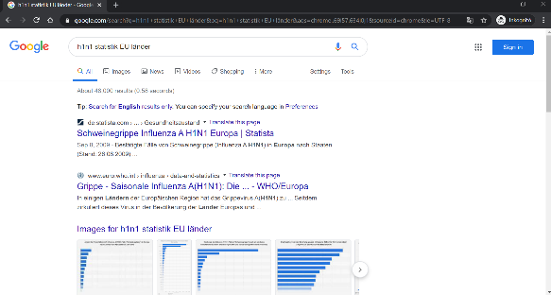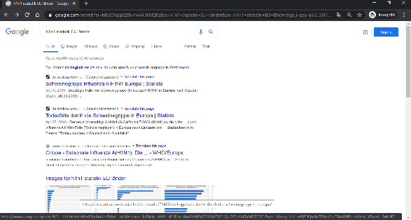
DUCK | It is also relevant, that the results of the Google Search can also be translated by Google as in case of each other Internet site. However, the identified charts, figures can consist description elements for example country names in our case in German where the Google Translator does not have any access rights because these information units behave themselves like images behind the PDF file before. In ideal case, the robot journalist will have timestamp-like data too. It means besides country names and statistics it is also important to know about the time aspects.  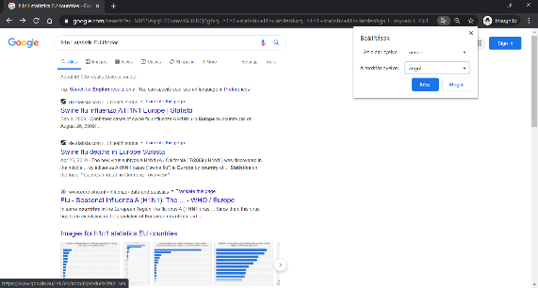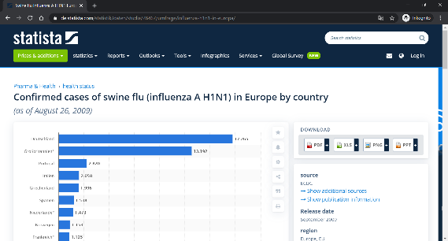
DENT | But how can we copy and or download the identified data in text format? Figures, charts, animations are images, and these can only be processed through retyping the needed values and descriptors like country names, timestamps. Stew! You are our expert for ethical hacker tricks and tips. Do you know what have we to do in such a case? I think, the robot journalist and therefore we all need some idea to ensure efficiency in the data processing. Stew! It is now – your - turn!
STEW | Aye-aye, Sir! Sir, I can immediately present you not only one but two parallel possibilities. There are two spells for such kind of HTML-oriented problems. The one spell is: CTRL+U, and the other one is F12. Of course, spells should be trained like in Hogwarts even for Harry Potter. In these cases, training means you should know about one specific HTML-tag-pair. These tags are the opening and closing tags for HTML-tables. By the way: these tags can also be used in searching phrases. This is a technique-oriented support parallel to the keywords before about statistics, tables, etc.  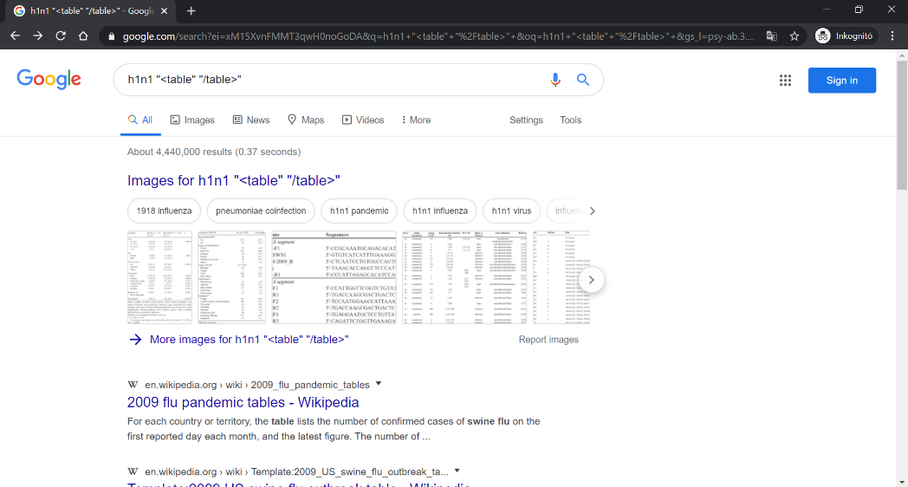
DUCK | Excellent! And one further spell - if we want to use such kind of analogies – is the hotkey CTRL+F. This button combination makes possible to search within the source codes. Namely, the spells of Stew lead us directly into the deepness of the world of HTML-tags and Java-Scripts. The first views demonstrate the codes after the command of CTRL+U. With CTRL+F it is possible to identify the opening tag and the needed data can be read at once. For transferring the data into Excel, it is necessary to select each character including the closing HTML-tag for tables.  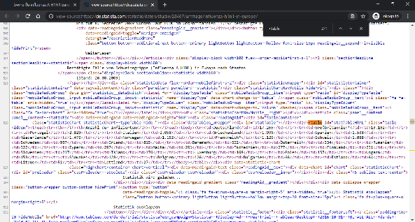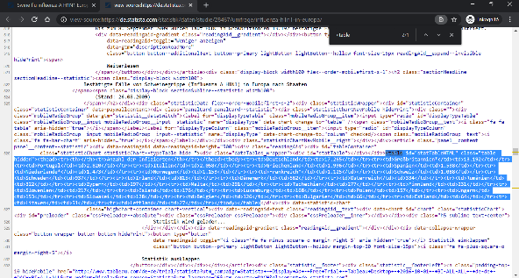
DENT | I have tried the other spell – it means the F12 for opening the development tool behind the browser of Google Chrome. As everybody can immediately see, the opening tag can be identified and after selecting of the whole – very-very-long – row, and we can check the value for Germany. The number is 17265. This is the same value as before in image-view and also in case of CTRL+U. Fortunately, the Excel can transform the HTML-codes, and we and the robot journalist will have the needed data in a useful format.  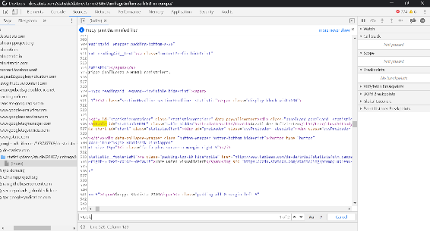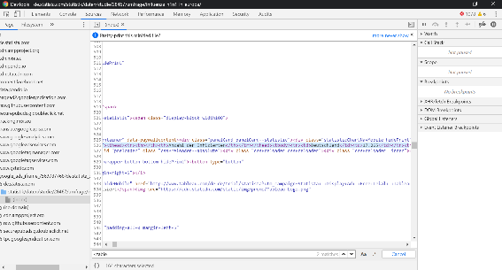  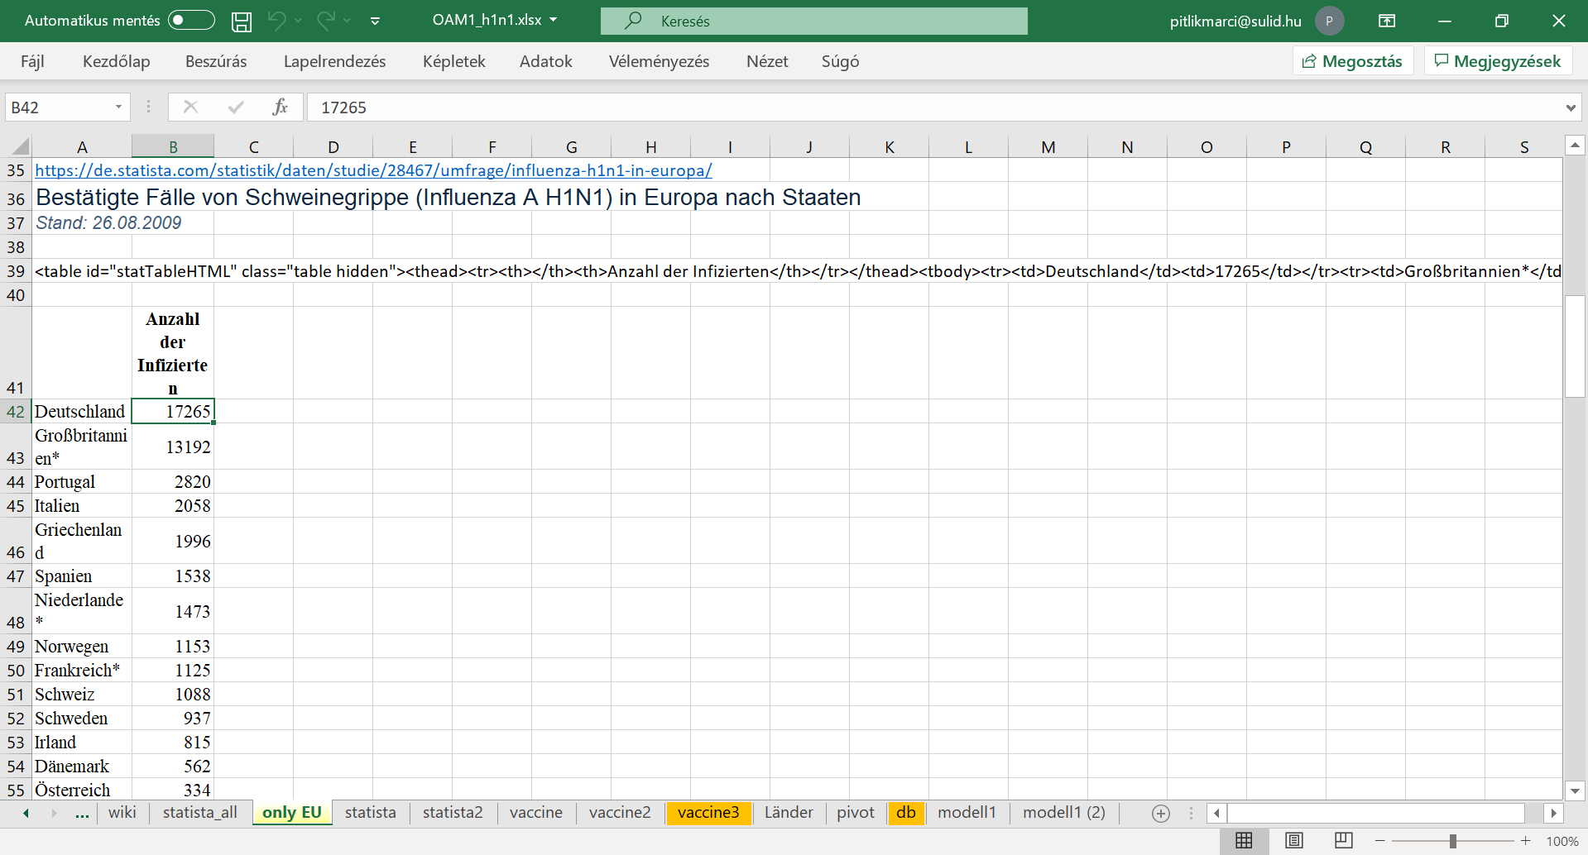
CON | Finally, let us declare something relevant one: All the spells are not important if somebody can pay for information brokering services for experts and or enterprises. Therefore, knowledge is a kind of power or even a kind of business potential. Information brokers are experts who are able to collect data in an ethical way as soon as possible. Common citizens have the possibility to choose experts and or online services – but they should mostly pay for the information. The business is simple: experts are so fast that the salary can be paid by the common citizens at any rate.

Persons | Messages of PART1d - …finalizing an OAM…
DUCK | The OAM is a key for automated intuition generating. It means to interpret the world around us in an automated way. The robot journalist and so, all of you have each necessary component for building an OAM. We have the searching possibilities and tools for their fine tuning. We are capable identifying objects and attributes. We also have the ethical tricks to identify and copy HTML-tables letting execute an efficient data processing. I should repeat my first sentence: The OAM is a key for automated intuition generating. It means to interpret the world around us in an automated way.
THOR | In case H1N1 we could download spreadsheet-compatible data about infection and death rates of countries in the EU. We have the population-density, and the level of urbanization. It means the ratio of people living in cities compared to the total population number. We could download a PDF with data about vaccination of different groups of the society like clinical risk groups, pregnant women, health care workers, staff of long-term care facilities, residents of long-term care facilities, and older population groups. Finally, we have the time as a strong structure to say what is X and what is Y.  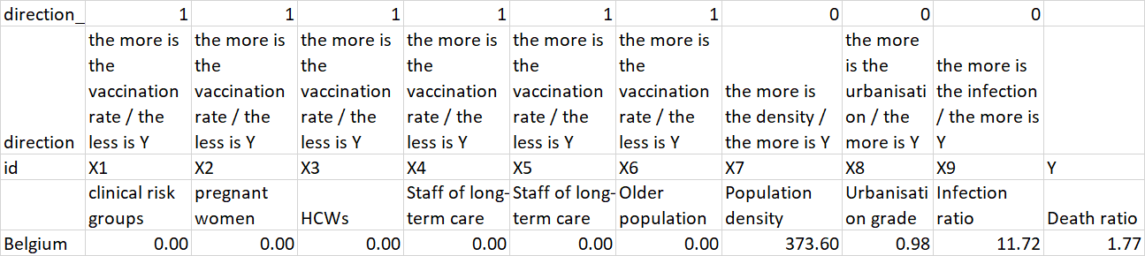
DENT | This is a very informative, strong-structured figure. But I have a lot of question: What you mean if you speak about X and Y? Why is time that important? How we can derive the so-called directions? Of course, I will immediately try to approximate the parameters of ideal Students who has not only questions but parallel the potential answers concerning them are also given. A good question defines at once its potential answers. The most trivial case is a question with two answer options: yes and no. Each question can always be transformed into a lot of yes-no-questions. For example:
DENT | I could have even asked: Does X stand for the independent variables? Answers: yes and no. Because, I think attributes with the X-sign should be the so-called independent variables or causes in a causal interpretation frame. The attribute marked with a Y-sign is therefore the dependent variable or with other word the consequence-variable. Time should be important to be capable of interpreting causes and consequences. Causes, reasons should happen earlier then consequences.
DENT | And finally, directions should be the potential types of the relationships between an X and the Y. The most simple types are proportion-oriented types: the-more-the-more and the-more-the-less. More precisely: the more is an X-variable the more is the Y variable. In case of H1N1: the more is the rate of infection (where infections happen before deaths) the more should be the rate of deaths caused by the viruses. However, relations between an X and the Y can be more complex. We can speak about optima where neither the lowest nor the highest value of X make possible to increase the values of Y.
THOR | Exactly! So, one single row of an OAM is a sentence or a rule or a declaration - assumed that each statistical value is correct enough. If the values of the X-variables in case of Belgium are that low and or that high as they even are in the database, then the Y-variable should exactly have the collected value. If we have a lot of objects – in case of the H1N1-project a lot of countries, then we have our database for simulations. Unfortunately, we do not know in general which relations are given between the variables. Fortunately, the robot journalist has an automated tool for this challenge!

DENT | But before we try to be introduced into the world of the robot analysts, it seems to be important how we can build an OAM based on the huge number of data-puzzle-pieces? I think it can not be the only way creating references in Excel - position for position - between the raw data and the OAM-cells. I expect if we have structured raw data then we should have the chance to integrate them to a standard structure for report-generation. Stew! Are you still awake? Do you have some idea, some new spells or even wizard-services?
STEW | Oh-yes, I am awake –of course- and yes, I do have the super tool! And yes, this is a wizarding surface. It is namely the pivot table generation. In order to use the Excel-pivot-tables, it is necessary, that the needed data can be integrated into a standard object-oriented structure. This structure makes possible to derive an OAM through the pivot wizard without doing anything with the data positions in a manual way. Of course, it is also possible, that the references to the row data positions will be integrated into the OAM-structure in a direct way. But the raw data may never be retyped!  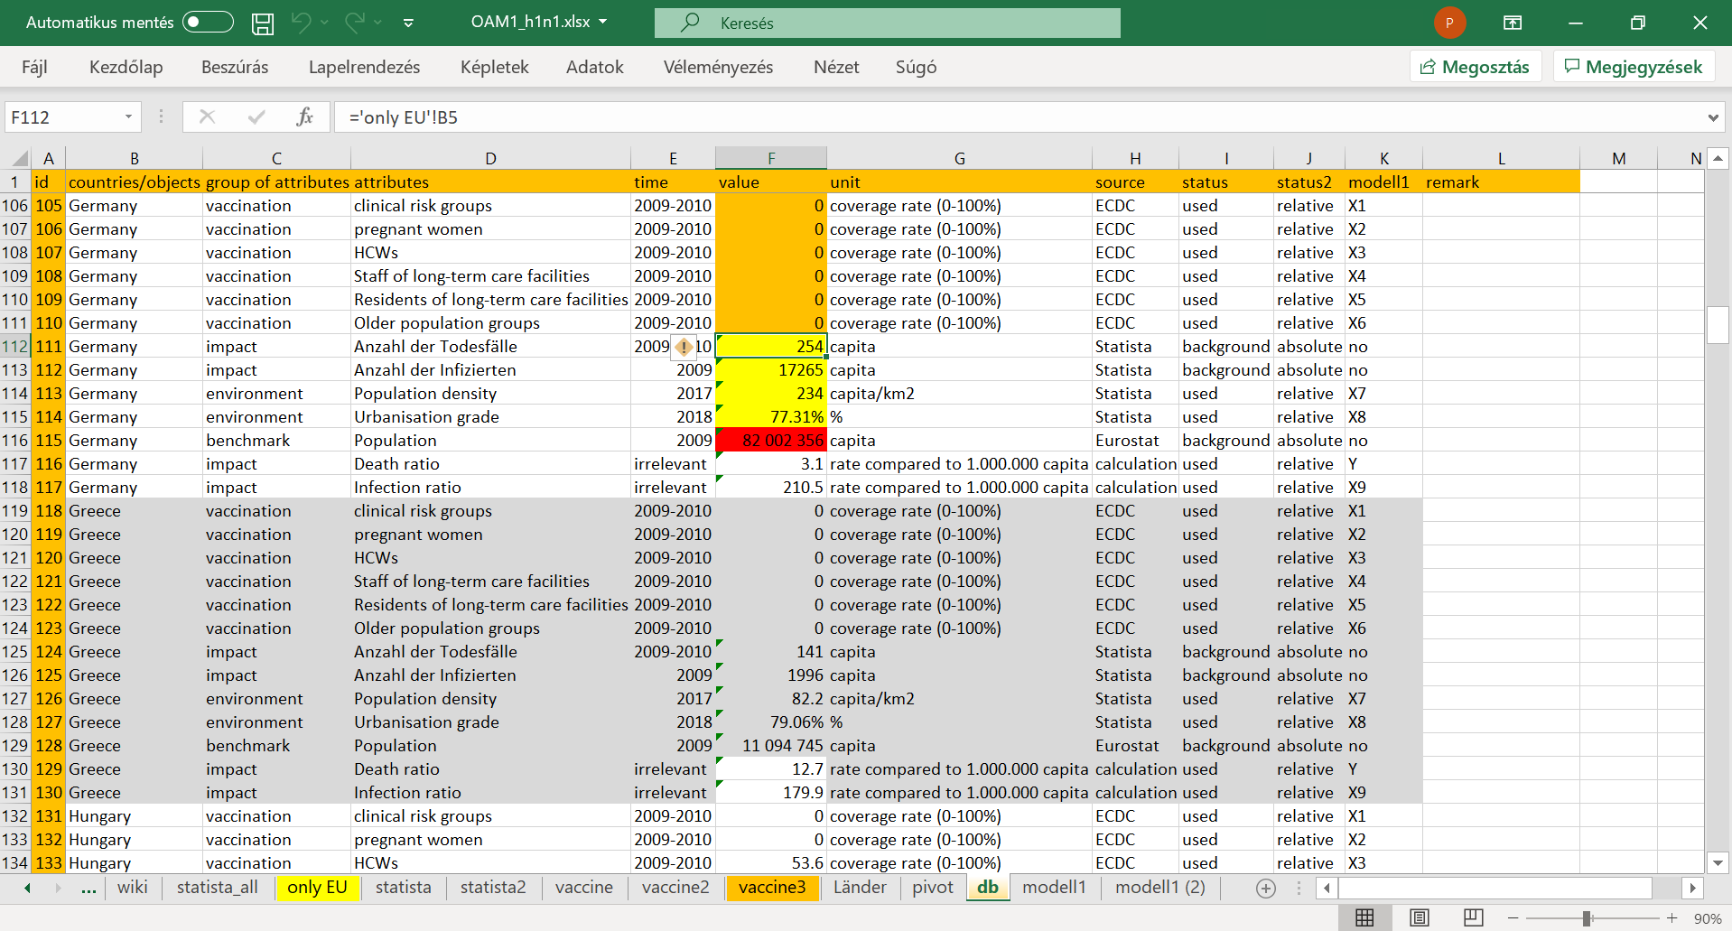  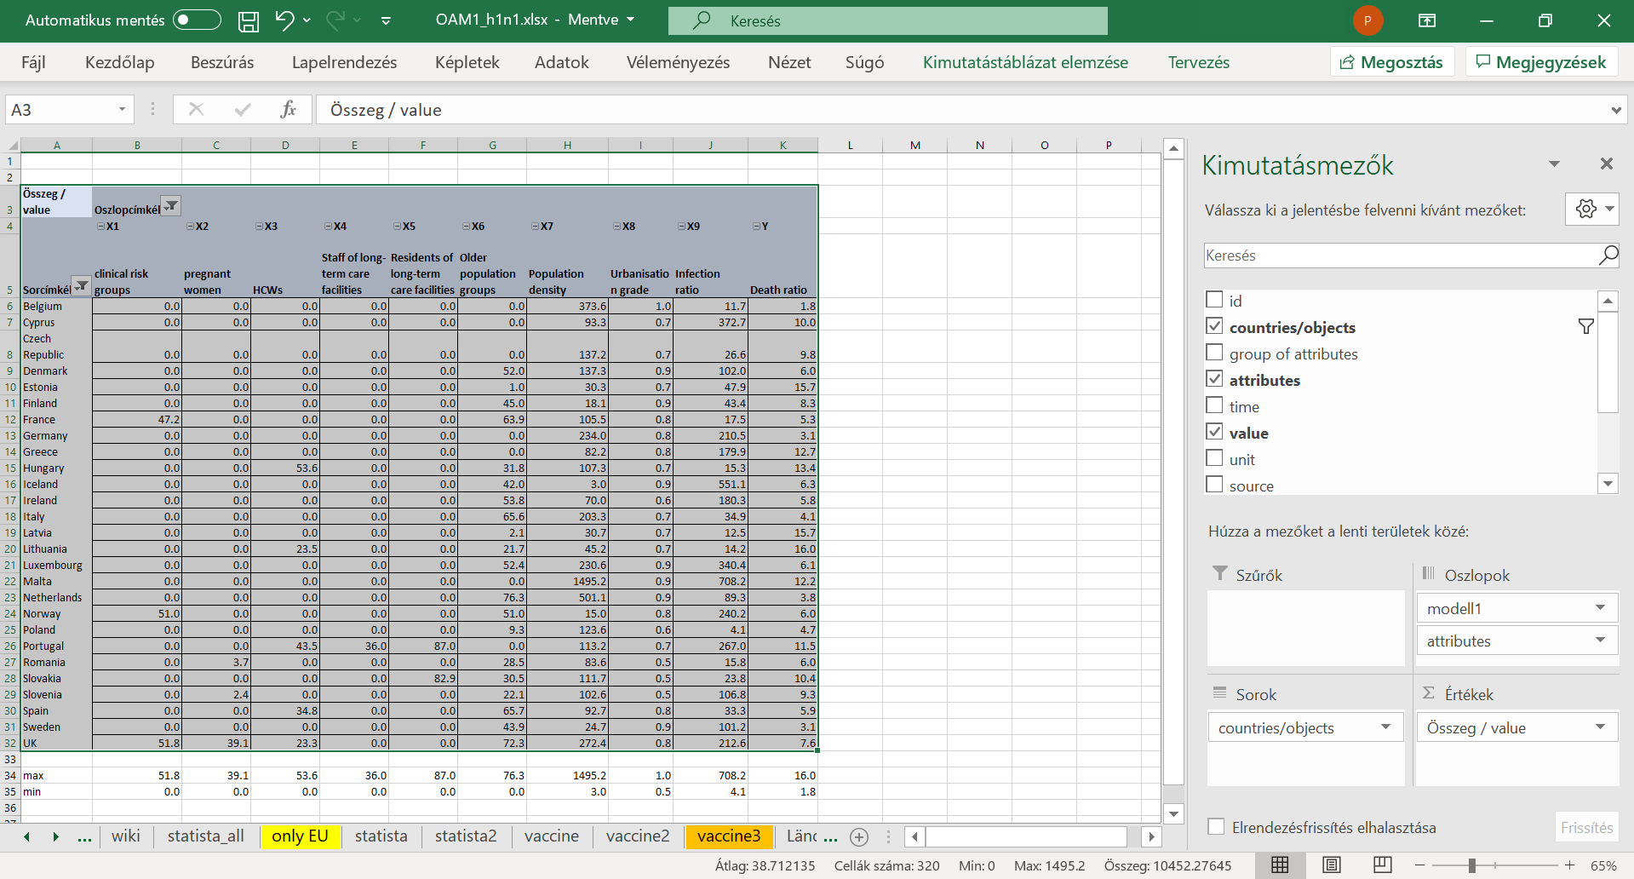

DENT | As I always do, I am trying to reproduce your idea, your instructions. It seems to be quite simple, mate! Even objects like Croatia because of lacking data can be excluded with a mouse-click from the OAM. The attributes can be placed in the expected position if you have a X-signs numbered. On the other hand, a kind of final checking is always necessary. For example, the maximum and minimum values for each attribute should be derived and interpreted. For an interpretation are definitions of the variables needed. In an ideal case, the ratio of the maximum and minimum values is limited.
XXXX | Please, watch the next video too, where the described phenomena can be detected…
CON | The previous video highlighted a lot of important steps of the quality assurance. For example: if we do not need the digits after the integer values, then these number should not be visualized. If we need a report, it is always to check, how many data unit are behind a cell. Here and now we may have only one raw data in every cell. If total and or subtotals are not necessary, they may not be visible. Maximum and minimum values should be checked. In our case, the density is realistic. The infection rate is critical. In general, for comparing we need relativized data instead of absolute numbers.
DENT | All right. Yet, I have new questions: What do you mean with the evaluation of critical in case of the infection rate? Besides, what kind of attributes got made invisible through the group of “no”? I could translate the German header-positions in this group, and I think, the no-group is the group of the attributes with the risky absolute values. The absolute values should however be collected to be capable of calculating the relative values – for example the number of infected persons divided by the number of the total population. Is this interpretation correct?
CON | Your interpretation about the relative and absolute values is correct. Good job! The data positions about the infection rate are critical because the maximum and the minimum values demonstrate a difference which can not be explained at once. It is important to know, that the number of infected persons and the number of the deaths are independent from each other in the logic of the statistics – unfortunately. Now, we come to a point what seems to be that important that we need a little bit more to talk about. Mr. Thor, what may be declared to this critical issue?
THOR | Well, the number of the infected person is never a good number. Only few people are tested in general. So, the real volume of infections can never be measured. The number of deaths is also a fuzzy number. The real causes for death can probably be derived through autopsy. But a person executing a bungie jump can have a heart attack although the rope will be cut by a killer so that the jumper will never know about this action. In this morbid case, the cause of the death will be the crash and not the heart problem.
DUCK | Now, short about a relevant part of our history: Winston Churchill once reportedly said that “the only statistics you can trust are the ones you have falsified yourself”. With other words: “I only believe in statistics that I doctored myself”. They mean - for good interpretations we always need exact definition about our attributes. Parallel, in an artistic performance, Vonnegut designed a table about the most important persons of the second world war – about Churchill, Hitler, Roosevelt, Il Duce, Stalin and Tojo. The next video presents a core message:  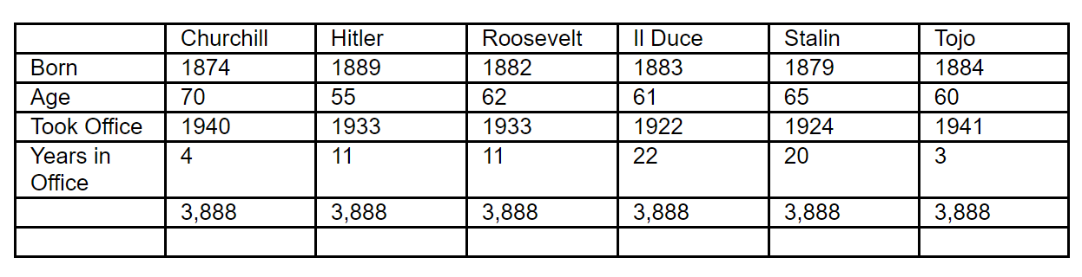

Persons | Messages of PART2a - …working with an OAM…
THOR | Well, we have now an OAM. This matrix is the key for the publication. The robot journalist does not have real competences in the field of statistics, epidemiology, etc. Yet, it was possible to identify relevant phenomena – it means attributes and objects – and data sources letting use them in an efficient way. The data could be structured at least in a manual way – but in optimal case based on the pivot wizard in Excel. The robot journalist is interested to derive questions and answers never existing before and being extreme for news. The OAM is the answer for each lack of human competences.
THOR | The OAM is a system – in general the OAM is a causal system. The independent variables are the causes for each change – it means for the consequences - concerning the dependent variable. Therefore, the potential questions were existing before the OAM with H1N1-relevant content could be filled. The OAM is a kind of closed universe supporting all human purposes concerning the attributes and objects of this universe. This universe is a system and therefore system-theoretically it means context free knowledge can be used to interpret it.
THOR | And before somebody ask me to stop with this kind of high-levelled magic of words and to present at last examples, I change my strategy on my own and I will demonstrate some general questions. These general questions are: Which correlation level can be reached based on flexible online robot analyst or with other words: based on online analytical tools? Correlation is an index value being capable of describing the similarity between the consequences and their estimations based on a model using the independent variables.
THOR | And you want surely and immediately to ask me that I have to use from now on just a H1N1-relevant terminology. Well, the question before can be translated into a context relevant form as follows: How close can a flexible model estimate the values of the death rate of countries based on all collected variable like vaccination rate of different groups, population density, grade of urbanization, infection rate? Your next remark should be at once: Why it is important to know whether the collected data are capable of a close enough estimating of the facts or not?
THOR | Well, the human and animal brains and probably the plants and one-cell-systems too, they do the same interpretation task since ever. And they do this based on the strong force fields of the evolution and selection step by step better and better. It seems to be at least so. Back to the focused H1N1 terminology and parallel to the recent situation determined through the corona virus pandemic processes, we need for rational, sustainable actions interpretations, models, simulation possibilities for the whole society and parallel for our own decisions.
THOR | Therefore, a model being robust enough based on the available data, leads us to further questions. Before they will be listed, it is necessary to highlight that this project about H1N1 can not use a real big-data background, but the modelling process is quite the same independent from the number of data units. The next very-very relevant question should be: when may be seen model as good enough or when is a model better than an other one? This learning material is not defined for answering this probably most interesting question. But the following URL is maybe a good starting point: https://miau.my-x.hu/miau/196/My-X%20Team_A5%20fuzet_EN_jav.pdf

THOR | The next interpretation level in case of a good model is, what kind of objects – here and now countries – can be estimated close enough and which produce extreme errors or differences between the fact about the death rate and the estimations about the same phenomenon? As you could see and hear, we have now the first extremity what our robot journalist should handle with. This is therefore a kind of thinking experiment which can be played, executed without real data.
DUCK | I think the next analogy could be helpful: If you tend to make a survey and design a questionnaire later then you should be capable of interpreting the expected data without seeing them. It means you must be capable of generating randomized answers concerning your questions and also capable of analysing them. Why? Because the analysing of the real data will inspire you to read interpretation into them. A consequent, consistent, existing rule system for analysing arbitrary randomized or real answers is protected from this risk. Ein system created before can not be corrupted through fresh data.
DENT | I think, you know by now that we need again examples. It is clear that the robot journalist got programmed based on the system-theoretical backgrounds. It is also clear that we human beings needs a kind of quite universal frame for our thinking experiments. But here and now we can see a classic antagonism. We are still not matured enough to make thinking experiments in an unlimited complex level, and parallel, in order to become more and more matured, we need the theoretical complexity. This is a power field to form our personality – if we “fight” with the challenges.

Persons | Messages of PART2b - …the first models…
THOR | All right, it is time to create our first model and parallel, we will also see the online analytical tool. You could believe me – this tool is “toll” if somebody learned German! Worth knowing: The Excel Solver is a useful add-on and the Solver is being capable of substituting the online tool - in a limited volume. On the other hand, Google spreadsheets can also involve online solver engines (like the NEOS server). Summa summarum: if you have a raw OAM and you also have a connection to a solver-based service – for micro problems it is irrelevant whether online or offline – then you can go on.
THOR | Fortunately, the usage of online services does not need any mathematical pre-knowledge. Online analytical engines could even be installed in smart phones because the only input they use is a ranked OAM. The raw OAM contains values with their identified or calculated units like population density in capita per square kilometre. A ranked OAM contains however integer values without any units where in case of each attribute only ranking values are stored in the OAM. Ranking values mean: the object having the highest or lowest value can have the ranking value No.1.
THOR | If you still remember, Dent spoke already about the types of relationships between independent and dependent variables. The-more-the-more approach can be re-defined for the ranking of the values of one single variable as follows: the highest value of a variable will have the ranking value of No.1. And vice versa: A the-less-the-more approach means – the lowest value of a variable will have the ranking value No.1. Ranking values have seemingly a reduced information value because the differences between the ranking levels will not be processed.
CON | May I interrupt you? On the other hand, ranked values are kind of standardized values with a lot of advantages. These advantages are for example: it is not necessary to use delimiters like dots or commas and digits after the integer values. Therefore, the X-part of the OAM can always be checked in a trivial way: the minimum value is always 1 – it means No.1 in case of each X-column. The maximum value of each X-column is the number of the objects. This logic makes the transferring of OAMs relatively easy and the volume of this data communication is as compact as possible.
DENT | If I understood you correct, then the ranking values and all advantages will only concern the so-called X or independent variables? Assumed an answer of YES, let us make a short thinking experiment: This standardization ensures therefore a kind of context free situation in case of each OAM. The same ranked OAM can namely be calculated or derived based on a lot of raw X-values. It seems to be for me as a new impulse why the robot journalist and the robot analyst do not need the context-interpretations human beings execute. Is this derivation or this logical way correct?
THOR | Excellent! You identified here and now one of the core characteristics concerning the robotizing. I should highlight again and again: the way to an OAM did not need any contextual interpretations as human beings do. With other words: the variables in an OAM will validate each other because these attributes are available online for the same object-set. And if the building of an OAM can be automated without human-like context interpretations then the using of an OAM should also be automated, and also without human-like context interpretations.
DUCK | The well-known analogue situation is the automated generation of the annual final reports of enterprises. These reports contain an OAM with 2 objects: previous year and current year. The number of the attributes is balance-dependent and quasi unlimited. The robots produce texts based on the values of the OAM. The logic of interpretations is pre-defined. For example: the profit is higher in the current year compared to the previous year. The increasing will also have percentual values. Such kind of reports can be downloaded in Hungary for each Internet user without any restrictions.
DENT | I think, this is clear enough. But we should also clarify what we have to do with the Y-values of the OAM? It seems to be trivial based on the previous declarations that the Y-values will have their single or common unit or with other words: they are quasi raw values even if they can be derived through calculations. In case of the H1N1-project: instead of the raw X-values of the calculated relative infection rates, we will have ranking values in the OAM, but the parallel calculated Y-values of the death rates will have the calculated unit – for example capita vs. 1000000 population.
THOR | I can confirm your interpretation about the raw or calculated Y-values with their own single unit. And parallel, this is the answer to the limitation of the context free characteristics. The ranked X-part of an OAM can belong to quasi unlimited real situations or contexts, but the Y-values are quasi the guarantee for the needed uniqueness. The Y-value can be seen as a kind of fingerprint. And now, the next presentation will demonstrate the first modelling steps in frame of the online analytical tool. This tool can be accessed with the following shortened URL:  https://miau.my-x.hu/cocostd
THOR | You know, in this phase of the co-operation, we will only use muted presentations in order to catalyse your personal interpretations. In advance, I have to say, that we will see the raw OAM with units and also the ranked OAM without units for the X-part and with a unit for the Y-column. The X-values are enforced integer values, and the Y-values are integer too but not ranked. We will see 27 objects – it means 27 countries of the EU. And we will also see the 9 X-attributes: 6 attributes about vaccinations and the population density, the grade of urbanisation, and the infection rate.
XXXX | Please, watch the next video too, where the described phenomena can be detected…
STEW | All right! All the theoretical aspects and the previous and recent presentations by you before about the X and Y signs and direction and by me about pivot tables can be matched. Yet, I have the question: Why did we need that long theoretical information if you said: we do not need any mathematical pre-knowledge for the usage of the robot engines? As a common citizen, I think, an application is then trivial, if we need hardly anything to use it. And we could even see: if we have an input matrix, then we can select it, copy it, and the results are immediately present.
THOR | Well, this is a new antagonism what you are focusing on here and now. Dent have already spoken about one antagonism before - concerning a kind of circular reference problem with becoming more matured and being more matured. Your remark let highlight one of the most important problem of the didactic: if I did not speak about something before, then somebody will me ask later to the topic - as a sign: you should have spoken about it. On the other hand, if I speak about something - let me say in a direct way - in advance, then your will be right to ask, why should we handle something that early?!
THOR | But it is time to see how the robot analyst can be used. The next presentation will be short. We will make a simple copy about the ranked OAM to the clipboard and we will insert our data into the input field of the robot. After clicking the run-button, the results will be present immediately. The results will have four layers. The first one is the confirmed task. The second part will be the model in the detailed form. The third part will present the model in simplified form. And the last, the fourth one will be the evaluation view where we can see the original Y-values and the estimated ones.
XXXX | Please, watch the next video too, where the described phenomena can be detected…

STEW | Okay! Then even back to the last presentation. We speak almost continuously about automation and robotizing. And the presentations are made with manual controls. I think it could be important for all of us to highlight, that even pivot table can be derived with macros. And macros are the source codes for Excel. Parallel, the usage of an online service can also be initiated based on a C-URL call where we can have parameters for the input matrix and of course for the needed online service. A C-URL-call can deliver as result the same view as before or even only that part what we really need.
THOR | Thank you for the relevant extension of the common horizon. The next presentation demonstrates even a C-URL call in order to deliver only estimation values for the starting OAM. We will see again how the correlation will be calculated and how simple it is to visualize country-specific colouring effects based on the differences between facts and estimations. The realized correlation value based on our manual-driven directions for each attribute led to a relatively low level - although the directions can be seen as correct based on the literature.
XXXX | Please, watch the next video too, where the described phenomena can be detected…
DENT | I think we do not have any other chances concerning the definition of our directions. It seems to be relevant to say loud out all directions and the arguments behind them: The more is the rate of the vaccination in case of each risk group, the less should be the death rate - because the vaccination makes possible: to increase the robustness of our immune system. And parallel, the more is the population density, and the more is the grade of urbanization, the more should be the death rate because of increased infection risks. And finally:
DENT | And finally: the more is the infection rate, to more will be the death rate compared to the total population. It is therefore not really clear, why we do not have a higher correlation level – it means a better model? With other words: do we have any chance to visualize what kind of relationships or even directions between each X and the Y will lead us to a better model? I know that we have already declared that our collected data are probably not that correct. From an other point of view: when may we say: we have wrong data?
XXXX | Please, watch the next video too, where the described phenomena can be detected…
DENT | Because we can see, that five from 6 vaccination-variables do not the expected impacts, especially they could not be involved into the model in a way what our pre-defined directions declared. The third and the fourth layer of the model about the simplified model-parameters demonstrated through the previous figure that the vaccination quasi in general can not be seen as a kind of prevention. On the other hand, we know, that vaccination needs its time and vaccinating in the middle of an infection wave should not lead to expected impacts at all.
CON | Excellent interpretations and questions! It is always a great pleasure for me to see and hear that the quality and or risk management can also be important for the new generations. All these questions will be answered in the next presentations where you will see a simple and a general trick how we can enforce new relationships between each X and the Y based on the same online analytical engine. The simple trick is to use doubled directions. The general approach is exploring through the online engine itself, what kind of relationships could be existing at all.
XXXX | Please, watch the next video too, where the described phenomena can be detected…
CON | As you could see, a model with both direction in case of each X-variable led to a significantly better model. The expected impacts could partially however not be confirmed. The R^2 is already high enough. As far as the expected directions are concerned: these may not be generalized that easy because the generalization is against the Liebig-principle. Proportion-oriented types of relationships between an X and the particular Y is mostly valid in bubbles. It means: to see the expected impacts of principles there are preconditions necessary.
DUCK | And it is now my turn: we need namely an example. Everybody knows that the gravitation is given overall. Therefore, the water should be run from the top towards the bottom. Yet, we also know about capillary force fields where the water (although the gravitation is always given) can flow from the bottom to the top. Concerning the Liebig-principle, there is a well-known interpretation: How many waters can be filled in a barrel where the side-panels have different length?
DUCK | The general answer is the shortest side-panel is relevant. The fine-tuned interpretation is more tricky: the previous rule is only valid, if the barrel stands ant does not lay.  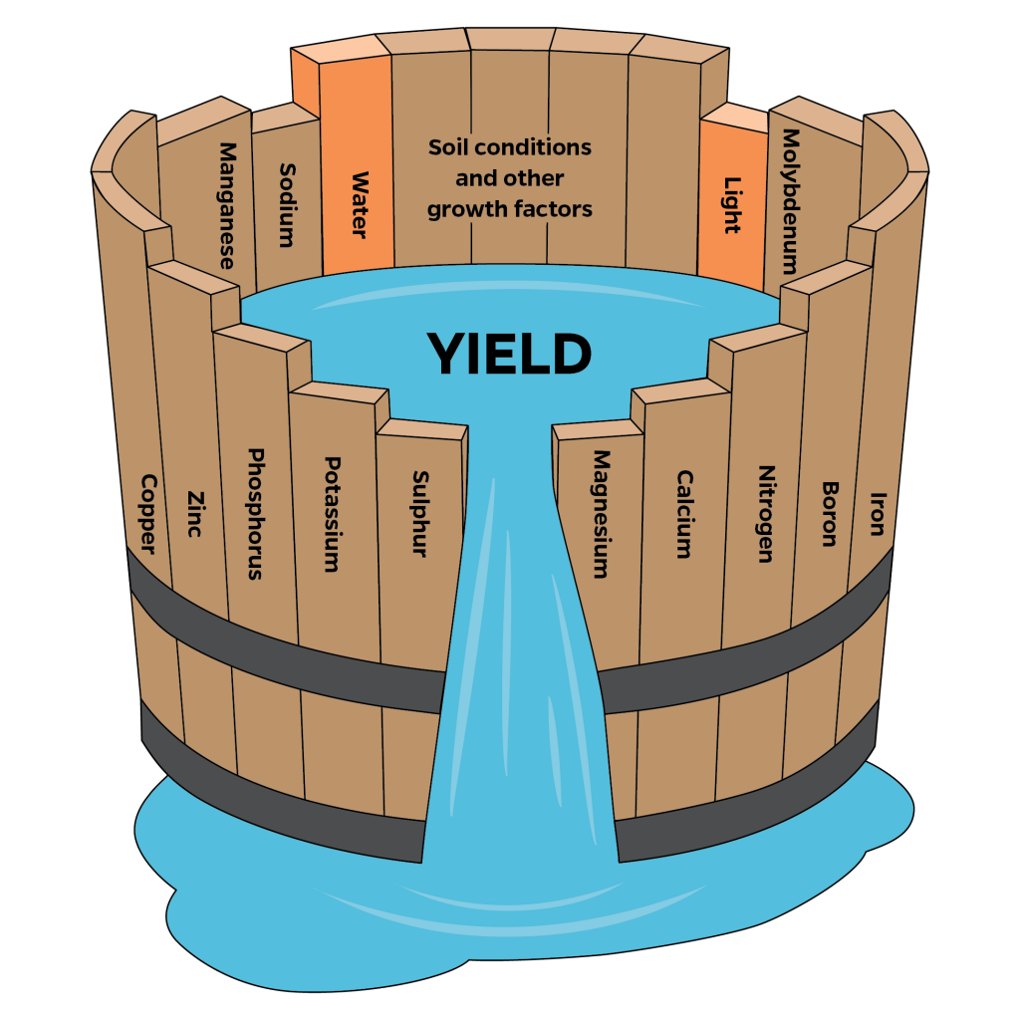
CON | As before promised, we have an other way to explore the relationships between each X and the Y variables. The explorative modelling can also be executed with one of the previous modelling tools: MY-X FREE - COCO, it means component-based object comparison for objectivity. For an exploration process it is necessary to reduce the resolution of our OAM. We have 27 objects, but we will only enable 7 levels – circa 4 counties will build a group in order to see a set of simplified relationships.
XXXX | Please, watch the next video too, where the described phenomena can be detected…
CON | Relationships can be monotonic or even polynomial – it means wave-like. Strong wave-like relationships are mostly risky – a sign of misunderstandings or unexpected complexity. If we had 27 objects or impact levels, then the potential relationships can be very different. If we only had 3 levels, then the number of the basic relationships will be very limited. There will be a few – maybe strict - monotonic and a pair of optimum-oriented.
XXXX | Please, watch the next video too, where the described phenomena can be detected…

THOR | Let us summarize the core messages of these presentations: you can double the number of the attributes based on your logically derived – it means direct – directions and based on the so-called inverse directions. This kind of doubled setting can be seen as a kind of question: What is the stronger direction in case of an attribute – the direct one or the inverse one? The general trick works without directions. The more flexible or more polynomial a relationship is the higher can be the correlation value. The wave-like relationships can also be seen as a kind of randomized relationship.
DUCK | It is important to highlight: the online analytical engines did not need any headers: neither row-headers about the affected countries nor column-headers about the involved attributes. This is a kind of evidence for the existing of the context-free approaches. And parallel, the cloud-services like the online engines will never know about the real content – the calculations will however be delivered. Therefore, the results will only contain general headers like X1, X9 or O1, O27. For further interpretations we will use these headers, but these header-names will only be used as alias or tag.
DENT | I think we already have two problems solved. We have seemingly high enough correlation values. It means we can declare that the death ratios could be approximated in a rational way. Parallel, we could see, which X-variables have an other relationship to the Y-variable than expected. A high-correlation-model makes possible to speak about good, norm-like and bad countries. Good countries have a higher estimated death rate than in the statistics. Therefore, they could save life because the death rate could have been higher. In case of the bad countries, the relations are mirrored.
DENT | All these results seem to be enough to start with writing of a case study. The core messages are derivable in simple ways. We will highlight the good and the bad countries with the formulation where is worth living or being ill and where it is relatively risky. On the other hand, we will write about the relationships of the X-variables concerning the Y-variable as follows: the vaccination levels seem to have an unexpected impact mechanism. Therefore, the H1N1-vaccination seems to be irrelevant in general based on this data-driven approach and this too was already assumed, meant, said earlier.
XXXX | 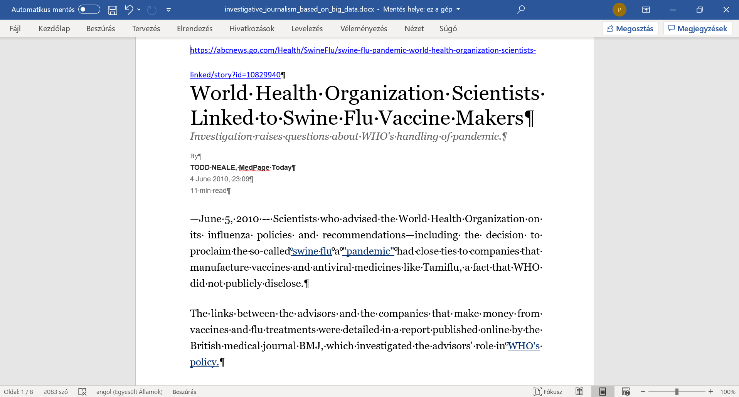

Persons | Messages of PART2c - …the article/case-study/publication…
THOR | Well, the summary of Dent can be used for the planning of the publication. Now, we know at last what kind of core messages we want to publish. So, we can derive a good title – maybe an appropriate subtitle. We can also create a kind of lead-text or abstract. We will also be able to declare a few keywords. The chapters can be the standard chapters like introduction, literature, data assets, methodology, results, discussion, conclusions, references, annexes. We have to estimate the proportions of the chapters and also the ration of figures and texts in advance.
THOR | It is also important to go back the our robot journalist. The robot journalist are we ourselves. What we can do in a proper way, that can also be executed by the robot journalist. The Knuth’s principle said: Knowledge is what can be transformed into source code. If we do something then this action should always be checked in details, whether we are capable of programming it. And now, I have to introduce Doctor KUN. Doctor KUN will be your new conductor on the field of writing publications. Doctor KUN has an extrentric personality. Doctor KUN speak very compact – very-very compact - believe me.
THOR | Doctor KUN will produce step by step – what else as - a minimalistic version of the H1N1 article where in case of each involved text, sentence, chapter or even image will also be a kind of argumentation delivered in order to increase the feeling that the activities of robot journalist is not an artistic challenge. It means the Knuth’s principle can also be realized in case of the writing as such. Doctor KUN is not against the magic of words. Doctor KUN just tries to find an optimum concerning it. Doctor KUN – it is your turn from now on:
KUN | Hi! I am KUN. I never use commas. My sentences will be short. Why? Computers need clear commands. We can use them too. Others speak longer. Maybe they are not sure enough. I mean what to say exactly. I am sure. It is just a question of training.
KUN | We will have simple steps. Step No.1. We need a title. A good title is relatively short. Our title will only have two words. H1N1 and scandal. A robot journalist is always careful. Questions can not be harmful. A question mark is a good solution. Solution for being fuzzy enough. The title is: H1N1 – SCANDAL? The title can generate a lot of associations. The curiosity of the Readers will be given. H1N1 is not a person. H1N1 can never start a legal process.
KUN | Step 2. A subtitle is always useful. A subtitle can highlight new aspects. Our subtitle will focus on AI and big-data. The subtitle must not be short. The subtitle may not need too long space. The subtitle will be: …proving former suspicions - based on an artificial-intelligence- and a big-data-driven approach… The author is the Robot Journalist. The organisation will be the MY-X team. The MY-X team is an Idea-Breeding-Farm. We have already the first view of the article.
KUN | Recommendation: academic writing skills should be learned. A short version can also be found on the MIAU-server. The Hungarian version can be translated automatically in the browser. Unfortunately, the alert-texts will not be translated in a direct way. These text pars can be translated in a manual way through the Google Translator. The alert-texts contain argumentations about the good or bad options.
KUN | Step 3. The keywords can be set in different ways. There can be some standard expectations. These standards prescribe the potential keywords. And you can only select a pre-scripted number of keywords. The other way is more flexible. Each word of the title and subtitle can be seen as a keyword. The words of the abstract also deliver keywords. The useful synonyms/associations will therefore be used as declared keywords. Our keywords will be: corona virus + prevention + suspicion generating + robot analyst + automation. These keywords may not be involved into the abstract.

KUN | Step 4. The abstract should be able to transfer the core messages. First part of the abstract: The vaccination should have preventive impacts in general. This prevention can be re-formulated as follows: the more is the ratio of the vaccinated persons the less should be the death rate. An explorative or AI-based model should therefore have parameters describing this relationship exactly in case of each risk groups. If the models will not reflect this expectation then the preventive impact is not valid from statistical point of view. It does not mean that the vaccine as such is not effective.
KUN | Second part: The production function between causes and consequences let derive an evaluation for each country. This evaluation means where is worth living – where is the life safer compared to other EU-countries. The model can also support simulations. The simulations deliver answers for the following questions: How would be the death rate in case of any changes of the independent variables? The developed results let declare following statements, presumptions: the preventive impact could not be validated! 9 of 27 countries have a relatively low safety: GR<EE<LV<FI<DK<LT<CZ<LU<SI
KUN | The first part of the abstract describes a thinking experiment. This is an operative one. This experiment has immediately an interpretation layer. Without real data! Like in the ideal case of questionnaires. Please, repeat the part 2a! Professor Duck’s first example! This interpretation is a simple rule. Model-parameters can not be set in an arbitrary way in case of real data. The second part of the abstract uses already the context-depending keywords. Here will be spoken about the EU. More exactly about 27 countries. An attribute is also defined. The consequence variable is the death rate.
KUN | The second part declare two results: the preventive impact of the vaccination could not be validated. And there is a risk ranking for countries. The most risky countries could also be visualized. Potential critiques concerning the abstract: The independent variables should have been listed. The excluding of Croatia should have been explained. The group of risky countries could have been characterized more precisely: e.g. they are relatively small countries. Altogether the abstract is able to generate curiosity for further details. Yet, the abstract is true. The abstract is not too fuzzy.
KUN | There are two approaches how to create an abstract. The first one could be seen till now. This is the so-called free-style approach. Texts can be created without any limitations. The full text should not be existing before. The second type is the citation-based approach. New sentences may not be created. The most relevant sentences of the finalized article should be quoted. The second type needs therefore the full text in advance. The generation of citation-based abstracts could already be derived - years before through Microsoft Word in an automated way.
KUN | Step 5. Chapter - Introduction. The introduction has to clarify: Why it is important to write about the topic for the society and for the author? What are the targeted groups? What are the objectives? What kind of utility can be expected after reading the article? It is preferable to have subchapters for each relevant part. Subchapter – Basic information. Subchapter – Objectives. Subchapter – Targeted groups. Subchapter – Expected utilities. Subchapter – Personal motivation.
KUN | Subchapter – Basic information. It is useful to define the most relevant keywords like H1N1 as such – especially as a previous pandemic situation. Other relevant keywords are artificial intelligence, big-data, suspicion generating, automation, robot journalist, etc. The Readers should have the chance to identify the aspects of the authors. It is not really good to explain unnecessary details. Only short definitions are needed. These definitions should be existing in order to better understand the abstract. More details can be offered in form of a footnote.

KUN | Important remarks: each relevant sentence should only be used on one single place of the article. It is possible to move one sentence to an other place later. Repetitions are not necessary. An article is not a learning material or not a political speech. An article is a declaration. An ideal article should ensure reproducibility. An article has not to convince anybody. The chance of the reproducibility is the only validation of the declarations in the article. An article of a robot journalist is always reproducible. Being programmable is the reproducibility as such.
KUN | Subchapter – Basic information: “Influenza A virus subtype H1N1 (A/H1N1) is the subtype of influenza A virus that was the most common cause of human influenza (flu) in 2009” – according to WIKIPEDIA (end of March 2020). In case of almost each governmental decision, there are suspicions. Suspicions will be handle based on the legal ways. Legal ways use the magic of words. Here and now, suspicion generating will be demonstrated based on a big-data- and artificial intelligence-driven approach. This approach can be automated. Therefore, this article can be seen as a product of a robot journalist.  
KUN | Subchapter – Objectives: The goals of the article are simple. To identify structured data about H1N1. To model death rate based on nine independent variables: like vaccination rates of six different risk groups, population density and urbanisation rate, and infection rate. To derive impacts of the independent variables to the consequence variable. To compare impacts to the expectations. To estimate death rate for each involved country of the EU-28 where Croatia should be excluded because of lack of information. To evaluate estimations and fact in order to see which country is safer.
KUN | Further goals are to have steps of data collecting, modelling, analysing in a reproducible form. Besides, to conclude in an automated way based on a prepared interpretation rule set without any human influence after involving the real data where conclusions were searched for existing prevention impacts and the difference of estimated and measured death rates of the countries. Parallel, to use solver-based online analytical tools for exploring relationships between the death rate as dependent variable and each independent one.  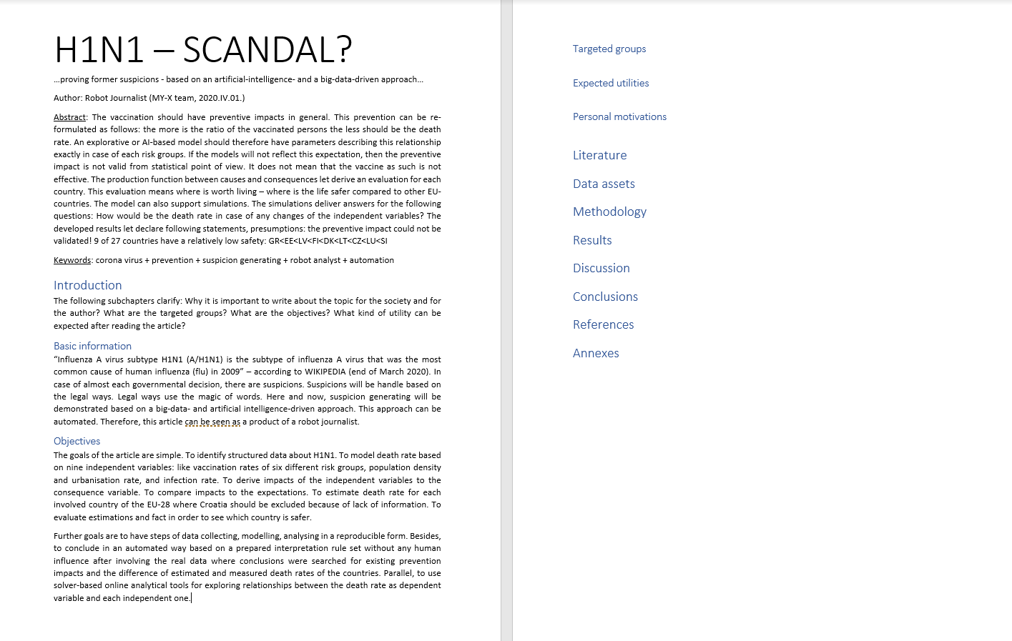
KUN | The objectives should be interpreted as orders or milestones. Each objective should be checked by the authors and the Readers. The objectives can also be seen as a check list. The objectives are promises. The objectives may be context-free. The objectives are however mostly content-oriented in a direct way. The reasons leading to the objectives must not be interpreted in the subchapter – objectives. The argumentations should be presented in subchapter – expected utilities or subchapter - targeted groups.
KUN | Subchapter – Targeted groups: Investigative journalists work on suspicion generations in a professional way. The suspicion generation should also be driven by legal experts. The robotizing of this activity is important of the entire society. The robotizing brings more efficiency and more objectivity. A good presumption is trivial or self-evident. The proofs and the whole logical can immediately be interpreted by the Readers. The suspicion generating process must be reproducible. The logic of an evidence-based suspicion generating process must be existing before the needed data are available.
KUN | Subchapter – Expected utilities: The most trivial expected benefit behind the automation is the increasing the efficiency. Efficiency means what kind of impact can be expected concerning a given volume of resources. The articles about possibilities of robotizing supports shifting paradigms especially in case of relevant phenomena like the corona pandemic process or even the predecessor – the H1N1 process. The credibility of the global process can not be evaluated based on personalized experiences – only on statistics and system theoretical approaches. The same is valid for the global warming.
KUN | Subchapter – Personal motivations: The article tries to demonstrate in case of a closed pandemic process what kind of controls should always be executed. The consequences of the H1N1 database should be transferable to the pandemic process caused through corona virus infections. The Industry 4.0 strategy it means the robotizing is valid for each segment of the human life. Valid therefore for the suspicion generation. Valid for the investigative journalism. Valid for the teaching and learning strategies as such.  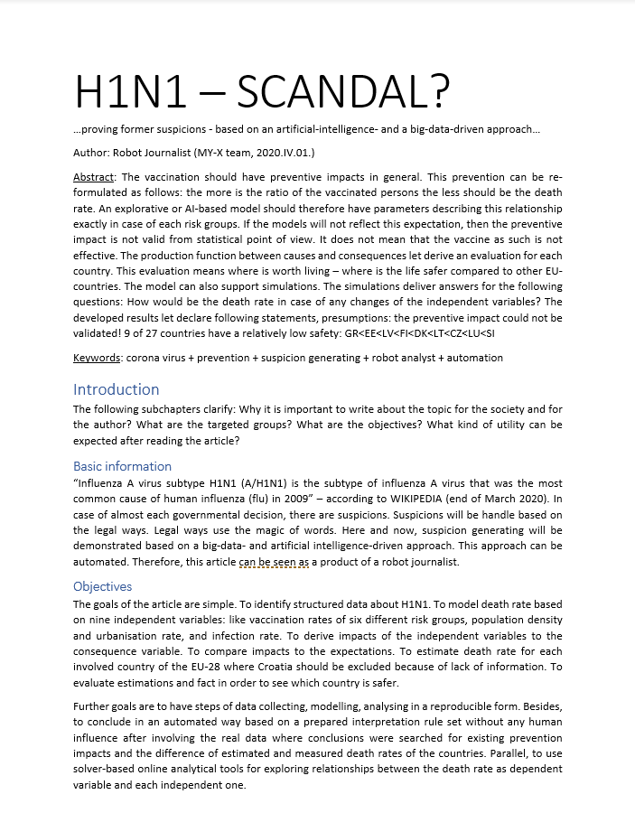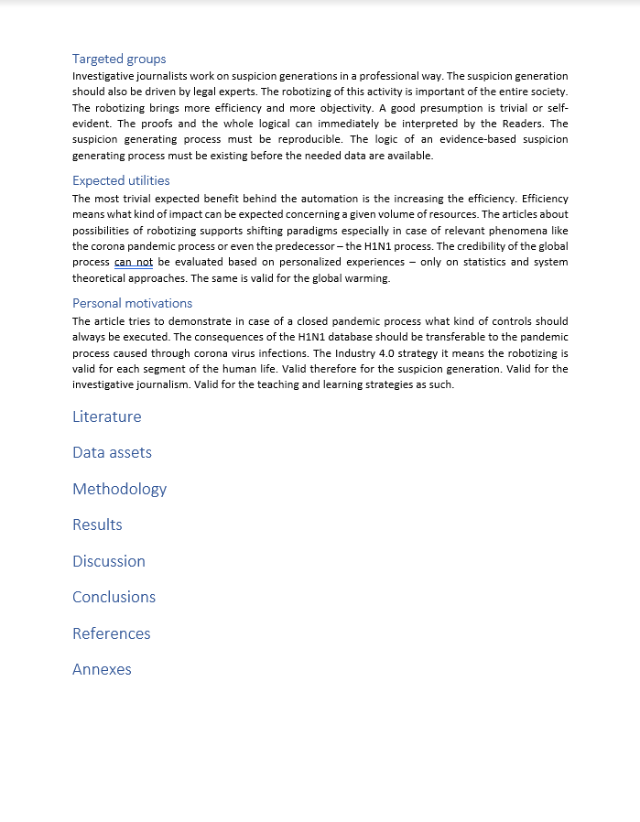
KUN | Chapter – Literature: This chapter should mostly deliver citations. These citations should demonstrate a kind of status report. What did others, when and how? What are the well-known problems? What can be expected in future? It is enough to find one single sign for a problem. It is not necessary to have a statistical view. It is important to work with qualitative sources. Qualitative sources are reproducible. Each other source is only a subjective opinion. The most sources are subjective opinions. Subjective opinions are products of the magic of words. Interviews are always subjective.
KUN | Chapter – Literature: It is important to comment each citation. The comments should describe why it is important to quote a text in the article. Citations are like images. They deliver information without comments. But they can be better understand with comments. Comments may not be transform the original meanings of the quotes. Comments may only highlight the relevant parts. The exact URLs and timestamps for the citations should always be present. These data are part of the reproducibility. Each processed data should be available behind a publication.
KUN | Chapter – Literature: It is not relevant who is the publisher. The cited publication must be correct. Publisher can support the quality management. Publishers do not however create content. Quality management means to ensure the reproducibility. But reproducibility should be ensured through the cited publication itself. It is not relevant how many publisher publish the same content. The quantity becomes never quality in this case. One single no-name server and a no-name author is a good source if the reproducibility is given.
KUN | Chapter – Literature: If the potential literature can not be evaluated as a reproducible one then the own article should be reproducible. The suspicions of the non-reproducible sources should be proven through the own article. The non-reproducible sources can not be seen as sources of proven declarations. Non-reproducible sources can only contain ideas, associations, intuitions. The expected reproducibility has limitations. If all data can be identified then it is not expectable to validate the used data like in a legal process. But the plausibility of the source’s data should be checked.
KUN | Chapter – Literature: This chapter are mostly used to pretend a kind of consensus. Pretended consensus means we try to legitimate our declarations based on quotes from so-called famous authors published by famous publishers. Reproducible publications do not need however pretended consensus. The reproducibility as such is alone responsible for validation – not the name of the authors, publishers. Robot journalists will never have names and a subjective credibility. Robot journalists will always and only be evaluated through the reproducibility of their performances.
KUN | Chapter – Literature: Based on all these expectations – we only need an URL about a potential source with critical aspects. A few sentences quoted from this source about potential critiques. All these will only be visible in the article itself. And one single focus point written by us: This article of a robot journalist will present the reproducible way, how a big-data-oriented and artificial intelligence-related robot investigation can be processed by each Reader/Student/Teacher/Citizen.  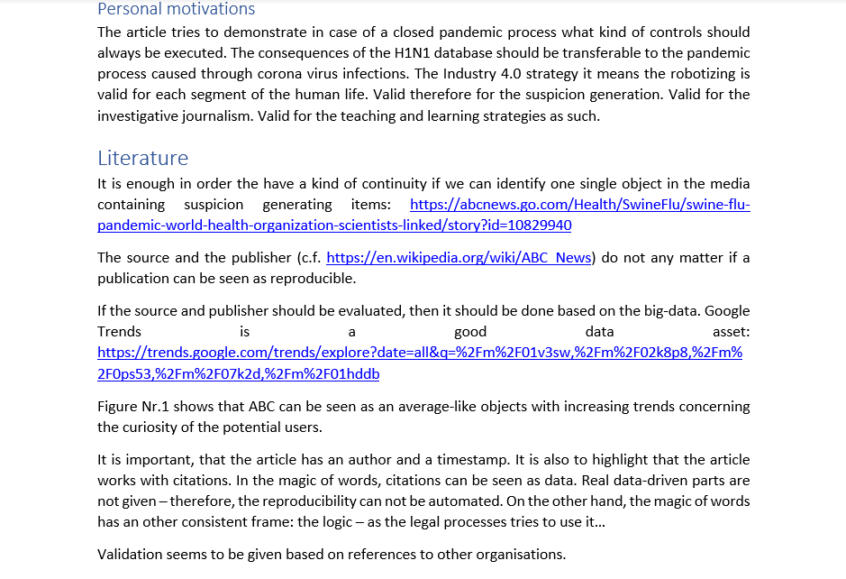  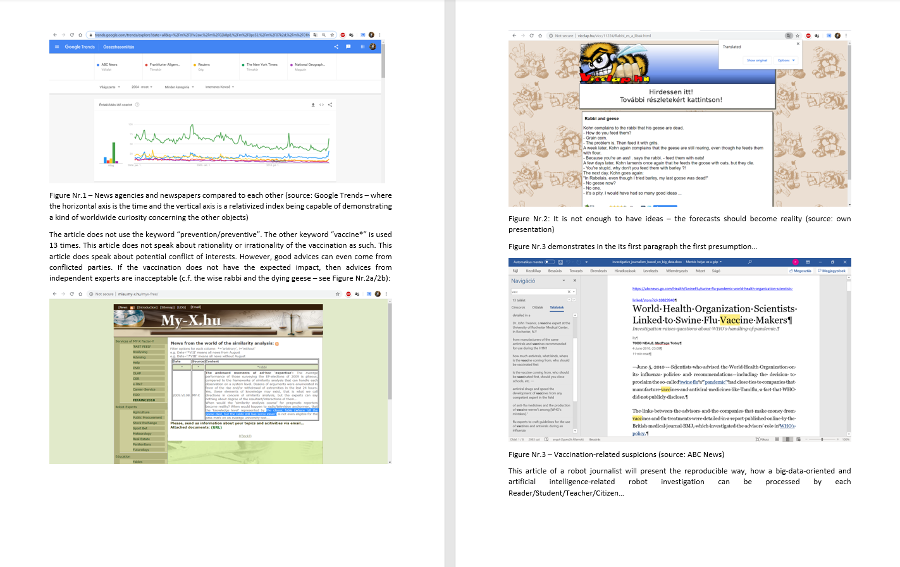

KUN | Chapter – Data assets: This chapter should be strong informative. We only need a list of URLs where the used data can be downloaded. We need a short argumentation why these objects and attributes are adequate for deriving suspicions. We use then qualitative data if the source documents contain definitions, units and interpretation intervals about the variables. In case of values, an interpretation interval can be described through the rational acceptable maximum and minimum values. In case of alphabetic or alphanumeric content, the interpretation interval prescribes the potential options.  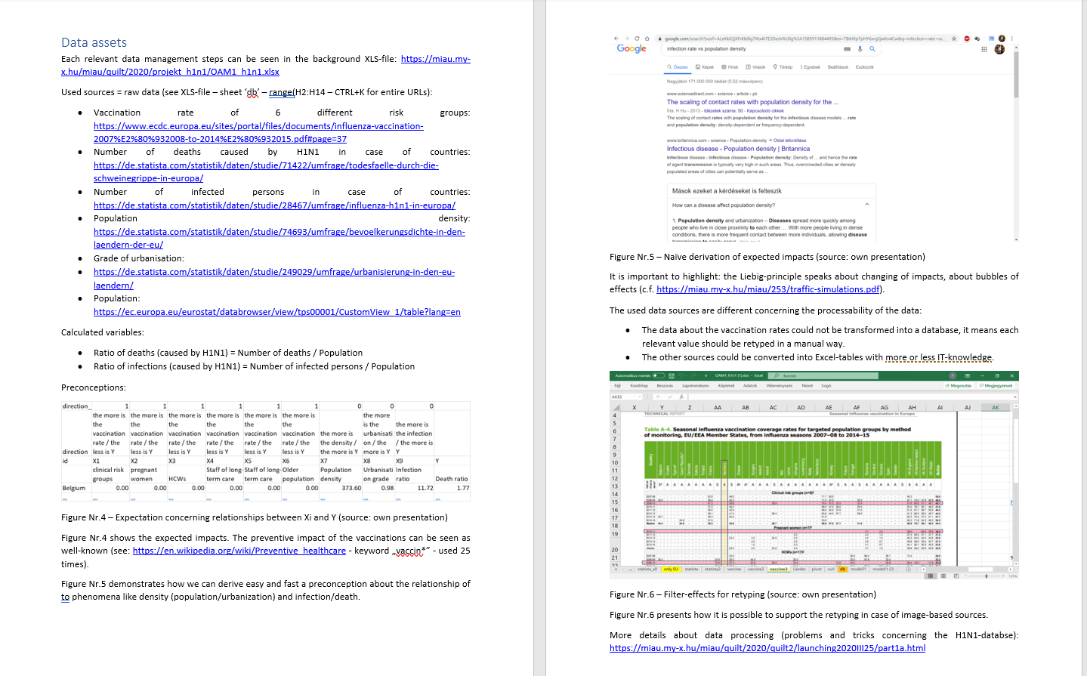
KUN | Chapter – Methodology: Big-data alone are mostly not enough to perform a proving process. Of course, there are simple situations where a fact is an evidence. For example: Do have expert of an international organisation contracts with business-oriented enterprises? Potential answers: yes or no. In case of one single existing contract, the relationship between a theoretically independent expert and the business world is given. Transparency is therefore the most trivial evidence-generating force field. Transparency means making visible each relevant fact. Rules should always be concern facts.
KUN | Chapter – Methodology: The data processing steps should be described in a reproducible way. It is important to ensure that everybody can repeat the whole calculation process. Each raw data should be available. Each relevant parameter of the modelling should be given. Each parameter should be interpreted: Why these particular parameters are necessary? The interpretation rules of the results should always be existing before real data will be processed. Interpretation rules should be independent from the particular data set and they should be used frequently for similar data sets before.
KUN | General remarks: Concerning data asset and data processing steps, it is to expect, that the steps of the authors are the same as the steps in case of arbitrary other authors. This is the basic principle of Kazohinia! Everybody should act so that she or he could never make critiques concerning these (own) actions from point of view of each other human being or role. This is the principle of the universal proportionality. Transparency supports to detect trivial lacks of this proportionality. Model-based suspicion generating process are the automatable forms of ensuring transparency. (https://en.wikipedia.org/wiki/Kazohinia)    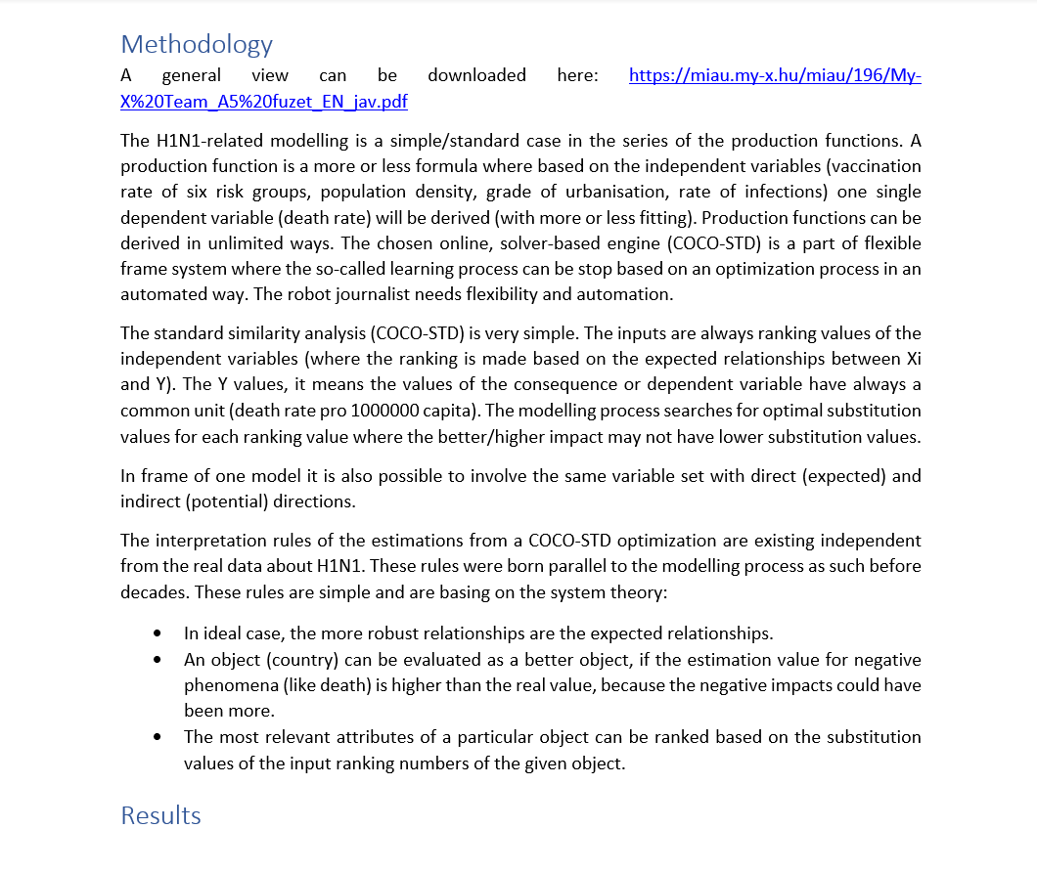

KUN | Chapter – Results: The results may be quasi textless declarations. Of course, the figures, their legends should always be detailed enough. But more interpretation is not needed. The results should be capable of delivering trivialities. The demonstrated results should be interpretable based on the already declared rules. This is the guaranty for a context free interpretation and the automation. It is useful to integrate specific visualization effects (like colouring or inverting). The numeric elements of an interpretation rule should be defined exactly (c.f. correlation).  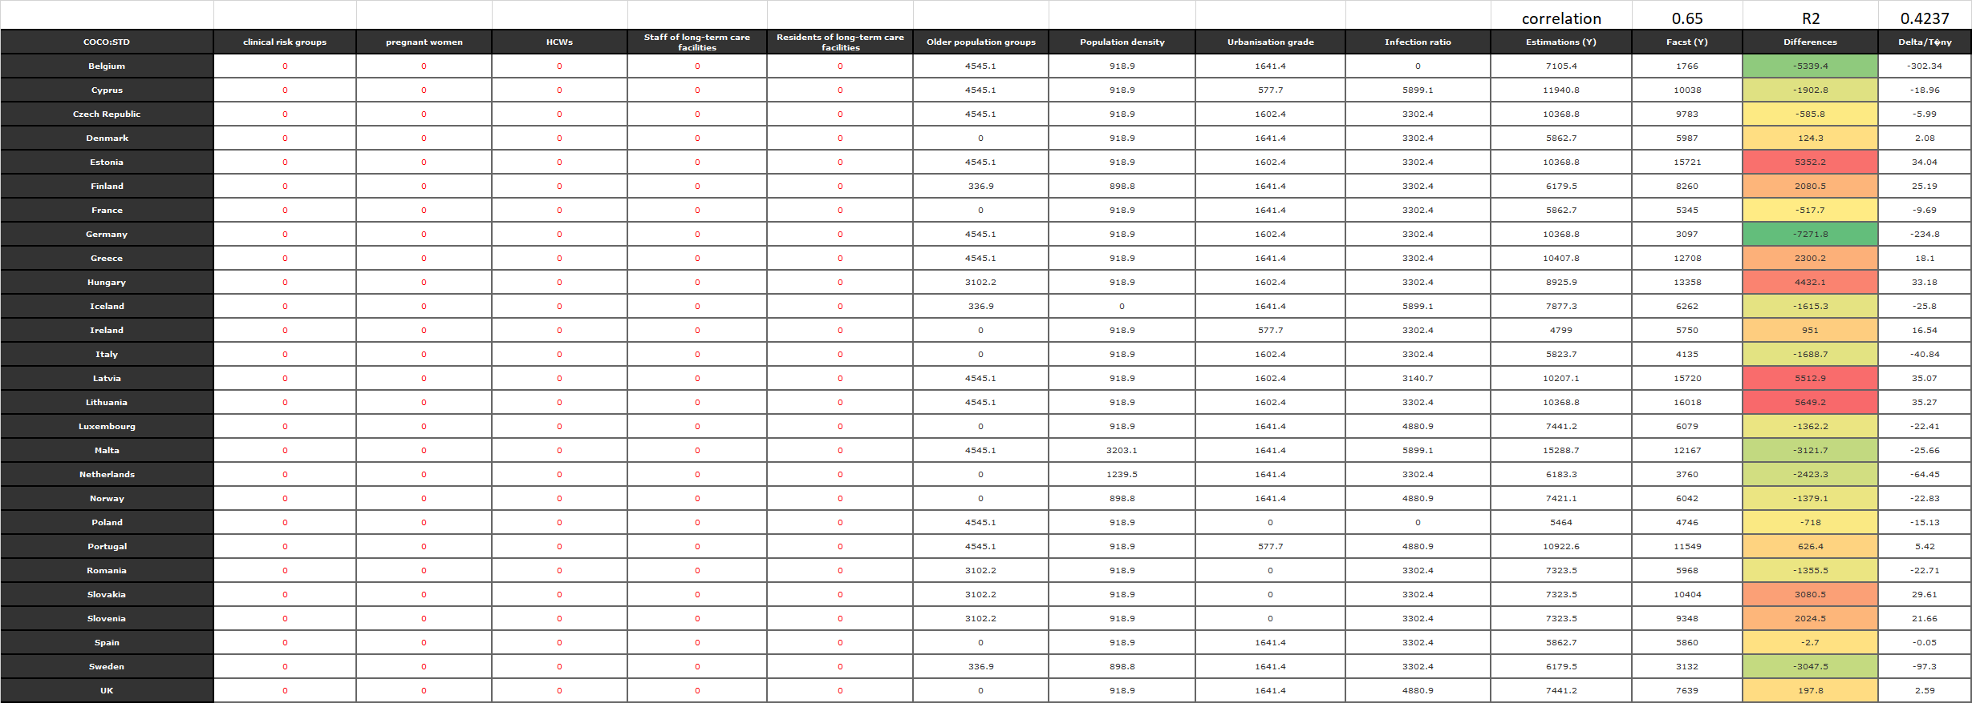  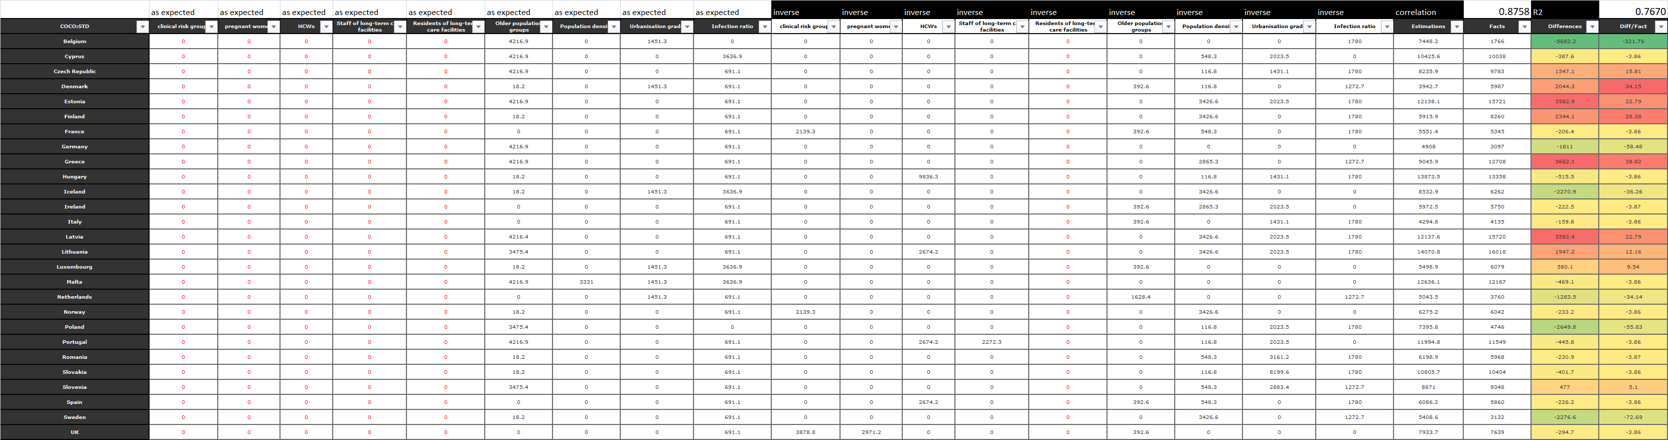  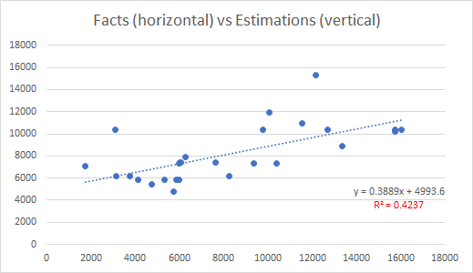  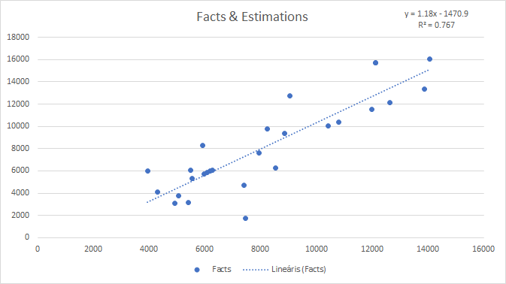  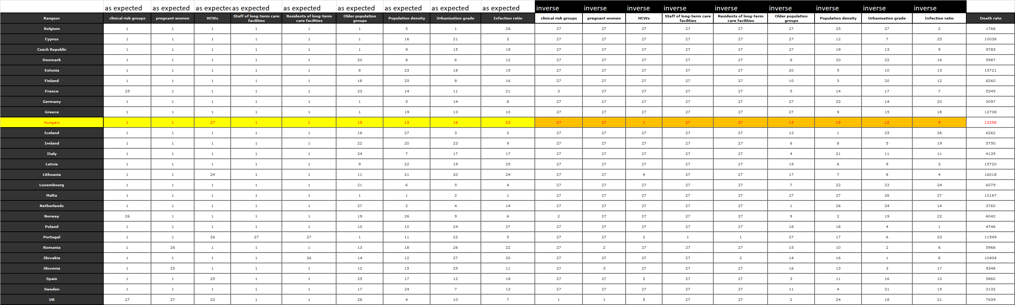  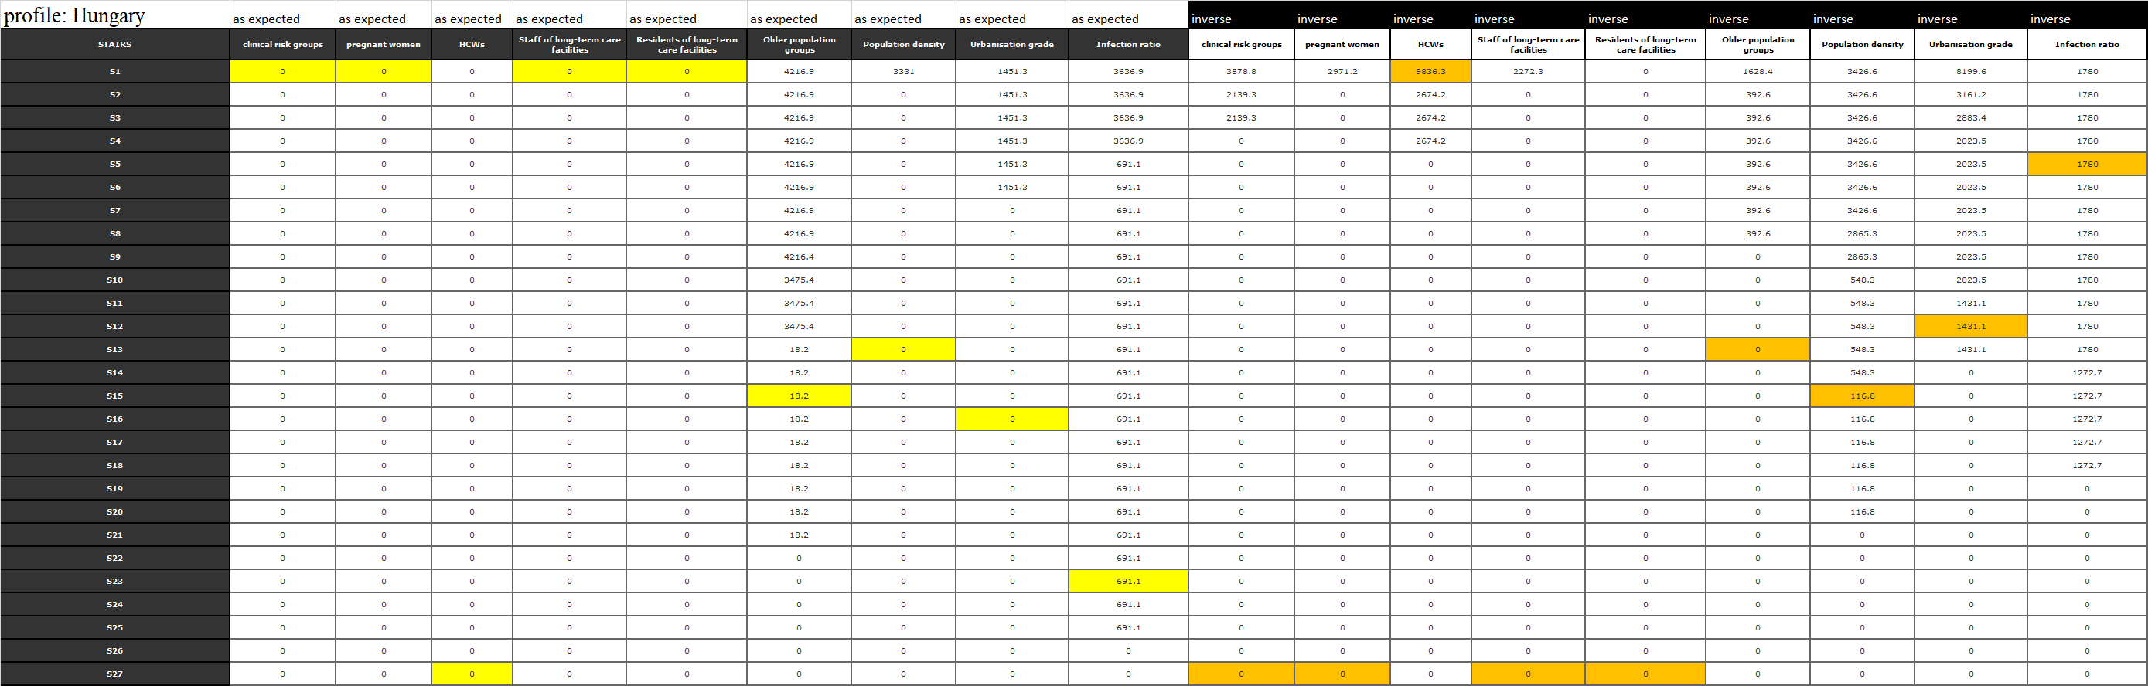  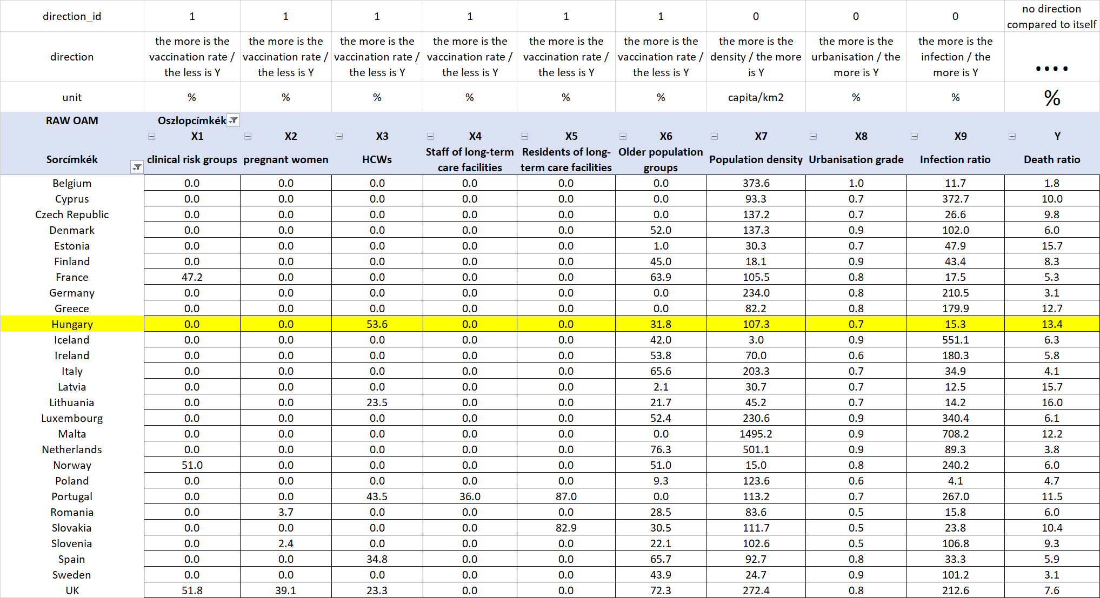
KUN | Chapter – Results: The more flexible model with doubled attribute set is close a high benchmark where the correlation is ca. 0.9 and the R2 is therefore ca. 0.8. The model with the expected relationships between each X and the Y is not robust enough. The preventive impacts could not be derived – neither in the model with expected relationships nor in the model with the doubled attribute set. The model parameters have a constant value of zero where we need higher values in 5 cases of the 6 vaccination variables. Expected relationships in a pure form can not be detected.
KUN | Chapter – Results: The countries can be ranked based on the differences between the estimated and the published death ratios. The ranking can involve the absolute difference of the estimated and published death ratios and the ratio of the relative difference (divided through the published data). The latter one is a kind of specific standardisation – compared to the reality. The same absolute values may not have the same interpretation because the published facts can be very different. The coloured backgrounds of the cells make the differences of the two approaches visible.
KUN | Chapter – Results: The best country is Belgium based on both calculations. The most weak positions belongs to Greece (based on the absolute differences) and Denmark (based on the relative differences). Hungary and Germany seem to be on the good side. Germany has the most logical country profile with only expected impacts. It means: relatively high problems with the older population and the infection rate. The profile of Greece is mixed. The population density is relativly low, and this seems to become a problem. The topography may cause problems.
KUN | Chapter – Results: The case of Hungary is relatively confuse. The profile is mixed. Hungary has an unexpected impact concerning the HCWs. The estimation is instable. The substitution value for the low ration in case of HCWs could be lower. This will have a norm-like evaluation instead of a good score. The increasing of the ratio of vaccination in case of the HCWs will lead to a lower estimation value compared to the published data.
KUN | Chapter – Results: This simulation in case of Hungary highlights that Hungary could improve the own health care system but the relatively weak health potential of the population will cause relatively high death rates. Unfortunately, these confuse force fields make not irrational the low level of HCW-vaccination. The relationship between the vaccination of the older population makes visible in case of Hungary, that the average-like level of the vaccination is not worth increasing or decreasing. There is namely a kind of optimum.

KUN | Chapter – Results: The case of Germany is more robust. A higher level of the vaccination of the older population could not ensure a better situation. Parallel, the infection rate could also be decreased but the impact would only be marginal. Each other variable does not have any impact in case of Germany. Therefore, Germany is in a rational and robust situation. The country-specific interpretations can be seen as a specific approach to visualize the bubbles of different realizations of the Liebig-principle.  <<>>
KUN | Chapter – Discussion: The chapter about the discussions means to present arguments against the derived declarations. The world seems to be not deterministic enough based on partial data assets. We will never information about arbitrary details. So, we need strategies to handle with the uncertainty. Therefor critiques are always possible. Although critical aspects are given, yet, it is also necessary to be capable of concluding to rational consequences. It is also a rational conclusion when an analytical system says: I-do-not-know-my-Master…
KUN | Chapter – Discussion: The relatively low number of the objects – of the countries can be seen as a kind of risk concerning each result layer. On the other hand, the unexpected relationships can be realistic. As already declared: the statistical impact of the vaccination depends on a lot of other circumstances. It is therefore possible to vaccinate in a less appropriate time and or in case of not really affected groups, persons. The unexpected, impacts concerning the vaccination could be derived through three different model types.
KUN | Chapter – Discussion: The preventive bubbles according to the Lieber principle can however be seen in case of particular countries. Therefore, it is rational in a parallel way, that the expected preventive impact could not be generalized, but the existing preventive impact can be realized in certain situations where the circumstances are ideal compared to each other. As everybody can see, the complexity of the problem does not make rational to speak about in a naïve way.  <<>>
KUN | Chapter - Conclusions: The conclusions have to take in account both the derivations based on the big-data + the artificial intelligence-oriented engines and the critical aspects. In ideal case, the conclusions are operative commands: what should be done or what should have been done. In this chapter, it is also possible to speak about analogies like H1N1-situation vs. corona-virus-situation. Each analytical process should be automated. In case of appropriate data assets, the analytical steps should be used immediately. The analytical steps should include the interpretation rules.  <<>>
KUN | Chapter References: References can be listed in standardized ways (like APA – see: https://www.citationmachine.net/apa/cite-a-book) or the used literature items can be involved into the text streams as URLs or footnotes.  <<>>
KUN | Chapter Annexes: All figures and their background can be identified in the XLS-file. This XLS-file is the real basic of the expected reproducibility.  <<>>

Conclusions
The article demonstrated which kind of rules and basic IT-knowledge can lead to a reproducibility-oriented article where the magic of words has only a limited force-field.

Potential FAQ-elements
Part | Player | Content | Question | Answer
1d | STEW | Highlighted images | What is a correct number of the rows in case of 28 counties and 6+4+1+2 attributes? | 28 multiplied by 13 because each country should have a cell, a value-position for each attribute
2b | CON | Ranked OAM | Why do we have ranking values with lacks – for example 1, 1, 3 instead of 1, 1, 2? | Both two approaches are identically good. The Excel does prefer the version with the lacks.
muted videos | system | Steps/flows demonstrated in a dynamic way | Why do we have parts in German/Hungarian? | It is useful to be trained to use different sources in different languages. This will be the reality in the LLL processes.
muted videos | system | Steps/flows demonstrated in a dynamic way | Why are the videos muted? | The muted video makes possible to be more enforced to interpret each detail. Parallel, it is also possible to create subtitles as a form of the teach-others-expectations.
system | all | errors | What should we do if we identify errors in the LLL-materials? | These errors are willingly set errors. In case of movies, there is a movement to search for errors (like wristwatch on Tarzan). The errors here (like typing errors, didactical errors: flow of conversations or inconsistence in case of keywords, text-voice-differences, not hidden screen-parts, etc., try to make possible gamification effects like in case of movies…
…

