QuILT 2.0 – roundtable of avatars in the asynchronous distance education/learning – the case “Cold-War” from a Robot-Historian with a positive Turing-test
László Pitlik, László Pitlik (jun) (MY-X team)
The HTML5-based streaming version can be used through this URL: https://miau.my-x.hu/miau/quilt/2020/quilt2/launching2020IV15/part3.html.
Abstract: The first roundtable in frame of QuILT 2.0 tries to demonstrate how thinking experiments could be designed based on avatars (on text-to-speech-machines) in order to prepare the KNUTH’s principle in case of the robotized writing. The focus will set on the keyword “Cold-War”. The thinking experiment presents at last a Robot-Historian who will have a positive Turing-test. The topic of the “Cold-War” is one of the unlimited potential keywords that could be set as a starting point for developing a Robot-Historian. A Robot-Historian is good enough if its logic and explaining about force fields behind the “Cold-War” can be seen as acceptable for human beings (c.f. Turing-test).
Keywords: robot teacher, robot journalist, advanced Turing test, thinking experiments, automation, efficiency, big data, solver-based modelling/interpreting/hermeneutics, intuition generating process, artificial intelligence, OAM, robot historian

Introduction
The first part of the QuILT 2.0 frame system can be downloaded here: https://miau.my-x.hu/miau/quilt/2020/quilt2/launching2020IV08/quilt_2_0.docx
The first QuILT 2.0 solution offered a multi-voiced presentation and its story board with 5 avatars based on the ttsdemo.com limited online services. The avatars had the simple role to speak instead of human beings and support a multi-layered approximation (personality layers) in order to explain phenomena from different point of views. Parallel, the chance to work in with multi-personality makes possible to demonstrate ideal-like roles for Students and Teachers.
The roundtable-oriented QuILT 2.0 attempt tries to create a new look (a roundtable look) and parallel a new controlling where (contrary to the first attempt) the dialogues will be demonstrative strong. The roundtable will have 4 players (2 Students and 2 teachers). The reason of the four-role-solution is the Windows 10 where 4 quarters of the screen can be managed in a parallel way. The OBS capturing layer will be on and off concerning the recording of the video streams. In this experiment, cutting of the video will not be used in order to demonstrate that everybody is capable of producing similar contents. It is important if Students will have the task to produce roundtable-scenarios for limited challenges.

The storyboard of the roundtable
Like in the first part (about the case H1N1), each text part written for THOR will have a turquoise background colour, and the same logic is valid for each other player (virtual actor/actress): DENT will have the colour-code of magenta, STEW will be grey highlighted. DUCK “can not have an other” colour as yellow. The colour-scheme is quasi a randomized one. CON’s colour should be the red, but Professor CON will not have a role in this thinking experiment.
The whole story with generated voices can be streamed here: https://miau.my-x.hu/miau/quilt/2020/quilt2/lauching2020IV15/part3.html. It is worth reading this article before switching to the animated version:
Persons | Messages of PART3 - … Cold-War-Project or roundtable with avatars…
THOR | In medias res: Welcome everybody! This is the first roundtable in frame of the QuILT 2.0 system in order to present an avatar-based conversation for initializing a thinking experiment about how the case “Cold-War” can lead to a realistic article starting from the experiences concerning the case H1N1.
DUCK | Hello! Here I am again, and I hope, we can simulate a good conversation.
DENT | Hi! It is a great pleasure for me to be part of this experiment.
STEW | Ahoy! Me too…
THOR | We hope, everybody could follow the case of H1N1 with each of the offered documents. They are the elements of the building we have to construct here and now.  https://miau.my-x.hu/miau/quilt/2020/quilt2/launching2020III25/part0.html
DUCK | It is important to highlight: each stone can only be placed on the previous stones! You know it is not the same building a house on the rock or on sand… https://en.wikipedia.org/wiki/Parable_of_the_Wise_and_the_Foolish_Builders
DENT | Do you also mean through this, that each generation should be better than the previous ones? Should have been we used QuILT 1.0 before we use QuILT 2.0 – or at least in cases where we have questions?
STEW | I think – it is not necessarily so - as far as we are concerned through the challenge “becoming better”: the repetition is also a kind of dependence where the previous steps and their connections should be known as far as possible error-free. On the other hand, the repetition always means to know about the previous activities.
THOR | Both of your interpretations are correct and yet, to fine-tune: we can not speak about a level of complexity if we do not know the necessary elements and relationships from before. And parallel, a repetition can always a little bit other than the so-called masterpiece before because the experiences of the creation of the former masterpieces are always given.
DUCK | I agree with the necessity of the fine-tuning: a puzzle piece setting to the others or even the decision to set it to the other is not better than the other puzzle-pieces or decisions before, yet more complex because the previous information should be processed in a rational (but not in a total) way.
DENT | All right! It seems, we can close the first challenge – we know namely that we have to read the referenced files (it means both the articles of the Students of the previous semester and the former learning materials, plus the recent worth-reading-objects) at any rate.
STEW | Good – it is trivial for us active players in the QuILT-system. We were namely part of the pre-history. But: Our Readers, our Audience should also follow our strategy!

THOR | Well, we may never forget, that we need ideas, interpretations, action being transferable into source code. Therefore, we have to go on step by step. We may never use knowledge in a moment what we do not derive before or it was not always available in a system-theoretical layer. Now, we only have in the starting point one single keyword – the keyword of the “Cold-War”. Parallel, we have two expectations: we have to work based on big-data and we have to involve solver-based analytical steps.
DUCK | It is also important to highlight that we always need a mirror. This mirror is responsible for the quality management. In our case, the mirror could be for example the Turing-test where we try to realize an artificial pattern satisfying human evaluator. On the other hand, the Turing-test can lead to a kind of renaissance if we are capable of evaluating the human knowledge as such. Renaissance means here and now that we will see our own competences with other eyes if we never know before whether a competence can come from an AI.
DENT | I think, I have already a question – at first for me: It seems to be an unavoidable question whether I could detect with arbitrary fitting which historical texts got written by human beings and which ones come from an AI? It means for our case about the “Cold-War” at least that the focus of the text should be well-known. In case of a totally strange content, I would think, it is less human than artificial. The artificial neural networks produce namely models which can hardly be interpreted based on the standard human interpretation patterns.
STEW | I think, a kind of similar fitting value could we derive at once if not-affected human beings would evaluate the annual reports of the enterprises. The affection means that people should be involved they could never hear about the real process behind. A very strong evaluation would be if each AI-related document would be accepted as a kind of human performance and the reports written by Students of the high school as a kind of final exam, would be evaluated as a relatively weak performance of a robot analyst.
THOR | It seems to be existing a consensus about the Turing-test. It would however be necessary to have an evaluation rule for the potential fitting values, for the acceptance-thresholds. Is it good enough for a positive Turing-test if one single human being thinks that an AI-performance could be accepted as a human one or is it necessary, that more people evaluate an AI performance as a human one than contrariwise?
DUCK | It should never be forgotten that the test persons in frame of a Turing-test should also deliver arguments. It is namely not the same, if an argument is relevant and correct. It means a real weakness of the AI is highlighted because there can be argumentations existing where the human logic can be definitely wrong and or inconsistent. For example: more militant, a lot of persons can also be if they have something valuable one and they want to protect the fortune and vice versa: more militant, people can also be in cases where they lost quasi all.
DENT | How could we make a more structured summary about these important details – especially for our case about the “Cold-War”? It seems to be relevant to highlight here and now the term of “directions” from the publication and learning material about the case of H1N1. The phrases “the-more-the-more” and “the-more-the-less” should be interpretable between two arbitrary phenomena.
STEW | Parallel, if I may say the already more times used expression: we may never forget that we have a statistical indicator, the correlation which is capable of describing parallelisms. Therefore, I would say, the expected structure could be existing – but I do still not know, what will it be exactly…

THOR | Well, I will then explain you, what this structure could be for example. Not relevant, what the real goal of the article concerning the “Cold-War” will be, we will work with phenomena. Between these phenomena, we will see, explore, identify, assume relationships. These relationships will have different origins based on big-data: at least three different ones - the correlation, the literature and the models.
DUCK | My is responsibility is in this team to highlight that the case of H1N1 demonstrated that we need interpretation rules before we have the real data. Professor THOR said before: we need an interpretation rule for the thresholds. The case of H1N1 presented production functions and their interpretation rules were also given in a system-theoretical way – in advance.
DENT | It is very motivating to see that quasi each detail mentioned before can be used overall! But what is now the expected structure exactly?
STEW | I think, we will have a matrix – an OAM. If the columns will be the variables, the attributes and the rows will be the objects (for example countries in case of the “Cold-War”) then we will be capable of calculating correlation values between variables. We will also be able to search for textual interpretations for the same relationships in the literature. Finally, we will explore relationships in frame of our models.
THOR | Excellent! This is a context-free thinking experiment, where nobody used in a direct way any specialities of the case of “Cold-War” and yet, we have one potential structure for our quality management – let alone – quasi independent from the Turing-test which is only a subjective approximation and it will be so for ever.
DUCK | I would also like to repeat this evaluation. Excellent! We could speak about fitting, goodness that we still not have the final data, the OAM. We do not have our focus points, questions, hypothesis. It is very-very important to be capable of focusing on the evaluation as such. This is one of the most relevant characteristics of the artificial intelligence. AI is all approach where the computer is able to derive when is a solution better than other ones?!
DENT | O.K. If we focus on the word “better” then we can immediately identify goals in case of the keyword of “Cold-War”. In case of H1N1, we tried to derive a better suspicion generating process than before in the literature – or at last a similar good one. Here and now, we will have the chance through a few Google Search activities to visualize already existing goals.
STEW | This identification process can be mixed with the search activities for data. Therefore, my recommendation for the first keywords would be: cold+war+”<table”+”</table>”. These HTML tags as keywords were already useful in case of H1N1.
XXXX | 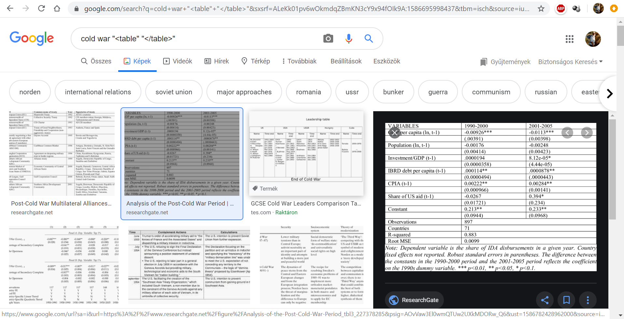

THOR | The next figure demonstrates the literature knows about models concerning the military spending or expenditure – as everybody can see the alternative keywords above the images. The keywords for the Google Search activity are trivial: cold+war+data. Now, we have the necessary variables for modelling. And we have one potential goal, a focus, a core message. We should derive a new model where the consequence variable will be the annual military expenditure of countries and each other variable will be part of the independent variables.
XXXX | 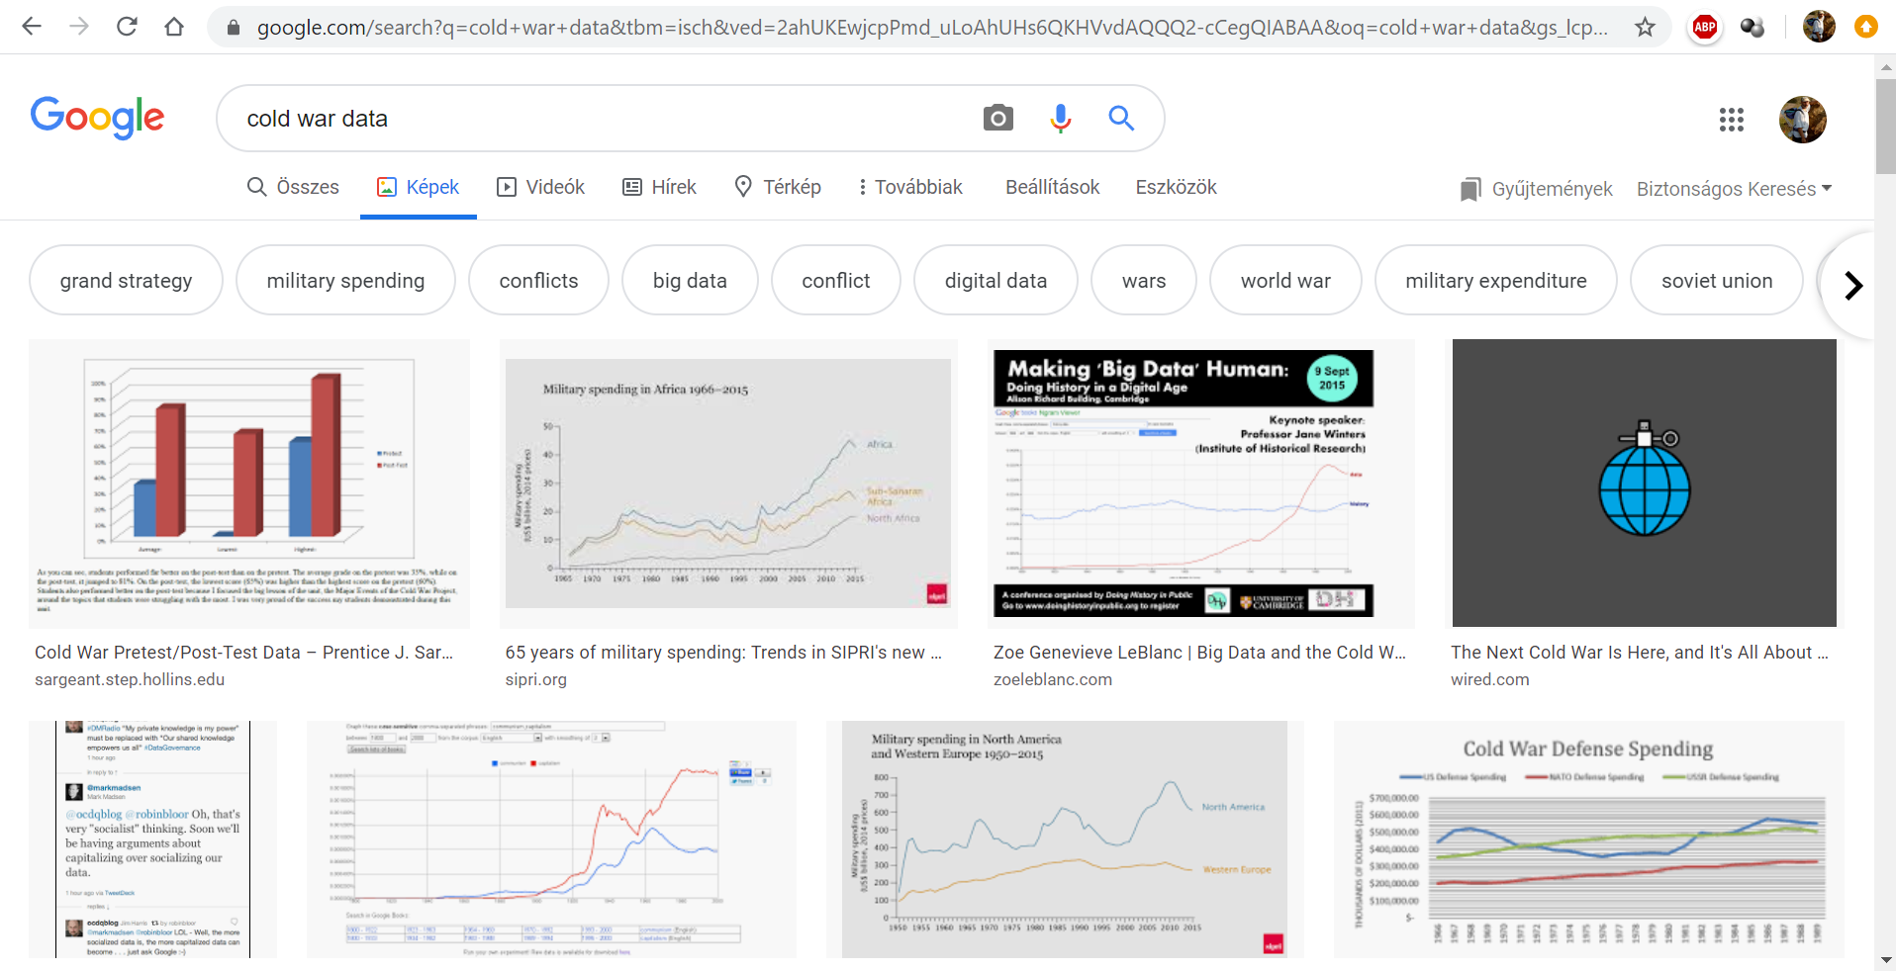
DUCK | Parallel to the general Google Search, there is a specific Google service available – the Google Books Ngram Viewer: This is an online search engine that charts the frequencies of any set of comma-delimited search strings using a yearly count of grams found in sources printed between 1500 and 2008 in Google's text corpora in English, Chinese, French, German, Hebrew, Italian, Russian, or Spanish. There are also some specialized English corpora, such as American English, British English, English Fiction, and English One Million; and the 2009 version of most corpora is also available.  https://en.wikipedia.org/wiki/Google_Ngram_Viewer
XXXX | 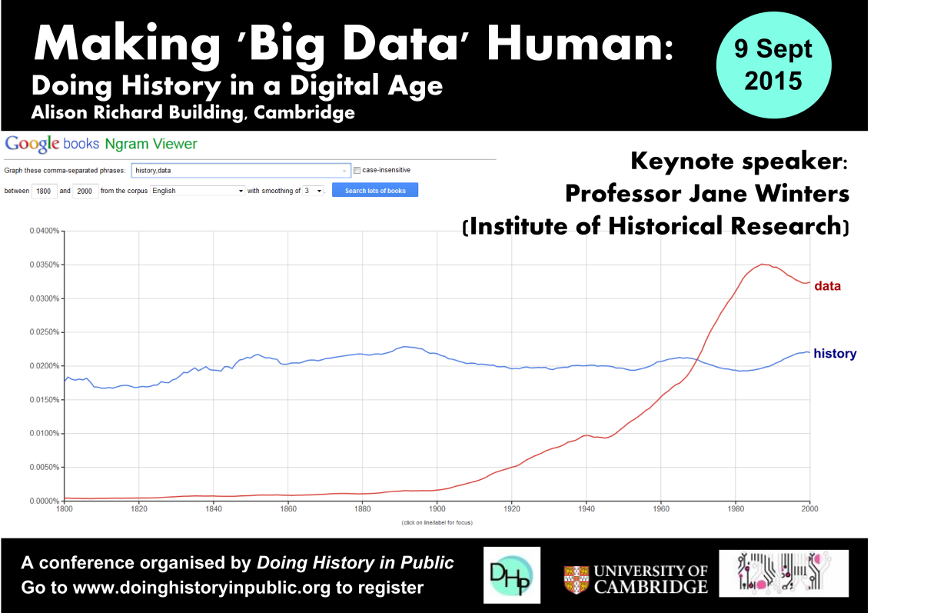  https://books.google.com/ngrams  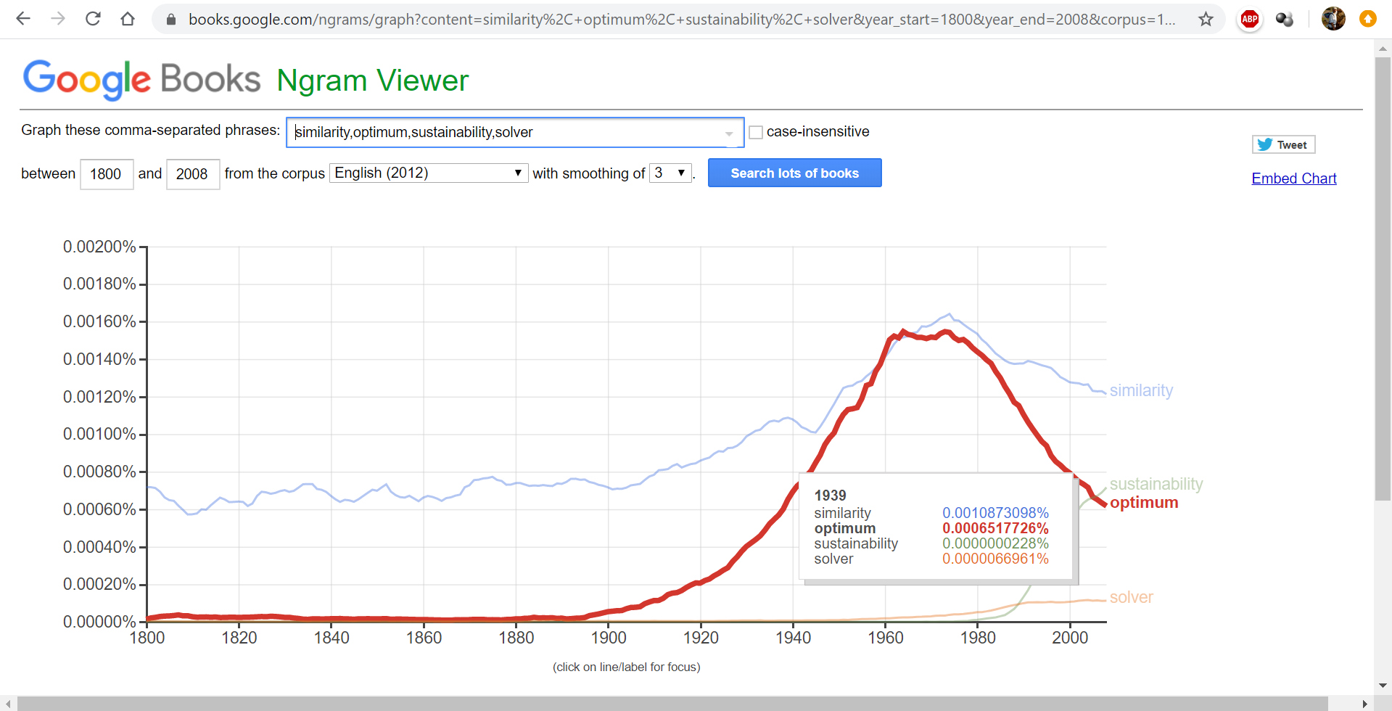
DENT | Unfortunately, I can not find a possibility, how to download the data of the chart in an efficient way. In case of Google Trends, a comfortable download option is given – fortunately. As we can clearly see the four keywords demonstrate entirely new proportions compared to the ratios coming from the Google Books Ngram Viewer – for the same time interval -of course.
XXXX | 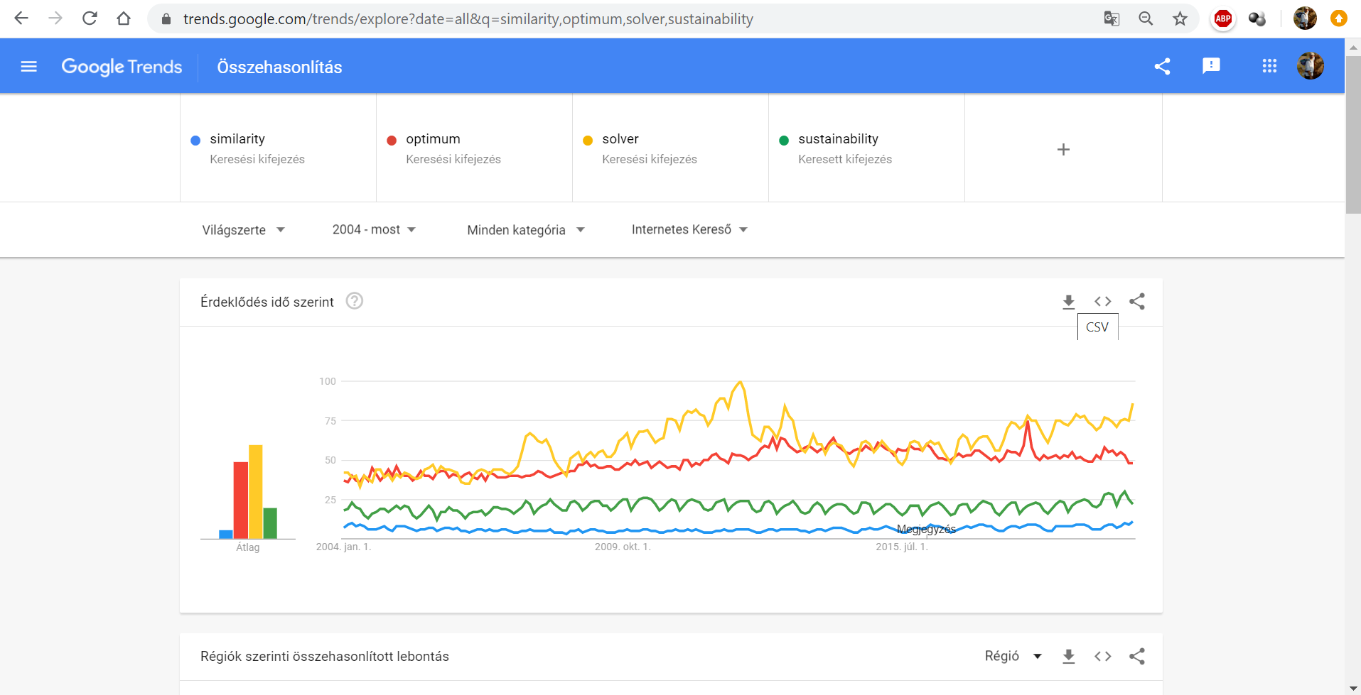
STEW | If I may derive a simple conclusion then I would say: It is not a real problem nowadays to identify such kind of data assets researchers may not dream about for decades and centuries at all. This data can be time series being capable of supporting a historical view. It is just a question of time, how long these time series will be. If we try to use following keywords like countries+html+xls+longformat+Europe+1500+2010, then we will immediately identify one of the most relevant data sources – the CLIO INFRA services.
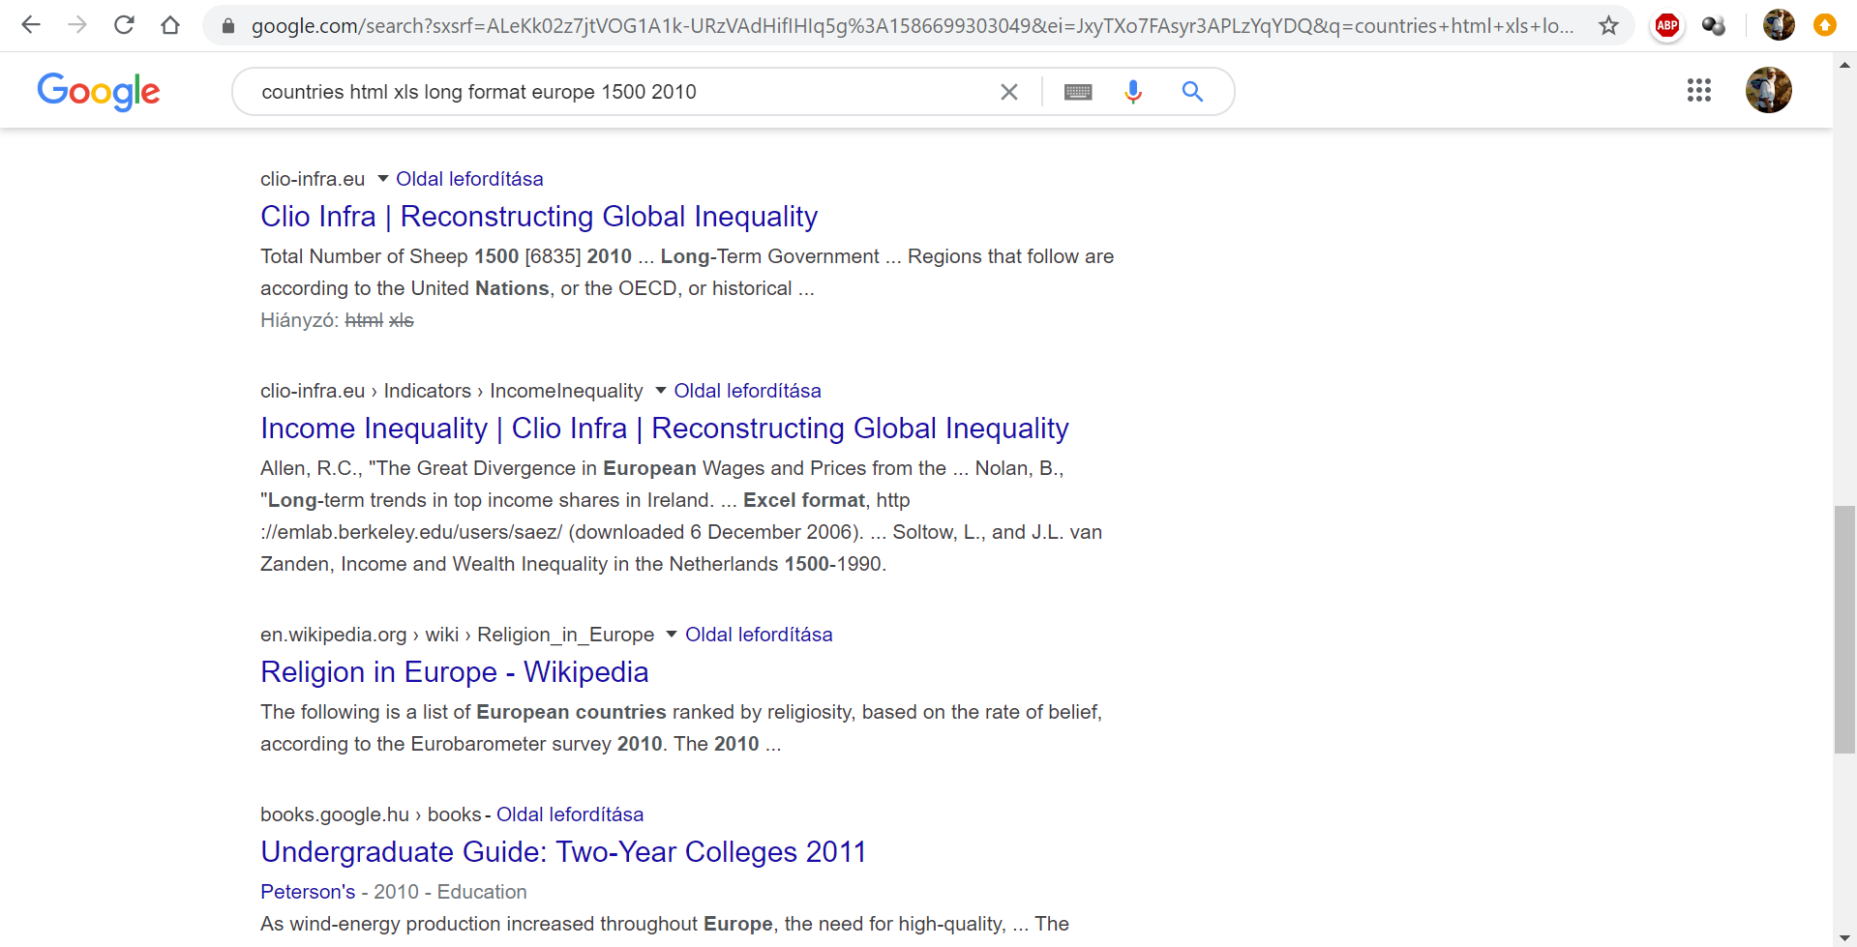
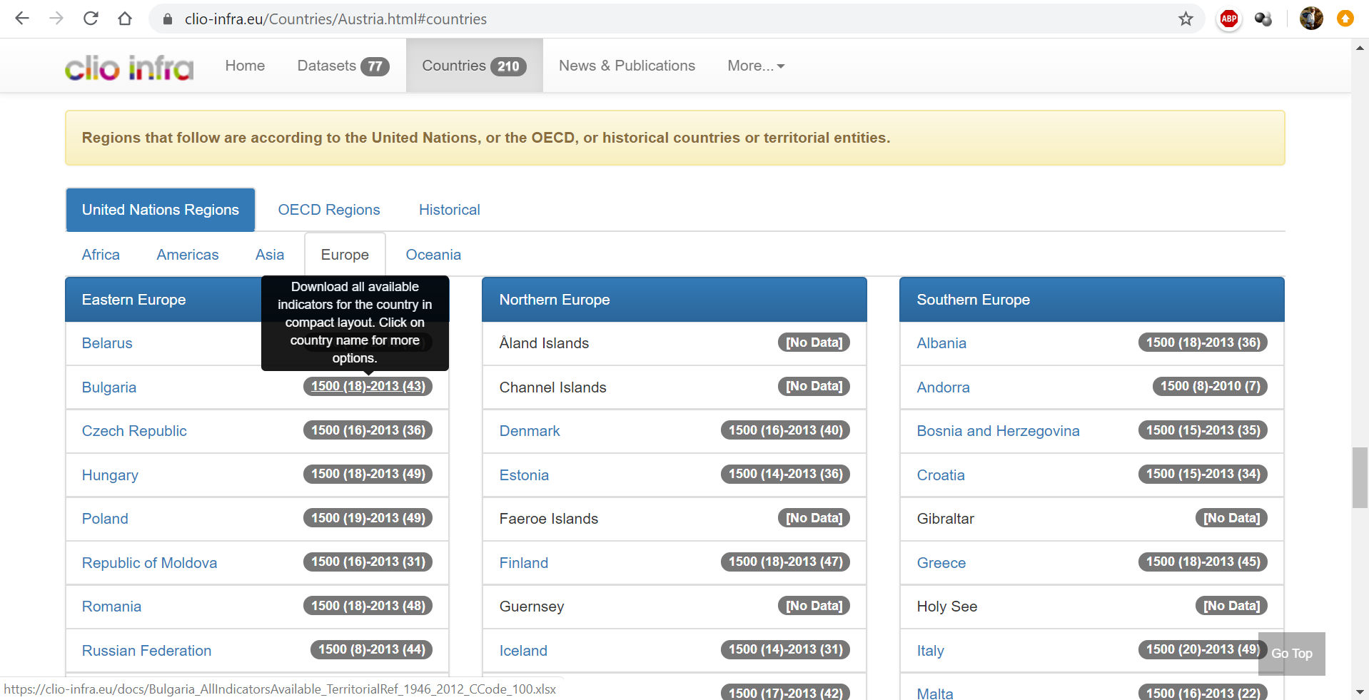
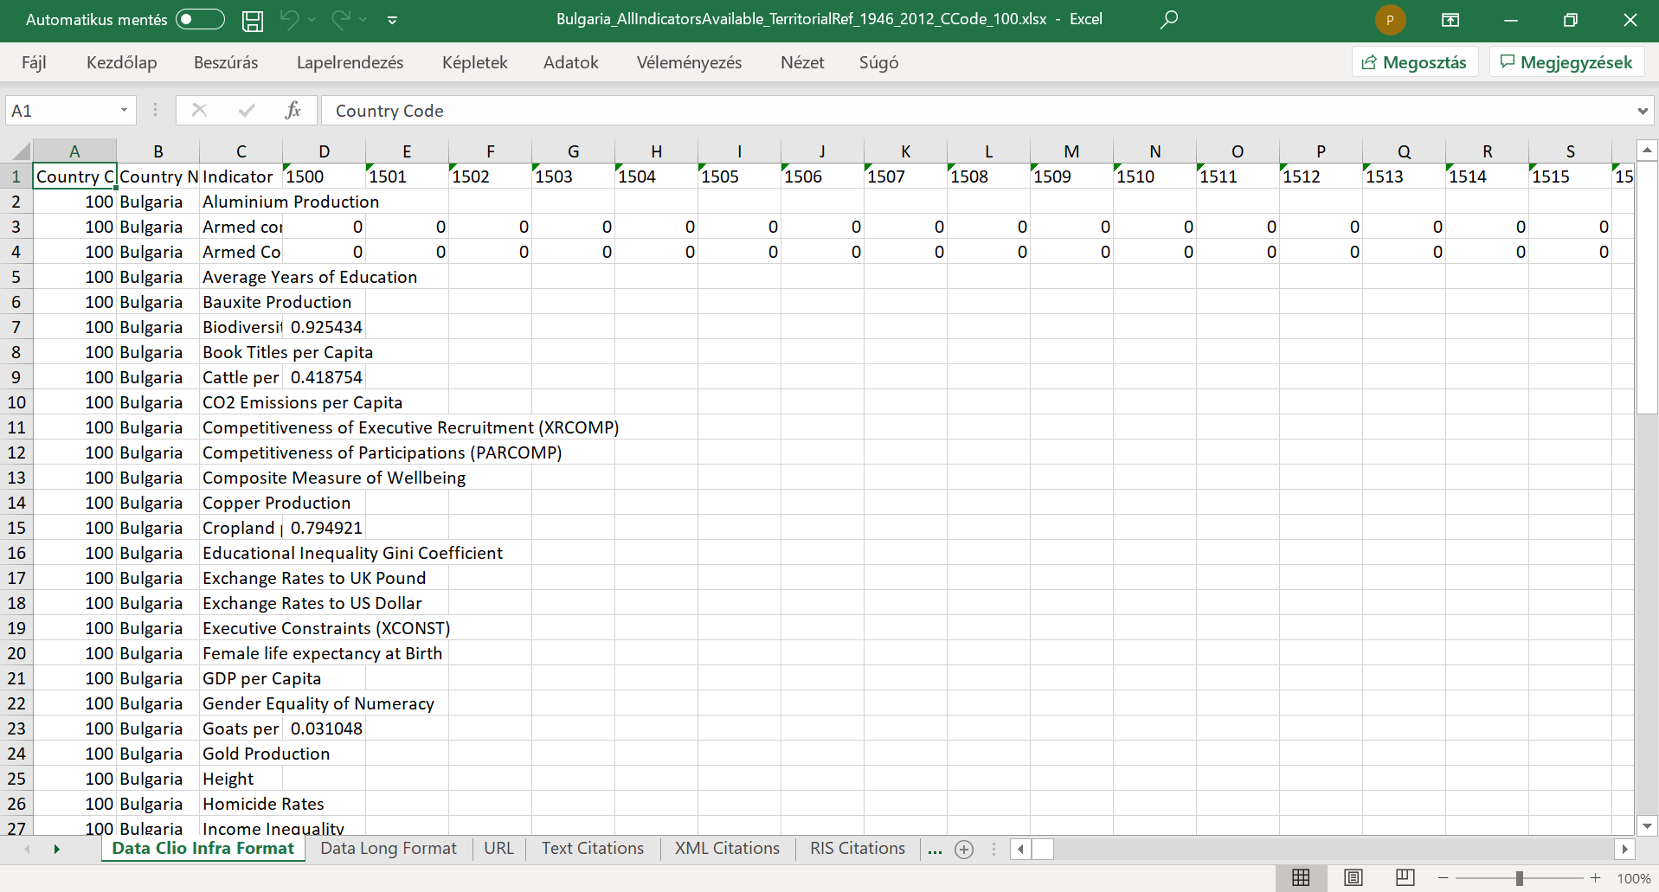
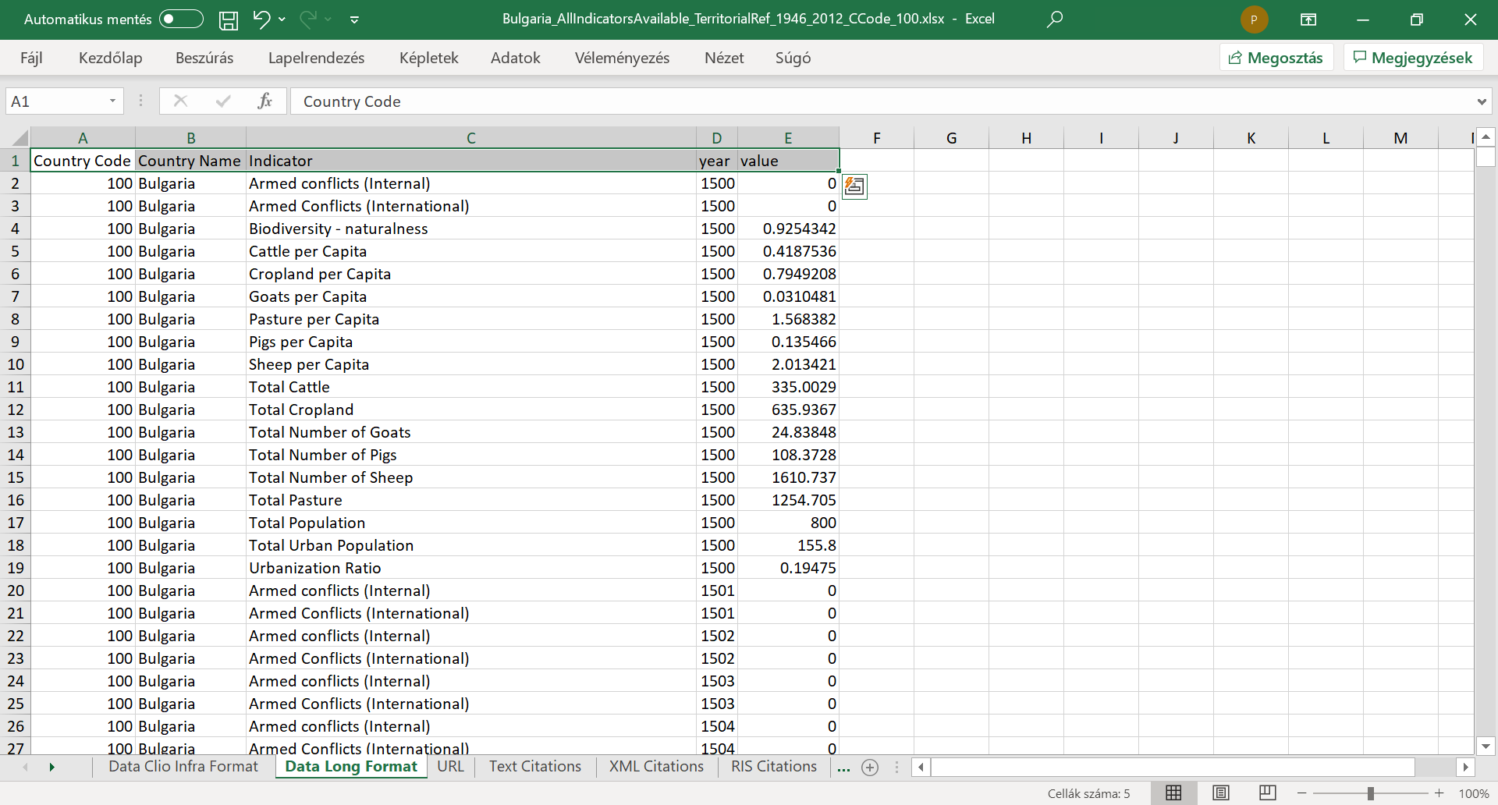
THOR | Former experiences with audiobook-like learning materials made trivial that this kind of impression-driven learning methods increase the risk to lose the contact to the reality. It means this kind of avatar-based distance learning methodology should also define concrete tasks for the Audience.
DUCK | I agree! Dear Audience! Your next task is to reproduce the entire “db” sheet in the coldwar.xlsx based on the country-specific files of the CLIO INFRA services. The appropriate URL could be seen in the figures before. The exact URL of the Excel-file can also be found in the annex.
DENT | Stop! Please! Do you really think that somebody alone or Students in team will complete a database with 157215 records integrating the country-specific long-formats? Is this challenge really worth executing it? What could be the needed time for completing that volume of data?
STEW | Dear Dent! I think the proverb-like formulation is valid for this situation too: PRACTICE MAKES PERFECT! Moving just on the surface of problems will never ensure the points of views which we need becoming a master…
THOR | Unfortunately, or even fortunately - I have to agree. On the other hand, the reproduction is not the real goal – not the real task. The reproduction may still not be closed if somebody has the 157215 rows in Excel completed in the pre-scripted way. We need a reproduction of the two reports too what you can see for 1960 and 1990 in the sheet of “pivot”.
XXXX | 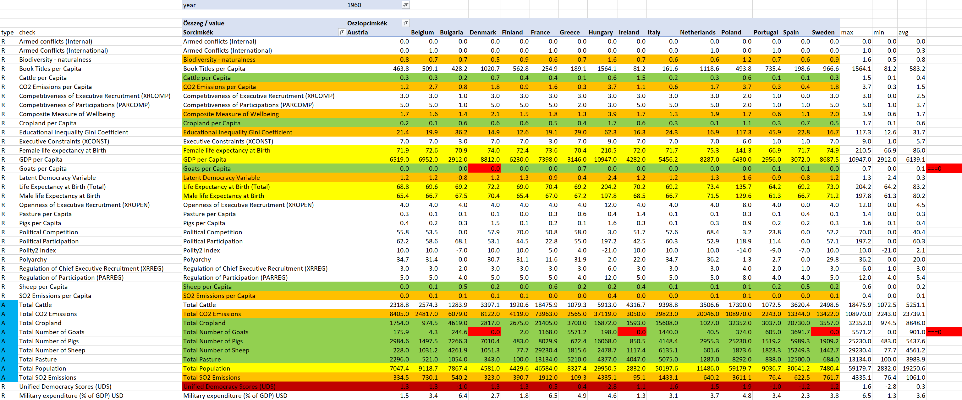
XXXX | 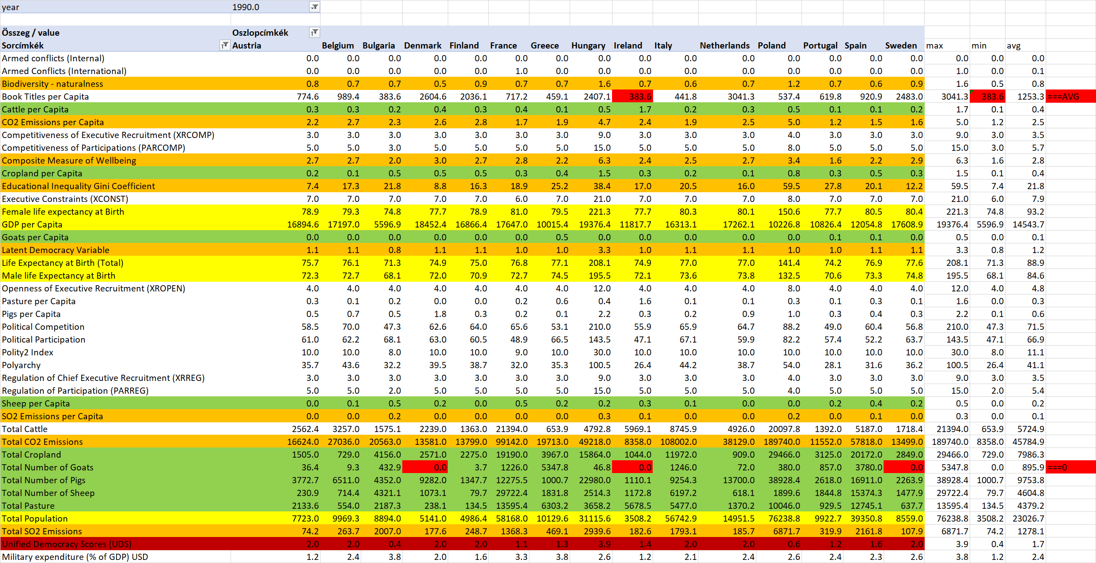
DUCK | Tasks should be defined in a scalable way. The above-mentioned task including the pivot reports is just the basic level. The master level is: how can we derive the maximal volume of cells where we do not have any lack? With other words: how many countries and attributes may we select in order to ensure the most voluminous OAM?
DENT | It is always amazing what kind of connections can be identified in the learning materials. The demonstration files about the 2DM-games used a file about salts, about compounds. The last layer of this presentation was to check whether we have matrix with 3 rows and with 3 columns but without any lack concerning the cells – concerning the salt names:  https://miau.my-x.hu/miau/quilt/2020/salt_names.pdf  https://miau.my-x.hu/miau/quilt/2020/salt_names.docx  https://docs.google.com/spreadsheets/d/1sEbStn1MlsfE4dlu5JOPPkZKKAALPZT6TQH-wtycKU4/edit#gid=1142366670
XXXX | 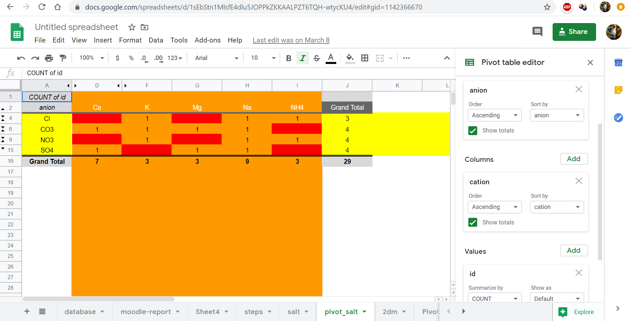
STEW | May I repeat the previous sentence of Dent! It is really amazing how fine is the web of connections between the different core messages of the course. Everybody could have been realized a final score immediately at the start of the course. The keyword or even the motto was PLA (the prior learning assessment) or If-I-were-you. The first successful closing delivered totally new aspects for the 2DM-game-development. It means the authors dared to be themselves. Here and now, I think, it would be possible to have the final credits if somebody could derive even a plan for the previous master-task.

THOR | Well, we have to summarize the situation by now: we could find time series where the objects are the countries. The sources are CLIO-INFRA and the server of ourworldindata.org/military-spending. The military expenditure as share of the annual GDP is given in percent. The country profiles contain a lot of variables. We could find the data in long format which are capable of supporting the pivot-reports.
DUCK | We have therefore two OAMs for 1960 and 1990 and we could calculate the differences between the two years based on the following formula: value of the year 1960 – value of the year 1990 divided through the value of the year 1960. The number of the selected countries (objects) is 15. The number of the involved attributes is 29. The lack of data is limited. The number of the lacking animals could be seen as zero and for Ireland, it was necessary to estimate the number of books. More country and or more variable could have been led to more lacks.
DENT | We have a goal to model the military expenditure based on the country profiles. This goal let immediately declare the potential core message: whether the AI-based Robot-Historian will be capable of explaining relatively consistent the force fields behind the changes of the input variables concerning the changes in case of the military expenditure. The reference models will be a correlation-based approach and an approach based on the literature (or human expectations).
STEW | Because we have 3 comparative models, we will be able to speak about the Turing-test. The Turing-test will be positive for the AI-based approach, if the number of anomalies in case of the solver-based solution is less than in case of the other approaches. Anomalies can however be defined in different ways like anomalies for similar variable-groups, number of none-answers on system level, etc. For modelling, we will use the solver-based online engine: COCO-STD
THOR | Based on these conversation layers, we should already be able to derive the title, the abstract, the keywords, and the chapters like the introduction, the literature, and the data assets. Here and now, it seems to be necessary to explain, why the COCO-STD-engine is capable of supporting the realization of our goals from the point of view of the next chapter: the methodology.
DUCK | The COCO-STD-engine is an online tool for deriving production functions. And we need a production function at any rate. The COCO-STD-engine is a solver-based engine and it works data-driven. It means it is not necessary and not possible to influence it through other pre-knowledge like groups of attributes. The results of the COCO-STD-models can be integrated into a logical chain. This is the basic of a consistence-oriented but not context-free interpretation.
DENT | All these declarations seem to be clear. However, the H1N1-project demonstrated that it is worth having a pre-set direction for each independent variable concerning the dependent one. The Cold-War-project tries exactly the contrary one. We are searching for the directions at last. How should we call the online analytical tool at all?
STEW | The H1N1-project has the answer for this question! The H1N1-project used pre-set directions, but parallel, it also used an inverse set of directions in order to explore what directions are more robust in case of each variable. This technique could be involved here too. If we do not have a preferred set of directions then we can use pure scenarios where in case of the direct view, we will have the monotonous relationship “the-more-the-more” and vice versa. The inverse view will only involve directions from the type “the-more-the-less”.

THOR | Excellent! This is again a clear part of the needed thinking experiments where we try to imagine what we have to do and why we do what we do. It is a high-levelled planning activity what is useful to handle with arbitrary complexities. The using of model-pairs is a trivial trick in order to ensure a clearer view concerning competitive interpretations. And the Cold-War project brings a lot of alternative interpretations like - when should we more militant, if we have fortune or if we lost fortune?
DUCK | But before we start interpreting the potential results, we have to clarify, that this technique with the direct and inverse directions needs a high fitting between the estimated and the real Y-values. Fortunately, these high fitting levels for the direct and for the inverse model are unlimited given. The correlations between the estimations and facts are 1.000 in case of both models.
DENT | If I understand these information units in a proper way, then we can say, the changes of the military expenditures country by country could be explained with the same and high fitting level – although the directions were mirrored but the data positions were the same. On the one hand, it is a kind of evidence, how flexible is the chosen online engine. On the other hand, it is not trivial at all, why a phenomenon like military expenditure can be interpreted in competitive data-driven ways with that robustness?
STEW | This question seems to have for me a kind of connection to the well-known Pygmalion-effect where the causes and consequences can not be clarified. The Pygmalion effect highlights a kind of mirroring concerning the X and Y positions. The doubled-direction-technique is a kind of other mirroring where we have X and Y stabilized but the relationships between them can be mirrored in a successful way.
THOR | The remark concerning the mirroring effects is very relevant and it would lead to a deep philosophical direction. Here and now, it is more relevant however, that the high correlation levels in cases of the mirrored parameter settings have a simple explanation. The number of the objects (15 countries) is definitive less than the number of the involved attributes (29 X-variables). There is a simple rule in the modelling. The ration of the number of the objects divided by the number of attributes should be unlimited high in order the minimize specialities and maximize the generalizing potential.
DUCK | If this ratio is unlimited low – it means we have significantly more attributes than objects, then it is trivial that each object will have one or more variables where this object has an extreme low or extreme high value. The flexibility of the similarity-based modelling philosophies can be derived based on the flexible interpretation of extremities. The extreme characteristics can be seen as a kind of fingerprint of the objects. These extremities can also support to understand the Liebig-bubbles.
DENT | O.K. It means we should later check how many variables are really involved in case of the direct and in case of the inverse model country by country. If the amount of this active bubbles is relatively high, then the view (the directions) are more robust than in case where we will basically have just one or two active bubbles. I expect therefore, that we will have more cases where we find the relationship between an X-variable and the Y-variable as a form of “the-more-the-more”.
STEW | I think, your micro thinking experiment can immediately be checked whether it is correct or not? The three approaches define 3 times 29 positions for the directions. Only 19 cases can however be identified where we have the code of 1 – it means the code for the relationship “the-more-the-less”. And the numbers of the active bubbles in the direct and inverse views are very different. The direct view delivers bubble-numbers between 8 and 2. The inverse view has only 2 or 1 bubbles country by country.
XXXX | 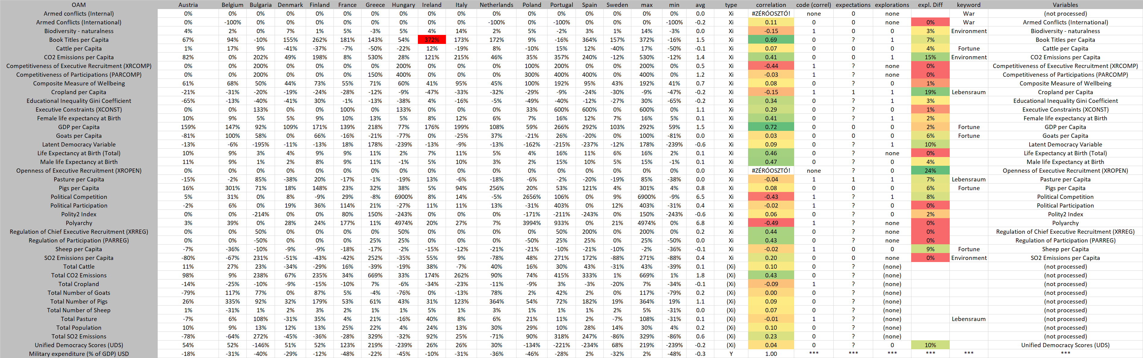
XXXX | 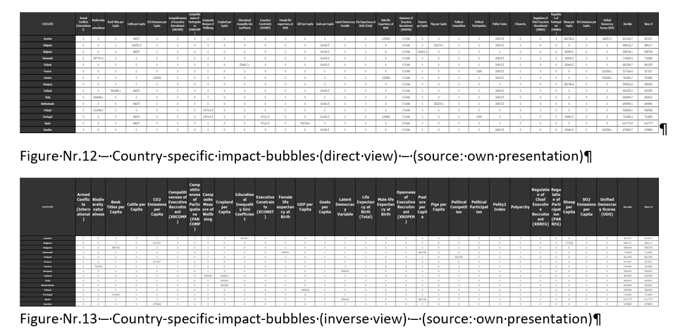

THOR | These micro thinking experiments where we have the chance to check our expectations immediately, are very important to prepare further interpretation rules before we involve real data into the planned analytical processes. We have to introduce now the groups of variables. Concerning these groups, it will be necessary to define interpretation rules. These interpretation rules are the rules which should be used in case of a Turing-test where people have to decide whether the behaviour of the Robot-Historian is human-like enough.
DUCK | It is important to highlight again and again that the groups of the X-variables are not context free. They are consequences of the definitions of these variables. On the other hand, it is also possible to re-formulate these kinds of rules on a higher complexity level. The group-oriented rules are context-free rules because only the building of the groups is project-dependent. The rules for the groups do not use the contents concerning the groups anymore. For example – the direction ids concerning a group should be the same. This is a general formulation independent from the name of the group.
DENT | All right. We have here 29 variables. It is not a real challenge to see which variables could build a group without any complex explaining necessity. The most trivial group seems to be for me the group of the animal-related variables like numbers of cattle, goats, pigs and sheep per capita. These variables in the country profiles describe a kind of fortune, asset. A sentence from Professor Thor should immediately be quoted here and now: “when should we more militant, if we have fortune or if we lost fortune?” What do you think, Stew – what kind of groups could still be built?
STEW | Yeah, I think a new group could be the group of variables concerning the space like cropland and pasture per capita. The space can be described with a more unlikely used term – it means with the Lebensraum as such. The citation before is worth repeating here too – but even with some additional parts: “when should we more militant, if we have fortune” to defend it “or if we lost fortune” and we do not have anything more just our “chains”. You know: “We have nothing to lose but our chains”! This is a line from The Communist Manifesto by Karl Marx and Friedrich Engels.

XXXX
THOR | Well, nice association. We have however chance to build further groups. The two variables about the armed conflict could be a group of “war”. Parallel, the emissions and also the biodiversity could be seen as a new group, the group of “environments”. To the group “fortune”, it would also be possible to involve the variable of the GDP. GDP is a kind of money. And money is a sort of fortune. Besides, there are a lot of index-values like unified and latent democracy index. The book titles per capita seems to be a strange one. Variables being not relativized are not part of our models.
DUCK | All right, we have basically our groups. We need now to convert each partial result to a view where we can evaluate them immediately. This conversation will be the introduction of direction ids. The same direction ids will we use as in case of the H1N1-project where the id of 0 meant the relationship “the-more-the-more” and the id of 1 meant the type “the-more-the-less”. Based on this nomenclature, we can convert the correlation values between each X and the Y into these ids. This set of zeros and ones leads to the first approach, to the correlation-based approach.
DENT | Sorry, but I see in case of two variables the error signs of divided-by-zero. They should mean that we can not calculate the correlation value. This is only possible, if these two X-variables do not have any changes within 30 years concerning the involved countries. Fortunately, this can be checked at once based on the OAM containing the changes.
STEW | It is also important to highlight that the colouring concerning the correlation values is greenish where the correlation is close to its maximum. It means the correlation is close to +1. And reddish in the reverse case where the correlation is close to -1. If the correlation value is over the zero-level, then we speak about the relationship “the-more-the-more” and vice versa. Below the zero-level is should be talked about the type “the-more-the-less”. The most positive correlation has the X-variable of GDP compared to the military expenditure as Y. The lowest case is the case of polyarchy.
XXXX

THOR | And now, it should be my turn to explain, what does it mean, if we have a cell in case of the openness of executive recruitments where we see the error sign but parallel, we see a massive green background-colouring effect too combined with the highest value of 24%. This high value is the difference between the direct view and the inverse view in case of the X-variable. The explanation is simple. The models can use variables without any impact, any changes as a kind of buffering or finetuning force field. Therefore, the openness of the executive recruitment may not have any importance.
DUCK | My task is to introduce the so-called “none” system-answer and to help to understand the difference between a question mark and the none-answer. The none-answer is a derived system-answer where the importance values of the two (mirrored) views are the same. These importance values can be zeros or even higher ones. The interpretation is simple: if there are no data-driven conclusions possible in case of a variable, then the system-answer should be none. Parallel, the question marks signalize only a kind of lack of information. Therefore, the none-answer is more valuable than a question mark.
DENT | I think, the maximum and minimum values concerning the changes of the X-variables are not only present to have just two additional columns. One of the challenges concerning the “Cold-War” project is the affected level of the magic of words. It means we have to speak or write about changes and their relationships on both sides – on the X and Y sides - in frame of the standard lingual forms. For example: if the maximum and minimum values are above the zero level, then we know, each change within 30 years is a kind of increasing and vice versa.
STEW | May I speak about the cases of mixed signs? In case of the strange variable about books per capita, we have to say or write instead of the frequently used formulation “the-more-the-more” following re-formulation. If the number of books per capita increased or showed a less decreasing, then the changes of the military expenditures country by country will more or less decreased. Namely, the Y-variable demonstrates the maximum and minimum values below the zero level. Hard job – I think – to have the relatively simple but correct formulations.
XXXX

THOR | Well, we have to explain here and now the logic of the colouring effects in case of the differences between the two model-views (the direct one and the inverse one). These differences are absolute values. Therefore, the zero differences (highlighted wit reddish background-colours) mean that the type of the relationship should be the none-answer. The massive greenish coloured cells highlight strong connections – however the connection type can only be derived based on the two importance values. These values could be seen in the cover image for this part of the video stream.
DUCK | Therefore, a cell can have a massive greenish background independent from its direction code. A “the-more-the-more” relationship can also have a sign of the robustness as the relationship “the-more-the-less”.
DENT | May I go back to the groups of the X-variables? It seems to be existing a special content-depending effect too: the names of certain variables make possible to derive new expectations like: the unified democracy index and the latent democracy index should be interpreted in a mirrored way because they are inverted view compared to each other.
STEW | Nice, very nice, Dent! Following the same logic: it is also to expect, that the life expectancies on case of the female and male population should produce the same relationships because they speak seemingly about the same phenomena. On the other hand: it is theoretically possible, that a group of variables (although they belong to the same group) will produce specific characteristics. For example: the space is a kind of fortune and the animals or money is also a kind of fortune. The relationships are however not the same.
XXXX
THOR | Excellent observations! If the human beings become relatively more militant in case of reducing their Lebensraum but parallel they become relatively more militant if they have more fortune to depend it, the we can see, that rules can be activated on both ends of an interval valid for a lot of countries and decades.
DUCK | Therefore, it is not trivial that we should reject the hypothesis where the life expectancy of the female population will have an other rule than the seemingly same life expectancy of the male population. Even the wars lead to the experiences that a massive lost of the male population should not need to a collapse of the society but a massive lost of the female population is more dangerous for the population dynamics.
DENT | I think, it is time to declare, that the AI-based approach should have a positive Turing-test because the AI-based interpretation of the focused data-universe is more robust than the same value in case of the two other competitors.
STEW | Yes, I agree, and I have to say, further details, arguments, evaluation layers can be found in the article itself. The URLs for the article and for the involved data and calculation and visualization effects about the Cold-War, about the Robot-Historian can be seen below this video…

Potential focus points for distance-discussions
The QuILT 2.0 frame system offers co-operation possibilities concerning the avatar-based videos: https://miau.my-x.hu/mediawiki/index.php/QuILT2_parts
The H1N1-project prepared already potential FAQ-elements and this list will also be completed here and now:
Part | Player | Content | Question | Answer
3b | XXXX | Figures | Why could be presented the figures after the spoken parts in group? | This technique is on the one hand a kind of enforced way in a roundtable presentation. On the other hand, the video streams make possible to stop and jump or to produce parallel views. Through the lack of the synchronicity, these techniques are worth using.

Annexes
The background data and the final version of the article can be downloaded here:
- https://miau.my-x.hu/miau/quilt/2020/coldwar_military_expenditure_project/coldwar.xlsx (data, models, visualizations)
- https://miau.my-x.hu/miau/quilt/2020/quilt2/launching2020IV15/turing_test_for_robot_historian_cold_war.docx (based on the conception of a robot-journalist)
- https://miau.my-x.hu/miau/261/coldwar_robot-historian_turing-test.pdf (version of the initiator)

