Turing-test for a Robot-Historian

or about the force fields of the Cold-War based on big-data and AI

Robot-Journalist, MY-X team, 2020. IV.

Abstract: Based on the KNUTH’s principle, it should be possible to transform each human competence into source code, if we believe in that the knowledge/profession is a real knowledge and not an artistic performance. A Turing-test should be positive, if the human intelligence and the artificial intelligence (based on big-data and solver-based modelling tools) lead to the same results for example in case of the exploring of force fields or determinants.

Keywords: production function, model, dependent and independent variables, determinants

# Introduction

The Cold-War as keyword for an article written by a Robot-Journalist or even a Robot-Historian, is a real challenge nowadays. This article has a pre-history:

* <https://miau.my-x.hu/miau/258/kome_v1.docx>
* <https://miau.my-x.hu/miau/quilt/2020/quilt2/launching2020IV08/part2d.html> (incl. an article, a storyboard, a proof-reading version, a reference-version and the background data)

And this article has also a werkfilm with a storyboard, and of course the background file ensuring the reproducibility:

* <https://miau.my-x.hu/miau/quilt/2020/quilt2/launching2020IV15/part3.html>
* <https://miau.my-x.hu/miau/quilt/2020/quilt2/launching2020IV15/quilt_2_0_round_table_1_0.docx>
* <https://miau.my-x.hu/miau/quilt/2020/coldwar_military_expenditure_project/coldwar.xlsx>

The werkfilms behind the previous and the recent articles are part of a didactical experiments where different types of the avatar-based asynchronous distance education/learning will be produced like:

* Presentations (see H1N1-project)
* Roundtable-effects (see Cold-War project)
* Exam-situations
* Teach-others-based challenges…

# Literature

If somebody is searching for the keywords cold+war+”<table”+”</table>”, then the second figure presents a model. The model tries to describe relationships between determinants (like population=Xi GDP=Xi, IDA-disbursements=Y) coming from the country profiles (see: <https://www.researchgate.net/publication/227378285_As_the_World_Bank_Turns_Determinants_of_IDA_Lending_in_the_Cold_War_and_After/figures?lo=1> (IDA = International Development Association). Figure Nr.1 demonstrate the statistical background information as such:

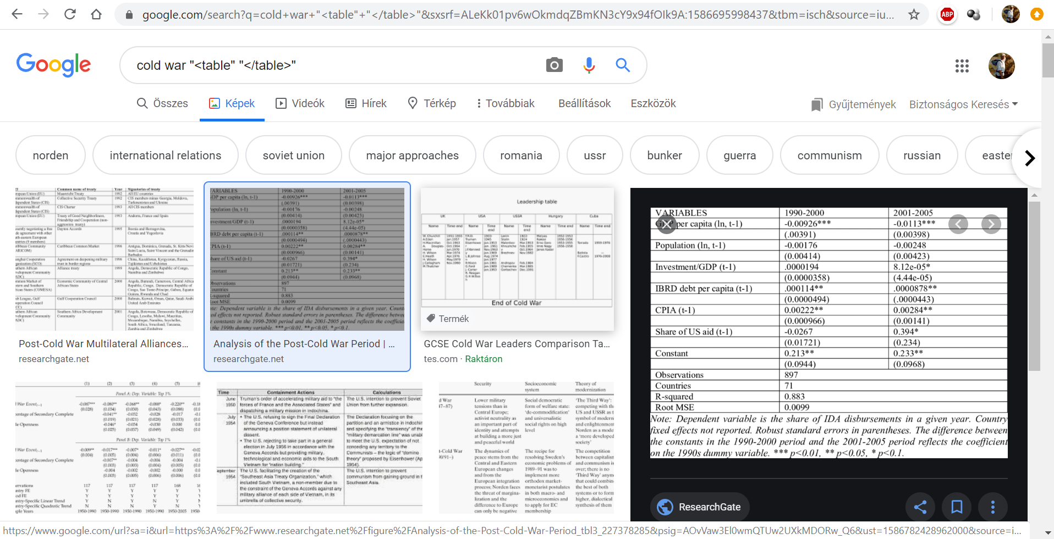

Figure Nr.1 – Production function concerning the Cold-War (source: Google)

The Robot-Journalist has therefore immediately a kind of goal: to derive production functions, it means to explore force fields or determinants behind at least one cold-war-related phenomenon. But what is a cold-war-related phenomenon being described through data? The simplest (automated) way to find such phenomena is: to explore synonyms and/or related words in definitions (see Figure Nr.2):

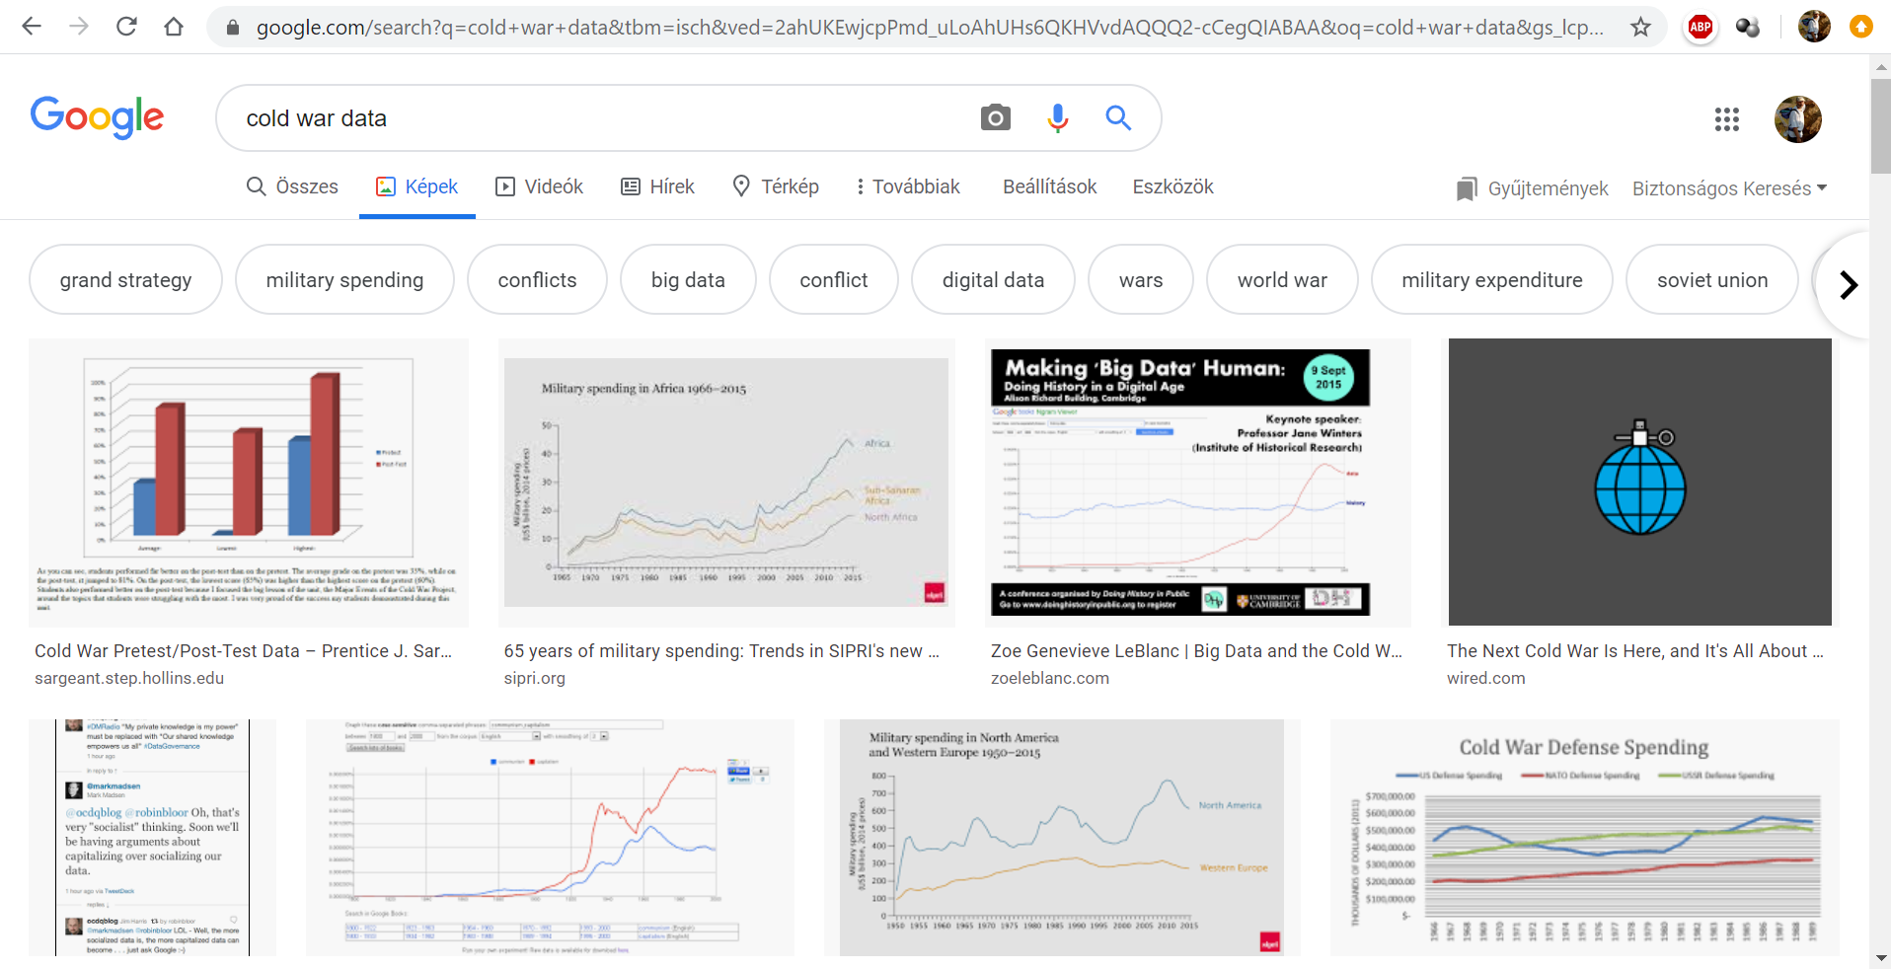

Figure Nr.2 – Relevant keywords (source Google)

Data concerning the Cold-War can immediately be identified in form of figures about military spending/expenditure. This variable could be the dependent one (Y) and each other variable in the country profiles can be seen as independent variables (Xi).

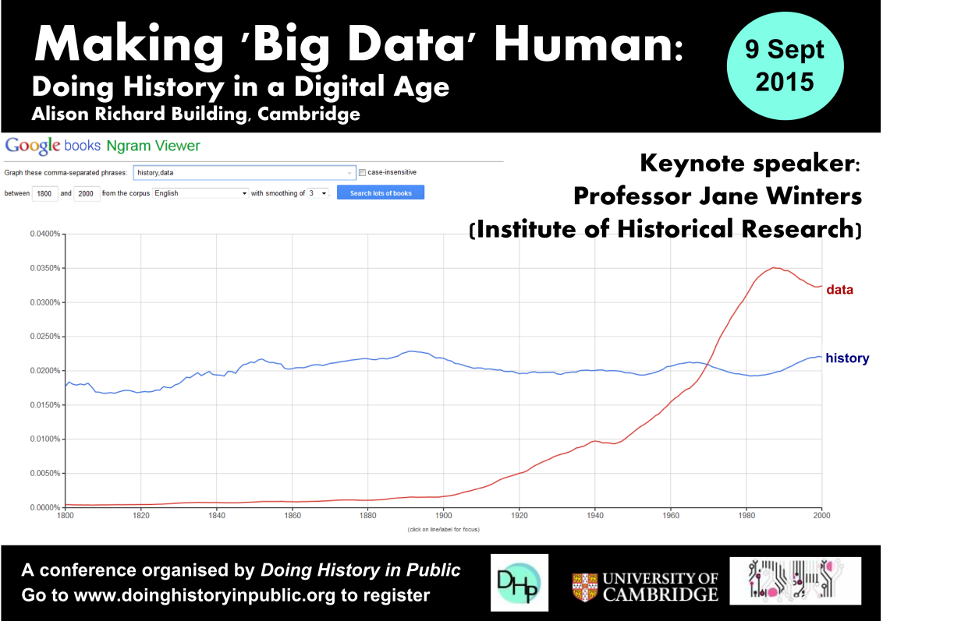

Figure Nr.3 – Importance of phenomena like history and data (source: <https://zoeleblanc.com/blog/big-data-and-the-cold-war/>)

Parallel, it is also relevant to see, what is the connection between the history as such and data big-data? Figure Nr.3 demonstrates a trivial core message: we speak about data more and more but about the keyword “history” quasi in a constant form.

# Data assets

The country profiles are useful if they are in long format and for long time series (see Figure Nr.4):



Figure Nr.4 – Identification of CLIO-INFRA as data provider (source: own presentation)

The country profiles are given for continents (see Figure Nr.5):

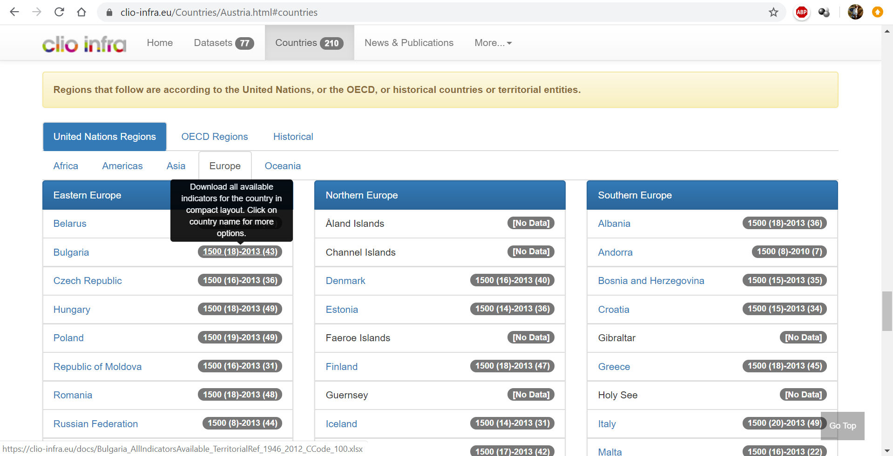

Figure Nr.5 – CLIO-INFRA services I (source: own presentation)

The country profiles can be downloaded in Excel-format (see Figure Nr.6 / Nr.7):

The first view demonstrates an OAM with a huge lack of data units (see: Figure Nr.6):

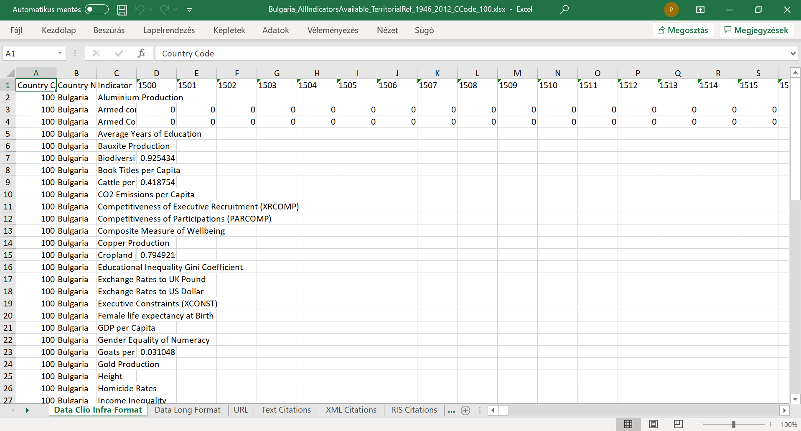

Figure Nr.6 – CLIO-INFRA services II (source: own presentation)

The CLIO-INFRA-services ensure data in long format (useful for pivot-reports – see Figure Nr.7):

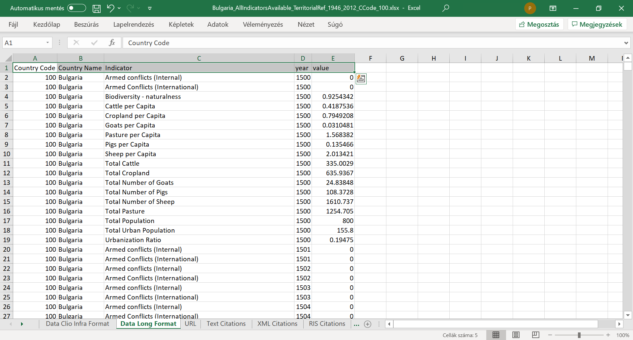

Figure Nr.7 – CLIO-INFRA services III (source: own presentation)

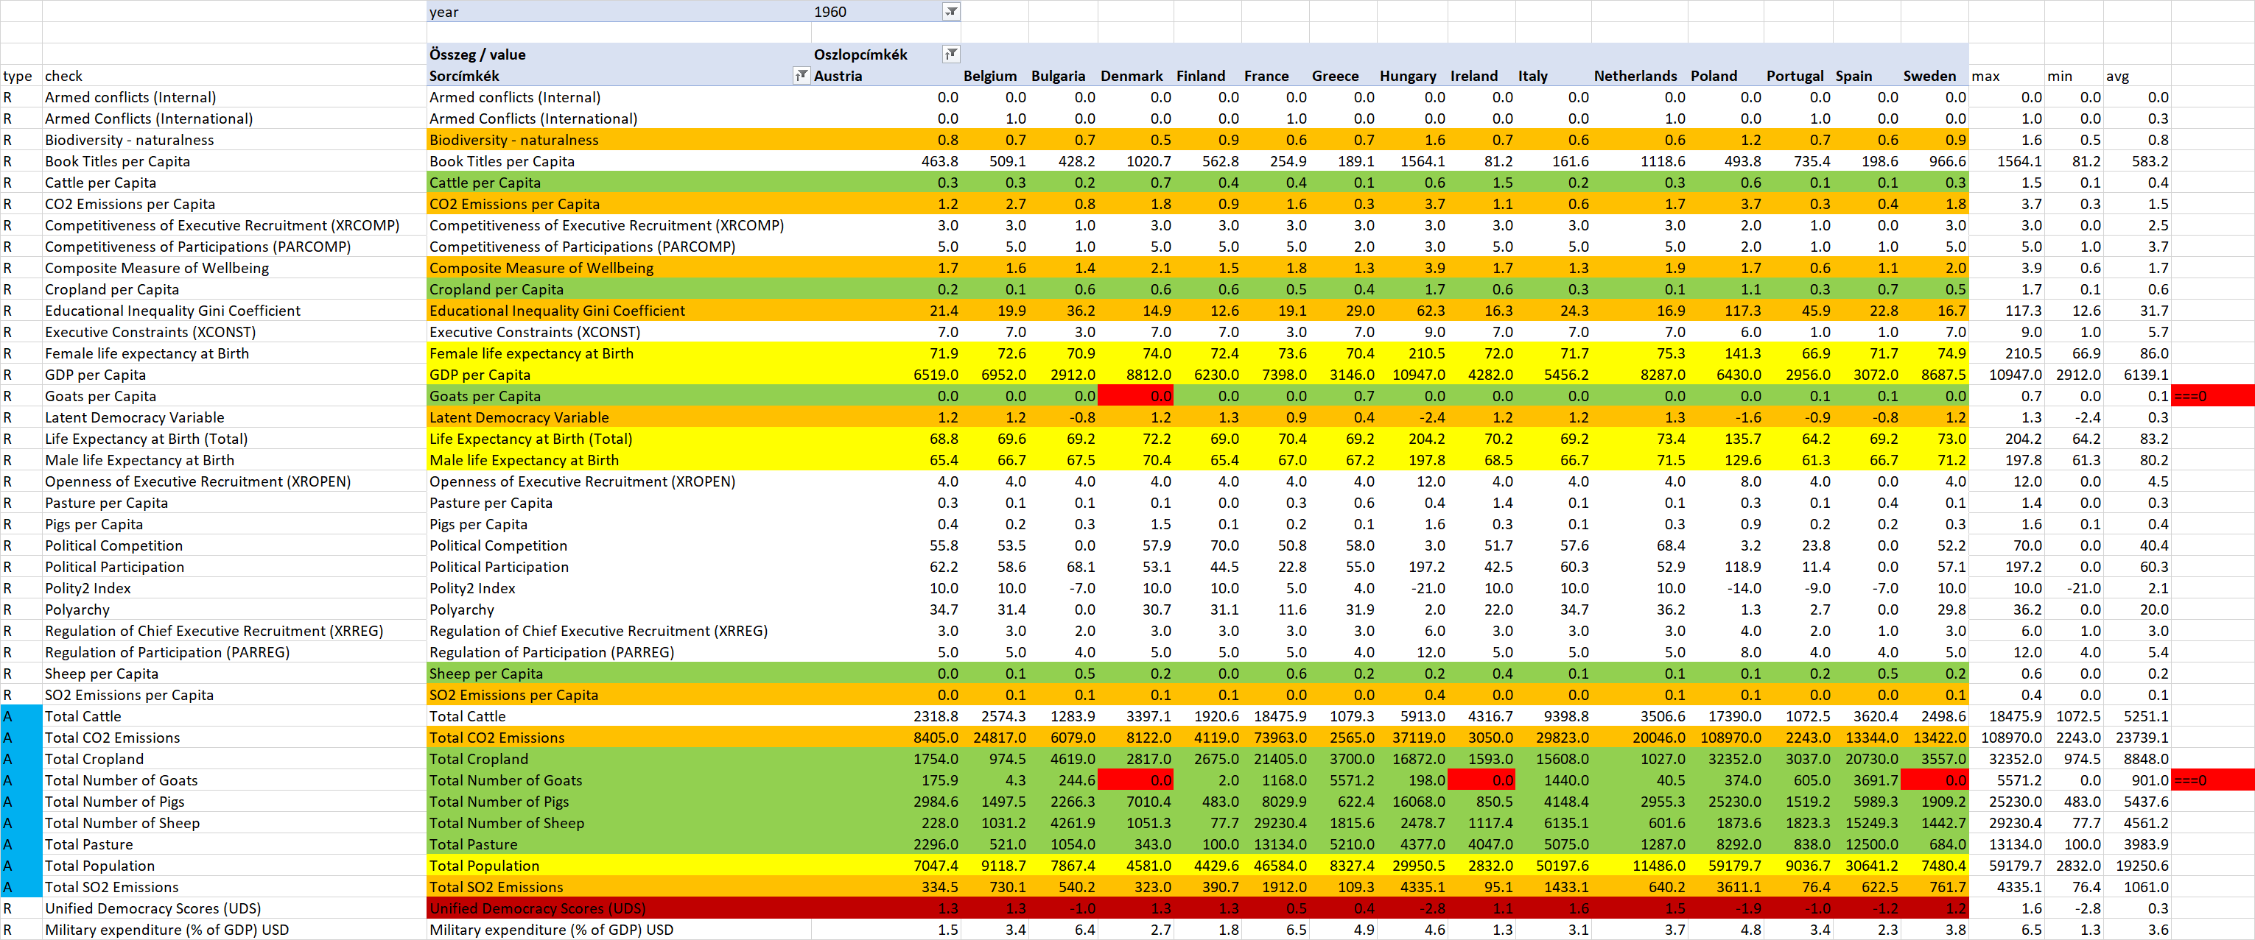

Figure Nr.8 – Filtered/selected variables and countries for 1960 (source: own presentation)

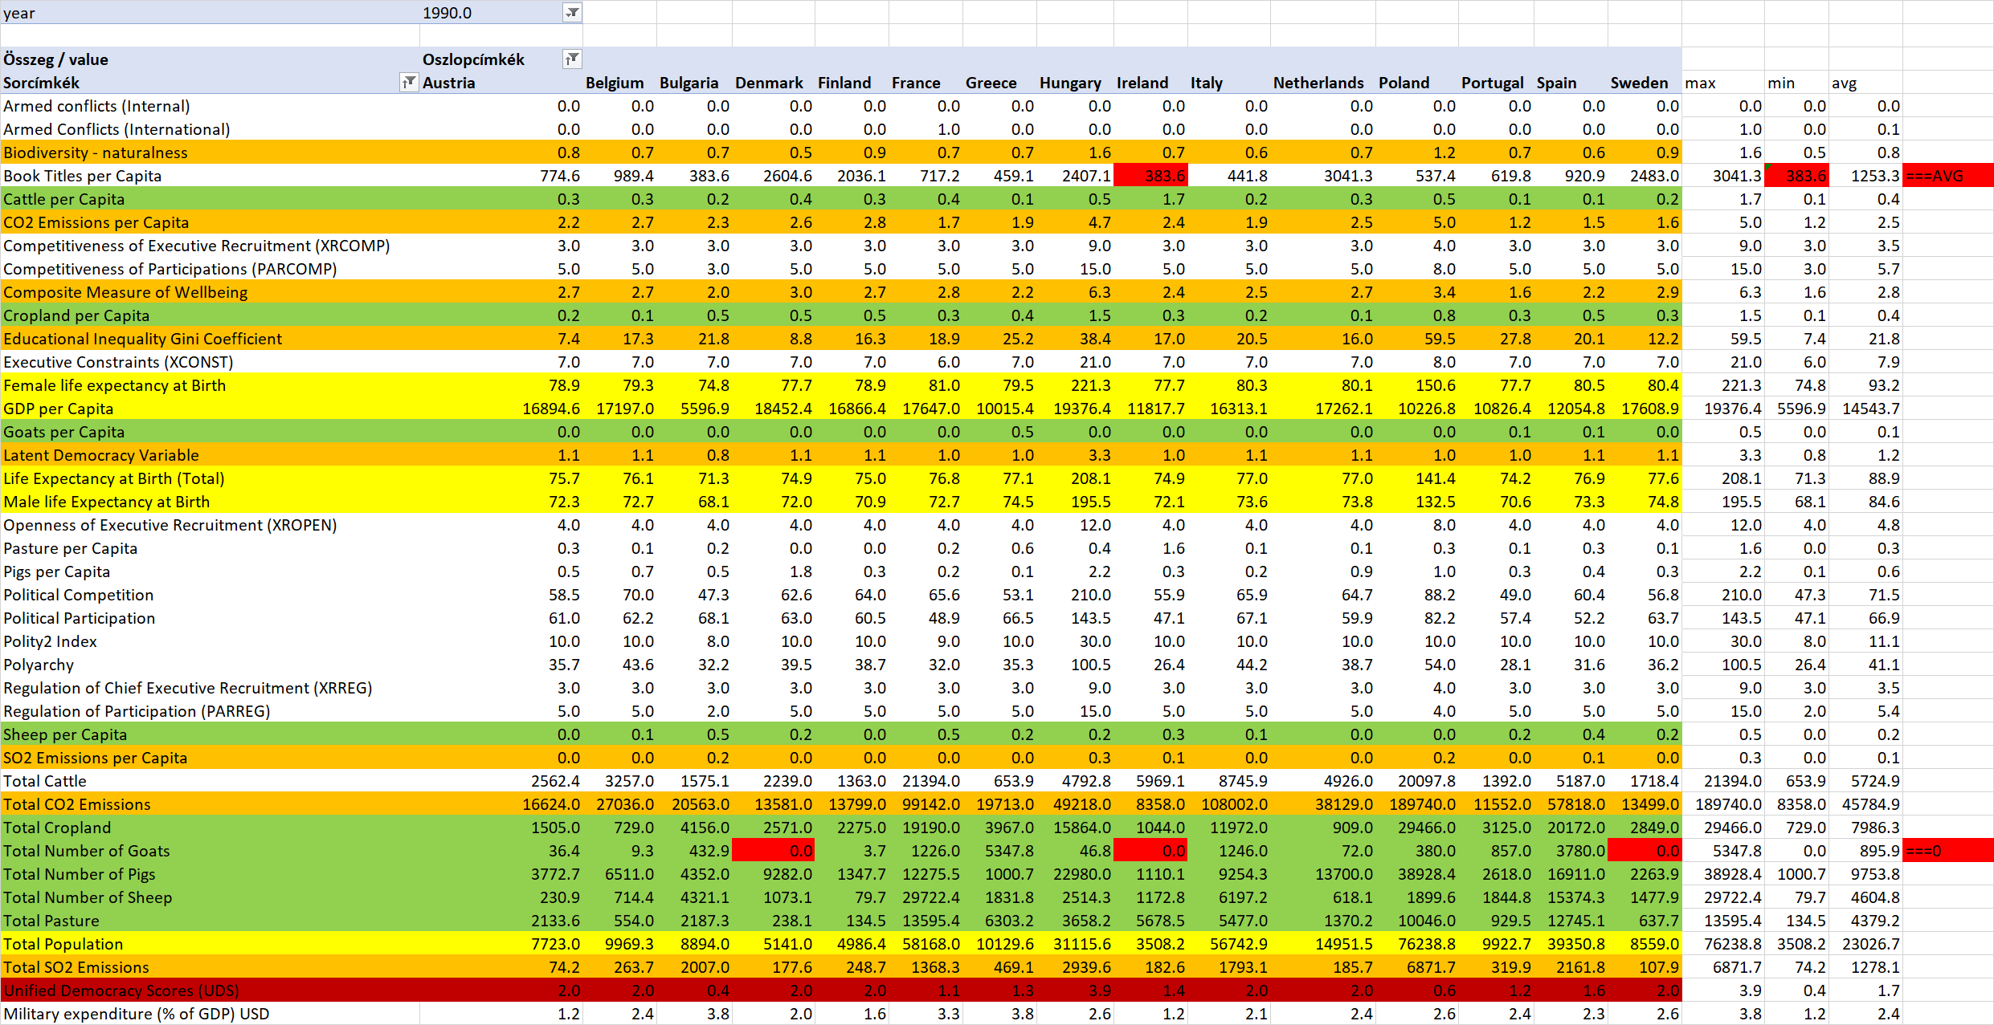

Figure Nr.9 – OAM for 1990 (source: own presentation)

# Methodology

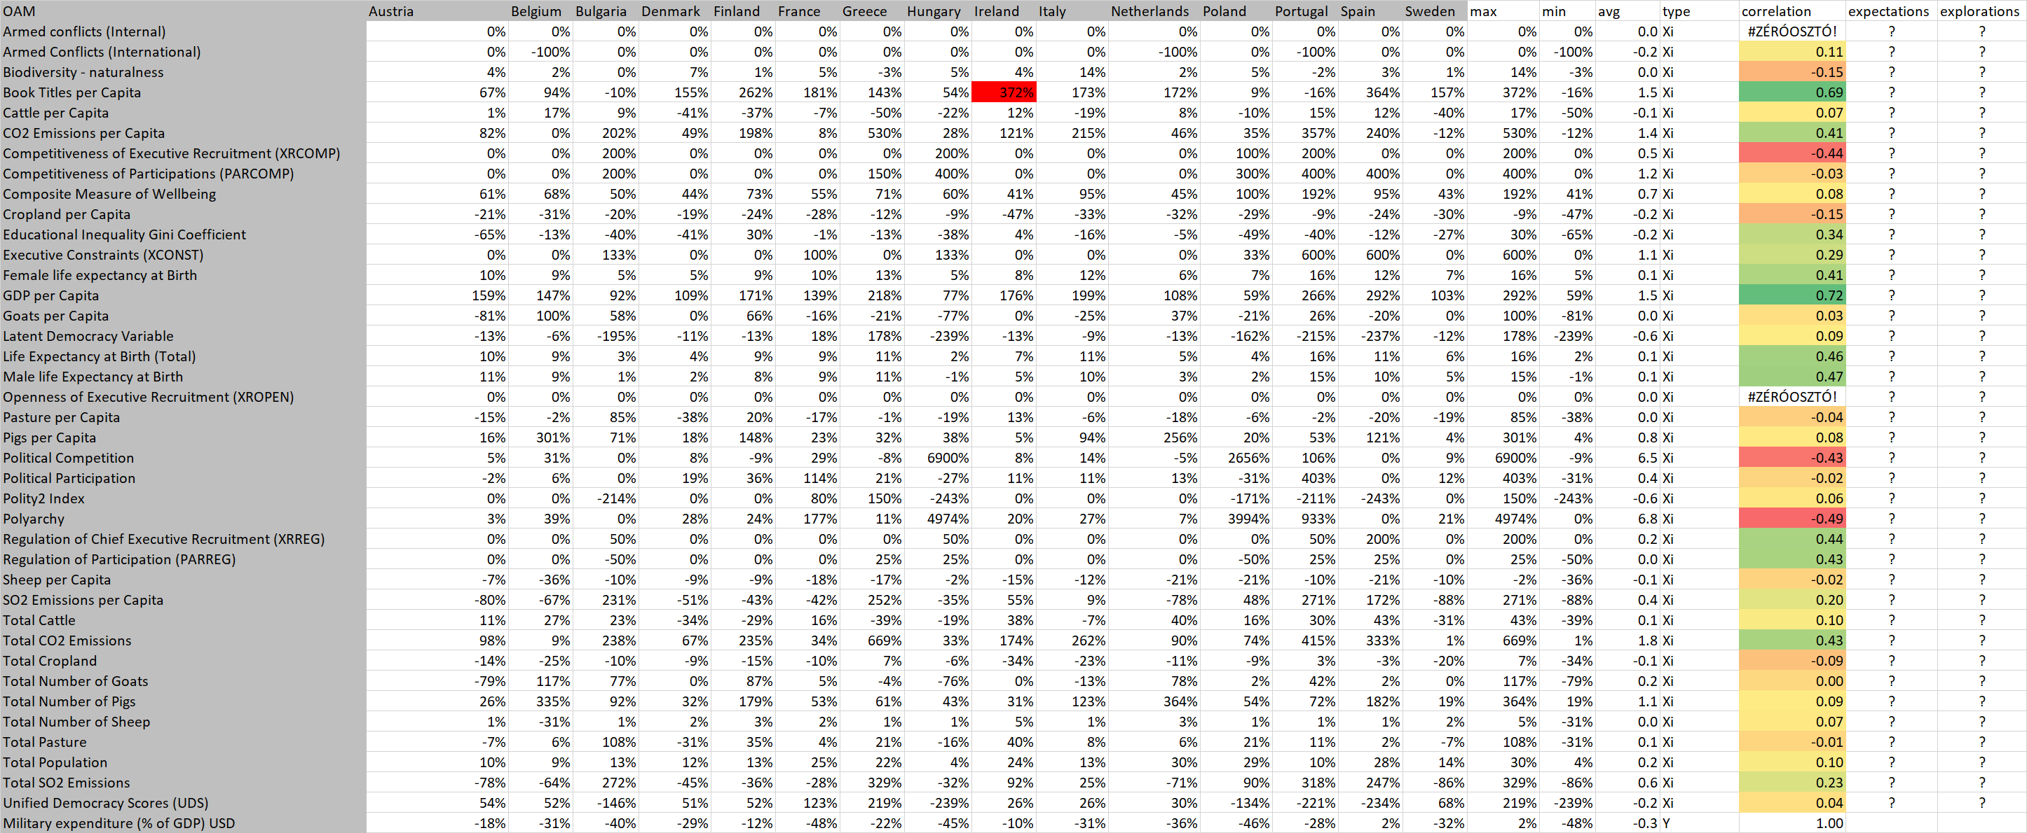

Figure Nr.10 – Changes (1960 vs. 1990) and correlations (source: own presentation)

The data processing logic is very simple. If we have the two reports about the year 1960 and 1990 then we can derive a kind of difference. The changes will be expressed as percent where the formula is: (value of 1990 – value of 1960) / (value of 1960). The relative differences in percent will be a negative value if the value of the year 1990 was less than the value of the year 1960 and vice versa (see Figure Nr.10).

We can also derive the correlation values between the military expenditure (Y – last row in Figure Nr.10) and each other variable before. The correlation means – the cell will be green highlighted if the independent variable and the dependent variable has a relationship of the type “the-more-the-more” and vice versa: the cell around the correlation value will be red in case of the relationship “the-more-the-less”.

The most green cell belongs to the variable “GDP/capita” – therefore, the more is the increasing (or the less is the decreasing) in case of the GDP/capita the more will be the increasing (or the less will be the decreasing) of the military expenditure within 30 years. The most red cell belongs to the variable “polyarchy” (<https://en.wikipedia.org/wiki/Polyarchy>). The phenomenon of the polyarchy means the number of centres where people are active concerning political activities. Therefore, the less is the changing of the number of the active peoples/centres the more will be the increasing (or the less will be the decreasing) of the military expenditure within 30 years. As you can see, the changes can within 3 decades can be positive or negative (or even zero). The formulation of the relationship in frame of the magic of words is not easy: we have always to interpret the real changes. These real changes can be described with the maximum and minimum values of the changing concerning each involved countries.

The GDP/capita increased within 30 years: at least of 59% and maximum 292% - therefore, we do not need to speak about decreasing. So, the formulation is less complex: more GDP leads to more military expenditure. In case of the polyarchy, the minimum is zero (%), therefore, the formulation can also here be simplified: the less people want to be active (from point of view of the politics) the more will be the military expenditure.

Based on the Figure Nr.10, we need at last 2 models: one of these models will be created with monotonous directions where each variable is transformed into ranking values according to the relationship: “the-more-the-more” (id = 0). The second model is an inverse model based on the type of the relationships “the-more-the-less” (id = 1). We do not know namely, what force field should be stronger in a complex model where the variables can also have interactions.

Figure Nr.11 demonstrates the needed structure of the results:

* The correlation ids describe the types of the relationship based on bilateral connections between the variables.
* The literature and/or the naïve human logic can derive expectations like the more is the number of conflicts, the more will be the military expenditure or even: the more fortune somebody has, the more defence spending seems to be realistic – however we know: the less fortune somebody has or the decreasing of the fortune is rapid and deep the more militant become people…
* The explored relationships will however be derived based on solver-driven models (c.f. online AI engines).

The interpretation rules for the variable names on the row header and for the 3 columns described before are:

* If the ids in each column are the same (0-0-0 or 1-1-1) then we can speak about consensus between human intelligence and artificial intelligence based on big-data.
* If we have the same direction ids in case of similar phenomena like war, fortune, environment, “Lebensraum”, etc.), then the evaluation of our knowledge is stronger. (The well-known but not frequently used term of “Lebensraum” means place/space to be active…)
* This second rule should be more rigorous than the first one, because it is not acceptable, if the variables in the same group have different relationships to the military expenditure. In such a case, we have to assume that the history produces Liebig-like bubbles – it means the rules are not to generalize – they are only existing under specific circumstances.
* It is also a kind of value if the direction ids for one of the 3 columns within the groups of the similar phenomena are more consistent than in case of the other knowledge sources (literature vs. correlation vs. model).
* A Turing-test for a model-based approach should be positive, if this AI-based approach is not the most irrational compared to the two others.
* None of the 3 knowledge forms should have a direction id for a given variable at all. It is acceptable, even very acceptable, if we can say, no relationship can be derived for a particular attribute (and the military expenditure).
* It is however better, if the number of the none-answers is less. The question mark is also a kind of none-like answer. Each explored none-answer is a strong result from the AI-engine – however the question marks mean we do not have a clarified statement – it means – we do not know so exactly. This non-knowledge is less valuable than a strong knowledge about a derived or moderated “discretion” on system level.

# Results

It is very important to declare, that the military expenditure of the 15 objects (countries) could be estimated in an exact way based on the 29 attributes in both cases: in case of the direct and in case of the inverse approximation. These facts give a robust background for each further interpretation:

<https://miau.my-x.hu/miau/quilt/2020/coldwar_military_expenditure_project/coldwar.xlsx>

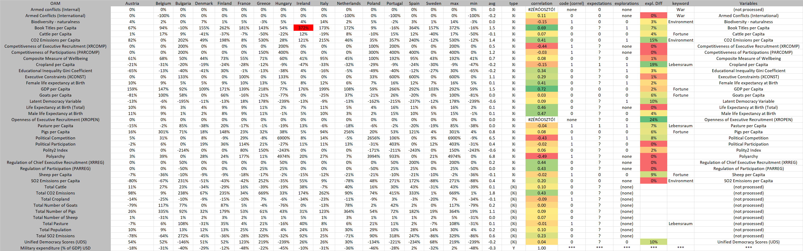

Figure Nr.11 – Correlations, expectations, explorations (source: own presentation)

At first, it seems to be relevant to evaluate the 3 knowledge forms as such – in case of the environmental variables in order to demonstrate the evaluation process as such:

* The correlation-based ids show in case of the group of environmental variables (biodiversity, CO2, SO2) that they are different.
* The expectations want to be consequent and produce an id of 0 (the-more-the-more) for the three cases (variables).
* The explored ids are different too – let alone there is a none-answer (SO2) besides an id=0 (biodiversity) and an id=1 (CO2) status.

Remarks:

* It is not trivial why should be given the same ids for the 3 variables in this group? The emission is a kind of disadvantage, but the biodiversity is a kind of advantage. Therefore, the naïve expectations are illogical.
* The correlation-based approach says 0-0 for CO2 and SO2. The model-based approach shows an id=1 status for CO2 and a none-answer for the SO2.
  + The correlation-based logic seems to be stronger – it is namely the same for two similar cases. This logic can be reformulated like the more military expenditure is given the more will be the production and therefore the emission of each materials. This logic of let also assume that the expenditures for decreasing of the emission values are competitors for the military spending (see: the less is the CO2-emission based on higher expenditures for environmental issues, the less can be the military expenditure as such).
  + The model-based approach means however: the quality of the air should be defended on the same way as the quality of the biological/ecological systems. Therefore, the public fortune should be defended as such. The increasing of the biodiversity is the same as the decreasing of the emission (CO2). The more fortune needs more military expenditure.
  + Which concept can be seen as stronger, it is not to decide here and know – but each concept seems to have a partial logical evidence at any rate. A better evaluation can be derived if we inspect the variable-group about personal fortune:

The personalized fortune can be for example cattle, goats, pigs, sheep / capita – because private persons and/or enterprises can have animals.

* Except the position for sheep in case of the correlation-based approach, each other id = 0.
* It means, the AI-based approach is more consistent concerning the animals and more consistent concerning the public and personalized fortune-sorts – without any knowledge about these variable-groups in advance!
* Therefore, the fortune-based logic seems to be here and now stronger: it means the fortune should be defended in general.
* This theory presume that the GDP/capita has also an id=0 position (in each knowledge sources) – and everybody can see this is so!

The last relevant group is the group of “Lebensraum”-variable (cropland/capita, pasture/capita):

* In both cases we can see the monotonous id = 1 status.
* Therefore, the space as such is an other kind of fortune than animals or public goods (like air-quality, biodiversity).
* The id=1 means if we lose space (Lebensraum) then we are motivated fight for it.
* This is an inverted logic and valid for the involved countries (compared to the animals and environmental resources).
* The lost animals let decrease the militant attitudes, but the lost space let increase the militant approaches.

As well as the logical connections, there are also numerical values behind the direction ids (see red-yellow-green) signs in two columns (Figure Nr. 11):

* It was already spoken about the most green (GDP) and red (polyarchy) positions in case of the correlation-based approach.
* The most green position is the openness of the executive recruitment. For this position could not be a correlation value calculated. It means this position produced NO changes in the OAM within 30 years. Therefore, it can not be seen as relevant behind the changes of the military expenditures. Through this position can be declared, that the raw result in case of the AI-based approach needs a kind of fine-tuning. The AI-based approach can use variables for buffering numerical impacts for example in case of impact-free inputs. The interpretation rules can be prepared on system level, so this kind of green position can be eliminated in a real analytical report. Here and now, this was relevant to have the chance to speak about this speciality of the AI-approach.
* The most red positions in case of the explorations are the zero positions. It means the AI-approach let derive the direction ids and the strongness of them. This is namely an ABS()-transformation where the signs (+/-) do not play any roles. The correlation-based approach has an interpretation interval between -1 and +1.
* Therefore, the further greenish positions should be interpreted in case of the AI-based approach:
  + The Lebensraum-variables have a relatively strong positions (the 19% for cropland is the realistic highest value, but the 7% for pasture is also strong enough where these percentual values between 0-100 mean what is the difference between the two approximations – between the homogenous direct and the homogenous inverse approximations ).
  + The strongness of the variable CO2-emission has a value of 15% what increase again the probability of the direction id = 1 status (see before). The none-position for SO2-emission means the direct and invers models do not have any differences and/or both are 0% independent from each other.
  + The numbers of published books are important for both approaches (see correlation-column and exploration-column). The correlation-based model says: the more books can be published the more will be the military expenditure. The AI-based approach speaks about an inverse logic: the less is the volume of publishing the more will be the military expenditure. The decreasing cultural values seems to have the same impact as in case of decreasing space (Lebensraum).
  + The animal-related fortune-defending logic is strong in general (4-6-6-9%).
  + Further (strong and on approach-levels consistent) variables:
    - The less is the political competition the more will be the military expenditure.
    - The more is the (unified) democracy (as such), the less will be the military expenditure.
    - In case of the latent democracy, the two competitive approaches have different opinion.
    - The further index-like estimations could not be involved into the AI-model in a robust way.
    - The male and female life expectancy is more consistent in case of the correlation-based model because the ids are the same (0-0). The AI-based approach says: the female life expectancy could even have an id=1 status with a robustness of 2% (with a relatively low robustness).

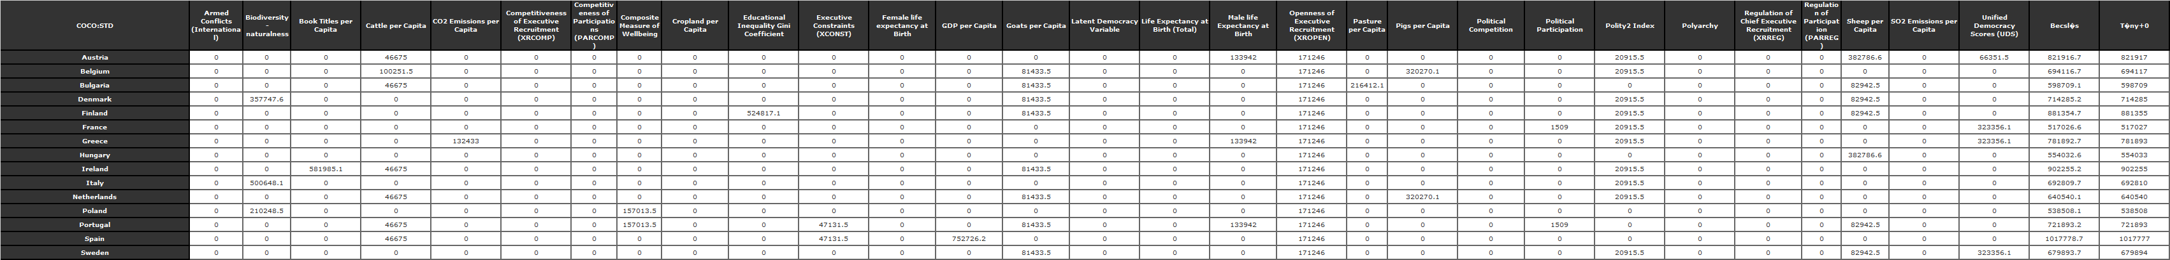

Figure Nr.12 – Country-specific impact-bubbles (direct view) – (source: own presentation)

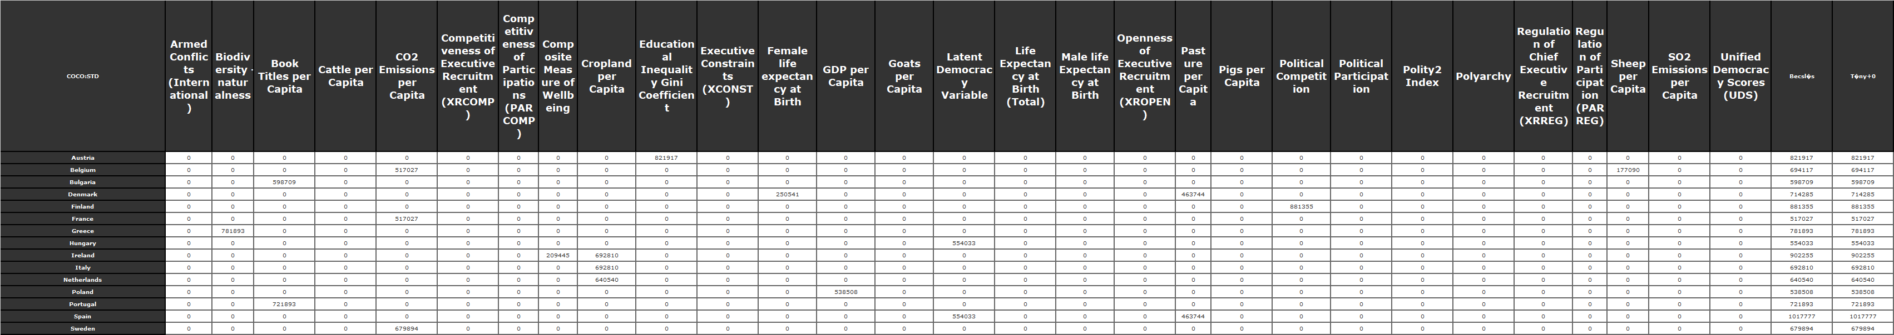Figure Nr.13 – Country-specific impact-bubbles (inverse view) – (source: own presentation)

The Figures Nr.12-13 demonstrate the so-called bubble-effects concerning the military expenditure of the countries in a direct (the-more-the-more) view and also in an inverse view. Each cell with a value above zero could be analyse but it seems to be enough to highlight some specific effects:

* The inverse view in case of Italy shows one single bubble: the variable “cropland/capita” (more exactly its change) is alone responsible for the changing of the military expenditure within 30 years. With other words: in case of Italy is the decreasing of the value of the cropland/capita (c.f. Figure Nr.10: max = -9%, min = -47%) was so massive that this effect alone seems to be enough to cover the motivations behind the military expenditures. It is important to declare, that the military expenditures (except of Spain with +2%) could be decreased within the observed 30 years. In case of Italy, the increasing is -31% (see. Figure Nr.10). This value of -31% is norm-like in the max-min-interval of -48% vs.+2%. These additional information units make possible to reformulate the previous sentence: In case of Italy, the strong reduced “Lebensraum” is responsible for the realized reduction of military expenditure from 3.1% to 2.1%. (The enforced relativism, it means the using of differences of two OAMs for 1960 and 1990 is a real lingual challenge which could be used as task for final exams in high schools parallel to poetry/novel-oriented tasks…)
* In case of Hungary (again in the inverse view), one single attribute is active – the variable of the latent democracy. The value of the latent democracy got decreased with the maximal value even in case of Hungary within 30 years. This effect becomes alone responsible for the changing of the military expenditure (from 4.6% to 2.6%).
* The number of bubbles in case of the inverse view 11 times 1 single effect, and each further effect-number is on the level of 2. The same statistic for the direct view produces a minimum value of 2 bubbles. Each other effect-number is higher. The maximum number of the bubbles is 8.

# Discussions

A part of the discussion can already be seen before in the chapter about the detailed results where the approaches are compared, and inconsistences are explored.

Here and now, it is relevant to highlight, that the AI-based approach seems to be more consistent (or at least it has the same goodness potential) than/as the real competitor (the correlation-based approach). The correlation is namely a kind of linear approximation. Therefore, non-linear relationships can not be interpreted based on it not arbitrary robust enough.

The human expectations have a lot of question marks. These could be substituted with detailed searches in the literature. On the other hand: e.g. in case of the latent democracy it is not trivial to decide whether the direct rule (the-more-the-more see correlation-based approach) or the inverse rule (the more-the-less see the AI-based approach) seems to be more robust? The standard (unified) democracy variable could be evaluated in case of both approaches with the same logic. Therefore, the latent one (compared to the visible one – as a kind of inverse version) could even be produce an id=1 interpretation – what makes the AI-based approach again and again better…

# Conclusions

About the socio-physics can be read in the literature (c.f. <http://miau.gau.hu/miau/215/Pitlik-L_v3_nokorr.docx>, <http://miau.my-x.hu/miau/211/szocio_fizika.docx>). The Robot-Journalist or the Robot-Historian are products of the KNUTH’s principle where the history can be seen as a big-data project. Unfortunately, the collecting of historical data is not a trivial goal among the experts being concerned through the history as such.

The above presented way and method for creating an article about a historical keyword could demonstrate that the AI is already prepared to support the explorative (c.f. investigative) activities of historians, journalists.

The AI-based approach for deriving force fields (relationships) behind the military expenditure seems to be at least so good, as the competitors! So, the Turing-test can be evaluated for the AI-based approach as positive!

# References

…in the text stream…

# Annexes

The background data and the final version of the article can be downloaded here:

* <https://miau.my-x.hu/miau/quilt/2020/coldwar_military_expenditure_project/coldwar.xlsx> (data, models, visualizations)
* <https://miau.my-x.hu/miau/quilt/2020/quilt2/launching2020IV15/turing_test_for_robot_historian_cold_war.docx> (based on the conception of a robot-journalist)
* <https://miau.my-x.hu/miau/261/coldwar_robot-historian_turing-test.pdf> (version of the initiator)
* <https://ourworldindata.org/military-spending> - Military expenditure as a share of GDP (%)
* Online analytical engine: COCO-STD = https:/miau.my-x.hu/cocostd