QuILT 2.0 – Teach-others with avatars in frame of an asynchronous distance education/learning – the case “Food-Kaleidoscope”
László Pitlik, László Pitlik (jun) (MY-X team)
The HTML5-based streaming version can be used through this URL: https://miau.my-x.hu/miau/quilt/2020/quilt2/launching2020IV22/part4.html.
Abstract: The paper tries to demonstrate how Students can execute the specific knowledge transfer process “teach others” based on real conversation schemes from the last almost 4 decades. Both questions and answers will show a wide spectrum from the most irrational ones to the ideal ones. The didactical relevant demonstrations will support the creation of a new article about the Food-Kaleidoscope. The Food-Kaleidoscope is a big-data-oriented project where solver-based online analytical engines will derive aggregated and optimized food supply index value for single and multiple countries and years (1961-2013) in order to make possible to speak about parallel running social/economical processes. The methodology is a kind of antidiscriminative modelling where the sensitivity of the visualizing can be increased if the not-entirely- involved food-categories may lead to new and newer models. Besides, the life expectancy pro country and year can also be modelled based on production functions in order to derive whether the ideal food ratios can be explored.
Keywords: robot teacher, robot Student, thinking experiments, automation, efficiency, big data, solver-based modelling/interpreting/hermeneutics, intuition generating process, artificial intelligence, OAM

Introduction
The Food-Kaleidoscope was firstly used for Japan and Hungary (c.f. https://miau.my-x.hu/miau/184/japhun.doc - 2013.XII.) to demonstrate what is the minimum expectation for a Best Student Paper (TDK) based on big data and AI-driven analyses. Here and now, the FAO food supply quantities (d /capita/day) will be used to offer co-operation possibilities for quasi unlimited number of Students in order to present their countries alone and compared to other countries. The Food-Kaleidoscope makes possible to follow the logic of Hippolyte Taine (https://en.wikipedia.org/wiki/Hippolyte_Taine - c.f. „history from below” – where the big-data-logic (little pieces of information) can be used for understanding of more complex processes – like food-supply.
The article is a part of an other thinking experiment where Students try to derive whether a classic lecture could support only 5 % from the whole knowledge transfer process (https://miau.my-x.hu/miau/quilt/2020/teaching_is_learning.png) but the teach-others treatment should have more potential at any rate.
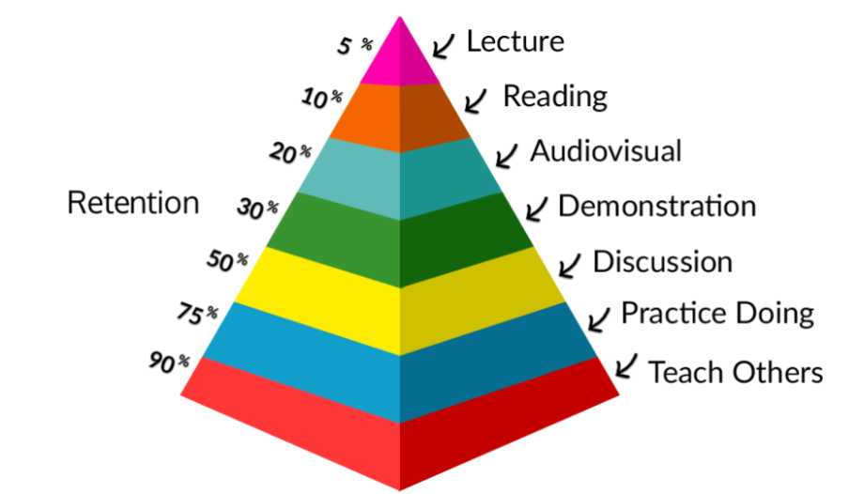 Figure Nr.1 – The mystic pyramid (source: see URL above)

The storyboard
Like in the first and second parts (about the case H1N1 and the Cold-War), each text part written for THOR will have a turquoise background colour, and the same logic is valid for each other player (virtual actor/actress): DENT will have the colour-code of magenta, STEW will be grey highlighted. DUCK “can not have an other” colour as yellow. The colour-scheme is quasi a randomized one. CON’s colour should be the red, but the Professors THOR, CON and DUCK will not have any role in this thinking experiment.
Here and now, Dent and Stew will have conversations about the simple task: we need an article with two constraints: the article must have a big-data-like background and the data should be analysed with solver-based online AI-engines. The article’s keywords are food & history.
The whole story with generated voices can be streamed here: https://miau.my-x.hu/miau/quilt/2020/quilt2/lauching2020IV22/part4.html. It is worth reading this article before switching to the animated version.
It is important to highlight that the conversation patterns are real but anonymized and these patterns could be heard and/or read in the last 4 decades with more or less frequencies. The patterns present a wide spectrum from quasi irrational ones to the ideal ones. Irrational is a behaviour pattern if it is not sustainable – it means – if every human being had the same thinking pattern then human beings would have their “residence” still on trees.
Persons | Messages of PART4 - … Food-Kaleidoscope – or teach others…
STEW | Hi! Could you help me, Dent? I have a seemingly simple task but even this simplicity seems to be the highest challenge I have ever had...
DENT | Hello! What is this mystic problem – if I may ask you? Who does say, it is simple? Who does think, it is not?
STEW | Thank you for your helpfulness. Well, the task is – I will try to cite the parts of the description - I have to write an article about an arbitrary topic being interesting enough for me to focus on it. There are hardly restrictions or constraints. The article must have in the background a big-data-like information pool and these data should be processed through a solver-based online/offline engine. Besides, it is worth writing as minimal as possible – but it is also worth having data-visualisation effects as maximal as possible.
DENT | I know this task. The magic of words should be minimized. Parallel, it is also positive, if the process of the writing steps can be automated as far as possible. This task is therefore the newest form of the Academic Writing Skill – what you will need to your final exams. This task is a kind of bridge to the AI-oriented future or more precisely to our real present. I assume, you do not have any deadlines and you may build teams if you want. And let alone, you have already a lot of demonstration materials. Yet, you do not know, what should you really do?
STEW | Exactly! Can you help me? Want you help me? Could you explain me why it is good for me to have that freedom? Why it is not possible to write tests? Or why can we not perform a kind of presentation? Why should I co-operate (let alone) with conductors, with other Students? And why conductors? Why not teachers? Why do not want anybody to give me clear commands? How should we teach others if nobody knows anything? I feel as if I were in a very strange escaping room – with no single idea what to do?

DENT | Good! You have a lot of excellent questions! I have a lot too… Did you discuss them with the conductors? Did you read already each of the recommended learning materials? Did you already answer each question of the conductors? Did you already solve each offered task? Did you try to reproduce each step, partial result of the learning materials, previous publication? I assume, you did not! Do you know the proverb-like formulation: Practice makes perfect?! The knowledge acquisition has namely two layers: the understanding in general, on the surface and the intuitions coming from experiences.
STEW | Okay, okay – you are right. I did not use the ideal way, the way you did exactly described through your questions. In case of other courses, there are more command-like supports. Here and now, you have the whole freedom, the whole project and you have all the responsibilities. Each decision can have massive consequences. The biggest problem is that I never want to publish anything. My motivation is low. And the complexity is high. Okay, I know, I have to write a final study to have my degree and fortunately, I also know that the general evaluation is these studies have a low quality.
DENT | It will be easy from now on to help you. At least, we do not need a kind of psychologist. You see your situation clear enough. Our starting point should be to identify a force field where you can find a higher level of motivations. Were you probably asked, please, send your CV to the conductors? It is not a sign of an unnecessary curiosity. The conductors need information about us. Similar as you would like to have more command-like support. Okay, your nodding makes me clear – you did not send your CV to the conductors. Well, then, I have to ask you: what is your hobby?
STEW | I like reading, and I think, I am a gourmand – it means I like to create new dishes. I like to check the quality of food on the market and… But, stop! Do not you want to tell me to write about the food? Do you really want to demonstrate here and now at once that to have a keyword is that simple? And not only the keyword is given – I feel immediately being more motivated.
DENT | Good job! You have a real talent to see connections between elements. And yes, I do hope, we can start with the keyword of food. I have already closed my publication – and what a coincidence – my keyword was the food too. Funny, huh? I have to confess, at first, I was uncertain, how will I find databases behind the keyword of food. And I did not know what the core messages will be concerning the keyword of food. On the other hand, I like reading too – and I got two impulses – two figures with URLs – from the conductors.
XXXX | https://miau.my-x.hu/miau/quilt/2020/hocus_pocus_vonnegut_3888.png  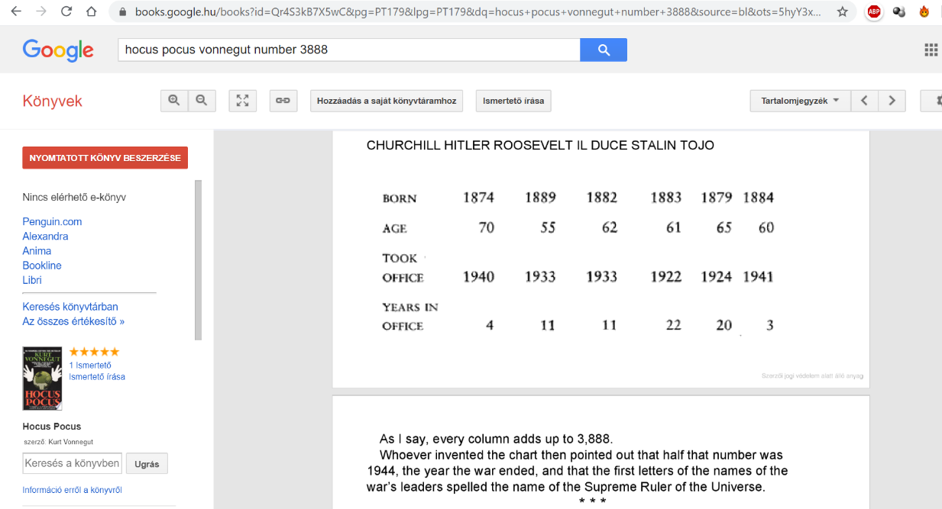

XXXX | https://miau.my-x.hu/miau/184/japhun.doc
STEW | Oops! The first one concerning Vonnegut is quasi well-known. The second one concerning Japan and Hungary is not really interpretable based only the lines. I assume, the second figure shows time series between circa 1960-2010, but the vertical axis should have a unit and the whole figure should have a title. These information units could be available as a kind of legend below the figure. On the other hand, I think, the title of the second figure has to concern the keyword of food. But my real problem is: what can be the connection between Vonnegut and the lines?
DENT | We have to go on step by step. The title of the second figure is: Food-supply-index for Japan and Hungary. The unit of the Y axis is score or goodness point. It means the value of 10000 is a kind of norm-value. Each index-value above the norm is a sign of a good year, good period for the country and the index-values below the norm let define a suspicion that the affected years/periods are bad phases of the history of the particular country. You will surely ask me - sooner or later, how the index values are calculated? But I could even ask you the same!
STEW | Before I try to answer – a question from me to you. Why do you think it is rational to ask me? It is not the job of you, of the conductors, of the teachers to declare definitions. The test-questions later can be seen as rational, but questions before teaching something, seems to be irrational for me.
DENT | This question is really important for the further steps too. You said, without motivation it is not really good to be part of learning processes. The questions before teaching are a tool to create motivations and parallel, this technique is the technique of the conductors who are responsible for supporting you. Teacher have to make declarations and have to ask you whether to learned them – without to evaluate your motivations, opinions, alternative approaches. But I think, you will have an appropriate answer to my question before.
STEW | Yes, I do – or rather I hope to have the answer. The index values could be the total value of each food-categories measured in gram per capita per day where the world average value could be seen as the norm value of 100.00 % - without digits it means 10000 scores or goodness points. It seems to be not very complicated, but I think, so easy can not be the proper answer. May I ask you: what is the solution of this riddle-like question?
DENT | Yes, you may ask me, but I will only answer you, if you try to answer your own question before. It is the same technique as in case of the previous question. If you dare to have an own statement, you should have more motivation to handle the problem furthermore. I see, you do not have any idea. But I am here to help you if you can not go on alone. The additional information is a new question. If you can decide what kind of food-sorts is worth to have during a journey assuming you may have only 3000 gram per capita per day, then I think you will have ideas, what would be better?
STEW | Thank you! Based on the last question, it is very simple to say what the general problem is with my first approach building a total value of each food-category. This addition leads to a total weight (it means quantity) without any qualitative evaluation. 3000-gram water has not the same value concerning a survival potential as 3000-gram juice. Therefore, the red and blue lines, the index values should be capable integrating qualitative and quantitative aspects. However, I do not know, how it is to realize?
DENT | Excellent interpretations! You declared immediately the so-called naïve approach with the total values. And you could also derive a critical approach to your own hypothesis. It is very-very good! The next question is, therefore, how can I explain you the calculation logic of the index values in a way where you will believe that you do not need a robust pre-knowledge in mathematics. The keyword for increasing of complexity without having trouble with the mathematics is the phenomenon of the black boxes.
DENT | A black box is here and now a closed problem where the science may declare a solid solution without deep interpretations. If I say you examples then it will immediately be clear, what all black boxes can be: you know about calendars, chronometers. But you have only foggy details in your head about cosmology and or quantum physics. I am in the same situation and almost all people speak about the time and use chronometers day by day frequently. The real nature of time is hidden – with other words: we have the deep layers of the phenomenon “time” in a closed, in a black box.
STEW | All right, I do understand! And therefore, it seems to be enough, if I have the core idea of something as before. I try to cite myself: “the index values should be capable integrating qualitative and quantitative aspects”. This low-levelled mathematical knowledge is the essence of the needed complexity and here and now it is not relevant how it is possible to calculate a kind of anti-discriminative index values. I may use this new component as a new LEGO-element never seen before.
DENT | Exactly! The so-called artificial intelligence-based aera expects that we are capable using black boxes. The classic teaching methods and philosophies tried to explain each detail for everybody. We learned things decades long which were never used later by the most of us and were ever used just by a little group of professionals. Let alone, even they had always the possibility to search for details if they already understood the core ideas. Therefore, we need to know, there are offline and or online and solver-based engines being able to derive antidiscriminative index values.
STEW | All right! My motivation level is increasing with each of your sentences step by step. I see that seemingly horror-like keywords like solver-based engines or even big-data, artificial intelligence should only be seen as labels, tags and we should not afraid of them at all. On the other hand, I think, revolutionary new ideas need that a few of us want to open and be able to open the black boxes sooner or later. Even the geo-centric concept about the world and later the helio-centric approach is a good example what will happen with us, if black boxes may be opened.
DENT | Well, enthusiasm is good, solid processes are however better. We have to go back to the still open questions. We have namely a lot of them. I think we should now focus on the Vonnegut-question. Vonnegut used a lot of existing number in order to derive a well-known date of 1944 in connection with the involved persons being also affected through the second world war. Following the analogy and focusing on the question of the core messages of the needed article, it would be amazing if we were able to derive highlighted years of a country for example in Wikipedia based on food-supply-statistics.
STEW | Sorry, but I do not know whether I did really understand now your interpretation concerning the surprising effect. Did you really say that we will have the chance to derive time series of food-supply-index-values about a country with positive and negative peaks and parallel we should find highlighted years in Wikipedia where the history of the particular country is presented, in such a way, that these years will be the same? And if, will it be not a kind of coincidence?

DENT | Exactly, it is that what I wanted to express. It could be seen as a specific interpretation of the Turing-test because coincidences are coincidences, but a high frequency of repetitions can not be a coincidence. We will be searching namely not only for one suspected year what can naturally be one of the highlighted years in Wikipedia about the history of a country. No, we will derive a lot of food-based views and we expect that the years with the highest occurrence are the same years which were highlighted in Wikipedia.
STEW | Stop-stop-stop! I hope to understand that we are capable of deriving time series of aggregated and yet optimized food-supply-index-values. But I could not understand why and how should we have the possibilities to derive parallel more alternative figures (time series)? How can a black-box-engine create alternative models at all? Through which parameters will be possible to initiate parallel interpretations? Is this not a kind of trap? Should I not still know significantly more about these AI-engines – contrary to our previous black-box-interpretation?
DENT | Your question is not without reason. Did you ever see a Kaleidoscope or even did you try to see well-known forms (like animals, hearts, etc.) in clouds? The parallel interpretations of clouds are depending on the goals: a heart-like or V-like form can be rotated and interpreted as a mathematical sign of bigger/smaller – the parallelism affects here and now the meaning. On the other hand: the same statistical data can be processed in a more or less sensitive way. The most trivial example is the case of the moving averages. The smoothed lines will can have other peaks than before.  https://en.wikipedia.org/wiki/Moving_average  https://www.youtube.com/watch?v=q2fIWB8o-bs or https://www.amusingplanet.com/2012/04/clouds-that-look-like-things.html
XXXX | 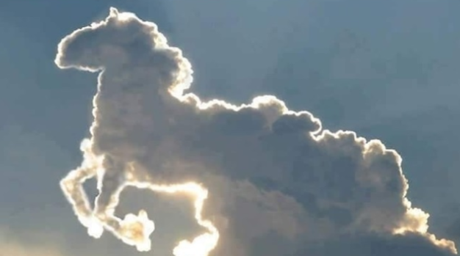  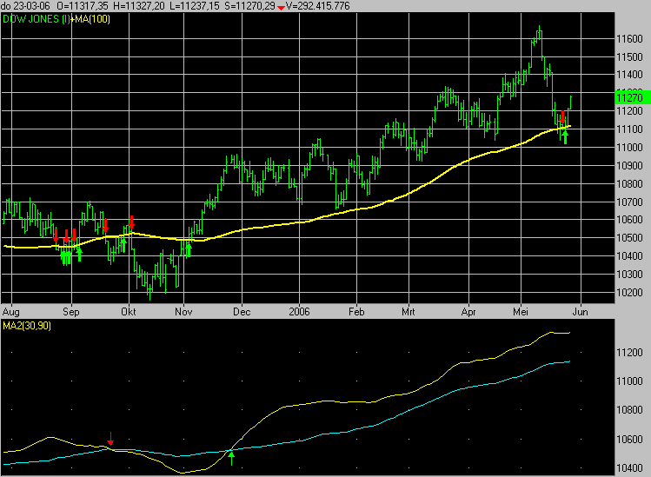
STEW | I think, I could understand your examples. And I think parallel - we will see later - what kind of parameters the online solver-based engines use at all. Let alone, the mentioning of the Kaleidoscope made me understand in a plastic way, that the numbers of the average food-consumptions for each food-category in case of a country and a year can be seen as the coloured stones in a Kaleidoscope, which can lead shaking by shaking to new pictures. It means the core idea of the parallel figures can be accepted again without deep pre-knowledge in mathematics.
DENT | All right. We could clarify a lot of important puzzle pieces. I think, it is time to re-interpret these components in order to see which further elements are still needed and why? We have a keyword. This is the food. We have a goal – deriving suspicion concerning time periods/years where these years will be validate through the identities with other sources about the history of a particular country – however, only in cases of years which could be derived based on a lot of parallel views in the so-called Food-Kaleidoscope. Are we agree?

STEW | Aye, aye, Sir! We definitely agree. However, this thinking experiment needs two persons at any rate. This kind of logic expects that you have already a closed final publication about the same keyword I accepted to focus on it. And this thinking experiment supports a kind of reproduction of already tested processes. It does not mean however that the whole process could not also be interpreted in a way, that I should be able to create a publication based on a totally different keyword. Especially, if I will study - in a more precise and detailed way - the given demonstration materials.
DENT | Well! Could you from now on create the needed publication - on your own? What would you do at first if I may ask you so directly? What is that you still need? Which key-element is still not given if you are remembering of the cited task-description at the starting point of our conversation? May I cite you? “You have to write an article about a topic being interesting enough to focus on it. There are hardly restrictions or constraints. The article must have in the background a big-data-like information pool and these data should be processed through a solver-based online/offline engine.”
STEW | Well, we have the topic including a goal. We have the connection to the black boxes, it means, to the solver-based engines – let alone, in parallel ways. But, but, but we do still not have the data, the so-called big-data-references. I think – the ensuring of a big-data-relevance is the next step we need to manage.
DENT | Yes, you are right. We need at last the data. Quasi nothing is useful from these conversation units if we do not have the appropriate data sources. I think, it is trivial what kind of keyword-set we will use in order to identify the potential data sources based on a Google Search action. Our keywords should naturally be: food+supply+”gram/capita/day”. The data source will be visible on the first place. The organisation managing the needed data is the FAO. The offered format of the data is the long format supporting the data processing and reporting in an ideal way.
XXXX | 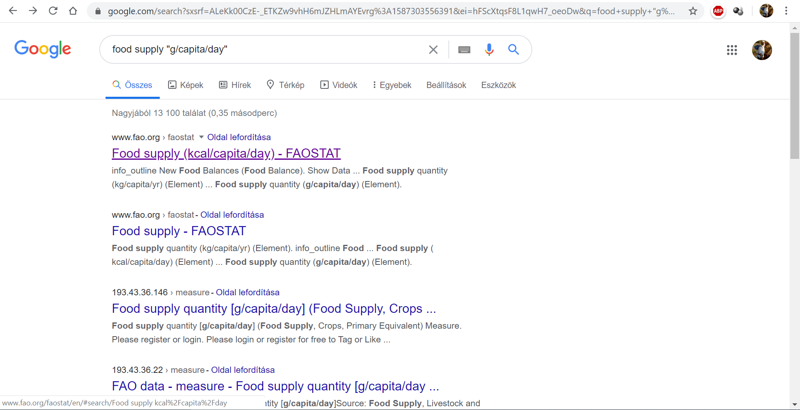  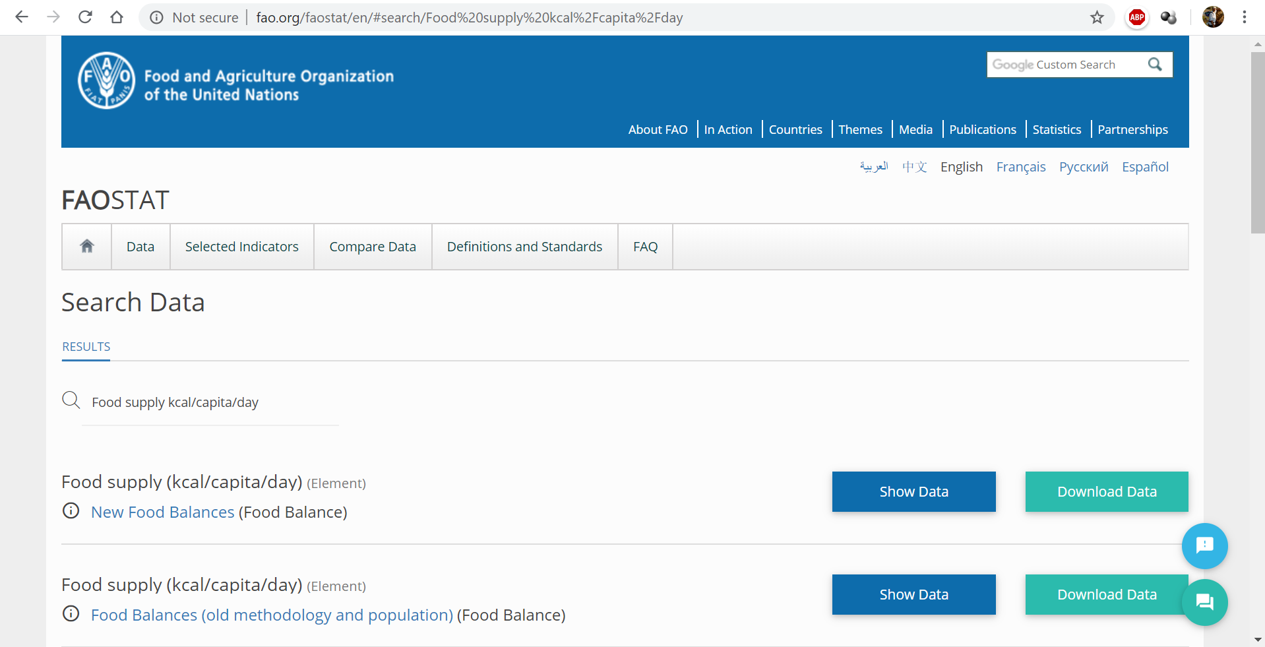  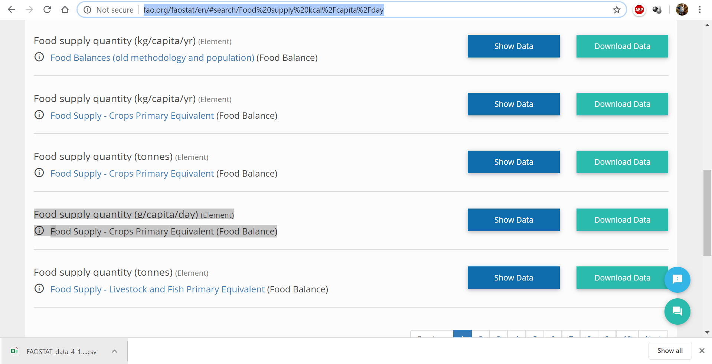  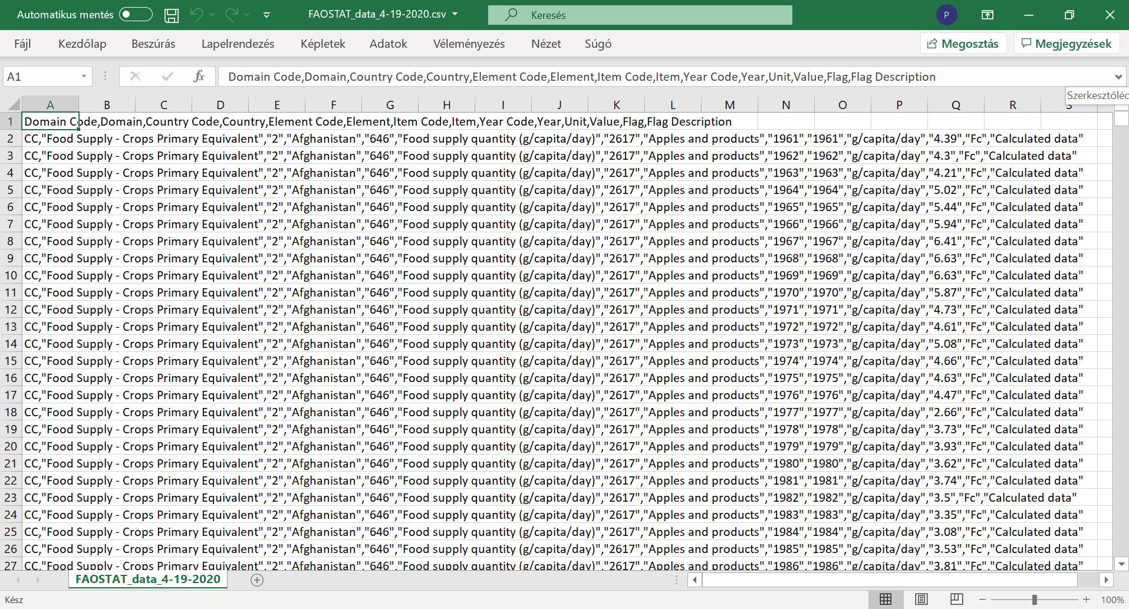  More details: https://miau.my-x.hu/miau/quilt/2020/food_project/how-to-use-data-in-long-format.mp4 + https://miau.my-x.hu/miau/quilt/2020/food_project/how-to-create-models-and-figures.mp4
STEW | I have to say, the video-tutorials are very useful – even if the Excel-language-setting is not English. Everybody can immediately see what kind of steps are necessary and how to manage them. I think there is a further important keyword: the expected co-operative working as such. It means the conductors are always available – for example if we need the parallel views. I hope it is time by now to speak about the problem of the parallel views. How can we derive these certain parallel views?
DENT | All right. We can speak about the parallel views, about the parallel models. However, I think, a good part of the answers you will be able to identify – if you read a closed article about the Food-Kaleidoscope. On the other hand, the reading of this article will help you to find the answer to your next possible questions: What kind of chapters and volumes should be prepared in order to have a proper article? Or even: how to involve the figures into the text streams? One of the useful URLs is the URL about the Congo-study:  https://miau.my-x.hu/miau/261/food_kaleidoscope_case_congo.docx
DENT | Before you will start reading the demo file, it seems to be useful to speak about, how it is worth interpreting it concerning the two core questions from before. In order to identify parameters how make possible to create parallel figures, it is necessary to see each figure of the demo file including legends, titles. Based on the descriptions of a particular figure, it is trivial to identify, what kind of differences between the descriptions can be found. Concerning the necessary chapters, the process is more simple: each author should have each identified chapter in the own publication.
DENT | Finally, you will see the logic of the integrated figures and the role these figures have and therefore it will be clear, that the core messages are the figures as such and each text – it means – the magic-of-words-effects make only seemingly easier for the Reader (also using the magic of words) the interpretations. I said – seemingly easier – and this is not just a random used formulation! The human interpretations concerning figures with complex core messages can definitive be wrong. The Cold-War-Project demonstrated how complex it is to speak about changes of X and Y variables parallel.
STEW | Well! This was a really complex introduction! I have never thought, that so much useful instruction could I ever have before I start with reading an article. Thank you. Although your interpretations were multi-layered, I think, we have at least on open question – the question of the text-volumes. Is it worth writing rather more or it is better to formulate only briefly? Or the length of the interpretation texts is irrelevant – we should create texts being even long enough to describe the complexity in a still proper way.
DENT | Before I say YES to one of your three options, it is important to highlight that you could identify in case of a seemingly yes-and-no-answer-pair the third option! Good job, Stew! The third answer-option is very important. Through this option, we can signalize that the question should not have an answer at any rate. This is a kind of the none-options or with other words: it is a kind of the system answers from type of “I-do-not-know”. By-the-way: it is a great challenge for the AI to produce this type of system-answers. The non-knowledge as such is namely a kind of real knowledge!
DENT | And my answer therefore is the third option is the good answer. The length of the article depends on the complexity needing to present. The volume of an article, or with other words the length of an article is also depending on the figures needing to explain. Theoretically, we do not need textual interpretations (not a single word) to explain a figure. Unfortunately, we all are socialized to use the magic of words – although we have visual communication experiences in form of card games, chess, or even traffic signs. Yet, we speak about figures – probably not seldom in wrong ways.

STEW | All right. It is then time for me, to read the demo publication. The reading process can be simulated in frame of two different video streams where the needed focus points will be highlighted with the mouse. In the first one we will see the identification of chapters. In the second one we will see the identification of the figures and their parameters. This is the same effect as in case of a face-reader process and or in case of an eye-tracking application where we can see in an animated form which part of the picture the eyes are seeing at.
XXXX | https://miau.my-x.hu/miau/quilt/2020/quilt2/launching2020IV22/chapters.mp4  https://miau.my-x.hu/miau/quilt/2020/quilt2/launching2020IV22/figures.mp4
STEW | The needed main chapters, content elements are now trivial. We need a title, an abstract, the keywords, a kind of introduction, information about the data assets in a form supporting the expected reproducibility, short description of the methodology, the results with a lot of figures, a kind of discussion, the conclusions, and finally the references and the annexes. Subchapter should be defined depending on content – I assume so at least. But it would be nice to have rules, recommendations – what should be written in these chapters at last?
DENT | I could say again and again: please, read the other demo articles about H1N1 and about the Cold-War in order to derive on the own what are the rules you search for. But in such a case you could make a rational repost: why should you search for something what can and should be defined before? And you would be right. The rules are however very simple. Introduction is not really regulated but goals, targeted groups, benefits, and motivation are the keywords. The data assets need the URLs, and two lists: about the objects and about the attributes with units, definitions, interpretation intervals.
DENT | The methodology should contain the logic how and why we process the data. The results are the figures and the core messages formulated in human words. The chapter of discussion contains each critical aspect explored during the whole creation process of the publication. Conclusions are declarations, recommendation what we would do if we were in the role of the targeted groups. References are the sources being involved in the chapters of the publication. Annexes are details which is not worth presenting in the text stream because the readability would be disturbed through them.
DENT | I see you could also identify the important parameters of the figures as parts of the legends. Excellent. You highlighted – as the muted video shows them without any doubt – the number of the parallel processed countries and the number of the models/steps. Here and now, I should try to summarize the theoretical background. Well! If you see only one single dog, and this dog should even be a Labrador with webbed fingers, then you would assume, each dog should have webbed fingers. But this assumption is not correct. It means: the analysis with one or more countries can lead to different results.
STEW | Oh! Wow! This example is very useful. I would like to guess a little bit about the meaning of the second parameter – about the number of modelling steps. In case of the figures where the number of the modelling step was only one, we see Y-values close to the norm-value of 1000000. The further figures where the number of steps is two or more led to significantly higher/deeper peaks around the same norm-value. Therefore, I have to assume, that the number of the modelling steps causes a kind of increased sensitivity. But I do not know how we can realize this increased sensitivity?
DENT | Good conclusion and good question. The antidiscriminative models try to involve each attribute - it means each food-category. In general, in case of a huge number of attributes, it is not necessary to involve all of them. A part of them could be enough to ensure, that each country seems to be so as if it should have the same aggregated food-supply-index-value. The not (really) involved attributes have however information units being useful in the second and third steps. Altogether, the less and less number of attributes leads to more and more sensitive estimation concerning.

STEW | All right. It seems to be easy on the needed understanding level. If I do not have to reproduce the modelling steps, then I may say that I understand the black box logic. I could for example give commands/orders for experts, I need an antidiscriminative analysis with one or more countries and in one or more steps. The interpretation logic should however be the same. And the publication demonstrated that the evaluation rules are really the same. We only need to make visible the positive and the negative peaks in case of each figure.
DENT | Exactly. Our result has a pre-definable structure: the years could be the row-headers and the figures could be the column headers where each cell can contain a + or a – sign for the suspected years. The + sign is a positive peak and the – sign is a negative peak. The result-table should have to layers: one layer for the absolute values and an other one for the differences between the neighboured absolute values because the most intensive changes produce peaks to in the difference-view. The pre-defined structure of the results makes possible to declare interpretation rules in advance!
STEW | Well, I think, it is time again to summarize the information units we have. We have the necessary data about countries, years, and food-categories – let alone, each variable has the same unit – and this unit is already relativized (gram/capita/day). We have our online modelling tool MY-X-FREE-COCO where we have the appropriate model type is the COCO Y0. We know, we have to involve one or more countries and we have the possibility to increase the sensitivity based on the number of the modelling steps. Finally, we know the interpretation rule in advance for the pre-defined results.
DENT | If I were you, I would ask me, what is this famous rule?! And I would say, this rule is a simple one: we are searching for the years being suspected frequently enough or in case of each figure. Parallel, we expect, that these years concerning positive and or negative peaks based on absolute and or relative figures can be identified in the online literature speaking about the history of the particular country. Everybody can see in case of Congo – it can not be a simple coincidence that we see quasi the same numbers or years in Wikipedia and in our Food-Kaleidoscope.
STEW | These parallelisms can also be seen as a specific kind of a Turing-test where theoretically human beings should be decide about algorithms. Does an algorithm behave itself human-like enough? The specific test says: We do not need human – it means subjective – votes to derive whether an algorithm is a good AI. We only need a corpus – for example, the Internet where we can find human opinions about the critical years independent from the existence of the tested AI. If the conclusion of the AI and the conclusion of the human experts lead to the same or similar results, then the AI is good.
DENT | Excellent! Here and now, I have to highlight one important parameter of a publication. We could write about our own subjective opinions concerning the critical years of a country. All these sentences would always be a subjective approach. Or it is also possible, that we find an estimation from an unknown AI and we have to check it. In both cases, we need our own but objective derived conclusions. And these conclusions should always be made in a data-driven and solver-based way! Each other publication is a form of the magic of words. Shifting paradigms mean: this magic should be minimized.
STEW | Wow, this is a very hard declaration – I think. Generations are conditioned to be perfect by using of the magic of words. And now, we have two new keywords. The new communication should be more and more data-driven and solver-based. This will lead us to a new situation – I hope, and I believe. This new situation makes possible to be intuitive and subjective where it is needed – and parallel, there where we can produce more objective estimations we have to do so. The human and machine interaction will be more and more sophisticated.
DENT | This new situation has already a name. This could be Kazohinia!
XXXX | 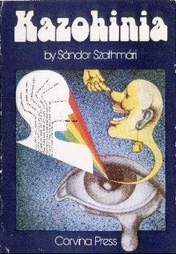

Potential focus points for distance-discussions
The QuILT 2.0 frame system offers co-operation possibilities concerning the avatar-based videos: https://miau.my-x.hu/mediawiki/index.php/QuILT2_parts
The H1N1-project and the Cold-War-project prepared already potential FAQ-elements and this list will also be completed here and now:
Part | Player | Content | Question | Answer
System-level | all | Figures/Videos | Why are figures available in case of a radio-theatre piece? | Voice-based core messages should also be prepared concerning visual content elements. Like in case of muted videos in the previous parts, it is here and now useful to expect that the voice-based declaration and the visual impulses should be paired later too.
…

Annexes
The background data and the final version of the article can be downloaded here:
- https://miau.my-x.hu/miau/quilt/2020/food_project/?C=M;O=D
- https://miau.my-x.hu/miau/quilt/2020/food_project/CONGO_HU%202.xlsx
- https://miau.my-x.hu/miau/261/food_kaleidoscope_case_congo.docx
- https://miau.my-x.hu/miau/quilt/2020/food_project/how-to-use-data-in-long-format.mp4
- https://miau.my-x.hu/miau/quilt/2020/food_project/how-to-create-models-and-figures.mp4

