QuILT 2.0 – Exam versions in frame of an asynchronous distance education/learning – the 21st century is here

László Pitlik, László Pitlik (jun) (MY-X team)

The HTML5-based streaming version can be used through this URL: <https://miau.my-x.hu/miau/quilt/2020/quilt2/launching2020IV29/part5.html>.

Abstract: The asynchronous distance education for Students is a module of the Life-Long-Learning system for adults. The new technology and philosophy need new approaches concerning the examination too. The old-school approaches should mostly be forgotten. Techniques like supervisions by human beings on the spot during the written exams, general deadlines instead of customized deadlines, arbitrary excluding sources/tools being part of the daily working processes of experts, questions/tasks where it could be searched for the answers in an automated way, planned exams instead of randomized challenges, useless tasks instead of real creation processes, lack of quality assurance, test-options without a real misunderstanding potential, etc. are not appropriate for the modern knowledge management, knowledge acquisition. The new situation catalysed through the COVID19-risks makes possible to change the culture of examination too. The paper, the storyboard of a radio-theatre piece presents alternative solutions. The question is not whether the Reader want to believe in the new possibilities or not. The question is, can we prove the significantly positive impacts of the new treatments concerning the practice-oriented success potential, concerning the sovereignty or not?!

Keywords: robot teacher, robot Student, thinking experiments, automation, efficiency, big data, solver-based modelling/interpreting/hermeneutics, intuition generating process, artificial intelligence, OAM, LLL

# Introduction

If Students have a task to create a publication with objective derived results for real publishing purposes and not a subjective set of randomized opinions – called as presentation for never more to share with others, and the Students did not have the possibility to involve prior learning experiences in this field (because the expectation before did not supported their sovereignty and the black-and-white quality management processes, then a new bridge should be built above a very wide gap. The above-mentioned publication-challenge is namely one of the new forms of the examination of competence/knowledge levels. In case of a publication, each source, tool can be used unlimited – especially then, if the publication should be finalized in a co-operative form with one or more conductor.

Of course, in a real teleworking environment, where each subtask can be executed in a flexible and asynchronous way, the Students could theoretically involve appropriate experts, because the time is given. But it is also possible, that these publications should be presented by their “authors” prompt on the spot (c.f. drug-test for champions) quasi in form of a life-long-responsibility and including all details needing for reproducibility in unlimited frequency without having information about the test situation before. Parallel, Students with competitive positions should evaluate the publications of the others and the explored lack of the quality should be fixed immediately by the authors.

This new world of the evaluations of Student’s performances also expects the evaluation of the log-data coming from the learning and/or content management systems where the learning behaviour can be interpreted and based on these interpretations the reactions of a (Robot)-conductor can be customized too. Is this a phalanstery or the near future of the distance education?

# The storyboard

Like in the first and second and third and fourth parts (about the case H1N1 and the Cold-War, and the Food-Kaleidoscope ), each text part written for THOR will have a turquoise background colour, and the same logic will be valid for each other player (virtual actor/actress): DENT should have the colour-code of magenta, STEW should be grey highlighted – but they will not play in the storytelling where Professor DUCK (she can not have an other” colour as yellow) and Professor THOR will be active. The colour-scheme is quasi a randomized one. CON’s colour should be the red, but the Professor CON will not have any role in this thinking experiment too.

The storytelling will be realized in frame of a radio-theatre because, this form does not need and does not supports visual effects. The stories about old-school examination forms and modern alternatives come from the last 4 decades where the critiques of the old system were and are day by day reality on the universities and high schools.

|  |  |
| --- | --- |
| Persons | Messages of PART5 - … expected exam-versions in the 21st century … |
| THOR | Hello! It was very interesting to hear how Dent and Stew spoke about the Food-Kaleidoscope in frame of the teach-others-scenario. There were a lot of questions of Stew which could still not answered. For Example: Could you explain me why it is good for me to have that freedom? Why it is not possible to write tests? Or why can we not perform a kind of presentation? Why should I co-operate with other Students, or even (let alone) with conductors? And why conductors? Why not teachers? Why do not want anybody to give me clear commands? Professor Duck, do you remember? |
| DUCK | Hello! Of course – I do remember! These are important questions and they should have answers at any rate. I would start with the expression freedom and at once I would highlight an other word – the sovereignty. Sovereignty means - even a single Student should be capable of solving problems never seen before. It means too - the Students do not need commands because Students are not machines having a source code in their head written by the teachers. The world will produce new and newer problems, therefore, the knowledge being only useful in well-known cases, is not enough. |
| THOR | This is a good starting position being for a few seemingly to hard. And I will try to make it still harder: the education systems are functioning just well if the new Students can stand on the shoulders of the older generations. It does not mean that the new and newer generation can repeat without any errors each component of the whole knowledge collected before. It means however that the new generations have the responsibility to search for errors, lacks, uncertainty in the collected knowledge system. The new generation should simply be better, more competitive. |
| DUCK | There is a trivial and long existing situation in the human life. If a family has an enterprise and the time is coming where the old generation should at last let that the new generation makes the decisions – but the life of the whole family is depending on the decisions of the new generation. This scenario was already valid in tribal societies too where the hunting strategies could be seen as existential. Nobody could be sure to have the stone of the wisdom. Decisions should be made at any rate. And please never forget there are tribal societies and or family enterprises making bad decisions. |

|  |  |
| --- | --- |
| THOR | A bad decision can be letting the new generation to be active and it makes a decision, leading to collapse of the system - however other competitors find ways to survive. Fortunately, the evolution is not just black and white. There are cases (with a significantly higher frequency) where the way to lose the competition has a cumulative character. It means instead of totally ineffective decisions a lot of less efficient decisions can also be made. The ineffectiveness is if it brings definitively no result. Inefficient a decision is if it could have been more result based on the same efforts. |
| DUCK | A series of inefficient decisions can reduce the market share of an enterprise step by step below the critical level where the enterprise should be terminated. To be good enough means too that we are capable of measuring the GOODNESS. And we need not only l’ art pour l’ art the capability of measuring the goodness as such, this competence is the basic of the automation of learning, the automation of machine learning. A robot teacher, a robot conductor will only be able to support learning processes of the human beings in an effective way if the impacts of an action can be simulated in advance. |
| THOR | It is important to see examples, but it is more important to have a generalized capability to solve arbitrary problems. Teaching and learning are only then good if the generalization potential will be increased through them. This expectation could be denied before the area of computers and therefore before the area of the artificial intelligence. The KNUTH’s principle made however clear that almost each human capability can be transferred, transformed, translated into source code. It is just a question of willingness. What should be as the next one transformed, it a question of efficiency. |
| DUCK | The above-mentioned expectation should be interpreted in the statistical levels. The unique individuals can be just curious, and they can enjoy the information streams like National Geography, Spectrum, etc. These are the so-called popular science channels. In these cases, it is seemingly not relevant what kind of changes of the knowledge levels and wat kind of changes of the knowledge structures the users will be realized. In case of accredited school systems (like universities, high schools, etc.) it should be relevant, what kind of promises can be identified and later proven. |
| THOR | The accredited institutions and the accreditations process should be handled like nuclear power plants. Each parameter value should be planned, and the interaction of the parameter values should be estimated and later proven whether the plan values and the fact are close enough compared to each other. Similar situation can also be observed in case of precision farming. The teaching and learning process should therefore support the increasing of the culture of evidence-based thinking. Evidence-based thinking means we are able, and we want to prove the correctness of declarations/hypotheses. |
| DUCK | Unfortunately, the evidence-based thinking is not a central parameter in the school systems. Teachers declare the knowledge and they seldom have time to derive it. Instead to say, the Earth is round and or we should speak about a helio-centric approach, we should offer each detail about how these declarations could be proven in the past. This kind of shifting of paradigms will lead to a generation where the population will less believe and more understand. You could say at once, the evidence-based learning and the former black box theory seem to be antagonistic to each other. |
| THOR | Fortunately, the antagonism is just partial realistic. In ideal case, each human being should know each component of the entire human knowledge. It is however impossible. The proper question is what parts of the entire knowledge should be known to have the highest level of adaptivity, the highest level of generalised problem-solving potential. For example: to accept that the Earth is round we just need images from satellites where the planet can be seen from a lot of point of views. Black boxes are the satellites, the physics of the space programs, the photo-technical backgrounds. |

|  |  |
| --- | --- |
| DUCK | On the other hand: to accept that images from different point of views lead to the conclusion that the Earth is round, expects, that we can prove, that we can understand in a mathematical way, how images can be integrated for example to a hologram of a sphere. We can ignore in a moment parts of the evidences and we can see parts of the human knowledge hidden in black boxes, but sooner or later, it will be important to prove each details – fortunately not by a single individual. |
| THOR | All these briefly presented theses can be found in important works (novels, movies) if somebody would like to interpret more details. Worth reading (about the static and dynamic characteristics of the quality by Robert Pirsig). Worth watching (about how weak out evidence-based strategies can be in a moment and how strong is the logic in long term – in case of acceptance of nutrition rules in the society and economics).  About the objectivism, you can collect impulses in form of a novel too – the novel is from Ayn Rand, and the title is Fountainhead. The novel of Kazohinia written by Sándor Szathmári is also a relevant frame to support the understanding processes of the new aera – worth therefore reading – especially if somebody is in a quarantine situation. |
| XXXX | Worth reading (about the static and dynamic characteristics of the quality by Robert Pirsig): <https://terebess.hu/zen/mesterek/Robert_Pirsig-Lila.rtf> |
| XXXX | Worth watching (about how weak out evidence-based strategies can be in a moment and how strong is the logic in long term – in case of acceptance of nutrition rules in the society and economics): <https://www.arte.tv/de/videos/083970-000-A/dick-dicker-fettes-geld/> |
| XXXX | About the objectivism, you can collect impulses in form of a novel too – the novel is from Ayn Rand, and the title is Fountainhead: <https://www.youtube.com/watch?v=x7o-kbgjeOI> |
| XXXX | The novel of Kazohinia written by Sándor Szathmári is also a relevant frame to support the understanding processes of the new aera – worth therefore reading – especially if somebody is in a quarantine situation: <https://en.wikipedia.org/wiki/Kazohinia> |
| DUCK | If we may assume, that the above-mentioned expectation concerning our future on the field of teaching and learning are relevant, then the next step is, to make short thinking experiments about potential exam-situations in frame of the distance education. We have to define new forms of examinations and we have to test these forms as if we were ethical hackers. Ethical hackers are experts if they accept a challenge about finding out weak points of physical systems and or virtual regulation systems without having any interests to use this knowledge for own benefits. |
| THOR | The first thinking experiment should focus on the exam situations where Students are checked concerning their competences on foreign languages – of course – in an online system. The old-school solution is - the Students, the room for examinations will be observed by human beings in case of written tests. The surveillance through human beings is in case of the verbal tasks given. In an online system however, Students will be at home. What can be checked, controlled, observed and what should be? The naïve approaches speak about video and voice streams what will be part of the communication. |
| DUCK | These video- and or voice-streams will be interpreted by human beings in case of verbal tasks. In case of written tasks, the online software as such could be used for controlling. The classic written tests could ever be faked – for example through cheat sheets. The verbal situation in an old-school-system could more and more faked through high-tech solutions – like in case of spies. If somebody is at home, then this person can prepare a parallel working station where a language-expert will be available. The expert can see, hear parallel each impulse. |

|  |  |
| --- | --- |
| THOR | These experts can even control in a remote mode the computer of the Student in case of written tests. In case of verbal challenges, the Students should only be capable of reading if the expert speaks in an other room to a speech-to-text software and the text version can be projected for the Student for example in form of a second monitor or to smart eyeglasses. A human being will never be able to prove whether a Students had helpers and in which form if at all? The personal identification of a Student can even not be guaranteed at home. |
| DUCK | Please, imagine, however, that a Student can only choose the online exams if this person before produced log files about mouse and or keyboard activities – as far as possible in the same online learning system where this person learned day by day. The identification of this person is therefore a question of mathematics like in case of fingerprints. Parallel, the learning patterns collected during the training phases will make possible to estimate the potential errors in structural-qualitative and in quantitative layers. |
| THOR | Let alone, it could be pre-scripted in case of an online exam that the Student should have an EEG-headset. The exam is not valid, if the EEG-signs are not appropriate either in technical or in contextual layers. The contextual layer should estimate whether the Student had a remote influence or not. And the best quality management in long-term would be if each Student could be stopped in a prompt way without any pre-information in order to test on the spot a before absolved competence. |
| DUCK | Everybody can feel that this phalanstery-like environment could only ensure a real controlling of person-related competences. On the other hand, the more or less faked competences will be used in real problem situation where other persons with more or less faked competences are present. These group with more or less faked competences should solve the particular problem – hopefully in a frame where responsibilities can not be faked. The fake-oriented societies will therefore find intuitive techniques to minimize risks through uncertain volume of pretence being everywhere present. |
| THOR | Well! We are probably living since ever in this pretence-driven society! This sarcastic conclusion leads to a hypothesis where each exam-situation should be forgotten. Each person should “only” have the log-files produced before and each HR-expert of an enterprise should have access to AI-based solutions where these logs can be evaluated from point of view of different questions. |
| DUCK | Before we however switch to a specific phenomenon, to the observation, we should speak about the test-based measurement of competence, knowledge. Tests can be seen quasi everywhere. We have to write tests before we have a driver’s licence or we have a new job where about fire regulations, or even occupational safety tests are prepared. The evaluators behind the EU-applications in case of research and development activities should also write tests concerning the regulations needing used in the evaluation processes. |
| THOR | These tests are mostly irrational challenges if the person who should be tested has an unlimited access for relevant sources. It means if we have the fire regulations in file format and a computer where we can search for keywords then the test questions should even not be understood to find the proper answer. It is only necessary to identify the most seldom word in questions and or in answers and for this specific keyword should be search in the file about the fire regulation. In quasi all cases, the questions and the proper answers will not have any difference compared to the written rules. |
| DUCK | If the proper test answer can not be identified in form of searching activities, then the lowest level of rationality could be reached. On the other hand, the tests where one or more options should be chosen as the proper ones, should have in case of the bad choices/options such an alternative answers which could be proper if the question would be modified in a marginal way. The bad choices can therefore not be random choices because each choice could be transformed in a yes/no-question with interpretation expectation where the random choices could not have rational arguments. |
| THOR | We should demonstrate examples here and now. The question should be: How many minutes are needed to produce the necessary results for an article based on online databases in case of the AI-relatedness-index? The shortened URL of the learning material needing interpreted is: <https://miau.my-x.hu/ai2020> |
| DUCK | Before somebody would try to inspect the pre-scripted contents, we have to see the potential answers to the question before. We need a number. Therefore, alphabetical options (like a week, a day, etc.) are not appropriate – we have namely the unit in minutes. The proper answer should be the total number of the length of each video-stream. It would be an evil question if the answer options would be given in minutes and we would need for the proper answer a kind of rounding rule – except, if the question uses the term “at least” – where the test-question would be a kind of attention test. |
| THOR | Following the previous logic, each answer option below the total could be a kind of disturbing, real possibility because the Student should not know whether each video-part should be accepted as a real part of the way leading to a rapid solution - from point of view of the teacher. This trap is more evil, if the proper answer is not the total but some partial total – it means the teacher really think that not each component is part of the needed way. So, the total would be a kind of overestimation. |
| DUCK | If I were a Student, then I would make notices about my argumentations if it is possible at all. If it is not possible for example in an online test-environment, then I would protest and ask a verbal exam where it can be proven whether I have appropriate arguments or not. The tests should therefore be clear understandable and yet not interpretable based on searching activities. Following the example about “at-least”, the question before could also be finetuned in order to ensure certainty about the needed and not-needed video-parts. |
| THOR | The new, finetuned question could be: How many minutes are needed to produce the necessary results from each point of views for an article based on online databases in case of the AI-relatedness-index? It means, the question as such should have parts with appropriate argumentations where the proper answer should be an other one among the potential options if one or more words would be changed. |
| XXXX | <http://miau.my-x.hu/miau/212/160506/observations.xlsx> |
| DUCK | The referenced Excel file contains an URL for an online questionnaire about observations and or being observed. As a kind of facultative task, it is worth filling the questionnaire and it is worth making a thinking experiment how this questionnaire should be evaluated if for example each Student of the course delivered the answers. This facultative task supports the competences concerning the final publication of the course because each thinking experiment can be seen as a kind of “mocking” – at least from point of view of the IT-experts.  <https://en.wikipedia.org/wiki/Mock_object> |
| THOR | The Wikipedia says: In object-oriented programming, mock objects are simulated objects that mimic the behaviour of real objects in controlled ways, most often as part of a software testing initiative. A programmer typically creates a mock object to test the behaviour of some other object, in much the same way that a car designer uses a crash test dummy to simulate the dynamic behaviour of a human in vehicle impacts. Concerning the questionnaire, it should be a real expectation, that everybody creates an interpretation system - after each question is finalized but before answers will be given. |
| DUCK | The interpretation of a questionnaire is a good task for a final publication if the interpretation rules are more complex than the well-known average, share, etc. calculations. The observation as such is a symmetric approach: I (as Student) may be able to want to observe something and I (as Student) can be observed through different human and or robotized agents. The exam-situations are observations. I am observed in order to know that I am honest. I am observed in order to know what I know, how fast I am, what kind of steps I am using, what I am correcting after what kind of impulses, etc. |
| THOR | I (as Student) am observing the tasks of the exams: I try to find sign where a question or task is helpful to solve the other ones. I (as Student) have to observe each word of the descriptions of task in order to minimize the misunderstandings. I (as Student) can observe other Student in order to see their reactions, speed, etc. during the exam situations – as far as possible. I (as Student) have to observe each detail of the evaluation concerning my works in order to see errors or to collect impulses for better performances later. |
| THOR | I (as Student) have to observe the learning materials in order to explore what kind of connections can be identified between parts. I (as Student) have to observe former performances of Students to be capable of evaluating myself compared to different benchmarks. I (as Student) should be think about my traces in the log-files and about the potential consequences of these traces. I (as Student) should observe statistics about Students to derive discrimination potentials. |
| DUCK | I (as teacher, conductor) have to observe behaviour patterns of Students in order to assume that somebody will be willing to use not allowed techniques. I (as teacher, conductor) have to observe former tasks in order to estimate whether the recent tasks are complex enough but not too complex. I (as teacher, conductor) am observed by Students wanting to use not allowed techniques depending on the changes of my attention potential. I (as teacher, conductor) am observed by other teachers, conductors in order to be benchmarked, evaluated, etc. |
| THOR | Here and now, it seems to be important to speak about the differences of teachers and conductors in general. A classic teacher tries to evaluate the behaviour of Students compared to a kind of norm, standard – basically independent from the potential information about the Students and basically independent from the legitimacy of these norms. This independence can be seen as a kind of (irrational) equity. The conductor however tries to understand the Students as systems and the conductor has to derive expectation about how Students will behave in future. |
| DUCK | Conductors are therefore rather system architects, simulation experts. Teachers are rather project manager. Conductors and teachers try to choose the most rational one among the potential actions. But the teachers see an action rational if it is useful to approximate the norms. The conductors see an action then useful if the expected impact is sure enough. Pure teaching and pure conducting are not realistic. Conductors may also have norm values – for example: the number of repetitions can not be arbitrary low to reach a planned impact level. Parallel, teachers can also be tolerant. |
| THOR | If we know at last what is a pure teacher and what is a pure conductor, then it is also important to explain, why a co-operative task involving Students and conductors is more rational than letting Students alone creating solutions in arbitrary ways. Arbitrariness is a dangerous freedom. The society needs human beings being capable of cooperating. The co-operation potential is depending on reproducibility, critiques and innovations. The reproducibility means everybody should be able to follow commands/recommendations. Critical aspects are relevant in order to avoid trivial errors. |
| DUCK | And innovations will be catalysed through the experiences during the reproducible working steps and through deriving potential errors. To be innovative means to have the capability of evaluating alternative solutions. Reproducibility, critique and innovation need sovereignty. Reproducibility is in general not a kind of detailed command-series – rather a common interpretable goal-definition. Reproducibility needs creativity where parallel steps may be executed in arbitrary ordered ways. |
| XXXX | <http://miau.my-x.hu/miau/212/160506/observations.xlsx> |

# Potential focus points for distance-discussions

The QuILT 2.0 frame system offers co-operation possibilities concerning the avatar-based videos: <https://miau.my-x.hu/mediawiki/index.php/QuILT2_parts>

The H1N1-project and the Cold-War-project prepared already potential FAQ-elements and this list will also be completed here and now:

|  |  |  |  |  |
| --- | --- | --- | --- | --- |
| Part | Player | Content | Question | Answer |
| XXXX | --- | MP3 | How can be downloaded an mp3 voice-file without capturing and letting speak to end of the prepared texts? | With F12 everybody can activate the DevTools for the domain of ttsdemo.com. After CTRL+R the log can be activated and the network menu supports the opening of the sent voice-file in a new tab where the downloading option can already be used. |
| … |  |  |  |  |

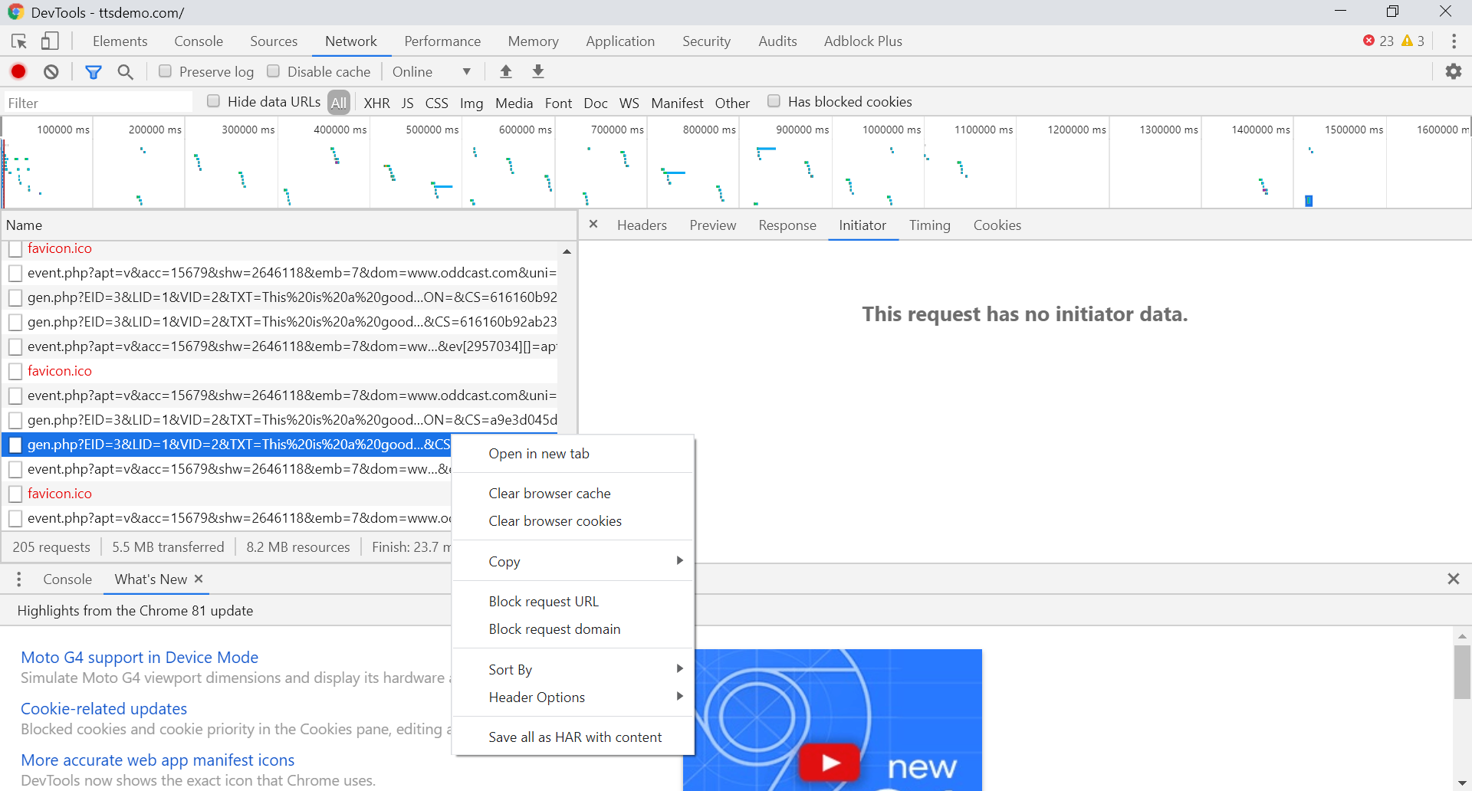

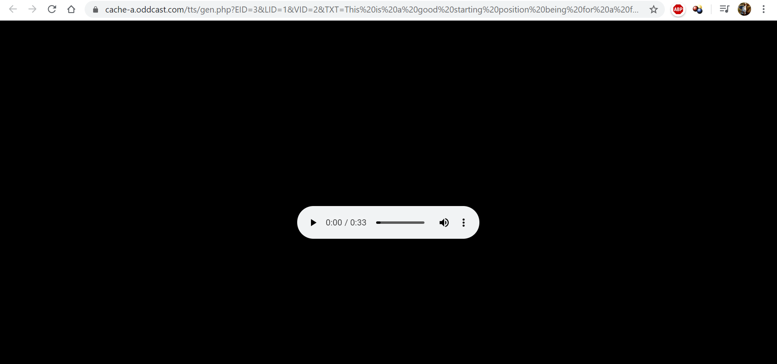

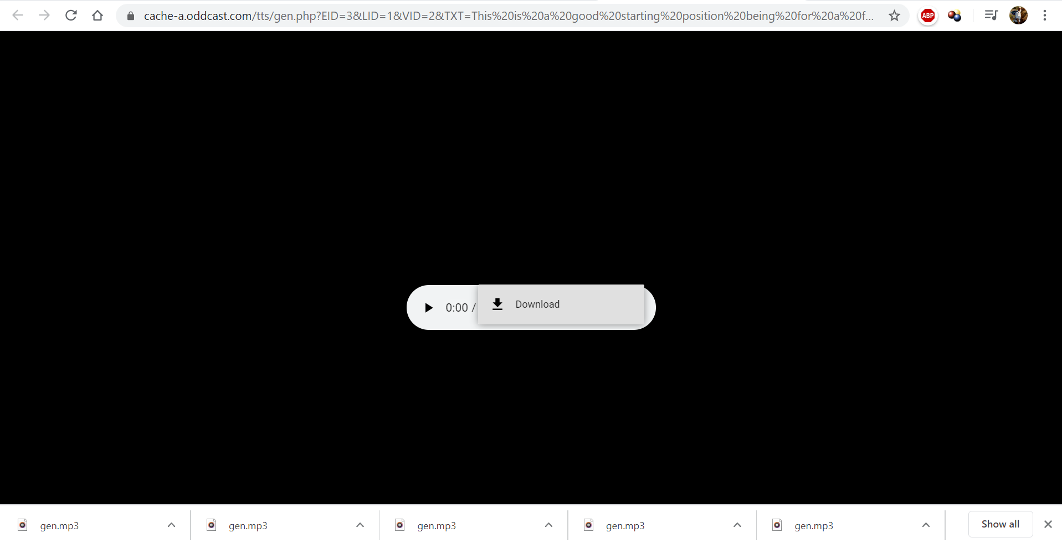

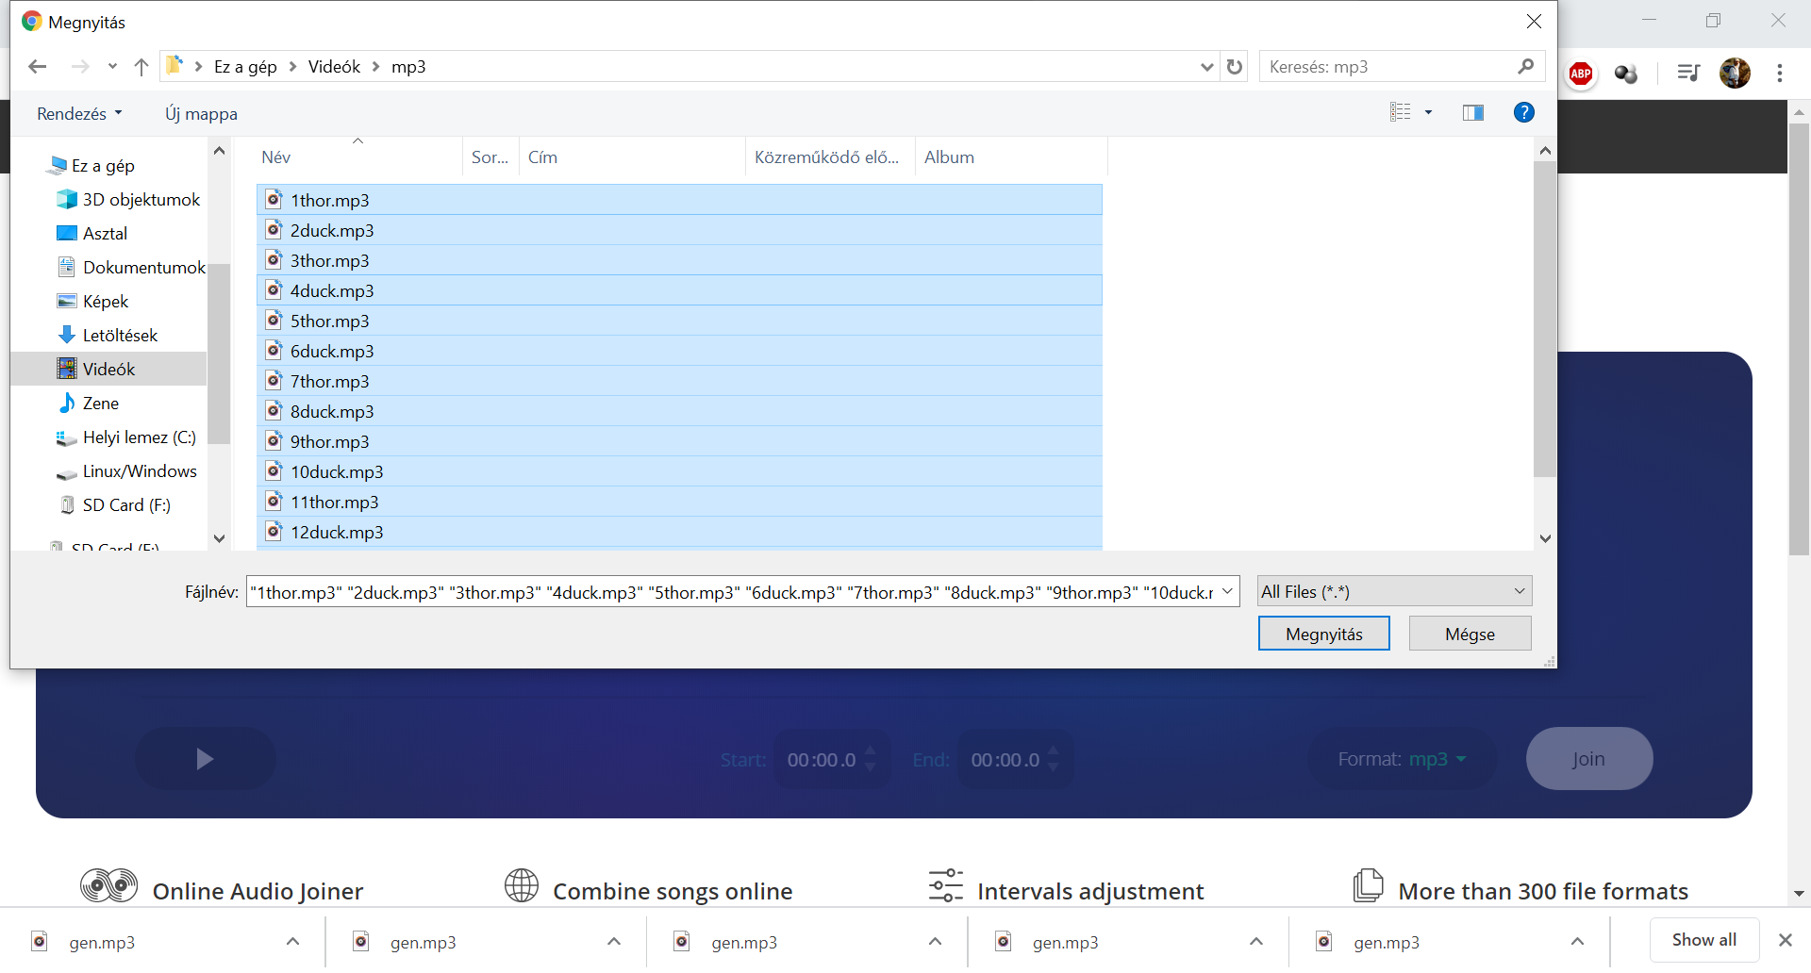

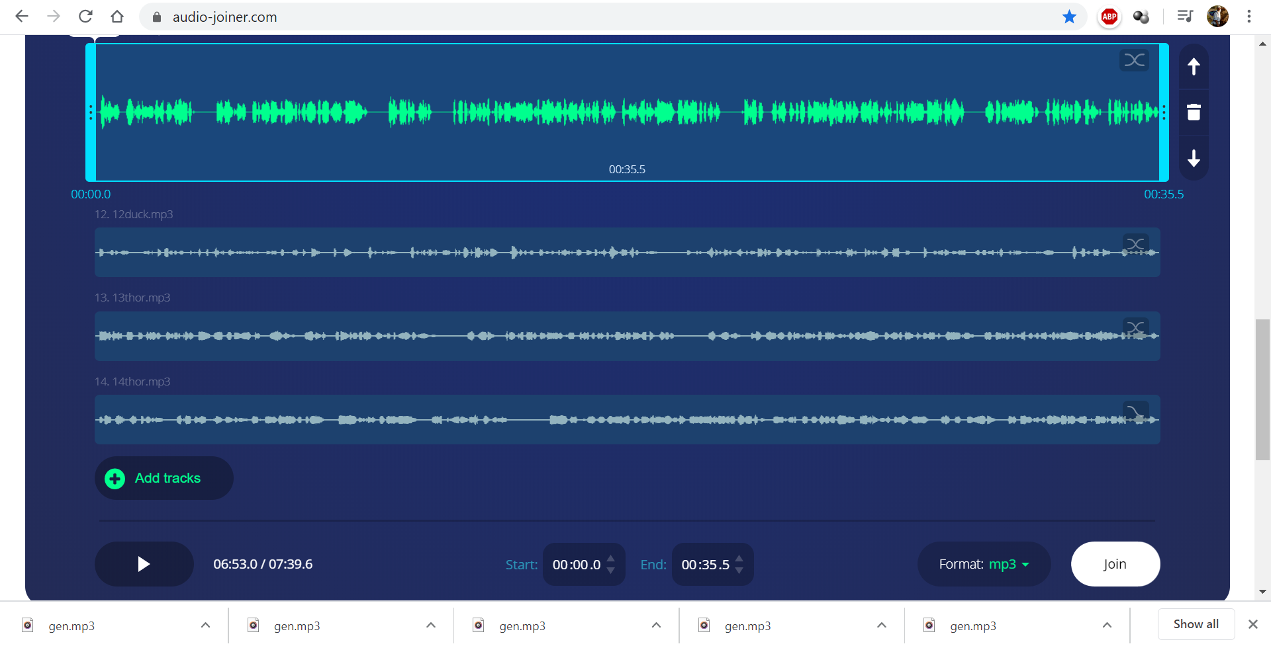

Figure Nr.1 – Steps of the management of the MP3-files (source: own presentations)

# Annexes

Parts of a rapid publication strategy (the videos should be used in a chronological order):

* <https://miau.my-x.hu/miau/quilt/2020/AI-project/tutorials_eu/?C=M;O=D>