QuILT 2.0 – Layer-integration – or Food-Kaleidoscope-based knowledge tests in 2DM-frames
László Pitlik, László Pitlik (jun) (MY-X team)
The HTML5-based streaming version can be used through this URL: https://miau.my-x.hu/miau/quilt/2020/quilt2/launching2020V06/part6.html.
Abstract: The asynchronous distance education delivers seemingly closed knowledge layers in frame of the separated learning modules. It seems to be trivial. Each learning module needs a clear focus (e.g. how to identify databases for an article, how to create pivot-report from data in long-format, how to involve online solver-based engines into the modelling, etc.). On the other hand, these separation effects are risky. The world around us is not a box with LEGO-elements without any connection between them. There are universal, general rules – there are connections between the seemingly closed learning modules. This paper tries to demonstrate a lot of potential connection between the gamification- and log-generation-based 2DM-game and the Food-Kaleidoscope (being capable of interpreting the human history in a robotized way). The fusion of a gamified frame and the knowledge elements of the Robot-Historian is the phenomenon – “knowledge test”. The gamified frame of 2DM produce log-data about the test-behaviour of the Students. Based on these logs, it will be possible to generate a big-data-force-field leading to similar analyses as before in case of the Food-Kaleidoscope (interpreting the FAO data about the food supply statistics in country-level.) So, the potential connections build a “perpetum mobile” of the knowledge acquisition and management.
Keywords: gamification, log-based evaluations about log-based evaluations, robot-teacher, knowledge acquisition, knowledge management

Introduction
Pre-history of the article:
- Werkfilms, storyboards, articles: https://miau.my-x.hu/miau2009/index.php3?x=miau128&where[indexkod]=miau260
  - https://miau.my-x.hu/miau/quilt/2020/quilt2/launching2020III25/part0.html
  - https://miau.my-x.hu/miau/quilt/2020/quilt2/launching2020III25/part1a.html
  - https://miau.my-x.hu/miau/quilt/2020/quilt2/launching2020III25/part1b.html
  - https://miau.my-x.hu/miau/quilt/2020/quilt2/launching2020III25/part1c.html
  - https://miau.my-x.hu/miau/quilt/2020/quilt2/launching2020III25/part1d.html
  - https://miau.my-x.hu/miau/quilt/2020/quilt2/launching2020III25/part2a.html
  - https://miau.my-x.hu/miau/quilt/2020/quilt2/launching2020IV01/part2b.html
  - https://miau.my-x.hu/miau/quilt/2020/quilt2/launching2020IV01/part2c.html
  - https://miau.my-x.hu/miau/quilt/2020/quilt2/launching2020IV08/part2d.html
  - https://miau.my-x.hu/miau/quilt/2020/quilt2/launching2020IV15/part3.html
  - https://miau.my-x.hu/miau/quilt/2020/quilt2/launching2020IV22/part4.html
  - https://miau.my-x.hu/miau/quilt/2020/quilt2/launching2020IV29/part5.html
  - Running projects of this semester: https://miau.my-x.hu/miau/quilt/2020/?C=M;O=D
  - Already closed publications: https://miau.my-x.hu/miau/261/?C=M;O=D / https://miau.my-x.hu/miau2009/index.php3?x=miau128&where[indexkod]=miau261
  - Course-diary (2020): https://miau.my-x.hu/mediawiki/index.php/QuILT-IK045-Diary
- https://miau.my-x.hu/miau2009/index.php3?x=e0&string=2dm
- https://miau.my-x.hu/miau/quilt/2020/th1b.docx
- https://miau.my-x.hu/miau/quilt/2020/food_project/?C=M;O=D
The Food-Kaleidoscope analysed till now three countries in a successful way (Congo, Pakistan, Hungary) and Zambia and Belgium should also be analysed where the goal is to derive suspected years/periods based on the food-supply-statistics of FAO in a way what can be automated and what lead to relevant years/periods of the history too.
There is also a closed publication (see MIAU Nr.261) about the innovative re-interpretations of the 2DM frame system.
Here and now, the goal is trivial: how can we create row/column-header-positions (3+3) and answer-cards (9) – as soon as possible language-free – where the knowledge will come from the Food-Kaleidoscope and the 3+3+9=15 cards will be inserted in new 2DM-games. All new 2DM-tests will also produce log-files. These log-files and the 15 graphical parameters (cards/figures) should be capable of supporting real didactical scenarios. It means a didactical situation can be seen as realistic, if the single questions or the rule system based on the 3*3 answer cards speak about existing knowledge layers being capable of integrating into a real exam/test.
The tasks below can be seen as homework (Motto: Practice makes perfect!) or it can be used as basics for an own publication too!

The storyboard
Like in all the previous parts (about the case H1N1 and the Cold-War, and the Food-Kaleidoscope, etc.), each text part written for THOR will have a turquoise background colour, and the same logic will be valid for each other player (virtual actor/actress): DENT should have the colour-code of magenta, STEW should be grey highlighted. Professor DUCK can not have an other colour as yellow. CON’s colour will be the red. The colour-scheme is quasi a randomized one. The storytelling will be realized in frame of a radio-theatre – in this module the voice-modules and the OBS-based video-modules will be mixed. The integration of knowledge layers in case of the 2DM-games needs massive visualization effects.
Persons | Messages of PART6 - … layer-integration…
THOR | Hello! This part of the QuILT 2.0 system expects definitely that the Readers/Students read/watched already the relevant pre-history-elements about the 2DM-games and about the Food-Kaleidos-COP. The Food-Kaleidos-COP is a kind of ROBO-COP who is searching for suspected details in an automated way based on food-supply data. In general, it is always important to know the pre-history of a challenge. The publication-oriented, co-operation-driven exam-situations can also be seen as a complex task because the pre-history should always be understood before somebody tries to create a publication.
DENT | I would like to say as a joke – unfortunately! but in fact rather fortunately, we as Students must be agreed with this prologue highlighting the necessity: knowing the pre-history of a chosen project. The co-operative working on a publication as such is trivial if the core messages of the appropriate learning materials and or clone-publications could be understood before deep enough. Without these core messages, each sub-task seems to be huge and complex – although we will only need in fact minutes to execute the particular next steps.
STEW | Well! So, I have the joyful task here and now to speak about the core messages of the 2DM-games and the Food-Kaleidoscope before we start integrating the both fields. A 2DM-game is a frame where 9 particular questions should be interpreted. Each question has two parameters coming from the row- and column-headers. The appropriate answer card means if the affected row- and column-headers are the keywords, which card should be interpreted as the most proper association to these keywords. The logical pattern is simple: if A and B then C. Let alone - the headers may not be arbitrary.
STEW | Important to know: a 2DM-game expects only 8 proper answers, the last one is a kind of trivial plus point. The 2DM-games have namely connections between the cells. The 8-answer-approach can also be criticised. The 3 rows and 3 columns need only 2 proper answers if somebody knows at least, which answer-cards belong to a row and or column. Altogether, if somebody can deliver 2 times 2 proper answers, then the rest can be derived based on the basic rules of a 2DM-game. This thesis can be used for a kind of IQ-test: Personalities can be explored based on the solution logic.
STEW | If the test-person have the free choice to decide which cell will be worked on, then there are two basic types of personalities. The one type are the persons with a SUDOKU-mentality where a row or a pattern will be closed at any rate as logical consequence from two proper answers. The other ones have a RANDOM-mentality where the test-persons solve the partial task following arbitrary sympathies concerning the particular 2DM-cells. The SUDOKU-brain tries always to complete a row or a column. The RANDOM-brain works with intuitive preferences where ranking of cells is depending on the content.
STEW | In addition, it seems to be important, whether a test-person starts with the central cell or not? The central cell has namely the most neighboured cells in a direct way. It means, the second proper answer in a row or in a column is a neighboured cell and the last cell in a row or in a column embodies a kind of finality. On the other hand, if somebody takes the cell on the top and on the left side (it means the top-left corner), then it is possible, that the next proper answer will only be set into the top-right corner. The central cell in the upper row is rather a lack then a sign of finality.
THOR | If we are that near to the test-psychology, then it should also be mentioned, that the central cell, the question for the central cell can be the most difficult (directly designed in a conscious way so). It means, for personalities who are starting a 2DM-game quasi always with the central cell, the uncertainty concerning the central cell can cause a chain reaction. To identify a new starting position makes the test-person instable and the statistics will show a significant difference concerning the test-fitting depends on the first cell being central or not.
THOR | Parallel, it is worth always knowing that the 2DM-game has or can have a special parameter. It is possible to let setting a bad answer-card to a cell or not. The above interpreted test-strategies are valid in cases where each answer-card can only be set to the right position. The chain-effect of the evaluated answers leads to the rationality of the above described strategical thinking. In this case it is also important to evaluate which positions was bad. If the answer-cards can be set in arbitrary positions, then a test-situation can be characterized as a kind of blind flight.
THOR | The 2DM-games with conducting effects where the already placed cards can be seen as proper answers, make therefore possible to explore human test-strategies or even to derive personality groups based on a relatively high number of games. The log-data of the 2DM-games are a kind of big-data because not only the ranking positions of cells, the fitting of the answers, the timestamps are available, but also the mouse-coordinates which are capable of describing a kind of fine-motoric pattern about the test-persons. Worth knowing: the mouse- and keyboard statistics can substitute EEG-waves!
DENT | A new aspect: A 2DM-pattern can even be interpreted for the classic yes/no-questions or tasks too. For example, a task-form could be as follows: Please, say a declaration having a direct connection to a phenomenon (set to the row-header) and being proper or wrong or even out of scope (as one option on the column-header). I think, it is time to support the understanding all these interpretations through demonstration materials. Please, call a species of the mushrooms being not poisonous! Without the visual frame of a 2DM-game, we would guess for examples: champignons.

DENT | Parallel, following visual effects would be used in a 2DM-game: pictogram about the mushrooms in the row-header, pictogram for the proper answers in the column- header and a picture about the champignons among the answer-cards. It is important to highlight column-headers should have a connection to each other. For example: should be eaten, may not be eaten, worth not be eaten. Parallel, the row-headers should also have a trivial connection to each other. For example: mushrooms, plants, animals. Each answer-card may be inserted in one of the 9 cells in the 2DM-structure.
DENT | The above-mentioned test-psychological effects are valid here and now. The 3 pictures about mushrooms will always be interpreted as a subset – as a row or as a column. So, if somebody does not know a certain mushroom but the other two species are well-known, then the third mushroom can only belong to the last position in the mushroom-subset. A special effect could be in case of foods if the ingredients of a real dish build the proper answers for the good-food-subset. This meta-level is not a 2DM-parameter, it is rather a conducting gesture for the test-persons.
DENT | Finally, it is also important to highlight, that the answer-cards can demonstrate the same content with different levels. About food-elements we can speak based on pictures or even based on texts where the answer can be described in the common language or in case of species even with Latin names. The most tricky games can mix the above-listed conceptions. All these variants can support the personality of a person to explore. Classic tests – let alone hand-written do not make possible to analyse potential data being capable of existing at any rate.
XXXX | 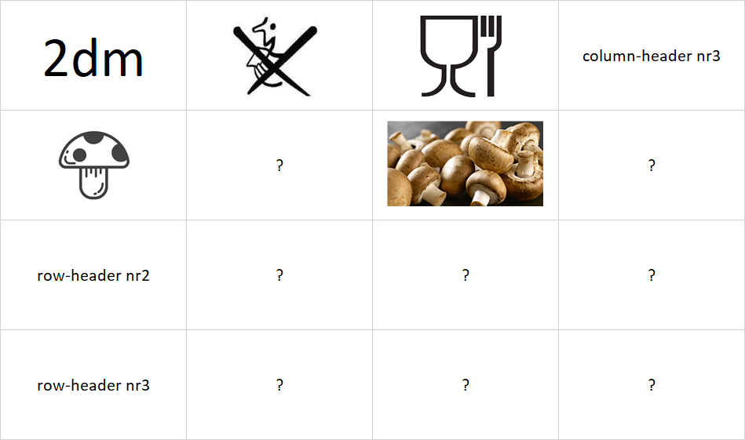  Task Nr.1: Please, complete the game above in different variants where the parameters could be identified in the previous interpretations!

STEW | The core messages of the Food-Kaleidoscope are also simple – if we interpret the suspected years and not about the life expectancy. In case of the years, the objects are the countries. The objects could be set into the positions of the row-headers. The countries could also be presented in short or long text-format or even with the flag. The short format could be a international country-ids. The long-format could be the English name used in the international statistics or even the name of the country in the own language (and with the own script) in order to ensure different complexity levels.
DUCK | Excellent! We have at once not only the core messages about the techniques needing to be integrated, but the first integration approach concerning the 2DM-game and the Food-Kaleidoscope. The strong structure of the 2DM-game expects 3 row- and 3 column-headers being connected to each other within the row-header-positions and also within the column-header-positions and altogether concerning each cells in the 3 times 3 matrix. If we define the row-headers as objects then we can define the column-headers as attributes. The Food-Kaleidoscope works with the countries as objects in a direct way.
THOR | In this object-attribute-approach the 2DM-structures can be interpreted as an OAM. A row-header-position and a column-header-position and a cell with its answer-card can be re-formulated as a triplet where an object has an attribute, and this attribute has a value. The 2DM-game can also be seen as a two dimensional database – but not in long-format. A 2DM-game can also be interpreted as a parameterised task or task scheme for more Students parallel with the same difficultness, where the result is dependent on the row- and column-headers.
DENT | Following STEW’s interpreations about the countries as objects involved into the Food-Kaleidoscope and accepting the last remarks from Professor THOR about the OAM as 2DM, we need now attributes - being relevant from point of view of the Food-Kaleidoscope. Relevant information units coming from the Food-Kaleidoscope are for example the suspected years. Years and countries in form of a table are at once well-known. The knowledge representation about historical facts can lead to such kind of tables. Each country and each year can produce namely relevant events. The Wikipedia can deliver them.
XXXX | e.g. https://en.wikipedia.org/wiki/2002_in_Pakistan
STEW | The years could seemingly be used as attributes however we can see in form of a thinking experiment, that it is never sure having the same three years in case of three arbitrary countries explored as suspected years through the Food-Kaleidoscope. On the other hand, the Food-Kaleidoscope deliver results for each year and each country. These results can be the frequency of the suspicions or the food-supply-index from one model or aggregated from a lot of parallel models supporting the calculations of the above-mentioned frequencies. The question is what is worth presenting in 2DM-form as test?
DUCK | We could even create a 2DM-game about countries and phenomena like war, economic crisis, environmental catastrophes where the answer-cards will be the years as such. This game can however not be seen as a real integration of the 2DM-frame and the Food-Kaleidoscope as automated suspicion generating technique because countries, phenomena and dates are the keywords of the history. Food-Kaleidoscope relevant knowledge should be identified in order to have the right speaking about a real integration.
XXXX | 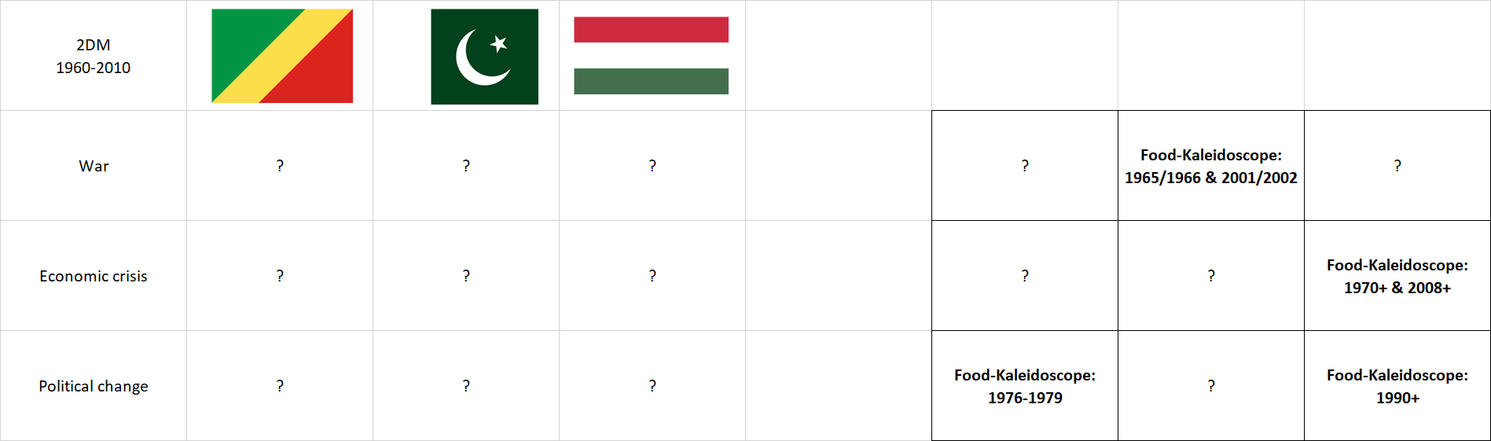  Task Nr.2: Please, check/complete the game above based on the 3 articles (and the modules of the asynchronous distance education/learning) + Internet-Search-Activities:  - https://miau.my-x.hu/miau/261/Food_Kaleidoscope_Pakistan.pdf  - https://miau.my-x.hu/miau/261/food_kaleidoscope_case_congo.pdf  - https://miau.my-x.hu/miau/quilt/2020/quilt2/launching2020IV22/food_kaleidoscope.docx  - (https://miau.my-x.hu/miau2009/index.php3?x=miau128&where[indexkod]=miau260)

DUCK | In a real integrated game, the knowledge about the functionality of the Food-Kaleidoscope should be tested and not the results – it means, not the suspected years and the highlights in these years. The functionality of the Food-Kaleidoscope can be tested if the partial results of the Food-Kaleidoscope can be interpreted. The interpretation rules are the most relevant knowledge elements concerning the Food-Kaleidoscope. The Food-Kaleidoscope can only then a black-box for Students if they are capable of interpreting the suspicion generating system.
DUCK | The interpretation rules are also important if we will try to realize the KNUTH’s principle and if we will try to transfer, transform, translate the human interpretation steps into source code. The first step of the quality management of interpretation rules can be to transform them into test questions – even into 2DM-games. To interpret the partial results of the Food-Kaleidoscope, it is not relevant to know, how to work the online engine in the background. The black-box-logic has therefore more layers.
DUCK | The 2DM-games are example-oriented approaches. Therefore, it is not recommended to try to speak about theoretical aspects. The 2DM-games can test whether a test-person is capable of reproduce case studies realized in frame of the Food-Kaleidoscope. But it is not the real challenge to speak about the similarity analysis as such. It would however be possible to create highly theoretical 2DM-games. For example: the row-headers could be the 3 main applications: COCO-STD, and Y0, and MCM. The column-headers could be the number of modelling steps. The answer cards could be situations.
DUCK | The general question for each answer-card would be in this high-theoretical approach: When can be speak about a closed model? For example: A COCO-Y0 model can be seen as closed after one single modelling step, if each attribute is involved into the model independent from the final conclusion about the estimated index values - independent from the existence of an antidiscriminative evaluation for the investigated objects. This test could substitute a verbal exam at any rate. Even a robot-teacher could be produced who supports the derivation of the good answer-cards through keywords.
XXXX | Task (facultative): Please, complete the above-drafted 2DM-game about theoretical aspects based on the following document (see pages 7-26):  https://miau.my-x.hu/miau/196/My-X%20Team_A5%20fuzet_EN_jav.pdf

DENT | Very exciting! The practice-orientation was ever clear, but the substitution possibility of verbal exams opens a new dimension for me. The previous part of the asynchronous distance education, distance learning presented already seemingly complex interpretations about exam-situation. I did not expect that this complexity can still be increased quasi for unlimited levels. On the other hand, it would be interesting enough to see at last case-study-driven 2DM-games concerning the countries like Congo, Pakistan, Hungary.
THOR | OK! The first example should be a 2DM-game where only one country is affected. The row-header is the number of countries being involved into the analytical process. The column-header is the number of modelling steps. The game needs two further parameter: the name of the country and the type of the estimations where the estimations can be absolute values or differences (relative values). The number of countries and the number of modelling steps can be changed in the header positions. The type of the estimated values has only two options. Therefore, it is not a good dimension - seemingly.
THOR | I said – seemingly. Because the differences can be built from differences too. It means, the type can also have 3 options. Therefore, we have at least 4 dimensions with at least 3 options. The countries: Congo, Pakistan, Hungary. The number of countries: 1 or 2 or 3. The number of modelling steps: 1 or 2 or 3. The types: absolute estimations or differences or differences of differences. Theoretically arbitrary 2 dimensions can be chosen as headers and the preferred values of other 2 dimensions can be selected. But what can be the central question for all 9 cells?
DENT | I think, one singe central question can not be defined. The phenomenon of the central question can only be interpreted after setting the headers. For example: in the first case (being highlighted by you too) where the 2 preferred dimensions are the numbers of countries and modelling steps – always assumed a given country and a given type, we could ask: Which are the most suspected negative peaks or years? For answering, we would need the figures of the articles. In form of a thinking experiment – it means without knowing exactly the partial results, a real risk should be highlighted.
DENT | This risk is the possible lacks of any modelling steps in cases where 1 or 2 or 3 countries were involved into the modelling process. More than one step is not necessary, if the first modelling step involve each food-categories into the model – independent from the result where the estimations can be the same or the estimations can be entirely or partially different from each other. Here and now, I have a new question suddenly. Is the phenomenon of micro-patterns (with other words the rounding) not relevant in the interpretation process?
DUCK | They are relevant! And how relevant they are! If we accept the rounding as such, it means, if we exclude the micro-patterns entirely, then we will have with a higher frequency results where no suspected years can be defined! The micro-patterns are fundamental risky interpretation layers, therefore too, we have to prepare the answer-cards with the content of “NONE”. Parallel, the excluding of micro-patterns needs a rule. This rule should define what kind of differences around the norm-values may be erased at all. The rounding is a trivial rounding if we want to erase differences between + and – 0.5.
DUCK | We can however use a wider spectrum for erasing differences around high norm-values like 1000000. We can define a doubled border of plus and minus 1 or even 10 – especially if not all variables, attributes, food-categories are involved into the given model. Summa summarum: the virtual erasing marginalized differences leads to new view through the Kaleidoscope. The virtual erasing means we are not enforced the interpret risky (arbitrary-like, random-like) micro-patterns. And it is time to see whether DENT’s central question could lead to an acceptable game.

STEW | I think, we have still to clarify a new parameter. The rounding is relevant not only in case of the first modelling steps. The rounding is a general parameter. The rounding has an influence on the definition of the most suspected objects. If we do not have a rounding concerning the estimations, then we will have in lower frequency more than one winner or with other words - more than one suspected year. If we should handle alternative solutions, then the answer-cards can have to variants: the list of the suspected years with one or more than one element and or even the number of extreme years.
DUCK | Excellent! You can see what the difference is between writing an article about the Food-Kaleidoscope using the force fields of the magic of words. Or clarifying each details and rules for automation of an interpreting robot basing on the Food-Kaleidoscope. The KNUTH’s principle needs a significant stronger precision in each aspect than the general rules of the academic writing skills. Therefore, the QuILT-system is a finetuned academic writing skills. The QuILT-system tries to highlight why the reproducibility is that important.
DUCK | The big-data-focus ensures a kind of reproducibility because each step of the derivation of conclusions is automated. On the other hand, the reproducibility is relevant not only in case of the results but also in case of their interpretations. The human beings are weak in these both fields. The human intuition is not a machine leading error-free to the calculated results and our human logical capacities are also not robust enough. We, human beings can not handle with arbitrary complexities or arbitrary long logical chains. Yet, even these lacks make the human brain special and innovative.
STEW | This formulation sounds like poetry for me! On the other hand, we should define a further rule if my thinking experiment is correct. The dimension about the number of parallel analysed countries could lead to a special situation immediately when we try to interpret the number of 2 countries. In case already of 3 countries it is namely possible to have 2 different scenarios if one of the countries is preferred. It means: if we prefer Hungary then an additional country could be Congo or Pakistan. We must clarify that we will select the most suspected years based on both cases parallel or alone.
STEW | If we have 2 times 2 country-models and we interpret each model separately then we will have always at least 2 suspected years. However, if we interpret the result coming from these 2 models as one set of suspicion potentials, then we need a consolidation rule how we can transform the results of the first model into the interpretation interval of the second model. It is namely possible, that the first model is less sensitive than the second model. By the way: the same chaining effect should be used in case of Google Trends data if we will describe more than 5 objects parallel.
DUCK | Dear STEW! You do play the role of Professor CON more and more perfect! Congratulations! All these additional remarks should make clearer and clearer for each Reader that the professionality begins where the KNUTH’s principle can be made visible. Each other expert-like activity is just a kind of behaviour pattern of the fabulous rabbi from the well-known joke who always has new and newer idea although all the geese are already dead for ever. And now back to the poetry-like interpretations before. Everybody can be sure our rabbi will produce sooner or later a really good idea!
DENT | Dear Professor DUCK! I do also have a new idea. We said, we will have 2 parallel interpretation layers for the first 2DM about Hungary and its absolute estimations. But I think, we have at least 3 parallel views. The first view could be the list-view with all suspected years. The second view is then the number of the listed elements. And the third view should be the numbers of the source-figures where the estimations can be analysed. And following ideas before the fourth view could even be the number of these sources.

DENT | Seemingly unfortunately, these fourth view will involve only a few answer-cards because the number of sources can be 1 or 2 – and this last one just in case of 2 countries. On the other hand: this kind of in this moment still irregular 2DM-game could be used for master-exams – especially if we will use answer-cards from 1 to 9 although we would need maybe 8 times 1 and only one time the answer-card with the number of 2. And if we do not manipulate the answer-cards through irrational options, then this special view could detect the test-persons who can go on along the KNUTH’s principle.
DUCK | Dear DENT! This mentality is called as the sovereignty-driven philosophy of life or ideology or world view. Thank you also for your excellent interpretations. You are capable of decreasing the so-called white spots on the map of knowledge because you do not afraid to go close to the borders of the already interpreted world. And you do dare hoping that a next piece may and can also be explored by you because you are not a repeating machine for old sentences but a free soul searching for new challenges!
XXXX | 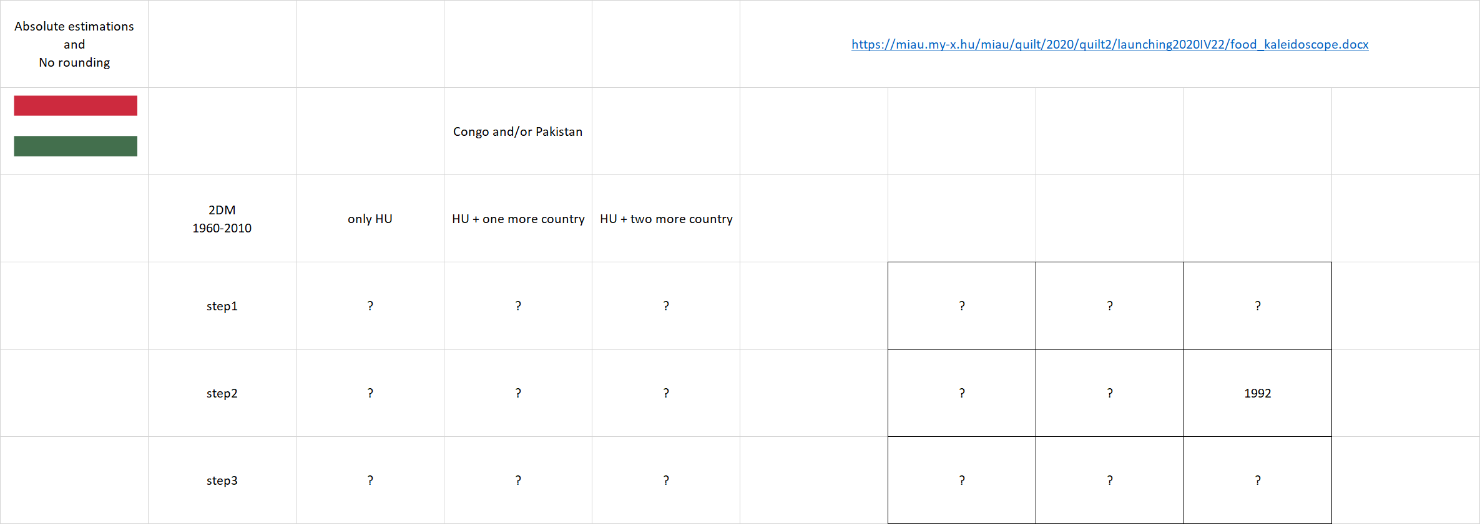
XXXX | 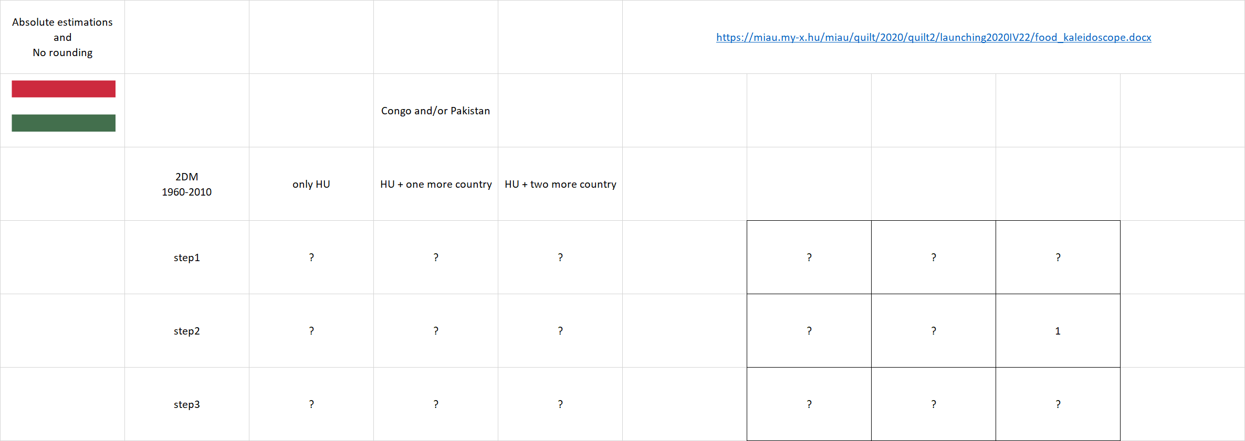
XXXX | 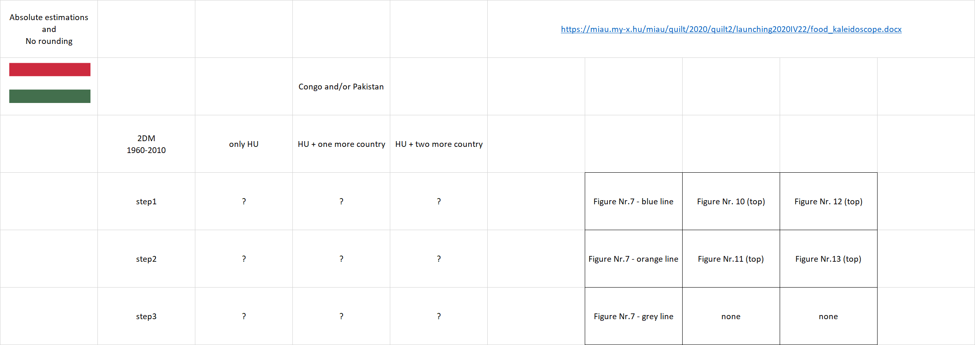
XXXX | 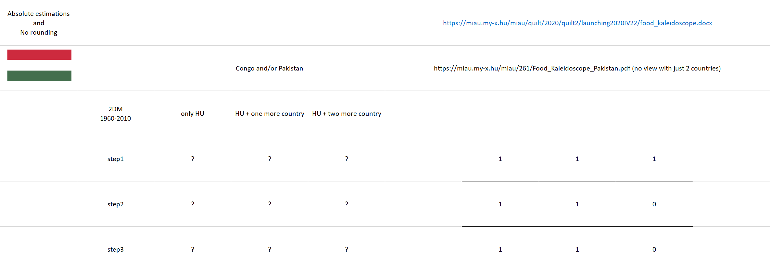
XXXX | 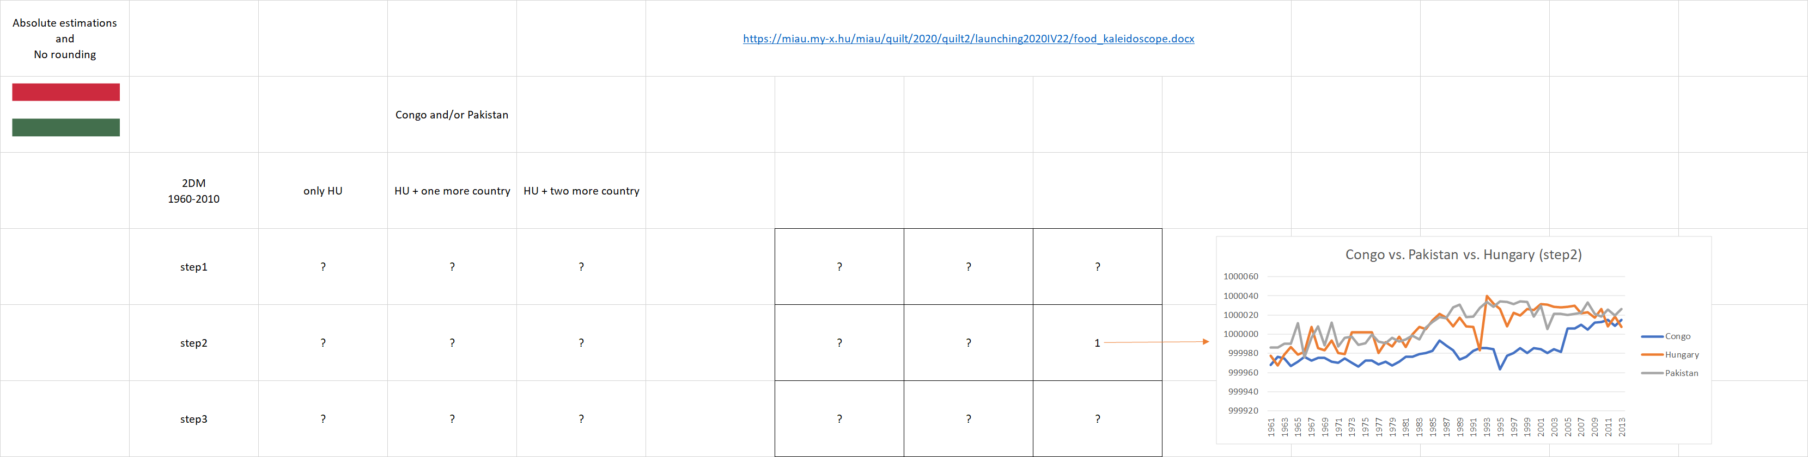  Task Nr.3: Please, complete the 2DM-game-variants based on the article about the Hungarian case in frame of the Food-Kaleidoscope:  https://miau.my-x.hu/miau/quilt/2020/quilt2/launching2020IV22/food_kaleidoscope.docx

THOR | If you do interpret the subtasks before it will be trivial that we can define more and more views. For example, it is also possible to select the appropriate figure as picture in frame of an answer-card. This could be the view Nr.5. And we did not speak about the potential role of the naïve estimations. On the other hand, we need to interpret the further two-dimensional possibilities. What can be the central question, if we change the type instead of the steps and the focus is furthermore on Hungary and we try to analyse just the step1 figures?
THOR | As you can assume or see we could follow the former central question. This leads to the conclusion, that central question can be defined for more scenarios not only for each parameter setting? On the other hand, the preferred option of step1 makes possible to ask a new question too: May we set the parameter in case of the dimension of steps with a value of all? If we could define rules for the case of 2 countries, then the same logic may also be interpreted for figures about different steps? May we interpret figures in a consolidated way as a common set of estimations?
THOR | We may never forget that the goal of a 2DM-game is the testing of complex relationships between knowledge elements. A part of the potential parameter settings can only be used for IQ-test-like measurements without any connection to real competences. However, we should always prefer those parameter settings where the tested knowledge can be involved into the management challenges of real decisions. Here and now, the first parameter setting about the Hungarian absolute estimations and its variants deliver a frame for testing the understanding level and the capability of reproduction.
THOR | Although it would be possible to derive new and newer integrations between the suspicion generation through the Food-Kaleidoscope and the 2DM-games, the next challenge should be now the integration of the models about the life expectancy and the 2DM-games. It seems to be important to highlight at once, that the modelling of the life expectancy and the suspicion generation have different objectivity levels.
THOR | The suspicion generation or the artificial intelligence-based term-creation processes can only be measured through the Turing-test. They can not deny namely that the reality did not have the abstraction what we are interpreting. There is no aggregated food-supply-index. There is however a life expectancy what can be studied in an objective way. The food-supply-index – even if being optimized calculated – is just a logical construct and it will be accepted if the Food-Kaleidoscope can support for example the exploration of critical years.
THOR | The life expectance is a real phenomenon – even if this is also a statistical abstraction but this abstraction can be forecasted, estimated for the future and the calculated life expectancy can follow the estimations, their changes with high frequency or not. The life expectancy for one single person is a forecast of the length of the life or the day of the death and it can be checked in an objective way. The same is valid for populations and their all statistical values.
DUCK | On the other hand, it is also important to highlight that the we know about the suspected years from the history. Therefore, a 2DM-game about countries and extreme situations (like war, catastrophe, crisis) is just a test about important historical dates where the 2DM-characteristics become irrelevant. Parallel, the modelling process of the life expectancy based on annual food-supply-data delivers a model where we can derive new knowledge about the importance of more or less food in each food-category. Without this model, we could not say anything to this question!

DUCK | Therefore, the integrated game can test the interpretation capacities of the test persons not only concerning the functionality of the suspicion-generation process or even the production-function-generation process but in a direct way concerning the new knowledge and its origin. As you can see, here and now, it would be possible again to create 2DM-games where the understanding or reproducibility of the core process of the production-function-generation could be tested. We could use again the 3 countries for the column-header-positions. And we could define the row-header-positions as follows:
DUCK | We have to derive 2 separate models in order to see whether the homogenous direction based on the-more-the-more-principle is stronger in case of a given food-category than the inverse direction (with the-more-the-less principle). Two row-headers are therefore given. The third row-header-position could be the integrated view where the results of the direct and inverse force fields are calculated. The general question for this 2DM-game would be: which food-category/categories have the highest importance pro country and model-type?
XXXX | 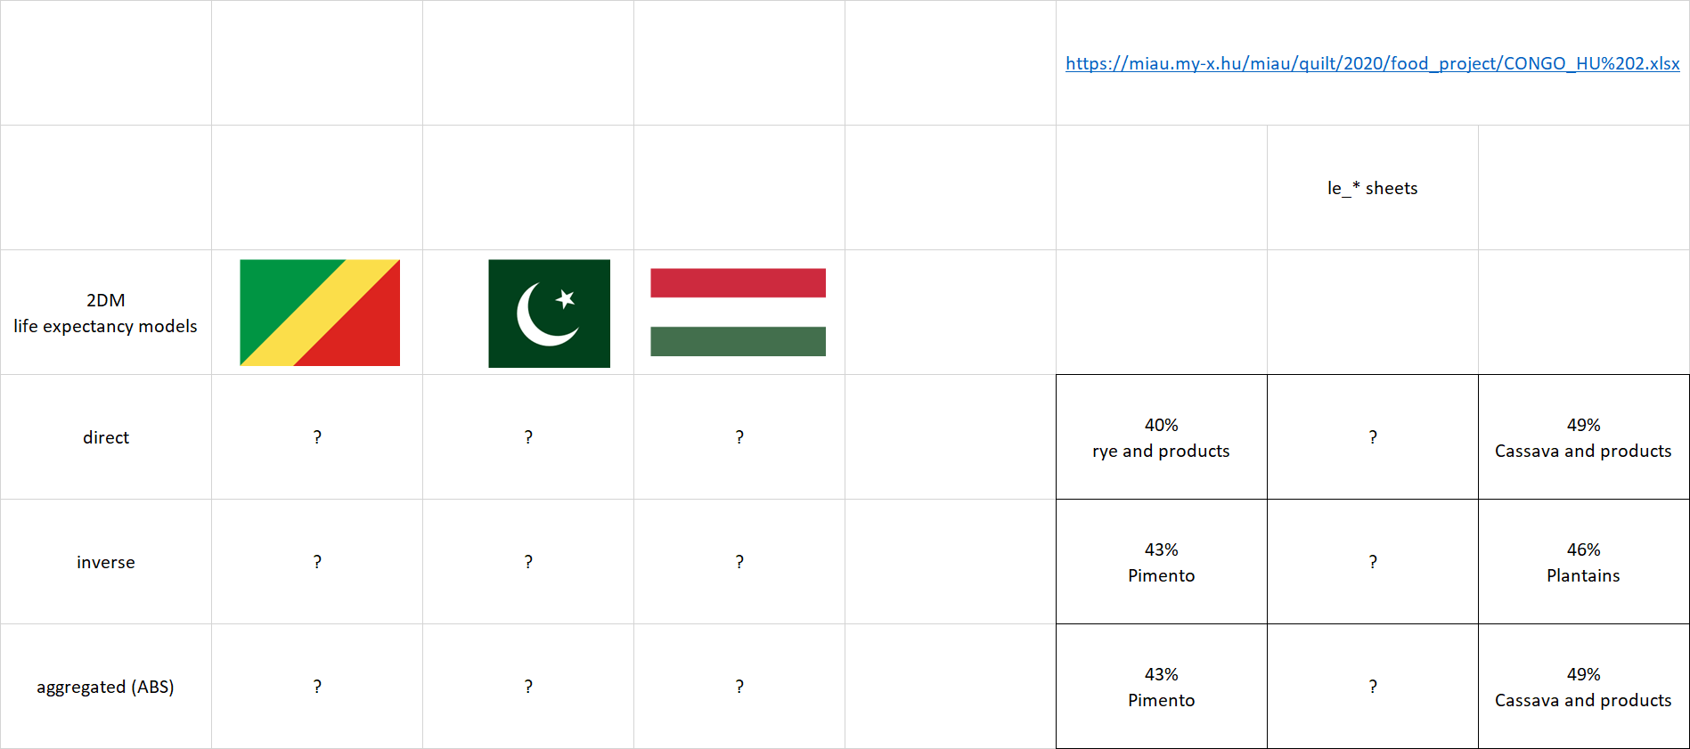  Task Nr.4: Please, check and/or complete the answer-cards based on the following xlsx:  https://miau.my-x.hu/miau/quilt/2020/food_project/CONGO_HU%202.xlsx

DUCK | The previous reproducibility- or understanding-oriented 2DM-game itself delivers relevant information about the optimal food ratios. But this level is just a basic level. The more complex interpretation levels would affect the nutrition science and or the sociology. To approximate the nutrition science, we should build groups of the existing food-categories like fruits-vegetables, cereals, (non)-alcoholic drinks, meats, milk, etc. The raw importance values should be aggregated according these groups not only on the level of food-categories but immediately on the level of the model types.
DUCK | The new 2DM-game could also use the countries on the column-headers. The new row-headers would however be the food-groups where the aggregated importance values are the most extreme values at least in case of one of the countries. So, the new game could involve answer-cards with only plus or minus or zero signs or even with numbers parallel to the signs. It can be expected that a lot of countries with similar nutrition culture should have the same signs at least for a certain food-group because the nutrition science does not communicate region-specific rules – in general.
XXXX | 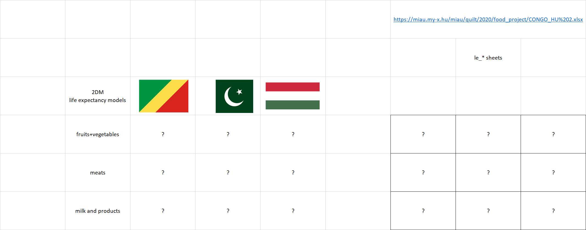  Tasks Nr.5: Please, build groups and aggregate the importance values (%) according to food-categories and model-types in one step where the inverse importance values should have a negative sign already before the aggregation.  The case of Pakistan should also be derived concerning the life expectancies (https://miau.my-x.hu/miau/quilt/2020/food_project/CONGO_HU%202.xlsx, https://miau.my-x.hu/miau/quilt/2020/food_project/Pakistan_AllIndicatorsAvailable_TerritorialRef_1971_2012_CCode_586.xlsx <-- data source for life expectancy values for Pakistan based on CLIO-INFRA: https://clio-infra.eu/Countries/Austria.html#countries – Asia / long-format + pivot-reporting).

DUCK | We could create sociology-oriented games too. For example: the column-headers could be again the countries. The row-headers could be terms like: money, consiousness, culture/environment, etc. These new terms can be interpreted as sociological force fields. In case of Hungary, it could be assumed, that the cassava-consumption as such is a sign for robust financial background – it means money. The same sociological pattern could be assumed in case of Congo, where the rye- and spice-consumption (syndrome) can be seen as an indicator for financial stability – it means again money.
XXXX | 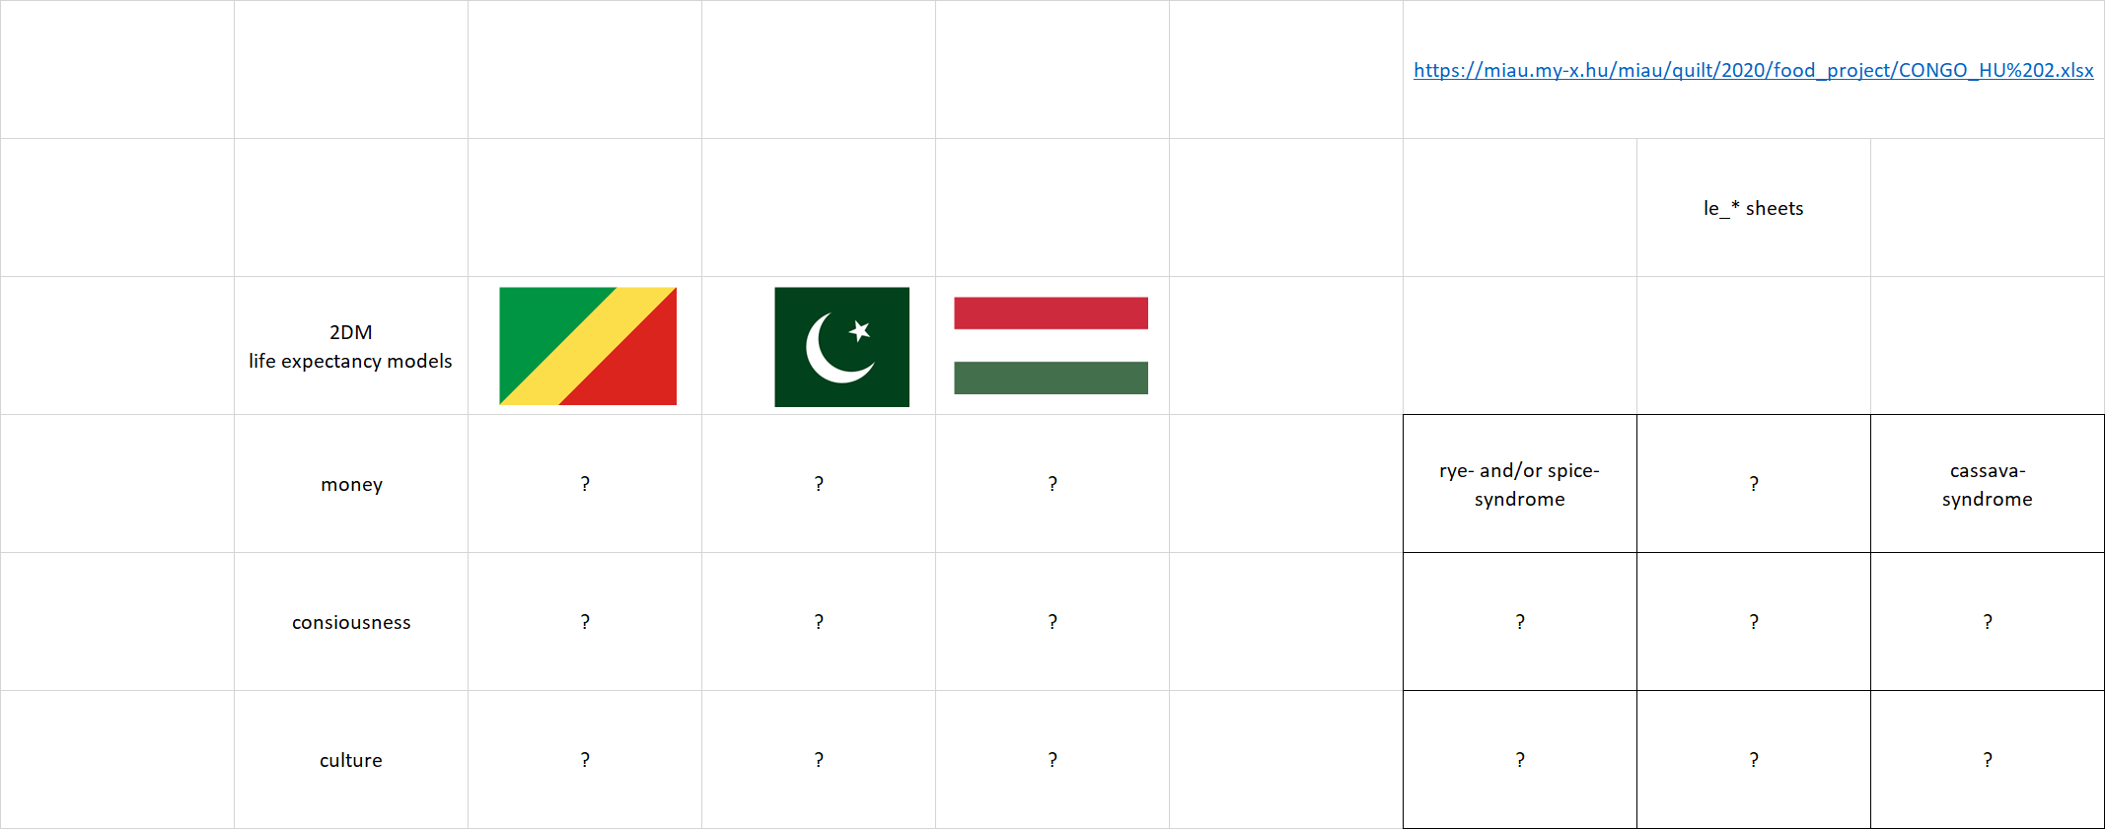  Task Nr.6: Please, check, modify or/and complete the game based on https://miau.my-x.hu/miau/quilt/2020/food_project/CONGO_HU%202.xlsx

DUCK | Finally, the production functions can also be used for simulations. A simulation means we can make estimations concerning the question what kind of change can be expected concerning the life expectancy if more or less food will be consumped in one or more food-categories?! This impact-values can be identified in the models. The so-called stair-case functions can be interpreted as a parameter set being capable of answering the above-mentioned question in a direct way. The stair-case functions can highlight so-called moorlands where the changes of X will not have any impact to Y.
XXXX | Task (facultative): Please, check, modify or/and complete the game based on https://miau.my-x.hu/miau/quilt/2020/food_project/CONGO_HU%202.xlsx

Conclusions
Based on the 2DM-games, it is possible to confront with a lot of challenges concerning the interpretations, understandings of methodological information and/or the knowledge management in general.

Potential focus points for distance-discussions
The QuILT 2.0 frame system offers co-operation possibilities concerning the avatar-based videos: https://miau.my-x.hu/mediawiki/index.php/QuILT2_parts
The previous projects prepared already potential FAQ-elements and this list will also be completed here and now:
Part | Player | Content | Question | Answer
6 | XXXX | Tasks | What should be written to the answer-cards if a row-header is not relevant in case of a column-header (in case of the history-related game in the given period 1960-2010)? | If one single answer-card is affected, then this answer-card could contain the answer of “NONE”. If more than one card should be a “NONE”-card – then this game can not be played in the recent 2DM-frame, because the available frame needs 1:1 relationships between the 9 matrix cells and the 9 answer-cards.
…

Annexes
- https://miau.my-x.hu/miau/quilt/2020/quilt2/launching2020V06/2dm_interpretations.xlsx

