The experiment is over: the artificial faces of our artificial professors and Students and/or the radio-theatre will not be used furthermore. Although the general question is given: Can the form be stronger than the content. The epilogue of the asynchronous distance education is again: a simple written learning material like in the starting phases before COVID19 – yet a potential storyboard for the avatar-based distance education/learning. Was it necessary producing visual, auditive effects to learn in an effective way – let alone to learn in an efficient way? It is trivial: the muted tutorials became independent force fields which can not be substituted that easy through simple texts. At least two of the planned final publications tried to handle the production functions concerning the learning/teaching methodologies – and it is important to know: each education activity should be part of the big-data where we can derive what kind of educative actions are capable of leading to the expected results. This forecast-potential is a realization of the frequently highlighted Knuth-principle: Knowledge, science, competence, competency is what can be transformed, transferred, translated into source code!

QuILT 2.0 – Popular-science-level in exam-situations or it would be possible even more? = AI-based modelling the term of decadence
László Pitlik, László Pitlik (jun) (MY-X team)
The HTML5-based streaming version can be used through this URL: https://miau.my-x.hu/miau/quilt/2020/quilt2/launching2020V13/part7.html.
Abstract: This part of the asynchronous distance education/learning integrates again more layers like the previous part did concerning the 2DM-games and the Food-Kaleidoscope. Here, the history, sociology, psychology – especially their robotized approaches will be presented in frame of the artificial intelligence-based (or even solver- and similarity-oriented) term-creation where the term of decadence will be derived. Parallel to the already published future-readiness-index, the decadence index makes possible to speak about high-levelled abstraction in a data-driven, reproducible way – which is a totally inverse approach compared to the general used magic of words. The frame of all these thinking and real experiments is the reality of the final exams and its trend where the level of the demonstrated knowledge is lower and lower along the time and the recent level is frequently under the benchmark of the level of the average popular science. The decreasing level of the exam-challenges and the phenomenon of decadence in general let start a kind of “early” warning system – although these decreasing processes can be observed for decades.
Keywords: robot-teacher, knowledge acquisition, knowledge management, competence, competency, decadence-index, artificial intelligence-based term-creation, robot-historian, robot-sociologist, robot-psychologist, digitalisation, Industry 4.0, automation

Introduction
The goals of this paper are as follows: demonstrating
- world-wide tendencies concerning quality management in education processes…
- how to derive abstractions/terms in a reproducible way
- what can be the threshold of fake news
- what can be done and who has potentials and responsibilities to minimize risks of unsustainability
- how the initialized and closed final publications can be seen as elements of the course
Pre-history of the article:
- Werkfilms, storyboards, articles: https://miau.my-x.hu/miau2009/index.php3?x=miau128&where[indexkod]=miau260
  - https://miau.my-x.hu/miau/quilt/2020/quilt2/launching2020III25/part0.html
  - https://miau.my-x.hu/miau/quilt/2020/quilt2/launching2020III25/part1a.html
  - https://miau.my-x.hu/miau/quilt/2020/quilt2/launching2020III25/part1b.html
  - https://miau.my-x.hu/miau/quilt/2020/quilt2/launching2020III25/part1c.html
  - https://miau.my-x.hu/miau/quilt/2020/quilt2/launching2020III25/part1d.html
  - https://miau.my-x.hu/miau/quilt/2020/quilt2/launching2020III25/part2a.html
  - https://miau.my-x.hu/miau/quilt/2020/quilt2/launching2020IV01/part2b.html
  - https://miau.my-x.hu/miau/quilt/2020/quilt2/launching2020IV01/part2c.html
  - https://miau.my-x.hu/miau/quilt/2020/quilt2/launching2020IV08/part2d.html
  - https://miau.my-x.hu/miau/quilt/2020/quilt2/launching2020IV15/part3.html
  - https://miau.my-x.hu/miau/quilt/2020/quilt2/launching2020IV22/part4.html
  - https://miau.my-x.hu/miau/quilt/2020/quilt2/launching2020IV29/part5.html
  - https://miau.my-x.hu/miau/quilt/2020/quilt2/launching2020V06/part6.html
  - Running projects of this semester: https://miau.my-x.hu/miau/quilt/2020/?C=M;O=D
  - Already closed publications: https://miau.my-x.hu/miau/261/?C=M;O=D / https://miau.my-x.hu/miau2009/index.php3?x=miau128&where[indexkod]=miau261
  - Course-diary (2020): https://miau.my-x.hu/mediawiki/index.php/QuILT-IK045-Diary
- https://miau.my-x.hu/miau/quilt/2020/sovereignty-pla.docx
- https://miau.my-x.hu/miau2009/index.php3?x=miau128&where[indexkod]=miau259
- https://miau.my-x.hu/miau/quilt/safety-index.docx
The one of the above-listed components concerning the distance education/learning focused already on exam situations in a direct way (see part5). This approach tried to demonstrate a kind of ideal situation. Here and now, the reality will be presented. A reality which seems to have only a low level of complexity concerning knowledge acquisition, knowledge management, competences/competencies. Where the PLA-oriented sovereignty, the reproducibility, the data-driven-approximation of problems, the objectivity, and the quality as such do not play any role (see appropriate literature-items above) – even worser: the levels are lower and lower along the time.
The history and/or the psychology speak about decadence – like in case of the ancient Imperial Rome! (https://en.wikipedia.org/wiki/Decadence). The responsibilities can be detected on all sides:
Figure Nr1: (Ir)rational, (non-)sustainable ratios, trends (source: own presentation – where the ratios about circa 50% seems to be not sustainable – rather an irrational reaction for complex social changes)
Task about the minimal level of reproducibility: Please, collect appropriate data, download the software GAPMINDER (constructed by Professor Rosling for highly complex visualization effects – c.f. https://www.youtube.com/watch?v=jbkSRLYSojo), prepare the needed data structure for the Gapminder, set parameter to ensure the same effect like in the Figure Nr.1 (in the mp4-file behind the static picture! (c.f. https://www.google.com/search?q=rosling+animation+site%3Amy-x.hu)
Tutorials: https://miau.my-x.hu/miau/quilt/2020/quilt2/launching2020V13
https://miau.my-x.hu/miau/224/unesco4.xlsx
- In case of the education systems with high proportions of the populations born in the same years concerning the higher education levels (https://miau.my-x.hu/miau2009/index.php3?x=e0&string=anteil + https://miau.my-x.hu/miau/224/ (mp4 files) + especially: https://miau.my-x.hu/miau/224/multikulti_gapminder_Y_Xlog_trails.mp4.
- In case of the economies, where the dual-like-education is not the triviality. Enterprises see the co-operation with Students and universities rather as a problem than for chance.
- In case of the Students, who want to have the degree, but they do not want to have real competences if/because these can be proved in an objective way – what would lead to not realizing the degree as a sheet of paper.
The following storyboard is a chain of thinking experiment presented by Professor KUN:

The storyboard
Persons | Messages of PART7 - … popular science not even realized as a maximum level …
KUN | Hello! This performance can be seen as a kind of epilogue for the asynchronous distance education, asynchronous distance learning. This part should summarize all the precious core messages – and parallel this part should react to the national and international happenings of the semester. The following thinking bubbles have a lot of relationships, connections to each other. Therefore, it is quasi irrelevant, what will be the starting point. To be operative, it seems to be a practicable decision to choose the last impulse of this semester. This impulse is the final exam!
KUN | The raw material for the following short stories has different origins. The real happenings are realized in national and international levels during the last months concerning Students and teachers who have partially written communication to others. Therefore, we can speak about a kind of randomized survey about the recent life in the higher education.
KUN | For final exams, it is necessary to collect questions. In case of IT-oriented courses, these questions can have two layers. The fairy-tale-layer and the objective layer. The fairy-tale-layer makes possible to speak about arbitrary associations concerning the keywords of the official questions. The objective layer expects information being immediately controllable facts. For example: Which kind of business processes of an enterprise and how can be analysed based on the OLAP/pivot-techniques?
KUN | The which-kind-part is the fairy-tale part, where it seems to be enough to repeat each associative term concerning to the word enterprise or business because quasi each business process, each aspect can be analysed based on reports. Therefore, the Students can not give wrong answers if they speak about costs, human resources, investments, marketing, forecasting, customer relationship management, production, services, etc. This kind of questions can be evaluated as a sort of rescue-question. Partially correct sentences with these associative keywords should be accepted form teachers.
KUN | The objective part is the how-question. About how-it-is-made-questions, nobody may speak in an unreasonable way. It means for example: a technology description about a dish is either correct in each detail or the description leads to wrong results. Therefore, if somebody is not capable of demonstrating a report-generation-process step by step in a reproducible way, then we can not speak about knowledge, competence in an objective way. The partially correct sentences in frame of a fairy-tale do not have any objective benchmarks.
KUN | The technology description can be executed, and the results are what they are: either correct or not. It is the basic for the following additions: The double-layered questions should be reduced to the fairy-tale-parts. The how-parts were interpreted as too complex, too deep, too professional – causing unexpected effects where neither the Students nor the not-IT-related-members of the committees will be able to handle the objective challenges. You see correct - it was really written: nor the not-IT-related-members of the committees!
KUN | It means in the 21st century not even teachers (irrelevant what kind of focused profession they have) can handle the report-oriented skills of Excel or its big brother – the OLAP – the online analytical processing services. It is a serious risk for the whole society. On the one hand, the pivot-tables are part of the ECDL-level. The European Computer Driving Licence is a movement where the challenges can be covered before ending the high schools. The pivot-technique is well-known for decades. If teachers are not capable of living in the 21st century, then their Students will also do not!

KUN | On the other hand, Students, who are not capable of handling rational IT-solutions, are not welcome in the enterprises. Decision makers, who do pay wages, they want to see performances where the salaries produce values – let alone profits. The enterprises do have problems therefore with the dual education and with the education in general. Maximal 1 of 10 employees with diploma degree are not capable of working immediately useful after closing the university. They need a lot of internal courses.
KUN | They do not have the necessary sovereignty. They were never said, what is a correct performance and what is not. They did not yet confront with objective benchmarks, thresholds. They might produce presentations about they subjective opinions – life long. Objective selection criteria like in the nature are avoided in a conscious way in the education systems. Instead of supporting individual differences, the objectivity is excluded to avoid having to say no to a person - in a moment - about a competence.
KUN | Of course, the above formulated critical evaluations should be interpreted as a statistical force field. Everybody should ask himself/herself – would he or she willing to pay relatively high salaries for the other (fellow) Students in case of a common start up? Or a little bit later: Is the new generation already prepared to take over the family-enterprise or to have credits within the family to launch a new start up where the whole investment can be forgotten - it means can be lost in an objective way - within months if the decisions are not proper enough.
KUN | A discussion-oriented course could offer here and now possibilities to confront with opinion of each other. But the discussions are just valuable if the response will be derived in an objective, reproducible, data-driven way. Each other subjective opinion is relevant as raw material for further derivation – I have to repeat - in an objective, reproducible, data-driven way.
KUN | The social media operating with short remarks - for example below a YouTube-object do not support the qualitative discussion culture where reproducible, data-driven derivation should be inserted instead of instinctive, grammatically foggy text-fragments with a lot of irrational emotions. All these critical aspects can be handled by each person – Students and or teachers – on their own responsibility. Nobody must be involved into processes leading to the new decadence.
KUN | Yes – decadence! This will be our central term for the next chapter. This is a high-levelled abstraction where quasi each human being could only produce comments in a subjective way. There are a lot of similar complexities. For example: the term of talent is also not defined in an arbitrary exact way. Who is talented even gifted? The Wikipedia says – I quote: An aptitude is a component of a competence to do a certain kind of work at a certain level. Outstanding aptitude can be considered talent. Unfortunately, this definition is not good enough for the Knuth-universe. (https://en.wikipedia.org/wiki/Aptitude)
KUN | The word competence is not defined – at it can not be defined in a better way as the word decadence – because of the magic of words where the terms will be used for defining each other. This effect leads always to foggy relationships. The word of certain is not defined and it can not even be defined, because this word would like to highlight a ratio. Numbers can not be defined just derived. The word of outstanding is not defined. This is also a number and it must therefore be derived.
KUN | The phenomenon of talent is a higher and let alone numerical complexity than the above-cited text. Therefore, the phenomenon of talent should be modelled. Each phenomenon can be modelled. The phenomenon of talent needs an antidiscriminative function where the numerical characteristics can be handled in an objective way. An antidiscriminative function is capable of exploring relationships between phenomena – phenomena they can be measured. The antidiscriminative character of the optimum-oriented modelling ensures that the measurable variables can be aggregated to a non-measurable abstraction.

KUN | For example if we want to decide about the musical talent potential of each person then we can use following variables and directions: the less is the error concerning the used voice-frequencies in case of re-singing melodies or in case of writing an orchestral score the more musical talent can be assumed. Or even the less is the realized practical time for instrumental playing a melody in an error-free way the more musical talent can be assumed. The less error can be detected in case of the observed person during re-singing in a chorus of naïve singers the more musical talent can be assumed.
KUN | Well, we could see a drafted term-creation process concerning the phenomenon of talent – especially concerning the phenomenon of the musical talent where the abstraction could be reconstructed based on measurable variables in frame of an optimized modelling approach. The same logical way will be gone in case of the focused term of decadence. The difference compared to the music (as mathematical phenomenon) is that the decadence of societies, groups, persons can produce less connection to the measurable world. Although the definition of decadence according to Wikipedia says – I quote:
KUN | The word decadence, which at first meant simply decline in an abstract sense, is now most often used to refer to a perceived decay in standards, morals, dignity, religious faith, honour, discipline, or skill at governing among the members of the elite of a very large social structure, such as an empire or nation state.
KUN | The searched connection to the mathematics is the word of decline. Declination can only be observed if the affected phenomena can be measured. The definition uses an other important word. The word of the standards! Standards are not average values in any rate. Standards are rather norm-values being derivable in an ideal case based on the available information, data – and never in an arbitrary way through negotiations concerning the affected force fields, persons. Standards should be seen as sustainable benchmarks.
KUN | The world before the artificial intelligence - where the magic of words was the unique platform for definitions and argumentation like in case of John Duns Scotus (from the 13th century) who wrote logical chained argumentations about the infinity of God in a volume of 80 pages – is over. The Industry 4.0 needs standards approaching the Knuth-universe. Sustainable standards and therefore the word of Good/Better/Best is a kind of mathematics and not the daily happening of the human instincts. From now on, it is a kind of watershed, who is able to work with this objectivity.
XXX | https://www.franciscanpublications.com/products/john-duns-scotus-the-examined-report-of-the-paris-lecture-reportatio-iv-a-volumes-1-and-2?variant=16846809925 +  https://miau.my-x.hu/miau2009/index.php3?x=e0&string=mathematical.issue
KUN | Back to the abstraction of decadence. If a human historian, psychologist and or sociologist want to write about declinations then it will be necessary to derive the existence and volume of the decadence. If the thesis is that our world becomes more and more decadent, then it should be proven it – else it is just a fake news. Proven means however a reproducible, transparent, data-driven, solver-oriented approach and not a subjective feeling – which is nonetheless a product of the chemical data-driven human intuition.
KUN | It is not an error: the human intuition is data-driven – on the level of the biochemistry! Concentrations of materials, electron potentials, temperatures, pressures, osmotic constellations, gravitation, light, etc. are impulses for each biochemical process – it means these impulses determine the human brain activities. Unfortunately, it was no other chance (century long) than only to accept that we are prisoners in the world of the magic of words. The computers made possible to erase to fog and to point out that the Knuth-universe is existing, and it will be bigger and bigger.

KUN | The last centuries highlighted quasi only poets, writers, painters, in general artists, but the former workers of the Knuth-universe – the engineers, workman were seemingly not that important. Fortunately, historians (who are by the way a sort of artists if they use the magic of words) collected information about the history of science and about process descriptions preparing the recent TV-series: How it is made? Centuries long, the schools transferred definitions, declarations, statements – and hardly the ways, the evidences why a declaration should be accepted as a truth.
KUN | The black-box theory was abused continuously. The black boxes are helpful to support that the focus is on the reality, on the real activities instead of repetitions of theoretical details. Parallel, the evidences of the declarations can not be hidden behind black boxes. Without evidence-management, the acceptance of each declaration can be enforced through power. The black boxes do never mean that we do not have the chance to know the evidences if we are done to handle with. The evidence-management is the management the scale of good-better-best. And the AI can not exist without this scale!
KUN | The AI-based term creation process is now at last reality. Therefore, the word of decadence can also be derived in an automated way like each other abstraction. We will only need attributes and their directions (like before in cases of the other final publications - see: the chapter with introduction and pre-history). The objects can be set arbitrary because the decadence as such is a system characteristic. Declinations can be observed in case of each potential objects like human individuals, groups of human beings, settlements, regions, counties, countries, continents or even enterprises.
KUN | The word of decadence assumes an evaluation where an aggregated goodness value will be decreased along the time. Therefore, the objects should always have a secondary characteristic – namely the time aspect. One of the already closed publication processes of this course tried to create an AI-readiness or AI-relatedness index. The primary concept was to analyse the American Time Use Survey (ATUS). The USA can be seen as more AI-related, if the population spends more time for intuitive activities than for repetitive (working) activities. (c.f. https://miau.my-x.hu/miau/quilt/2020/AI-project/)
KUN | What is however the real difference between decadence and AI-relatedness if the AI produces so-called free time for the population and decadence means declination of the ratio of rational activities compared to irrational activities where working without AI is a rational activity? The answer is relatively simple: the free-time-activity-structure is different in case of a modern but sustainable society and in case of a decadent (not-sustainable) community. Sustainable is an activity or a set of activities which can be done unlimited along the time.
KUN | The literature and the statistics speak about not-sustainable daily activities in following cases with a high triviality-level: directly suicide behaviours, indirectly suicide behaviours like drug-consume, alcohol-consume, no or low-levelled hygiene or waste management (where the competitive living creatures and or material-contaminations can become stronger and stronger), etc. From a pure theoretical point of view, each activity can be irrational or not-sustainable (also the working, producing) - depending on the circumstances.
KUN | There are time-bomb-like effects too – where the negative force fields have a statistical nature. For example: nuclear power, climate change, ozone shield, sun eruptions, meteors, Vulcan activities, extreme winds, precipitations, temperatures, earthquakes, mobile phones, micro-plastic, sugar-consume, etc. The cumulative impacts can not be estimated in an easy way – because cumulative effects can even have antagonistic and or catalytic force fields.

KUN | In a fake-news-oriented world, it is also possible, that seemingly rational strategies lead to not-sustainable ratios: who knows, whether the consumption of only bio/eco-food-products combined with strong hygiene actions will lead to decreased immune systems of the human beings because the levels and frequencies challenges are limited. The same question is valid for body-building activities compared to the daily hard muscle-work in the real production or even the using of the vaccinations with potential unexpected impacts vs. not letting use vaccines. Please, think about COVID-actions too...
KUN | Why are jogging and other sport activities that popular instead to collect waste and or instead to work in gardens, in the agriculture where the potential volume of challenges seems to be unlimited? Why can be seen more and more new, extreme sport discipline for example in case of the Olympic Games or in general in case of (still) not-Olympic disciplines? Why it is important to have adrenalin-peaks compared to the life of Sisyphus? What is still useful if we go towards extremities?
KUN | Summa summarum: Each extremity seems to be as not-sustainable! On the other hand, to avoid extremities totally – it seems also be to not-sustainable! And in case of this complexity - the human beings speak about decadence since ever in an instinctive way. And we also speak about the Golden Ratio and Leonardo’s famous Vitruvian man. The artificial intelligence is a mirror where we can see what we can really do and what we can still not do Knuth-like enough. To demonstrate an extremity-oriented approach, we will evaluate the USA for 16 years in order to see the trend of the declinations.
XXX | https://en.wikipedia.org/wiki/Golden_ratio or even the Vitruvian-man: https://en.wikipedia.org/wiki/Leonardo_da_Vinci  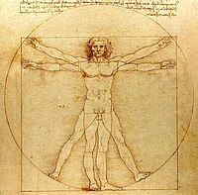
KUN
XXX | 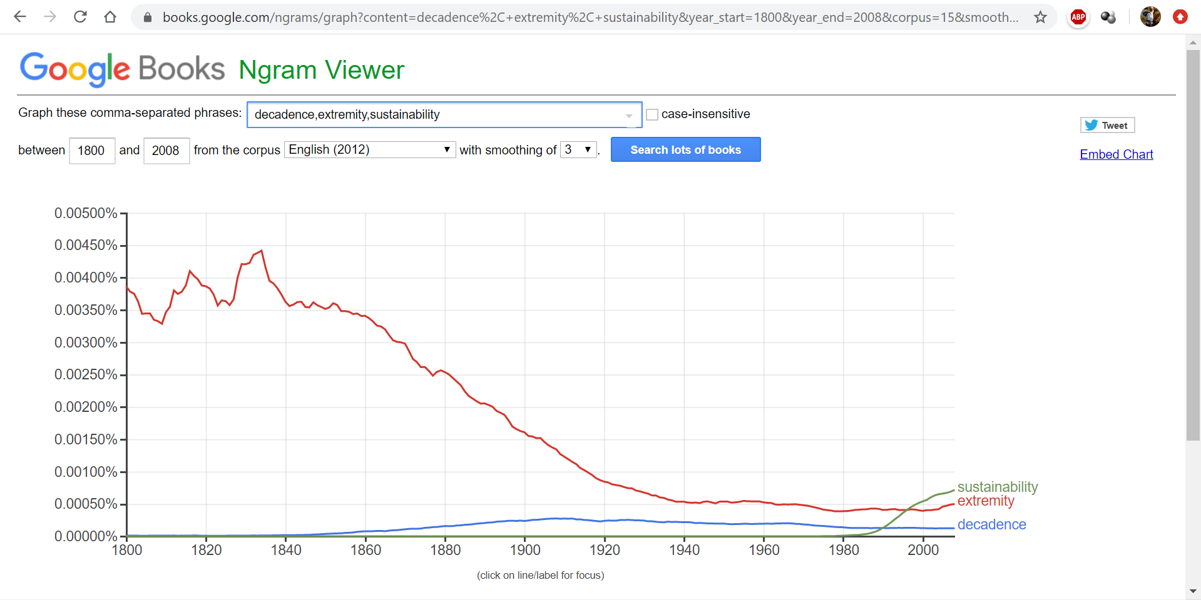

KUN | If we are curios how important are or were words like decadence, extremity and sustainability then we can use the Google online service – the Ngram Viewer. The most relevant expression among these three highlighted words is the extremity. And we can also see that the importance of the sustainability is increasing like buzzwords do in general. Fortunately, the most impact belongs to the most trivial expression – to the extremity and the other two words with their higher abstraction levels are less important along the time in general.
KUN | Unfortunately, the priority of the mathematical characteristic through the word of extremity is now lost. The word of extremity is a word what quasi everybody should understand immediately because the highest and or lowest values belong to the naïve level of the mathematics. If the last decades demonstrate the decreasing effects of the expression with lower abstraction level, then we can assume, this can be a sign for a declination, for the decadence?!
KUN | The above-mentioned thinking bubbles can be seen as a kind of theoretical or strategical background – especially based mostly on the magic of words, what should be now transformed, transferred, translated into source code. We will derive a robot historian, and or a robot psychologist and or a robot sociologist instead to speak about the American soul as such in an uncontrollable, subjective, instinctive way. The robots will use a big-data, American Time Use Survey (ATUS) for 16 years and for 997 potential time-spending-categories.
XXX | XLS-backgrounds:  https://miau.my-x.hu/miau/quilt/2020/quilt2/launching2020V13/atus_demo.xlsx  https://miau.my-x.hu/miau/quilt/2020/AI-project/long_format_usa.xlsx
KUN | The first step is always a draft thinking experiment where we outline the goals and the steps. The most direct goal is to derive a diagram where the X-axis is the time and the Y-axis is the aggregated decadence index of the USA between 2003 and 2018 based on the ATUS-data – especially based on a quasi randomized chosen selection of the potential time-spending-categories. The random-effect belongs to the keyword of “incl” – it means includes, inclusive, including. This characteristic supports to select time-spending-categories being quasi independent from each other.
XXX | https://www.bls.gov/data/#spending
KUN | The time-period between 2003 and 2018 contains 16 years. The number of the selected attributes is 12. Therefore, we should be capable of identifying and downloading 192 records. These records can have a strong structure in long-format or it can be transformed into this expected structure. The semi-structured outputs of an online database can be manipulated in an efficient way in Excel. The manipulations steps can be interpreted in form of muted animations.
KUN | If we have the planned data asset, then it is necessary to derive the extremities as such. The extremities will be calculated as a kind of absolute difference from the average of the particular attribute compared to the average itself in order to have extremity potential values in percent. These potentials should be ranked based on the principle: the-more-the-more. It means, the higher is an extremity potential value, the higher should be the aggregated decadence index based on a solver-oriented online modelling tool (COCO-Y0).
XXX | COCOY0 = https://miau.my-x.hu/cocoy0
KUN | Parallel, it is always relevant to see whether the naïve approaches deliver a significant different solution or not where the first naïve approach can be derived as the total value of the extremities and the secondary naïve approach will be the total value of the ranking number consolidated to the potential value of 16*12=192 (in order to have the same interpretation point of view for the two naïve and the optimized approach).

KUN | The online modelling of the aggregated/optimized decadence index needs an antidiscriminative modelling tool in order to ensure that each year can theoretically have the same aggregated index value – the norm value of 1000 units. The number of the modelling steps can be more than one. If the first model demonstrates the possibility of the antidiscriminative principle – it means: each year will have the same estimated norm value, then it is necessary to check, whether each variable could be integrated into the model or not?
KUN | If not, then one or more variables will have a maximal score of 15 in the staircase function in case of 16 objects (years). These not integrated set of the potential variables makes possible to derive new and newer models. The expectation is: each variable should be integrated (independent from the ratios of the estimated values) or the model may not reflect the norm value in case of each year. The estimated values of the last modelling step can be accepted as the final estimation. These final estimations should be visualized in the expected diagram.
KUN | The expected diagram should also have a trend function in order to be capable of forecasting the decadence index for 2019-2020-2021. The trend can be linear or parabolic – more complex (it means polynomial) trends for this relatively short time-period can be seen as irrational. The linear trend can be increasing, decreasing or neutral. The parabolic trend can be increasing or decreasing from point of view of the future. It is possible, that the linear trend is decreasing but the parabolic trend is increasing. The R2-value will decide what is the better naïve trend-approximation.
KUN | The decadence and the sustainability are not inverse phenomena. Therefore, it is necessary to create two terms. The decadence-model will maximize extremities. The sustainability-model will minimize extremities and maximize the standard deviation of extremities in order to cover the secondary expectation where a frozen average is less sustainable than an impulsive, as far as possible not extreme happening-series. These to models can become the inverse version of each other, if the data in the OAM leads to erased effects concerning the standard deviation as plus variable.
KUN | The above-listed thinking bubbles can be interpreted as part of a norm-like thinking experiment, where the expert should be capable of drafting each relevant step in the analytical process with potential junctions. It is to expect that a thinking experiment can be executed by each Student of a university or even of a high school. The capability of planning is the basic of the efficiency. Errors should be detected in advance in the planning phase and not in the reality.
KUN | Well! From now on, the planned steps for both term-creation-challenges should be executed, and the results should be interpreted, compared. The planned and real process elements are mostly the same – except of the number of modelling steps. The term of decadence needs two modelling steps where 4 variables are involved into the second step. The term of sustainability needs two modelling steps too where also 4 variables are involved into the second step – but partially not the same variables.
XXX | 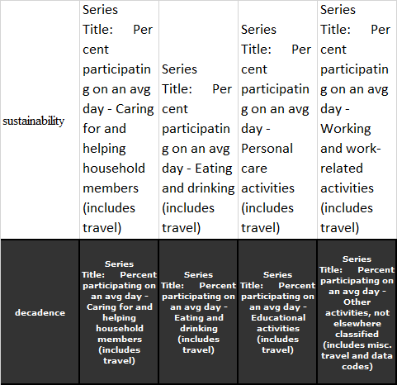
XXX | Animations (muted screen-captured processes – using in chronological order)  https://miau.my-x.hu/miau/quilt/2020/quilt2/launching2020V13/atus/?C=M;O=A
KUN | It is important to highlighted that all the variables deliver information about participating ratios and not about time spending. The 12 variables are:  Series Title: Percent participating on an avg day - Caring for and helping household members (includes travel)  Series Title: Percent participating on an avg day - Caring for and helping nonhousehold members (includes travel)  Series Title: Percent participating on an avg day - Eating and drinking (includes travel)  Series Title: Percent participating on an avg day - Educational activities (includes travel)
KUN | Series Title: Percent participating on an avg day - Household activities (includes travel)  Series Title: Percent participating on an avg day - Leisure and sports (includes travel)  Series Title: Percent participating on an avg day - Other activities, not elsewhere classified (includes misc. travel and data codes)  Series Title: Percent participating on an avg day - Personal care activities (includes travel)  Series Title: Percent participating on an avg day - Purchasing goods and services (includes travel)
KUN | Series Title: Percent participating on an avg day - Storing interior household items, including food  Series Title: Percent participating on an avg day - Telephone calls, mail, and e-mail (includes travel)  Series Title: Percent participating on an avg day - Working and work-related activities (includes travel)
KUN | The first steps of the both modelling processes lead seemingly to an antidiscriminative status where each year seems to have the same index value – it means the norm value. The second steps after deleting the already integrated variables lead immediately to different index values. The both index value set is not the inverse version of each other because of the partially different variables of the second modelling steps.

KUN | The results are now trivial. It is possible to visualize the trends of the estimated index values for each term including moving averages and parabolic trend functions. The USA produced a decadence decreasing trend till 2016. This is for example the year of the last election – with the winning position of Trump. After 2016, the decadence started rapidly increasing again. The question seems to be not to avoid: Is there any real connections between the elections and the low aggregated extremity-levels of the USA?
XXX | 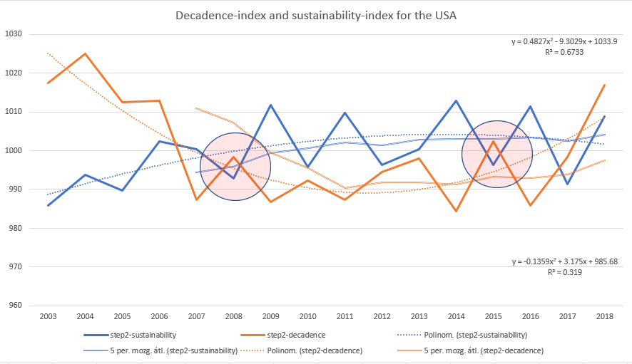
KUN | The sustainability index values, and the decadence index values produce parallel-running periods, therefore, it can not be spoken about a real inversion. The system of the USA seems to be more and more unsustainable in the future. If somebody likes the chart-analyse and/or Vonnegut’s works (c.f. Hocus Pocus) or even Nostradamus, then the two red transparent circles highlight two specific, repetitive constellations where the consolidated/normed force fields of the decadence and the same for the sustainability demonstrate crossing positions.
XXX | https://miau.my-x.hu/miau/quilt/2020/hocus_pocus_vonnegut_3888.png
KUN | The trivial questions are here and now: whether this pattern can be seen as a sign for system change in the USA? Or are these just coincidences? Let alone: Could we forecast the re-election of Trump based on this specific abstraction-driven Kaleidoscope (c.f. Food-Kaleidoscope-projects)? The (third) junction concerning 2017 is a sign of the massive movements for an impeachment? What was happened in the USA around 2006 where the last crossing position can be identified? How can be interpreted the crossing of the parabolic curves?
KUN | The parallel and close running lines around 2012 (see Obama’s second period) or even the parallel but far away running line around 2004 (see Bush’s second period) compared to and the potential parallel running curves nowadays can be seen as a sign for a re-election (for Trump’s second period)? Is this diagram a kind of measurable version of the American soul? Could our predecessor see the world more complex than this random-like but deep mathematical approach?
XXX | https://en.wikipedia.org/wiki/List_of_presidents_of_the_United_States

KUN | It is important to quote Robert Pirsig, who speaks about the static and dynamic qualities 6 times in the book of Lila: “Not subject and object but static and Dynamic is the basic division of reality.” + “When this reality of value is divided into static and Dynamic areas a lot can be explained about that baby's growth that is not well explained otherwise.” + “With the identification of static and Dynamic Quality as the fundamental division of the world, Phaedrus felt that some kind of goal had been reached.” +
KUN | “That is the whole thing: to obtain static and Dynamic Quality simultaneously. If you do not have the static patterns of scientific knowledge to build upon you are back with the cave man. But if you do not have the freedom to change those patterns you are blocked from any further growth. You can see that where political institutions have improved throughout the centuries the improvement can usually be traced to a static-Dynamic combination: a king or constitution to preserve the static, and a parliament or jury that can act as a Dynamic eraser; a mechanism whereby new Dynamic insight can wipe out old static patterns without destroying the government itself.” +
KUN | “This identification of rta and areté was enormously valuable, Phasdrus thought, because it provided a huge historical panorama in which the fundamental conflict between static and Dynamic Quality had been worked out. It answered the question of why areté meant ritual. Rta also meant ritual. But unlike the Greeks, the Hindus in their many thousands of years of cultural evolution had paid enormous attention to the conflict between ritual and freedom. Their resolution of this conflict in the Buddhist and Vedantist philosophies is one of the profound achievements of the human mind.” +
KUN | “A revolution of freedom against old rituals produces a new order, which soon becomes another old ritual for the next generation to revolt against, on and on. In the Orient there are plenty of conflicts but historically this particular kind of conflict has not been as dominant. Phaedrus thought it was because dharma includes both static and Dynamic Quality without contradiction.”
XXX | https://terebess.hu/zen/mesterek/Robert_Pirsig-Lila.rtf
KUN | The above-constructed patterns can be seen – on the one hand - as a parable of the magic of words and parallel – on the other hand, it is quasi the door to the artificial intelligence where data-driven and solver-oriented connections will be explored between arbitrary layers of the so-called measurable reality. Whether the computers (having the capabilities of generating intuitions) can produce positive Turing-tests quasi in case of each phenomenon? It means: is this interpretation good enough for a scientific study/article/publication – if nobody knows how it is made?

Conclusions
A sustainability-oriented (c.f. Kazohinia) society produce decadence-signs in case of each irrational ratios/trends. Fake news is a news where the transparent reproducibility is not given. The subjective opinions (and therefore each form of the magic of words – including exam situations below the level of the popular sciences - have a huge fake news-potential. Each affected person is responsible to minimize a volume of these potentials. Knowledge is what can be transformed, transferred, translated into source code (c.f KNUTH). Exam-situations should handle with the KNUTH-principle – not only with the level of popular sciences. Competences/competencies is part of the KNUTH-principle. Artificial intelligence is each (human) activity where the KNUTH-principle will be involved. If we will have a world where fake news is minimized, we have to change our motivations, preferences – in a robust way… Decadence is not sustainable. Decadence means to do what no rational is. The rational ratios (c.f. Kazohinia) is sustainable. The term of decadence can be modelled based on a system theoretical approach where the extremities (relative differences from averages of the variables) should be maximized. The modelling of the term of the sustainability can use the same variables as the model about the term of decadence with inverse directions and in addition it is necessary to involve at least one new variable: the standard deviation of the extremities which should be maximized.
Motto (let us never forget): Practice makes perfect! – Instinctive, subjective opinions lead to risks!

Potential focus points for distance-discussions
The QuILT 2.0 frame system offers co-operation possibilities concerning the avatar-based videos: https://miau.my-x.hu/mediawiki/index.php/QuILT2_parts
The previous projects prepared already potential FAQ-elements and this list will also be completed here and now:
Part | Player | Content | Question | Answer
7 | XXXX | Rosling-animations | If somebody is capable of creating a Rosling-animation, then it can be seen as a closed final publication?! | YES – if the thinking experiment is in written and co-operative form given before making the animation where the interpretation of the planned animation should also be part of the thinking experiment
…

https://miau.my-x.hu/miau/quilt/2020/impacts_of_discursive_learning/ + https://miau.my-x.hu/miau/quilt/2020/5percent/ based on https://miau.my-x.hu/miau/quilt/2020/teaching_is_learning.png
It means: in this file quasi each relevant URL of the semester should be involved

