Solver-based problem-handling

László Pitlik, Marcell Pitlik (MY-X team)

Abstract: The paper tries to support the understanding and/or training processes concerning the phenomenon “Solver-based problem-handling”. Problems are challenges where the way for solving the problem seems not to be given at once. Task (in contrary to the problems) can be defined as a kind of process where the steps for solving a “problem” can be planned in advance. Solver-based actions can be seen as specific approach where the available human knowledge is not good enough to solve the problem, but it is enough to co-operate with engines/robots like Solver in MS Excel and/or e.g. NEOS-server through the Google spreadsheets. The human individuals become cyborgs in a soft way if they can work successfully with the artificial intelligence components. For the involving of AI into the problem-solving processes, the human objects need a high-levelled competence in translation – translation the textual presented problem-descriptions (the magic of words) into elementary spreadsheet-cells and their connections (based on the KNUTH’s principle: where knowledge is what can be transformed/transferred/translated into source code – and source codes are already the non-verbal structures of a spreadsheet-logic).

Keywords: learning/teaching methods, shifting paradigms, efficiency through tools vs. theoretical backgrounds

Introduction 1

First steps for autodidactic learners 2

Translating text to structure 3

Alternative solution 4

Formulas 6

(Semi-)automation possibilities 7

Solver-based solution 8

Conclusions 10

Training tasks 11

References 12

# Introduction

The first task in more and more new courses from elementary level to PhD-level is the following description: **We are searching for a 4-digit number. If the number composed from its first 3 digits (starting from left) then the one from first 2 digits and then the first digit will be subtracted from the original value step by step, then the result is 3333. What is the original number searched for?** Example: 9876-987-98-9 = 8782 > 3333 (<https://miau.my-x.hu/miau/quilt/2020/th1.docx>)

There are a lot of alternative solutions available online:

* <https://miau.my-x.hu/miau/quilt/2020/?C=M;O=D> (see th1solution_*ofn.*)
* <https://www.google.com/search?q=4-jegy%C5%B1+sz%C3%A1m+kivon+3-jegy%C5%B1+2-jegy%C5%B1+1-jegy%C5%B1+3333+site%3Amiau.my-x.hu>
* <http://miau.my-x.hu/miau/208/solver_csodak_001.xls>

The problem could be used

* for pupil under 14 years (e.g.: <https://miau.my-x.hu/miau/solver4u/?C=M;O=D>)
  + in classic education frames (e.g. in additional school activities)
  + being private Students
* for Students (15-18-year-old) of high schools (see before) in form of additional activities
* for (Hungarian and international) Students of universities
  + in frame of specific/guest lectures
  + in frame of normal courses (
* for adult persons (e.g. <https://miau.my-x.hu/mediawiki/index.php/FARAD-DAYS>)
  + in form of specific education activities
  + in form of training courses initiated by enterprises for employees

The experiences are quite homogenous concerning ca. 1000 individuals: **NOT A SINGLE person used robots/engines!**

It could be said from critical point of views that the problem with the 4-digit-number as such does not seem to be a relevant business problem. That is right – but on the other hand the alternative question/task/problem (a REAL problem – see: <https://miau.my-x.hu/myx-free/index.php3?x=iq>) could never be approximated from the targeted persons – not in case of unlimited long supporting/preparation processes).

Therefore, it can be concluded that the education does ignore the introduction into this parallel world of problem-handling although this kind of problem-handling can be seen as a very efficient way where the general/problem-lasted e.g. mathematical education could be substituted/supported in a partial way.

# First steps for autodidactic learners

Before starting – a promise: EVERYBODY is capable of learning the following logic! It is just a question of time! Online demonstration material:   
<https://docs.google.com/spreadsheets/d/1sEbStn1MlsfE4dlu5JOPPkZKKAALPZT6TQH-wtycKU4/edit#gid=0>

Remark: the MS Excel offers a more professional Solver than the Google-spreadsheets, but the online tool can be interpreted in a lot of languages depending on personal settings. Therefore, here and now the following figures are inserted from Google-views.

## Translating text to structure

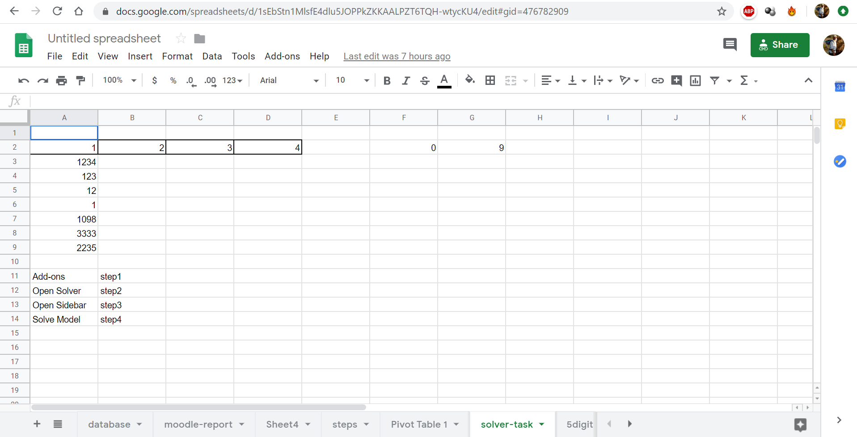

Figure Nr1: the initial view of the demonstration material (source: own presentation)

Figure Nr1 demonstrates the whole problem-solving-process in spreadsheet-view. We need

* cells for the results (see bordered cells – offering places for estimations too)
* cells for calculation steps (see cells with 4-3-2-1-digit-numbers)
* cells for particular constant values (like 3333, 0, 9)

To identify the appropriate menu-items, the characteristic ones are also given.

Remark: Please, never forget, the focused challenge is, to TRANSLATE/TRANSFORM/TRANSFER the textual problem (see above bold and underlined) description into a spreadsheet-logic!

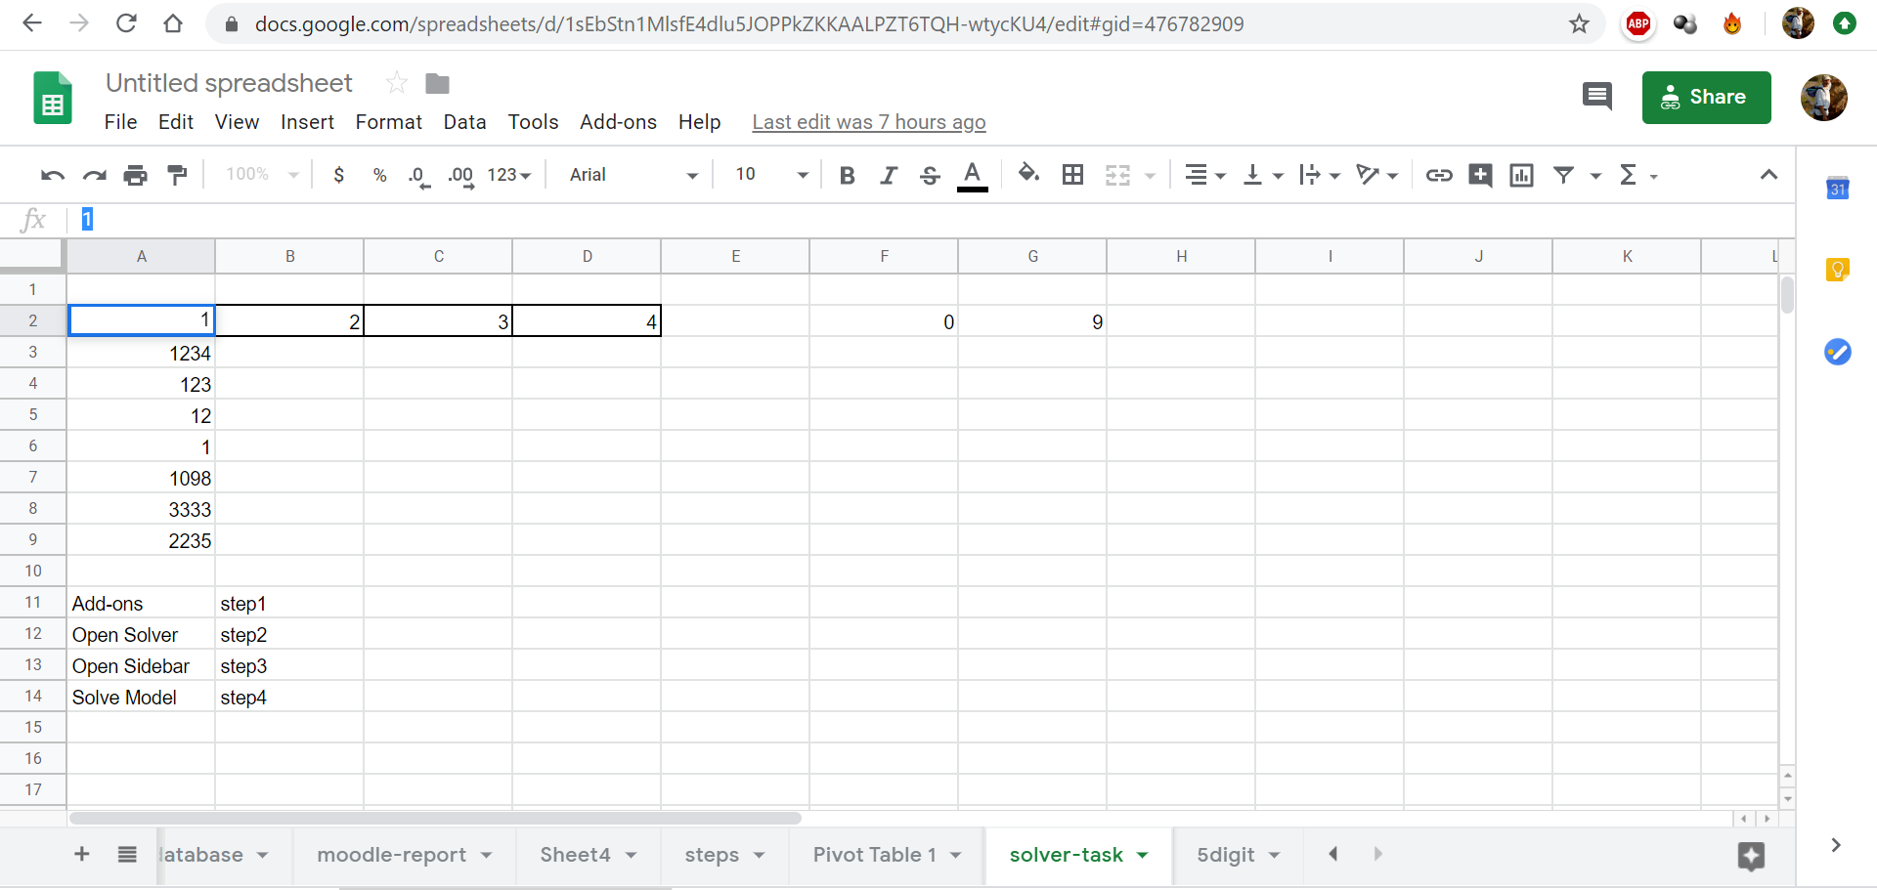

Figure Nr2: the raw inputs / cell without formulas – (source: own presentation)

Without quasi any pre-knowledge about spreadsheets, it is simple to check, which cell does contain constant values or formulas. The row signalized “fx” (below the menu, but above the cells) shows always the content of the selected cells (see A2 = 1).

Following cells have a constant value:

* A2 (digit for thousands)
* B2 (digit for hundreds)
* C2 (digit for tens)
* D2 (digit for the last number in the 4-digit number)
* F2 (0 = the minimal value for the range of “A2:D2”)
* G2 (0 = the maximal value for the range of “A2:D2”)
* A8 (the value of 3333 comes from the task-description above)

The Range of “A2:D2” presents a kind of estimation for visualizing the further calculation steps. The estimation (a wrong result) can be an arbitrary 4-digit number or this range could even be empty.

The used cells can be chosen in a more or less arbitrary way. There is only one rule: the cells of the bordered range should be cells with strong neighbourhoods – in general.

Needed mathematical basic knowledge till now: it is necessary to know what a 4-digit-number is (it means: numbers between 1000 and 9999)

Potential effects of the magic of words: e.g.

* we can create 3-2-1-digit-numbers starting from the left side (see Figure Nr1 and Nr2)
* or even starting from the right side (where the solution is not existing see Figure Nr3)

## Alternative solution

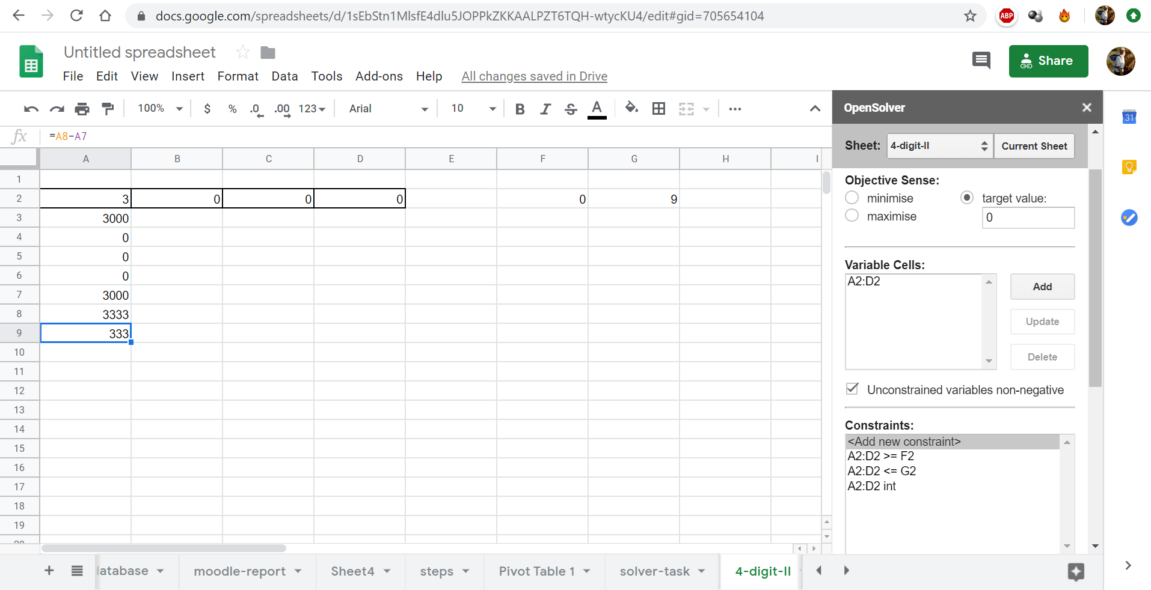

Figure Nr3: Problem-translation starting from the right-side (source: own presentation)

If somebody is not sure enough that the Solver-based solution is correct, then it is possible in case of rel. little problems/numbers to work based on the power principle. The power principle says:

* create each possible estimation in form of a column (from 1000 to 9999 or even from 3333 to 9999 or … where the min. and max. value can be derived more sophisticated with some tricks)
* create the formulas for each subtractions incl. the formula with the constant of 3333 in case of each estimation – in the same row (copy&paste after the first definition:-)
* set the auto-filter above the columns
* filter the differences (between 3333 and the result after the subtractions with 3-2-1-digits)
* identify the difference = 0 cases (if there are existing at all – see Figure Nr4)

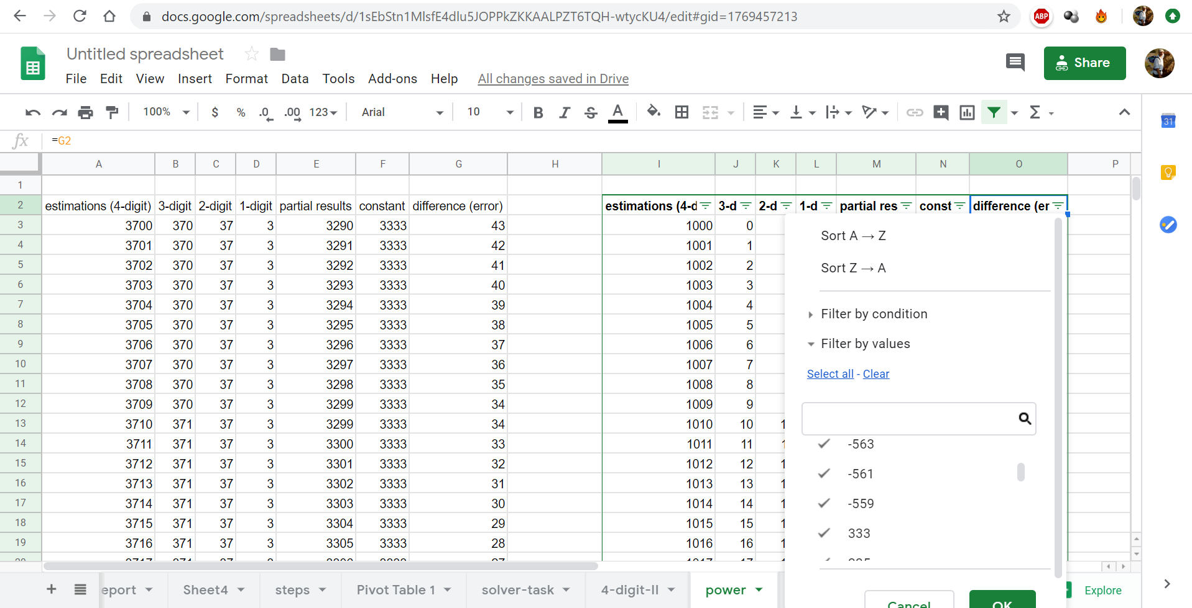

Figure Nr4: Power-techniques without a difference of ZERO (source: own presentation)

Figure Nr3 and Figure Nr4 expects “matured” spreadsheet-competences. The solutions based on the power techniques ensure that we see the solution(s) or the lack of the solution(s). Now, back to the original track:

## Formulas

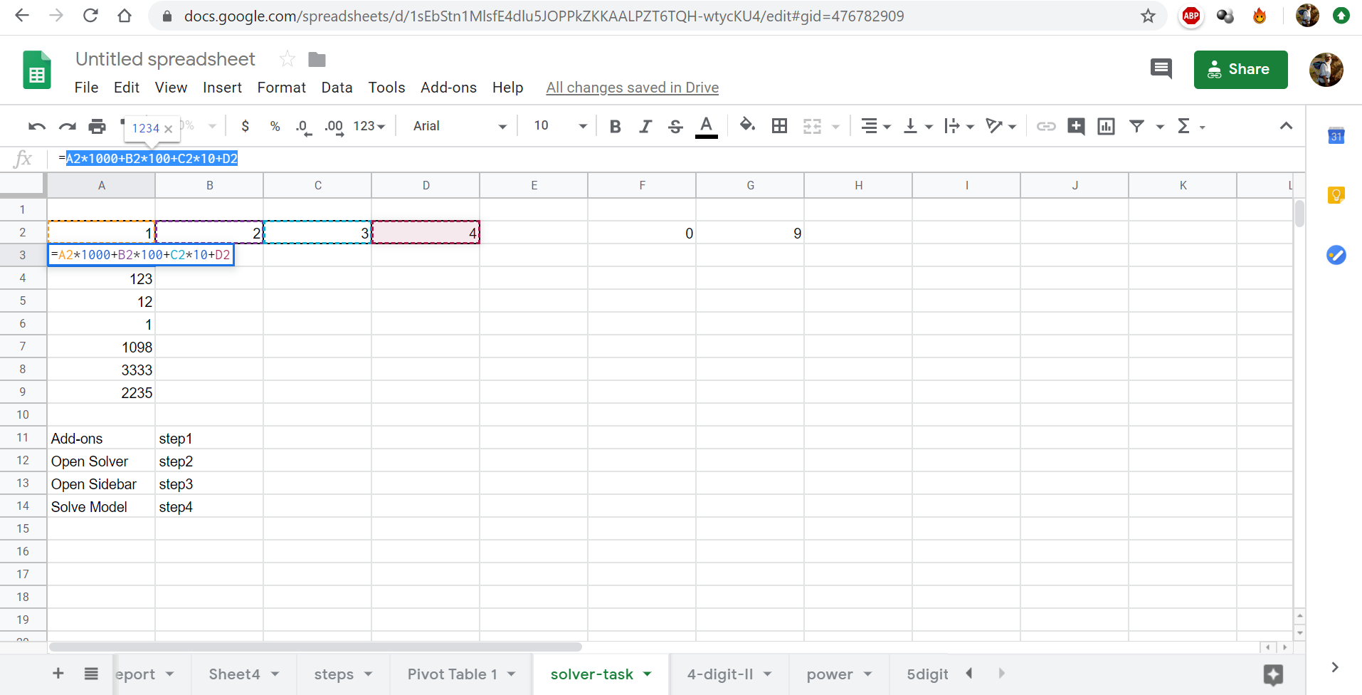

Figure Nr5: The formulas (source: own presentation)

As it can be seen based on Figure Nr5, the formulas can have references (cell-coordinates – like A2;B2;D2;E2) and constant values (1000, 100, 10, 1) and let alone operators (+, *) or even brackets. The result is also visible (1234). It is worth of checking the power sheet and identifying what kind of alternative solution can lead to creation of numbers.

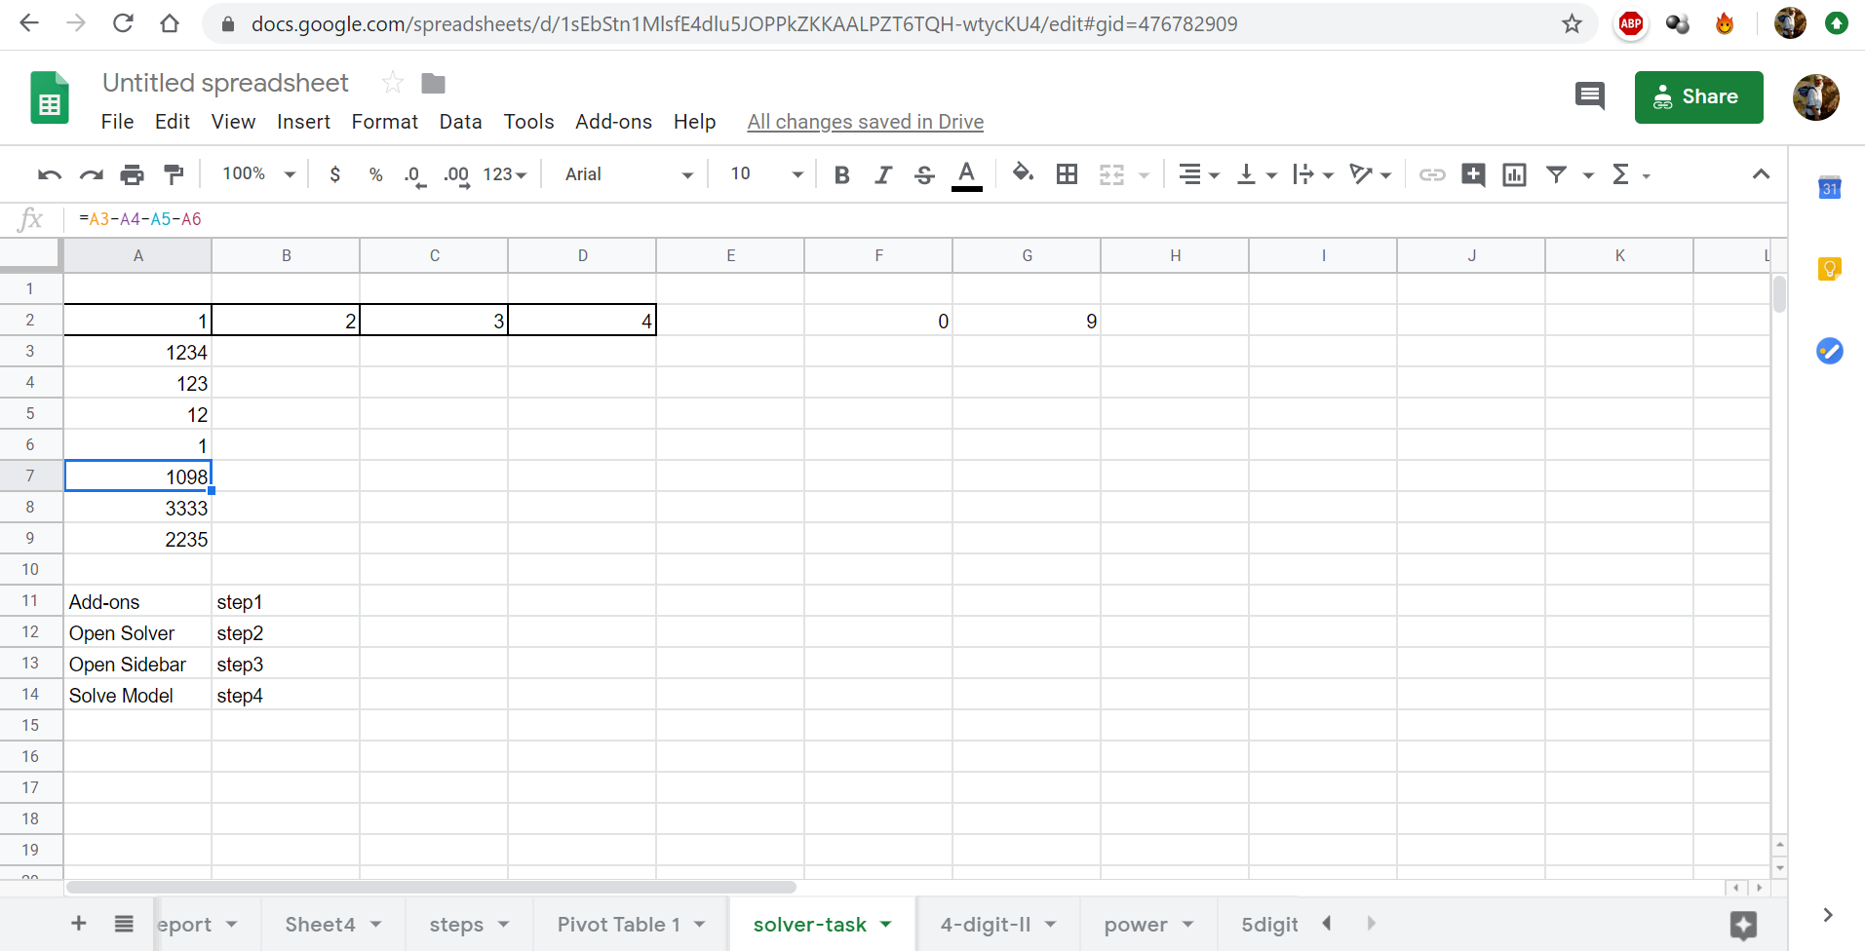

Figure Nr6: partial result after subtractions (source: own presentation)

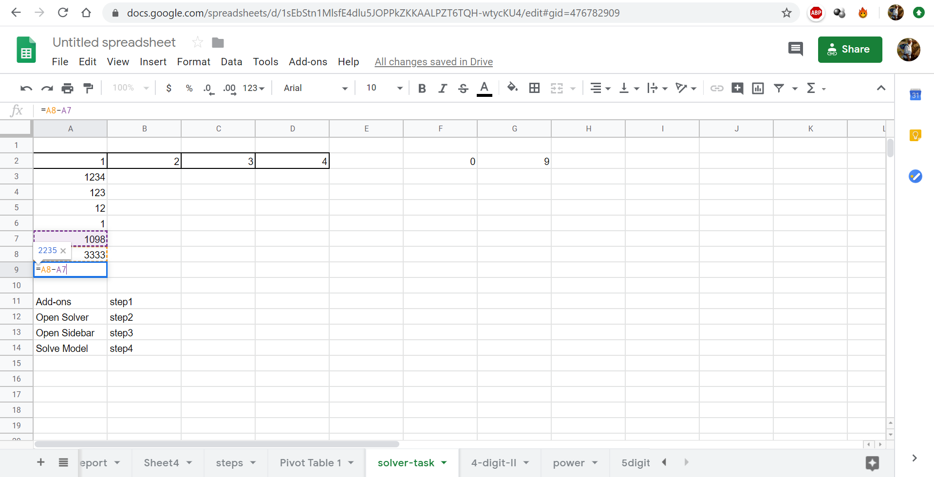

Figure Nr7: Comparing the partial result and the targeted constant value (of 3333) – (source: own presentation)

After a double click in a cell (A9) it can be seen what the formula is, and which cells are involved into the particular formula. The result can also be identified (2235).

## (Semi-)automation possibilities

Cell “A9” can be called as a kind of modelling error which should be minimized or reduced to zero. In order to approximate the targeted error (=0), the estimation (the 4-digit-number) should be changed.

How could we change our basic estimation of 1234?

* as it could be seen concerning the power-principle, we could create each potential estimation
* we could develop a macro (Visual Basic program-code running behind the MS Excel application) in order to produce estimations from 1000 to 9999
* we can change/set estimations manually and randomized (even within a process where we study in an intuitive way the errors and depending on its sign and/or value we change the estimations)
* …

Remark: based on <https://miau.my-x.hu/miau/quilt/2020/documented_solution_nr1.xlsx>, it can be seen, that the intuitive changing must not be without any definitive logic! The approximation is a kind of technique having specific rules in the background (e.g. difference-oriented generation of the next estimation, or deriving the half-distance to the targeted value).

## Solver-based solution

The following steps should be chosen to go on towards solver-parameter-settings:

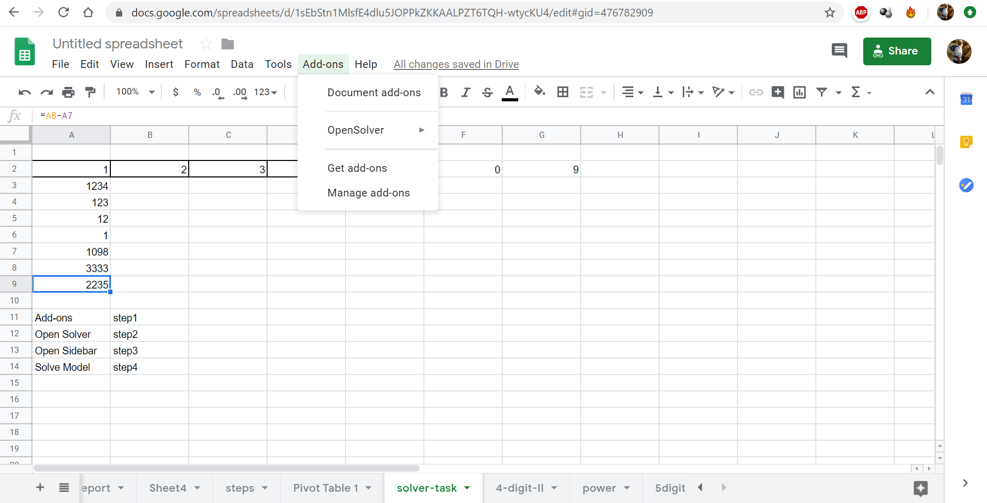

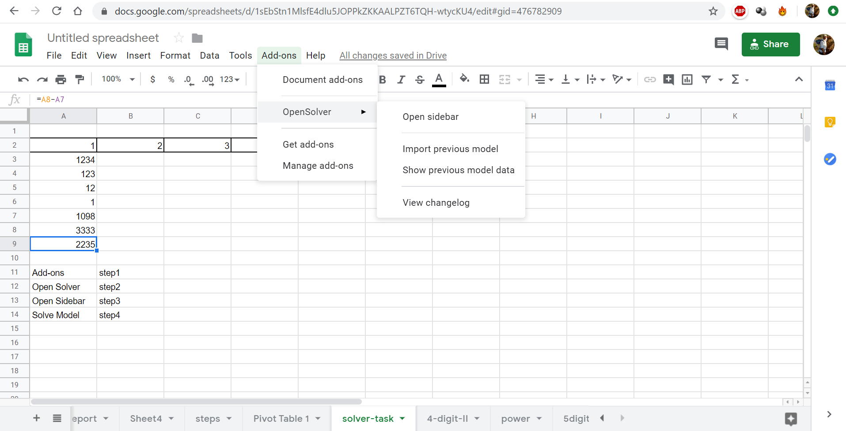

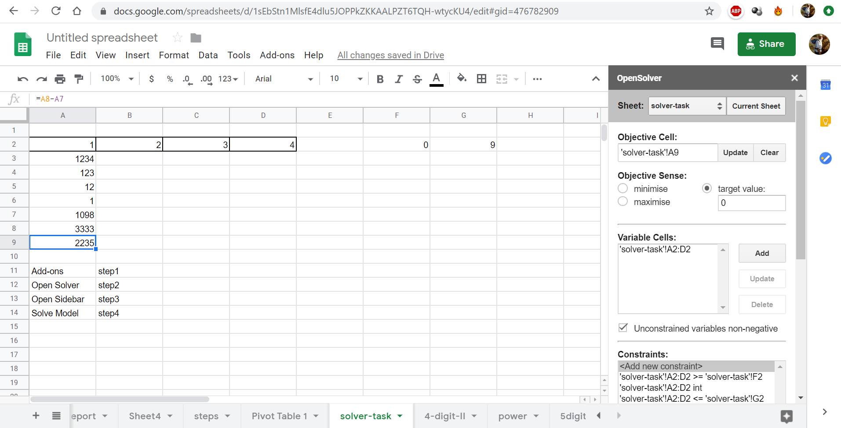

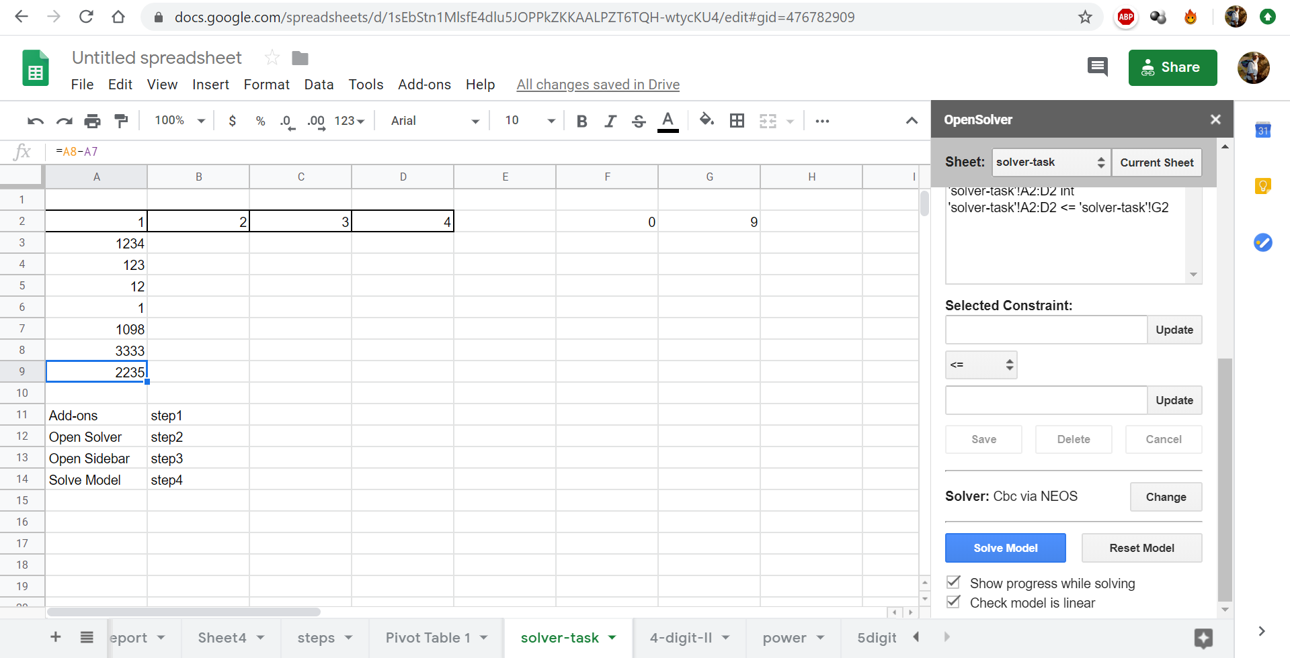

Figure-series Nr8-9-10-11: Steps of using Solver (NEOS) – (source: own presentation)

The figure-series (see above) can be interpreted as relevant parts of a video-stream. The Solver (add-on) offered by Google should be used following the listed rules:

* update-buttons: before clicking it, the targeted cells should be selected
* objective sense: the so-called model-error (difference between the value of 3333 and the particular partial result after subtractions) can be minimized, maximized or minimized as far as possible to zero
* variable cells: they are the spots for the final results
* constraints: expectations needing enforced for an acceptable result
  + our digit can only consist values between 0 and 9
  + and even just in integer form
  + parameters of the constraints can be set with updating or manual
  + new constraints can be added through “selected constraints”
* solver: there are more alternatives – with different capacities/competences
* solve-model-button: here can we start the solving process (see Figure Nr12)

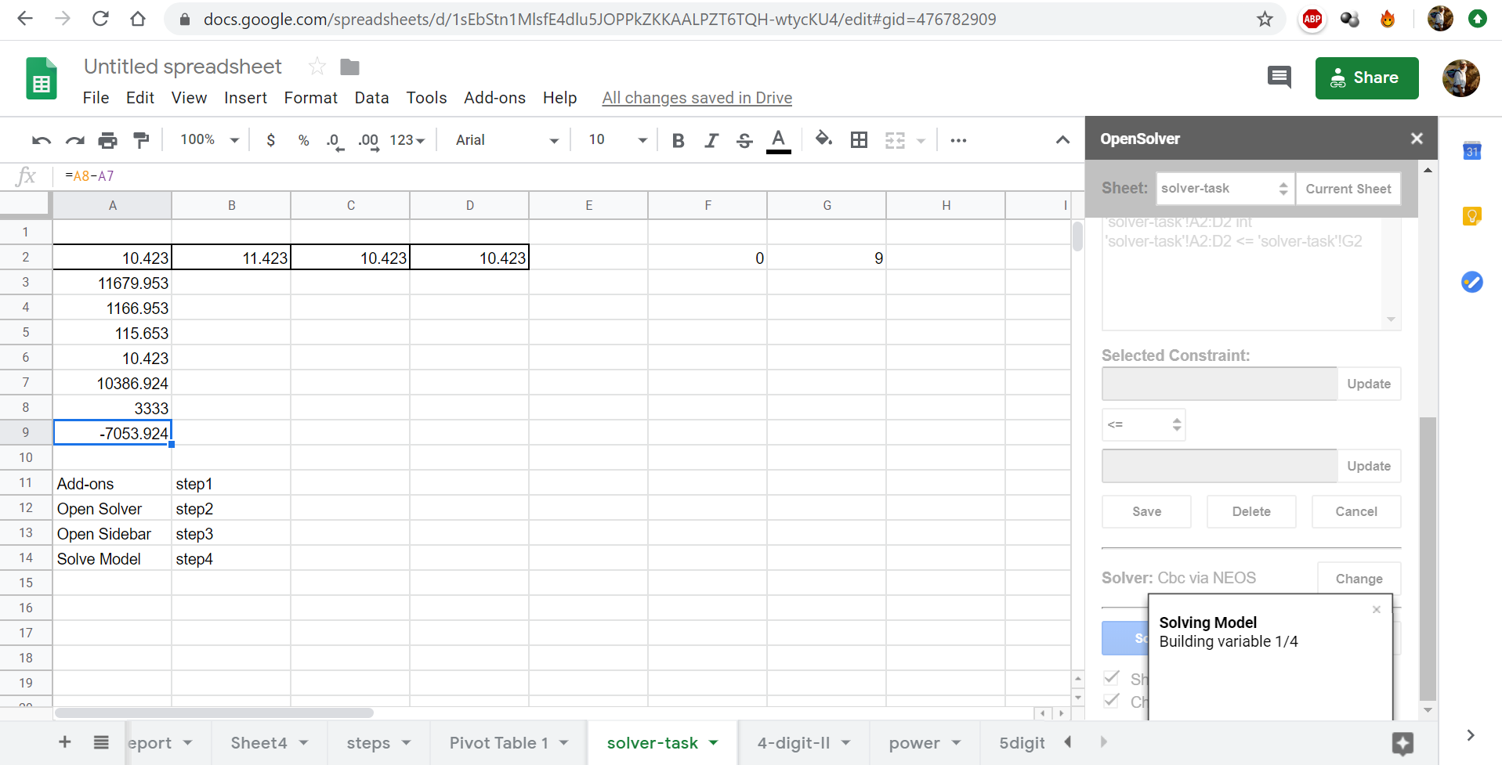

Figure Nr12: views during the solving process (source: own presentation)

Needed mathematical knowledge-elements:

* numbers of the result can be 0-1-2-3-4-5-6-7-8-9
* this numbers are integer values

Important question: What is the real performance of a Solver-add-on?

* Solver-modules derive equations based on the contents of the cells.
* The equation systems can be solved as a kind of universal (context-free) problem through different solver-engines.
* This universal competence makes possible to avoid more mathematical inputs for a solution process than describe here and now.
* Solver engines are complex calculation robots.
* There are further (online – problem-specific) tools/engines like: <https://miau.my-x.hu/myx-free/> (COCO = component-based online comparison for objectivity - Y0/STD/MCM <= similarity analysis).

# Conclusions

The paper presented introduction, philosophy and a technical guide for using Solver-tools/engines. The introduction tried to describe the necessity of a new thinking/learning/teaching methodology. The philosophy supports to see the whole process detailed enough and yet from a meta-point-of-view in order to be capable of identifying customized capabilities. The technical guide demonstrated that the challenge of learning solver-based competences is not too high…

The golden rule is valid here too: practice can not be substituted entirely with thinking experiments!

It means: in case of a user with appropriate technical experiences in this field, a solution can be enforced within seconds instead of intuitive/random-like guessing with trial&erros-effects.

# Training tasks

Source: <https://miau.my-x.hu/miau/256/sc2019_solver.xlsx>

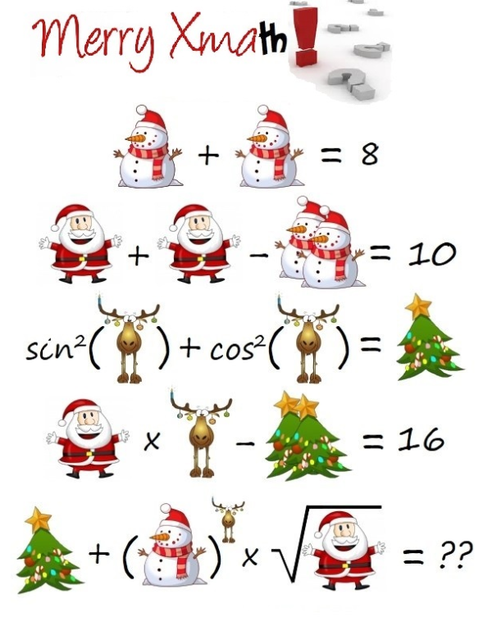

And/or: tasks for SUDOKU-fans

<https://miau.my-x.hu/miau2009/index.php3?x=e0&string=sudoku>

# References

…URLs see in the text-stream…

+ <https://miau.my-x.hu/miau/quilt/2020/google_4_5_digit_number_demo_saved.xlsx> (safety copy without NEOS-parameters)

+ <https://miau.my-x.hu/miau2009/index.php3?x=e0&string=hangos> (video-stream about Excel using with Hungarian narration)