Sovereignty-oriented/PLA-based future of the (higher) education or case study how to measure the future-readiness?!
László Pitlik, Marcell Pitlik MY-X team
Abstract: The future of the higher education is determined through two phenomena in the 21st century: the MOOC (massive online open course) and the PLA (prior learning assessment). The MOOC-based sovereignty of the potential Students (parallel to their different life experiences) ensures that more and more Students could bring well-prepared knowledge/competences for each course of the classic organized higher education. These previous experiences must be evaluated in the higher education based on the legal framework. The last two decades (2000-2020) demonstrate intensive increasing on MOOC-like courses but hardly changes concerning the PLA activities of the universities and the Students as such. Namely, it is not enough to create rules without the willingness to use it. This paper tries to measure the future-readiness of universities based on the term-creation potential of artificial intelligence because the KNUTH’s principle formulates clear: knowledge/science is, what can be transformed/transferred/translated into source codes – each other human activity is a kind of artistic performance. The paper presents a case study where the reality of the higher education will be presented through Student’s behaviour patterns.
Keywords: robot politician, robot rector, robot teacher

Introduction
The declarations of the abstract need the appropriate evidences like the changes of importance of phenomena (e.g. MOOC, PLA). Figure Nr1 demonstrates for the whole world and for 15+ years that the term of MOOC has a characteristic history – but parallel, the PLA can not be evaluated as a well-known term.
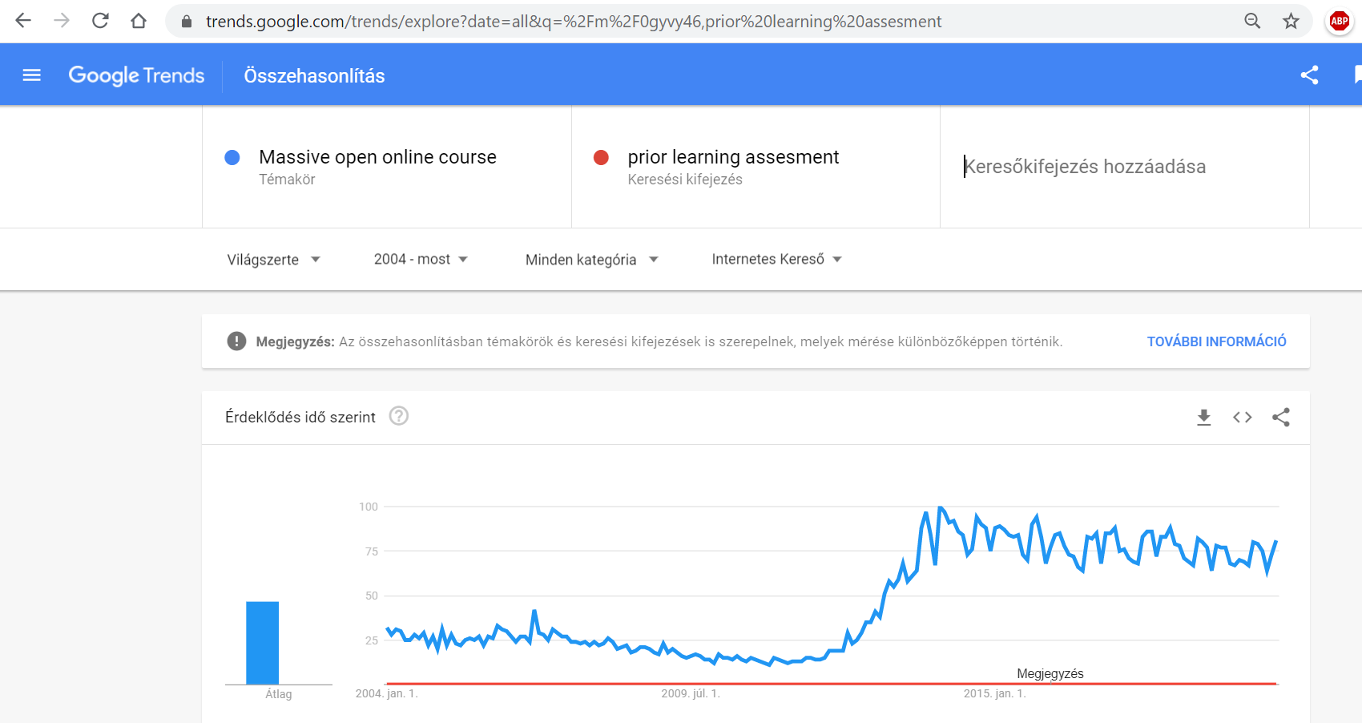
Figure Nr1: MOOC vs PLA (2020-III-02) – (source: Google Trends – own presentation)
The term of sovereignty (supreme power or authority) should also be defined concerning the higher education: Students expect two antagonistic force fields during their education periods: the freedom and the safety. The freedom for choosing courses on their own (decisions) and the safety to see the curricula ensuring credits/degrees. The antagonism is trivial given: a set of randomized chosen courses must not lead to a degree because the consistence of the randomized chosen knowledge-elements/competences must not be given in a form to be capable performing on the market/reality (e.g. a half-doctor + a half-poet = nothing, it means two times something can not be seen as a unit, as a good employee in a hospital and/or in an editorial staff). Free chosen courses can lead to quasi randomized set of competences without massive consistence of the knowledge. On the other hand, innovations will mostly be identified if the classic curricula can be modified (see trans/inter/multi-disciplinary approaches). Rational changes of curricula can be caused through free chosen courses.
These layers of the antagonisms can not be eliminated from the classic point of views. The phenomenon of PLA could be a kind of new point of view (a kind of shifting paradigms). Instead of accreditation of curricula in the well-known ways, we need a combinatorial approach where each potential set of courses/competences/knowledge-elements (independent of their origin) would be evaluated and connected to degrees incl. an expertise: what kind of additional knowledge could lead to a degree in the shortest way?
The above drafted conception could be transformed into the daily praxis of the universities from legal points of views, but the economical frames are not really given.
Therefore, Students produce two characteristic reaction patterns:
- no official questions, suggestions, opinions about the curricula – and parallel no motivation to be deep involved into the courses
- “rise and rise again until lambs become lions” (it means: ignoring the classic/legal ways, ignoring canons, accreditations, official views – and enforcing validation through the market – see history of Google, Facebook, etc.)
However, the world is mostly not so simple – not black and white. Students can use and/or expect PLA-oriented legal frames. The following anonymous case study demonstrates real events, actions and appropriate conclusions concerning the aim how can we measure the future-readiness of the higher education in an objective way?

Case study
The case is seemingly very simple: the case is the reality. There is a course with following characteristics:
- PLA-oriented (e.g. because the motto of the first contact meeting was – “if I were you” and this event presented one way to realize the final credits at once (see: https://miau.my-x.hu/miau/quilt/2020/objective_evaluation_of_publications.docx)
- the course has an archive with all components about a successfully closed semester (see: https://miau.my-x.hu/miau/quilt/ and https://miau.my-x.hu/mediawiki/index.php/QuILT-IK045-Diary)
- the course as such tries to shift paradigms (even towards the MOOC-based/PLA-oriented approaches, where the archive about the previous activities can be seen as a simple MOOC and the credit realization process is PLA-oriented because the final publication in co-operation with one/more conductor(s) is the type of exam where the Student (alone or in team) can be free and yet supervised
- each information unit (learning/demonstration material, navigation support, rule, etc.) is always online available in advance (it means: each Student has always the possibility to prepare himself/herself in advance)
- the course started with a kind of gamification effect (treasure hunting process: https://miau.my-x.hu/miau/quilt/2020/th1.docx - in order to warm up for sovereignty in general)
All background files from the recent point of view: https://miau.my-x.hu/miau/quilt/2020/IK045_2020III03.docx (where each URL is part of the background information set)
This only paper can not involve each relevant detail therefore, it seems to be necessary to read quasi each object (document) in order to have a complex view about the case itself.
The case study has a central object – the Synchronicity Test Nr1: https://miau.my-x.hu/mediawiki/index.php/QuILT-IK045-Diary#4._Day_.282020.II.26._.2F_FR135_.2F_14.15-15.45.29 (It is important to know, that each course should ensure at least 3 tests during the semester and ca. 200-300 pages learning materials – in advance.) On the other hand, the PLA-oriented/MOOC-based approaches do not work with deadlines and they make not possible to deliver arbitrary performances of Students. Only co-operative performances of Students (with the conductors) can be evaluated (like in the real world of enterprises).
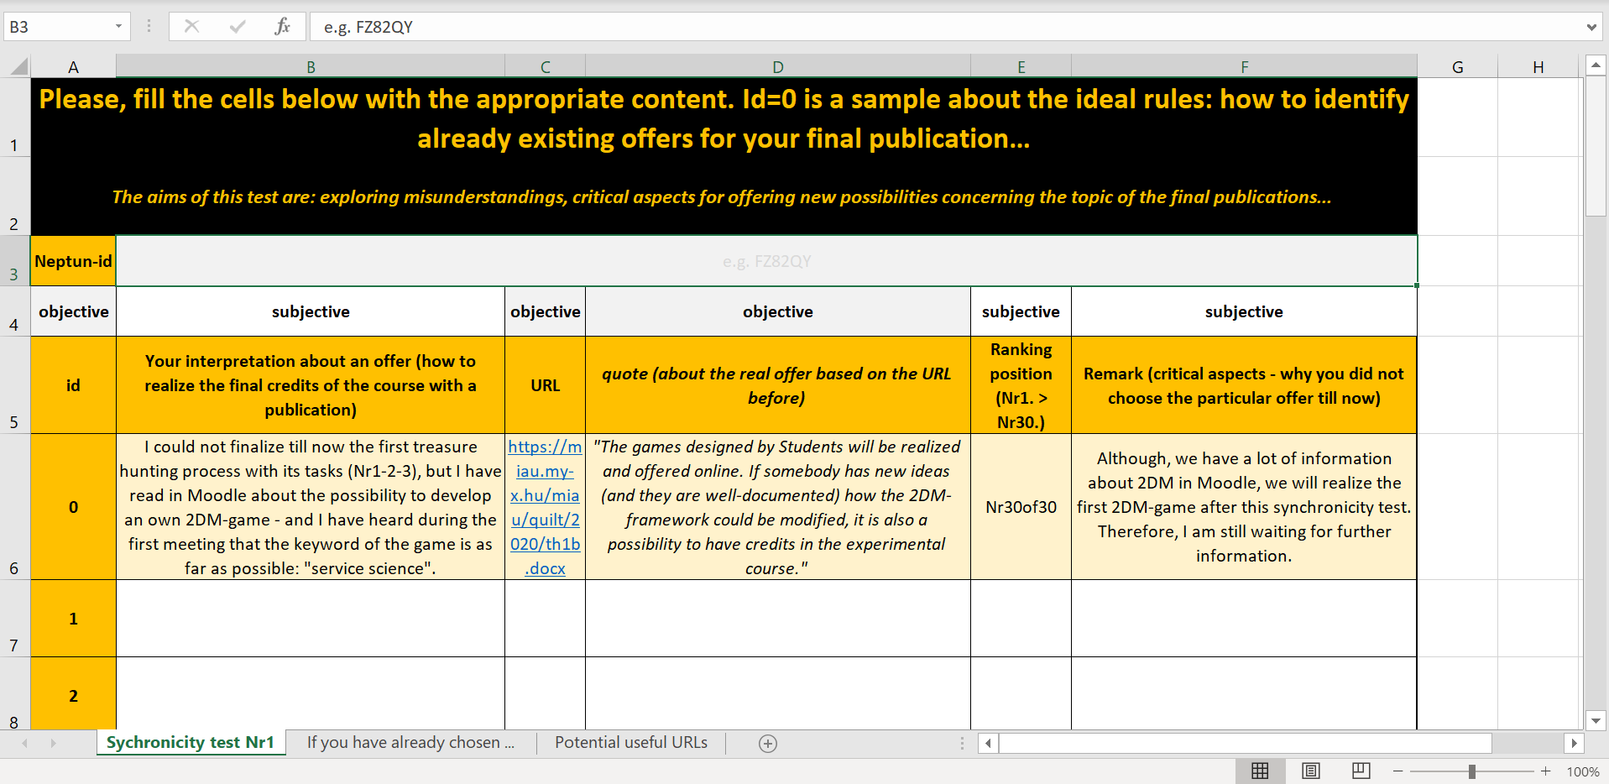
Figure Nr2: The first layer of the test (source: own presentation - where each relevant rules for testing can be identified through the URL above concerning the Day Nr4)
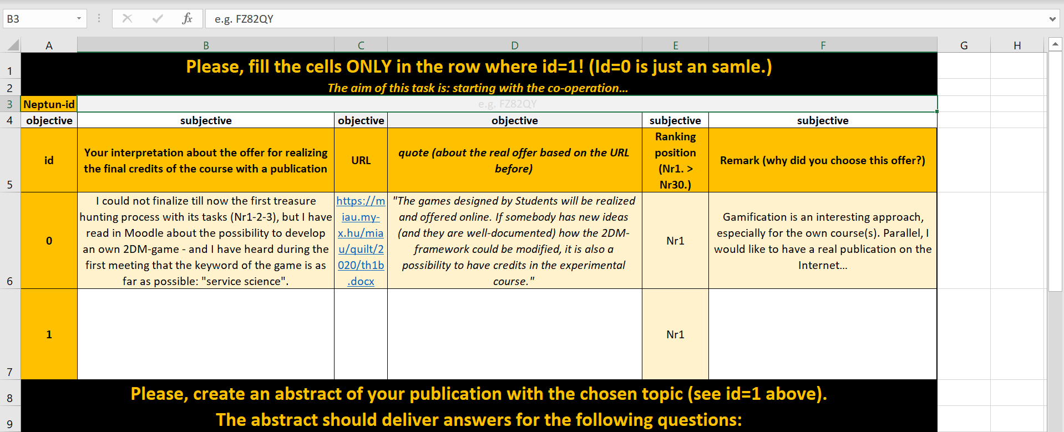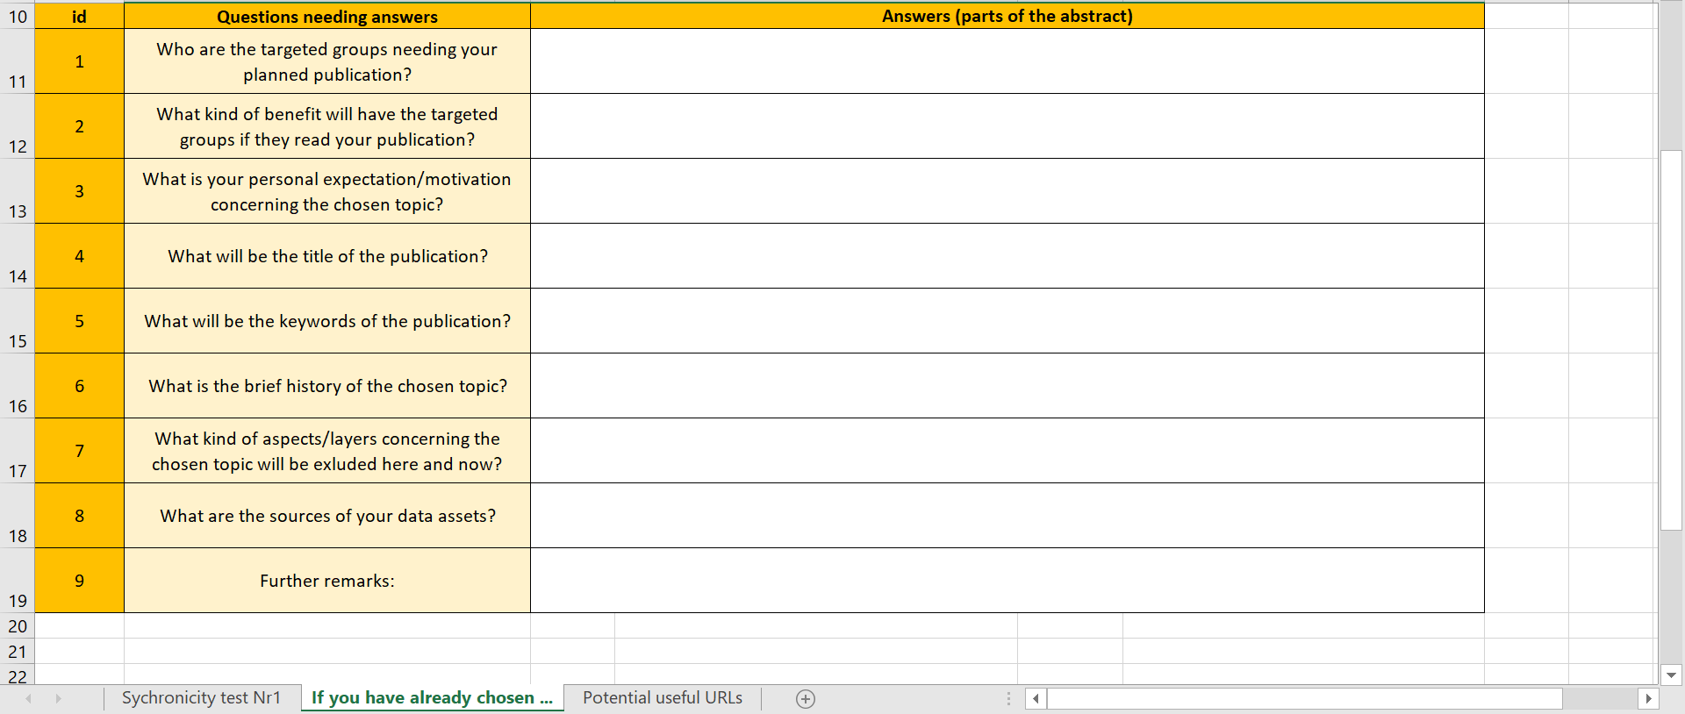
Figure Nr3: The second layer of the test (source: own presentation)
The test has following characteristics:
- the test got checked by test-persons before publishing
- the test could be downloaded before testing in frame of the official event (meeting)
- a kind of MIAU-WIKILEAKS-effect got started 2 hours before official testing
- at least one test could be filled with quasi ideal answers
Concerning this synchronicity test, it is important to know. The test-answers are ideal filled, if
- each rule could be followed (e.g. Neptun-id, real quotes, etc.)
- there is a Nr1 position (it means, the person could choose a topic – irrelevant, whether an official or even a private topic)
- the subjective interpretation could be evaluated as a kind of constructive pattern (where the real objectives of the final publication could be identified at least in an indirect way)
- the chosen topic had a draft description (based on the second layer)
- new URL could be identified (especially one/more from the archive and/or from the set of the not-mentioned-but-existing recent URLs)

Why it is important to have an ideal (even with the above-mentioned components)?
- rule-like behaviour is important to achieve sovereignty
- arbitrary behaviours bring unnecessary risks
- the preference of rule-like behaviours does not mean that it is not possible to break some rules in a conscious way and with written argumentation
- constructive thinking is important because one of the keywords of the meeting was: “efficiency” – and the solver-based thinking is hardly possible without focusing on relevant details (e.g. https://miau.my-x.hu/miau/quilt/2020/solver_based_problem_handling.docx)
- constructive thinking means e.g. having a good question, having potential answers for the question, having methods to filter the best answers from the set of the potential ones
- a good question is the title of a final publication (at once)
- the readiness to read learning materials (to identify relevant objects/URLs) could be declared from different point of views and more times (see: Figure Nr4)
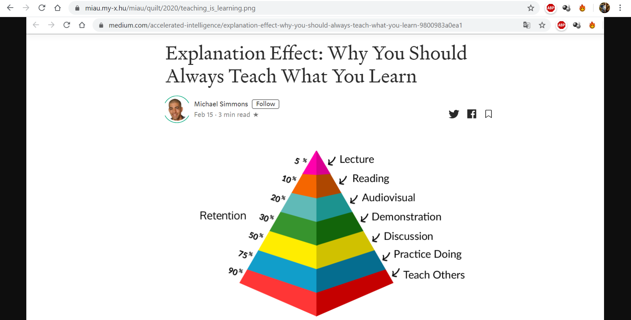
Figure Nr4: Focused topic of the course about knowledge economy, research (source: https://miau.my-x.hu/miau/quilt/2020/teaching_is_learning.png / https://miau.my-x.hu/miau/quilt/2020/urls.htm / https://miau.my-x.hu/miau/quilt/2020/?C=M;O=D)
Summa summarum: the course itself delivered impulses for PLA-orientation and/or MOOC-based learning possibilities.
The next chapter demonstrates how can we create a future-readiness index in order the be capable of measuring this complex abstraction (it means the term of the future-readiness). Based on the KNUTH’s principle, it is important for each Student to have experimental experiences about the translating/transferring/transforming processes of highly abstracted phenomena into source code because only the experience level can ensure a kind of paradigm shifting from the classic approaches (e.g magic of arbitrary words) towards solver-based thinking and acting without mathematical pr-knowledge (c.f. literal programming also by KNUTH).

Future-readiness index
The following figure (Nr5) demonstrates what kind of objective measurable information can we derive from tests:
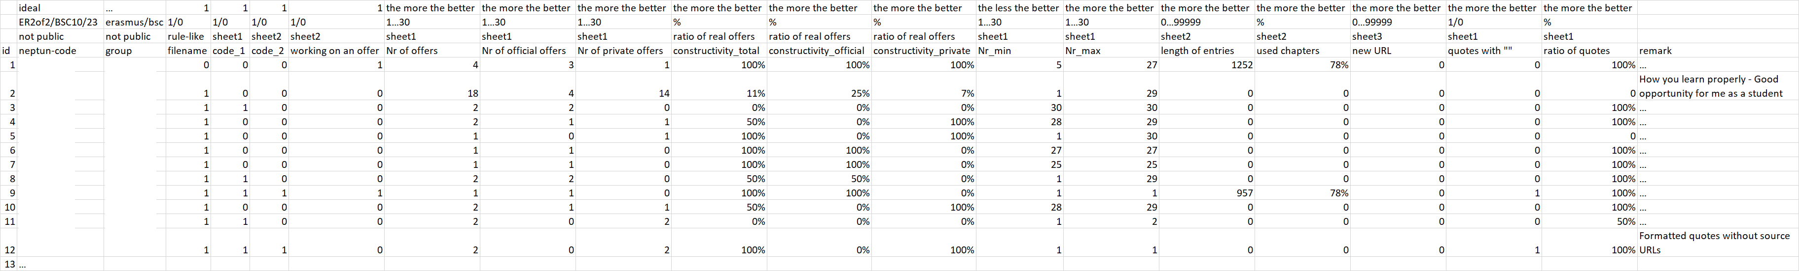
Figure Nr5: Result of the test (source: own presentation with anonymous objects)
The OAM (object-attribute-matrix) can be interpreted as follows:
- rule-like behaviour patterns:
  - the needed Neptun-id could only be set in case of one person for each expected position
  - one single person did not use the own Neptun-id
  - one single person used quote-signs
  - not each person used quotes as such
  - not each person was constructive enough (but in an indirect way, the subjective sentences had appropriate content elements in order to fine tune an offer for the topic of the final publication – see below)
  - not each person used the ranking number “Nr1” as a sign for a direct and constructive position
  - not each chapter for the draft got used by the persons who had a direct decision
  - the 12 submitted tests come from 23 Students (being active on the official test event) – it means: quasi only 50% of the active test persons sent the test file to the pre-defined email-address after closing the testing phase (where it should be highlighted that the test file will also be used in future for fine tuning the communication between Students and conductors)
The Students had the possibility to use pre-defined URLs. The figure Nr6 presents the so-called usage statistics (again in an anonymous way):
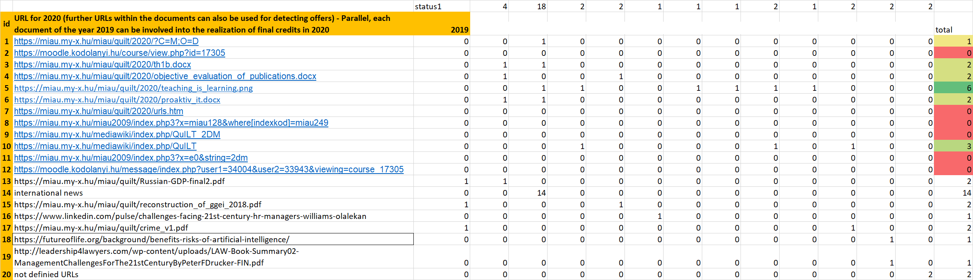
Figure Nr6: Usage statistics (source: own presentation – where the blue highlighted URLs were defined in advance and each other URL comes from the test results of the Students)

As it can be seen (Figure Nr6):
- the PNG-object (see Figure Nr4) was the most used object
- 3 documents from archive (see status1=2019) could however be involved into the URL-database
Based on the OAM (Figure Nr5), it is possible to speak about the best test person (where a Solver-based modelling approach could be executed. BTW: this is also a potential topic for a final publication). The index value behind the modelling of best test person can be seen as a kind of future-readiness index because the Student’s behaviour can be interpreted as a mirrored picture of an educational system.
The methodology for creating a future-readiness index is a solver-based approach (see: https://miau.my-x.hu/miau/196/My-X%20Team_A5%20fuzet_EN_jav.pdf). The attributes in Figure Nr5 should have a direction (the more the more or the less the more). So, we can derive ranking numbers and based on them, we can involve the Solver-add-on in form of an antidiscriminative modelling (like in case of the best publication in the archive – see before).
If we will make similar tests during the semester (and create a kind of standardization for comparing the test result in case of different test files) then we will have a similar OAM but with more and more rows (objects). Based on this time series, the test persons will have mostly different attribute values and different (future-readiness) index values. The trend of this time series for persons and test events demonstrate the changes concerning the future-readiness. Namely, the future-readiness is not a static phenomenon, it should have dynamic changes…

Conclusions
https://www.tk421.net/lotr/film/fotr/01.html
“The world is changed.
Han mathon ne nen…
I feel it in the water.
Han mathon ne chae…
I feel it in the Earth.
A han noston ned gwilith…
I smell it in the air.”
The world is changed – the world is changed in a relevant way in the last two decades: teaching and learning will not be the same as ever before! And this should be so! Everybody will change and the new aera makes possible to be more and more sovereignty-oriented and to except educational systems supporting PLA-based education…

Further references (…URLs see in the text stream too…)
https://miau.my-x.hu/miau2009/index.php3?x=e0&string=pla- (2013-2015-2017)
http://ofi.hu/sites/default/files/ofipast/2010/09/tot_eva_a_validaciorol.pdf (2009-2010)
http://www.okm.gov.hu/letolt/felsoo/ujhonlap/ujh_felso_kredit-ajanl.pdf (2001)

Annex I – Attributes of Figure Nr5
Figure Nr5: Result of the test (source: own presentation with anonymous objects)
Attributes:
- neptun-id: hidden information to ensure an anonymous presentation and a new treasure hunting process about self-identification experiments (c.f. https://miau.my-x.hu/miau/quilt/2020/th2_help1.docx)
- group: there are classic and Erasmus-Students behind the matrix – the group-information is also hidden as the neptun-id because one of the subgroups has just a few quasi identifiable persons and according to the rules of statistical publication: information about small groups may not be declared especially if one player among the few group members is bigger than the others
- file name: Could be the neptun-id identified in the file name of the first test object? (yes/no=1/0) – the question is important to describe a layer of rule-like functioning which is relevant for detail-oriented publication
- code-1: the first test sheet has a field for the needed neptun-id (the attribute is important to describe a layer of rule-like functioning which is relevant for detail-oriented publication)
- code-2: the second test sheet has a field for the needed neptun-id (the attribute is important to describe a layer of rule-like functioning which is relevant for detail-oriented publication)
- working on an offer: it means, the second sheet (where the abstract of the planned publication could be worked out) was used or not? (it is a sign for progress towards the final publication)
- number of offers: the first sheet in the test file had 30 positions for identified official offers and/or own suggestions (private offers) – the direction “the more the more” means: in ideal case the Students are motivated to identify quasi each official offers and also motivated to declare own ideas
- number of official offers: an offer can be seen as an official offer if there is already a document (URL:site:miau.my-x.hu/*) where a quote about the offer can be identified in a direct or in an indirect way – the direction “the more the more” means: in ideal case the Students are motivated to identify quasi each official offers and also motivated to declare own ideas
- number of private offers: an offer can be seen as a private offer if the URL does not contain “miau”-relations – the direction “the more the more” means: in ideal case the Students are motivated to identify quasi each official offers and also motivated to declare own ideas
- ratio of real offers (constructivity total): it means, the number of all (official + private) operative relevant offers / number of all offers (official + private) where an offer is operative relevant in case if the offer can be interpreted as a kind of command (opinions, evaluations as such can not be interpreted as command for working on them) – it is important to become more and more operative to be capable of delivering the final publication as soon as possible
- ratio of real official offers (constructivity official): it means, the number of all (only official) operative relevant offers / number of all offers (only official) where an offer is operative relevant in case if the offer can be interpreted as a kind of command (opinions, evaluations as such can not be interpreted as command for working on them) – it is important to become more and more operative to be capable of delivering the final publication as soon as possible
- ratio of real private offers (constructivity private): it means, the number of all (only private) operative relevant offers / number of all offers (only private) where an offer is operative relevant in case if the offer can be interpreted as a kind of command (opinions, evaluations as such can not be interpreted as command for working on them) – it is important to become more and more operative to be capable of delivering the final publication as soon as possible
- Nr_min: the lowest number in the appropriate column for ranking offers from point of view of the particular Student – where the minimum value should be Nr1 in order to be operative enough
- Nr_max: the highest number in the appropriate column for ranking offers from point of view of the particular Student – where the maximum should be as less as possible to have the chance to become as operative as possible
- length of entries: the number of characters being used in the second sheet (where the chapters of the abstract for the chosen topic could be worked out) – the direction the-more-the-more makes trivial that a (planned) publication needs volume
- used chapters: the number of the filled cells concerning the layers of the abstract where the direction the-more-the-more makes trivial that the planning should be complex (free of lacks)
- new URL: the number of the presented URLs (behind of this attribute there is the same expectation as in case of the number of offers: the more the more)
- quotes with “”: the number of quotes with correct format (this expectation measure the rule-oriented handling too)
- ratio of (correct formatted) quotes: number of quotes (correct formatted) / number of all quotes (the relative attributes makes possible the comparison of objects with huge differences concerning their absolute values)

Annex II – Finetuned offers
The following finetuned offers for the topics of the final publications could be formulated based on the test results. It is important to highlight: these topics do not need deep mathematical knowledge and parallel they are complex, relevant (even capable of shifting paradigms as the course is going to do so):
id | offers (being not really too complex if we use solver-based models - see publications of the previous year:-) | annexes | others
1 | your test can be used as a good starting point!  :-)  according to me practice doing bis the best way of teaching because the more we practice we will be able to understand it more fluently .  practice makes a man perfect so according to me practice is far better way for teaching which will helpmake a good bond between student and teacher which is helpful for studies  You declared a clear hypothesis about the connection of praxis and theory.  THIS HYPOTHESIS should be proven in a final publication for credits.  To be operative:  - we had till now two praxis-oriented learning materials being discussed / having presented  1. https://miau.my-x.hu/miau/quilt/2020/objective_evaluation_of_publications.xlsx  2. https://miau.my-x.hu/miau/quilt/2020/solver_based_problem_handling.docx  - we had an email about the possibility to create tutorials instead! of a classic publication (s. email below)  - please, choose one of the 2 URLs above  - please, produce a short tutorial video following the messages in the chosen URL  - if we have your video and my docx, then we will make a test with Students where e.g. 10 persons will only have the docx, the other 10 persons will only have the video  - we will create a short test about relevant questions which should be answered based on the docx and/or your video  - finally, we will see, what is the added-value of the video produced by you (it means: what kind of differences can be detected based on the test results group by group)  - the classic written publication IS NOTyour task!!!  - you/we can involve an other Student to write it (or I will write it as a new learning material:-) | 19 Február 2020[1]  6:49 :  Dear Students,  at first: thank you for your activities till now!  As we all could see, the room (FR135) is not really good for supporting activities of a conductor on the spot.  Therefore it is necessary to have tutorials parallel to the learning materials.  Online tutorials in general e.g. about the Google-Spreadsheets+Solver  (https://www.youtube.com/watch?v=JwYYIdmrmN8) can be identified e.g. in Youtube in an simple way.  BUT we need eventually our special tutorials (captured video-streams with voice + subtitles).  So, you can realize the credits of the course if you deliver tutorials.  The learning materials (till now at least 3 docs) can be interpreted as a kind of story board  1. https://miau.my-x.hu/miau/quilt/2020/solver_based_problem_handling.docx  2. https://miau.my-x.hu/miau/quilt/2020/objective_evaluation_of_publications.docx  3. https://miau.my-x.hu/miau/quilt/2020/th1b.docx  where the main messages and the relevant visual effects can be identified.  The tutorials should be capable demonstrating of each step between two relevant phases/stages of the learning materials.  Tutorials can be produced in teams or even alone... | https://miau.my-x.hu/miau/quilt/2020/teaching_is_learning.png
2 | How can be proved whether the %-values of the png are correct or randomized (faked)? | https://miau.my-x.hu/miau/quilt/2020/proaktiv_it.docx | https://miau.my-x.hu/miau/quilt/2020/teaching_is_learning.png
3 | development of a simulator for emerging countries based on the statistics of developed countries concerning touristic events | https://miau.my-x.hu/miau/quilt/2020/solver_based_problem_handling.docx | https://miau.my-x.hu/miau/quilt/GDP_final_en.doc
4 | development of 2DM games for serives science | https://miau.my-x.hu/miau/quilt/2020/th1b.docx
5 | development of 2DM games for fashion phenomena | https://miau.my-x.hu/miau/quilt/2020/th1b.docx
6 | analyses of statistics about diseases (like corona, H1N1) | https://miau.my-x.hu/miau/quilt/GDP_final_en.doc
7 | your test is a good starting position for our co-operation.  :-)  "Management was appeared as a science to provide the best ways for increase in productivity in 19th and 20th century" / "Management is the specific and distinguishing organ of any and all organizations. Howeve, it is very important for a firm to have an efficient management in order to have a successful business." / "In order to have a good business, the only key is to have an efficient management and their challernges or problems must overcome to get good results. However, it is very important to know the challenges of the management."  It would be nice to create a publication about the process how can we prove the validity of the above cited sentences?  The keyword could be e.g. the word of "BEST" (way).  If there is a best one, then it should be a lot of other "competitors" (alternative ways).  Which alternative ways could be identified? (= objects of a solver-based analyse)  O1 = management  O2 = automation?  O3 = education?  O4 = ???  ...  O12 = ???  ...  How can/will we measure the productivity? (unit? process?)  Will we have data about productivity changes in 19th and 20th century?  Can we say (based on statistics) what is the share of a total value of productivity change between 1900-1910 vs. 1980-1990 concerning our objects (see before)?  Can we model based on tricky attributes (like education statistics, investitions, etc.), what kind of impact of a level/ratio of well-qualified managers to the productivity could have?  How would you like starting the collection of data?
8 | your test can also be used as a good starting point!  You declared a clear hypothesis about the impact of the discussions in teaching/learning processes.  THIS HYPOTHESIS should be proven/interpret in details in your final publication for credits.  To be operative:  - we had till now at least one critique-oriented learning materials where the suspicions of visual fake news could be identified:  1. https://miau.my-x.hu/miau/quilt/2020/urls.htm => https://www.youtube.com/watch?v=jbkSRLYSojo  2. https://miau.my-x.hu/miau/quilt/Exercises_for_critical_thinking_and_doing.docx (learning material from the previous year)  - on the other hand, we have a PNG-file: https://miau.my-x.hu/miau/quilt/2020/teaching_is_learning.png  - plus we have a file (mostly in Hungarian) with a lot of critical aspects concerning the PNG-file above: https://miau.my-x.hu/miau/quilt/2020/proaktiv_it.docx  - if you learn Hungarian and/or if you use the Google Translate to handle language-challenges at all, then please, translate=interpret the appropriate parts of the Hungarian article and  - please, complete them (with new questions and/or alternative answers) | https://miau.my-x.hu/miau/quilt/2020/proaktiv_it.docx | https://miau.my-x.hu/miau/quilt/2020/teaching_is_learning.png
9 | "In my order I believe the ranking shgould be in a form of as the Lacture should be on the 30% whereas the demonstration should be in a percentage of 50% and practice is something which makes it perfect so it sould have been on 90%"  This hypothesis is very good - it would be nice to prove it in your final publication!  The test-evaluation file (which will be public as soon as possible) has already a lot of entries - even concerning the PNG (teaching=learning). You can see an abstract below.  There are more Students having the same focus.  To be operative:  - we should identify a very extrem topic (where the other Students may not have any pre-knowledge, but the topic should be relevant for each person)  - we should prepare a short lecture (PPT) about this topic  - we should prepare a test about the transferred knowledge (see PPT+lecture)  - the other Students should follow your lecture  - after this lecture, the other Students should write the test and  - if your hypothesis is proper, then we should realize a test-fitting-level about 30% (where the other Students could not deliver any correct answers before your lecture - having the specific/extreme topic) | https://miau.my-x.hu/miau/quilt/2020/proaktiv_it.docx | https://miau.my-x.hu/miau/quilt/2020/teaching_is_learning.png
10 | I hope, you already identified here (https://miau.my-x.hu/miau/quilt/2020/urls.htm) the history-oriented items like:  - https://www.facebook.com/amazingmap1/videos/205413444160735 + https://observablehq.com/@mbostock/the-wealth-health-of-nations + https://www.youtube.com/watch?v=gMMxWaJW8yg&t=547  - (and we discussed already about the Rosling-animations: c.f. https://www.youtube.com/watch?v=jbkSRLYSojo)  Your focus (relevant events of the cold war - presented in a smart way) is acceptable on the strategic level.  To be operative:  - (y)our real question will be: what is the most intelligent/smart presentation of a set of facts concerning the cold war (of the same set of facts in each cases)  - we will have two different layers:  -- the layer (nr1) of a thinking experiment really needs alternative presentations (ca. 12 objects - fully prepared) and based on these presentations, wehave to derive attributes (like length, numer of figures, etc.) and we have to derive the seemingly (in the planning phase) best object using a solver-based modelling process  -- the next layer (nr2) is the layer of the collecting evidences where a lot of test-persons should see all presentations and based on a questionnaire, each test-person should evaluate each presentation from a lot of point of view (see attributes before in the planning phase)  You can involve a new team member for one of the layers - if you want to share the complex task. Of course, you can also work alone... | https://miau.my-x.hu/miau/quilt/2020/proaktiv_it.docx | https://miau.my-x.hu/miau/quilt/2020/teaching_is_learning.png
11 | "i think that this publication is more good but missed a lot of things  Europe's cities are the engines of the European economy, providing jobs and services, and serve as hubs that catalyse creativity and innovation. Almost 70% of the EU population now lives in urban areas. However, they are also home to some of our greatest challenges: economic, social, environmental and demographic, which are often interrelated"  your critical approach is a good starting point for your final publication.  To be operative:  - if we choose a lot of countries (objects)  - and if we choose a lot of statistical attributes (Xi) about these countries having a direct connection to the level of the urbanization (Y)  - then we could derive a modell being capable of estimating the future level of urbanization of at least one country  - if we assume changes concerning the Xi-values of this country (based on literature or own estimations) | https://miau.my-x.hu/miau/quilt/2020/teaching_is_learning.png
12 | your simulation-oriented interpretation is a good starting point for your final publication.  To be operative:  - if we accept the estimated crime index values (Y) of the explored publication of the previous year  - then we can identify attributes for the same countries (Xi)  - describing the action-parameters living safer (e.g. number of policemen, etc.)  - based on this new data we could derive a simulation model  - making us possible to estimate the changes concerning the crime-index-value  - if a country will change its action-parameters (Xi) in the future (based on literature or based on own estimations) | https://miau.my-x.hu/miau/quilt/2020/teaching_is_learning.png
13 | it is impressive to see your private offers/suggestions.  2 keywords can be identified in the descriptions: "future" and "sport"  These two keywords let derive a potential association: "e-sport"  It would be nice to make an estimation (forecast) about the future of the e-sport based on the till now realized increasing processes country by country - independent on private/subjective evaluation about the advantages and/or disadvantages of the phenomenon of e-sport. The estimation (modelling) process could be described in your final publication...  To be operative:  - we should identify e-sport-relevant phenomena (like number of players, etc. - as Y)  - we should identify attributes (Xi) influencing the Y-values in countries and/or years (objects)  - we should derive a model being capable to approximate the above descripted reality - the above drafted connection between Y and Xi (OAM) involving solver-based approaches  - the results and the way leading to these results should be summarized in the final publication | https://miau.my-x.hu/miau/quilt/2020/teaching_is_learning.png
14
15
16
17
18
19
20
21
22
23 | based on the sheet "stats", it would be possible to create a publication for the question: Who has the best test-profile?

It is important to know that ca. 25% of the Students react concerning the challenges of the treasure hunting process – and nobody could close this process during the first 4 weeks of the course with 15 official weeks).

