Course title: Service Science & Knowledge Economy: Research Methods | Credits* 5 | Course code  • BSc in Tourism and Catering 18NBTUVIKk (3. semester)  • Erasmus Students  • BSc Business Administration and Management 18NBGAMIKk (3. semester)
Type of the course  Practice | Assessment:  QuILT-log-data (history) about all activities  QuILT-articles, discussion pages
Semester (according to the standard curriculum): 3
Course availability (according to the standard curriculum): Spring
Language of instruction (if not in Hungarian): English
Prerequisites (according to the standard curriculum): --- (ECDL can be seen as useful)
Type of the course (compulsory, obligatory elective, free elective): compulsory
Course schedule: in the QuILT-system (https://miau.my-x.hu/mediawiki/index.php/QuILT)
Course objectives:
The QuILT-based course tries to balance between content and thinking and teaching methodology. Swotted content can not be accepted contrary to souverain and prompt problem handling based on all sources. Students should be faced the ideal-oriented behavior pattern concerning teaching and learning processes incl. objective evaluations of own and other’s performances based on written logs. High quality content concerning expected keywords and/or connections between them will be derived through objectivity-driven conducting phases, where co-operative and/or critical activities support the permanent increasing of competencies – like in the real world of daily working.
The QuILT-based course will use jam sessions, where more than one conductor will always be present and interact. Interpretation challenges will catalyze inter/cross/multi/trans-cultural effects.

Learning outcomes (based on professional competences):
Knowledge: Students will know
- definitions about the focused keywords
- how to use arbitrary sources for problem solving (like deriving qualitative definitions, proving evidences, etc.)
- typical problems and their appropriate handling methods
- how to create complex learning materials
- how to communicate about focused contents
- how to evaluate performances based on a lot of logged attribute-values in a parallel way
- how to increase quality/evaluation values in a planned way
- how to work as knowledge engineers following of the Knuth’s principle: Knowledge is what can be transformed into source code!

Skills: Students will be capable of
- defining keywords
- criticizing definitions and solutions of problems/tasks
- working in groups and/or souverain
- using collaborative tools like Wikipedia
- evaluating own and arbitrary performances in static and/or dynamic way
- identifying ideal behaviors in teaching/learning processes
Attitudes: Students will be open for
- log-based, objective evaluation-processes
- permanent increasing the quality of knowledge/solutions
- critical thinking about sources, persons, processes
- co-operative, effective and efficient working
- swot-free problem handling based on all sources being available
Autonomy and responsibility will be given on the field of
- suspicion generating
- possibility for automation
- quality-driven management
- data-driven decision making

General competences:
The course can support/conduct having new points of views, and/or exploring new thinking patterns/methodologies without any enforcements to agree with them – even with expected critics concerning them.
The course offers credits for each Students – the question is, how many times will be required by a given person to deliver appropriate answers/log-patterns at all.

Course content:
1-12 week
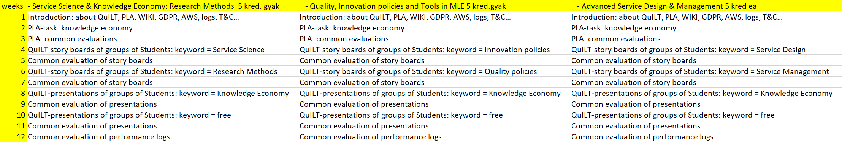

Teaching methods: Ideal-oriented behavior patterns will be presented in form of theater performances (live and/or in written form) and in frame of the performances of the previous semesters. The most activities of teachers and Students will be logged in a Wikipedia-tool (QuILT) / Neptun / Moodle. Each log-data will be involved into a permanent objectivity- and benchmarking-driven evaluation process. Students should co-operate, and/or be critical to each other and contrary to the whole teaching process. Negative scenarios (concerning knowledge, skills, attitudes, responsibilities) are also welcome like positive ones. As far as possible, each activity should be taken in written form – online in the QuILT system.

Requirements: (exam’s evaluation criteria and list of topics): Evaluation (concerning to content elements and/or methodology how they are made) will be executed by each affected person/group concerning each affected person/group based on the logs from the QuILT system.

Full-time study (workload according to credits*): 5ECTS:

Assessment & Grading:
Everybody may define evaluation-attributes being derivable from logs. Everybody will be benchmarked. Positive scenarios lead to the credit-realization at once. Persons/groups with relative negative evaluation phases will be asked again and again. In case of an equilibrium (where each person can be evaluated with the same value), each person will get the credits at once.

Department/faculty responsible for the course: Department of Interdisciplinary International Studies

Required average students’ working hours (number of credits multiplied by 30):
30 contact hours, where teleworking is preferred contrary to working on the spot.
150 working hours, where the activities (of other Students and the conductors) in the QuILT system should be followed and commented with relative high frequency which can be monitored through the log-system.

Individual assignments (expected number of hours and list of activities): Each task should be handled by each Student either in a positive or in a negative way – but in general in written form before teachers/conductors give the first impulses to catalyze new Student’s activities.

Compulsory reading: Each article in the QuILT-system - https://miau.my-x.hu/mediawiki/index.php/QuILT

Recommended reading:
- Each external URL in the QuILT-system
Course leader: Laszlo Pitlik (QuILT-administrator, main-conductor, producer and regisseur:-)

Lecturers/further conductors): Matyas Pitlik

