How to design a graphical expert system with teaching/learning effects?
László Pitlik, Marcell Pitlik, Mátyás Pitlik (MY-X team)
Abstract: The KNUTH’s principle expects a kind of capability of transferring human knowledge into source code. One of the simplest code-like solution is an empty table where the row- and column-headers can be interpreted as two parameters of a question/rule: What is the appropriate conclusion IF parameter Nr1 AND parameter Nr2 are parallel given? This kind of knowledge (ruleset) can be demonstrated in form of a two-dimensional-matrix (2DM) where the users can test their capabilities concerning correct conclusion in case of each parameter-variant. Therefore, a little combinatorial space (3*3) can support teaching/learning effects if users just see the mini games. Parallel, it is to expect that users check their memories and identify problems where similar knowledge structures are existing as with validated/documented knowledge source. The designing of games makes possible for Students to see the knowledge management processes through the eyes of the conductors.
Keywords: 2DM-based gamification, planning of games, validation of rules

Introduction
The development of the 2DM-games has already a rel. deep history: https://miau.my-x.hu/miau2009/index.php3?x=e0&string=2dm. The last item in the previous list presents a little expert system (c.f. https://miau.my-x.hu/myx-free/ego) designed for a chemical knowledge layer in Hungarian (e.g. https://miau.my-x.hu/miau/254/2dm_kemia_demo/). The documentation of the development process can also be downloaded – also in Hungarian:
- https://miau.my-x.hu/miau/solver4u/sonevek.pdf
- https://miau.my-x.hu/miau/solver4u/sonevek.docx
- https://miau.my-x.hu/miau/solver4u/sonevek.xlsx
- https://miau.my-x.hu/miau/solver4u/2dm_ego.html
Here and now, the whole designing process of the chemical problem will be offered with relevant methodological remarks in order to support everybody who would like t construct own games.
This paper is a part of an experimental education processes (QuILT: https://miau.my-x.hu/mediawiki/index.php/QuILT) where a kind of treasure-hunting-based gamification should be demonstrated (https://miau.my-x.hu/miau/quilt/2020/th1.docx).

Steps of designing 2DM-games
The first step can be executed from two different point of views:
- it is possible to know simple problems (like plant/animal/mushroom systematics, diagnostics, etc.) where the conclusions (actions) are depending on exactly 2 input parameters – OR
- it is also possible in lack of appropriate memories that somebody tries to identify publications where acceptable rules can be identified in form of text streams and/or pre-structured presentations (like tables/matrixes)
Remark: a lot of complex rules can quasi always be reduced to 2DM presentations because the reduction of the complexity excludes a set of consequences. On the other hand, the here and now expected 3*3 conclusions should not always be given without any lacks based on a particular source documentation.
In this paper, the second way will be chosen – it means: the whole game-designing process will be presented based on an existing documentation.

Source documents
The identification of potential source documents (validation being capable of delivering quotes about the existence of rulesets) is hardly planable. The game-designers have the fully responsibility to see what kind of text-streams/structured information could be useful involved into a 2DM-game.
Classic text-stream (c.f. magic of words) are mostly rhetoric/style-oriented and less capable of supporting clarification (c.f. the identification of all rules having the same text-quality – as specially for validation quotes in the process of quality management of the ruleset).
In case of a pre-structured source like the one used for demonstration here and now, the clarification process (quality-control) is basically to spare. The quantity-control is – however – a harder problem – especially in case of a rel. large data asset (c.f. big matrix).
The particular data asset is for this paper a rel. long table containing anions and cations, common names and fields for using the descripted materials (inorganic molecules). The level of the knowledge needed to have, is a very low level concerning chemistry. Teenagers should meet with ions and inorganic (basic) molecules/compounds already in their school-time. Therefore, the challenge should be manageable for each person over the 14-year-old-threshold having the possibility to attend school.
The planned teaching/learning effects are:
- training of
  - common names
  - fields of usage
  - partner anion for the given cation (and common name)
  - partner cation for the given anion (and common name)
  - E-numbers
  - formulas
  - professional language skills

The source document can be downloaded here: https://miau.my-x.hu/miau/quilt/2020/salt_names.pdf
After opening the file, the following information and structure can be identified:
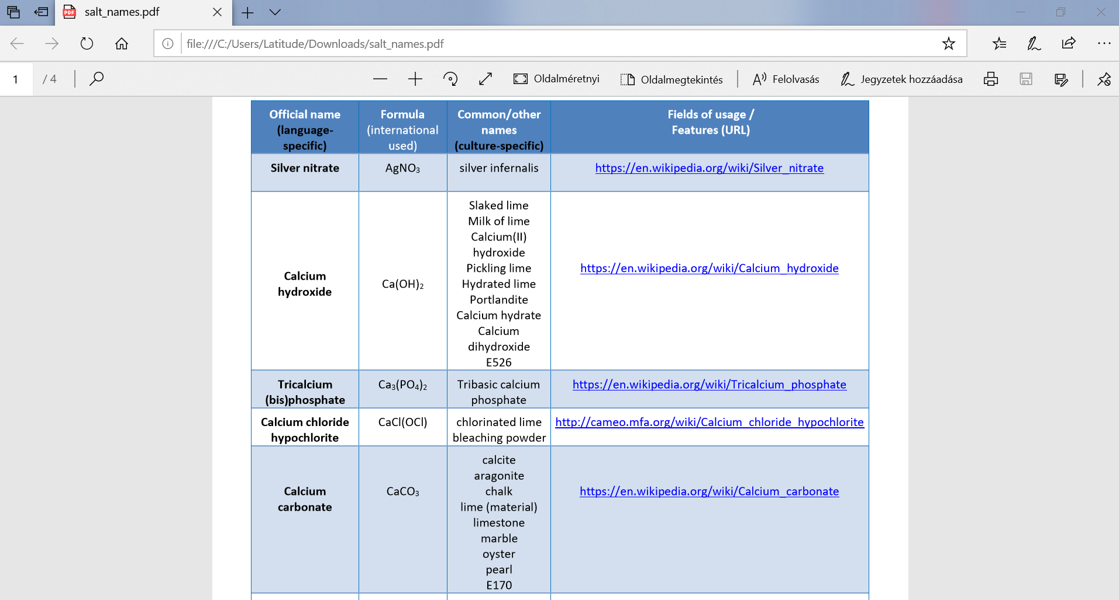
Figure Nr1: Abstract of the source file (source: own presentation)
The structure (from qualitative point of view) seems to make possible to realize the above listed teaching/learning effects in an unlimited way. From quantitative point of view, the game-designer need to check whether there are 3 appropriate anions and cations leading to a 3*3-matrix?!

Checking the combinatorial space
In order to ensure a high level concentration on the manipulation steps (instead of the content), the transformation process of Hungarian source document will be presented. Parallel, the English version of the source document (pdf) can be used by Students (game-designers) as a kind of training material where the below presented steps can be executed under partial other circumstances. Steps of the checking processes
- transformation the PDF into DOC(X) – this can be executed in WORD itself or based on online converters like https://pdf2doc.com/
  - HU: https://miau.my-x.hu/miau/solver4u/sonevek.pdf --> https://miau.my-x.hu/miau/solver4u/sonevek.docx
  - EN: https://miau.my-x.hu/miau/quilt/2020/salt_names.pdf --> https://miau.my-x.hu/miau/quilt/2020/salt_names.docx
- the content of the DOC-version should be copied into an Excel-sheet in order to prepare the content for report-generating based on the pivot-services in Excel
  - HU: https://miau.my-x.hu/miau/solver4u/sonevek.xlsx
  - Sheet=„atalakitas elott“
- as everybody will see, the source matrix delivers a lot of problems like
  - merged cells - e.g. Sheet=„atalakitas elott“, Cell=A3 (hiding A4)
  - filling shadow cells caused by cell-merging - e.g. Sheet=„atalakitas elott“, Cell=D3 (filled also A4)
  - irrational used potential delimiters (like “-“) - e.g. Sheet=„atalakitas elott“, Cell=A6 (where the “-“ sign is used not only for separating cations and anions)
- elimination of problems like
  - avoiding merged cells (but saving contents)
  - substitution of irrational used delimiters (see: Sheet=”atalakitas utan”, cells with red characters)
- execution of delimitations (see: https://www.excel-easy.com/examples/text-to-columns.html) where
  - it is necessary to copy of column “A” to column “E” (Sheet = “atalakitas utan”)
  - and it is also necessary to use the Excel-service “Text-to-columns” which leads to 2 columns (one for cations and an other one for anions – see column “E” and “F”)
- selection of the results of the delimitation process (column “E” and column “F)
- preparation of reports based on the pivot wizard in Excel where
  - each existing cation * anion should build a report in order to see what kind of ions were mentioned in a database-record at least 3-times (see yellow highlights - Sheet=”feldolgozas utan” report on the top)
  - each cation and anion should be hidden with less than 3 counts (see Sheet=”feldolgozas utan” – report on the bottom)
- interpretation of Figure Nr.2 where it can be seen that
  - a filtering could be executed for anions with an occurrence over 2
  - this cation-filtering filtered at once the anions
  - what lead to 13 records distributed through 5 cations and 4 anions
  - what does mean lacks in the matrix (5*4=20 > 13)
  - and these lacks cause that just in case of 2 cations are given at least 3 necessary occurrences with anions – but each remained anion has at least 3 occurrences with cations
  - therefore the source document can not be accepted as a document with appropriate quantity of records (information: compounds)
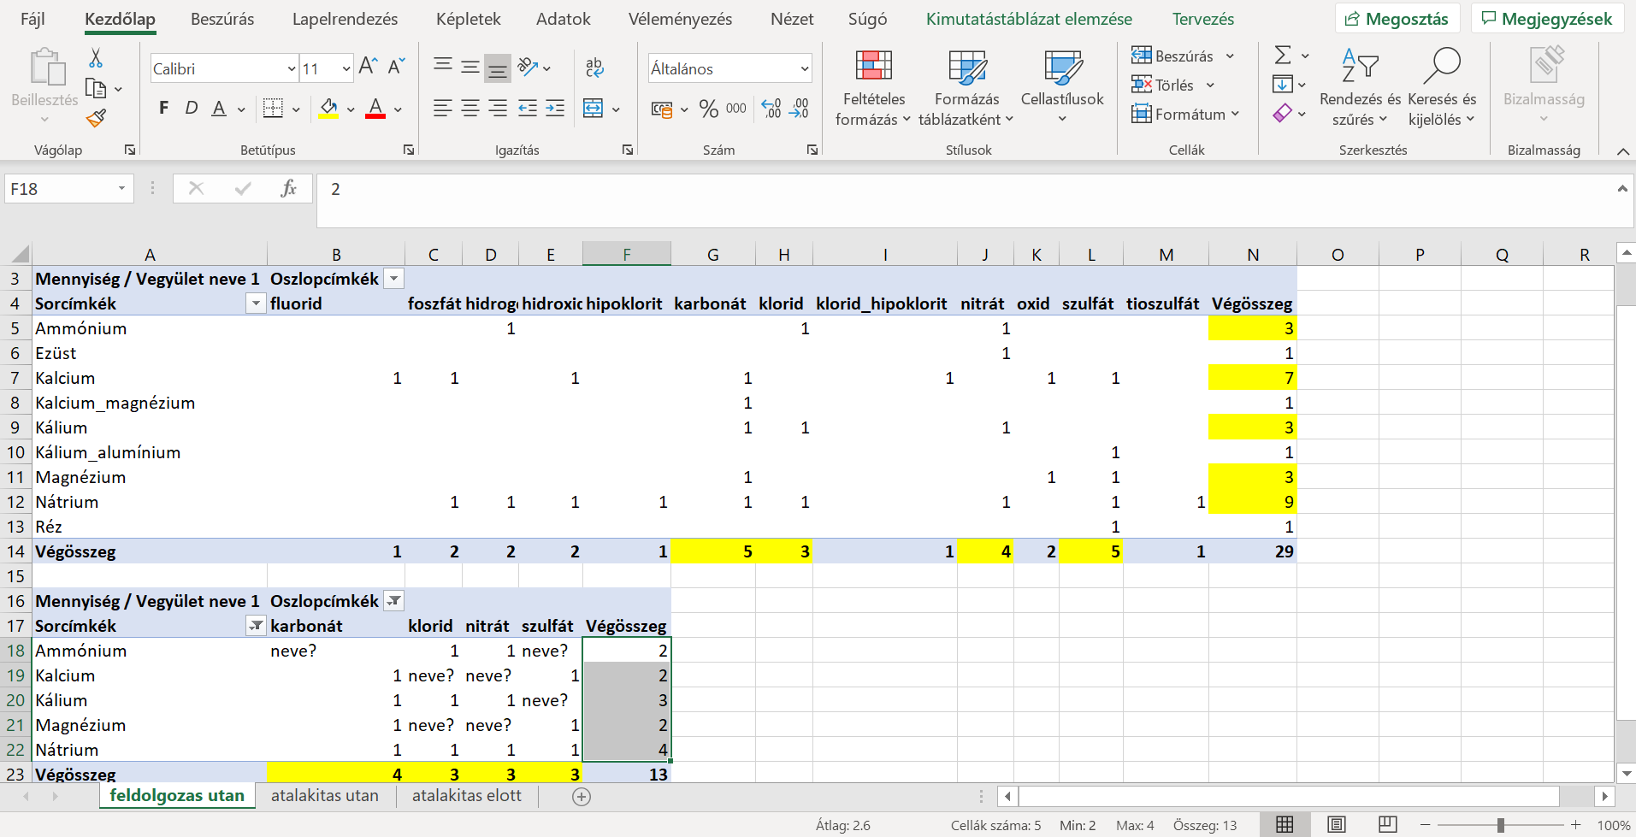
Figure Nr2: Checking the combinatorial space of ions (source: own presentations)

Visual game-parameters
The game (based on additional records) could be developed: https://miau.my-x.hu/miau/254/2dm_kemia_demo/
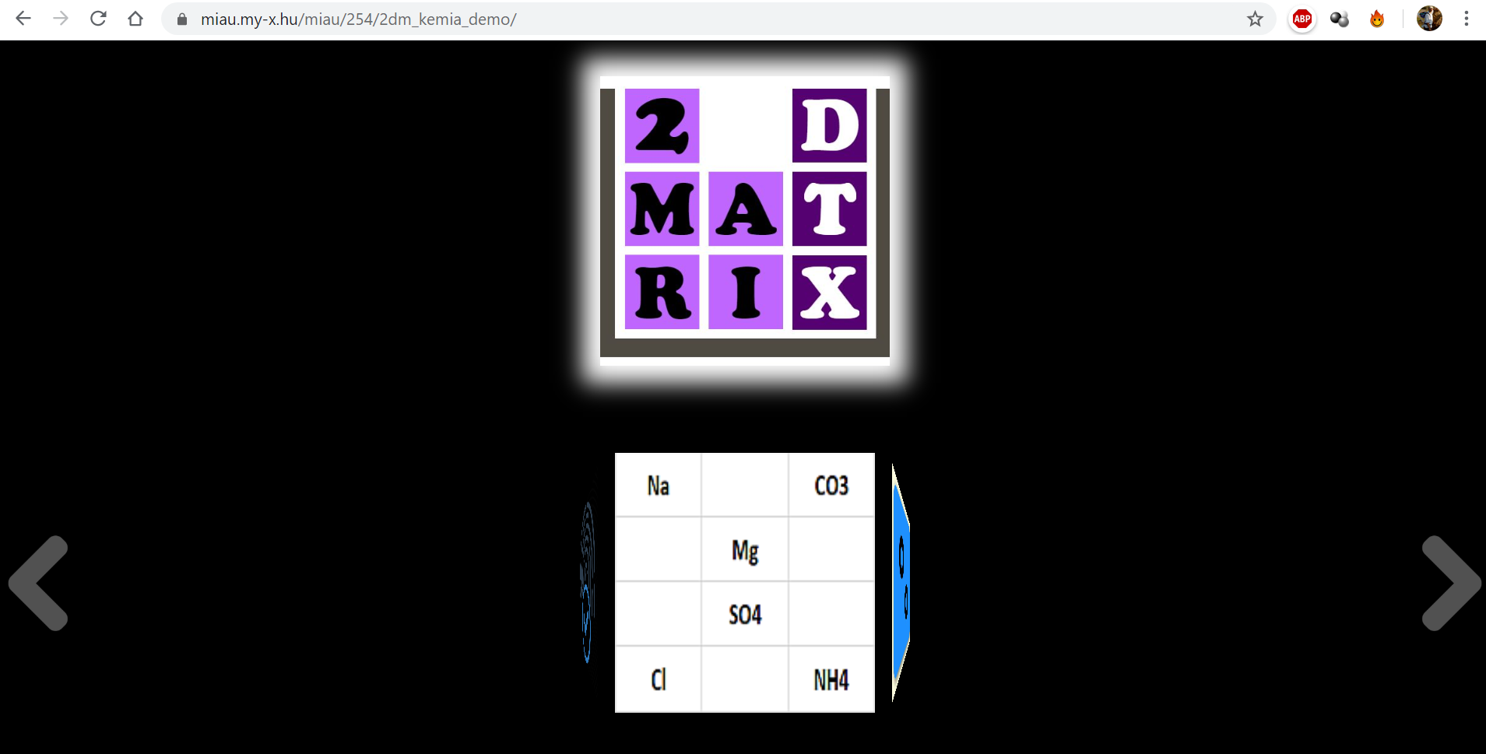
Figure Nr.3: The game with chemical content (source: own presentation)
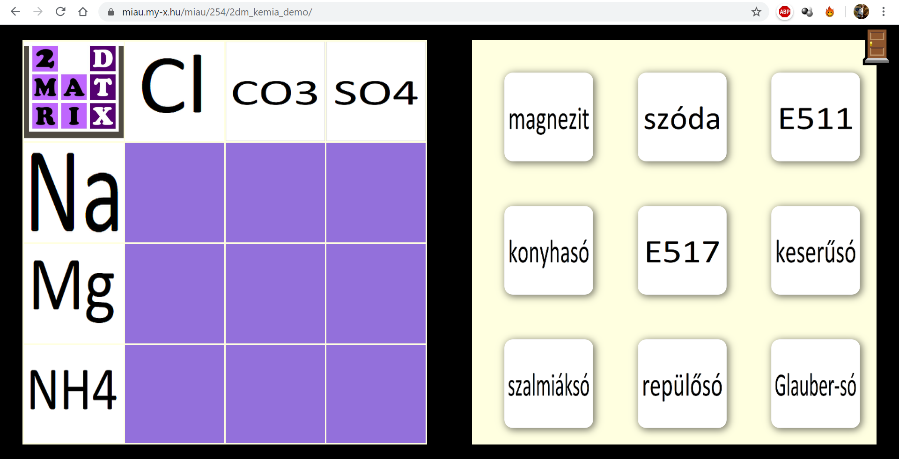
Figure Nr.4: Visual game parameters
As everybody can see (Figure Nr.4), the cation-cards (3 png-files) got into the row-header-positions and the anion-cards (3 png-files) got into the column-header-positions. The cards with the names of the compounds (9 png files) contain 7 common names and 2 E-codes (as additional effect).
The realisation of the game with chemical content needs therefore: 3+3+9 png-files processed through the Java-Script-code behind the game. The game can be downloaded and used unlimited in an offline modus too.
Remark: It is important to highlight that the rule for each answer-card is a row of the matrix in the source document. In case of text stream, rules should be identifiable in the text stream. In an ideal case, the quote (rule) contains words like IF/AND/THEN/ELSE… In cases, where text stream are less technocratic, it becomes a real challenge to identify rules in an appropriate way.

Conclusions
The paper presented the steps of the game-designing-process and their interpretations/argumentations. As it can be seen: the game-designing-process has a rel. low complexity. On the other hand, the quality management expectations need a set of useful IT-knowledge (like Excel-pivot-generation, etc.).
The ECDL-movement (http://ecdl.org/faqs) defines a rel. clear threshold concerning computer using in the XXI. century – what is valid especially for Students on the universities…

Future actions
The games designed by Students will be realized and offered online. If somebody has new ideas (and they are well-documented) how the 2DM-framework could be modified, it is also a possibility to have credits in the experimental course.
Potential ideas for modifying the 2DM-tool:
- Always one answer card could have step by step a specific highlighted design – what means just this card may be moved. This feature could support learning processes where the answer cards belongs to different levels of challenges (like initiated flags can be answered with flag, with the name of the country, or with very specific attribute of the particular country - even within the same game). The ranks of the answer-cards even on the same problem-level can also support the identification of thinking patterns of users.
- The above described version could have a further specification where the not highlighted answer-cards are invisible. This way makes possible to increase the complexity of the same game because the combinatorial space can not be interpreted at once.
- An analytical layer could be integrated to these challenge-level – assumed, that the highlighted card will be derived based on the log-data of one or more game(s) played by one or more persons.
- Always 2-3-x answer-card could have step by step a specific highlighted design – what means just these cards may be moved. If not only one particular card can be moved, then it is possible to test what kind of personality prefers what kind of cards. This effect can also be initiated if all cards are moveable, but in this complex case it is not trivial to form hypothesis what happens when and why?
- (It would be a great pleasure to have more and more recommendation about potential new features incl. argumentation and utilities/advantages for specific targeted groups and/or contents/messages/knowledge needed to transfer…

Annex
This file can be identified by Students in frame of the treasure hunting if they could execute the following steps before:
- interpretation of the welcome message: https://miau.my-x.hu/miau/quilt/2020/th1.docx
- solving the first task and having the appropriate URL for going on: https://miau.my-x.hu/mediawiki/index.php/QuILT_3747
- sending a CV to the conductor
- receiving an email from the conductor with the following URL: https://miau.my-x.hu/miau/quilt/2020/th1.docx
- playing with 2DM in a successful way, where the closing messages after each game let see the URL of this paper: https://miau.my-x.hu/miau/quilt/2020/th1b.docx (
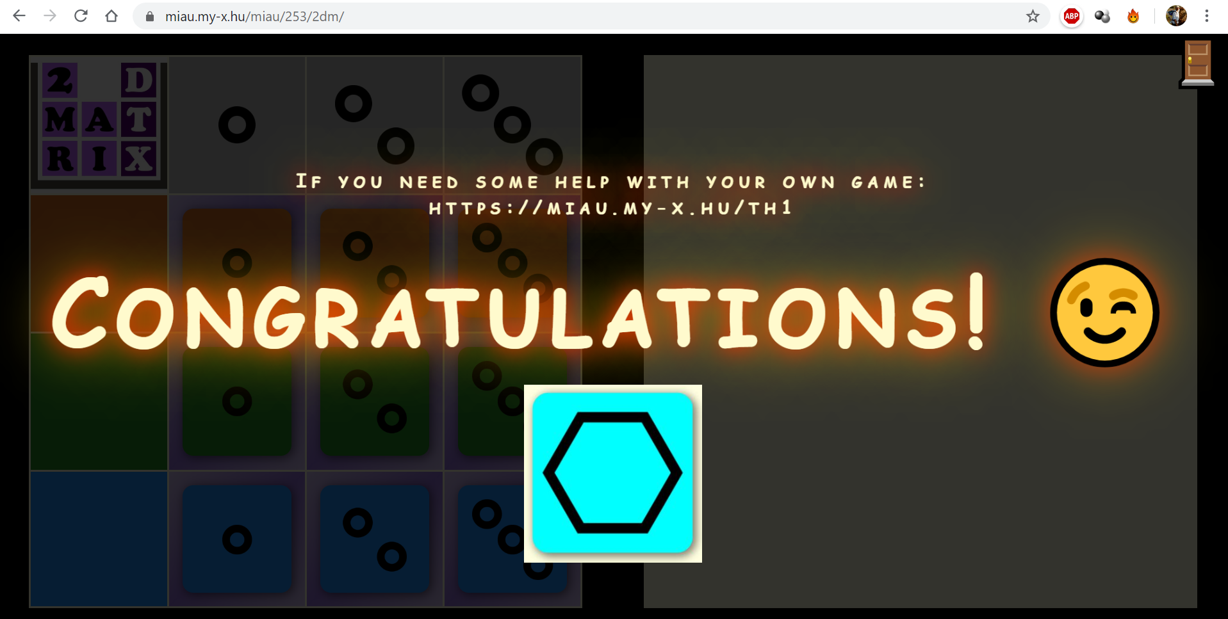

It is possible that the identified matrix-structures are directly the searched ones– it means 2DM-rule-presentations – or it is also possible that the identified tables can be transformed into the expected 2DM-logic. The chemical problem being given here and now belongs to the second group of structured documentations.

