Dear Students!

IMPORTANT NOTICE
Unfortunately, the next (contact) meeting (11.III.2020 / Room FR135) should be cancelled because of a relevant committee activity on university level. Following the “customs” of the course, the new treasure hunting process (Nr2) is now starting!
Further information:
- the planned topic for 11.III.2020 will be postponed to 18.III.2020 (see Moodle and/or MIAUWIKI’s course-diary - https://miau.my-x.hu/mediawiki/index.php/QuILT-IK045-Diary) –
  - fortunately (as you already know based on the last Moodle-email), the first decisions about these topics are already given, therefore, we will start working on these topics on our further meetings
  - from now on (incl. the delay signalized above), your specific/personalized/team-oriented publication process will/can be supported more and more - if we have your choice...
  - besides, it is important to have new and newer learning materials - see EGO for multidimensional expert systems in addition to the knowledge representation possibilities in the 2DM-games
- the didactical aims are the same: we have to increase of the potential of your sovereignty concerning the final publication through each potential action (incl. treasure hunting processes)
- independent from the treasure hunting process Nr2: it would be important to send me the first test file as soon as possible (in cases where this test could not be completed till now) https://miau.my-x.hu/mediawiki/index.php/QuILT-IK045-Diary#4._Day_.282020.II.26._.2F_FR135_.2F_14.15-15.45.29 (with appropriate content: https://miau.my-x.hu/miau/quilt/2020/sovereignty-pla.docx) in order to finalize the choosing a personalized topic for the necessary publication in this semester.
- please, do never forget: lectures brings probably 5% percent (https://miau.my-x.hu/miau/quilt/2020/teaching_is_learning.png), the rest of the learning success comes from reading, discussing, practice doing, teaching others, etc. :-)
- the treasure hunting (if somebody tries to complete each task) can be interpreted as a kind of “practice doing” and/or teaching others/discussing (if you consult about the task in teams) – furthermore, the reading of the learning materials can also not be avoided for a successful treasure hunting process
- worth repeating again and again: your portfolio (set of modern possibilities for knowledge representation) is now good enough to start with working based on them, because the final publication needs hardly texts (see the risks of the magic of words) but a lot of figures with appropriate legends and interpretations…
- your already discussed portfolio elements (needing involved into the treasure hunting process Nr2) are:
  - solver-based approaches (see evaluated publications and learning materials from the archive/previous semester)
  - 2DM-games
  - Rosling-animations
  - pivot-reporting
  - OAM-based data/problem-structures

Treasure hunting process Nr2 / TASK Nr1 - questionnaire
Please, derive the proper answers based on the learning materials and please, chain the letters of the proper answers to a single word, and please, add this letter by letter constructed word to the following URL (replacing the red & sign): https://miau.my-x.hu/& (like in case of the first treasure hunting process about the 4-digit-number):
- What is the proper answer to the following question: what is the correct number of the objects (=publications written in the previous year by Students in English, and being analysed in this semester in order to derive the best publication as such) - based on the learning material of https://miau.my-x.hu/miau/quilt/2020/objective_evaluation_of_publications.xlsx?
  - 13
  - 12
  - 14
  - 11
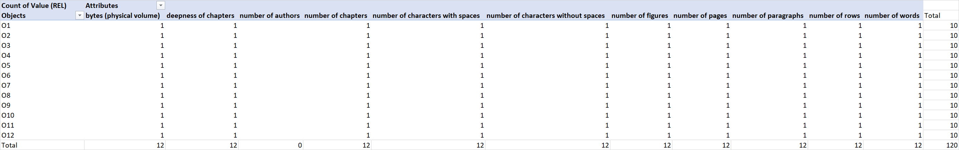
Help-Figure Nr1: Number of objects (publications) and attributes (source: own presentation)

- What is the proper answer to the following question: what is the correct (URL) id of the MIAU No (e-Journal) where the publications written in the previous year by Students in English can be downloaded - based on the learning material of https://miau.my-x.hu/miau/quilt/2020/objective_evaluation_of_publications.docx?
  - 249
  - 257
  - 258
  - 259

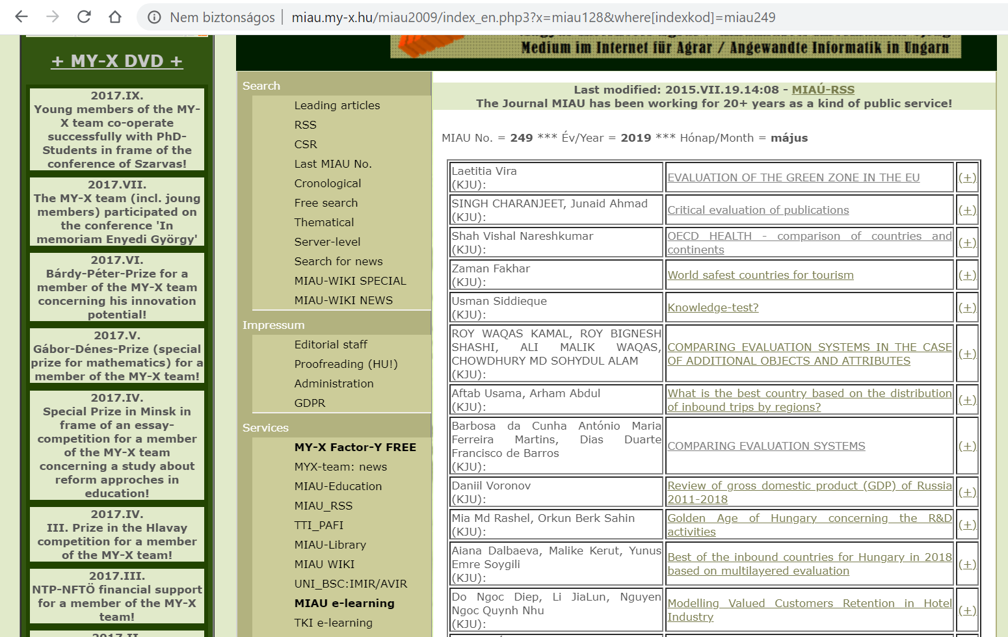
Help-Figure Nr2: The library-view of the publications of the previous year (source: own presentation)

- What is the proper answer to the following question: what is the correct number of the needed pictures (PNG-files) in a new 2DM-game where the row-header should have 5 positions, and the column-header should have 4 positions - based on the learning material of https://miau.my-x.hu/miau/quilt/2020/th1b.docx
  - 3+3+3*3=15
  - 4+4+5*5=33
  - 5+4+5*4=29
  - 5+5+4*4=26

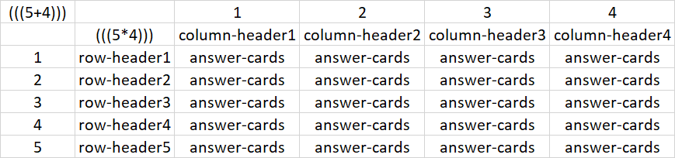
Help-Figure Nr3: Pattern (source: own presentation)

- What is the proper answer to the following question: what is the correct number of the used constraints in the Solver-based calculation process (searching for the ideal 4-digit-number) - based on the learning material of https://miau.my-x.hu/miau/quilt/2020/solver_based_problem_handling.docx
  - 0
  - 1
  - 2
  - 3

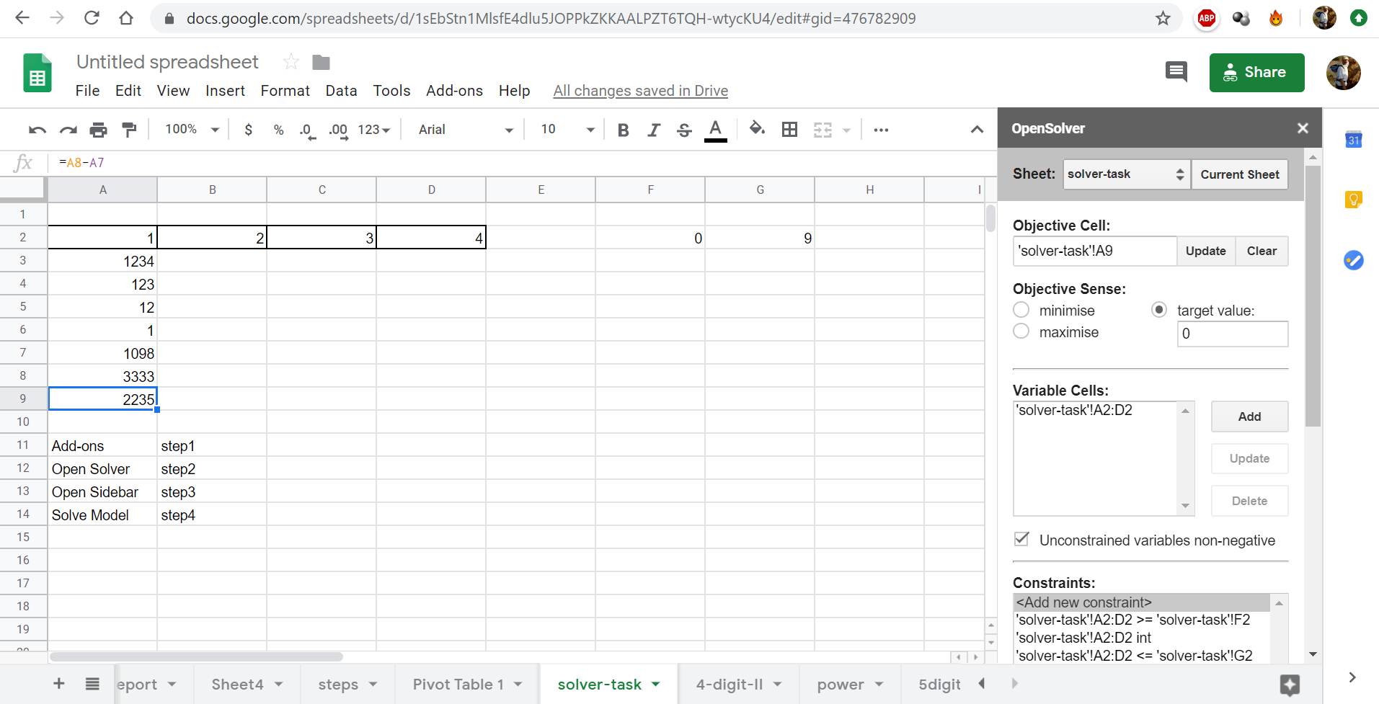
Help-Figure Nr4: Constraints (source: own presentation)

- What is the proper answer to the following question: what is the correct number of appropriate (unique – non-highlighted) answer-cards in a 2DM-plan about the missing dollar riddle where the absolute values were involved - based on the learning material of https://docs.google.com/spreadsheets/d/1sEbStn1MlsfE4dlu5JOPPkZKKAALPZT6TQH-wtycKU4/edit#gid=1562205329
  - 9-3-2-2=2
  - 9
  - 9-2=7
  - 9-3*2=3

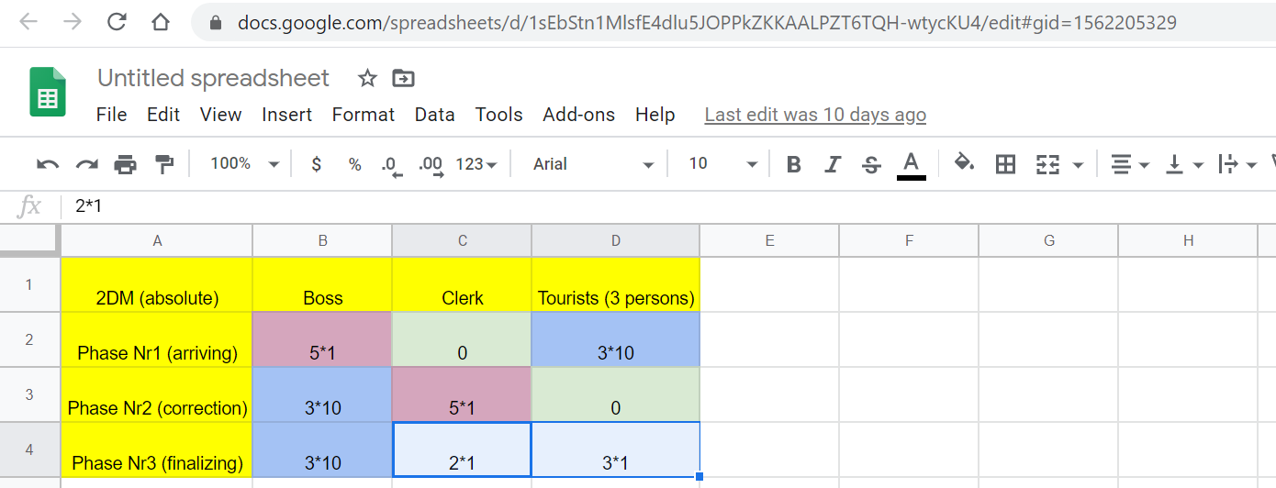
Help-Figure Nr5: Relevant parts are highlighted with blue borders (source: own presentation)

- What is the proper answer to the following question: what is the correct result of the formula: (number of appropriate anions * number of appropriate cations + 1)/number of the lacks in the filtered report (where an ion is appropriate for a 2DM game if the number of its occurrence is higher than 2, and lacks are highlighted with red) - based on the learning material of https://docs.google.com/spreadsheets/d/1sEbStn1MlsfE4dlu5JOPPkZKKAALPZT6TQH-wtycKU4/edit#gid=1142366670
  - (1*6+1)/7=1
  - (5*5+1)/13=2
  - (0*29)/7=0
  - (4*5+1)/7=3

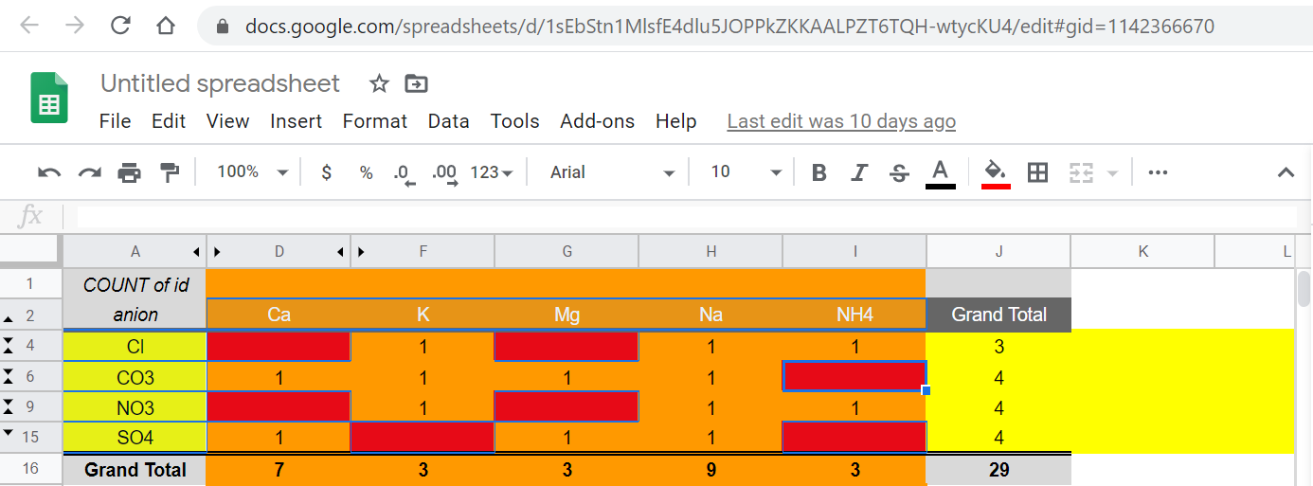
Help-Figure Nr6: Relevant parts are highlighted with blue borders (source: own presentation)
Please, build now the letter-chain from the id-letters of the proper answers, and use the 6-letter-“word” as before described. The URL will lead to a new task (Nr2) in frame of the treasure hunting process Nr2.

Please, do not forget: A<>a if you use letters in a URL!

If you have any questions please, do not hesitate to contact me immediately:
Conductor: László PITLIK, KJU, 01.II.2020. (email: (pitlik@kodolanyi.hu / subject = your Neptun-Code)

Bridge to the new learning material EGO(en):
- the test above has a combinatorial space of 4^6=4096 – therefore the guessing-strategy would not be efficient enough
- on the other hand, it seems to be necessary to create an expert system (a robot “teacher”) for each existing six-letter-word (solution) in order to explain, what is not really correct (there are 4095 wrong six-letter-word-variants and only one six-letter-word can be correct)
- fortunately, the useful amount of the so-called error-message can be minimized because the structure of the errors is strong: in case of each question there are only 3 potential errors and these errors are independent from each other
- therefore, the amount of the error-messages is limited: 6*3=18 – it means: each bad choice should have a kind of remark
- in the rel. big combinatorial space (see above) the 18 text-patterns (remarks) could be delivered in the appropriate form
- the remarks have to clarify why an involved choice (bad answer-option) could be misunderstood – it means: why it is important to focus on these types of misinterpretations

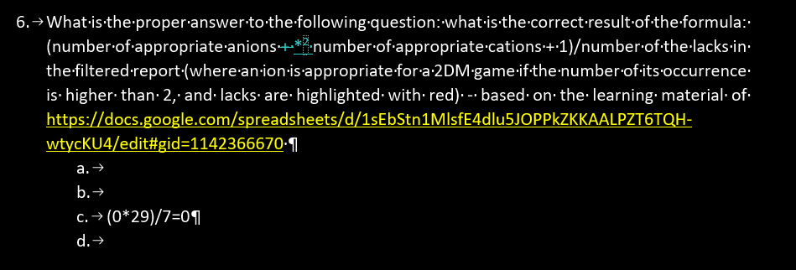
Help-Figure Nr7: Remark concerning Question Nr6 (source: own presentation)
The Help-Figure Nr7 demonstrates a choice where the remarks could be:
- the value of 29 can be identified in the Help-Figure Nr6, but this value is a kind of disturbing data concerning the question Nr6
  - 29 does not belong to cations or anions
  - it belongs to the whole table (to the potential compounds/salts)
- the value of 7 as such is correct, but in the inappropriate formula it is not relevant
- the value of 0 could be correct theoretically, but the values of the grand totals (for rows and columns) present a few numbers above the limit of 2
The further 17 remarks can also be produced and the whole phenomenon about questions and reasons for bad answers could be the core of a final publication.

In ideal case, each publication should be read by each Student (as a kind of benchmark). At least one of the previous publications should be evaluated as the (subjective) best one and this publication should be seen as the benchmark for the own publication. The own publication should be better as far as possible than the preferred one from the previous year. The best one should also be derived based on a solver-oriented (objective) process (like in the first learning material: https://miau.my-x.hu/miau/quilt/2020/objective_evaluation_of_publications.docx).
Each detail is important (c.f. “+” <> “*”: each error should always be reported/consulted. Guessing is also a kind of sovereignty, but the capability of co-operation is here and now more important than guessing alone and/or ignoring problems…
It is important to declare: the literature and/or expert’s opinions (incl. teacher’s sentences/figures) should not always be correct, therefore the capability of handling errors in a discursive way is a relevant part of this course (of the sovereignty) where the competences of Students should be increased concerning publications…

