Risk potential of words based on 20Q-games
Laszlo Pitlik (sen), Laszlo Pitlik (jun), Matyas Pitlik, Marcell Pitlik (MY-X team)
Abstract: This paper shows a calculation scheme for deriving risk potential of arbitrary human abstractions/words (like horse and/or knowledge) being guessed by a lot of human beings in order to demonstrate that the level of abstractions and therefore the level of risk potentials caused through misunderstandings can be measured based on the subjective/intuitive answers of human being to question of an online 20Q-robot. The highlighted examples could be characterized with a set of variables in a parallel way where each variable is capable of evaluating risks. Therefore, an aggregated risk potential of each word should be derived in frame of an antidiscriminative model where the objects are the words, the attributes are the description variables and the cells are the descriptive values as such. The similarity-based modelling needs hardly mathematical competences, yet it is able to estimate the appropriate risk potential for each human abstraction. The sentences contain words, so the risk potential of sentences can also be derived. The speakers having (constantly or increasingly) high-level risks through the used words in their sentences should not have the possibility of the freedom of speech?!
Keywords: measuring of abstraction levels, freedom of speech, measuring of misunderstanding potentials of human sentences

Introduction
This paper is the newest part of the series about experiences of the QuILT-based education processes. Previous articles and their annexes can be downloaded here:
- https://miau.my-x.hu/miau/quilt/Definitions_of_knowledge.docx + annexes like:
  - https://miau.my-x.hu/miau/quilt/demo_questions_to_important_messages.docx
  - https://miau.my-x.hu/mediawiki/index.php/QuILT-IK045-Diary
  - https://miau.my-x.hu/mediawiki/index.php/Vita:QuILT-IK045-Diary
  - https://miau.my-x.hu/mediawiki/index.php/QuILT-IK059-Diary
  - https://miau.my-x.hu/mediawiki/index.php/Vita:QuILT-IK059-Diary
- https://miau.my-x.hu/miau/quilt/reality_driven_education.docx + annexes like:
  - https://miau.my-x.hu/miau/quilt/chained-translations-legal-slang.docx
  - https://miau.my-x.hu/miau/quilt/demo_chained_translations.docx
  - https://miau.my-x.hu/miau/quilt/demos_chained_translations.docx
  - https://miau.my-x.hu/miau/quilt/forum_details.docx
  - https://miau.my-x.hu/mediawiki/index.php/QuILT-IK057-Diary
  - https://miau.my-x.hu/mediawiki/index.php/Vita:QuILT-IK057-Diary
- https://miau.my-x.hu/miau/quilt/Exercises_for_critical_thinking_and_doing.docx
- https://miau.my-x.hu/miau/quilt/st1_all.docx
- https://miau.my-x.hu/miau/quilt/20Q.docx
- https://miau.my-x.hu/miau/quilt/GDP_final_en.doc
- https://miau.my-x.hu/miau/quilt/st2_all.docx
- https://miau.my-x.hu/miau/quilt/harmony.docx
- https://miau.my-x.hu/miau/quilt/safety-index.docx
- (https://miau.my-x.hu/miau/quilt/20q_based_fingerprints_of_words.docx)
Parallel, there are a lot of spreadsheets supporting the needs for details: https://miau.my-x.hu/miau/quilt/?C=M;O=D
The force fields of the magic of words are used ever since for communication between/among human beings. The magic of words can be interpreted from different points of views: e.g. the magic of words is responsible for the misunderstandings of the text-based (verbal and/or written) communication. But parallel, the magic of words makes possible to derive new innovative ideas even based on the potential misunderstandings. The principle of KNUTH (c.f. knowledge is what can be transformed into source code – each other human activity is a kind of artistic performance) expects that we are capable of measuring the misunderstanding potential of the human words (abstractions). This paper presents a simple way to achieve the expectations of KNUTH.

20Q-games
Based on following preparation works like:
- https://miau.my-x.hu/miau/quilt/st1_all.docx
- https://miau.my-x.hu/miau/quilt/20Q.docx
- https://miau.my-x.hu/mediawiki/index.php/QuILT-20Q-raw-games
- https://miau.my-x.hu/mediawiki/index.php/QuILT-20Q-9
- https://miau.my-x.hu/miau/quilt/20q_horse_demo.xlsx
and based on the online services of http://20q.net/, the collection and analyses of appropriate data assets could be executed in co-operation with Students. This paper will present each relevant step of the reproducibility based on the above-highlighted XLSX-objetc.
At first, it seems to be relevant to summarize, what kind of input and output will be realized if somebody tries to play a game with the robot of 20q.net?
- it is relevant to select a thinking/cultural frame
- it is also relevant to define basic data about the human player
- the human player has to choose a word (e.g. horse or knowledge)
- and the human player has to answer the questions of the robot
- where the answers can not be arbitrary words just one from the prepared list
  - the first question is always the same and it makes possible to classify the keyword to the main categories like animal, plant, etc.
Figure Nr1 shows the steps of a game:
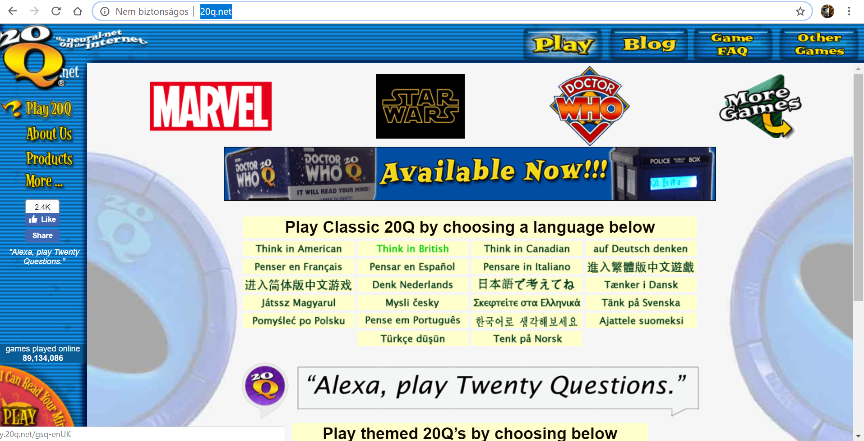
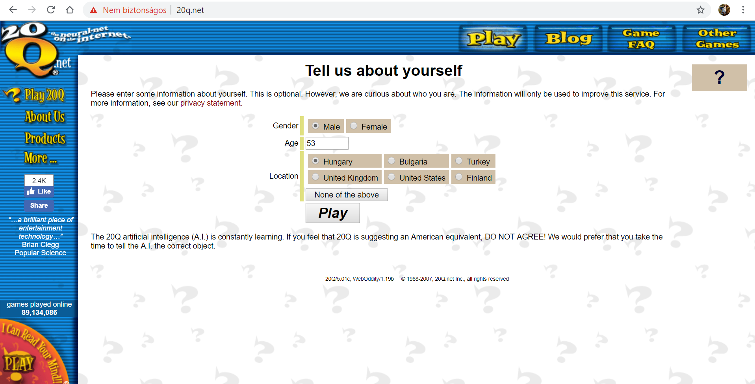
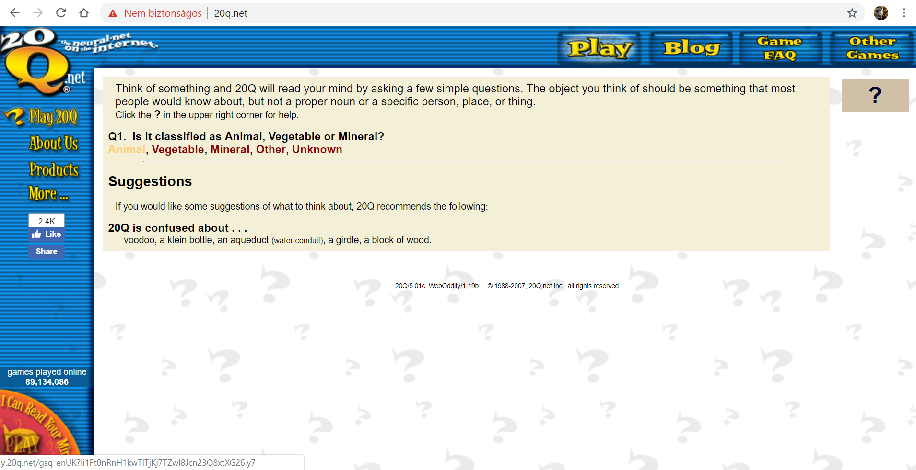
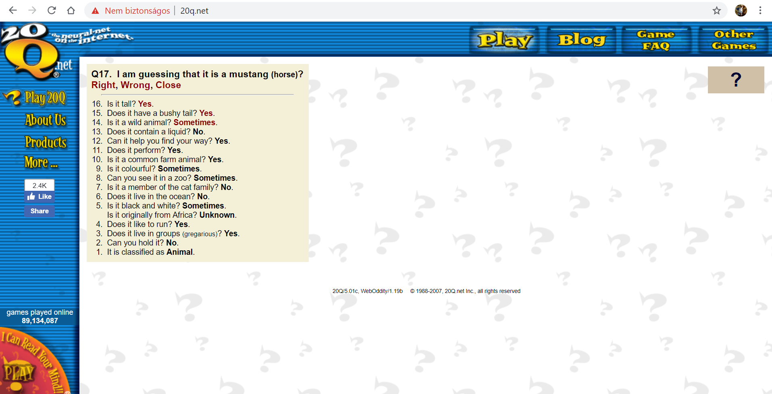
Figure Nr1: The process of an online 20Q-game (source: own presentation)

Data processing steps
If a lot of people play the game in the background with the same keyword (like horse or knowledge), then it is possible to see a lot of parallel guessing processes where the robot selects questions from the question pool in a randomized or even in a logical way. The same question can be answered from the players free – it means: quasi each human misunderstandings could be detected concerning the keyword and the particular question.
Based on a lot of games, a database can be defined (see Figure Nr2):
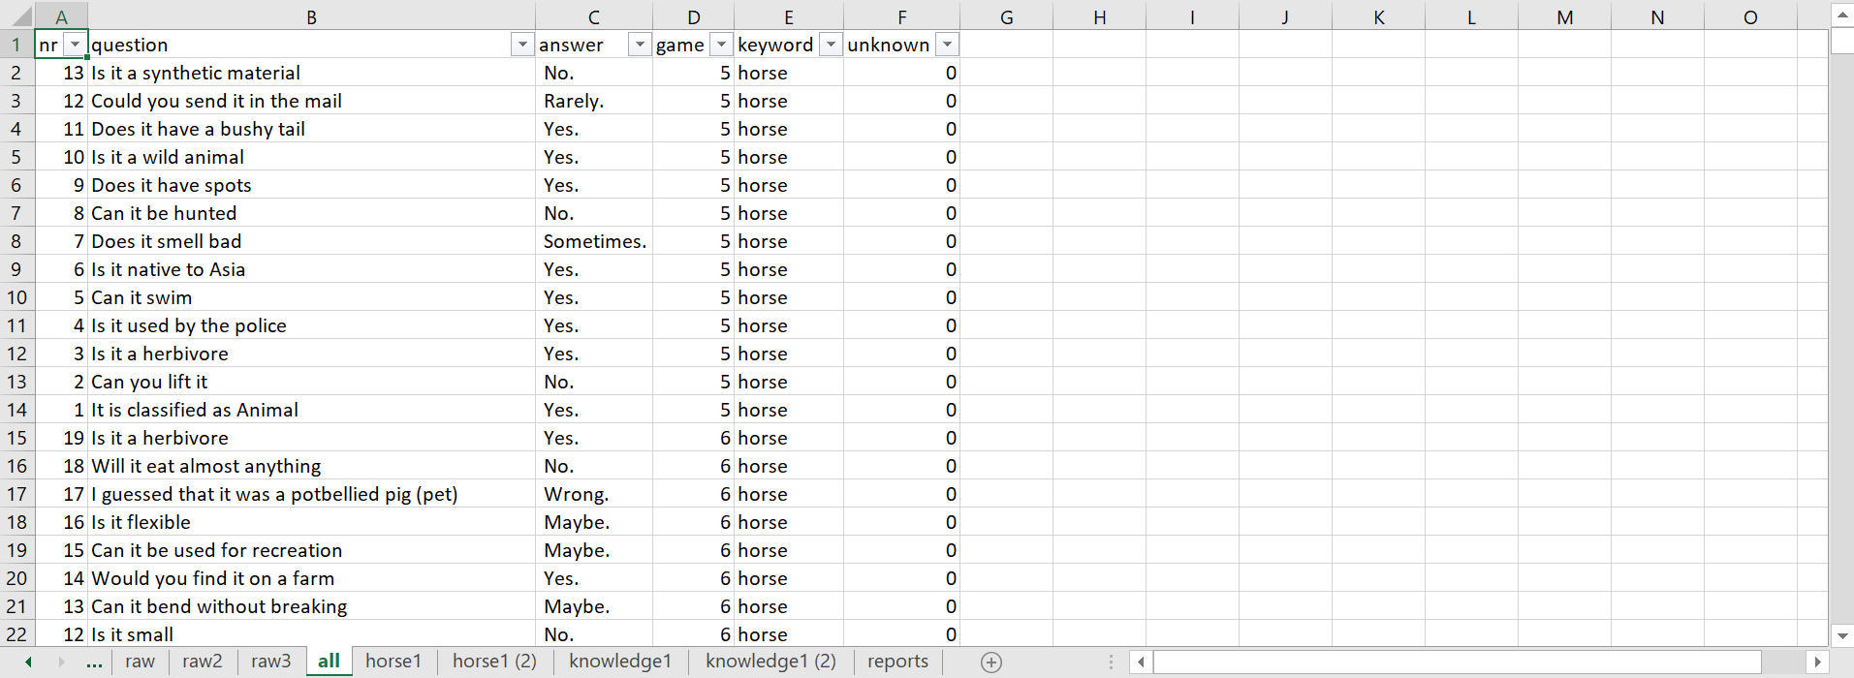
Figure Nr2: Structure and content of the database (source: own presentation)
The general database can contain information about
- the ranking number of a question within a game (nr)
- the question itself (question)
- the particular answers for the particular question in the particular game (answer)
- the id of the game (game)
- the keyword needing to guess (keyword)
- and arbitrary further columns like a binary status variable (answer is unknown or not)
Specialities making the integration of data (game by game) for a complex challenge:
- Each game can have different amount of questions.
- The questions having the answer of “unknown” do not have a ranking number within the particular game.
- The different basic parameters (like age, thinking/cultural basis, etc.) can lead to different output-formats: see
  - starting letter is a space or
  - not in case of a question or is a dot available as last letter in a string, etc.
Sooner or later, the consolidated data asset can be ensured. This data assets can be analysed based on the Excel-reporting wizard (pivot). Figure Nr3 shows the basic report about the keyword of “horse” where
- the rows are the question having more than one single mentioning
- the columns are the potential answers
- the cells contain the ratio of the chosen answer options compared to the sum of the row (=100%)
- the coloured background means: the more green is a cell the more simple could be answered the question
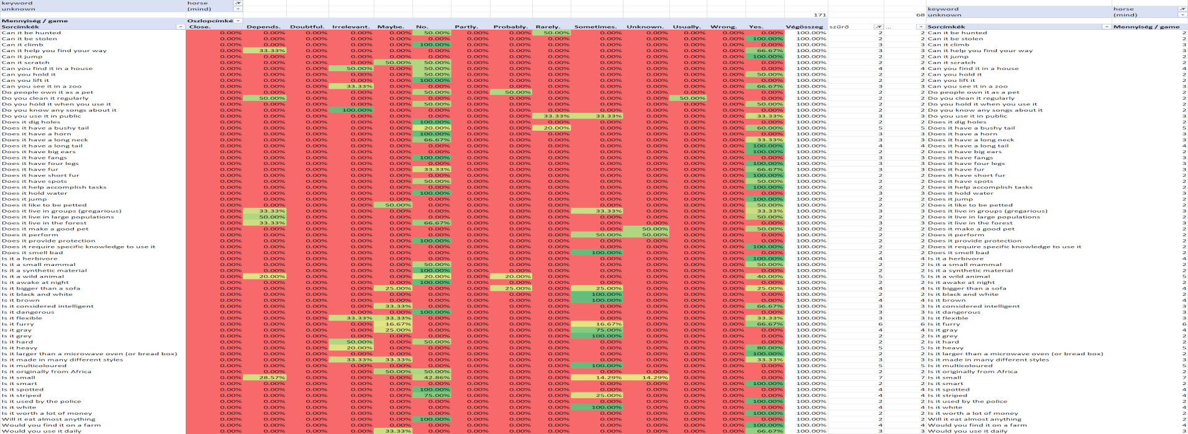
Figure Nr3: The basic pattern of the keyword of “horse” (source: own presentation)
The keyword of horse generates 171 questions. 68 questions were used at least two-times.
The same pattern for the keyword of knowledge can be seen in Figure Nr4:
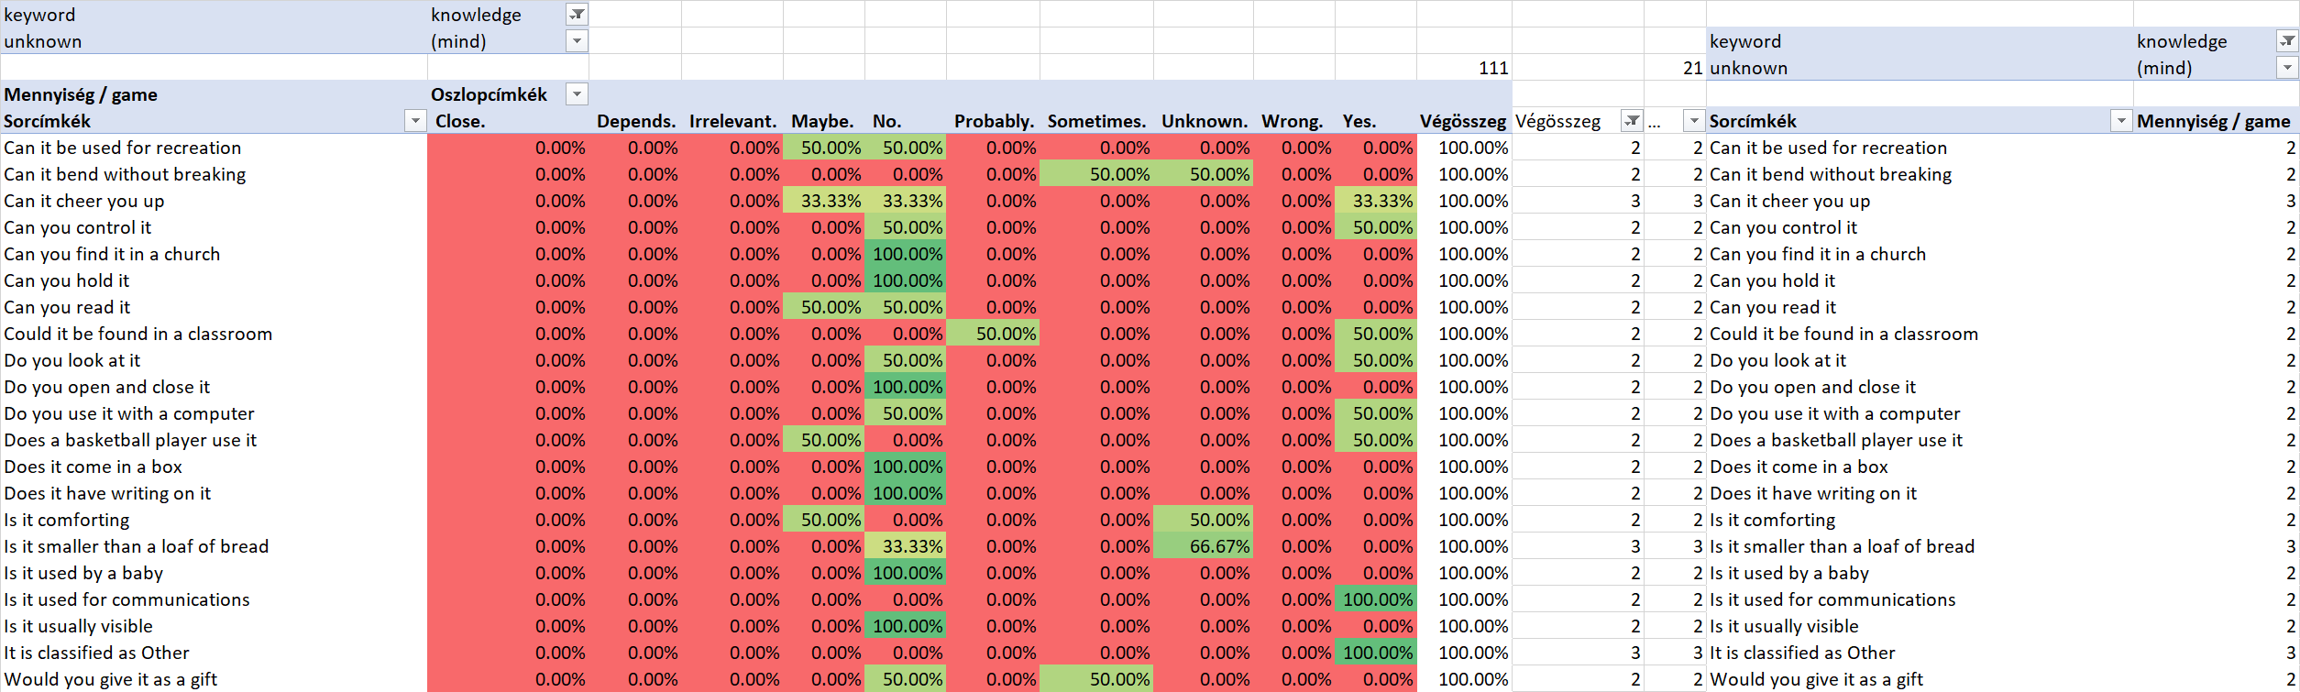
Figure Nr4: The basic pattern of the keyword of “knowledge” (source: own presentation)
The keyword of horse got selected in order to demonstrate a word with lower risk potential. The keyword of knowledge should present however a higher level of risks.
The basic patterns of the two words are to complex to derive/see relevant variables for risk-descriptions. Therefore, it is necessary to create new views (see Figure Nr5-6):
The relevant indicators can be seen on the bottoms of the figures:
- ratio1: 100% position for option “yes” + option “no” compared to the number of the visible questions
- ratio2: amount of more-times-used question compared to all question used in case of the keyword
- average: average using frequency of the visible questions
Further indicators could be:
- ratio of the affected answer-options: the average of the amounts of the used answer options in case of each visible questions compared to the permitted amount of answer-options (it is the same number for each questions)
- standard deviation of the using frequencies of the visible questions
- standard deviation of the ratios of the affected answer-options, …
The above listed potential indicators can be accepted as indicators for risk-estimations of the words in general because they have directions like:
- the higher is the value of ratio1 the lower is the interpretation-risk of a word
- the higher is the value of ratio2 the lower is the interpretation-risk of a word
- the higher is the value of the average frequency of the visible questions the lower is the interpretation-risk of a word
- the lower is the ratio of the affected answer-options the lower is the interpretation-risk of a word
- the lower is the standard deviation of the using frequencies of the visible questions the lower is the interpretation-risk of a word
- the lower is the standard deviation of the ratios of the affected answer-options the lower is the interpretation-risk of a word
- the lower is the ratio of unknown answer-option the lower is the interpretation-risk of a word (see Figure Nr7)
- the lower is average amount of the needed question for a correct guess the lower is the interpretation-risk of a word (see Figure Nr7)
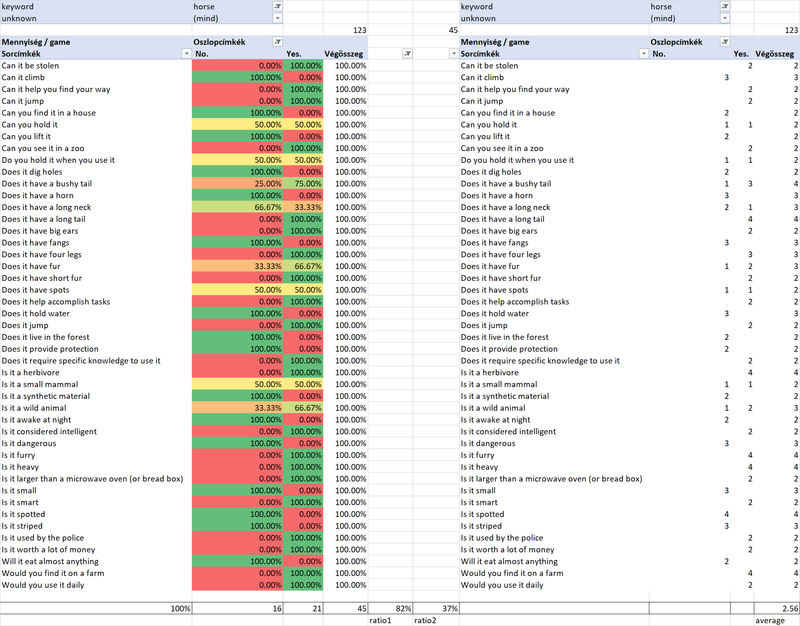Figure Nr5: The characteristics of the keyword of “horse” (source: own presentation)
The above-listed indicators can be completed for each word in a common OA-matrix (see Figure Nr8) where objects are the words and the attributes are the indicators. Figure Nr6 demonstrates the characteristics of the keyword of “knowledge”. It seems to be trivial, that the abstraction levels of words like “knowledge” should be higher than for words like “horse”. Therefore, it is to expect, that the indicators are able to reflect these relationships.
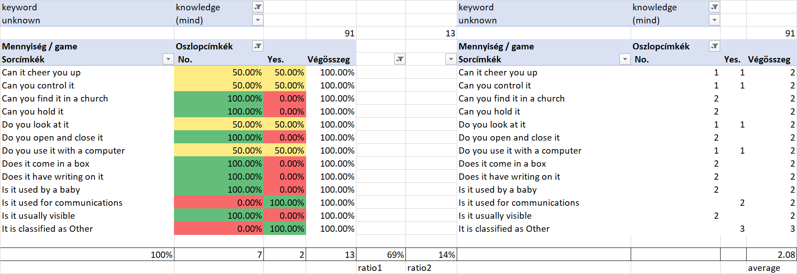
Figure Nr6: The characteristics of the keyword of “knowledge” (source: own presentation)
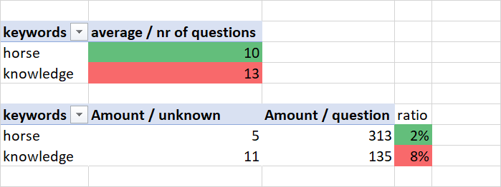
Figure Nr7: Further characteristics of the words (source: own presentation)
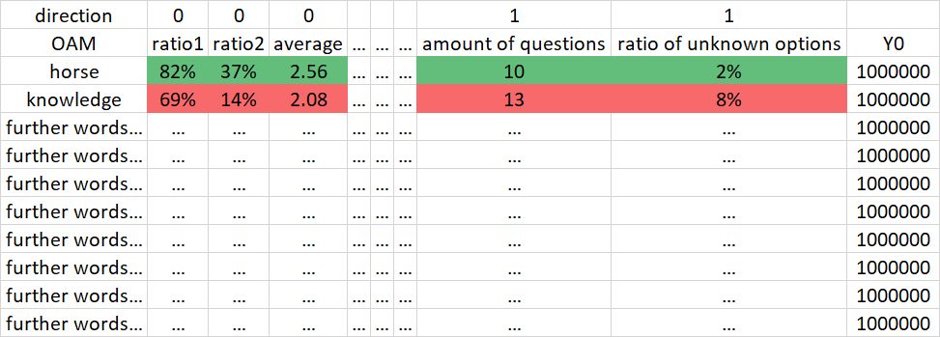
Figure Nr8: Comparing words in frame of an antidiscriminative approach (source: own presentation)
The risk potential of the words should be estimated in frame of an antidiscriminative model (https://miau.my-x.hu/myx-free/coco/) where the objective is the prove whether each word can have the same evaluation value? If there are just two words where one of them has always a better position than the other one, then it is impossible to accept the same risk potential for each word – like here and now at once.
A “horse” has a lower abstraction potential than the keyword “knowledge”. This could also be demonstrated through the real guesses of the 20q.net-robot (see XLSX-object with detailed backgrounds):
- the “horse” could be approximated like
  - racehorse
  - pony
  - mustang,
  - Clydesdale (horse), etc.
- the “knowledge” could be approximated like
  - idea
  - logic
  - brain
  - concept, etc.
Unfortunately, the closeness to the basic keyword can not be measured in a direct way. But the ratio of the potential synonyms compared to the amount of the games (see: direction: the less - the lower risk) could also be used as a kind of synonyms.

Conclusions
As it can be seen, the 20Q-game is capable of exploring the potential of distortions of meanings. The frequently used question with more involved answer-options can be interpreted as a kind of misunderstanding potential where the answerers are not sure enough what should be answered. It could be focused on this kind of question in a more massive way (see Figure Nr3-4).
Parallel, it is possible to integrate status variables like age, sex, culture, country (region) into the general database. Therefore, it would also be possible to see regional, cultural, gender-oriented, gaining-oriented, etc. differences concerning the questions, answer-options, risk-indicators.
If the 20q.net-servers create and archive logs then the above-outlined steps could be processed at one!

