Ali Malik Waqas
Kamal Waqas AUJKRC
Roy Bignesh Shashi T17DJ0
Chowdhury MD Sohydul Alam NT54H3

time | decl |  |  | question |  |  |  | sign
mistakes/action | option/task | mistakes/action | ////// | mistakes/action |  | *** |  | option/task
ORGANIZED | FLEXIBLE | FOCUSED | RESPONSIBLE | UNDERSTANDING | SKILLED | ADAPTABLE | FOCUSED | AMBITIOUS
9 | 0 | 6 | 92% | 6 | 15 | 1 | 50% | 6
10 | 2 | 9 | 62% | 7 | 12 | 0 | 60% | 5
12 | 1 | 8 | 50% | 9 | 19 | 1 | 75% | 7
17 | 5 | 0 | 91% | 3 | 9 | 1 | 65% | 8
20 | 4 | 0 | 71% | 6 | 13 | 1 | 90% | 2
2 | 3 | 0 | 35% | 2 | 16 | 0 | 95% | 6
6 | 1 | 7 | 60% | 1 | 14 | 0 | 35% | 4
9 | 5 | 6 | 91% | 0 | 17 | 0 | 45% | 3
15 | 2 | 3 | 35% | 9 | 6 | 0 | 62% | 9
13 | 1 | 1 | 40% | 10 | 8 | 1 | 89% | 10
16 | 1 | 2 | 55% | 6 | 20 | 1 | 47% | 9
18 | 3 | 3 | 48% | 3 | 11 | 0 | 64% | 6
9 | 3 | 1 | 37% | 8 | 6 | 1 | 59% | 4
8 | 5 | 5 | 60% | 0 | 8 | 1 | 80% | 9
20 | 2 | 9 | 85% | 4 | 14 | 1 | 70% | 0

As we can notice figure 1

Organised=time×mistakes/action the weight of organised was 70%

As we can notice figure:2

Flexible = declaration × option/task The weight of flexible attributes was 45%

As we can notice figure:3

Focused= mistakes/options the weight of focused attributes was 55%

As we can notice figure:4

Responsbilities= There are no futher outcomes or attributs so the weight of focused attributes was 71 %
As we can notice figure 5

Understanding= mistakes/ations × questions the weight of attributes was
7%

As we can notice figure 6

skilled: there is no outcomes or particuller actions show but the weight of attributes was 81%

As we can notice figure 7

Addaptable =options/tasks× actions the weight of attributes was 35%

As per the calculation, we organised the best figure for students attributes.

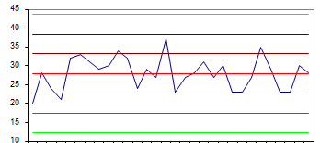
organised Flxible focused responsibilities understanding skilled adaptated

we also put all information in the form of histogram and you can see that all attributes and their activities
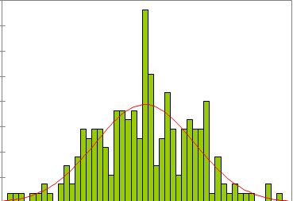
Und Foc Flx Org Res Sk Adap

conclusion: in conclusion we did not finished with that because it wont be correct that if we stuck with this

