Managing Valued Customers Retention in Hotel Industry

Do Ngoc Diep (X30RZA), Li JiaLun (CJIJ80), Nguyen Ngoc Quynh Nhu (KN9OBE).

Kodolanyi Janos University - Advance Service and Design Management

16 April 2019

Abstract: The aim of this paper is to demonstrate how to manage the valued customers retention in hotel industry based on serching for the realistic data and creating simple index. We analyze this topic through different aspects: employee quality, service quality, sanitation, marketing, management, membership and the satisfaction of customers. According to these dimensions, it can be understood more easily how it can have an impact on hotel industry. Through comparing different models and data, it can be more clear about what customers expect in hotel industry and how to keep their attention on products and services then hotel could make correct strategies to make their service more attractive.

Keyword: valued customers, retention, realistic data, service, management, satisfaction.

Introduction:

The article will consist of 3 main parts namely the steps of data processing, decision-oriented interpretations and analysis of one specific case. To increase the customer retention, customer satisfaction in the hotel industry, 6 variables should be evaluated, which are: service quality, employee quality, sanitation, marketing program, membership program and management. The table below present the primary approach to the main topic:
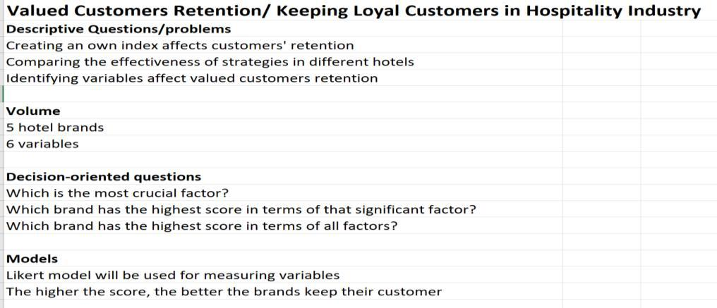
Figure 1: Descriptive and decision-oriented problems for a set of available data

The general background excel sheet could be found in: Article.xlsx

In the data processing part, the Likert model would be used for measuring the 7 factors in 20 hotel brands worldwide. The most crucial factor and the hotel having the best plan for keeping valued customer would be identified through that. In addition, it would play a significant role to answer the question “How to keep loyal customers in the hotel industry?”, which aspects need to take more into consideration. For one specific hotel, it will help them acknowledge their strength and weakness to improve so as to achieve the goal.

Steps of Data-processing

This chapter includes the research design, research model, tested variable (dependent and independent) hypothesis, population, sample size, questionnaire reliability; data gathering procedure, statistical analysis method and the response rate all these things are discussed in this chapter

Sample size

The sampling techniques, which are used in the collection of the data that is non-probability sampling techniques. Non-probability sampling was applied because the customer was not common we select answer from every customer which comes in this hotel. For this reason, we distributed one hundred and forty questions in 5 hotels. Twenty questions were filling up from all 5.

Statistical tool

In this study both, the primary and secondary data are used. The primary data are collected in a form of questionnaire. A Likert scale was designed with options from strongly agree to strongly disagree, whereas 1 refers to strongly disagree, 2 for disagree, 3 for neither agree nor disagree, 4 for agree and 5 for strongly agree. For analysis of statistical tools, we used Excel Toolpak. The Excel Toolpak is a statistical package for social science software. We applied the frequencies, descriptive statistic, reliability test, as well as regression and correlation.

Theoretical framework

The theoretical framework for the research is that the customer retention in the hotel industry is the independent variable and the customer retention is the dependent variable. The independent variable of that factor which attract the customer retention in the hotel industry, which are show in the following services: employee quality, service quality, marketing (brand image), sanitation, membership program and management.

Data analysis
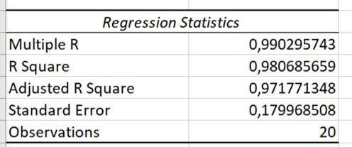

The R value of 5 hotel is averagely over .9 which means that the independent variables

- 90% correlated with dependent variable. The R² value is averagely .96, this means that independent variables will explain 96% the dependent variable. The adjusted R2 value is .94 in average.
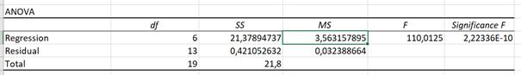

The f-values 281, 110, 107, 23.6, 26.7 are greater than mean value 5.9, 3.5, 5.1, 0.6, 3.5 respectively and the p-values are 0.000 which shows the statistical model is 99%.
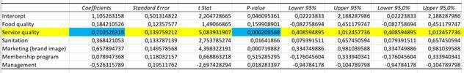

The independent variable service quality beta value is .71 (highest), meaning that the independent variable service quality explains 71% of dependent customer retention. The p-value is .000, which shows significant association of service quality with customer retention. The other variables are as being illustrated in the table.
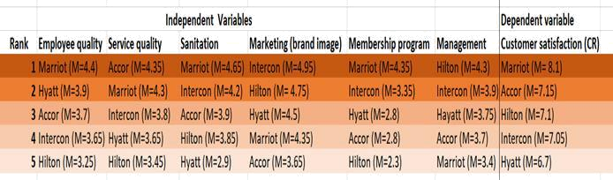

Hypothesis proposed that there are differences in services (variables) offered by 5 hotels and of which the focus was put on the service quality sector. Tables above presented that Marriot gained the highest score in customer satisfaction (retention in other word) of 8.1 and simultaneously it possessed the second greatest score in service quality of 4.3. Further analysis of the means show that since higher the services score better the perception of services. In this line, the results show that services provided by Marriot better than hotel 3,4 and 5.

On the other hand, in general, score of variables of Accor Hotel is lower than those of other 4 hotels. However, hotel 2 service quality score is the highest which hugely contributes to the its total score of 7.15, which ranks as second position. To recapitulate, service quality is a crucial determinant in deciding level of customer retention within hotel industry, as being indicated through the research.

Further data can be found in this link

https://1drv.ms/x/s!AljLTKXmPRHKiiXPI1dd6Vm6D2da

Decision-oriented interpretation

The service the brands deliver to customer is a key to make them feel satisfied. They would feel that the amount of money they spend is worth what they receive and what they expect or even beyond their expectation. It would greatly influence the customer’s assumption on the brand image. Secondly, in terms of the employee quality, they are the one who would directly involve in the customer journey in the hotel through several ways. Their polite and professional attitude, knowledge, needed skills and ability to deal with guest is essential in the process of making them come back next time. The founder of Marriott International said that:” Taking care of your employees first, and they will take care of your customer”. The third factor to be noted is the sanitation, and it is important more than ever especially in the hotel industry. Sanitation is considered to make the first impression on the guests about that hotel. No one would like to check in or sleep in the hotel has f

ull of trash, insects or unpleasant smell. Another variable to be mentioned is the marketing program. It is necessary to have the appropriate, suitable and attractive marketing program designed for the target group to make them comeback. Acquiring a new customer can cost five times more than retaining an existing customer. Furthermore, the likely chance to reach the existing customer is 30% higher than successfully marketing to the new one. Next, creating the membership program for the loyal valued customer is one of the great ways to attract them to comeback. They could accumulate score or miles when they use the service, the higher the score they earn, the better treat they would get from the brand. Hotel brands nowadays also connect with other companies in other industries such as aviation, food and beverage with an attempt to create one unique “ecosystem” for customer. Subsequently, the way of management in general – technological or R&D aspect would also have to gain the customer retention.

The 6 factors discussed above all contribute and lead to the customer satisfaction – which is also the most crucial factor to keep loyal valued customer as the data provided in part 2. It is believed as the foundation for every business’ success. However, customer satisfaction isn’t the same thing as customer loyalty. Customer loyalty can be a result of customer satisfaction, but only along with a lot of other factors above. And the Accor Hotel Group has the highest score regarding to customer satisfaction, yet Marriott International tops the chart when measuring all variables. It is greatly because the high-quality service, employee quality and amazing membership program contribute to the customer satisfaction.

Case

Hotel Memories Budapest

It is a hotel in Budapest which is located at central area. According to the comments from customers, this hotel offers good services like free Internet, airport pick-up and safe and it has ability to make correct strategies to keep the valued customers retention. It also has a good reputation due to its good services so that many customers express that if they will go back to Budapest again, they will choose this hotel again.

There are some data which can help us to demonstrate why this hotel can receive massive good comment. (The rank of these data is from 1 to 10)

- Employee quality: 8

- Service quality: 7

- Sanitation: 9

- Marketing: 9

- Management: 8

- Membership: 7

- Satisfaction of customers: 9

All of these data are above average, but some of them are high obviously like sanitation and marketing which got 9 and employee quality and management which got 8.

There are some comments from customers. For example, “Nice hotel situated in heart of city. You can walk almost everywhere on foot. Although check-in time is scheduled for 2:30pm, but the lady made us prior check-in.” According to this comment, it is easily to analyze the situation of marketing and employee quality in this hotel. A good location can help a hotel to enlarge the markets, especially if it is located at city center, it can attract a lot of tourists. In any industry, marketing is a vital issue and it plays an important role to make business bigger. Employee quality should be considered into an internal factor of enterprises and it is a long-term issue to figure out. It requires an excellent selection mechanism and training mechanism to ensure that the quality of employee can be good. In this case, it is obvious that the employee of this hotel put customers first and facilitate customers to make them prior check-in. Customers will be impressed by these good qualities of employees, by contrast, hotel will also get a good satisfaction index.

From the index of this case, it does not mean that these factors (employee quality, sanitation, marketing, management and satisfaction of customers) are more important than others, they are more like prerequisites. Food quality and membership can also not be ignored in hotel industry. In a sense, they are connected strongly, if a hotel lacks the ability to provide a particular service, customers will reduce their desire to consume and choose the services from another hotel.

Conclusion

This article demonstrated six dimensions which are employee quality, service quality, sanitation, management, marketing and membership, through presenting simple modeling steps, searching for necessary data, finding out the main issue from nowadays that hotel could face and solving these problems. It is evident that these factors can influence the satisfaction of customers and promoting the competitiveness of hotels. All of these measures aim for managing the valued customers retention in hotel industry.

For hotel itself, it needs to pay attention to all aspects of whichever internal construction and external construction. It means hotel needs to keep a big picture of how it can run its business more reasonably, but from the case, it is founded that customer satisfaction is the ultimate goal of a hotel to be taken into consideration because all the measures that the hotel tries to achieve are for improving customer satisfaction.

