Definitions of knowledge – case study about shifting paradigms

or towards big-data/data-mining/AI

starting from the classic way of the magic of words
Laszlo Pitlik, Laszlo Pitlik (jun), Matyas Pitlik, Marcell Pitlik (MY-X team)
Abstract:
The classic/traditional way of learning and teaching can not be existing without words/sentences. On the other hand, the magic of words generates massive risks (e.g. of misunderstandings). A new approach (called QuILT: https://miau.my-x.hu/mediawiki/index.php/QuILT) tries to canalize efforts of Students being capable of shifting from the ancient canon to the data-driven modern reality in order to minimize damages caused through misunderstandings of keywords.
The QuILT-system combines real activities of real Students and catalysed activities of virtual (ideal) Students in order to demonstrate the real potential of the conducting-based education where Students will not have declarations but a lot of experiences with the possibility of deriving own conclusions so, that each of the conclusions and its deriving process should always be transparent for other Students. The transparency makes possible to avoid personal errors and it also ensure a kind of balanced evaluation.
This paper shows real facts and generated impulses about an experiment with international Students having the task: creating definitions and re-definitions of the keyword of knowledge - based on different professional impulses like being involved into an international knowledge test and/or watching a video stream about the functioning of the human brain. Virtual impulses have also been generated there where the real activities could not bring appropriate details – during the limited time periods for meeting.
The paper will also be used as a kind of learning material (or rather status report). Based on the real and virtual effects and their connections, Students can be confronted with the possibility of a kind of supervised self-control-mechanism.
This paper is – therefore – not a declaration needed to be learned (swotted/crammed). This paper should have a catalytic force field for further meetings where the behaviour patterns of Students should be more and more ideal and step by step more efficient so that the creating of appropriate evaluation rules sets for these patterns (digital finger/foot-prints) is a part of the task for the involved Students.
Keywords: self-catalytic learning, conducting, capability of changing

Content
Content 2
Introduction 3
Interpretation of potential Student’s reactions 6
Factual and virtual elements 10
Examples 10
Knuth’s original 10
Conductor’s demo 10
IK045 10
IK057 11
IK059 11
Potential questions 12
Specific tasks/questions to the second meeting: 12
Possible conclusions 13
Case study of a complex but classic definition creation process 16
Case study of re-re-re-definitions 17
Remarks/questions to the KNUTH’s definition 19
Remarks to similarity index 20
Annexes 21
Supporting searching 21
Examples for chained translations with suspicion-generation effects 21
Example I. 21
Example II. 22

Introduction
Experimental meetings will be hold week by week. First, conductors play each role (following the principles of the QuILT-system) in the planned meeting where each agenda is well-prepared and supplementary tasks/games are available too: e.g.
- https://miau.my-x.hu/mediawiki/index.php/QuILT-IK045-Diary
- https://miau.my-x.hu/mediawiki/index.php/QuILT-IK057-Diary
- https://miau.my-x.hu/mediawiki/index.php/QuILT-IK059-Diary
After closing the meetings, conclusion will be derived: e.g.
- https://miau.my-x.hu/mediawiki/index.php?title=Vita:QuILT-IK045-Diary
- https://miau.my-x.hu/mediawiki/index.php?title=Vita:QuILT-IK057-Diary
- https://miau.my-x.hu/mediawiki/index.php?title=Vita:QuILT-IK059-Diary
The three courses have different number of participants (IK045: 10=6+4, IK057: 4=1+3, IK059: 17=6+11). Ratio of presence/attendance in the first meetings (following the IDs increasing series): 50%, 100%, 100% (estimation because of dynamic changing of the registered persons). The Students could work on the tasks (listed in the appropriate diary) either online or offline. Independent from the courses (from the actually keywords), the first task-series was the same for each Student.
Definition-tasks, impulse-generation-tasks, and quality-assurance-tasks:
- OT1a: Please, create a definition (being valid especially for you) about the keyword "KNOWLEDGE"!
- OT1b: Please, create an other definition too (being valid in general or especially for somebody else in the team) about the keyword "KNOWLEDGE"!
- OT1c: Please, create an evaluation rule set describing how somebody should evaluate/rank the quality of a lot of definitions (see above)!
- OT1d: Please, create an evaluation rule set describing how somebody should evaluate/rank the quality of a lot of rule sets (evaluating definitions)!
- OT2a: Please, choose the probably correct options in case of each question in the test!
- OT2b: Please, make remarks - if any is available - about the content of the questions and/or their options!
- OT3a: After closing the international knowledge test, the task-layer OT1a should be repeated!
- OT4a: Please, watch the following video stream and please, send posts to the appropriate topic with impulses for a new re-definition of the focused keyword of KNOWLEDGE... URL: https://www.ted.com/talks/jill_bolte_taylor_s_powerful_stroke_of_insight?language=hu#t-340954
- OT5a: After closing the video stream, the task-layer OT1a should also be repeated...
- OT6a: Please, collect appropriate attributes being capable of describing performance layers (especially such kind of layers where somebody seems to be rel. good)…
Moodle-views:
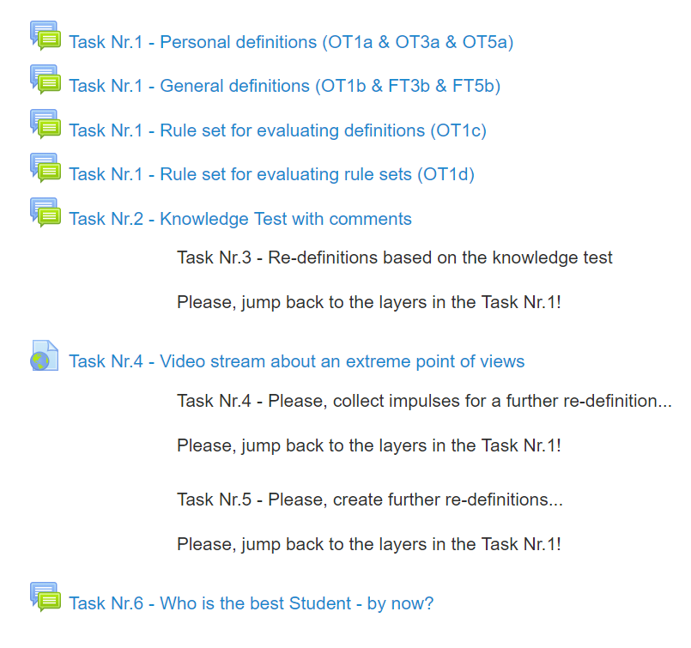
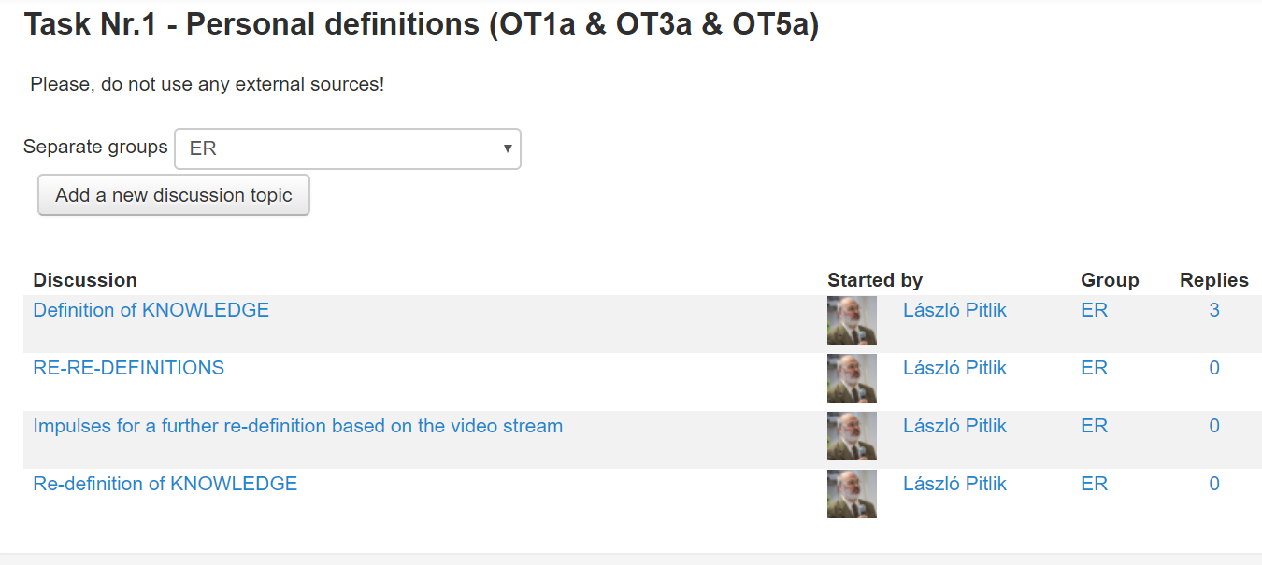
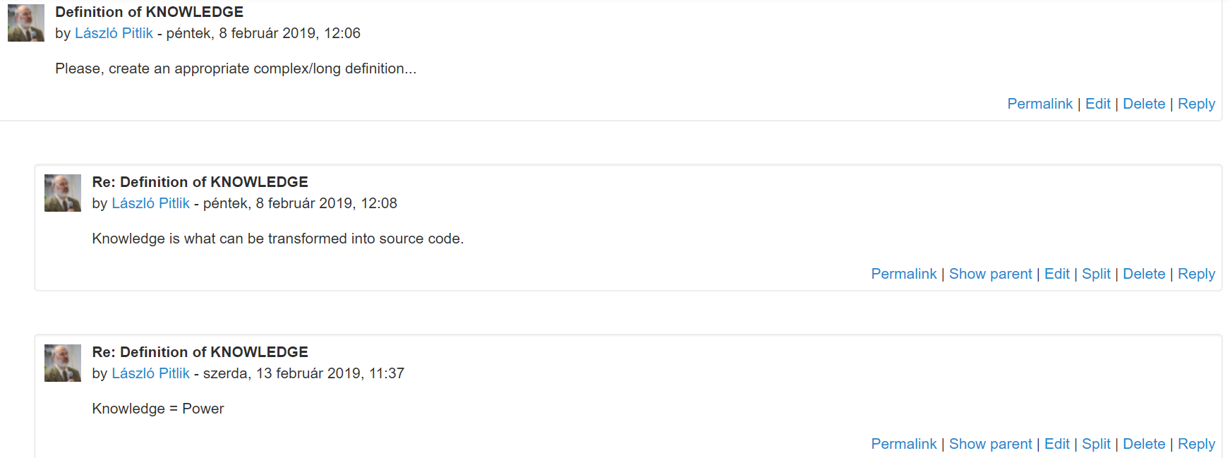
The above presented three layers show in what kind of visual frame what kind of content can be found. Each activity has a timestamp and some content. The evaluation of student’s activities (see Task 6) will be based on these elements of the digital finger/foot-prints. Content elements (like definitions) can be commented through the reply bottom. New definition can be created through the reply button of the initial content element (see: Please, create…).
Re-definitions have always an own forum, but it would also be possible to create fine tuned version for a given definition as a content element through the appropriate reply button of the focused element.
Impulses are remarks, notes, examples (see diary’s remarks). Ideal impulses should criticize the previous state of a definition based on deeply operative instructions.
In an ideal case, a given Student can produce at least one personal definition, at least three re-definitions, and a general definition. In the background of each re-definition should have been a reason too. A reason is a kind of critiques incl. an exact direction for improving.

Interpretation of potential Student’s reactions
The QuILT-system must produce patterns of ideal Students even if first just in virtual form. In case of a suddenly offered task of ‘creating definitions’ Students should have a kind of inner impulse to be willing to so. It is mostly given – in an instinctive way. If maybe not, it is necessary to generate motivations (e.g. clarifying before: why a task like this could be seen as an important task, and/or as an important part of a relevant whole picture). If the needed level of motivations is given, then the brain creates a kind of association/intuitive (seemingly arbitrary) reaction. It means: the brain delivers a lot of words having close connection to the focused phenomenon (here and now to the keyword of knowledge) in an instinctive way. This prompt reaction is supervised through the main conditions of the given persons (like Students might tend to see the world from the point of view of the education – c.f. detailed analyses of real definitions below).
The associative reactions (it means the first version of the definition) can also be seen as a kind psychologic test (c.f. Baum-test/Koch-test: https://en.wikipedia.org/wiki/Baum_test, https://www.researchgate.net/publication/280122930_The_Tree-Drawing_Test_Koch's_Baum_Test_A_Useful_Aid_to_Diagnose_Cognitive_Impairment). The brain as such is capable of creating a lot of point of views, but the first, spontaneous reaction is an other one (c.f. https://www.ted.com/talks/jill_bolte_taylor_s_powerful_stroke_of_insight?language=hu#t-340954 about left and right hemispheres in the brain) as the enforced point of views after thinking about the logic possibilities. Therefore, to create a personal/private definition is a task dedicated to the spontaneity. The further task (creating an other/parallel/potential/general definition) is a kind of game concerning the flexibility of the thinking.
Potential approximations (different point of views for parallel definitions):
- mechanistic approaches (if permitted)
  - quasi each language version in Wikipedia about the keyword knowledge could be translated (e.g. to English) - https://en.wikipedia.org/wiki/Knowledge
    - the number of language variants being available is over 100
    - the different articles are mostly not a direct translation from an other language
      - remarks: this interpretation initialize the second meeting’s tasks (where a lot of chained translations should be generated based on proper reasons)
        - https://miau.my-x.hu/mediawiki/index.php/QuILT-IK045-Diary
        - https://miau.my-x.hu/mediawiki/index.php/QuILT-IK057-Diary
        - https://miau.my-x.hu/mediawiki/index.php/QuILT-IK059-Diary
      - remarks: the chained translations make also possible to define synonym-like words (knowledge =?= understanding – see below, other keywords like data, information, intelligence or intelligent/smart …) and it is also possible to go on towards other topics having direct connection to the course contents like service design, research methods, etc. – and the keywords as a kind of new chain-building logic…
      - remarks: chained translation can also be seen as a kind of Academic Writing Skills (https://en.wikipedia.org/wiki/Academic_writing --AWS) where nobody is capable of working alone (without human experts) – during a chained translation frame makes possible to learn in an autodidactic way (https://miau.my-x.hu/mediawiki/index.php/QuILT-Robot-English)
      - remarks: If it is important to formulate with less possible amount of letters, then the robot-language-exercises make possible to check (alone) the impacts of arbitrary shortening techniques to the similarity of the first and final sentences. It means: the goodness of actions can be derived in an objective way – without any expertise-needs (e.g. text version ability to = capability of in the level of the meanings, but the one version is shorter than the other version)
    - special effects can also be seen (e.g. the word of knowledge will be substituted at once with a synonym – HU: tudás/ismeret=knowledge)
  - it would also be possible to search (by Google) for the keyword knowledge AND definition excluding wikipedia sites and/or the keyword of dictionary
    - https://www.google.com/search?q=knowledge+definition+-site%3Awikipedia.org
    - https://www.google.com/search?ei=vYJmXIjmFI-vrgTzsZiYDA&q=knowledge+definition+-wiki+-dictionary
- system-theoretical approaches with advantages and disadvantages [including solution-like remarks too in case of critical aspects]
  - artistic/poetic approximation (it means a lot of rel. wide-ranged associations like): knowledge is power (where mostly just one single aspect of the usage/utility of knowledge is highlighted therefore):
    - advantages of this approximation:
      - it is short (c.f. evaluation rule set for definitions - https://miau.my-x.hu/miau/quilt/OT1c.xlsx - c.f. Occam’s razor: https://en.wikipedia.org/wiki/Occam%27s_razor – the simpler/shorter - the better)
      - it is easy to remember
      - it is (seemingly) clear, …
    - disadvantages of this approximation:
      - it is partial (why even so?) [further associations can be involved - but this way makes the definition more and more longer – c.f. antagonisms]
      - it needs the definition of the used association at once in order to have a real definition for the word of knowledge (see: what is power?), [creating further/chained definition layers is possible – with antagonistic effects again], …
  - production-oriented view (it means a kind of willing/anthropomorphic acts like): knowledge will be produced through learning processes
    - advantages of this approximation:
      - it let us imagine doing so,
      - it is (seemingly) near to the expected objectivity, …
    - disadvantages of this approximation:
      - the production-like expressions are fuzzy to interpret (e.g. what kind of real processes should be executed?) [creating further/chained definition layers is possible – with antagonistic effects again],
      - further keywords (like learning) need further interpretations too, [creating further/chained definition layers is possible – with antagonistic effects again], …
        - remarks: learning is changes in the brain?
        - remarks: production is changing parameters?
  - origin-oriented view (it means a kind of existence independent from human beings like): knowledge comes (can be derived) from data (not relevant who/what is the acting force field)
    - advantages of this approximation:
      - it supports having a focus on quasi (raw) materials (c.f. data) instead of productions processes,
      - it permits, that knowledge can be existing without the human beings (too), …
    - disadvantages of this approximation:
      - (raw) materials can be processes in a lot of ways, [creating further/chained definition layers is possible – with antagonistic effects again],
      - (raw) materials are defined as such - mostly not clear enough too [creating further/chained definition layers is possible – with antagonistic effects again], …
  - umbrella-term or analogy view (it means an associative view based on subtypes like): knowledge is a lot of capabilities, abilities, skills, etc.
    - advantages of this approximation:
      - it makes clear, that the terms/words are abstractions with a kind of holistic characteristics which can just be interpreted through its parts
      - it makes also clear to work with analogies (https://en.wikipedia.org/wiki/Analogy_of_the_sun), …
    - disadvantages of this approximation:
      - the terms describing parts of the holistic phenomenon needs also definitions, [creating further/chained definition layers is possible – with antagonistic effects again],
      - in case of analogies it is also important to make an attempt to separate/decontextualize the specific characteristics of the connected phenomena (e.g. sun - eye) [creating further/chained definition layers is possible – with antagonistic effects again], …
        - remarks: holistic effects vs. right hemisphere of the human brain?
        - remarks: handling of the partiality vs. left hemisphere of the human brain?
        - source: https://www.ted.com/talks/jill_bolte_taylor_s_powerful_stroke_of_insight?language=hu#t-340954
  - usage/utility view (it means the phenomena where knowledge can be used - like): knowledge is needed for problem solving, decision making, analysing, proving evidence, etc. (independent from the person and/or techniques of the problem solving as such)
    - advantages of this approximation:
      - here could be said the same as before in cases of analogy-view
      - and or artistic view,
      - because the used new terms have the same positive (and negative) effects – merely they have an other association layer behind…
    - disadvantages of this approximation:
      - here could be said the same as before in cases of analogy-view
      - and or artistic view, …
        - remarks: What is a problem?
        - remarks: What is a task?
        - remarks: Is a problem = a task?
        - remarks: What is an analysis?
        - remarks: When can be seen a problem as solved?
        - remarks: When can be seen a problem as solved in a valid – proved – way?
        - remarks: Is the phenomenon “being solved” binary or fuzzy?
          - binary: e.g. yes or no (or I do not know?! – see non-knowledge)
          - fuzzy: e.g. yes – partially – no
        - remarks: What is decision? (c.f. answering to a question – see here - directly below)
  - usage/utility view II: knowledge is knowing the correct answer to a given question
    - advantages of this approximation:
      - see before, …
    - disadvantages of this approximation:
      - see before, …
  - pie-view (it means: the word of knowledge will be described through words from the same (complex) layers – like): knowledge is what can not be defined as non-knowledge and/or not-knowledge
    - advantages of this approximation:
      - it is seemingly a kind of classified view with sets having no lacks and/or overlapping effects
      - it is seemingly an easy concept to have one/more lists about what should be proved/excluded before we use the word of knowledge, …
    - disadvantages of this approximation:
      - if people know, that they do not know something, then the forms of the non-knowledge are a part of the existing knowledge and the non-knowledge is therefore not a separable set of phenomena [this kind of inconsistence seems to be a paradox like: https://en.wikipedia.org/wiki/Paradox]
      - we do not have one or more lists like exceptions [if we had these lists, they would also be incomplete probably for ever], …
        - remarks: international knowledge test (c.f. https://miau.my-x.hu/miau/quilt/mgkt.docx)
        - remarks: knowledge is what can not be describe as
          - data
          - information
          - intelligence
          - or even capability, ability, skill, understanding, structuring, analysing, concluding, proving, etc. [see directly below for further interpretations]:
  - synonym-view (it means, it is a seemingly proper definition, if we choose a synonym-like word – like): knowledge is each kind of understanding (+ where the directly above listed words could also be placed to this view):
    - advantages of this approximation:
      - it can be short
      - it seems to be not for every single person like a trap, …
    - disadvantages of this approximation:
      - synonyms/synonym-like objects have no meanings, or they need also being defined at once [creating further/chained definition layers is possible – with antagonistic effects again],
      - synonyms are less artistic associations [see artistic view before on the top of this structured interpretation subchapter]
  - …… view
    - advantages of this approximation:
      - , …
    - disadvantages of this approximation:
      - , …
There are surely a lot of further views – where the views are probably not without lacks and overlapping effects what should be so!

Factual and virtual elements
The following view shows the factual items with a minimalized feeling of text mining (see coloured words). Virtual elements are each other definition attempts being integrated into the interpretations (like questions, conclusions, samples, etc.):

Examples

Knuth’s original
- Science is what we understand well enough to explain to a computer. Art is everything else we do.

Conductor’s demo
- Knowledge is what can be transformed into source code.
- Knowledge = Power
- Knowledge is what can be transformed into source code. Every other human activity is art.
(cf. Knuth, 1992)

IK045
- Knowledge is power. Having the power about explain things. Know to how. Knowledge is being aware.
- Knowledge is when someone has information about something.
- Knowledge is awareness of understanding something.
- Knowledge is what you get with the learning process.
- Knowledge is power. Having the power about explain things. Know to how. Knowledge is being aware.

IK057
- Knowledge is something can be earned by books, by experiences, and by getting new information. This knowledge can be used in daily lives and be forgotten.
- Knowledge is what we get with the learning process. / Knowledge is something than you can get trying to find the answer for your questions and is something unlimited.
- (to 059 too) Knowledge is a collection of information, data.
- (to 059 too) Knowledge: information or skills acquired through education. / Familiarity, awareness, or understanding of something.

IK059
- Knowledge is what you know and understand about something.
- Knowledge is what you achieved during your course of life which can be translated in to your daily activities including studying, working, thinking, communicating, etc.
- Knowledge can be described as the facts, information, and skills acquired by a person or the understanding of a certain subject.
- Knowledge is defined as information, facts that have been accumulated through education or experience.
- (personal/private) Knowledge, which separate people each other and effect their lifestyle and their … / (in general) Knowledge that related to people how they educated themselves and what experienced in their life.
- Knowledge is power of education.
- Knowledge: know every basic thing means basic knowledge. / Knowledge comes from getting the data and information which is going around you. It means gathering knowledge about every single thing.
- Skill acquired through experiences.
- Knowledge is everything you know. / It is from the process that people get educated.
- Knowledge means, being aware of something or understanding of information.
Legends:
- Each colour highlights a few of relevant words in order to visualize their frequencies quasi at once.
- IK045 is a course for BSC-Students, the other courses are for MSC-Students. (Potential question: If we had a lot more definitions could be derived a pattern for the differences between BSC and MSC thinking-level/complexity/…?)
- The rows (having more than one definition) can be seen as an attempt creating personal and general definition too.
- A few Students had two courses parallel, therefore specific definitions could be used for more course ids.
- The education and studying should be seen as synonyms (c.f. almost identical colouring).

Potential questions
- Which definitions should be seen as the best definition? (c.f. https://miau.my-x.hu/miau/quilt/OT1c.xlsx) where the attributes/variables are
  - count of words (the less the better)
  - count of sentences (the less the better)
  - count of letters (the less the better)
  - count of samples (the more the better)
  - count of keywords (the more the better)
    - Keywords can be seen as a kind of close-sitting words compared to the word of knowledge from the point of view of the text mining techniques (statistics about frequencies, distances, etc.).
    - Keywords can also be seen as a kind of words needing an own definition.
  - count of chained translations or chain-length (the more the better)
    - c.f. second meeting
    - c.f. special (highlighted) question almost directly here below
- Which general definition is better than the personal definition created before?
- Which definition is better than the conductor’s definition and/or Knuth’s definition (both known in advance)?
- What kind of reasons could be identified in case of each single definition leading to a better re-definition as before?
- Is there a pattern and/or a rule set for discrimination the general definitions and the personal ones?

Specific tasks/questions to the second meeting:
- Which definitions would lead in case of a chained translation quasi to the same sentence having it at the beginning? (c.f. binary view of similarities)
- Which definition(s) has (have) the same similarity between the first and final variants using a chained translation? With other words: Could be each definition has the same similarity index?
- How should be measured / derived the similarity between the first and final definitions in case of chained translations?
- Which definition(s) has (have) the longest translation-chain?
- Which languages build to longest chain(s)?
- Is the chronology of the chain-members important concerning the quality/similarity of the final sentence (definition) compared to the first sentence (definition)?
- Which languages are the most sensible chain-members?
- Are there identifiable reasons why a given language seems to be sensible?
- If a definition can be translated to one/more of the most sensible languages, then the translations to the less sensible languages should always be correct enough?
- Could each language be weighted based on its sensibility (it means: based on the number of the potential hidden/less-sensible languages)?
- Could the chain-length be relativized (evaluated) based on its sensibility (it means: based on the number of the potential hidden/less-sensible languages)?
- Are there any definitions being totally controversial compared to each others (pair-wise or chained)?
- …

Possible conclusions
- First of all: there is just one single definition (with a shorter and a longer variants) having no coloured sign. This is the conductor’s opinion – the finetuned (c.f. explaining vs. transforming into source code) version of the Knuth’s original. Each further definition has a coloured sign what means there are connections between definitions.
- Parallel, a lot of definitions use words like every* and/or some*. They words are clear (grammatical) signs for generalisation purposes.
- Interpretation attempts for several highlighted/coloured words before:
  - awareness: The two terms (knowledge and awareness) create a specific association space with a lot of questions supporting the interpretation challenges:
    - Is knowledge as such strongly bound to the human brain (or rather to the brain of living creatures)?
    - Can a (unicellular) Protista (or a mitochondrion) have knowledge?
    - Could e.g. bio-chemical reflexes be interpreted as a kind of knowledge?
      - Can e.g. an amoeba feel hungry/satisfaction/etc.?
      - Can e.g. an amoeba going to start searching for food?
    - May we speak about knowledge in case of inorganic/lifeless objects too (like stone, sand, air, etc.)?
      - remarks: Do need the definition of knowledge by Knuth impulses about the form of awareness?
      - remarks:
  - themselves:
    - The word (probably interpreted it in a little bit arbitrary way) let us lead to the association that knowledge can not be transferred between human beings, but it is quasi always given (c.f. right vs. left hemisphere of the human brain) and each person can activate layers/pieces of knowledge being always in an inactive form available and the activation is based on the circumstances around. It means the learning processes do not write the “white” surfaces of the brain/memory, but they do unwrap/unpack hereditary packages.
    - Other approximations focus on the logic of the intuition. It means constellations of inner and/or outer environmental variables catalyse reflexes (c.f. connection between inputs and outputs in an expert system or even simulator with arbitrary characteristics).
    - It is rel. sure: data/facts can not be available in the brain. These will be realized in an endless and chained process from each other. Therefore, knowledge is a capability of handling with impulses (facts, data) and this kind of capability can be available like muscles (trained or not-trained). New muscles between too strange points of the body will never be created in the lifetime. Conductors can - therefore – just train what is available -since ever?!
    - Memory-tests (c.f. Task 2 in Moodle-view) may not be called as knowledge test because the memory can be written and even the so-called writing of memory-units can be tricky (e.g. learning huge volumes based on the first n letters as a kind of acronym) where the tricks as such can be seen as knowledge (c.f. how to learn faster: https://www.youtube.com/watch?v=B9SptdjpJBQ)
  - understanding as such does not mean anything at once – what can not be measured/modelled is not existing…
    - The central question is how it is possible to separate randomized fitting (e.g. 2+2 = ? = maybe 4? or 5? here and now rather 4!) from correct derivations (e.g. 2+2 = ? = 1+1+1+1=4) and from derivation processes having double errors (e.g. 2+2 = ? = 1+1=3+2=4)?
    - An other important question is whether the test person can detect problems in the own interpretations processes or in the processes of other people (c.f. if a test question have 4 answer-options then the so-called incorrect answers should have reasons why they can be existing for a given ratio of the population)…
  - explaining as such does also not mean anything… but
    - The central question is whether it is applicable to create a model being adequate to estimate with a high-level fitting what will happen (in case of measurable phenomena like fitting ratio of tests) if a given person proceeds a given explaining logic?
    - In case of computers, explaining can not mean any other activity as creating source codes.
  - learning/education/studying:
    - It is important to make a clear differentiation between filling memory-units or unwrapping the existing mechanisms for problem handling or using tricks to fill faster memory units and/or to unwrap faster reflexes…
    - Example: We are searching for a number with for digits. If the first 3 digits then the first 2 digits and then the first digit (where the first digit is always the digit on the left side) will be subtracted from the original value, then is the result 3333.
      - What should be “offered” as learning material for an adult person with average IQ in order to make it capable of solving the problem?
      - What kind of learning content/methodology and what kind of personal characteristics (PLA) lead to what kind of success (like speed, generalisation potential, etc.)?
  - data/information/experience:
    - information units can probably be derived from data (like the trend lines about the importance of the word of knowledge worldwide and between 2004-2019 based on the data of Google Trends - https://trends.google.hu/trends/explore?date=all&q=knowledge,information,data) where deriving these trends will only lead to always temporary information if there is a kind of hermeneutical capacity - e.g. rules leading to prompt decisions – like a journalist should rather use nowadays data instead of information to be trendy)…
    - What is however the connection between data/information and knowledge?
      - Knowing about the online service of Google Trends? (Is this also a kind of fact like what kind of country is the western neighbour of Hungary?)
      - Knowing about how to find other/appropriate data/service if the key-service is not given? (it means being capable of searching in an efficient way? SEO services could be transferred into an expert system?)
      - Knowing about what is a trend as phenomenon? (If something can be found based on searching, then is it worth storing it in the memory?)
      - Knowing about forecasting techniques: how to create estimation for 2020? (c.f. searching techniques before)
      - Knowing about the mechanistical tricks how to transfer data from Google to Excel? (Is this also a fact? and can be search for?)
      - Being capable of deriving estimation for the respective next year WITH HIGH FITTING AND HIGH STABILITY OF FITTING?
      - Or knowledge is also a kind of temporary phenomenon like information – it means knowledge is always that kind of capability what is here and know needed to go on in an effective way?
        - Information is something if it is important temporary (?) Used information is fact (?)
        - Knowledge is something if it lacks temporary (?) Used knowledge (like searching tricks, estimation techniques, etc.) can also be stored like used information units (?)
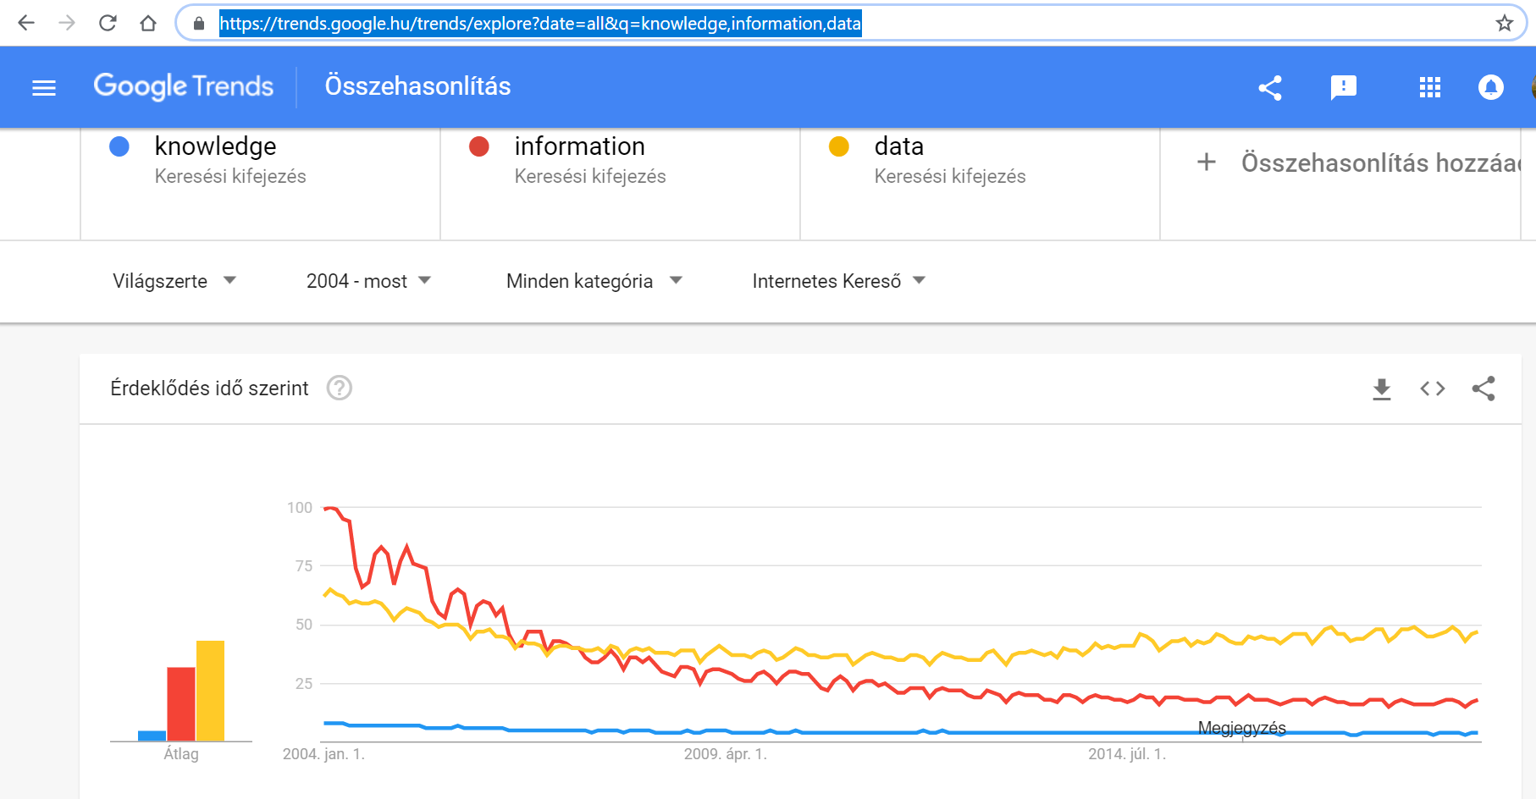
- Lacking keywords:
  - forecasting: the high and stabilized fitting rates can not be achieved in a randomized way
    - Is knowledge what supports to be sustainable in every point of views?
    - Can the estimation/modelling capability of a given person be transferred into source code?
  - objectivity: knowledge is not binary (like given/not-given) – knowledge can also have quantities (c.f. quantity can become quality) – knowledge should be on high-level objective/factual/evaluable - just based on measurable phenomena can we talk about quality in an objective way
    - The more the difference between randomized and conscious derived / copiable techniques for estimations the more adequate is to speak about a knowledge-like phenomenon.
    - Facts can also be seen as knowledge because the so-called knowledge also produce estimations and these estimations are facts too if the fitting is high – it means the knowledge is objective…

Case study of a complex but classic definition creation process
This chapter tries to summarize the impulses based on the tasks along the 1. meeting (see diaries), This summary can be seen as a kind of the interpretation of the ideal Student:
- Knowledge is a high-level abstraction – like each word of the human languages.
- Knowledge is a high-level abstraction because it can not be measured in a direct way – like intelligence test neither where a lot of questions will be asked, and the answer-series will be evaluated to create a kind of index value for the intelligence of different peoples (objects – like robots).
- Sample: low-level abstraction is e.g. pressure, temperature, distance, weight, etc. -they can be measured in a direct way.
- Knowledge (as noun) has a direct connection to words (adjectives) like smart/intelligent – and knowledge as such expects to be having to measured, because adjectives mean always a scale of values of the adjectives (e.g. smart, smarter, smartest or intelligent, more intelligent, most intelligent).
- Knowledge should have a kind of objective characteristics. Knowledge about the future (it means estimations) can be measured in an objective way - later. Lack of present data can also be seen as a kind of estimation being checkable in an objective way (if sources about facts can be explored later or at once/parallel).
- Knowledge as a kind of umbrella phenomenon can have types – even types from more points of views (dimensions):
  - dimension: derivation/approximation of facts being objective checkable:
    - e.g. forecasting capability with high-level fitting rates (c.f. the more precise are the estimations the smarter is the engine being able to generate them)
    - e.g. capability of searching (c.f. the faster the smarter)
  - dimension: forms of knowledge
    - e.g. knowledge of living creatures (clear/ready for transferring into source codes or artistic)
    - e.g. knowledge of robots (source codes – already existing or not)
  - dimension: evaluation (quantity becomes quality)
    - e.g. how to measure the goodness of source codes
    - e.g. how to measure the goodness of evaluation rule sets (e.g. for source codes – c.f. Who watches the watchers? or Who will watch the watchmen? - https://en.wikipedia.org/wiki/Quis_custodiet_ipsos_custodes%3F)
- Knowledge is a kind of sustainability? (the less is the standard deviation of differences between estimation and facts, the smarter is an engine)
- Knowledge is a kind of adaptability? (the less is the standard deviation of differences between estimation and facts, the smarter is an engine)
(c.f. the right and left hemisphere of the human brain interpreted by https://www.ted.com/talks/jill_bolte_taylor_s_powerful_stroke_of_insight?language=hu#t-340954)

Case study of re-re-re-definitions
This paper has till this chapter a rel. huge amount of potential/specific questions? Basic invention/assumption or how could following definition be refined (fine-tuned, re-defined):
- Basic constellation: Knowledge is the ability to ask. [Demo: How many (described in capita) tourists will check in 2020 in the Budapest Airport? –see forecasting of loads]
  - potential critiques: Potential answers could also be involved in a good question…
  - potential action leading to improvements: involving the keyword of answer…
- Re-definition: Knowledge is the ability to ask including potential answers. [Demo: More or less tourists will check in 2020 than in the last closed year (2018)? – the option equal is not mentioned just more or less]
  - potential critiques: Potential answers should not contain each potential answer…
  - potential action leading to improvements: involving the keyword of each…
- Re-re-definition: [Demo: More or less or ca. the same quantity of tourists will check in 2020 than in the last closed year (2018)? – the option of totally equal values means equal described in exactly capita – but it could also be meant a tolerance threshold e.g. +/- 1000 capita or 1% of a given basis value]
  - potential critiques: Potential answers should have problems of the overlapping effects…
  - potential action leading to improvements: involving the additional text of free of overlapping effects…
- Re-re-re-definition: Knowledge is the ability to ask including each potential answer without any overlapping effects. [Demo1: How many percent of the last closed year will be reached described in integer values? – Range of the potential answers: 0-100% step 1%] - [Demo2: How many percent of last closed year will be reached described with n digit after the delimiter sign? – Range of the potential answers: 0-100% - steps can be arbitrary detailed]
  - potential critiques: A more complex/sophisticated definition should have impulses towards the whole combinatorial space…
  - potential action leading to improvements: involving appropriate signs for combinatorics…
- Re-re-re-re-definition: Knowledge is the ability to ask including each potential answer without any overlapping effects so that the question itself makes possible to identify the entire combinatorial space behind. [Demo: How many percent of the last closed year will be reached described in integer values depending on the strategic parameters of the business plan like planned fixed-cost-level, flexibility-level in case of strikes, planned investment level, planned price-level)?
  - potential critiques: not only for answers should be formulated quality assurance expectations but also for influence layers handled through the particular question…
  - potential action leading to improvements: involving appropriate signs for the input/influencing layers…
- Re-re-re-re-re-definition: Knowledge is the ability to ask including each potential answer without any overlapping effects neither in case of the inputs/influencing variables nor in case of the consequences - so that the question itself makes possible to identify the entire combinatorial space behind. [Demo: How many percent of the last closed year will be reached described in integer values depending on the strategic parameters of the business plan - like planned fixed-cost-level (V1), flexibility-level in case of strikes (V2), planned investment level (V3), planned price-level (V4), where each factor can be set as high/medium/low with exact threshold in the background)?
  - potential critiques: …(no definition about a holistic phenomenon can be error-free)… e.g. the good question can also outline the alternative techniques deriving the appropriate answers…or even…the so-re-re-*-defined definition can quasi never be translated in the frame of chained translations for quality assurance…
    - remarks: it is also a potential answer if a constellation seems to be strange (c.f. none-option – compared to non-knowledge)
    - remarks: both in the input and in the output site of a complex phenomenon
  - potential action leading to improvements: …???... c.f. everybody has the last on the own shoulders to decide what can be made by one or more human beings in case of real time problems where the robots (created by humans) will have an other sensibility of real time effects based on the increasing calculation speeds…
    - remarks: Could be seen a question having unlimited potential answers as an ideal question?
    - remarks: If a set of options has the element of “others” – could one or more lacks be identified among the options without having relevant combinatorial problems?
  - the combinatorial space is V1*V2*V3*V4 = 3^4=3*3*3*3=81 input scenarios with 1 consequence variable (capita in integer %)
  - THIS IS A SCHEME FOR STRUCTURED THINKING E.G. THINKING IN EXPERT SYSTEMS!
    - remarks: Where could already be seen a little expert system during the 1. meeting?
    - remarks: Which page has a figure about an expert system in this file: (c.f. https://miau.my-x.hu/miau/quilt/mgkt.docx)
    - remarks: What is the real function (the real utility) of the searched expert system? (e.g. frustrating test persons, checking/describing the details of understanding layers, avoiding/blocking actions without a robust understanding-level, etc.)
    - remarks: each answer-option directly before (see frustrating, checking, blocking) should always be have a reason before mentioning them: e.g.
      - frustrating: potential right but not targeted to the real action (blocking)
      - checking: potential right but the descriptions layers will be aggregated to a holistic value
      - blocking: this holistic value is either OK or not – it means: binary action
    - remarks: so-called knowledge tests with more prepared options should always have reasons behind each potential incorrect option and it is not enough mostly if the incorrect answers are simply randomized ones (without didactic interpretations before), …
    - remarks: Theologist / wise scholars (permitted interpreting Holy Scripts) were probably the first knowledge engineers, because they created the first (https://hu.glosbe.com/hu/en/v%C3%A9grehajt%C3%A1si%20utas%C3%ADt%C3%A1s vs. https://eur-lex.europa.eu/)
      - implementing instructions
      - implementation papers
      - enforcement orders
      - enacting clauses (modal interpretations)
      - it means: the first approximations of the expert systems – to minimize the fuzzy impacts of the magic of words at all…

Remarks/questions to the KNUTH’s definition
- What is a source code?
- Can a standard book/text be (interpreted as) a source code? (c.f. zoo-taxology?)
- Can the Knuth’s definition be interpreted as kind of rule/expert system? (c.f. IF-THEN-ELSE?)
- Do speak the Knuth’s definition about not-knowledge? (c.f. art is not science?)
- Do speak the Knuth’s definition about non-knowledge? (c.f. still not capable of explaining is non-knowledge?)
- What is
  - science?
  - knowledge?
    - (information?
    - data?)
  - explaining?
    - (learning?
    - education?)
  - (especially compared to each other) e.g.
    - modus ponens: https://en.wikipedia.org/wiki/Modus_ponens
    - modus tollens: https://en.wikipedia.org/wiki/Modus_tollens

Remarks to similarity index
If there are two sentences (in English) where the first one has been translated in a chained process and the final sentence should quasi be the same as the first one, then in the most of the cases, the expected sameness will not be realized. Instead of totally sameness, there will be one or more differences (like synonyms, order of words, punctuations, etc.). In order to be capable of measuring similarities in an objective way, a set of variables are necessary (see rule set for evaluations of arbitrary objects – like differences between strings). Variables like:
- differences of ratios of letter where 100 % would mean – the string contains just one particular letter and difference of ratios means: 0 % difference if in the two comparable sentences the ratio of the letter “E” has twice the same value - like 10% to 10 % - difference = 0%
  - advantages:
    - the differences of the ratio values can ensure that two sentences with the same words but with other order of the words can be seen as similar enough (as the same) – it means: the less is the average difference for all letters/signs/characters, the more similar are the two sentences
    - with other words and with other mathematical description: the higher is the correlation between the ratios ranked according to the order of the characters in the alphabet or in the ACSII-table, the more similar are the two sentences
  - disadvantages:
    - the letters as such do not have any signs of any meanings
    - the different orders for two sentences can lead to totally different meanings (like genitive constructions vice-versa)
- the higher the correlation between the ACSII-values of the characters in the two sentences ordered by the natural logic of the texts, the more similar are the two sentences
  - advantages:
    - the variable can detect the totally sameness
    - the variable can also evaluate two sentences with a high similarity if e.g. British and American writing customs should be compared
  - disadvantages:
    - the sentences with different lengths can only be compared in a partial way (e.g. just the first part till the end of the shorter sentence)
    - it is not trivial how to solve the problem of inserted words needing a kind of excluding from the proved sequence
- (in case of each evaluation rule set, the activity of Readers/Students is highly desirable)
Each evaluation activity of arbitrary phenomena should always tend to objectivity. It means tending to automation, to independency from human decisions…
In case of synonyms, a kind of replacements are necessary before deriving numeric variables (see above). Synonyms can be replaced in an automated way based on a kind of database especially designed for such kind of replacement tasks.
It is also possible to work with specific replacement already before the first translation in the chain. Specific replacement means a kind of symbols replacing characteristic words in the sentence (mostly nouns, adjectives: like knowledge is what can be transformed into A (A= source code where source code can be seen as a kind of specific keyword – being probably not interpretable in each language).

Annexes

Supporting searching
Day Nr. 1. Task Nr. 2. Abbreviation-Finder-Service-Online: https://www.abbreviationfinder.org/

Examples for chained translations with suspicion-generation effects

Example I.
IQ-tests and/or small talks in recruiting phases can use joke-like challenges: e.g.
- EN: Question: How can be dropped a raw egg onto a concrete floor without cracking it?
- (Real/expected answer: Just drop it - as you like, nothing will happen to concrete. Trust me, I am an engineer.) https://www.quora.com/How-can-you-drop-a-raw-egg-onto-a-concrete-floor-without-cracking-the-egg
- EN2DE: Frage: Wie kann man ein rohes Ei auf einen Betonboden fallen lassen, ohne es zu zerbrechen? https://nemet-magyar-szotar.hu/boden.html
- EN2HU: Kérdés: Hogyan lehet egy nyers tojást betonpadlóra dobni anélkül, hogy megrepedne(nénk)?
- EN2HU2EN: Question: How can a raw egg be thrown onto a concrete floor without breaking it?
- EN2DE2EN: Question: How can you drop a raw egg on a concrete floor without breaking it?
- EN2DE2HU: Kérdés: Hogyan lehet egy nyers tojást betonpadlóra dobni anélkül, hogy megszakítaná?
- EN2DE2HU2EN: Question: How can a raw egg be thrown onto a concrete floor without interrupting it?
Interpretations:
- What should be cracked?
  - EN: It should be cracked – it can mean in English: both the egg and the concrete floor.
  - DE: Der Boden / den/einen Boden vs. das Ei / ein Ei / es
    - It means: the German version is capable of uncovering the potential shifting of meanings (the basis of jokes or misunderstandings).
    - (The uncovering potential could be made stronger if the verbs were noun-specific: e.g. egg-cracking / concrete-breaking but: unfortunately, it is not relevant here and now)
  - HU: There is no sign for any inconsistence.
- Who should crack it?
  - EN: standard passive structure
  - DE: standard passive structure, but in the chained version the German “man” becomes in English “you”.
  - HU: lack of information about the person
- What should be made at all?
  - EN: drop
    - drop
    - throw
      - Can be seen drop and throw as synonyms for each other?
      - The chained translations can lead to drop or throw – dependent on the bridge-language.
  - DE: fallen lassen
    - Can this German version be seen as a kind of synonym?
    - letting fall <> dropping (c.f. want to be dropped <> do not want but let)
  - HU: dobni
- What should happen?
  - EN: cracking =?= breaking <?> interrupting
  - DE: zerbrechen vs. zerbröckeln (crumble or disintegrate)
    - Maybe, these kinds of verb-variants could be led to a higher probability for egg or concrete in case of a longer chain?!
    - (The uncovering potential could be made stronger if the verbs were noun-specific: e.g. egg-cracking / concrete-breaking but: unfortunately, it is not relevant here and now)
  - HU: this language generates the sensible effects concerning the verbs describing expected impacts.

Example II.
In English (basic version):
- Customer (the blond women): I would like a pink panther, please!
- Sale-expert: Of course, we have it, please.
- Customer: Could I also have it in other colorations, e.g. a white pink panther?
EN2DE:
- Kunde (die blonde Frau): Ich hätte gerne einen rosa Panther!
- Verkaufsexperte: Natürlich haben wir es bitte.
- Kunde: Könnte ich es auch in anderen Farben haben, z. ein weißrosa Panther?
EN2HU:
- Ügyfél (a szőke nők): Szeretnék egy rózsaszín párdót, kérem!
- Eladó-szakértő: Természetesen, kérem.
- Ügyfél: Szóval más színekben, pl. fehér rózsaszín párduc?
EN2DE2HU:
- Ügyfél (a szőke nő): Szeretnék egy rózsaszín párducot!
- Értékesítési szakértő: Természetesen megvan.
- Ügyfél: Más színekben, pl. fehér-rózsaszín párduc?
EN2HU2DE:
- Kunde (blonde Frauen): Ich möchte einen rosa Panther, bitte!
- Verkäufer-Experte: Natürlich bitte.
- Kunde: also in anderen Farben, z.B. weißer rosa Panther?
EN2DE2HU2EN:
- Customer (blonde woman): I want a pink panther!
- Sales Expert: Of course, you have it.
- Customer: In other colors, e.g. white-pink panther?
EN2HU2DE2EN:
- Customer (blonde women): I want a pink panther, please!
- Seller Expert: Of course, please.
- Customer: thus, in other colors, e.g. white pink panther?
Interpretations:
- Even the joke could be uncovered, because
  - the both colours have a lot of variants
  - the German variant (weiss-rosa) is not really existing as expression
  - the Hungarian version (fehér-rózsaszín) could also be not identified in a huge corpus based on text mining analyses
  - the real conclusion could be: what kind of colour is here and now relevant?
- However, the basic joke is functioning without saying an other colour.
  - Therefore: the chained translation is not always able to uncover suspicions concerning the real/ meaning (c.f. figuratively or literally).
  - But: the suspicion as such can be generated for human readers in form of a map where describe where is the weakest part of a text at all…
Conclusions based on both examples:
- The chained translations make possible to generate signs for suspicions.
- Human beings (able to read) can see the weakest parts of texts.
- It seems to be possible to create robots (source codes) too being capable of interpreting signs for suspicions.
- Languages can have specific interpretation layers like articles (the, a vs. der/die/das) where distortions/lack of meanings can be uncovered.
- Assumption: Each single problem of the potential meanings can not be uncovered based on chained translations.

About antagonisms in rule sets for objective evaluation
If performance dynamics should be measured in case of a lot of athletes, then
- an athlete should have better scores if he produces low levels at the beginning because the improvement (dynamics of the development) will seem to be higher from a lower level
- but: trainers can derive expectations based on physiological/morphological parameters for the same athlete where he will have a little score because of the rel. weak performance compared to the estimated potential for him
- it means elements of a rule set for evaluation of dynamic performances must have antagonistic variables to press the affected persons to be honest (as far as possible)
- c.f. an offered task for Students having a hobby of reading/writing (https://miau.my-x.hu/mediawiki/index.php/QuILT-IK045-Diary#Already_known_tasks) / worth reading: KAZOHINIA

