Exercises for critical thinking and doing

Laszlo Pitlik, Laszlo Pitlik (jun), Matyas Pitlik, Marcell Pitlik

Abstract: The magic of words works parallel with believes. The human intuition produces every moment believes – but a lot of believes can also become consistent – it means: near to the final truth. Critical thinking does not use believes. Critical thinking needs the proving of evidences. Critical thinking has two characteristic layers: exploring the incorrect meanings and the deriving correct meanings. To explore (to derive and not “just to feel”), that a beetle not a spider is, is already a kind of demonstration of critical thinking. But to be able to define the real position of this beetle in the animal taxonomy comparing to each other possible living creature, this is an other (higher – more consistent) level of critical thinking – it is a kind of critical doing because not only the problem itself could be detected but at one the correct solution could be delivered (c.f. simulation system vs. single estimation / plausibility vs. consistence). This paper tries to demonstrate examples about phenomena in the field of the critical thinking.

Keywords: plausibility, consistence, exploring, deriving, proving

# Introduction

This paper is the newest part of the series about experiences if the QuILT-based education processes. Previous articles can be downloaded here:

* <https://miau.my-x.hu/miau/quilt/Definitions_of_knowledge.docx> + annexes like:
  + <https://miau.my-x.hu/miau/quilt/demo_questions_to_important_messages.docx>
  + <https://miau.my-x.hu/mediawiki/index.php/QuILT-IK045-Diary>
  + <https://miau.my-x.hu/mediawiki/index.php/Vita:QuILT-IK045-Diary>
  + <https://miau.my-x.hu/mediawiki/index.php/QuILT-IK059-Diary>
  + <https://miau.my-x.hu/mediawiki/index.php/Vita:QuILT-IK059-Diary>
* <https://miau.my-x.hu/miau/quilt/reality_driven_education.docx> + annexes like:
  + <https://miau.my-x.hu/miau/quilt/chained-translations-legal-slang.docx>
  + <https://miau.my-x.hu/miau/quilt/demo_chained_translations.docx>
  + <https://miau.my-x.hu/miau/quilt/demos_chained_translations.docx>
  + <https://miau.my-x.hu/miau/quilt/forum_details.docx>
  + <https://miau.my-x.hu/mediawiki/index.php/QuILT-IK057-Diary>
  + <https://miau.my-x.hu/mediawiki/index.php/Vita:QuILT-IK057-Diary>
* (<https://miau.my-x.hu/miau/quilt/Exercises_for_critical_thinking_and_doing.docx>)

Critical thinking means being capable of exploring problems for example in the consistence of part of a system or concerning the usefulness of ideas, etc. Critics can be published in form of evaluation (like *adjectives* and/or **negations**: e.g.

* **no** service can be built based on the chained translations or
* although, it is **not** necessary for a successful chained translation to have language skills for each used language, **yet** chained translation is more *complicated* than *useful* or
* too *much* languages are necessary for a chained translation process, etc.).

Parallel to negative evaluations, critical thinking and critical doing together mean too: it is necessary to deliver improvements (ideas for fine tuning detected problem handling processes): e.g.

* in case of negations, it is useful to search for positive scenarios/constellations (like GLH2019 vs. estimated uselessness of chained translation techniques – see above - where a new filter/evaluation system for legal questions/documentations will be built on the chained translations) – parallel, positive scenarios can also be derived on your own…
* “complicated” is a process if it can only be executed in a manual/long way, but to derive chained translations a Google spreadsheet function should just be used (online) where the translated sentences in the middle of the chain should not be manipulated/processed – just the initial sentence alone (see annex)
* the amount of languages can be arbitrary – although, it is relevant to have the most sensible language(s)

# Antagonisms in the interpretation of sources

Consistent rule systems do not have antagonisms. Faked rules produce always (sooner or later) problems which can also cause specific interferences like: <https://www.facebook.com/682652555192499/videos/2034362689952015/?v=2034362689952015>

Antagonisms are useful in case of evaluation systems: in a consistent evaluation system it is necessary to have variables having no parallelisms like the example about antagonisms in the first paper in this series:

*“If performance dynamics should be measured in case of a lot of athletes, then*

* *an athlete should have better scores if he produces low levels at the beginning because the improvement (dynamics of the development) will seem to be higher from a lower level*
* *but: trainers can derive expectations based on physiological/morphological parameters for the same athlete where he will have a little score because of the rel. weak performance compared to the estimated potential for him*
* *it means elements of a rule set for evaluation of dynamic performances must have antagonistic variables to press the affected persons to be honest (as far as possible)”*

The first level of the critical thinking is: to be able to find new and newer point of views (c.f. Pendulum-video without any kind of chaotic effects: <https://www.youtube.com/watch?v=YhMiuzyU1ag>

## Rosling-animation vs Pendulum-video

The Rosling-animation (<https://www.youtube.com/watch?v=jbkSRLYSojo>) works with probably partially incorrect raw data and/or with a partially chaotic complex system (like history of the countries).

The Pendulum-video (<https://www.youtube.com/watch?v=YhMiuzyU1ag>) has a solid/permanent physical basis, yet the chaos seems to be partially given – from the point of view of a human observer.

The naïve/instinctive human interpretation generate the suspicions of the chaos there where no single possibility of a chaos might be given and the same human intuition process deliver peaceful believes about explored patterns where maybe no real patterns might be detected.

In order to demonstrate what kind of critical aspects in the Rosling-animation, especially in the subtitles (in the layer of the magic of words) are given, the following chapter brings deep details into the surface:

## Searching for critical aspects in the Rosling-animation

The above-mentioned Pendulum-video demonstrates a permanently strong-regulated physical phenomenon where the human eyes can be faked - c.f. hermeneutical illusions like:

* <https://www.optics4kids.org/illusions>
* <https://www.youtube.com/watch?v=llLVk2fqylA>
* or the movie itself where a series of static pictures cause dynamic feelings
* …

The quasi best dynamic data-visualization effect produced by Hans Rosling and his team (<https://www.youtube.com/watch?v=jbkSRLYSojo>) has a parallel layer, namely the layer of the verbal comments. In this verbal layer, it is worth searching for interpretations without real evidences behind:

### scenario

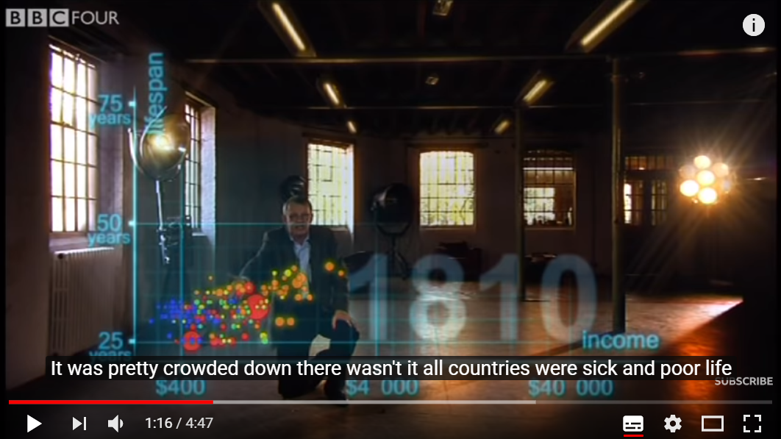





1. frame: “All countries – poor and sick” (source: Youtube-video)

Detailed interpretations to the frame Nr.1:

* the X-axis seems to be logarithmic because the axis units describe magnitudes (exponents: 4*10^2 and 4*10^3 and 4*10^4) – therefore the income difference between the richest and the poorest country is ca. 1 unit of the X axis, it means exactly an exponent more or less
  + therefore: the same poorness might not be declared for each country (just from point of view of the projected future (projected through the units of the X axis)
  + please, do not forget, China’s big-red-bubble is quasi directly in the middle both vertical and horizontal! - it means China is an example for a kind of massive average
* the Y axis it not logarithmic
  + the logarithmic and not-logarithmic views in the same picture are not accustomed for the average people
  + so, the intuition (hermeneutical) processes can be influenced through this distortion effect (c.f. hermeneutical illusion above)
  + the difference between the longest life expectancy and the shortest one is ca. +50% where the minimal value is the 100% threshold
  + so, this difference (ca. 12-13 years / from 25 years to 37-38 years) in the same moment can not be seen as the same on sickness (chances to live)
* from point of view of the objectivity:
  + if we had a lot of further variables about the countries to describe a kind of happiness-index
  + then we could probably derive index-values for several countries above the norm and below the norm and the same estimations of the index-values will not be exist for each country which would mean: each country can have the same happiness-index but based on different constellations
* the further subtitle elements (“slightly better – but not much”)
  + repeat the declaration before
  + c.f. rhetoric effect seemingly with samples
  + but with arbitrary evaluations (c.f. slightly better, not much better)
  + where we could speak about significant differences in the classic way
  + or even about lacks of norm-oriented objects based on similarity analyses
* therefore
  + the evaluation in the subtitle can not be derived from the static picture
  + it is just a kind of artistic/rhetoric effect serving in a conscious way the message of the whole animation (e.g. each country will become healthy and rich, because all countries were poor and sick)
    - although they all were not rel. poor and sick and
    - maybe they all will not become rich and healthy in an antidiscriminative way (see the same happiness-index for each single country based on their different statistical constellations)

## scenario

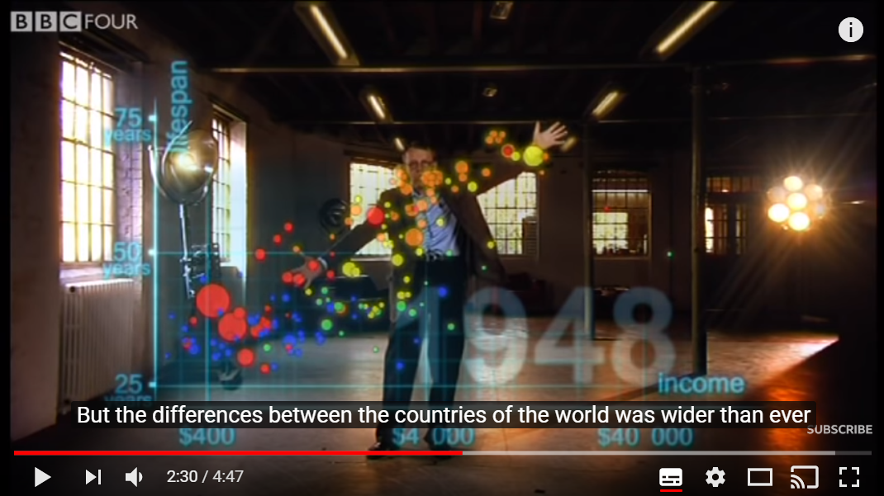

1. frame: Differences wider than ever (source: Youtube-video)

Interpretations:

* there is n doubt: the differences are “wider”
* the other part of the declaration is “than ever” – what can not be derive from the frame Nr. 2 and
* it is also critical based on frame Nr.1 and Nr.2 – why?
  + “ever” should mean in case of this animation: the years from 1810 to 1948
  + we should see 139 frames
  + and even based on these 139 frames, it is not trivial to speak about the consequence “ever”
  + because we need a kind of an ever-ness-index (system-integrity-index) where variables are
    - not only the X-axis-oriented differences between the county extreme left based on the X axis and the country extreme right based on the X axis year by year
    - but the sum of differences from the average of the world income (weighted through the amount of the country’s population – of course) too
    - because one single country with the support of the Martians / Aliens could cause year by year unlimited differences
    - contrary to the standard deviation which is not really voluminous
    - (and please, do not forget: where is China in the frame?)
    - the average of the world’s income per capita and its changes are also factors for the building of an ever-ness-index because the wideness can be seen in a relative way compared to the general chances to produce extreme values – and in case of less/decreased world-average, the same absolute wideness-value let assume a higher ever-ness-index-value…
  + the “wider than ever” declaration can not be interpreted alone – the human brain expects little rules: e.g. the wider (is the absolute difference)- the more instable (is the systems)? The system-integrity-index is therefore a kind of complex interpretation frame where the maximum value of the absolute wideness is just a data for a given year, but the real message is hidden in the little rule: the wider are the most extreme point in the chart, the more instable will become the system as such…
    - the real meaning of an adjective (like wider than ever before) can only be interpreted in a correct way in case of extreme system constellations – the question is in general: When a system is the most intact? – assumed, that the absolute difference and the average of all countries are always the same:
      * extreme situation Nr.1: just one single (let alone: a little) country is drifted away
      * extreme situation Nr.2: two little countries are wide from each other and the further (the rel. big) ones are in the middle position
      * extreme situation Nr.3: just one single (but: a big) country is drifted away
      * extreme situation Nr.4: two big countries are wide from each other and the further (rel. little) ones are in the middle position
      * extreme situation Nr.5: the one half of the countries is wide from the other half of the countries
      * extreme situation Nr.6: countries are randomized
      * the big countries are wide from the little ones
      * …
    - the above listed 7 scenarios should be proved again
      * in case of a lower average value for all countries as before
      * in case of a higher average value for all countries as before
      * and/or in case of different absolute differences between the two extreme countries
  + these and (arbitrary other) scenarios should be evaluated from point of view of the system-integrity:
    - could each scenario have the same integrity-index?
    - how should be created this kind of (aggregated) index based on standard deviations, averages, little and big subsets, etc.?
      * this evaluation should be made year by year
      * the calculated integrity-index should be involved into a chart about the time series
      * the time series will have a kind of
        + trend
        + standard deviation
        + a max-min-difference, etc.
    - all these effects are visible for human eyes and brains in the animation as such
      * but a lot of meanings can not be interpreted from one point of view (see Pendulum-effect)
      * one single point of view leads mostly to irrational conclusions
      * new point of views can support the more holistic interpretations…

## 3. scenario

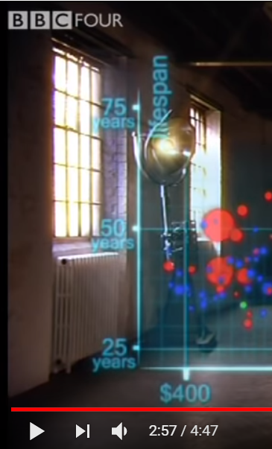 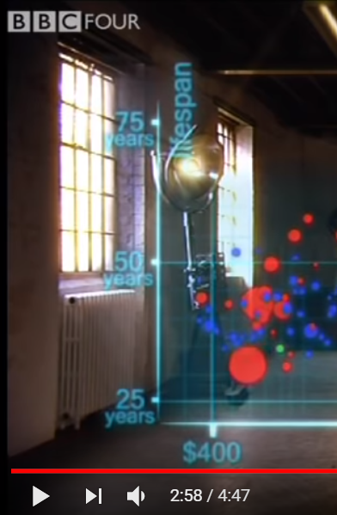 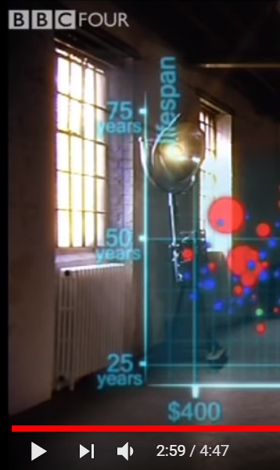

1. frame(s): China: 1957 – 1960 – 1964 (source: Youtube video)

Interpretations/control questions:

* How was it possible for the biggest country (for China)
  + to realize a ca. 20 years decreasing concerning the (average?) life expectancy within ca. 3 years (c.f. 50-30=20) and how it was possible
  + to realize a ca. 25 years increasing within the next ca. 4 years (c.f. 55-30=25) based on population dynamical rules and effects?
* An increasing about 5 years of the life expectancy in China could be realized within 7 years (1957🡪1964)
  + it is more realistic in a continuous way?
  + or it is more realistic with a huge decreasing effect ca. in the middle of this time period?
* In general:
  + How should the life expectancy as such be calculated in detail?
  + How many people among e.g. Students are competent enough to answer the above-mentioned questions with detailed numeric examples/derivations?
  + Without appropriate previous information about the whole phenomenon, what kind of associations might be derived in the human brains at all?

### 4. scenario

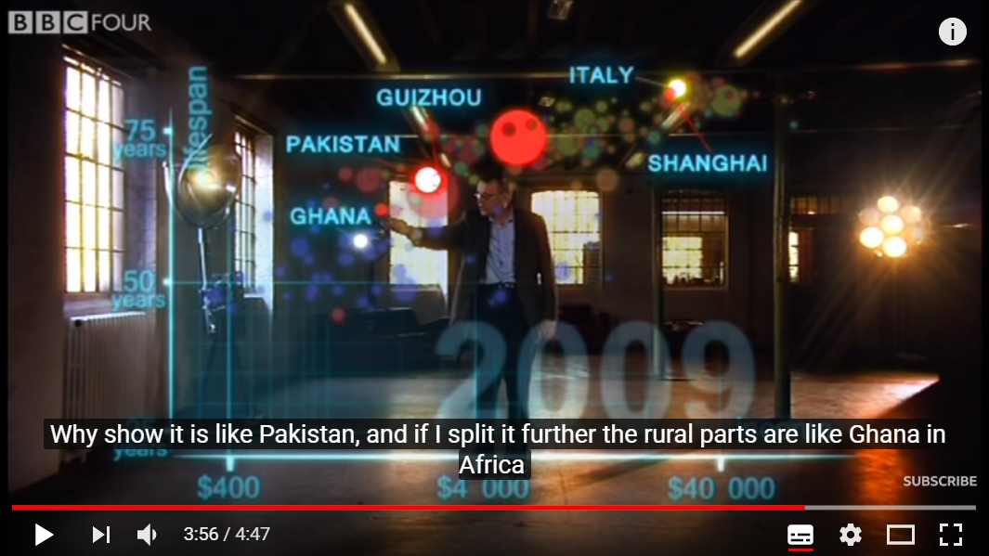

1. frame: China’s parts and their position (source: Youtube video)

Interpretations/questions:

* Whether we will have other associations based on the animation, if the bubbles have quasi the same volume? (it means instead of big countries their parts will be presented – c.f. scenario Nr. 2 about the integrity-index)
* What is happened in China (described through detailed numbers) between 1964 and 2009 (45 years) being able to realize an increasing of the life expectancy of 20 years (75-55=20 years)?

### 5. scenario

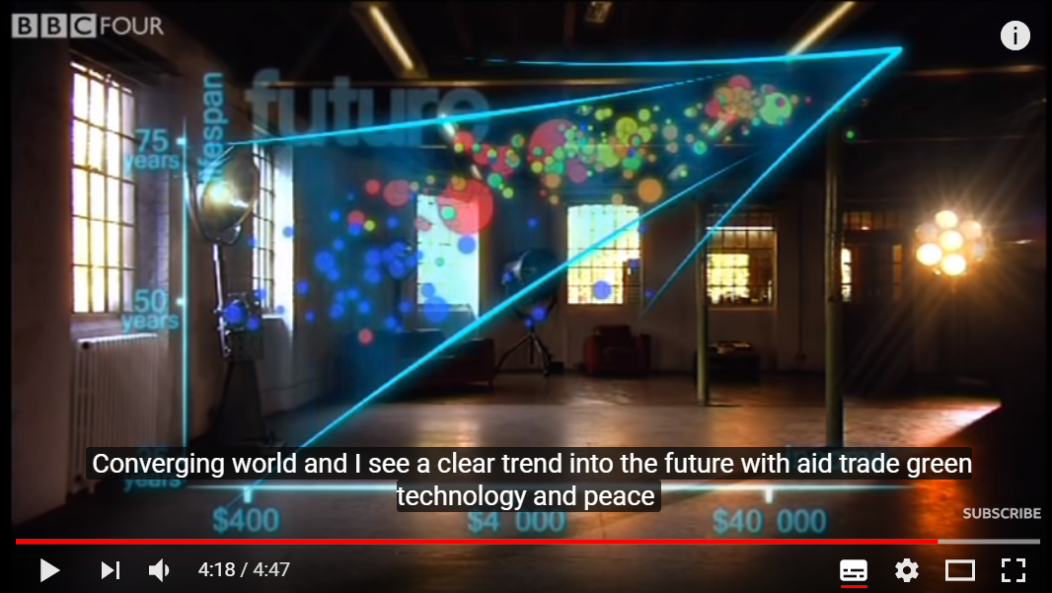

1. frame: Converging - but to what exactly? (source: Youtube video)

Interpretations:

* based on the recent approximations, the human life seems to have a genetic potential – what means: each country can/should/may/will reach the same life expectancy sooner or later, there fore the converging effect compared to the Y axis is just seemingly existing – nobody can produce divergences towards unlimited life time
* based on the X-axis, there is probably no converging effect to see, what means: the richer countries would like to have the same relative position compared to the rest of the world
* Kazohinia (see offer in the diary: <https://miau.my-x.hu/mediawiki/index.php/QuILT-IK045-Diary#2._Day_.282019.II.20..29>) projects a future of the rational ratios, but
  + will have every country the same X and Y value in the future?
  + should they really have them?
  + or rational ratios mean something other – like every country (human being) can have the same general (social value) index based on each attribute of them?
* in general:
  + do we have any clear conclusion after the animations?
  + or rather we have a lot new questions and/or tasks to see the details more precise?

# Annexes

## Google Spreadsheets – with GoogleTranslate()

### With absolute parameters for languages

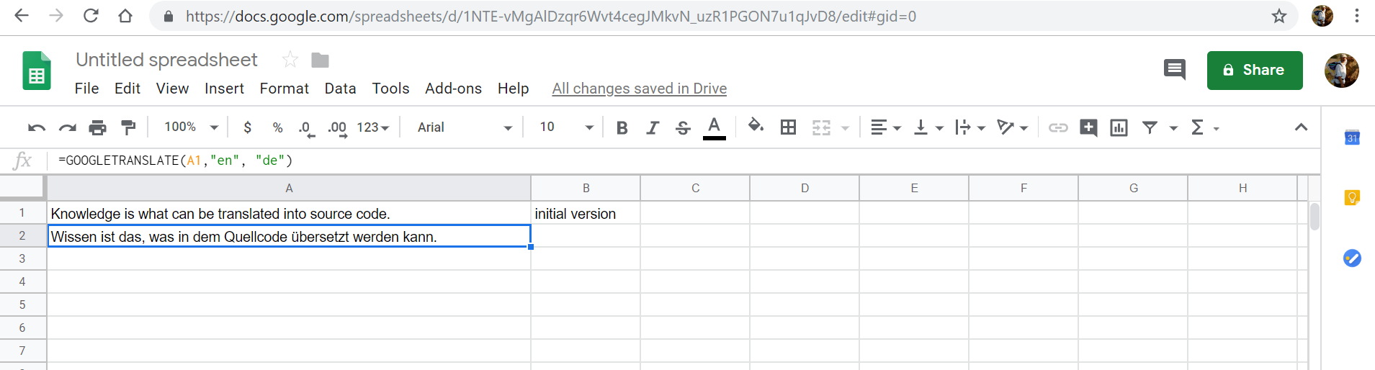

### With relative parameters for languages

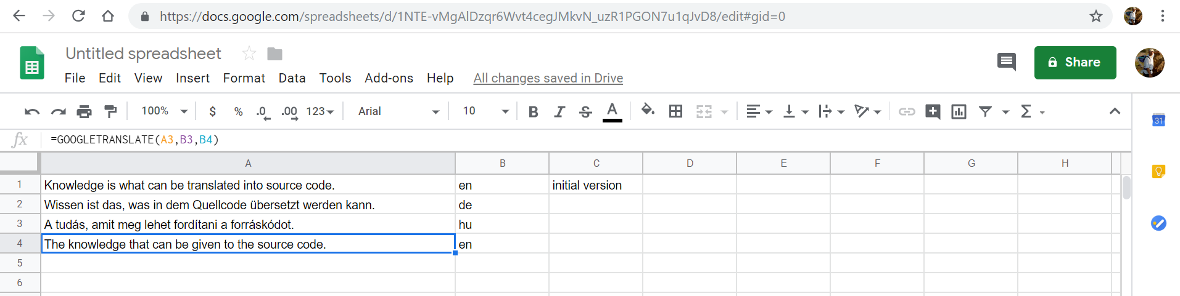

### Text mining possibilities

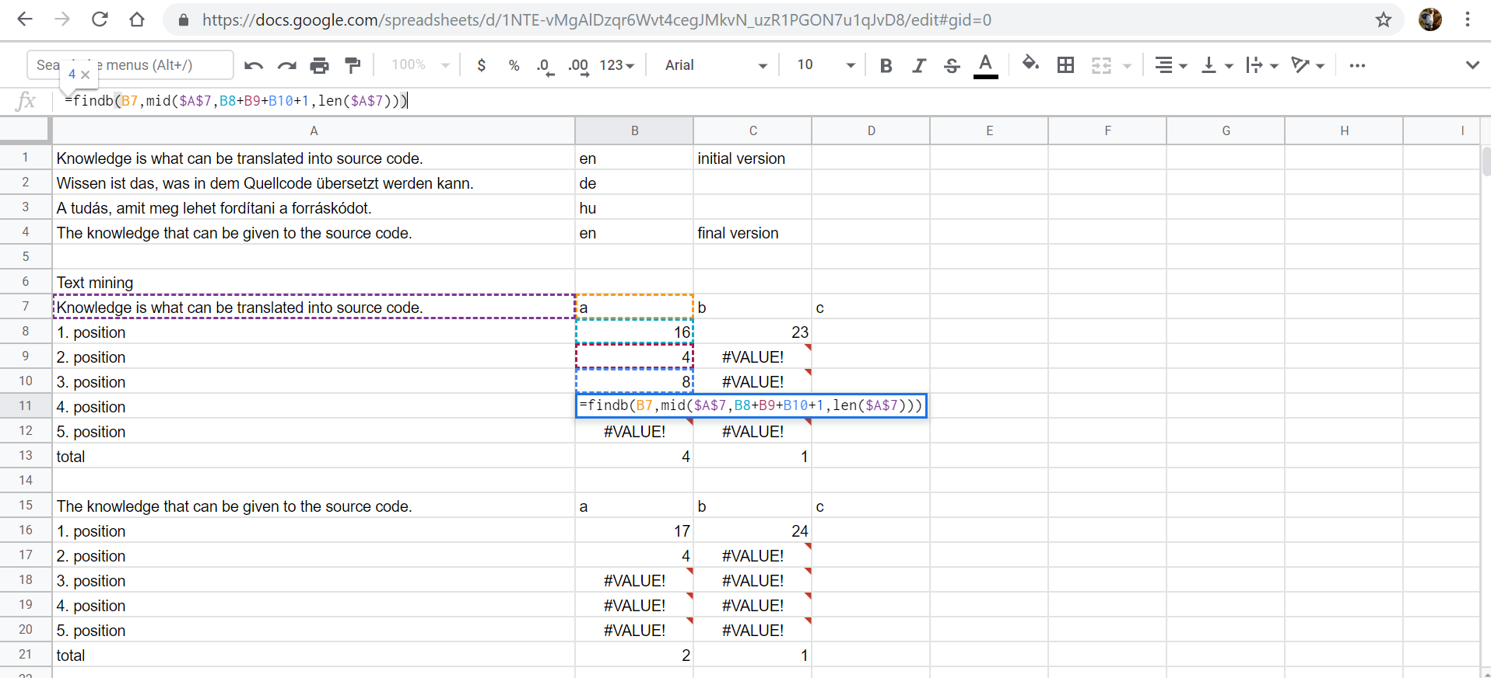

Statistics being delivered through text mining calculations can be used for similarity analyses…

### Help

# **GOOGLETRANSLATE**

Translates text from one language into another.

### **Sample Usage**

GOOGLETRANSLATE("Hello World","en","es")

GOOGLETRANSLATE(A2,B2,C2)

GOOGLETRANSLATE(A2)

### **Syntax**

GOOGLETRANSLATE(text, [source_language, target_language])

* text - The text to translate.
  + The value for text must either be enclosed in quotation marks or be a reference to a cell containing the appropriate text.
* source_language - **[** OPTIONAL - "auto" by default **]** - The two-letter language code of the source language, e.g. "en" for English or "ko" for Korean, or "auto" to auto-detect the language.
  + If source_language is omitted, target_language must also be omitted.
* target_language - **[** OPTIONAL - system language by default **]** - The two-letter language code of the target language, e.g. "en" for English or "ja" for Japanese.

### **See Also**

[DETECTLANGUAGE](https://www.google.com/docs/answer/3093278): Identifies the language used in text within the specified range.

### **Examples**

Translates text in the specified range from the source language into the target language.