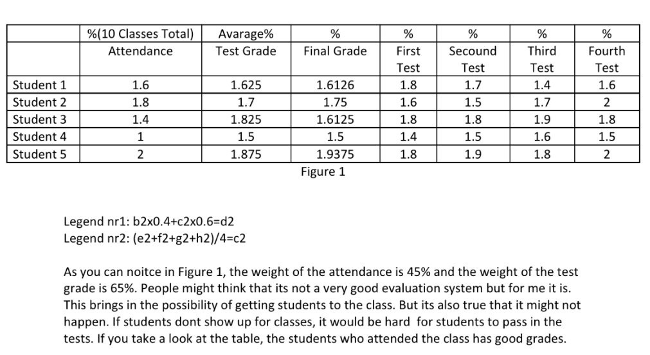

Needed details for a publication:

* Detailed definitions incl. how to measure the particular attribute
* Detailed/visible identification in the figure (b,c,d,e,f,g,h)
* Argumentation for weights (e.g. weights 45+55 or 50+50 or 40+60 🡨why not? what is the optimum? how can be derived a kind of optimum weighting?)
* Title and source for each figure
* Row-headers can not be blank
* Where can we see the test whether each Student can have the same final grade based on the row evaluations?
* Visualisation-support: e.g. coloured cell for raw evaluations (like test nr1-2-3-4)
* Introduction: why it is relevant to analyse education processes in frame of the particular course?
* self-critiques?
* alternative solutions?
* comparing of alternatives?
* (potential visualisation problem: the number of digits must be optimized)
* The lack of presence (attendance-series) can not be evaluated more complex? What kind of layers can be defined for the evaluation of the time-series behind of the attendance?
* …