Modelling Valued Customers Retention in Hotel Industry

Author: Do Ngoc Diep, Li JiaLun and Nguyen Ngoc Quynh Nhu.

Kodolanyi Janos University - Advanced Service and Design Management

7 May 2019

Abstract: The aim of this paper is to demonstrate how to manage the valued customers retention in hotel industry based on simulating the random data and creating simple figures such as descriptive and decision-oriented problems. We analyze this topic through different variables: employee quality, service quality, sanitation, marketing, management, membership and the satisfaction of customers. According to these variables, it can be understood how it works for managing the valued customers retention in hotel industry based classic statistical approaches and online similarity analyses. Through listing dependent variables, it can be known about what customers expect in hotel industry their attention on products and services then hotel could make strategies its service. The paper shows the risks of the different approaches too.

Keyword: valued customers, retention, random data, service, management, satisfaction.

Introduction:

The article will consist of 3 main parts namely

- The steps of data processing

- Decision-oriented interpretations

- Analysis of one specific case.

To increase the customer satisfaction in the hotel industry, 6 independent variables should be evaluated, which are:

- Service quality

- Employee quality

- Sanitation

- Marketing program

- Membership program

- Management

From that point, the dependent variables of customer satisfaction lead to the customer retention would be measured. The table below present the primary approach to the main topic:
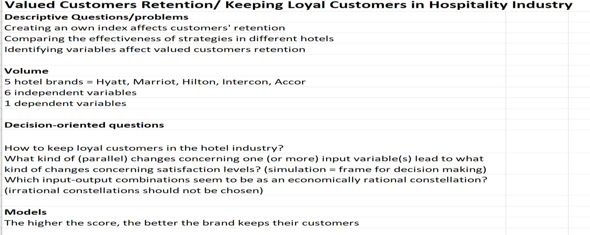

Figure 1: Descriptive and decision-oriented problems for a set of available data (source: own presentation)

The general background excel sheet could be found in: https://miau.my-x.hu/miau/quilt/article%20(1).xlsx

In the data processing part, the Likert model (delivering subjective estimations) would be used for measuring the 6 independent factors in 5 hotel brands worldwide. The final dependent factor of customer satisfaction would be presented after that. The most important factor and the hotel having the best plan for keeping valued customer would be identified. In addition, it would play a significant role to answer the question “How to keep loyal customers in the hotel industry?”, which aspects need to take more into consideration. For one specific hotel, it will help them acknowledge their strength and weakness to improve so as to achieve the goal.

Questions of the paper are:
- What is the most relevant/important independent variable?
- What is the best hotel?

Steps of Data-processing

This chapter includes

- the research designs

- research model

- tested variable

- (dependent and independent)

- hypothesis

- population

- questionnaire reliability

- data gathering procedure

- statistical analysis method and

- the response rate all these things are discussed in this chapter

Sample size

The sampling techniques, which are used in the collection of the data that is non-probability sampling techniques. Non-probability sampling was applied because the customer was not common we select answer from every customer which comes in this hotel. For this reason, we distributed one hundred and forty (140) questions in 5 hotels. Twenty (20) questions were filling up from all 5 hotels.

Annex:

List of 140 questions

List of 20 questions

Statistical tool

In this study both, the primary and secondary data are used. The primary data are collected in a form of questionnaire. A Likert scale was designed with options from strongly agree to strongly disagree, whereas 1 refers to strongly disagree, 2 for disagree, 3 for neither agree nor disagree, 4 for agree and 5 for strongly agree. For analysis of statistical tools, we used Excel Toolpak. The Excel Toolpak is a statistical package for social science software. We applied the frequencies, decision-oriented statistic, reliability test, as well as regression and correlation.

Annex: questionnaire

Annex: answers = database

Theoretical framework

The theoretical framework for the research is that the customer retention in the hotel industry is the dependent variable.

The independent variable of that factor which attract the customer retention in the hotel industry, which are show in the following services: employee quality, service quality, marketing (brand image), sanitation, membership program and management.

The similarity analyses (https://miau.my-x.hu/myx-free/coco/index.html) should be involved in order to ensure a kind of consolidation of the impact of potential different guests in the different hotels. Parallel, similarity analyses can deliver production functions being capable to describe relationships between input variables and the dependent variable.

Data analysis
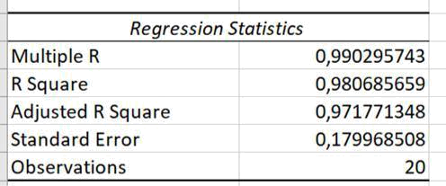

Figure 2: Regression Statistics (source: own presentation)

The R value of 5 hotel is averagely over .9 which means that the independent variables

- 90% correlated with dependent variable. The R² value is averagely .96, this means that independent variables will explain 96% the dependent variable. The adjusted R2 value is .94 in average.

It is possible, that the opinions of customers about the independent variables are quasi totally independent from the dependent variable (general satisfaction) because the limited amount of the dependent variables are not the direct causes of the low-level satisfaction or vice versa: the services can have a very low level but (therefore the hotel has always free capacities what is very important for some travelers having troubles with scheduling.

Satisfaction with the service levels is just one reason to generate customer retention. Price-performance ratio could be analyzed or the chance for free places/capacities could also be a kind of reason parallel to a low-level satisfaction.
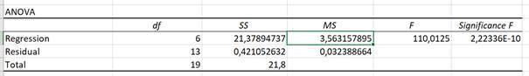

Figure 3: ANOVA (source: own presentation)

The f-values 281, 110, 107, 23.6, 26.7 are greater than mean value 5.9, 3.5, 5.1, 0.6, 3.5 respectively and the p-values are 0.000 which shows the statistical model is 99%.
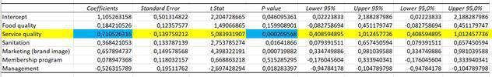

Figure 4: Coefficients of dependent variables (source: own presentation)

The independent variable service quality beta value is .71 (highest), meaning that the independent variable service quality explains 71% of dependent customer retention. The p-value is .000, which shows significant association of service quality with customer retention. The other variables are as being illustrated in the table.
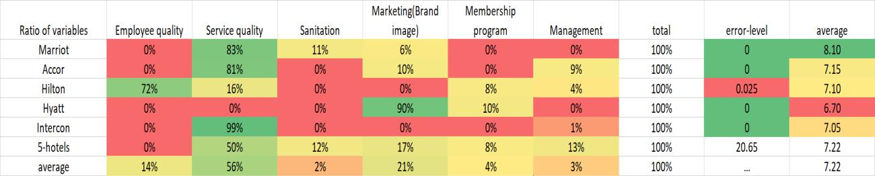

Figure 5: Ratio of the independent variables compared to the dependent variables based on simulator-results for each single hotel (source: own presentation)

Legends:

- The percentual values could be derived from the staircase functions about the relationships between the independent and the dependent variables (see background XLS).

- Total = 100 % means: the dependent variable could be derived in general based on the independent variables.

- Error-level: The customers of Hilton are more inconsequent than the other customers of the other hotels because the dependent variable could not be derived customer by customer without any errors.

- Average: The average satisfaction for the given hotel

- 5-hotels: Each (100) observation about the 5 hotels integrated into a holistic simulator

- average: average of the 5 hotels
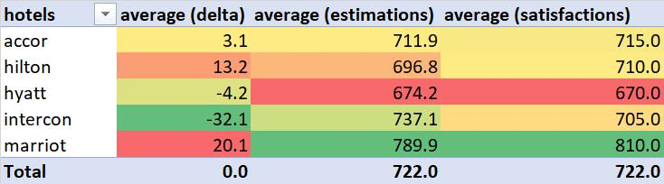

Figure 6: Results based on all (100) observations in an integrated simulation model (source: own presentation)

Legends:

- Marriot seems to be over-evaluated by its customers (8.10 > 7.89)

- Intercon seems to be under-evaluated by its customers (7.05 < 7.37)

- Hyatt seems to be under-evaluated by its customers (6.70 < 6.74)

- Hilton seems to be over-evaluated by its customers (7.10 > 6.96)

- Accor seems to be over-evaluated by its customers (7.15 > 7.11)

- (Model-correlation: 0.92)

Intercon (7.37) seems to be a better hotel than Accor and Hilton based on the consolidated estimations compared to the (totally subjective, directly observed) satisfaction-values of the customers. Marriot is the best – although a kind of over-estimation effect can be detected. Hyatt is the last in the ranking – although a kind of under-estimation can also be detected – but the consolidation could not have any impact to the ranking as such.
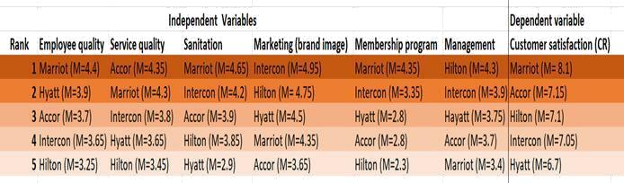

Figure 7: Likert Score of variables among 5 hotels (source: own presentation)

Hypothesis proposed that there are differences in services (variables) offered by 5 hotels and of which the focus was put on the service quality sector. Tables above presented that Marriot gained the highest score in customer satisfaction of 8.1 and

simultaneously it possessed the second greatest score in service quality of 4.3. Further analysis of the means shows that since higher the services score better the perception of services. In this line, the results show that services provided by Marriot better than hotel 3,4 and 5. Or the customers in Marriot are less critical and/or the critiques will be signalized through higher subjective values on the Likert-scales…

On the other hand, in general, score of variables of Accor Hotel is lower than those of other 4 hotels. However, hotel 2 service quality score is the highest which hugely contributes to the its total score of 7.15, which ranks as second position. To recapitulate, service quality is a crucial determinant in deciding level of customer retention within hotel industry, as being indicated through the research.

Further data can be found in the link https://1drv.ms/x/s!AljLTKXmPRHKiiXPI1dd6Vm6D2da

Decision-oriented interpretation

According to the statistic of figure 5 analyzed above, the service quality is believed to be the most impactful dependent variables on making the customer satisfied, which results in the customer retention. The service the brands deliver to customer is a key to make them feel satisfied. They would feel that the amount of money they spend is worth what they receive and what they expect or even beyond their expectation. It would greatly influence the customer’s assumption on the brand image. Secondly, in terms of the employee quality, they are the one who would directly involve in the customer journey in the hotel through several ways. Their polite and professional attitude, knowledge, needed skills and ability to deal with guest is essential in the process of making them come back next time. The founder of Marriott International said that:” Taking care of your employees first, and they will take care of your customer”. The third factor to be noted is the sanitation, and it is important more than ever especially in the hotel industry. Sanitation is considered to make the first impression on the guests about that hotel. No one would like to check in or sleep in the hotel has full of trash, insects or unpleasant smell. Another variable to be mentioned is the marketing program. It is necessary to have the appropriate, suitable and attractive marketing program designed for the target group to make them comeback. Acquiring a new customer can cost five times more than retaining an existing customer. Furthermore, the likely chance to reach the existing customer is 30% higher than successfully marketing to the new one. Next, creating the membership program for the loyal valued customer is one of the great ways to attract them to comeback. They could accumulate score or miles when they use the service, the higher the score they earn, the better treat they would get from the brand. Hotel brands nowadays also connect with other companies in other industries such as aviation, food and beverage with an attempt to create one unique “ecosystem” for

customer. Subsequently, the way of management in general – technological or R&D aspect would also have to gain the customer retention.

With regards to figure 6, the ratio of the quality is 56%, which is the highest compared to the others independent variables. Thus, quality service contributes the most to process of customer retention. Respectively, the marketing - brand image (21%), employee quality variable (14%), membership program (4%) and management (3%) follow next. And the sanitation variable accounts for 2%, which is the lowest, it proves that the sanitation variable contributes the least when it comes to customer satisfaction.

The 6 independent actors discussed above all contribute and lead to the customer satisfaction – which is also the most crucial factor to keep loyal valued customer as the data provided in part 2. It is believed as the foundation for every business’ success. However, customer satisfaction isn’t the same thing as customer loyalty. Customer loyalty can be a result of customer satisfaction, but only along with a lot of other factors above. Marriott International tops the chart with the score of 8.1 when measuring all variables. It is greatly because the high-quality service, employee quality and amazing membership program contribute to the customer satisfaction.

Case

Hotel Memories Budapest

It is a hotel in Budapest which is located at central area. According to the comments from customers, this hotel offers good services like free Internet, airport pick-up and safe and it has ability to make correct strategies to keep the valued customers retention. It also has a good reputation due to its good services so that many customers express that if they will go back to Budapest again, they will choose this hotel again.

There are some data which can help us to demonstrate why this hotel can receive massive good comment. (The rank of these data is from 1 to 5)

- Employee quality: 4

- Service quality: 3

- Sanitation: 5

- Marketing: 5

- Management: 4

- Membership: 3

- Satisfaction of customers: 5

Most of these data are above average, but some of them are high like sanitation and marketing which got 5 and employee quality and management which got 4.

There are some comments from customers. For example, “Nice hotel situated in heart

of city. You can walk almost everywhere on foot. Although check-in time is scheduled

for 2:30pm, but the lady made us prior check-in.” According to this comment, it is easily to analyze the situation of marketing and employee quality in this hotel. A good location can help a hotel to enlarge the markets, especially if it is located at city center, it can attract a lot of tourists. In any industry, marketing is a vital issue and it plays an important role to make business bigger. Employee quality should be considered into an internal factor of enterprises and it is a long-term issue to figure out. It requires an excellent selection mechanism and training mechanism to ensure that the quality of employee can be good. In this case, it is obvious that the employee of this hotel put customers first and facilitate customers to make them prior check-in. Customers will be impressed by these good qualities of employees, by contrast, hotel will also get a good satisfaction index.

From the index of this case, it does not mean that these factors (employee quality, sanitation, marketing, management and satisfaction of customers) are more important than others, they are more like prerequisites. Food quality and membership can also not be ignored in hotel industry. In a sense, they are connected strongly, if a hotel lacks the ability to provide a particular service, customers will reduce their desire to consume and choose the services from another hotel.

Conclusion

This article demonstrated six variables which are employee quality, service quality, sanitation, management, marketing and membership, through presenting simple modeling steps, searching for necessary data, finding out the main issue from nowadays that hotel could face and solving these problems. It is evident that these non-measurable variables can influence the retention of customers and promoting the competitiveness of hotels. All of these variables aim for managing the valued customers retention in hotel industry.

For hotel itself, it needs to pay attention to all aspects of whichever internal construction and external construction. It means hotel needs to keep a big picture of how it can run its business more reasonably, but from the case, it is founded that customer satisfaction is the ultimate goal of a hotel to be taken into consideration because all the measures that the hotel tries to achieve are for improving customer satisfaction.

References
see in the text

