Review of gross domestic product (GDP) of Russia 2011-2018.
Daniil Voronov Neptune code - N8WWNF
daniil98voronov@gmail.com

Demo:
https://miau.my-x.hu/miau/quilt/GDP_final_en.doc
https://miau.my-x.hu/miau/quilt/gdp_en.xls

Basic remark: It is necessary to have an XLS-file with all used data!

One of the key indicators of the country's progress within the macroeconomics is called the gross domestic product. It reflects the size of the value produced within the country for the consumption of products and services for the annual period of all economic sectors of the country. It consolidates the entire range of products produced, regardless of the ownership of production factors of a national nature involved in the production process, both for use within the country and for export purposes, accumulation. Introduced this term for the first time by S. Kuznets in 1934
Russia's GDP is expressed in rubles, and is translated into foreign currency at the exchange rate in force at the settlement period. For the refined version in the international comparative characteristics the system of purchasing power parities – PPP is used.
GDP at purchasing power parity
2003-2011: Russia developed faster than most countries
For the most obvious comparison is not to use the assessment of international organizations such as the world Bank or the IMF, and not the domestic Rosstat - and CIA estimates (CIA data. The World Factbook https://www.cia.gov/library/publications/the-world-factbook/rankorder/2001rank.html).
GDP at purchasing power parity is taken as the main comparative indicator of countries.
In this case GDP is used as the basis of comparison, not GNP (gross national product), as it allows to clear the comparison from the influence of export-import balance. In the Russian case, it is hugely positive - due to the export of energy resources, and will significantly affect the value and position of the country.
This is followed by a comparison of GDP, not GNP, as this clears the comparison from the influence of "free oil" as much as possible. In this case, the winner will be countries with a negative trade balance, such as Turkey, USA, Latvia or Greece, and countries such as Russia, Norway, Germany or China - to lose, well, okay. It should also be mentioned that the CIA comparison - the toughest to the position of the Russian Federation in the world (you can see here).
Importantly:
a) this comparison is made with the absolute value of the economies of the world, and not with the relative (per capita),
b) GDP is calculated on the basis of purchasing power parity rather than a simple mathematical conversion of the current exchange rates of the countries of the world. This is done to improve the objectivity of the assessment. Explanations are given on the website of the CIA, and the Network has a detailed explanation of why a simple conversion rate has long been actually not used for comparison, as not correct.
The period is taken from 2003 to 2011 - eight years, during which there were quite significant world events. First of all, it is the global economic crisis of 2008-2009, as well as a chain of "color revolutions", which greatly influenced the post-Soviet space and the development of the former Soviet republics.
There are two groups of columns in the table - for 2003 and 2011, and in each group there are 4 columns.
Column 1 - shows the country's place in the world for this year. The world (whole world) and European Union (EU) gauges, which are not country-specific but have been numbered in the common table, have been removed from the original CIA table. Left only the countries of the world.
Column 2 - country. Countries are taken only those that are significant for the study from the standpoint of Russia:
- the first twenty countries of the world - as a whole
- all the republics of the former USSR as a whole
- some countries interesting for General comparison (Poland, Israel, Turkey, Cuba, etc.)
Column 3 - the value of the GNP at PPP are taken from the respective annual section of the CIA website. The World Factbook. All data is easily verifiable. URL = ??? Dimension/unit = USD or USD/capita?
https://www.google.com/search?q=gdp+of+russia+per+capita
Data should be compared based on a relative basis like gdp/capita…
Column 4 - Weight of the economy of a particular country relative to Russia, as a percentage. Russia is taken for 100%, and the GDP of other countries is recalculated as % of its GDP - and for 2003, and for 2011. From this column you can clearly see - whether the size of the economy of a particular country relative to Russia has increased or decreased.
You can look at the indicator and Vice versa - whether Russia is catching up with a particular country, or behind it, for the considered 8-year anniversary? If the percentage in the column fell - catching up, if increased - behind. In addition, here you can clearly assess the relative weight of the countries in comparison with Russia. For example, Poland in 2011 is a third of the Russian economy (32.2%).
Column 5 (left column groups) - shows the color of who is rolling where and in what direction. White - remained in place in the world table of ranks, orange - rolling down, green - rises. Champions rise and fall are marked by more intense color.
Comparison of the world's GDP (PPP) with the indication of the size of the economy relative to Russia
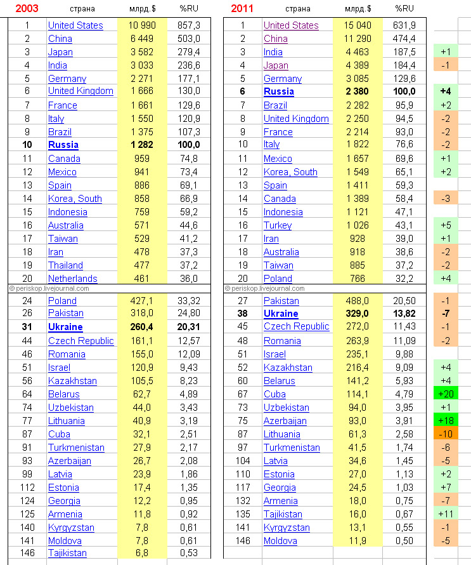
It is necessary to have column-header for each column like the column on the right side: e.g. change of ranking position?!
Time-„series”: 2003 and 2011

2011: + 4,3%
In 2011, Russia's GDP increased by 4.3 percent.
Russia's GDP grew by 3.9% in the first half of 2011 and is expected to grow by 4.5% in the second half. This was reported by the Minister of economic development Elvira Nabiullina at a meeting of the Presidium of the government.
In turn, Deputy Minister Andrei Klepach added that in the 2nd quarter, the pace of economic growth slowed slightly compared to the 1st quarter. If in the 1st quarter GDP grew by 4.1% compared to the same period of 2010, in the 2nd quarter growth is estimated at 3.7%. "June continued the trend towards fairly sustainable economic growth," the Deputy Minister said. Taking into account the seasonal factor, according to the Ministry, the country's economy in June showed an increase of 0.3%, while in may this figure was 0.4% compared to the previous month.
Despite the increase in the pace of development associated with the increase in oil and gas prices, the state of the Russian economy remains disappointing, according to Ernst & young (October 4, 2011). Reaching 4.5% in the fourth quarter of 2010, GDP growth fell year-on-year to 4.1% in the first quarter and 3.4% in the second quarter of 2011. Data with seasonal adjustments are not yet ready, but analysts suggest that quarterly growth decreased in the second quarter to 0.4%, which is much lower than usual indicators. This result does not meet the expectations based on quite encouraging indicators of industrial production and retail sales. Of course, the weakening of the economy was affected by the deterioration of the situation in the Eurozone, where the pace of development fell sharply due to widespread fears of a public debt crisis. Market sentiment deteriorated significantly, leading to a flight of investors into highly reliable assets. In Russia, this trend was manifested in a sharp increase in sales on local stock exchanges and the fall of the ruble by 5.8% to the dual currency basket. The slowdown in the global economy and the unwillingness of investors to take risks pose a major threat to Russia because of their impact on oil prices, despite the fact that up to now these prices have been determined by the volume of demand.
However, Russia can still count on economic growth, Ernst & young said. Inflation is slowing, which in turn leads to an increase in real wages and keeps interest rates, and in the budget adopted in September 2011, in the short term planned additional costs and wage increases. After the first half of the year, which did not bring the expected results, the projected GDP growth in 2011 was reduced to 3.8%. Despite this, the indicators should again grow closer to 2012 as a result of the growth of consumer demand.
2012: +3,4%
At the end of 2012, the Russian economy grew by 3.4 percent, but the main growth was at the beginning of the year. GDP growth has been declining since the second half of 2012.
In November 2012, according to the Ministry's forecast, in the fourth quarter GDP is expected to grow at an annual rate of 2.6-2.7 percent, and growth for the entire year will be 3.5 percent. The same assessment is given by the world Bank, which also predicts a slight acceleration in growth (up to 3.6 percent) at the end of 2013.
VTB Capital provided the following forecast of economic indicators until 2016:
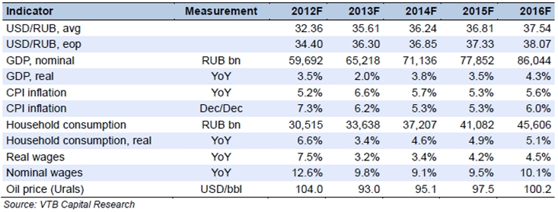
Figure Nr? Title? Legend? Country?
Time series: 2012-2016
URL=?
The report of the organization notes that the assessment of economic growth for the current year has been changed against the background of higher oil prices and some discharge of the debt crisis in the Eurozone.
The OECD associates the main risks of economic growth slowdown in Russia with the deterioration of the situation in the global economy, which can provoke a drop in world oil prices and an acceleration of capital outflow from the country.

The international monetary Fund (IMF) also recently raised its forecast for economic growth in Russia in 2012, predicting the acceleration of GDP growth from 3.3% to 4%. The main reason for this jump, IMF experts called the continuing high oil prices.
At the same time, the Ministry of economic development (MAYOR) of Russia lowered the forecast for GDP growth in 2012. from 3.7% to 3.4%. Then head the MAYOR Elvira Nabiullina noted that the Outlook revision resulted from a revaluation of the base and additional GDP growth in 2011, which was not expected.
Report of Experian Agency "Russian Economy: results and forecasts (2011-2015)"(https://drive.google.com/file/d/0BzQy9ZwUn-JeOTk2NGRiNDAtYzc5NC00YjZmLTlmMmYtMGVkZDM3YWJlNDY4/view)
The growth of the Russian economy in the first nine months of 2012 was 3.9 percent compared to the same period of the previous year (Rosstat). Rosstat data were slightly higher than the estimate of the Ministry of economic development, which considered GDP growth at 3.8 percent in January-September.
In the third quarter, Russia's GDP grew by 2.9 percent, while the rise in the first three months was 4.9 percent, and in the second quarter it slowed to 4 percent.
The year-on-year slowdown is largely due to the higher base in the second half of 2011. In the third quarter of 2011, GDP grew by 5 percent, while in the second - only 3.4 percent. With a high base as the main reason for the slowdown, Deputy Minister of economic development Andrei Klepach agreed earlier.
In October, the Ministry of economic development said that only with GDP growth of 4-4.5 percent per year will be able to balance the social obligations of Russia and its defense spending with resource capabilities.
Russia's GDP grew by 4 percent year-on-year in the second quarter of 2012. This was reported in the official press release of Rosstat, which provides a preliminary assessment of the dynamics of the country's GDP. According to Interfax, based on quarterly data, the semi-annual GDP growth can be estimated at 4.4-4.5 percent.
Rosstat data almost coincided with the assessment of the Ministry of economic development, which in mid-July 2012 estimated the increase in GDP in the second quarter of 3.9 percent. According to the Ministry, the country's economy rose by 4.9 percent in the first quarter and by about 4.4 percent in January-July.
In July, Russian Minister of economic development Andrei Belousov said that the forecast for economic growth for 2012 could be increased from 3.4 to 3.8-4 percent. It is expected that the revised forecast will be prepared by the Ministry of economic development by the end of August 2012.
At the end of April 2012. Dmitry Medvedev, as President of Russia, expressed his wish to increase the growth rate of the economy. "The GDP growth rate of 4% is not bad for the United States, we would have 6 or 7%, as in China and India," Dmitry Medvedev said.
In the first quarter of 2012, GDP growth compared to the previous year was 4% (the initial figure of 4.9% after the revision was significantly lower). Thus, the quarterly growth adjusted for seasonality was only 0.1%.
Ernst&Young (June 2012): the country's economy was Probably positively affected by additional fiscal stimulus measures in the first quarter, which significantly increased the salaries of civil servants. At the same time, the sharp increase in the purchasing power of the population may be associated with an artificial drop in inflation as a result of restraining the growth of tariffs for housing and communal services, which are usually revised in January. In 2012, however, due to the presidential elections held in March, the revision of tariffs was postponed until July.
The problems of the Eurozone will continue to have a negative impact on the development of the Russian economy throughout 2012, provoking a slowdown in export activity, as well as a decline in foreign direct investment and other sources of capital inflows. The situation will be exacerbated by the recent fall in oil prices, which are projected to fall by an average of 5% in 2012. In March and April, the growth of industrial production slowed, and the fall in global demand has a negative impact on business activity in sectors of the economy more exposed to external risks.
The main factors of economic growth are the strengthening of domestic demand, measures of state support in the field of fiscal stimulus, further reduction of the unemployment rate, which in may 2012 reached its minimum value of 5.4% in the last four years. However, at present there is a sharp tightening of fiscal policy, which to some extent levels the continuing strengthening of domestic demand.
According to Rosstat, Russia's GDP grew by 4.9% in the first quarter of 2012 compared to January-March 2011. This is the highest figure among the G8 countries. For comparison, in Germany during the same period, GDP grew by only 1.2%, in the US - by 2.1%, and in Italy and all decreased by 1.3%. However, the economies of China and India grew faster than the Russian economy, adding 8.1% and 6.5%, respectively (http://top.rbc.ru/economics/22/05/2012/651488.shtml).
2013: +1,3%
According to Rosstat, the nominal volume of Russian GDP in 2013 amounted to 66.7 trillion rubles, its real growth — 1.3%.
According to the structure of GDP consumption, the main driver remained final consumption expenditures — they provided the economy with growth of 2.3 percentage points out of 1.3%, and a little more than completely — at the expense of households, since the contribution of public administration expenditures was negative. A year earlier, household consumption provided the economy with 3.3 p. p. of 3.4% growth, but in 2013 the growth rate of population consumption slowed by 1.7 times.
Reduced investment wiclo from GDP growth of 0.8 percentage points, net exports — another 0.2 percentage points, considered Nikolay Kondrashov of the development Center of the HSE. The share of gross savings in GDP for the year decreased from 24.3 to 23.1%, and the share of consumption exceeded 71% (including households — 51.4%).
In the structure of GDP production there was a total slowdown in the growth of gross value added in all sectors — with the exception of agriculture, which compensated for the decline of the year before, and the sphere of public administration and security. In manufacturing, the growth rate of gross value added fell 3.4 times (to 0.8%), in mining — almost twice (to 0.9%). Energy and construction went into minus (http://www.vedomosti.ru/finance/news/22149961/ekonomika-rossii-zamedlilas-bolee-chem-vdvoe-za-god#ixzz2sFFUCTzC).
According to the forecast of the Ministry of economic development (December 2013) GDP in 2013 will increase by 1.4 percent.
In April 2013, the Ministry of economic development lowered the official forecast for economic growth in 2013 from 3.6 to 2.4 percent.
At the end of March 2013, the Deputy Belousov, Andrey Klepach has informed that in February 2013, economic growth in annual terms amounted to only 0.1 percent. In January, this figure was at the level of 1.6 percent, in December — at the level of 2.4 percent (http://lenta.ru/news/2013/04/12/recession/).
The pace of economic growth in Russia is declining against the background of relatively low demand for Russian exports, stable oil prices, reduced investment in fixed assets and a decline in industrial production. The leaders of the country Vladimir Putin and Dmitry Medvedev previously stated that Russia needs a steady GDP growth of 5-6 percent per year.
Typically, the word recession is understood as "technical recession", that is, the reduction of the economy for two consecutive quarters. At the same time, the term can be understood as a simple stagnation of the economy or its non-critical reduction.
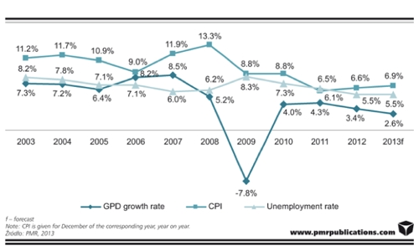
Figure Nr? title? Country?
Time series: 2003-2013
URL=?

2014: +0.6%
In 2014, GDP growth was 0.6%. The recession began in November 2014, when the first decline in GDP by 0.5% was recorded compared to November 2013.

According to the PMR forecast (November 2014), in 2014 the growth of the Russian economy will be close to zero.
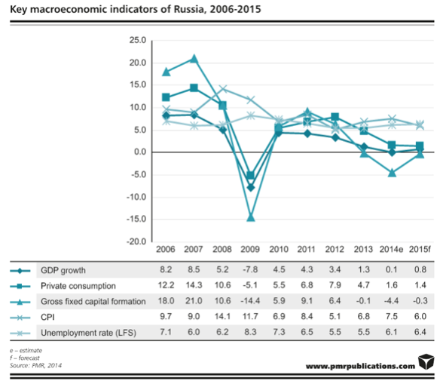
Figure Nr?
URL =?
Dimensions of the variables?
Time series = 2006-2015
As of August 2014, the Ministry of economic development expected the Russian economy to grow by 0.5%, the Central Bank of Russia — by 0.4%, the international monetary Fund — by 0.2%.
According to the forecasts of February 2014, the economic growth rate in 2014 will be higher than in 2013, assures Deputy Minister of economic development Andrei Klepach: the forecast of the Ministry of economic development for 2014 remains 2.5%. But "if we take the current trends", the growth rate may be lower, it does not exclude: in the first quarter of the Ministry of economic development expects economic growth by only 1% in annual terms, in II there is hope for acceleration — up to 1.5-2% (quotes on "Interfax")( http://www.vedomosti.ru/finance/news/22149961/ekonomika-rossii-zamedlilas-bolee-chem-vdvoe-za-god#ixzz2sFFUCTzC).
The Ministry of economic development hopes that investment and industry will revive, said the Deputy Minister. With the same hopes began in 2013, but then the forecast had to be reduced several times from 3.6% to the resulting 1.3%. Investments have not increased, but decreased and while the negative trend continues, Klepach admitted. The industry "started" at the end of 2013, but it can not be called a steady growth, he said.
Negative contribution to the growth of the economy contributed to the slowdown of credit — Ministry counted on 17-20%, but it turned out to 12.7%, Klepach said. Only investments can support the economy, and loans are needed for their growth, Minister Alexei Ulyukayev explained earlier. However, in 2014, the risks of credit slowdown remain, Klepach warned: they are primarily associated with the possibility that the Central Bank will raise rates due to inflation, which can be fueled by the weakening of the ruble. Raising rates can be a significant factor in limiting economic growth, Klepach warned.
In January, the Ministry of economic development maintained the forecast of economic growth in 2014 by 2.5%.
According to the forecast of the Ministry of economic development (December 2013) GDP in 2014 will increase by 2.5 percent.
In April 2013, the Ministry of economic development lowered its GDP growth forecast for 2014 from 4.3 to 3.7 percent.
According to the study, Russia HSE `the Economy of Runet 2014-2015` researched the Internet markets (content and services) amounted at the end of 2014 — 1 094 billion rubles, and the volume of the market of electronic payments — 476 billion rubles, in the amount equivalent to 2.2% of Russia's GDP for 2014. At the same time, the economy of Internet-dependent markets amounted to more than 11.8 trillion. rubles, which is comparable to 16% of Russia's GDP.
2015: -3,5% for the first half of the year
For the first half of 2015, the decline in GDP amounted to 3.5% in annual terms, and in the first quarter, the drop was 2.2%, and in the second quarter to 4.7%, according to Vnesheconombank, or 5-5,5% year-on-year, according to the HSE. If the first quarter of 2015 the crisis affected primarily non-industrial sectors: trade (-7.6%), the financial sector (-3.9%), real estate transactions, business services (-3.3%) and personal services (-6.9%), then in the second quarter the total GDP decline worsened due to the fall in industrial production.

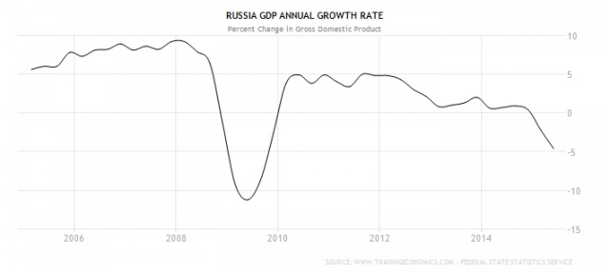
Figure Nr?
URL=?
Time series = 2005-2015?
In January 2015, the European Bank for reconstruction and development predicted the fall of the Russian economy by 4.8%, the international monetary Fund — by 3%.
At the end of 2014, the Ministry of economic development allowed GDP to fall by 0.8 % in 2015, and the Central Bank predicted a fall in GDP by 4.8%, if the average annual price per barrel of oil is $60. The amendments to the state budget adopted in April 2015 were expected to reduce GDP by 3%.
At the end of December 2014, the head of the Ministry of economic development Alexei Ulyukayev predicted a decline in Russia's GDP in 2015 by 3% at an oil price of $60 per barrel.
The three-year budget of Russia, adopted by the state Duma in November 2014, provided for economic growth at 1.2% in 2015, 2.3% in 2016 and 3% in 2017. The budget is based on the Urals oil price forecast of about $100 per barrel.
According to the forecast of the Ministry of economic development (December 2013) GDP in 2015 will increase by 2.8 percent.
In April 2013, the Ministry of economic development lowered its GDP growth forecast for 2015 from 4.5 to 4.1 percent.

2016: -0,2%
INTERFAX.RU - Russia's GDP decreased by 0.2% in 2016. This first assessment was published on Wednesday by Rosstat. This was significantly better than the assessment of the Ministry of economic development, which on Monday estimated the decline in GDP for the year by 0.6%, as well as the expectations of analysts - the consensus forecast of experts interviewed by Interfax at the end of December, also assumed a decline in the economy by 0.6%.
Rosstat did not give an estimate of GDP dynamics for the IV quarter. Earlier, Rosstat estimated GDP decline in the first quarter of 2016 in annual terms by 1.2%, in the second quarter of 2016 - by 0.6%, in the third quarter of 2016 - by 0.4%, and in General for 9 months estimated GDP decline by 0.7%. It is obvious that the quarterly dynamics of Rosstat will be significantly revised in the future, as the current dynamics does not lead to a decrease of 0.2% at the end of the year.
As reported, Rosstat in December has significantly recalculated the dynamics of industrial production in 2015-2016 (with the final figures published only for November-December and for the year as a whole), so it could have an impact on the dynamics of GDP, perhaps Rosstat has made some adjustments and the informal sector of the economy.
Rosstat has once again improved the dynamics of GDP in 2015: at the beginning of the year it improved its estimate of decline in 2015 to 3.0% from 3.7%, and now to 2.8% from 3.0%. Russia's GDP for 2016, according to the first estimate of Rosstat, amounted to 85 trillion 880.6 billion rubles 99.8% in current prices. The GDP deflator index for 2016 in relation to the prices of 2015 amounted to 103.4%. (https://www.interfax.ru/business/547998)
2017: +1.5%
Real GDP growth at the end of 2017 was recorded for the first time since 2014. At the same time, the key economic indicator entered the phase of recovery growth starting from the 4th quarter of 2016.
The dynamics of the real GDP of Russia in 2013 – 2017.
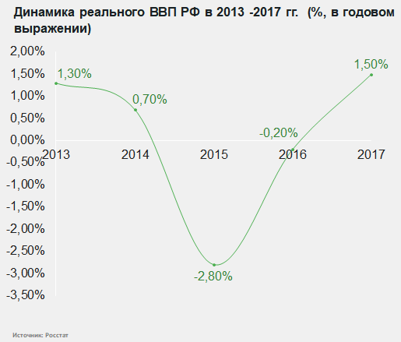
Figure Nr?
URL=?
Translation?
If we evaluate the results of 2017 from the point of view of economists ' expectations, and not the official forecast, they almost completely correspond to them. The consensus forecast of Interfax, made at the end of 2016, predicted the average annual prices of Urals oil in 2017 at the level of $51 dollars per barrel (in fact, for 11 months of 2017 - $52 per barrel).
Russian GDP growth in 2017 was expected by economists (according to a survey in December 2016) by 1.2% (in fact, according to the Ministry of economic development, growth for 11 months of 2017 amounted to 1.4%). The growth of retail trade in 2017 was projected at 1.2% (for 11 months amounted to 1.0%). (https://www.interfax.ru/business/593950)
2018: +2,3%
The impact of the 2018 world Cup on Russia's GDP was about $17 billion
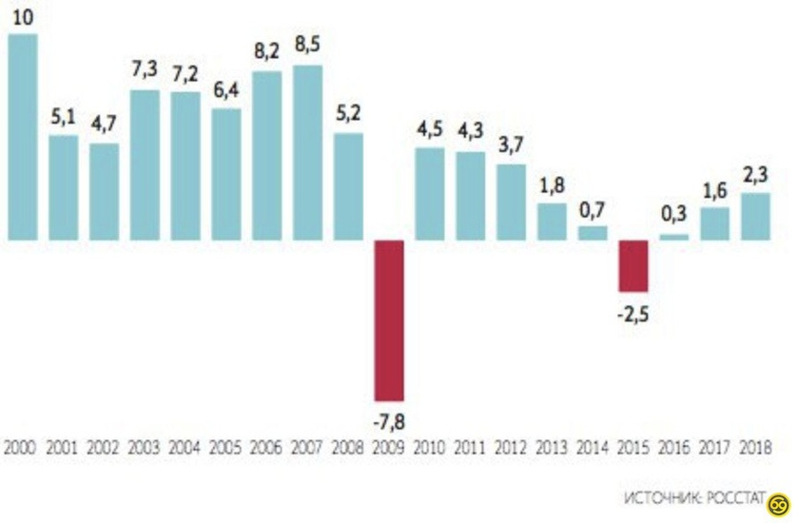
Figure Nr?
Title?
Variable? Dimension?
URL?
On October 16, 2018, the 2018 FIFA world Cup Russia organizing Committee published a report on the economic effect. According to him, from 2013 to 2018 it amounted to 952 billion rubles. This is almost 40% more than the cost of the tournament.
According to the organizing Committee, the total cost of the 2018 world Cup amounted to 688 billion rubles. Moreover, compared to similar tournaments in other countries, the Russian world Cup in terms of its impact on the economy has become one of the best. The total impact of the 2018 world Cup on Russia's GDP was about $17 billion, which exceeds the effect of similar Championships in Brazil, South Africa, Germany and South Korea and is closest to Japan. In relative terms, the effect of the 2018 world Cup was about 1.1% of Russia's annual GDP. According to this indicator, the tournament is second only to the championship in South Africa, as the GDP of this country in absolute terms is significantly less than that of other host countries.
Tangible economic effect of the 2018 world Cup will be observed at least in the future five years, according to the organizing Committee of the tournament. According to the forecast, it will be from 150 to 210 billion rubles per year. It is expected that about a third of the future effect of the 2018 world Cup will be on the development of tourism. While the main part of the long-term impact will be achieved through the catalyst effect of investment. The projected economic effect of the increase in tourist flow is determined at the level of 40 — 70 billion rubles per year, the impact of investments and operating costs — at the level of 110 — 140 billion rubles per year(https://www.radidomapro.ru/ryedktzij/economika/economika/tchm-2018-prines-rossii-trillion-64928.php?MD5email=$MD5email&utm_source=Openfield&utm_medium=email&utm_content=article&utm_campaign=B2728579).
Conclusion
It would be necessary to have an OAM, it means we need at least one single matrix about Russia, where each data of each variable should be available for the SAME (the longest?!) time series.

Meanwhile, already at the beginning of this year, assumptions were made about the factors and prerequisites for the growth of the country's GDP are still present. This makes it possible to forecast positive further growth dynamics of the gross indicator, but its main stages of growth can be observed only by the end of the annual period. The opinions of international experts and major players in the financial market are also disappointing: GDP growth will reach 1.5% at best, but in a crisis situation, and this is a good result. The development of individual sectors of the economy is also of great importance.
In many ways, GDP depends on the political and social situation in the country and in the international arena as a whole. Of great importance are the foreign policy and economic relations of the state, the degree of formation and development of the domestic market.<--The task of the semester is, to derive these kind of abstractions based on data and robot-engines (see demo files about GDP and innovation/tourism policy making).
Do we need a forecast of the GDP for the year “????” ?
Do we need a simulation model of the GDP based on a lot of variable like in the demo study and XLS?
Do we need a model supporting the derivation of the levels of importance of variables having an impact to the GDP? (see analyses about satisfaction in hotels).
It is necessary to use online (e.g. MY-X) and/or offline (e.g. Solver) robots for the analyses.

Sources
- https://www.cia.gov/library/publications/the-world-factbook/rankorder/2001rank.html
- https://drive.google.com/file/d/0BzQy9ZwUn-JeOTk2NGRiNDAtYzc5NC00YjZmLTlmMmYtMGVkZDM3YWJlNDY4/view
- http://top.rbc.ru/economics/22/05/2012/651488.shtml
- http://www.gks.ru/
- https://www.radidomapro.ru/ryedktzij/economika/economika/tchm-2018-prines-rossii-trillion-64928.php?MD5email=$MD5email&utm_source=Openfield&utm_medium=email&utm_content=article&utm_campaign=B2728579
- https://www.interfax.ru/business/593950

