MIAU – HU ISSN 141921652 – Special Edition 2019. May
Editorials: The papers in MIAU Nr.249 (2019.V) are products of a new education frame “QuILT” (https://miau.my-x.hu/mediawiki/index.php/QuILT).
The goals of QuILT are supporting/conducting Students on the way of KNUTH, who said (1992): Knowledge is, what can be transformed into source code, each other human activity is a kind of artistic performance. It also means we need to leave the world of the magic of words step by step. A solid evidence that we all are capable of going this way is: creating publications behind which the human expertise and the robotized knowledge (like online engines: https://miau.my-x.hu/myx-free/coco/index.html --- offering context free = quasi General-Problem-Solving force fields) can be integrated in case of a rational and relevant decision making scenario. The cyborg effects make possible to face the classic naïve and/or intuitive approaches and parallel the optimized approximations. This way can be realized without deep competences about mathematics, Excel (spreadsheets), statistics, etc. The new (inter/trans/multi-disciplinary) way just expects from us to be able and willing to co-operate with the best moments of the history – it means, with the already prepared robotized elements in order to build something creative one!

COMPARING EVALUATION SYSTEMS IN THE CASE OF ADDITIONAL OBJECTS AND ATTRIBUTES

ROY WAQAS KAMAL, ROY BIGNESH SHASHI, ALI MALIK WAQAS, CHOWDRY SOHAIL KJU, Budapest 2019

Introduction
We have done this essay in the course of “ADVANCED SERVICE DESIGN AND MANAGEMENT” and we are going to talk about some different evaluation systems and analyse them and in the end comparing them.
Previous documents:
- https://miau.my-x.hu/miau/quilt/comparing_evaluation_systems.pdf
- https://miau.my-x.hu/miau/quilt/st1_all.docx

Figure no 1 raw values and source is own presentation
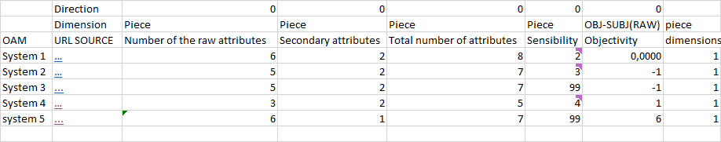

Legend Attribute1: Number of the Raw Attributes-System 1
Legend Attribute 2: Secondary Attributes-System 1
Legend Attribute 3: Total Number of Attributes-System1
Legend Attribute 4: Sensibility-System 1: Green=Pass; Red=Failed
Legend Attribute 5B: Objectivity-System1: Number of Objectives Attributes-Number of Subjective Attributes (the ratio-oriented attribute in the previous comparison leads to error, if the number of the secondary attributes is zero – c.f. error = divided by zero therefore the absolute difference or the difference compared to the total number of the attributes is less sensible)
Legend Attribute6: Dimensions COUNT OF THE USED DIMENSIONS (the seemingly monotonous percentage-using as dimension has in the background a lot of other dimensions: like piece of presence / piece of classes = ratio of attendance in percent)

How we can see the number of the raw attributes is six in the system 1, five in the system 2 and three in the system 3 and 4.
The secondary tributes are always 2 in all of the systems. The total of attributes is 8 in the system 1, 7 in the system 2 and 3 and the system 4 has a total of 5 attributes.
The biggest sensibility is in system 3 because is unlimited, and after this the second one is the system because its sensibility is 4. The system 2 has 3 in sensibility and the last one is the system 1 with 2.
The system4is the one with more objectivity with 2. The second one is the system 1 with 2 and the both last ones are the systems 2 and 3 with 0.6666666667 (these 2 last ones have more subjective attributes than objective: 2/3).

In system 5
- we derived number six for the attribute „number of the raw attributes” by counting the formula (B9:G9)
- secondary attribute is the final grade and there is no formula
- number of raw attributes plus number of secondary attributes is equal to total number of attributes is seven
- it is the code, but it is not the realistic value it could be interpreted as unlimited value
- this value is calculated by subjective minus objective and we find raw objective, and which is six
- it could be more, but it is the sign of the more the better

Figure no 2 ranked values and source is own presentation
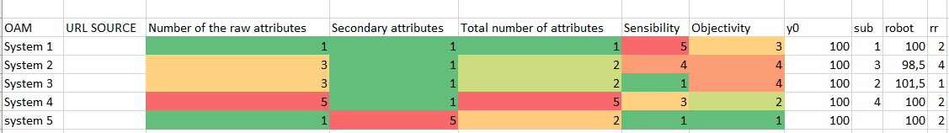
The lack in the column “sub” means: what is the realistic rank of the system nr5 compared to the other systems? The subjective estimation of the team was: RANK Nr1, because of 3 gold medallions – but the winner (system nr3) do not have rank nr5 just rank nr4. System nr1 and nr5 have ranking values “5”.

Figure no 3 ranked values and source is own presentation
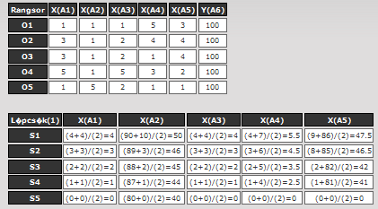
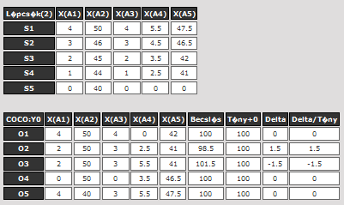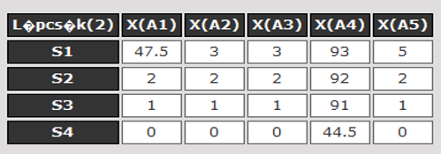
FiguresNR3 –Personal Opinion against Robot Opinion –Own Presentation, https://miau.my-x.hu/myx-free/coco/index.html and antidiscrimination module.
Parallel to the first system comparison, this comparing with 5 systems has the same robustness because the step “50” of the attribute nr2 in the staircase function above does have the same unlimited free position (c.f. value of 47.5 of the attribute nr1 in the previous paper).

Figure no 4 ranked values and source is own presentation
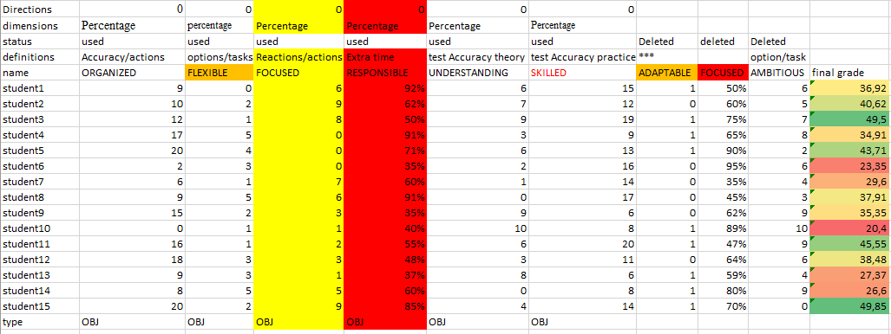
Figure NR4 –Students Evaluation –Source: Own Presentation
In our opinion, as you can see on figure 4, for the student’s evaluation we should have at least six attributes:
- in case of the first attribute, we can see the student’s accuracy (and/or presence) during class work, and it is not more than twenty percent
- in case of the second attribute, students are flexible on tasks during class work - in this attribute we easily define some students which touch parallel hundred results
- in case of the third attribute, students are focused in class and give reaction on teacher’s questions and the ratio can be defined as follows: compared to the number of the total tasks how many tasks are completed by a particular student
- in case of the fourth attribute, students show their responsibility on extra time to complete their tasks totally
- in case of the fifth attribute, students show interest in understanding and how many students understand lectures and complete tests measured by test accuracy in theory
- in case of the sixth attribute, students are analysed by practical knowledge and could also be observed by cameras or interpreted through test accuracy values

Conclusion
- the first level is the quality assurance on students’ activities where the evaluation systems support checking the daily routine work in class and in homework
- the second level is the adaptation challenge of previous systems or solutions on the level of the enforced objectivity
- finally, if we create our opinions than this process is subjective, and robots derive evaluations based on data. The ideal situation is, if the robot opinions and humans’ opinions are the same…

