MIAU – HU ISSN 141921652 – Special Edition 2019. May
Editorials: The papers in MIAU Nr.249 (2019.V) are products of a new education frame “QuILT” (https://miau.my-x.hu/mediawiki/index.php/QuILT).
The goals of QuILT are supporting/conducting Students on the way of KNUTH, who said (1992): Knowledge is, what can be transformed into source code, each other human activity is a kind of artistic performance. It also means we need to leave the world of the magic of words step by step. A solid evidence that we all are capable of going this way is: creating publications behind which the human expertise and the robotized knowledge (like online engines: https://miau.my-x.hu/myx-free/coco/index.html --- offering context free = quasi General-Problem-Solving force fields) can be integrated in case of a rational and relevant decision making scenario. The cyborg effects make possible to face the classic naïve and/or intuitive approaches and parallel the optimized approximations. This way can be realized without deep competences about mathematics, Excel (spreadsheets), statistics, etc. The new (inter/trans/multi-disciplinary) way just expects from us to be able and willing to co-operate with the best moments of the history – it means, with the already prepared robotized elements in order to build something creative one!

COMPARING EVALUATION SYSTEMS
Barbosa da Cunha António Maria Ferreira Martins, KJU, Budapest
Dias Duarte Francisco de Barros, KJU, Budapest
2019

Introduction
We have done this essay in the course of “ Service Science and Knowledge Economy: Research Methods” and we are going to talk about some diferent evaluation systems and analyse them and in the end comparing them.

Data Processing
Figure NR1 – OAM for Comparing Evaluation of Students – Source: Own Presentation
 | Direction | 0 | 0 | 0 | 0 | 0
 | Dimension | Piece | Piece | Piece | Piece | RATIO
OAM | URL SOURCE | Number of the raw attributes | Secondary attributes | Total number of attributes | Sensibility | Objectivity
System 1 | … | 6 | 2 | 8 | 2 | 1,0000
System 2 | … | 5 | 2 | 7 | 3 | 0,666666667
System 3 | ... | 5 | 2 | 7 | 99 | 0,666666667
System 4 | … | 3 | 2 | 5 | 4 | 2
A B C D E F G
1
2

3
4

5

6

7
Legend Number 1: Number of the Raw Attributes-System 1
Legend Number 2: Secondary Attributes- System 1
Legend Number 3: Total Number of Attributes- System1
Legend Number 4: Sensibility- System 1: Green=Pass; Red=Failed
Legend Number 5: Objectivity- System1: Number of Objectives Attributes/ Number of Subjective Attributes

How we can see the number of the raw attributes is six in the system 1, five in the system 2 and three in the system 3 and 4.
The secondary tributes are always 2 in all of the systems. The total of attributes is 8 in the system 1, 7 in the system 2 and 3 and the system 4 has a total of 5 attributes.
The biggest sensibility is in system 3 because is unlimited, and after this the second one is the system because its sensibility is 4. The system 2 has 3 in sensibility and the last one is the system 1 with 2.
The system4 is the one with more objectivity with 2. The second one is the system 1 with 2 and the both last ones are the systems 2 and 3 with 0.6666666667 (these 2 last ones have more subjective attributes than objective: 2/3).

Figures NR2 – Personal Opinion against Robot Opinion – Own Presentation, https://miau.my-x.hu/myx-free/coco/index.html and antidiscrimination module.
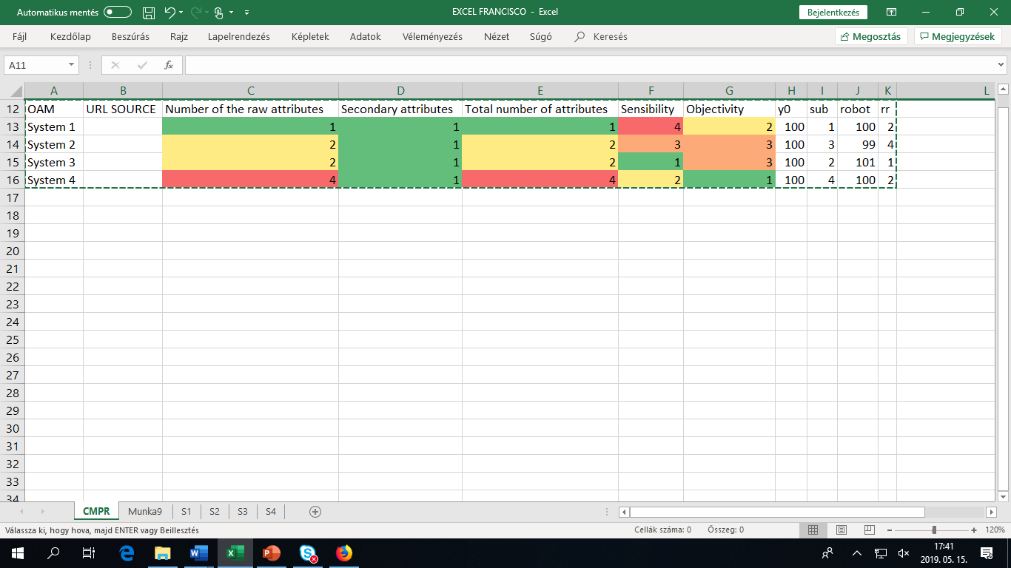
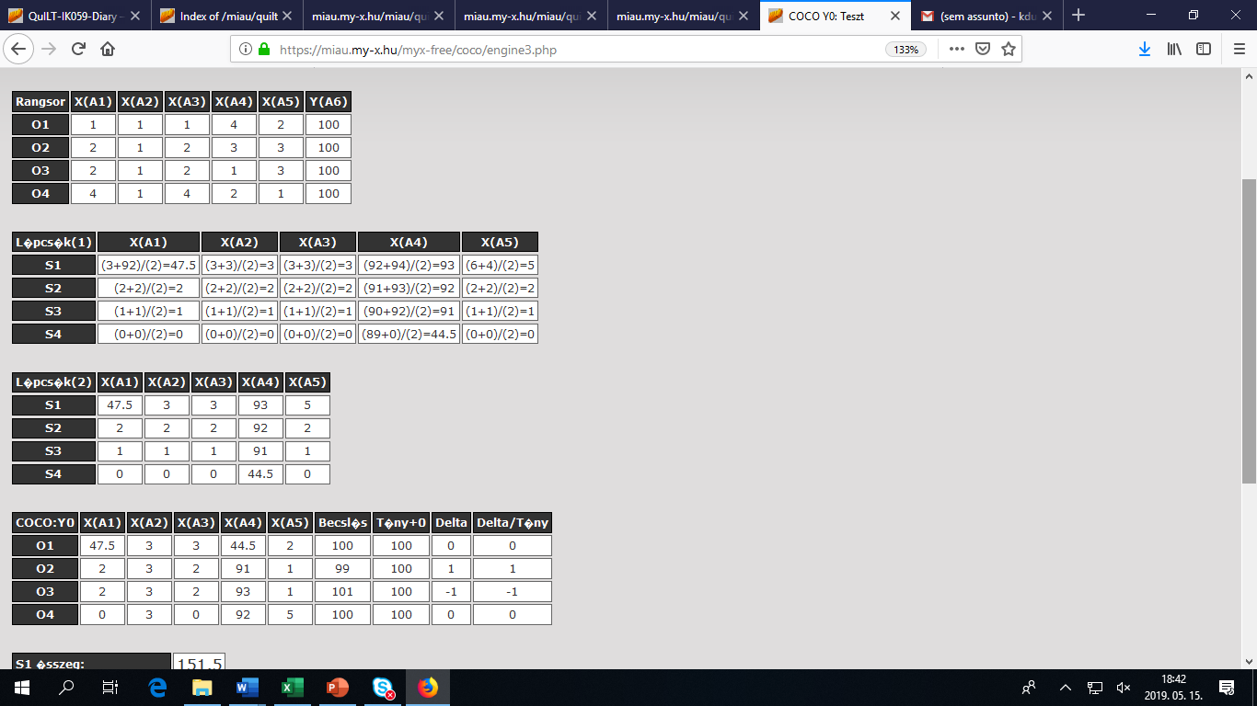
So, in the first system according with the robot opinion we can say that it has a little negative risk and a big positive chance because the first attribute could be revaluated (47.5 could be reduce to 3 but it could increase to infinity).
So, 47.5 and 44.5 could be added.

Figure NR3 – Students Evaluation – Source: Own Presentation
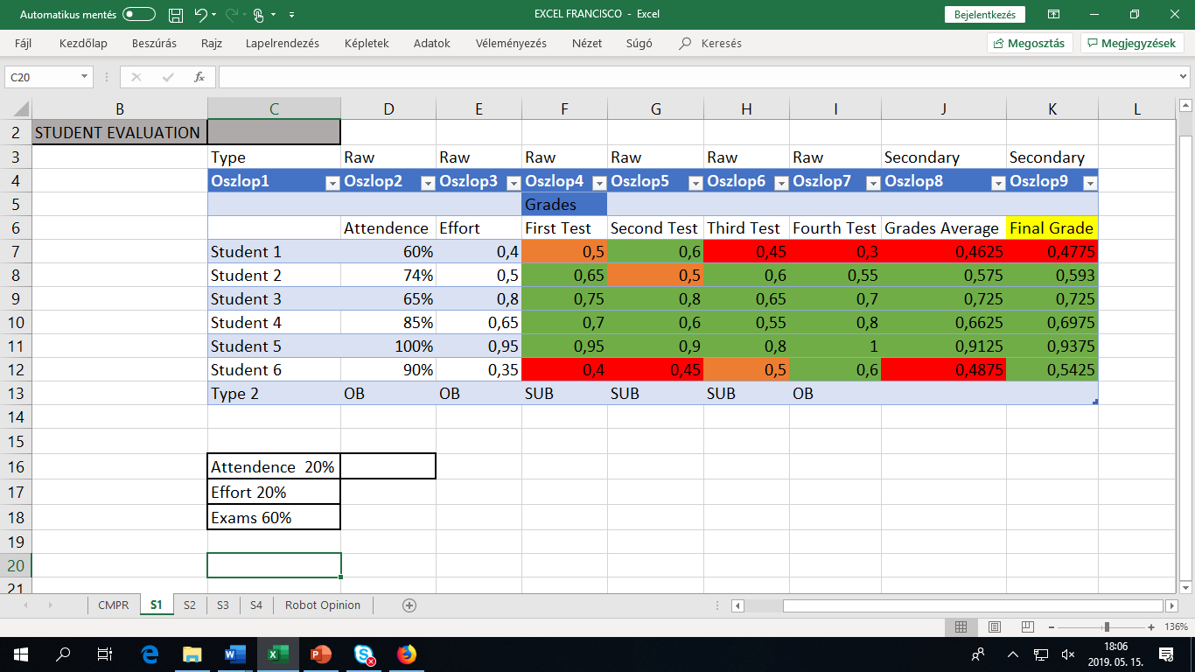

In our opinion, as you can see on figure 3, for the students evaluation we should have more than two moments (attendance, exam) of evaluation, that is, imagine that the evaluation moments were only attendance and the exams, a student could stay at home and study there and come only to the exams and pass, if the weight were 50% each. Because of that we chose the attribute “effort” that, for us is really important that reveals the commitment and dedication of the students. So how you can see in the legend of the figure 3, the weight of attendance and effort are both 20%, so together are 40%, and the remaining 60% are for the exam grades. So for the final grade, a student will need to come to the classes (attendance), will need to reveal dedication and commitment (effort) and will need to pass the exams. So the calculation of the final grade will be 20% of the attendance times the student attendance plus 20% of the effort times the student effort plus 60% of the exams times the student grades average.
This is a kind of class that is really practice, so as we have already said, the student need to come classes.

Figure NR4 – Students Evaluation – Source: Own Presentation
 | a | b | c | d | e | g | h | i
1 |  | % (10 Classes Total) | Avarage % | % | % | % | % | %
2 |  | Attendance | Test Grades | Final Grade | First Test | Second Test | Third Test | Fourth Test
3 | Student 1 | 0,6 | 0,625 | 0,615 | 0,8 | 0,7 | 0,4 | 0,6
4 | Student 2 | 0,8 | 0,7 | 0,74 | 0,6 | 0,5 | 0,7 | 1
5 | Student 3 | 0,8 | 0,825 | 0,815 | 0,8 | 0,8 | 0,9 | 0,8
6 | Student 4 | 0 | 0 | 0 | 0 | 0 | 0 | 0
7 | Student 5 | 1 | 0,875 | 0,925 | 0,8 | 0,9 | 0,8 | 1
8 | Correlation |  | 1,0 | 1,0 | 0,9 | 0,9 | 0,9 | 1,0
Legend nr1: b2×0,4+c2×0,6=d2
Legend nr2: (e2+f2+g2+h2)/4=c2

This publication is about the individual evaluation of each student in one specific course. This evaluation is individual and just about one course because is important to have the possibility of see which the best qualities in the different students are.
Like you can see in figure 4 the weight of attendance is 40% and the weight of the test grades is 60%. Probably a lot of people can think that is not a good evaluation system but for us it is. It is true that this give to the students the possibility of coming to the classes and don’t to almost nothing. But in true that does not happen. How you can see the number of classes that the 4 students come make a lot of sense with their test grades. This is a subject with a lot of practise. If you do not come to the classes, it will be very complicated to pass the tests. If you see the table, the students that come to the class has good grades. The students that do not come also do not learn and do not pass the tests.
To end this text, we will explain what our reason were to give almost the same weight to Attendance Test Grades. Like we said before this is a practical class. Off course it is always possible to learn outside of it but in our opinion that is not the goal. A student should be in the classes, learn the teacher ways and pass the test. Off course it is fairer that a student that do not come to the class and pass the test is with the subject done that one that just come to the class and do not pass the tests. Still for us in a practical class a student need to come to learn with the teacher. This is the reason to give to the tests grade more 10% of weight in the final grade and not more than that.

Figure NR5- System 3- Source: https://miau.my-x.hu/miau/quilt/HACS_WHIP_v2.docx
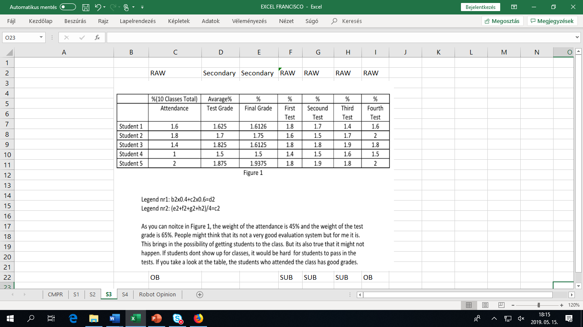
Figure 6- System 4- Source: https://miau.my-x.hu/miau/quilt/eu_guru_rug.xlsx 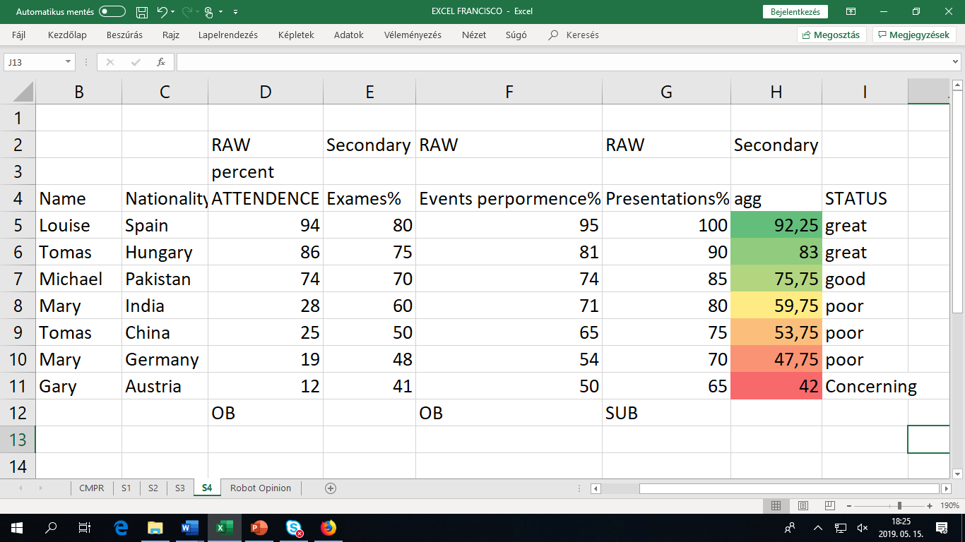

Conclusion: With this publication we have learned a lot of things. One of them is the big difference between the human and the robot opinion. We have also learned that in the process of evaluating students we have a lot of systems possibilities to choose with different ways of do it. We have also learned how to compare the different ones and how to analyse them.
This publication can also be used for other course-members having an own system and wanting to compare it to the already analysed ones. It is possible to derive new attributes concerning new systems. But it is important: the OAM should always be completed – it means: the new objects should have raw data about the already defined attributes and the new attributes should be interpreted in case of each older systems (objects). It is to except, that the above-mentioned sensibilities will have the appropriate impacts if the number of the objects will be increased.
Potential new systems:
https://miau.my-x.hu/miau/quilt/4-person-team.xlsx
https://miau.my-x.hu/miau/quilt/4-person-team.docx

