MIAU – HU ISSN 141921652 – Special Edition 2019. May
Editorials: The papers in MIAU Nr.249 (2019.V) are products of a new education frame “QuILT” (https://miau.my-x.hu/mediawiki/index.php/QuILT).
The goals of QuILT are supporting/conducting Students on the way of KNUTH, who said (1992): Knowledge is, what can be transformed into source code, each other human activity is a kind of artistic performance. It also means we need to leave the world of the magic of words step by step. A solid evidence that we all are capable of going this way is: creating publications behind which the human expertise and the robotized knowledge (like online engines: https://miau.my-x.hu/myx-free/coco/index.html --- offering context free = quasi General-Problem-Solving force fields) can be integrated in case of a rational and relevant decision making scenario. The cyborg effects make possible to face the classic naïve and/or intuitive approaches and parallel the optimized approximations. This way can be realized without deep competences about mathematics, Excel (spreadsheets), statistics, etc. The new (inter/trans/multi-disciplinary) way just expects from us to be able and willing to co-operate with the best moments of the history – it means, with the already prepared robotized elements in order to build something creative one!

World safest countries for tourism
Zaman Fakhar, KJU, 2019

Introduction
I have done this project in a subject of advance research as an implementation of my knowledge what I have learn throughout the semester. This implementation can provide information about the best country to visit and provide information about crime rate around the globe. I make this publication to provide information to the Tourists, the tourism industry and the tourism policy maker. They could pay me for this if they wish to get benefit from my publication.

Analytical steps

1 searching for appropriate data
The picture (figure no1) below provide the source of information from where I get information and create the publication.
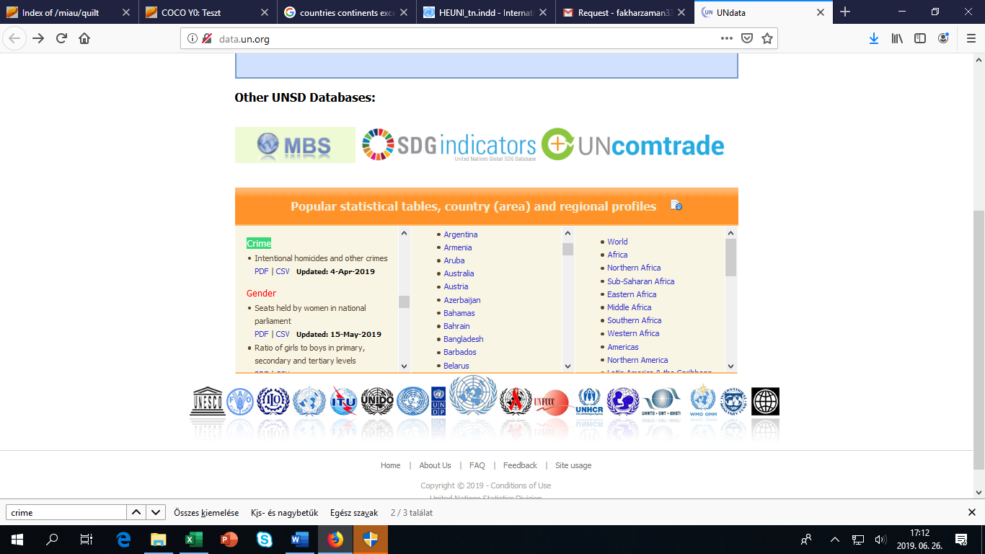
Figure no1: UNO statistical data bases (source: own presentation)

2. Downloading the source data
http://data.un.org/_Docs/SYB/CSV/SYB62_T05_201905_Seats%20held%20by%20Women%20in%20Parliament.csv
The above mention link can provide raw information about 3773 rows it means the number of the countries are 231 and the number of the attributes are 8:
Assault rate per 100,000 population Intentional homicide rates per 100,000 Kidnapping at the national level, rate per 100,000 Percentage of male and female intentional homicide victims, Female Percentage of male and female intentional homicide victims, Male Robbery at the national level, rate per 100,000 population Theft at the national level, rate per 100,000 population Total Sexual Violence at the national level, rate per 100,000
if we consider all the data it can be 31416 =8*231*17years values which is not provided by the organizations. the organizations can provide only 10% data, so we have 3773 results only. see figure no1-2-3-4 (each further detail can be seen here: https://miau.my-x.hu/miau/quilt/crimes_v2.xlsx)

3 identified average values for each attribute
Figure no5 shows the step-details. Averages can not be seen as a kind of penalty or advantage in case of lacking data.

4. Replacing cell content without any statistical data
Figure no6 shows the ratio of lacking data in a visual way.

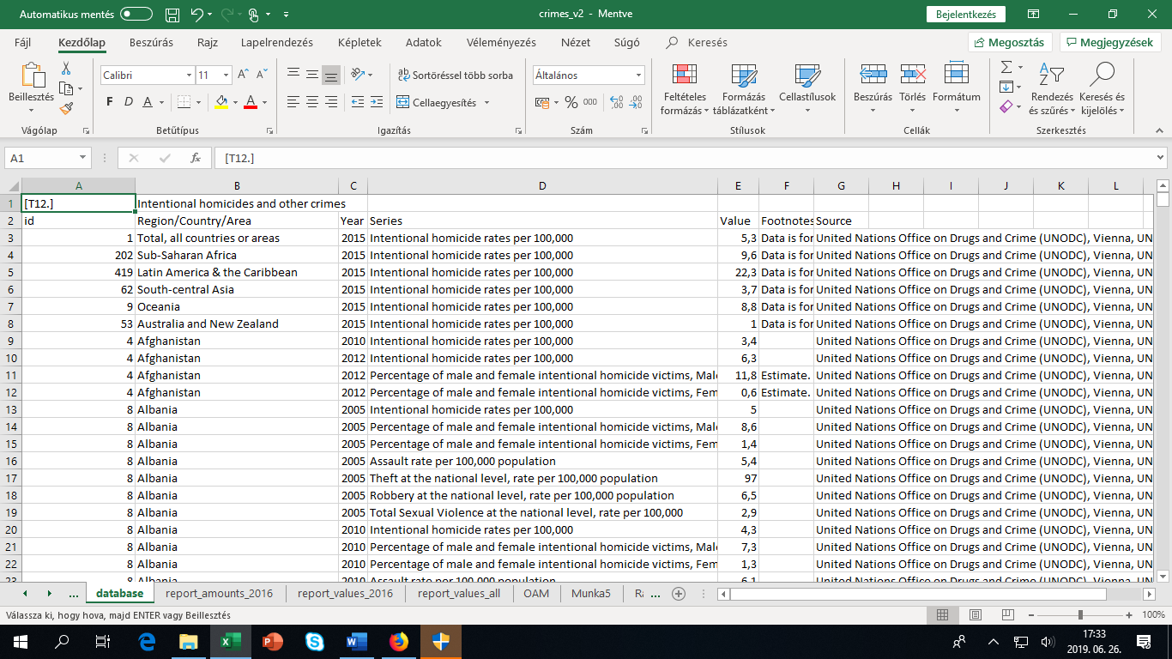
Figure no2: structured csv (source: own presentation)
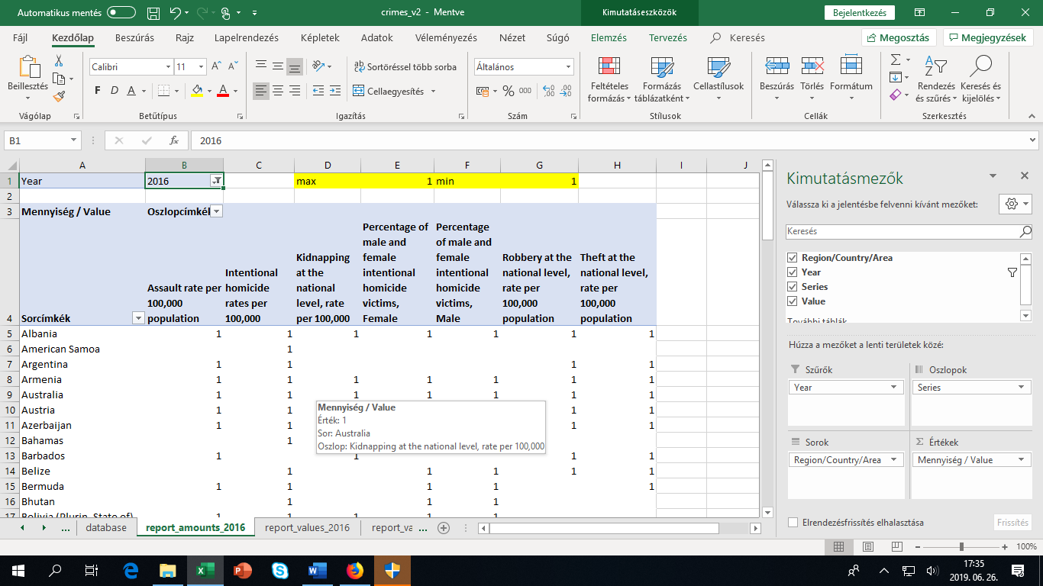
Figure no3: amount-statistics with lacking data positions (source: own presentation)
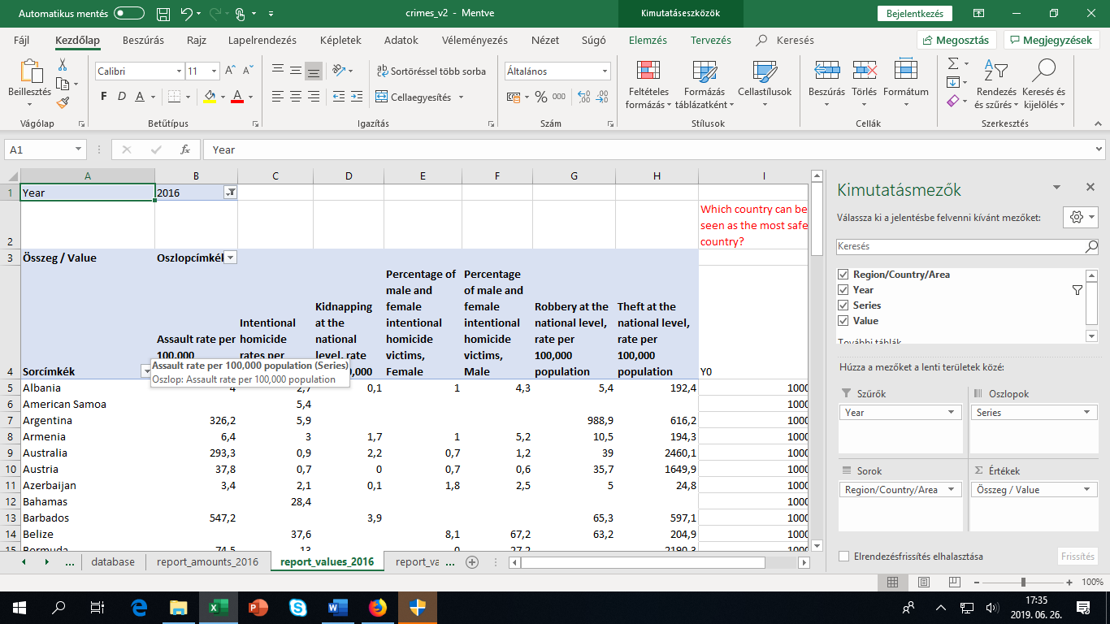
Figure no4: structured data for 2016 (source: own presentation)
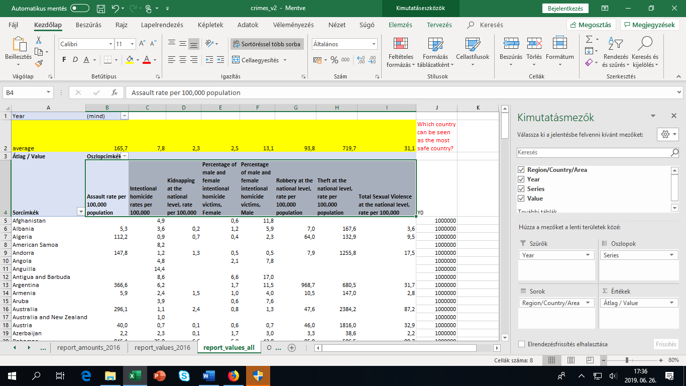
Figure no5: countries and attributes each year with averages (source: own presentation)
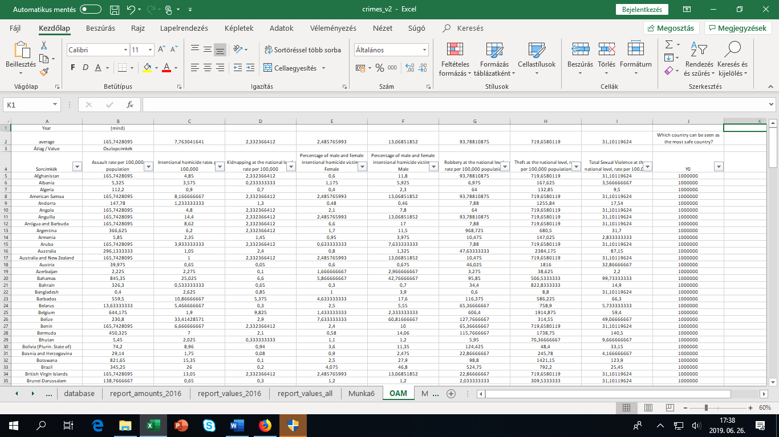
Figure no6: replaced lacking positions (source: own presentation)
The average (for each column) is a replacing value. The average is a neutral value (see ranking position).

5. ranking of the row data
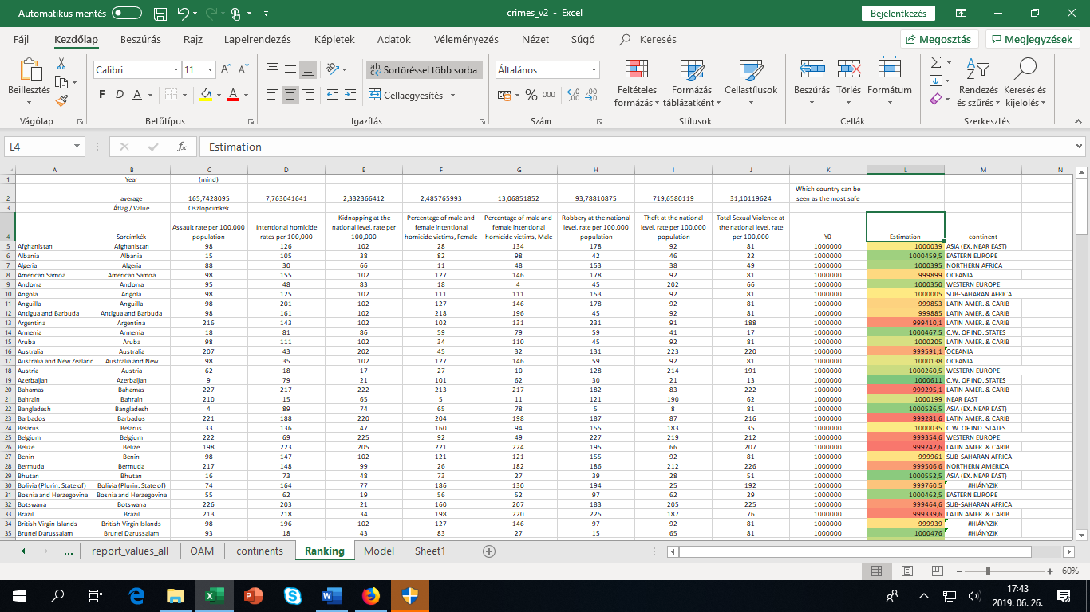
Figure no7: ranking data and estimation of safety index including continents codes (source: own presentation)
A ranking is considered to be more important here because we can identify all the countries with their best and worst rank in a standardised way (without any influence of units and absolute numbers).

6 modeling
https://miau.my-x.hu/myx-free/coco/index.html (y0)
We try to derive whether each country could have the same evaluation value (safety index)?
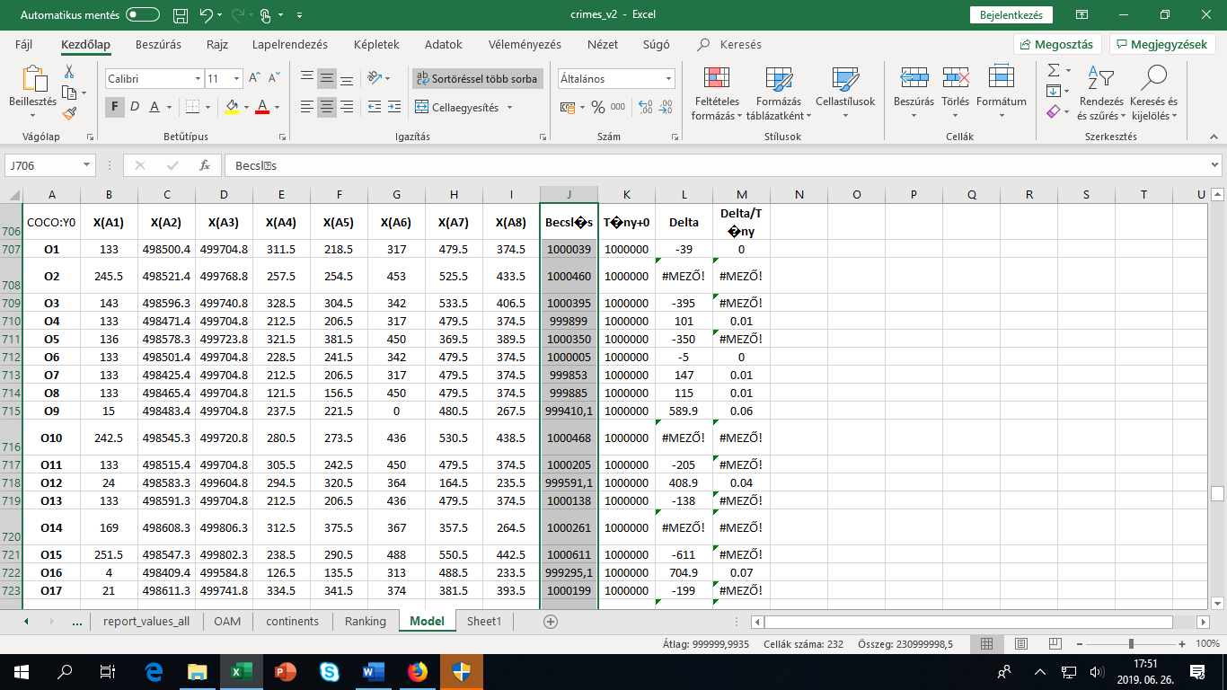Figure no8: estimation layers attribute by attribute based on similarity analysis (source: own presentation)
We searched for the appropriate keywords (like country continent table) https://www.google.com/url?sa=t&rct=j&q=&esrc=s&source=web&cd=1&ved=2ahUKEwiHv6DorofjAhUPposKHW87BEUQFjAAegQIABAC&url=http%3A%2F%2Fwww.statvision.com%2Fwebinars%2FCountries%2520of%2520the%2520world.xls&usg=AOvVaw2MwR5nAZwXVOVb2mQ0ygc3
With the formula vlookup() we could identified the appropriate code for each country where the letter series of the country names were identical. If not, then we got an error message.

7 creating report about continent like safety index values
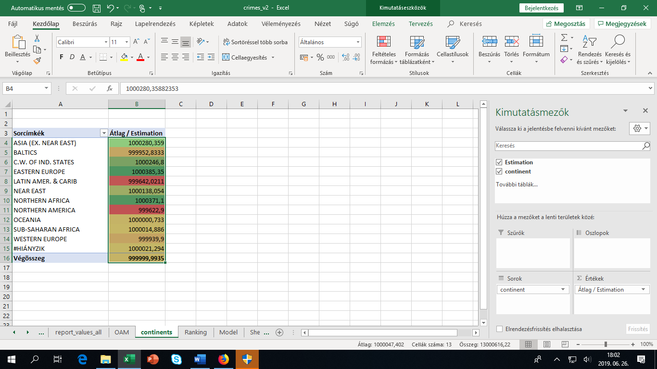
Figure no9: averages safety index value for continents (source: own presentation)
Conclusions:
The countries with green values are considered to be safe enough for visit while the other are consider too risky. They need to be improved so in this regard NORTHEREN AMERICA and CARIBIANS ARE IN BIG TROUBLE.
Safety index values for each county can be checked in the background XLS file (see before)…

