

**Name >**

**Junaid Ahmad**

**Neptune Id >**

**DHLJRF**

**Teacher >**

**Dr. Pitlik Laszlo**

**Subject >**

**(Advance service design & management)**

**(Quality, Innovation Policies And Tools In MLE)**

**Title of Publication:**

**Critical Evaluation of tourism data and figures About Hungary**

**Introduction:-**

The source publication is a finalized version, the goal is to support the quality assurance of the source document.

**Abstract:**

We can estimate a data which is really close to next year of data about tourist numbers with our data which show sample size, number of inbound trips, length of stay of visitors, expenditures of visitors, expenditures per day per visitor. Result of the data, we can present some ideas about which should we focus on countries to gain more profit? Besides, we can determine which countries are in last ranks and we can try to find new solutions. For example, we determined that France is last country in amount of tourist which visited Hungary in 2018 and we found new ideas to increase quantity of tourists from the France with our Interpretation Expert because we can see that there is a direct proportion between expenditure and tourists. Also, we can show a graph which everyone can create easily own abstract about amount of tourist according to countries without details.

**(Quality Of The Used Data Asset)**

The critical evaluation about the using data which I have used from the chapter. The data about the tourism in Hungary is to identify that how is the Hungary is popular for the tourism in Europe. As the below table, most of the tourist is travelling to Hungary year by year.

*Interpretation from the excel*

**Publication > “Hungarian’s Tourism” In European**

**Countries**

**ABBREVIATIONS USED IN THE PUBLICATION**

China–CEECs: China–Central and Eastern European Countries Tourism Coordination Centre, DCC: Danube Competence Center, ICCA: International Congress and Convention Association, ETC: European Travel Commission, HCSO: Hungarian Central Statistical Office, MNB: Magyar Nemzeti Bank (the central bank of Hungary), UNWTO: World Tourism Organization, V4: European Quartet/Vise grad Four countries.

**TERMS USED IN THE PUBLICATION**

Commercial Accommodation: hotels, boarding houses (previously guesthouses), bungalows, community hostels (previously tourist hostels and youth hostels) and camping sites according to the Act CLXIV of 2005 on Trade and 239/2009 (X.20) Government Decree. Other Accommodation: accommodation used for accommodation services, but not defined as commercial accommodations, are separate buildings not only used for accommodation services, the number of the rooms is up to eight and the number of the beds is up to sixteen. (According to the 239/2009 (X.20.) GD, other accommodation is to be used instead of private accommodation.) The publication is based on 2015 final data of the HCSO. The publication is also available in Hungarian. Hereby we would like to thank the Hungarian Central Statistical Office for its contribution.

**HUNGARIAN TOURISM AGENCY**

As the national tourism marketing organization, main objective of the Hungarian Tourism Agency is promoting Hungary’s tourism attractions and services to increase the receipts from incoming and domestic tourism.

**QUALITY OF THE USED CALCULATIONS**:

|  |  |  |  |  |  |  |
| --- | --- | --- | --- | --- | --- | --- |
| **The number of inbound trips to Hungary and the related expenditures by countries (2009–)** | | | | | | |
| Countries | Same day trips | | | | | |
|
| sample size, pieces | number of inbound trips, thousands | length of stay of visitors, thousand days | expenditures of visitors, million HUF | average length of stay of visitors, days | expenditures per day per person, thousand HUF |
| **$2018** |  |  |  |  |  |  |
| Austria | 5 749 | 7 241 | 7 241 | 139 368 | 1,0 | 19,2 |
| Belgium, Luxembourg | 20 | 60 | 60 | 432 | 1,0 | 7,2 |
| Bulgaria | 208 | 1 102 | 1 102 | 10 320 | 1,0 | 9,4 |
| Czech Republic | 618 | 1 014 | 1 014 | 6 038 | 1,0 | 6,0 |
| Denmark | 2 | 5 | 5 | 12 | 1,0 | 2,5 |
| United Kingdom | 10 | 39 | 39 | 452 | 1,0 | 11,5 |
| Finland | 2 | 1 | 1 | 33 | 1,0 | 61,1 |
| France | 26 | 100 | 100 | 467 | 1,0 | 4,7 |
| Greece | 5 | 26 | 26 | 158 | 1,0 | 6,2 |
| Netherlands | 51 | 58 | 58 | 421 | 1,0 | 7,3 |
| Croatia | 2 168 | 935 | 935 | 5 893 | 1,0 | 6,3 |
| Ireland | 1 | 0 | 0 | 4 | 1,0 | 14,0 |
| Poland | 473 | 1 892 | 1 892 | 9 666 | 1,0 | 5,1 |
| Germany | 889 | 1 082 | 1 082 | 8 552 | 1,0 | 7,9 |
| Italy | 183 | 211 | 211 | 2 514 | 1,0 | 11,9 |
| Romania | 5 299 | 9 796 | 9 796 | 100 009 | 1,0 | 10,2 |
| Spain, Portugal | 5 | 16 | 16 | 182 | 1,0 | 11,4 |
| Sweden | 9 | 29 | 29 | 282 | 1,0 | 9,6 |
| Slovakia | 8 079 | 9 272 | 9 272 | 91 971 | 1,0 | 9,9 |
| Slovenia | 1 505 | 374 | 374 | 3 554 | 1,0 | 9,5 |
| Other countries of EU | 5 | 33 | 33 | 30 | 1,0 | 0,9 |
| Member States of the European Union (except Hungary) | 25 307 | 33 284 | 33 284 | 380 360 | 1,0 | 11,4 |
| Russia | 17 | 54 | 54 | 401 | 1,0 | 7,4 |
| Serbia, Montenegro | 2 295 | 3 134 | 3 134 | 39 171 | 1,0 | 12,5 |
| Ukraine | 1 648 | 2 014 | 2 014 | 90 630 | 1,0 | 45,0 |
| Europe (expect Hungary) | 29 380 | 40 103 | 40 103 | 518 110 | 1,0 | 12,9 |
| Asia | 7 | 9 | 9 | 711 | 1,0 | 83,1 |
| Africa | 2 | 1 | 1 | 9 | 1,0 | 15,2 |
| America | 2 | 3 | 3 | 169 | 1,0 | 65,2 |
| USA | 2 | 3 | 3 | 169 | 1,0 | 65,2 |
| Australia | 1 | 1 | 1 | 5 | 1,0 | 7,3 |
| **Total** | **29 392** | **40 115** | **40 115** | **519 004** | **1,0** | **12,9** |
|  |  |  |  |  |  |  |
|  |  |  |  |  |  |  |

**Interpretation**

By using calculations in the form of using data by tables or figures is to identify the perfect facts and figures and as well as the strengths and weaknesses of the hosted tourist country.in the above table showing all the statistical calculations about the European influencing countries with Hungary and the other continents like Asia, America etc as well. This table form is the better way to compute the huge data about the tourism infrastructure of the Hungary and can interpret the scope of tourism in the Hungary.

**Population:** Over 93% of the population are Hungarians and 99% speak Hungarian. Ethnic minorities: Bulgarian, Greek, Croatian, Polish, German, Armenian, Roma, Romanian, Rusyn, Serbian, Slovak, Slovene, Ukrainian.

**Data Assets**:

<https://miau.my-x.hu/mediawiki/index.php/Vita:QuILT-IK045-Diary#9._Day_.282019.IV.17.29>

In a previous lesson, we worked on identifying and calculating the best countries for Hungary as an attractive touristic place. We chose the statistics of the year 2018 and after clarifying the proper data, 14 countries left on the list.

**Austria**

**Bulgaria**

**Czech Republic**

**France**

**Netherlands**

**Croatia**

**Poland**

**Germany**

**Italy**

**Romania**

**Slovakia**

**Slovenia**

**Serbia,**

**Ukraine**

As a result of the research, we surely can say Slovakia, Austria, Croatia, Romania and Serbia, are the best inbound countries for Hungary.

**Interpretation**:

The aggregated time series based on the principle “the more the better” of the diverse sorts of HR-categorieshas a decreasing trend and the Tourism could be the year Tourism Companies are resources therefore a decreasing trend seems to be a real good sign (c.f. efficiency).After this, we reached an aggregation point and we compared/aggregated the first level of aggregations to a second level tourism destinations.

**Quality of the created Visualization effect:-**

In vizualizáción effects the statistics about the tourisism in hungary, we can visualized and highlighted the tourism index in the form of table and graph. So the tourism effect can be presented by visualization effect showing the index about the increasing or decreasing the tourist attactions:

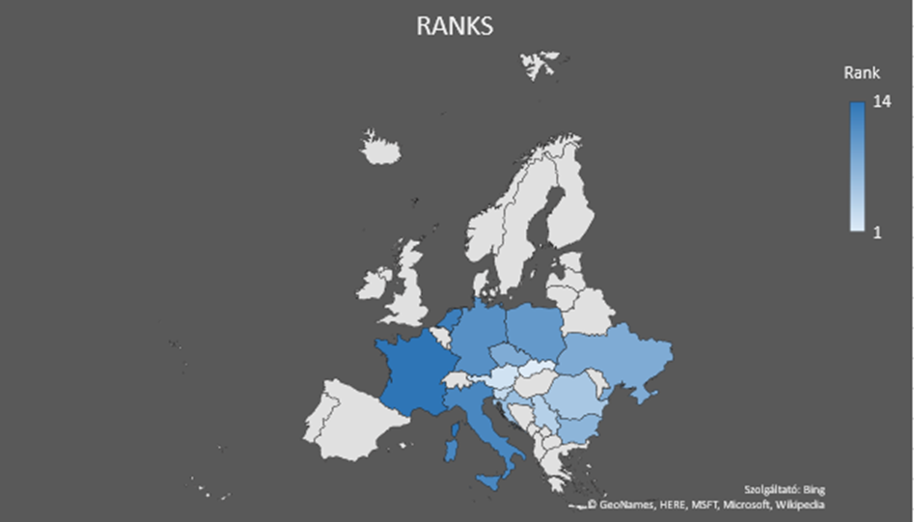

Annex – background information

<https://miau.my-x.hu/mediawiki/index.php/Vita:QuILT-IK045-Diary#9._Day_.282019.IV.17.29>

we can show a graph which everyone can create easily own abstract about amount of tourist according to countries without details.

**Interpretation:** The aggregated time series based on the principle “the more the better” of the diverse sorts of publications has an increasing trend and the **Hungarian** **Tourism** is promoting day by day in the European countries. Publications are products therefore an increasing tourism trend in teh European countries and also seems to be a good sign.

QUALITY OF THE QESTIONS/PROBLEM

This publication is to hightlight some of the question or problems about the tourism in hungary. Why the hungary is more famous for tourism in hungary? What is the reason behind that? Which european countries tourist select hungary for the better tourism destinatoins? what are the some problems identified by the tourists. etc.

In this chapter the basic attributes or aspect is that how hungarian Government can provide the better environment to all the tourists whose who coming from the Europe and also from the whole worl d in Hungary

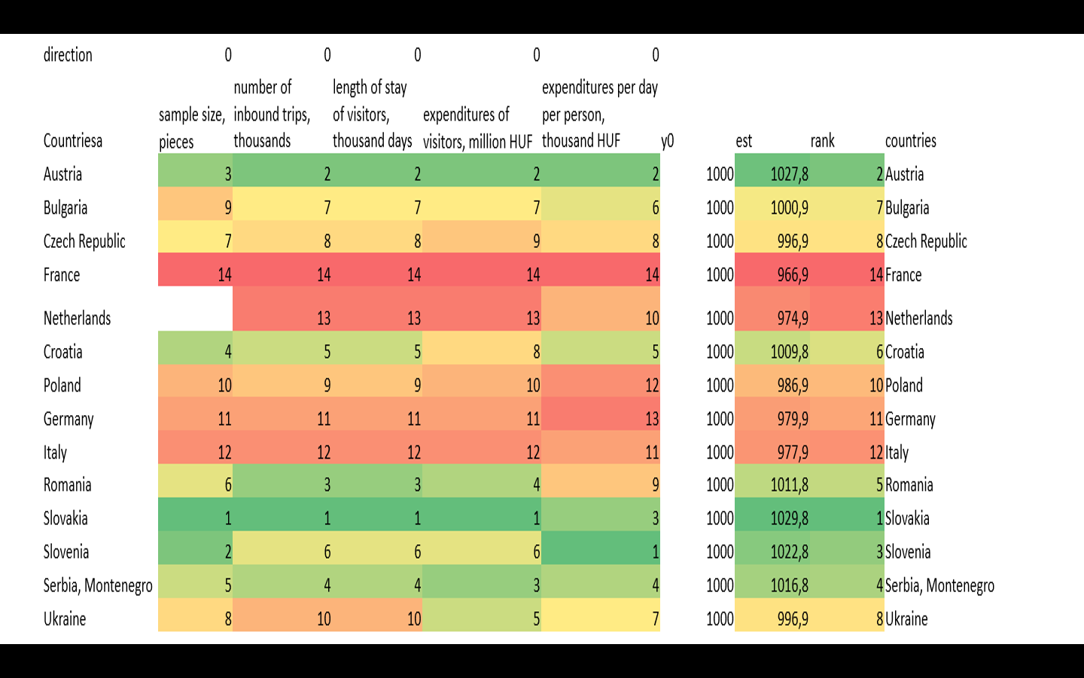

# Results**:**

When we look at the which show us sample size, number of inbound trip, length of stay of visitors, expenditures of visitors, expenditures per day per visitors who came to the Budapest from other countries, we can array them according to index. In this line, we can see that Slovakia, Austria, Slovenia and Serbia form top 4 rank among countries. Also, France, Netherlands and Italy form last 3 rank in the line. First 4 ranks are aqua and last 3 rank dark blue in our map which show us ranks of the counties.

However, there is top 5 countries for Hungary such: Slovakia, Austria, Croatia, Romania and Serbia and the rest are fine or should be attracted by Hungary more.

QUALITY OF THE CREATED MODELS:

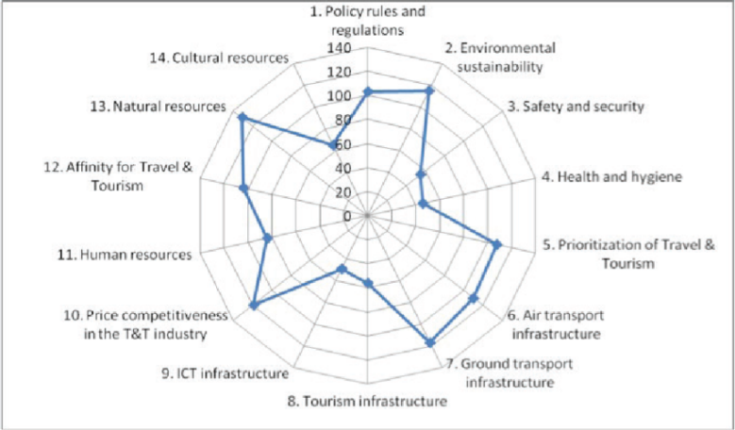

*THIS TYPE OF MODEL REPRESENTS THE STATISTICS AND ASPECTS OF THE TOURISM WHICH IS VERY IMPORATANCE FOR ANY COUNTRY BUT HERE WE DISCUSSED ABOUT THE HUNGARY.*

*THIS MODEL SHOWS WHATS IS BASIC REQUIREMENTS FOR THE TOURIST PRIVDED BY THZE COUNTRY. TOURISM INFRASTRUCRE MODEL REPRESENTS THE COUNTRY VOLUME/SIZE ABOUT THE TOURISM.*

QUALITY OF THE ONCLUSION

**Interpretation/Suggestion:-**

As a result of the research, we surely can say Slovakia, Austria, Croatia, Romania and Serbia, are the best inbound countries for Hungary.

Slovakia has best rank for Hungarian tourism in 14 countries. It means Hungary is attractive country for Slovakian tourists. In addition, Slovakia and Hungary really close to each other, cheap to travel and each two country has similar culture. Diplomatic arrangements can be made to improve the relations between these two countries. Affordable tours can be organized in order to keep good relations between the two countries and not to lose tourists. Also, the government may apply special discount programs for students and retirees. A promotional film that introduces Hungary can be produced and published on Slovak television and websites.

The last rank belongs to France. We can establish good relations with France to improve French people’s tourism rank on Hungary. As same as Slovakia, we can build good diplomatic relations with France. Seminars can be organized in France at schools to promote Hungarian tourism and places to travel. Through the mutual agreement, Paris Budapest tours can be organized in particular. Tourism can be supported with promotional films and advertisements.

**Conclusion:**

Finally, it is possible to exchange tourists with mutual agreements in both countries. Cheap tours can be organized by applying special discount programs. Historical places and natural beauties can be supported with visuals. Result of the data, we can present some ideas about which should we focus on countries to gain more profit? More profit can be realized based on an alternative hypothesis see future visions.