Harmony-index
Laszlo Pitlik, Laszlo Pitlik (jun), Matyas Pitlik, Marcell Pitlik (MY-X team)
Abstract: The classic literature works based on the magic of words. In the canon-oriented literature, specific terms like harmony can be used without the necessary details in order to approximate the KNUTH’s principle. This paper tries to demonstrate how it is possible to convert human intuitions into models. Parallel, the paper can be seen as a kind of minimum requirement for creating papers in general. The paper demonstrates a simple technique (based on similarities) for deriving optimum values in case of the harmony-index substituting randomized guessing of service parameters and/or creating complex analytical models.
Keywords: service science, service design, service management

Introduction
This paper is the newest part of the series about experiences of the QuILT-based education processes. Previous articles and their annexes can be downloaded here:
- https://miau.my-x.hu/miau/quilt/Definitions_of_knowledge.docx + annexes like:
  - https://miau.my-x.hu/miau/quilt/demo_questions_to_important_messages.docx
  - https://miau.my-x.hu/mediawiki/index.php/QuILT-IK045-Diary
  - https://miau.my-x.hu/mediawiki/index.php/Vita:QuILT-IK045-Diary
  - https://miau.my-x.hu/mediawiki/index.php/QuILT-IK059-Diary
  - https://miau.my-x.hu/mediawiki/index.php/Vita:QuILT-IK059-Diary
- https://miau.my-x.hu/miau/quilt/reality_driven_education.docx + annexes like:
  - https://miau.my-x.hu/miau/quilt/chained-translations-legal-slang.docx
  - https://miau.my-x.hu/miau/quilt/demo_chained_translations.docx
  - https://miau.my-x.hu/miau/quilt/demos_chained_translations.docx
  - https://miau.my-x.hu/miau/quilt/forum_details.docx
  - https://miau.my-x.hu/mediawiki/index.php/QuILT-IK057-Diary
  - https://miau.my-x.hu/mediawiki/index.php/Vita:QuILT-IK057-Diary
- https://miau.my-x.hu/miau/quilt/Exercises_for_critical_thinking_and_doing.docx
- https://miau.my-x.hu/miau/quilt/st1_all.docx
- https://miau.my-x.hu/miau/quilt/20Q.docx
- https://miau.my-x.hu/miau/quilt/GDP_final_en.doc
- https://miau.my-x.hu/miau/quilt/st2_all.docx
Parallel, there are a lot of spreadsheets supporting the needs for details: https://miau.my-x.hu/miau/quilt/?C=M;O=D

The main process – or defining objectives
The classic literature works based on the magic of words. Specific terms like harmony can be used without the necessary details in order to approximate the KNUTH’s principle. This paper tries to demonstrate how it is possible to convert human intuitions into models. Parallel, the paper can be seen as a kind of minimum requirement for creating papers in general.
The starting point should be a searching task with relevant keywords (here and now for the course) – like: https://miau.my-x.hu/mediawiki/index.php/QuILT-IK045-Diary#Basic_version_.28re-acting_to_learning_materials.29
The result of this searching activity could be a document containing appropriate parts being interesting enough for further modelling: “For products and services to be successful, they need to harmonize seamlessly with the customers’ needs and perceptions. Service design is an instrument for achieving this harmony.” (URL = https://www.stby.eu/wp_15/wp-content/uploads/2013/12/Service-Design-insights-from-nine-case-studies.pdf)
In order to be capable to create a harmony-index (the measure of the harmony), it is necessary to create a thinking experiment where we can derive the objectives of the planned modelling. Objectives should be constellations where at least one decision point can be identified. Here and now: we will need at least a model being capable to measure harmony in case of customer needs contrary to service characteristics in an objective way. Based on the harmony-index, decision makers (or robot experts) should be able to identify and/or execute necessary actions. The result of this action should lead to a better situation as before. After identifying the strategic level of an action (it means the basic direction of an action), it is also necessary to be able to select the best alternative way for realizing the needed effects. Therefore, at least two models are necessary where the second model is a model supporting selections of alternative solutions/actions.
From point of view of the quality management, a third model would also be necessary: this model should be capable of evaluating alternative MODELS. This evaluation is the same process as the evaluation of alternative actions. The challenge is however: what kind of attributes could be involved into the anti-discriminative modelling? This comparison could just be ensured, that a model e.g. for deriving the harmony index is better than the given alternatives.

Creating a harmony index
Harmony index could be created based on questionnaires where the questions are: Are you satisfied with a lot of attribute of a service (e.g. education can be seen as a kind of service – c.f. principle of “the ocean in a drop”). Personal satisfaction could be estimated in a totally subjective and arbitrary way by each person based on a scale e.g. from 1 to 10 where 1 < 10. The satisfaction scores for each variable could be aggregated in form of an average value for a person or for all persons - like in the schools concerning marks. This naïve/instinctive way can be interpreted as the most trivial alternative solution where nobody want / is able to derive/explain way should have each mark-change the same force field as an other change.
An other way would be an other questionnaire where the questions would be more sophisticated. Instead of asking the totally subjective opinions of the answerer about a low-level-defined term “satisfaction”, the answerer should declare personal requirements (numeric parameters for a contract).
If the two parallel questionnaires were prepared and used for the same set of attributes and in case of the same persons, then the consistence of the thinking processes of the persons could be visualized: a person is less consequent if the relations of the numeric personal requirements and the numeric service characteristics have an other direction as the personal/arbitrary evaluation of the attribute by using the fictive scale for satisfaction (1<10). Inconsistences could be identified in several ways like:
- inconsistent is a constellation, if a personal satisfaction value demonstrates the lack of satisfaction but the service parameter for the particular attribute is higher than the needs of the person in such a case of attribute where the more the better principle can be identified
- inconsistent is a constellation, if a subjective satisfaction value of an attribute is lower than the satisfaction value of an other attribute although the distance between the needed value and the service standard of this attribute is better compared to the distance in case of the other attribute
The questionnaire’s questions, the attributes of a questionnaire can be identified in form of an interview where each person may make one/more offer(s) about relevant aspects of a service concerning customer’s feelings about their satisfactions.
Figure Nr1 can be seen as the result of a series of interviews. Each further figures can be identified in the model-spreadsheet: https://miau.my-x.hu/miau/quilt/harmony_index3.xlsx
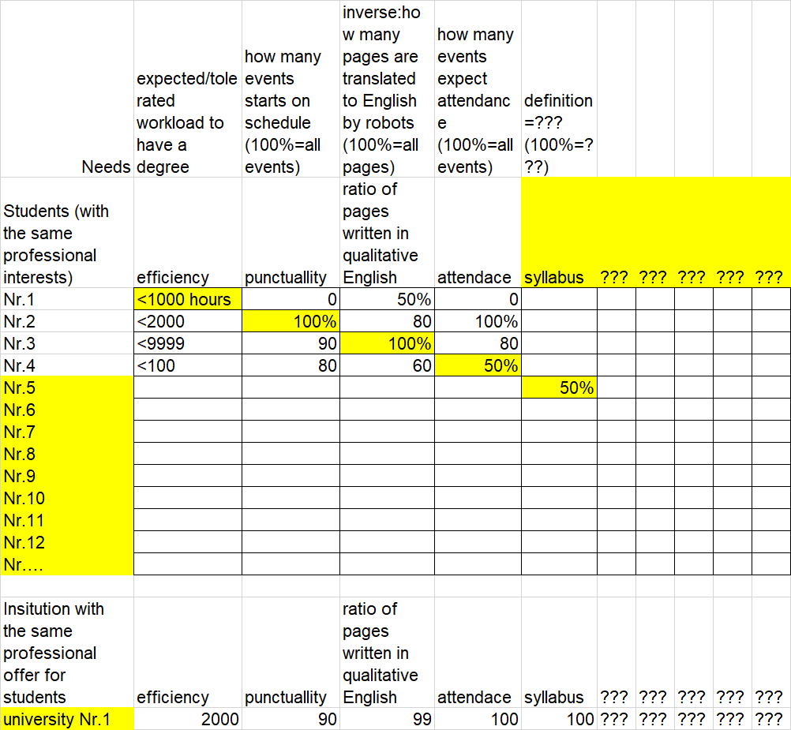
Figure Nr1: Attributes and personal needs of Students (source: thinking experiment)
Attributes can be quasi arbitrary phenomena where a kind of numeric needs can be formulated (measured) like:
- I think, the pre-planned amount of contact hours with teachers could be less than … unit.
- I think, the accuracy of starting times might never be less than 100%.
- I think, a ratio is acceptable to have scripts translated by robots from foreign languages in case of lower than 50% of all script pages.
- I think, the checking of attendance concerning pre-planned events should be approximately lower than 10%...
Contrary to the personal Student’s needs, the university could have arbitrary parameters. If the Students should derive their needs compared to the university’s parameters (where these parameters should be seen as 100%) then the needs/expectations/requirements of Students will be available in percentual values (see Figure Nr2):
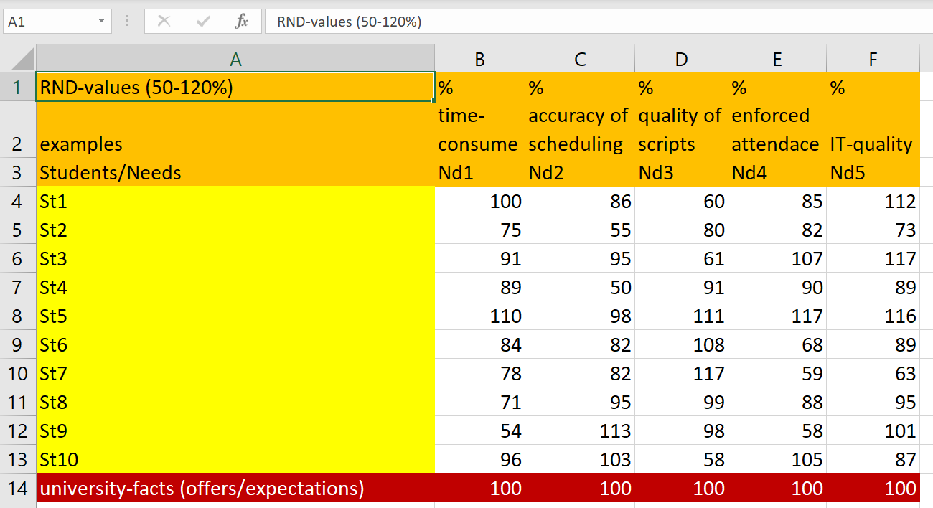
Figure Nr2: Random database about relative needs of Students (source: own presentation)
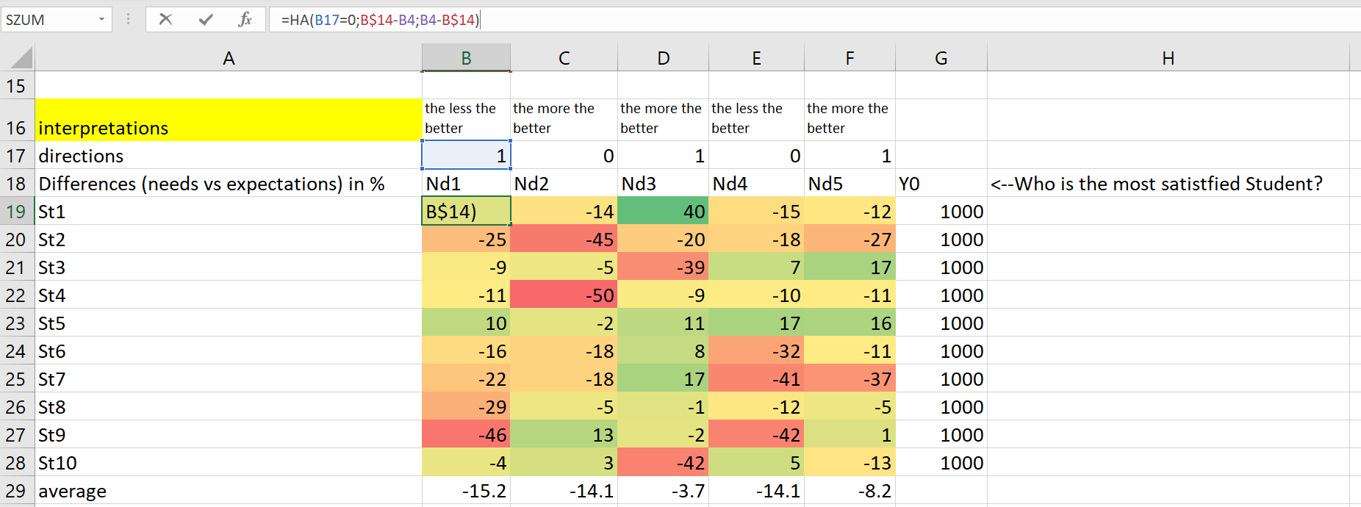
Figure Nr3: The differences with signs between Student’s needs and university parameters (source: own presentation)
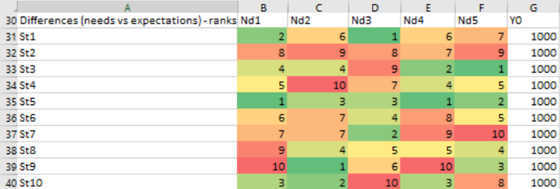
Figure Nr4: Ranking values based on the absolute differences and the attribute’s directions (source: own presentation)
As it can be seen (Figure Nr3), the differences may be interpreted based on a kind of direction (defined from the point of view of the Students):
- the less is the workload for a degree the better is the (education) service for the Students in general
- the higher is the accuracy concerning scheduling the better is the (education) service for the Students in general
- the more is the ratio of human-translated scripts the better is the (education) service for the Students in general
- the less is the enforced attendance for a degree the better is the (education) service for the Students in general, …
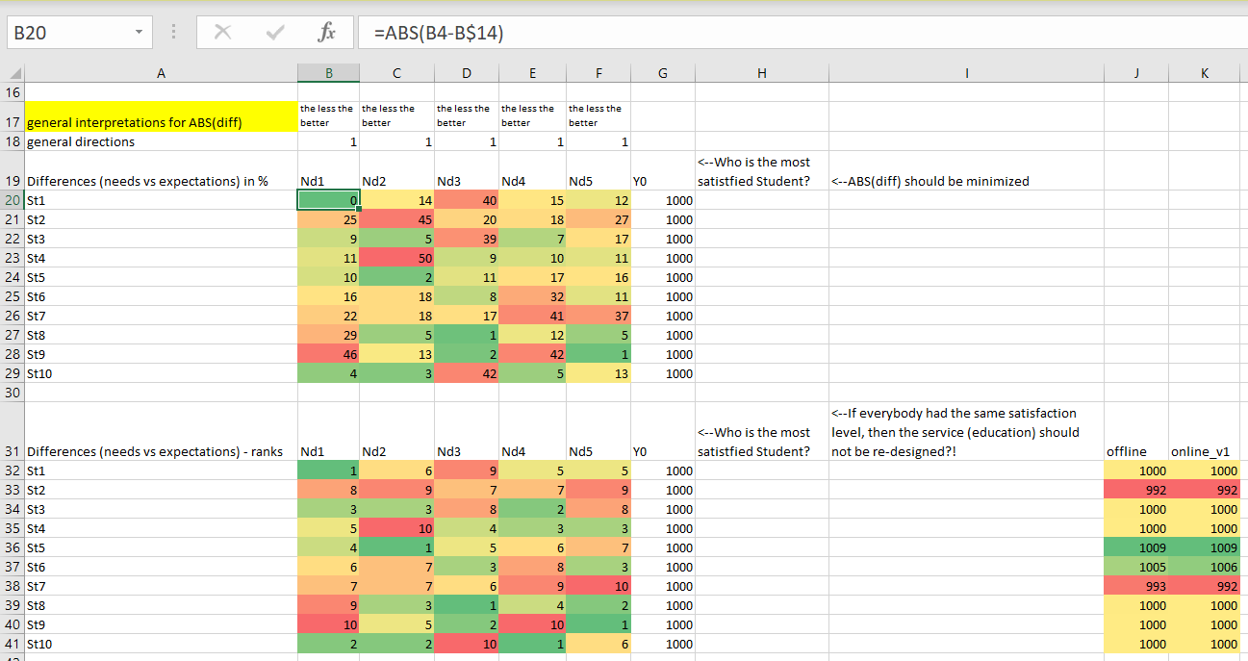
Figure Nr5: The absolute differences and their ranks based on the general direction (source: own presentation)
Figure Nr5 and Figure Nr3-4 highlight a relevant problem for calculation of a harmony index: What should be interpreted as a kind of harmony?
- the differences with signs and with a general direction: the higher the better?
or
- the absolute differences with the general direction: the less the better?
The first approach seems to be rel. confuse because:
- Why should have a person more harmony if this person wants to have more workload than given and/or more attendance than given compared the other persons they want to have less workload and less enforced attendance?
- What kind of role should play the attribute-specific direction in the calculation of harmony?
The seconds approach seems to be rel. simple:
- Each unit of difference (independent from the sign) is a kind of reason to be unsatisfied.
- Each difference should be minimized to have more satisfaction.
Therefore, the Figure Nr5 will be used as basis for the further calculations where an offline calculation can be executed based on the Excel-Solver add-on and the online solution can be derived based on the online analytical service MYX-FREE: https://miau.my-x.hu/myx-free/coco/
The question WHO IS THE MOST SATISFIED STUDENT? can be answered through antidiscriminative models where each Student could have the same satisfaction/evaluation-value (see 1000).
Unfortunately, one single model about one set of service-parameters and one set needs of Students does not make possible to speak about a scale for harmony. The same or different evaluation values for Students do not speak about the harmony as such in a direct way.
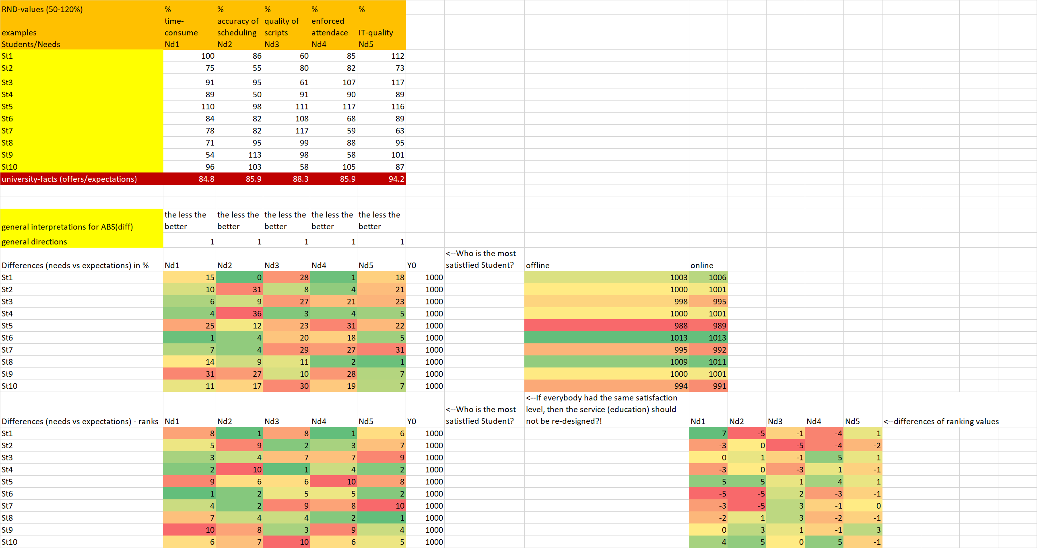
Figure Nr6: New calculation based on new parameters of the university (source: own presentation)
If the university’s service parameters will be changed e.g. toward the average needs of the Students, then the new set will be used for calculation of absolute differences and ranking values. The new question is hereby: What kind of parameter set can be seen as basis for more satisfactions among Students?
The two single models created till now should be transformed into one common harmony-scale:
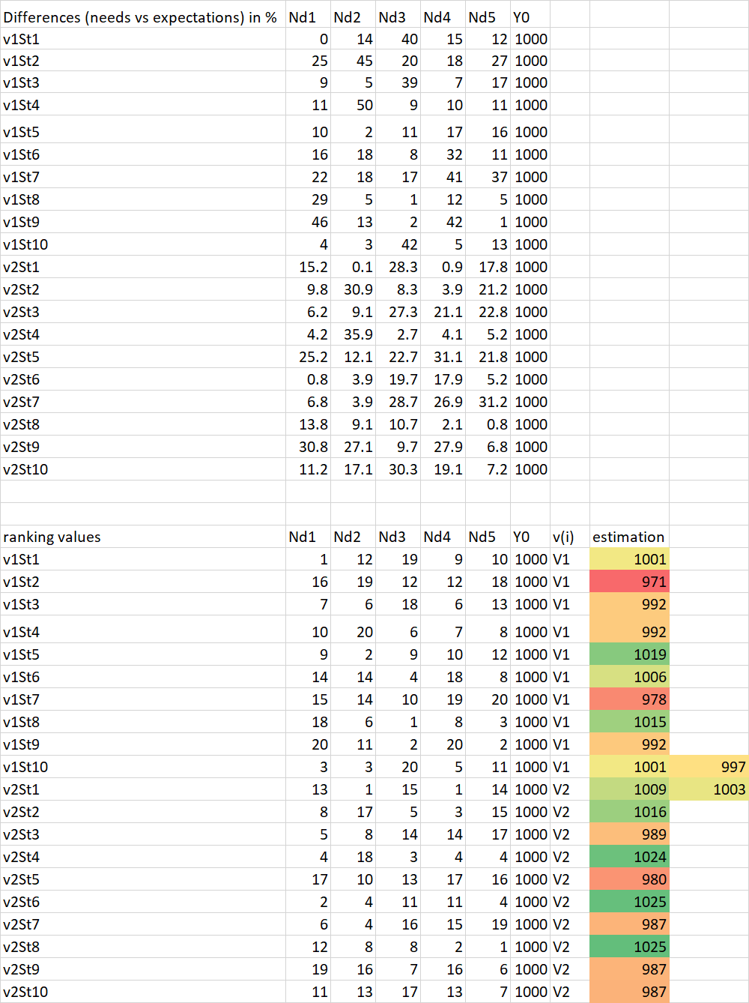
Figure Nr7: The aggregated view of the previous (v1, v2) models (source: own presentation)
As it can be seen (Figure Nr7):
- the versions of absolute differences derived for each Student based on the two parameter sets lead to new personal satisfaction level for each Student (compared to the single models above)
- the first parameter set (v1) leads to a lower average satisfaction (997) than the second (v2) version (1003)
- therefore, the pair-wise comparison makes possible to derive the better version
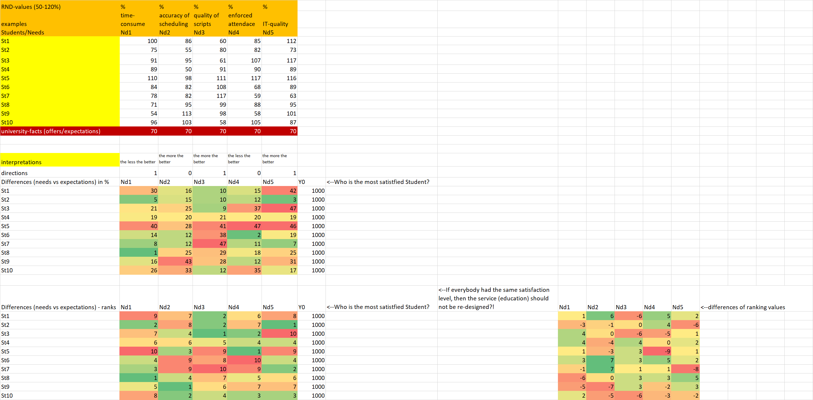
Figure Nr8: Arbitrary service parameters (source: own presentation)
Figure Nr8 shows a scenario where the university’s parameters will be reduced to 70% in general – as a kind of thinking experiment. The question will be hereby: Will this new set lead to a higher satisfaction than in case of the temporary winner (v2)?
Figure Nr9 presents the comparison of the second and third scenarios. As it can be seen: the average satisfaction level is higher in case of the second scenario. Therefore, the arbitrary (third) scenario could not bring higher satisfaction.
The optimizing of the harmony index is not focused here and now. This task needs a new paper. Based on the previous modelling steps, it is possible to compare parameter sets (pair-wise or even holistic). So, the approximation of the optimal parameter set can be realized step by step. A more efficient method would be, if a lot of further (parameter) versions and their aggregated comparison values could be derived compared to the rel. winner (v2).
The result of this step would be a new OAM (object-attribute-matrix) where the objects would be the versions, the independent attributes (Xi) would be the parameters and the conclusion variable (Y) would be the aggregated comparison values. This starting OAM could be interpreted like a production function where we are searching for the impact (Y) of arbitrary input-constellations (Xi).

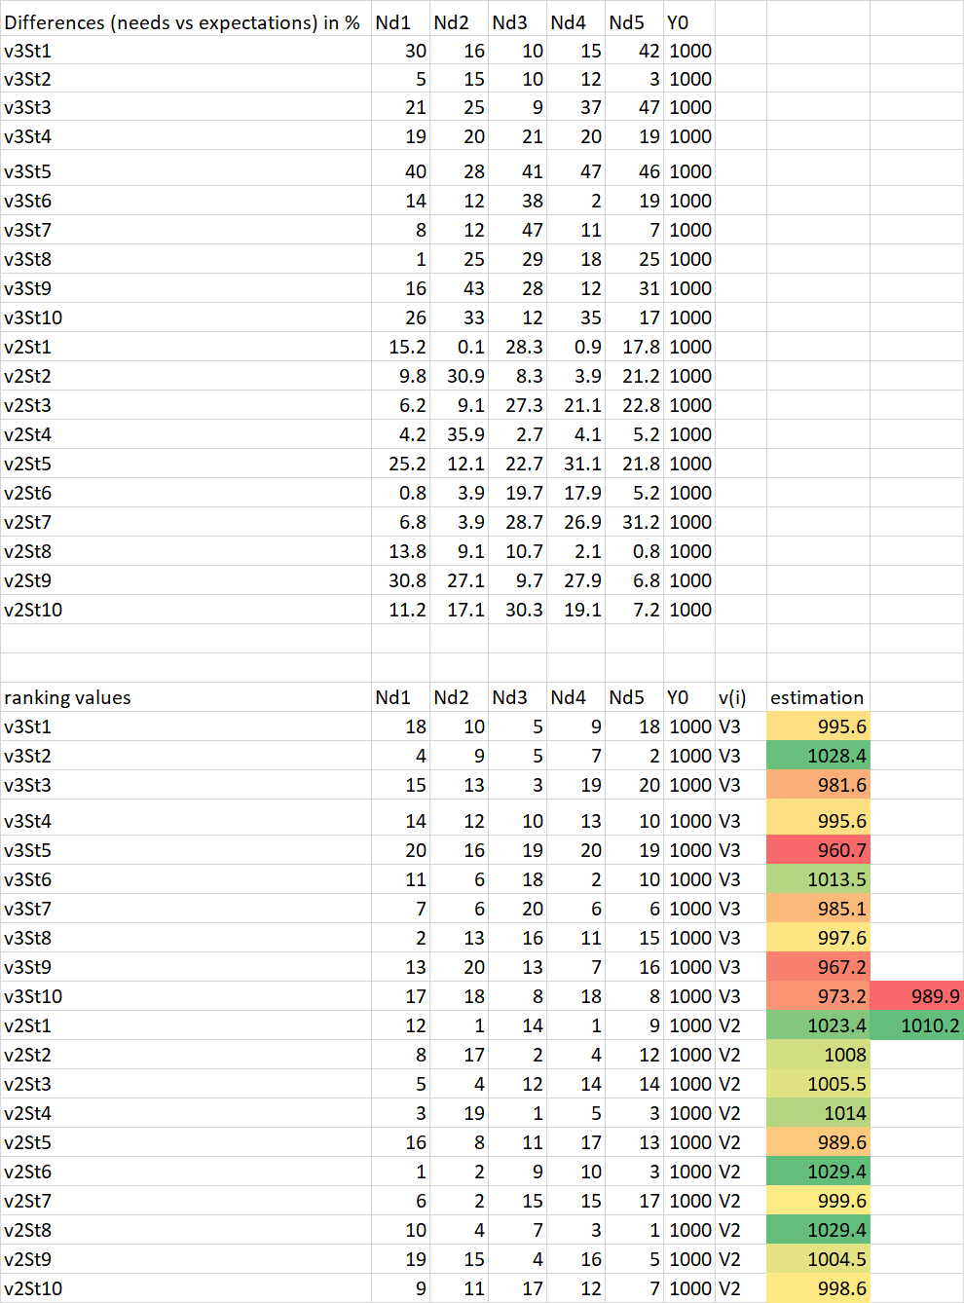
Figure Nr9: The third and the second scenarios compared to each other (source: own presentation)

Figure Nr10 demonstrates the detailed steps:
- in case of 5 scenarios (parameter sets)
- and based on direction of Student’s preferences (see above)
- the ranking values can be derived
- in order to estimate the previous comparison values (where v2:v2 should have the basic value=1000)
- so, the model (the estimation of the production function) delivers a higher maximum value (min. 1001) like before (1000)
- because the ideal set of the inputs (1:1:1:1 from point of views of the ranking values) could still not be realized
- for realization of the ideal ranking set
  - X1 should be decreased based on the calculated staircase function
  - X3 can be increased based on the finetuned staircase function where the value for the first stair of 4 is the minimal value (s not fine-tuned version with the value of 986)
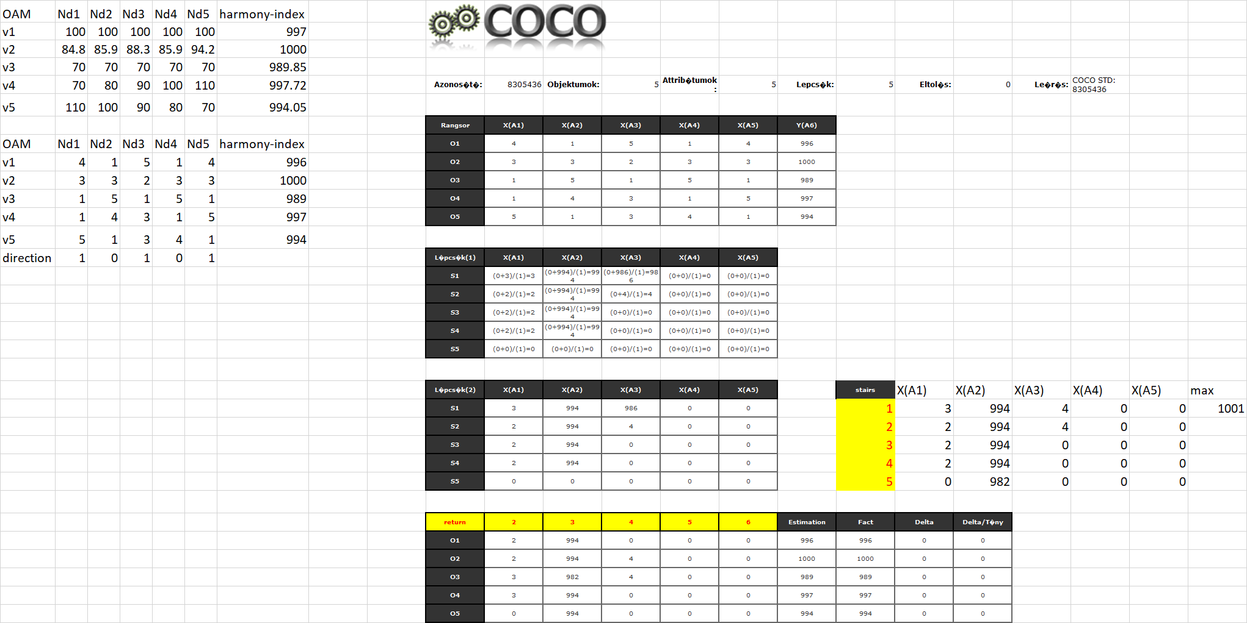
Figure Nr10: The production function (source: own presentation)
The Annex (with the Figure Nr11 and Nr12) demonstrates the details after the fine-tuning of the parameter set of the university based on the signs coming from the production function.
The above outlined and presented steps for optimum-oriented fine-tuning without randomized searching need a lot of randomized scenario and the estimation of the appropriate production function but this solution needs no deep mathematical approaches for optimizing. It is possible because the estimation of the production function based on the similarities of the randomized chosen parameter sets and their impacts are capable to simulate a kind of genetic potential effect. The genetic potential effect means that the ideal input scenario from point of view of the ranking values (1:1:1:1:1) makes possible to estimate a new best scenario and its potential impact to the harmony-index so that in case of each input variable, it will be possible to derive the direction (but still not the exact unit) of the necessary changes.

Searching for the best action
The Figure Nr13 demonstrates a new OAM for the question: What kind of action should be preferred if the expected result of each action should be the same (c.f. 1000) – here and now: the same increasing of the quality of the learning materials:
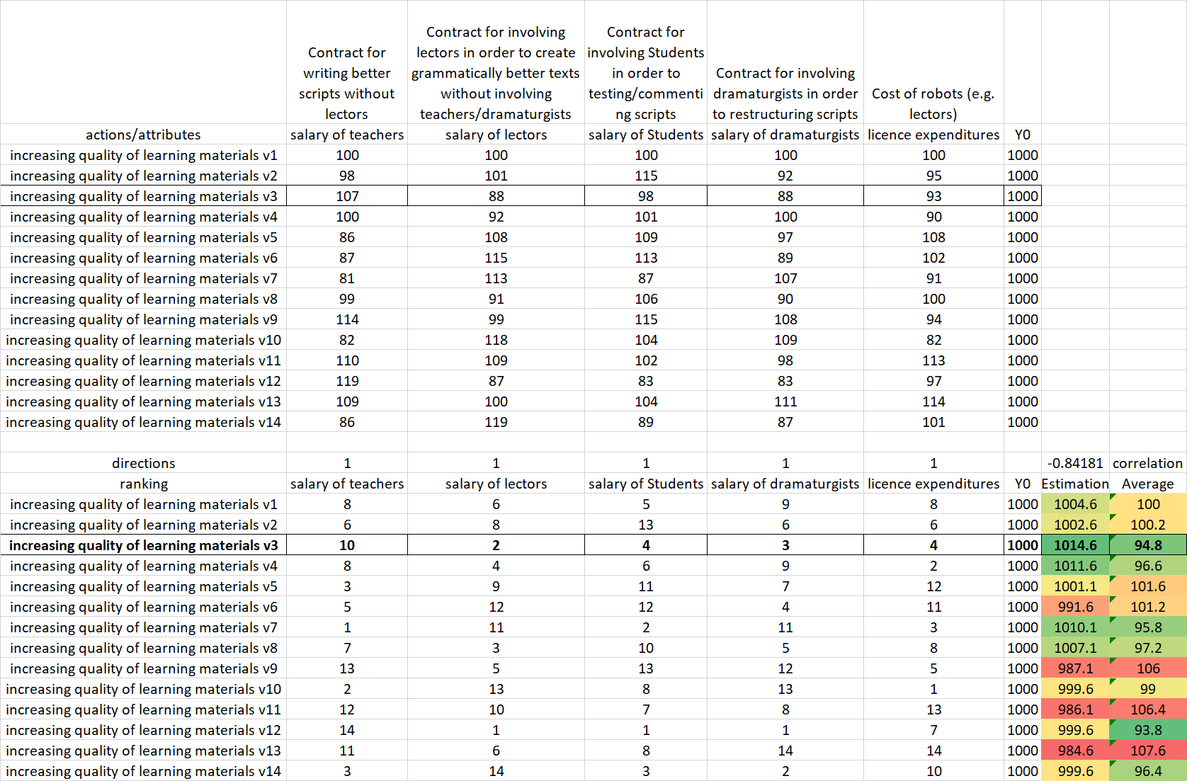
Figure Nr13: OAM for competitive evaluation of alternative actions (source: own presentation)
If each action has to same impact, then it is necessary to search for the less resource-intensive alternative. If the description variables of the actions may be aggregated in a naïve way (it means: the dimension are the same for each variable and therefore it seems to be possible to involve each variable into a calculation chain – at least in the deriving of averages/sums/etc.), then this can also be interpreted as a rational approach.
If the dimensions of the variables do not permit any calculation, then we need a kind of similarity-based estimation (see Figure Nr13). Similarity-based interpretation can also be derived in case of variables with the same dimensions. The similarity-based and the naïve solutions could deliver the same ranking values for the objects (actions) or it is also possible to have the same winners.
If the estimated impacts of the planned actions (competitors) are not the same (like here and now), then it is possible to derive a new production function for estimating the expected impacts. In this case, the winner would be (c.f. price/performance ratio-analysis) where the modelled impact is higher than the pre-defined impact and the ratio of the modelled value and the pre-defined value is the highest one.

Conclusions
As it can be seen:
- the magic of words can create a short sentence about an abstract phenomenon like harmony
- but the transformation of a single human abstraction into the KNUTH’s world can need a lot of modelling steps
- this modelling steps can be arbitrary difficult
- yet, the similarity-based approaches like
  - anti-discriminative modelling where the consequence variable (Y) is not really existing – c.f. harmony-index or
  - modelling of production functions where the Y is a valid phenomenon with real (different) values
- are capable of supporting interpretations/estimations for decision making processes on a level
- what can be accepted in form of a Turing-test
- where the robot performance and the human performance might not be evaluated with a different value…
From point of view of the service sciences (service design):
- the magic of words supports understanding processes so that the misunderstanding can lead to innovations, but it can also lead to bad (subjective/instinctive/naive) human decisions
- the model-based approaches do not need complex mathematical knowledge yet they are useful for creating robots with positive Turing-tests…

Annex
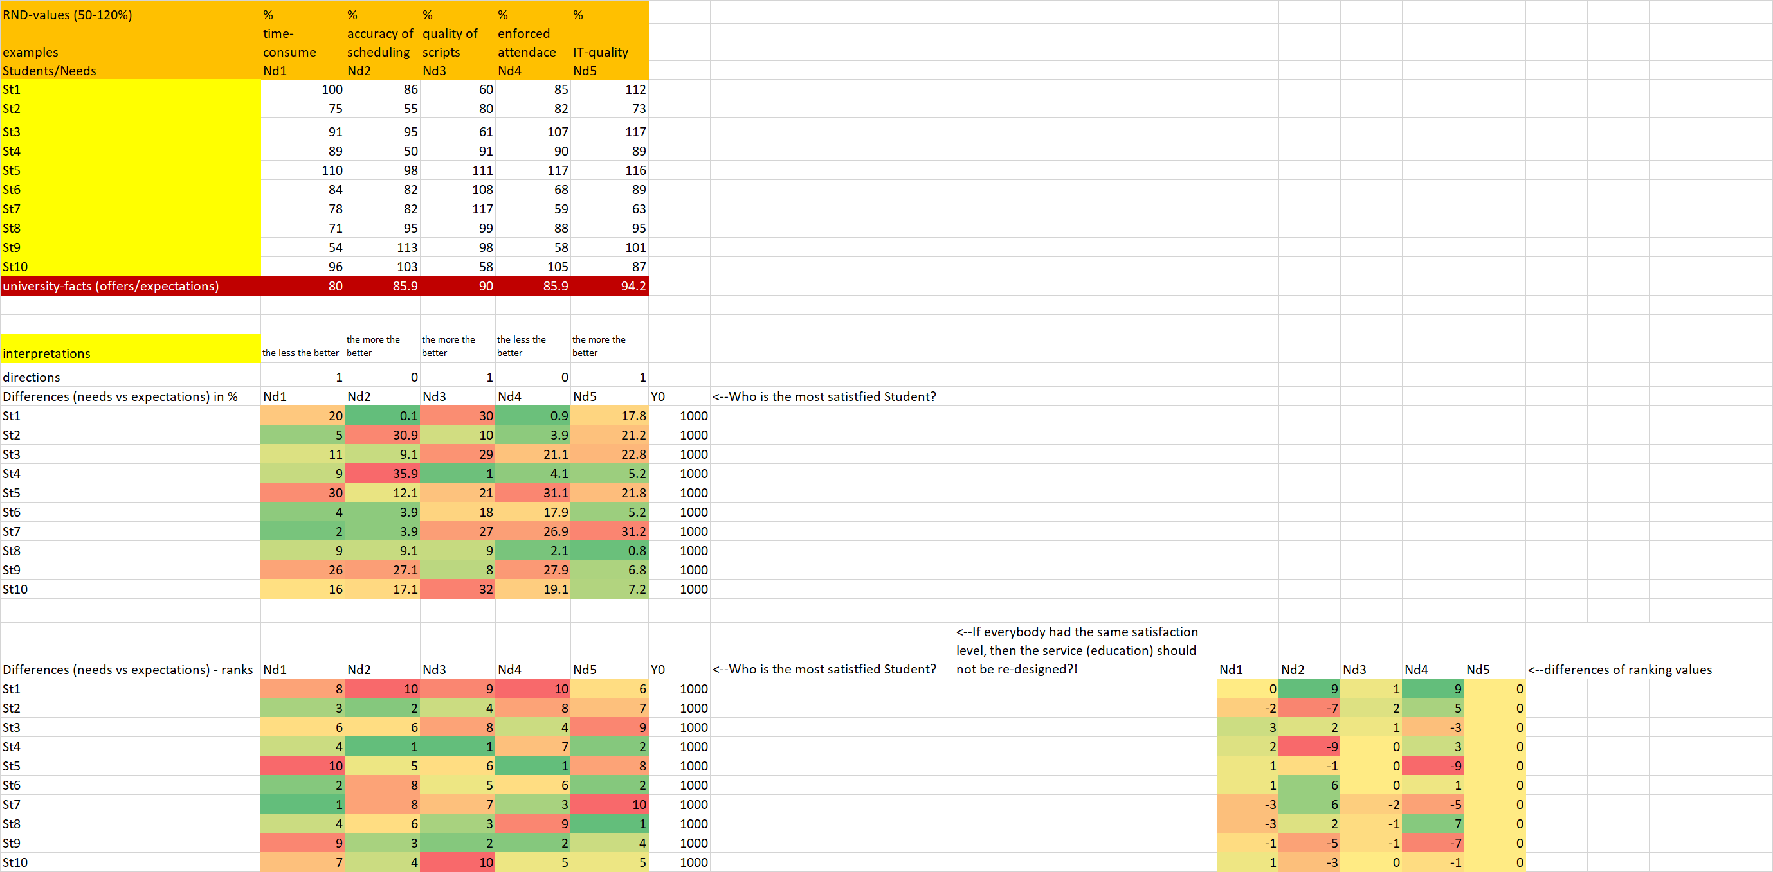
Figure Nr11: Scenario based on the production function (source: own presentation)

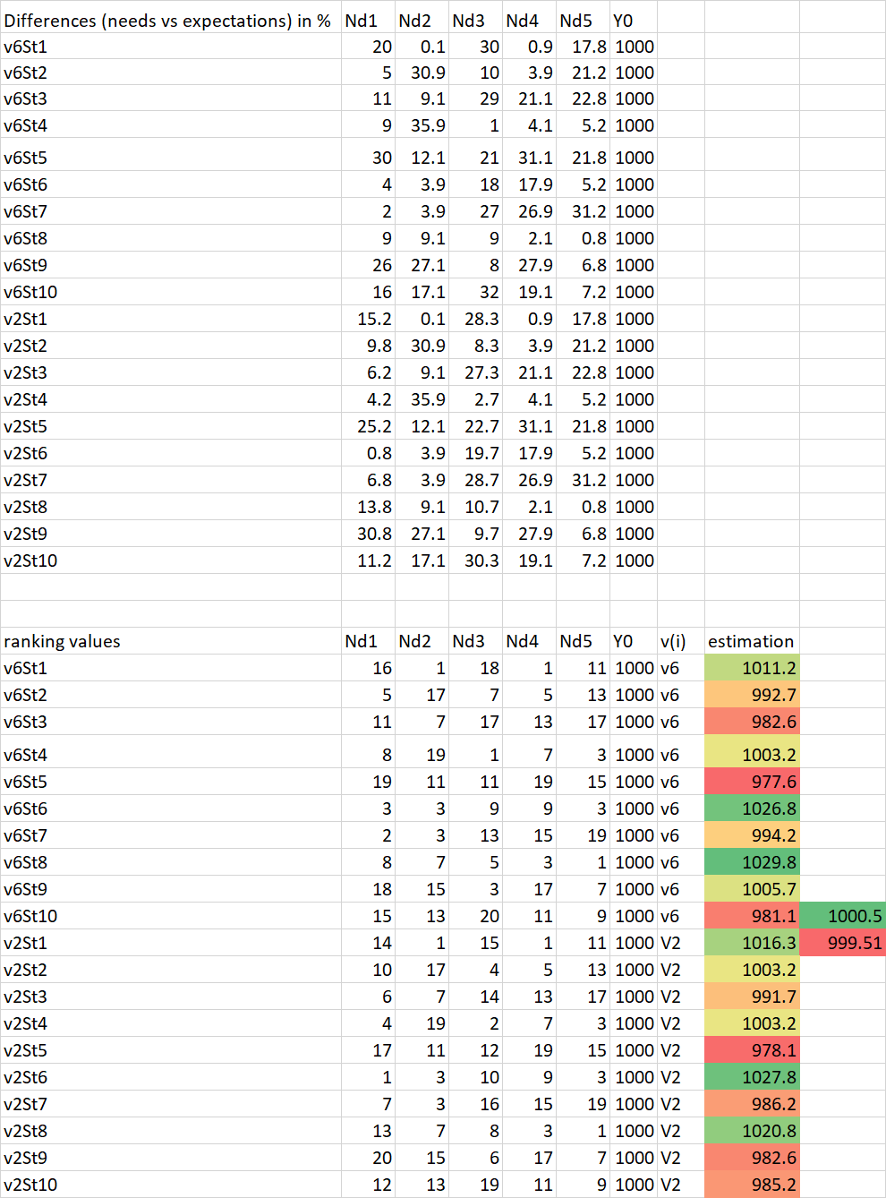
Figure Nr12: Scenario v2 to v6 (source: own presentation)

