MIAU – HU ISSN 141921652 – Special Edition 2019. May

Editorials: The papers in MIAU Nr.249 (2019.V) are products of a new education frame “QuILT” (<https://miau.my-x.hu/mediawiki/index.php/QuILT>).

The goals of QuILT are supporting/conducting Students on the way of KNUTH, who said (1992): Knowledge is, what can be transformed into source code, each other human activity is a kind of artistic performance. It also means we need to leave the world of the magic of words step by step. A solid evidence that we all are capable of going this way is: creating publications behind which the human expertise and the robotized knowledge (like online engines: <https://miau.my-x.hu/myx-free/coco/index.html> --- offering context free = quasi General-Problem-Solving force fields) can be integrated in case of a rational and relevant decision making scenario. The cyborg effects make possible to face the classic naïve and/or intuitive approaches and parallel the optimized approximations. This way can be realized without deep competences about mathematics, Excel (spreadsheets), statistics, etc. The new (inter/trans/multi-disciplinary) way just expects from us to be able and willing to co-operate with the best moments of the history – it means, with the already prepared robotized elements in order to build something creative one!

Laetitia Vira

laetitiavira@gmail.com

EVALUATION OF THE GREEN ZONE IN THE EU

Abstract

The purpose of this publication is to evaluate the EU countries as part of the Green zone using relevant data from Eurostat and re-create an index according to the collected data.

In order to reach the aim of the publication, the steps below played an important role:

* Collection of data from Eurostat: we picked the data related to ecological field, which helped us observe how green were the EU countries, which are going to be listed later in the publication.
* The data were processed and ranked, which constituted the new index. This re-created index is then compared to the result of the Global green economy index 2018.
* The Source URL for the publication about the backgrounds:

<https://miau.my-x.hu/miau/quilt/reconstruction_of_ggei_2018.xlsx> and the URL used for modelling:

<https://miau.my-x.hu/myx-free/coco/beker_std.php>

Fig. Nr1 – Raw data (source: own presentation)

The first set of collected data was the Global green economy index 2018, expressed as percentiles representing an aggregate result from the four main dimensions of the GGEI: leadership & climate change; efficiency sectors; markets & investment; and

environment.

Fig Nr2: Market shares (source: official statistics)

Market share of the largest generator in the electricity market - as a percentage of the total generation

The dataset is based on the principle “the more/the less” for the GGEI value. The more is the share, the less ecological is the country, therefore, the less green it appears on the index. The values are expressed in percentage.

Fig Nr 3 – Heating degree days (source: official statistics)

Fig Nr 4 – Cooling degree days (source: official statistics)

Fig Nr 3 and 4:

The dataset is based on the principle “the more/the less” for the GGEI value. The more are heating or cooling days, the less ecological is the country, therefore, the less green it appears on the index. The values are expressed in days.

Fig Nr 5 – Cocenant of mayors for climate and energy signatories (source: official statistics)

The dataset is based on the principle “the more/the better” for the GGEI value. The more are the people covered by the covenant, the more ecological is the country, therefore, the greener it appears on the index. The values are expressed in million persons.

Fig Nr 6 – Average CO2 emission per km (source: official statistics)

The dataset is based on the principle “the more/the less” for the GGEI value. The more is the amount of CO2 emission, the less ecological is the country, therefore, the less green it appears on the index. The values are expressed in gram per kilometre.

Fig Nr7 – Estimated GEEI based on similarity analysis (source: official statistics)

With the collected data from Eurostat, we re-created the green economy index. Which was then compared to the first.

Fig Nr8 Chart comparison: GGEI 2018 vs estimated GGEI (source: own presentation)

On the chart, it is obvious that the values almost coincide, except for a few countries, which are Austria, Czech Republic, Slovakia, Ireland and United Kingdom. These countries case is going to be explained later in the publication.

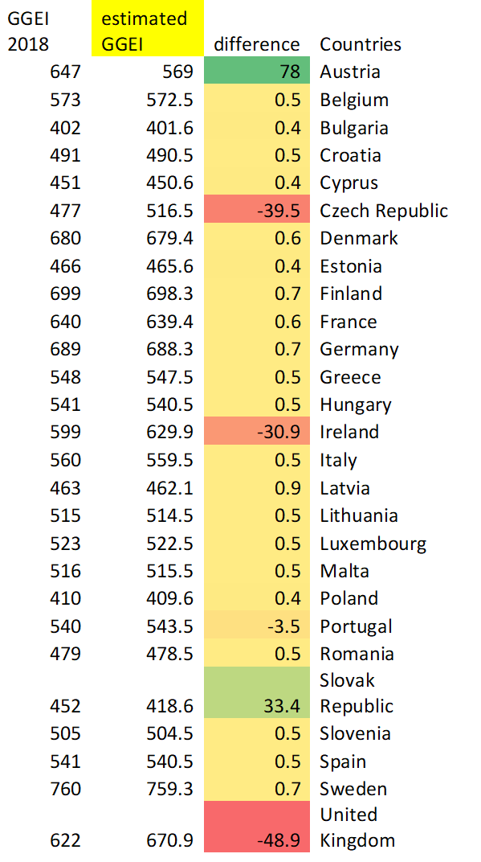

Fig Nr9 Table comparison: GGEI 2018 vs estimated GGE

This table presents the same comparison in details:



Fig Nr10 Raw data (source: own presentation)

The dataset above contains all the chosen and assembled data, before the ranking.



Fig Nr11: Ranked data with visual effects (source: own presentation)

After processing the chosen data, as well as ranking, the estimated GGEI appears on the table, followed by the observation of the difference between the GGEI 2018 results and the estimated GGEI.



Fig Nr12 Model (source: own presentation)

Modelling URL: <https://miau.my-x.hu/myx-free/coco/beker_std.php>

Remarks tot he countries having the highest estimation errors:

If somebody makes a look back to the years based on what the GGEI was calculated, particularly for the countries we are discussing, Austria's GGEI results was based on the range 2010-2018, the picked years for the attributes are in the time frame, however, for the attribute "Market share of the largest generator in the electricity market - as a percentage of the total generation", the are no data except for 2011 and 2012, so, I used those. Same issue for UK, the available data were 2012 and 2013, the later years' data are not available on the table. While for the rest of the countries on the list had the 2016-2017 data. Moreover, Slovakia's GGEI was calculated based on only one year: 2018. While the database I created contained more data for this country.

Conclusion

The Global Green Economy Index (GGEI) 2018 had been reconstructed and the new result is close to the first. The picked years influenced the new result. The GGEI 2018 is based on a certain range of years -for example for Greece, a range of 2010 to 2018; Hungary,2016 to 2018 – some of the years were not taken into account, nevertheless, the result turned out to be the same for the countries mentioned above. This could mean that most of the countries had the same trend in their “greenness” over a certain number of years. Nonetheless, some countries ( Austria, Czech Republic, Ireland, Slovakia-whose GGEI was given only for 2018, unlike the reconstruction which ranged previous years as well- and UK) do not have similar numbers on their yearly indicators, which gave a different result for the picked years.