**Subject:** Service Science and Knowledge Economy: Research Methods

Title:

Authors:

Key Words:

• Countries

• Tourists

• Expenditures

• Population

Abstract:

We can estimate a data which is really close to next year of data about tourist numbers with our data which show sample size, number of inbound trips, length of stay of visitors, expenditures of visitors, expenditures per day per visitor. Result of the data, we can present some ideas about which should we focus on countries to gain more profit? Besides, we can determine which countries are in last ranks and we can try to find new solutions. For example, we determined that France is last country in amount of tourist which visited Hungary in 2018 and we found new ideas to increase quantity of tourists from the France with our Interpretation Expert because we can see that there is a direct proportion between expenditure and tourists. Also, we can show a graph which everyone can create easily own abstract about amount of tourist according to countries without details.

Best country/countries:

Methodology:

Usage/utility:

Introduction

Goals/Objectives

Utility

Data assets

Data-processing

Results

Conclusions

References

**The team work**

In a previous lesson, we worked on identifying and calculating the best countries for Hungary as an attractive touristic place . We chose the statistics of the year 2018 and after clarifying the proper data, 14 countries left on the list.

**Austria**

**Bulgaria**

**Czech Republic**

**France**

**Netherlands**

**Croatia**

**Poland**

**Germany**

**Italy**

**Romania**

**Slovakia**

**Slovenia**

**Serbia,**

**Ukraine**

As a result of the research, we surely can say Slovakia, Austria, Croatia ,Romania and Serbia, are the best inbound countries for Hungary.

Slovakia has best rank for Hungarian tourism in 14 countries . It means Hungary is attractive country for Slovakian tourists. In addition Slovakia and Hungary really close to each other , cheap to travel and each two country has similar culture . Diplomatic arrangements can be made to improve the relations between these two countries. Affordable tours can be organized in order to keep good relations between the two countries and not to lose tourists. Also the government may apply special discount programs for students and retirees. A promotional film that introduces Hungary can be produced and published on Slovak television and websites.

The last rank belongs to France . We can establish good relations with France to improve French people’s tourism rank on Hungary. As same as Slovakia , we can build good diplomatic relations with France. Seminars can be organized in France at schools to promote Hungarian tourism and places to travel. Through the mutual agreement, Paris Budapest tours can be organized in particular. Tourism can be supported with promotional films and advertisements.

Finally, it is possible to exchange tourists with mutual agreements in both countries. Cheap tours can be organized by applying special discount programs. Historical places and natural beauties can be supported with visuals.

Annex – background information

<https://miau.my-x.hu/mediawiki/index.php/Vita:QuILT-IK045-Diary#9._Day_.282019.IV.17.29>

Annex – data visualization items

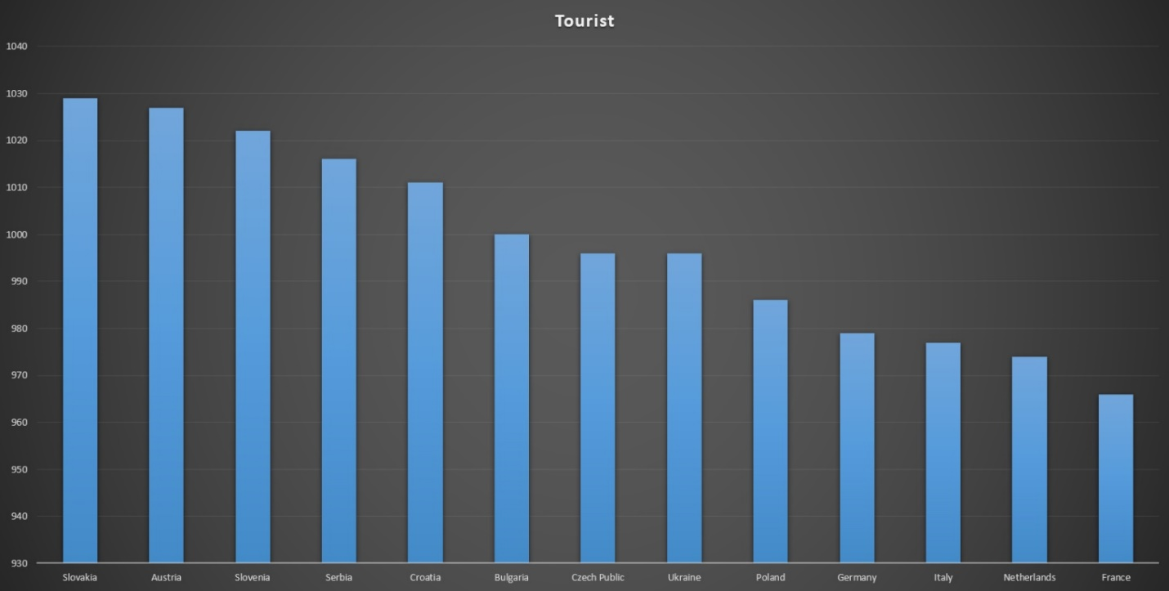

Figure Nr*: Long title (source)

Legends:

X-axis: incl. dimension

Y-axis: incl. dimension

Year: …

**<<remark: tables need headers both for rows and columns – see legends above>>**

**3 2 2 2 2 Austria**

**9 7 7 7 6 Bulgaria**

**7 8 8 9 8 Czech Republic**

**14 14 14 14 14 France**

**13 13 13 13 10 Netherlands**

**4 5 5 8 5 Croatia**

**10 9 9 10 12 Poland**

**11 11 11 11 13 Germany**

**12 12 12 12 11 Italy**

**6 3 3 4 9 Romania**

**1 1 1 1 3 Slovakia**

**2 6 6 6 1 Slovenia**

**5 4 4 3 4 Serbia**

**8 10 10 5 7 Ukraine**