Subject: Service Science and Knowledge Economy: Research Methods: https://miau.my-x.hu/mediawiki/index.php/QuILT-IK045-Diary

Best of the inbound countries for Hungary in 2018 based on multilayered evaluation
Aiana Dalbaeva PORAYZ, Malike Kerut HMB72Q, Yunus Emre Soygili ECK145

Keywords: Countries, Tourists, Expenditures, Population, Same day trips, Similarity analysis

Abstract: We can estimate the variable ‘Preference Index’ about tourist numbers and expenditures. In details: sample size, number of inbound trips, length of stay of visitors, expenditures of visitors, expenditures per day per visitor. Results of the analysis: we can present some ideas about which countries should we focus to gain more profit? Also, we can show a graph (which everyone can create easily) about the aggregated amount of touristic phenomena. Best country/countries: Slovakia, Austria, Croatia, Romania and Serbia. Methodology: We aggregate multilayer statistics in an optimized way in order to have an anti-discriminative Preference Index.

Introduction
The service science in a knowledge economy based on research methods should be interpreted as a challenge of the KNUTH’s principle: knowledge is what can be transformed into source code. Therefore, the decision problems of services (like tourism) should be interpreted in form of models:
In a team project about best inbound countries for Hungary as a touristic place in 2018, one of the relevant questions is: What is the best country or what is the rank of the potential countries?
The following statistics have been considered as variables such as:
1. sample size,
2. number of inbound trips,
3. length of stay of visitors,
4. expenditures of visitors,
5. expenditures per day per visitor.
Sources: https://miau.my-x.hu/mediawiki/index.php/Vita:QuILT-IK045-Diary#9._Day_.282019.IV.17.29

Results of the analysis: we want to present some ideas about which countries should we focus to gain more profit? More profit can be realized through more rational resource allocation e.g. preferring the best countries or based on an alternative hypothesis see future visions.

Data assets
The raw data could be identified online:
Background-XLSX: https://miau.my-x.hu/miau/quilt/045.xlsx
KSH-source: http://www.ksh.hu/stadat_annual_4_5
Used STADAT-table (HTML): http://www.ksh.hu/docs/eng/xstadat/xstadat_annual/i_ogt003a.html
Used STADAT-table (XLS): http://www.ksh.hu/docs/eng/xstadat/xstadat_annual/xls/4_5_2ie.xls
Background information: http://www.ksh.hu/docs/eng/modsz/modsz45.html
Meta information: http://www.ksh.hu/apps/meta.objektum?p_lang=EN&p_menu_id=110&p_ot_id=100&p_obj_id=OGT
Remarks a) and b) can be visualized with a mouse-over effect in the HMTL-view.
https://miau.my-x.hu/mediawiki/index.php/Vita:QuILT-IK045-Diary#9._Day_.282019.IV.17.29
Data-processing
- This teamwork is based on an initial version of the inbound countries for Hungary in 2018 based on multilayered evaluation, where the raw data is shown below (see Figure Nr1).
- The next step (see Table Nr1) was to identify the “clear” data without “b” sings, where the “b” sing means not clear enough data because the data was not clear enough to measure (s. html-version mouse-over effects).
- The statistics about the touristic activities should be divided by the population size of the countries in order to derive a kind of relative value set (see Table Nr2). The population sizes could be identified in Wikipedia country by country.
- After clearing the data we left 14 countries on the list, where each country has its rating instead of the raw statistics.
- Based on the ranking values of each attribute, an anti-discriminative model was involved (see: https://miau.my-x.hu/myx-free/coco/index.html) in order to derive the Preference Index Values (see Table Nr3) for each country (s: background spreadsheet: https://miau.my-x.hu/miau/quilt/045.xlsx)
- Based on the estimated preference index values, a map could be created in order to visualize the results in a geographical frame (see Figure Nr2).

4.5.2. The number of inbound trips to Hungary and the related expenditures by countries (2009–)
Countries | Same day trips
 | sample size, pieces | number of inbound trips, thousands | length of stay of visitors, thousand days | expenditures of visitors, million HUF | average length of stay of visitors, days | expenditures per day per person, thousand HUF
$2018
Austria | 5 749 | 7 241 | 7 241 | 139 368 | 1,0 | 19,2
Belgium, Luxembourg | 20 | 60 | 60 | 432 | 1,0 | 7,2
Bulgaria | 208 | 1 102 | 1 102 | 10 320 | 1,0 | 9,4
Czech Republic | 618 | 1 014 | 1 014 | 6 038 | 1,0 | 6,0
Denmark | 2 | 5 | 5 | 12 | 1,0 | 2,5
United Kingdom | 10 | 39 | 39 | 452 | 1,0 | 11,5
Finland | 2 | 1 | 1 | 33 | 1,0 | 61,1
France | 26 | 100 | 100 | 467 | 1,0 | 4,7
Greece | 5 | 26 | 26 | 158 | 1,0 | 6,2
Netherlands | 51 | 58 | 58 | 421 | 1,0 | 7,3
Croatia | 2 168 | 935 | 935 | 5 893 | 1,0 | 6,3
Ireland | 1 | 0 | 0 | 4 | 1,0 | 14,0
Poland | 473 | 1 892 | 1 892 | 9 666 | 1,0 | 5,1
Germany | 889 | 1 082 | 1 082 | 8 552 | 1,0 | 7,9
Italy | 183 | 211 | 211 | 2 514 | 1,0 | 11,9
Romania | 5 299 | 9 796 | 9 796 | 100 009 | 1,0 | 10,2
Spain, Portugal | 5 | 16 | 16 | 182 | 1,0 | 11,4
Sweden | 9 | 29 | 29 | 282 | 1,0 | 9,6
Slovakia | 8 079 | 9 272 | 9 272 | 91 971 | 1,0 | 9,9
Slovenia | 1 505 | 374 | 374 | 3 554 | 1,0 | 9,5
Other countries of EU | 5 | 33 | 33 | 30 | 1,0 | 0,9
Member States of the European Union (except Hungary) | 25 307 | 33 284 | 33 284 | 380 360 | 1,0 | 11,4
Russia | 17 | 54 | 54 | 401 | 1,0 | 7,4
Serbia, Montenegro | 2 295 | 3 134 | 3 134 | 39 171 | 1,0 | 12,5
Ukraine | 1 648 | 2 014 | 2 014 | 90 630 | 1,0 | 45,0
Europe (expect Hungary) | 29 380 | 40 103 | 40 103 | 518 110 | 1,0 | 12,9
Asia | 7 | 9 | 9 | 711 | 1,0 | 83,1
Africa | 2 | 1 | 1 | 9 | 1,0 | 15,2
America | 2 | 3 | 3 | 169 | 1,0 | 65,2
USA | 2 | 3 | 3 | 169 | 1,0 | 65,2
Australia | 1 | 1 | 1 | 5 | 1,0 | 7,3
Total | 29 392 | 40 115 | 40 115 | 519 004 | 1,0 | 12,9

Figure Nr1: Raw data
(source: http://www.ksh.hu/docs/eng/xstadat/xstadat_annual/xls/4_5_2ie.xls)

Table Nr1.
2018
Countriesa | pop | sample size, pieces | number of inbound trips, thousands | length of stay of visitors, thousand days | expenditures of visitors, million HUF | expenditures per day per person, thousand HUF
Austria | 8773 | 5 749 | 7 241 | 7 241 | 139 368 | 19,2
Bulgaria | 7102 | 208 | 1 102 | 1 102 | 10 320 | 9,4
Czech Republic | 10580 | 618 | 1 014 | 1 014 | 6 038 | 6
France | 67190 | 26 | 100 | 100 | 467 | 4,7
Netherlands | 17080 | 51 | 58 | 58 | 421 | 7,3
Croatia | 4154 | 2 168 | 935 | 935 | 5 893 | 6,3
Poland | 38430 | 473 | 1 892 | 1 892 | 9 666 | 5,1
Germany | 82790 | 889 | 1 082 | 1 082 | 8 552 | 7,9
Italy | 60590 | 183 | 211 | 211 | 2 514 | 11,9
Romania | 19640 | 5 299 | 9 796 | 9 796 | 100 009 | 10,2
Slovakia | 5435 | 8 079 | 9 272 | 9 272 | 91 971 | 9,9
Slovenia | 2066 | 1 505 | 374 | 374 | 3 554 | 9,5
Serbia, Montenegro | 7022 | 2 295 | 3 134 | 3 134 | 39 171 | 12,5
Ukraine | 44830 | 1 648 | 2 014 | 2 014 | 90 630 | 45

Table Nr2. This table shows the outcome of the formula Sample/Population. The example is 5749:8773=0,655306.
Countriesa | sample size, pieces | number of inbound trips, thousands | length of stay of visitors, thousand days | expenditures of visitors, million HUF | expenditures per day per person, thousand HUF
Austria | 0,655306 | 0,825373 | 0,825373 | 15,88601 | 0,002189
Bulgaria | 0,029288 | 0,155168 | 0,155168 | 1,453112 | 0,001324
Czech Republic | 0,058412 | 0,095841 | 0,095841 | 0,570699 | 0,000567
France | 0,000387 | 0,001488 | 0,001488 | 0,00695 | 7E-05
Netherlands | 0,002986 | 0,003396 | 0,003396 | 0,024649 | 0,000427
Croatia | 0,521907 | 0,225084 | 0,225084 | 1,418633 | 0,001517
Poland | 0,012308 | 0,049232 | 0,049232 | 0,251522 | 0,000133
Germany | 0,010738 | 0,013069 | 0,013069 | 0,103297 | 9,54E-05
Italy | 0,00302 | 0,003482 | 0,003482 | 0,041492 | 0,000196
Romania | 0,269807 | 0,498778 | 0,498778 | 5,092108 | 0,000519
Slovakia | 1,486477 | 1,70598 | 1,70598 | 16,92199 | 0,001822
Slovenia | 0,728461 | 0,181026 | 0,181026 | 1,720232 | 0,004598
Serbia, Montenegro | 0,32683 | 0,446312 | 0,446312 | 5,578325 | 0,00178
Ukraine | 0,036761 | 0,044925 | 0,044925 | 2,021637 | 0,001004

Table Nr3. In this table, the green parts mean best countries for Hungary, meanwhile the yellow parts are still fine, but the red ones mean countries less interested in Hungary on the list.
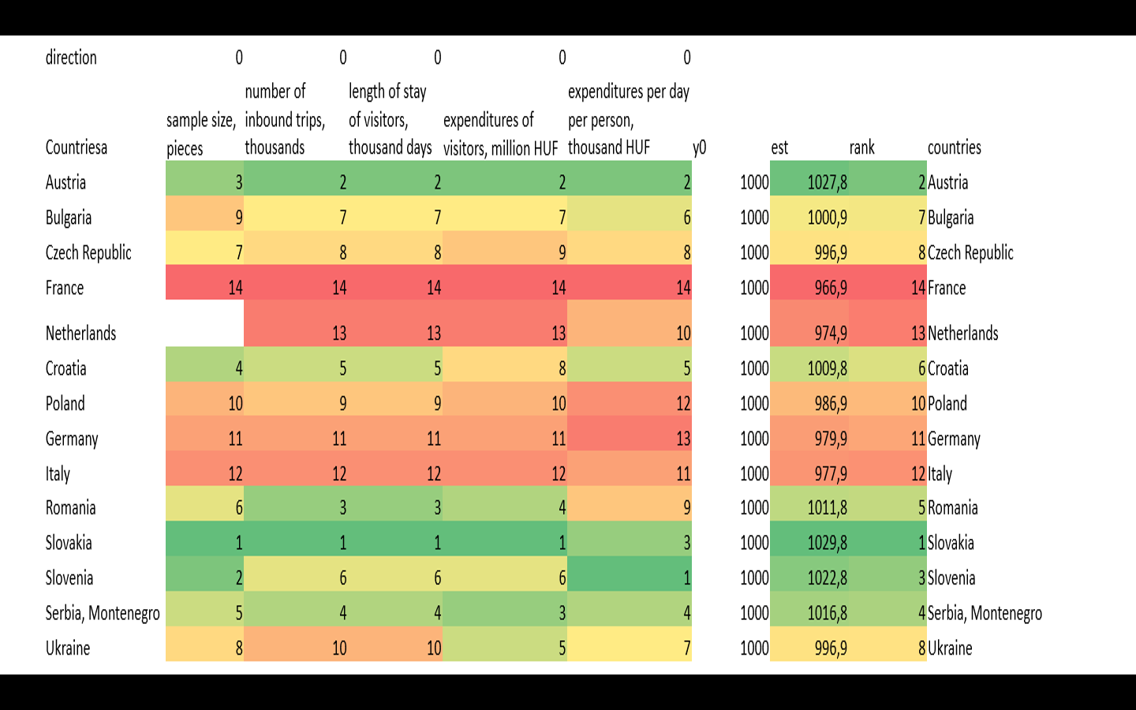

Results
When we look at the 2018-table (Figure Nr1) which show us sample size, number of inbound trip, length of stay of visitors, expenditures of visitors, expenditures per day per visitors who came to the Budapest from other countries, we can array them according to index. In this line, we can see that Slovakia, Austria, Slovenia and Serbia form top 4 rank among countries. Also, France, Netherlands and Italy form last 3 rank in the line. First 4 ranks are aqua and last 3 rank dark blue in our map which show us ranks of the counties.
However, there is top 5 countries for Hungary such: Slovakia, Austria, Croatia, Romania and Serbia and the rest are fine or should be attracted by Hungary more.

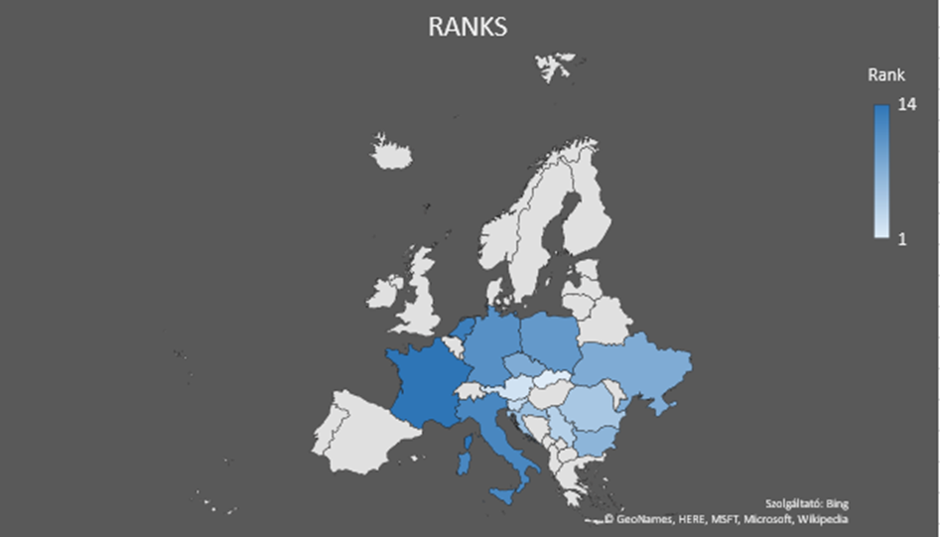
Figure Nr2. The results in a geographical frame (source: own presentation)

Conclusions
The best 4 countries for Hungary are Slovakia, Austria, Slovenia, Serbia. As far as we understand from our data Slovakia has 1029.8 preference index value. Austria has 1027.8, Slovenia has 1022.8 and Serbia has 1016.8 rank – compared to a fictive norm value of 1000. It means Hungary has developed tourism relations with those countries Also its effective those countries are close distance to Hungary it makes easy and cheap to travel. Slovakia has best rank for Hungarian tourism in 14 countries. It means Hungary is attractive country for Slovakian tourists. In addition Slovakia and Hungary really close to each other , cheap to travel and each two country has similar culture . Diplomatic arrangements can be made to improve the relations between these two countries. Affordable tours can be organized in order to keep good relations between the two countries and not to lose tourists. Also, the government may apply special discount programs for students and retirees. A promotional film that introduces Hungary can be produced and published on Slovak television and websites.
In addition, the last 3 countries are France, Netherlands and Italy. France has 966.9 rank, Netherlands has 974.9 and Italy has 977.9 rank. So, Hungary needs to improve relations with those countries.
The last rank belongs to France. We can establish good relations with France to improve French people’s tourism rank on Hungary. Like in case of Slovakia , we couldn build good diplomatic relations with France. Seminars can be organized in France at schools to promote Hungarian tourism and places to travel. Through the mutual agreement, Paris Budapest tours can be organized in particular. Tourism can be supported with promotional films and advertisements.

Finally, it is possible to exchange tourists with mutual agreements in both countries. Cheap tours can be organized by applying special discount programs. Historical places and natural beauties can be supported with visuals.

Future Vision
The parallel hypothesis could be reuse all sources for countries being deep on the ranking list. This hypothesis could be proved based on complex simulation model? However, we can determine which countries are in last ranks and we can try to find new solutions. For example, we determined that France is last country in amount of tourist which visited Hungary in 2018 and we found new ideas to increase quantity of tourists from the France with our Interpretation Expert because we can see that there is a direct proportion between expenditure and tourists.

References

https://miau.my-x.hu/mediawiki/index.php/Vita:QuILT-IK045-Diary#10._Day_.282019.IV.24.29
https://miau.my-x.hu/mediawiki/index.php/Vita:QuILT-IK057-Diary#10._Day_.282019.IV.24.29
https://miau.my-x.hu/mediawiki/index.php/Vita:QuILT-IK059-Diary#10._Day_.282019.IV.24.29
https://miau.my-x.hu/myx-free/coco/index.html

